Solutions manual

to accompany

Accounting information systems

5th edition

by

Parkes, Olesen and Blount

Prepared by
Alison Parkes

© John Wiley & Sons Australia, Ltd 2017
Chapter 1: System fundamentals – Introduction

Discussion questions

1.1 Describe some inputs, processes and outputs of an accounting information system.
(LO1, LO2, LO3)

Inputs: Sales order (record purchase requests from customers), purchase data (data about purchases initiated with our vendors), Receiving data (data about arriving goods), shipping data (data about goods sent to customers), invoices (received from vendors)

Processes: Check data is valid, sort data, manipulate data

Outputs: Invoice (sent to customer), cheque (sent to vendor), profit and loss report, accounts receivable report

1.2 What is the difference between data and information?
(LO2)

Data are the raw facts relating to or describing an event. For example, data relating to a sale could include the customer’s name, address, salesperson ID, the sale number, sale date, items purchased, quantity purchased and so on. On its own this data is not all that useful. However, through the application of rules and knowledge the data can be made meaningful, thus converting it to information. For example, the collection of data relating to sales may be summarised into sales by customer or sales by product, to provide information about high spending customers or slow moving products.

1.3 What is information overload? Why might it happen? What are its consequences?
(LO2)

Information overload refers to the situation where an individual has more information than required and can’t meaningfully process this information when making a decision. It can happen when data provided is not carefully selected (i.e. garbage dump), or where data provided has not been summarized or organized in a manner that makes it comprehensible. The potential consequences of information overload include the production of reports and information that serves no purpose and deleterious decision making by employees who are unable to synthesise the volume of information that they are exposed to.

1.4 Briefly summarise the changing relationship between accounting and information systems.
(LO4)

This question can be answered with reference to Figure 1.5, which depicts the changing nature of and interaction between accounting and information systems. Regarding the role of accounting we see that initially accounting was the primary source of information for an organisation. In the original manual accounting environment, the people who did the accounting also represented the technology of the system – the accountant kept records and stored data and synthesised it into reports. In essence, the accounting function and the information technology function were one. The advent of computing technology and other processing technologies described in the chapter were based around ways of making the accounting task easier. When the information technology first hit organisations it was predominantly seen as a way of helping the accountant – thus information systems were the domain of the accountant. This is represented in the top part of figure 1.5. The domain of information technology soon expanded, encompassing more than just accounting. As a consequence, we have the scenario depicted with the intersecting circles in figure 1.5. With the growth of information systems, the traditional roles of data management and storage that were previously the domain of the accountant began to be consumed by the information systems domain, with the accounting function being separate from the technology that allowed its execution. Finally, technology was incorporated to many areas of the organisation, not just the accounting role. The technology/information systems role became the focus, and it served many areas of the business, of which accounting was one. Thus accounting became a user of the information systems function in order to complete its tasks. Thus accounting has gone from being in control of the information systems function to being a user of the information systems function as technology has advanced and it has become necessary for people to be experts in technology.

1.5 Compare the role of the accountant today to his or her role before the introduction of computer technology. How have the responsibilities and duties changed over time?
(LO4)

The discussion of this question can be tied into the discussion in question 1.4. What becomes evident from the historical discussion of the evolution of the accounting and information systems function is that the accountant has gone from being responsible for both the accounting function and the information management function associated with accounting to just being responsible for the accounting function. The technically qualified personnel, who do not necessarily have accounting skills, have become responsible for the information storage function associated with accounting. In a sense, the responsibilities of the accountant have been reduced, since they have lost direct control of the information storage function associated with the accounting discipline. Some may also argue that this shift has created a greater need for accountants to be trained not just in the technical skills of accounting but also in skills of information management, for example information systems.

1.6 What are some of the uses of accounting information? Provide five examples of how accounting information may be used and who it would be used by.
(LO5)

The table below provides some typical examples of how accounting information may be used.

USER | USES OF ACCOUNTING INFORMATION
Shareholder | Uses the general purpose financial reports to assess the performance of the company they have invested in, assessing both historical performance and using the historical information to make predictions about future performance.
Managers | Are commonly exposed to bonus schemes that are based on profit levels or other financial performance indicators. Thus managers have accounting information being used as a performance assessment device.
Union | May use financial reports of companies – particularly profit information – to substantiate claims for higher wages for union members.
Bank | Will look at financial performance and financial position information when assessing credit worthiness of loan applicants.
Suppliers | A company’s suppliers may wish to view financial information before entering in to long term supply agreements, in order to ensure that the company is able to meet the terms of the agreement and pay for the supplies that are purchased.

Problems

1.1 Consider the following data input techniques: manual keying via a keyboard, and barcode scanning. Describe the characteristics of the data errors you would expect to find in data captured using each of these methods.
(LO2, LO5)

Manually keyed data is characterised by errors that are random, rather than systemic. Human beings rarely make the same data input mistakes repeatedly. By contrast, barcode scanning data errors are usually systemic; a mistake made once is made every time that same barcode is scanned.

1.2 You are responsible for advising a grocery retailer on appropriate data capture
techniques for its sales system. The grocery retailer makes approximately 1,000 sales per day per store, and has 20 stores. Considering the errors you anticipated occurring in problem 1.1, choose the most appropriate input technique and advise management on its strengths and weaknesses and why it is the best option for the organisation. Would you give the same advice to a grocery retailer with a single store making 20 sales per day? If not then why not?
(LO1, LO2, LO5)

For a large grocery store barcode scanning would be the most efficient and effective choice. The strengths of scanning include quick and accurate data capture, and the timely updating of inventory levels as the goods are sold. For a large organisation, the costs of such a system can be more easily absorbed due to economies of scale. The main weakness here is the need to ensure that the data linked to each of the barcode labels is high quality. Any errors in this data will result in erroneous sales data being recorded

A smaller organisation may be better to manually key in their sales transactions, provided that each transaction does not require a large number of items to be entered, and timeliness is not a critical factor. The weaknesses here are the possibility of random data entry error and the need for input validation controls and checks. A theme to consider here is that the needs of the organisation and the context in which it operates should determine the technology that is adopted – there is no one right answer. Do not allow yourself to be driven by the technology and just adopting technology for technology’s sake.

1.3 The chapter discussed the idea of a system and its components. Construct a table listing some of the likely inputs, processing, and outputs for each of the following accounting information systems:
(a) a university enrolment system
(b) an online sales system for a small manufacturer
(c) An airline ticketing system
(d) a large retail store sales system
(LO3, LO4)

SYSTEM | INPUT | PROCESS | OUTPUT
(a) A University enrolment system | Student Details  Subject Details | Confirm eligibility to enrol  Confirm payment options  Store data | Enrolment receipt  Timetable
(b) An online sales system for a small manufacturer | Job details  Customer details  Payment details | Calculate sales total  Check payment validity  Notify production | Invoice  Receipt
(c) An airline ticketing system | Customer details  Flight details  Payment details | Check seat availability  Check payment validity | Flight itinerary  Receipt
(d) a large retail store sales system | Customer details  Purchase details | Check credit limit  Record sale  Update amount owing balance  Update inventory balance | Invoice  Accounts Receivable reports

1.4 Describe some of the external influences that would likely affect the accounting information systems listed in question 1.3. To what extent do you think these influences dictate the design of an accounting system?
(LO4)

SYSTEM | External influence & impact
(a) A University enrolment system | Government legislation would have a strong impact on how student fees are calculated and collected.
(b) An online sales system for a small manufacturer | Changes in suppliers and customers technology expectations would influence how payables and receivables system processes are designed
(c) An airline ticketing system | Changes in government tax structures would necessitate changes to fare calculation and collection
(d) a large retail store sales system | Changes to GST would require adjustments in the accounting system

1.5 Based on the information contained in this chapter, along with your prior knowledge of accounting critically assess the following statement: ‘Accounting is an information system’.
(LO3, LO4)

This question is designed to get students thinking about the importance of information systems. Accountants rely on data in these systems to do our job. Being an accountant is not just about keeping the books and making sure that the debits and credits balance at the end of the day. A technical knowledge of accounting is a necessary but not sufficient qualification. Skills in information technology / information systems become important, as is some familiarity with business processes. Reference to Figure 1.2 could be a useful exercise, all of these career paths require some understanding of the information system being used by accountants.

1.6 Conduct a web search of the big accounting firms and identify some of the skills they are typically looking for in graduates. Do they seem to be emphasising accounting skills or information skills, or both? Why do you think this is so?
(LO1)

The “big 4” websites shown below indicate that they are seeking a wide range of skills as well as technical accounting ability. A job search via seek.com indicates that most accounting positions explicitly request excel expertise, as well as experience with one or more of the major accounting packages.

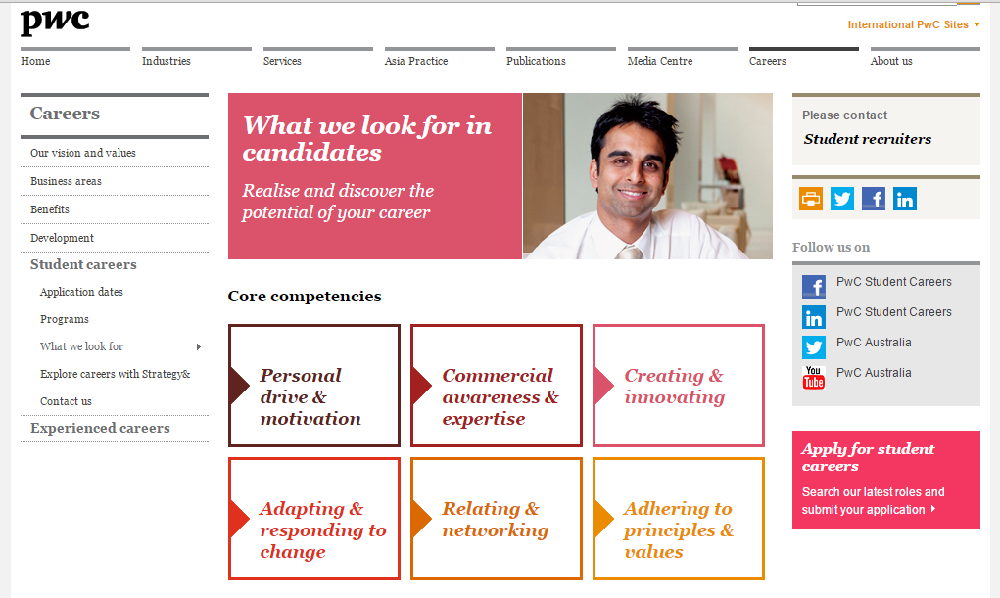

1.7 A computer science student says to you, ‘Studying accounting information systems is no use unless you are a programmer who understands how to build that system’ How would you respond to such a statement? Do you think the computer science student is correct? Why?
(LO1, LO4)

The response to the statement by the computer science student should emphasise that once a system has been built and implemented it needs to be used (by an accountant) managed (by an accountant) and maintained (ideally by a combination of an accountant and IT personnel)

1.8 Read AIS Focus 1.1 ‘Loyalty New Zealand - reaping the big data rewards’, and answer the following:

(a) Why would grocery retailers share their customer data with Loyalty NZ? What are the main corporate risks around such data sharing?
(b) What are some of the issues you could foresee around the ownership of customer data in these sorts of projects?
(c) What would be some of the expected benefits of this project?
(d) How do you think the categorisation project would be viewed by consumers? Would your answer be different if you were a parent who started receiving offers relating to the next lifecycle stage of your family?
(LO2, LO3)

(a) Grocery shopping g data collected instore is mostly anonymous – retailers can identify what is being sold but not their customer or any details of who is buying which products. By issuing a loyalty card it possible for the retailer to link the stored demographic information from the loyalty card with the product purchase information for each sale. The biggest risk for the retailer is that an external organisation will have access to details of their customers, leading to the possibility of inadvertent of deliberate use or sharing of this data.

(b) Retailers clearly own their sales data however customer data belong to the loyalty card provider. Retailers may be unable to access detailed customer data, or may need to pay the loyalty card provider for access.

(c) Retailers can identify patterns and trends in customer purchases, enabling them to more accurately target promotions, discounts, and advertising spend.

(d) Some customer may be disturbed at the thought of being categorised or profiled as being ‘Like xxxx” and if knowledge of this practice became public may hurt company reputation. The lifecycle stage offers are predicated on individuals behaving in line with the norm. Any deviations would mean you receive inappropriate offers. In the case of parenting lifecycle this could be lead to negative publicity in a case where parenting lifecycle does not follow the normal pattern, for example if a child dies, or is no longer living with the parent when a customer receives the offer.

1.9 Given the data in figure 1.3 use an excel spreadsheet or similar to prepare an example of a report that could be generated using this data. Who would typically use your report, and why would this information be useful to them?
(LO2, LO5)

(i) This example weekly Sales summary report would most likely be used by the sales manager as it shows weekly sales trends. This report would also be of use to a marketing analyst who was interested in assessing the success or otherwise of advertising and promotion campaigns

Weekly sales summary – June 2015
Date | Invoice # | Sales
02-06-15 | 1001 | 318.18
04-06-15 | 1002 | 110.00
05-06-15 | 1003 | 130.00
07-06-15 | 1004 | 363.64
Total sales week ending 7th June |  |  | 921.82
08-06-15 | 1005 | 590.91
09-06-15 | 1006 | 454.55
10-06-15 | 1007 | 384.55
11-06-15 | 1008 | 585.55
12-06-15 | 1009 | 1009.09
12-06-15 | 1010 | 204.55
13-06-15 | 1011 | 68.18
14-06-15 | 1012 | 622.73
Total Sales week ending 14th June |  |  | 3920.11

(ii) This example sales by customer report would be useful for sales staff to identify higher value and repeat customers.

Total Sales by customer report – June 2016
Customer | Total sales
D Malchio | 1009.09
B Earton | 986.37
K Riley | 920.91
M Blue | 740.10
B Dulloch | 590.91
S Pine | 454.55
M Cook | 333.64
A Bligh | 318.18
P Star | 204.55
G Macquarie | 130.00
A Phillip | 110.00
F McGrath | 68.18
Total Sales | 5866.48

(iii) This example profit margin per customer report would be useful for both sales staff and sales managers as it identifies $dollar and percentage profitability of individual customers.

Gross profit per customer - June 2016
Customer | Sales | Cost of sales | Gross profit $ | Gross profit %
B Earton | 986.37 | 600.00 | 386.37 | 39%
D Malchio | 1009.09 | 670.00 | 339.09 | 34%
K Riley | 920.91 | 590.00 | 330.91 | 36%
B Dulloch | 590.91 | 400.00 | 190.91 | 32%
M Blue | 740.10 | 580.00 | 160.10 | 22%
S Pine | 454.55 | 300.00 | 154.55 | 34%
A Bligh | 318.18 | 180.00 | 138.18 | 43%
M Cook | 333.64 | 200.00 | 133.64 | 40%
P Star | 204.55 | 100.00 | 104.55 | 51%
G Macquarie | 130.00 | 80.00 | 50.00 | 38%
A Phillip | 110.00 | 65.00 | 45.00 | 41%
F McGrath | 68.18 | 39.00 | 29.18 | 43%
Total | 5866.48 | 3804.00 | 2062.48 | 35%

Note that students may also present graphic reports rather than tabular, the examples below present the same data as the gross profit per customer report included above.

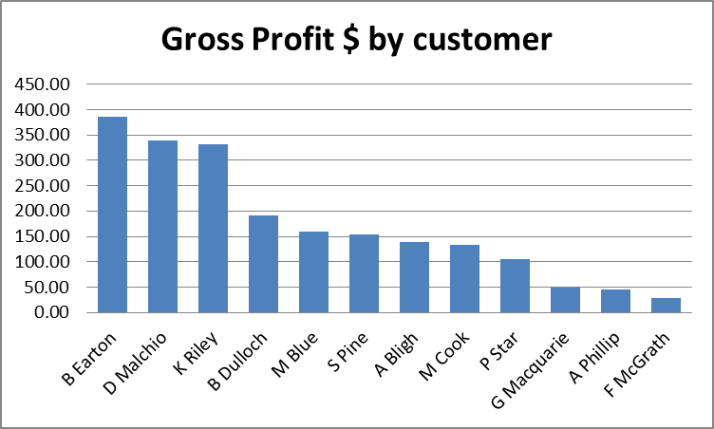

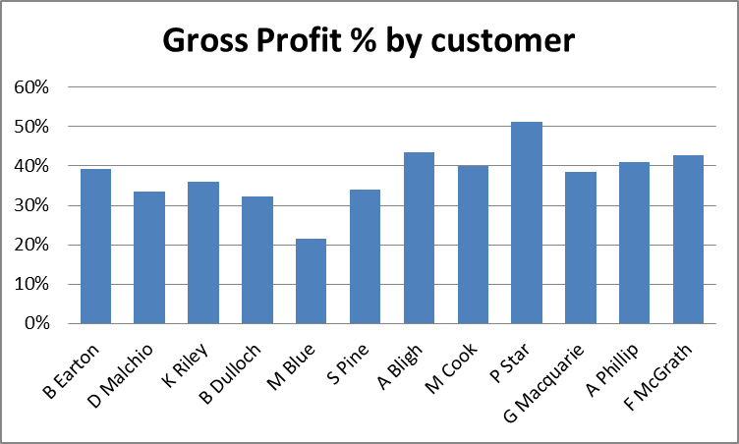

1.10 Read figure 1.6 ‘Integrated web portal MyCoatesHire built using agile approach’, and answer the following:
(a) What created the need for this online system?
(b) What are some of the people-based issues that may be confronted in making the switch from face-to-face to online sales?
(c) What are some of the technology-based issues that could be confronted in making the switch from face-to-face to online sales?
(d) Why do you think that Coates prototyped this system before finalising the design?
(e) What has Coates done (or what could it do) to encourage acceptance of the new system?
(LO4, LO5)

(a) The project was driven by customer needs.

(b) People based issues likely to be encountered include resistance to ordering online, errors in data input by the customer, and possibly a reduced ability for Coates to answer ad hoc customer questions interactively during the hire process.

(c) Choice of platforms and delivery channels would be one major issue. Is it a website? Is it an app? Is it both? Do we create a different version for iPhones and iPads? How about android phones and tablets? Another issue is the data linkage between the online hire front end and the corporate systems backend. How do we accurately populate the online hire data into our sales and hire management systems? How often do we need to update our sales and hire systems?

(d) Given this project was driven by customer needs and intended to improve customer satisfaction and therefore sales it is essential that the online site works as intended. Use of a prototype allowed Coates to test their design before moving on to create the full version. This not only can reduce the risk of project failure, it can also reduce costs. Errors in design are much cheaper to address at prototype stage.

(e) Coates worked directly with customers during the design and implementation stages to ensure they were happy with the online hire system. Once the site is live they could consider offering customers incentives such as discounts to book hire online rather than via other channels. They should also survey customer after they use the site to see whether the customer experience was as anticipated and identify any issues.

1.11 Read AIS Focus 1.3 ‘Hacktivists “Anonymous” attack Australian government websites’ and answer the following:
(a) What do you think of ASIO’s public response to this attack? How would you respond if you were the CIO?
(b) What are the potential benefits of hacktivism? Do you think this sort of activity can achieve these benefits?
(c) How would these acts of hacktivism impact the users and owners of the websites involved?
(LO1, LO5)

(a) ASIOs response was that (i) they had technical issues with the website and (ii) there was no risk attached to this. Students will likely either agree this measured response was appropriate or alternatively argue that this is deceptive and the truth should have been disclosed to the public. The CIO response should involve a thorough investigation of the event and some recommendations to reduce the risk of recurrence.

(b) Potentially hacktivism is a cost-effective way to gain broad exposure and highlight issues activists believe are important, but the costs to business and the public can be very high. A good answer here would explain what the benefits are, then justify if and how they believe those benefits would be achieved.

(c) Users would be unable to access the site and may have reduced trust in that website so become resistant to use over the longer term. The owners have to bear the costs of fixing the website and upgrading security over the site. Additionally the owner would need to address the reputational damage created by the attack.

1.12 Read AIS focus 1.4 ‘Is your email ready for the summer bushfire season?’ and answer the following:
(a) Identify the main difference between email and other types of corporate data.
(b) Do you think it likely that email messages are accounting data? How about emailed file attachments – could they be accounting data?
(c) How many of the six issues listed in the article would apply to all business information systems? Who do you think should be responsible for addressing these issues – the CIO, the CFO or someone else?
(LO1, LO2)

(a) Emails tend to be treated as a personal good by employees, unlike most other forms of corporate date. Unlike other forms of corporate data it is quite common for employees to unilaterally decide to delete, copy and share the contents of emails.

(b) Emails could definitely be accounting data – requests to supply goods, or a confirmation of an order are examples of accounting data which could be held in an email. Email attachments are also likely to contain accounting data, for example a .pdf file attachment could contain a receipt for a payment, or an invoice to be paid.

(c) All six of these issues would relate to all business information systems. The real issue here is that typically organisations do not think of email as a business information system so they tend not to manage it in the same way as their other systems. Primary responsibility for addressing these issues would rest with the CIO, however given the existence of accounting data content the CFO should also have some insight or overview of the quality of management of the email system.

