CHAPTER ONE – Introduction to Business Combinations AND THE CONCEPTUAL FRAMEWORK
1.1 GROWTH THROUGH MERGERS

A business combination occurs when the operations of two or more companies are brought under common control.

Merger activity over time is presented in Illustration 1-1 Part A.

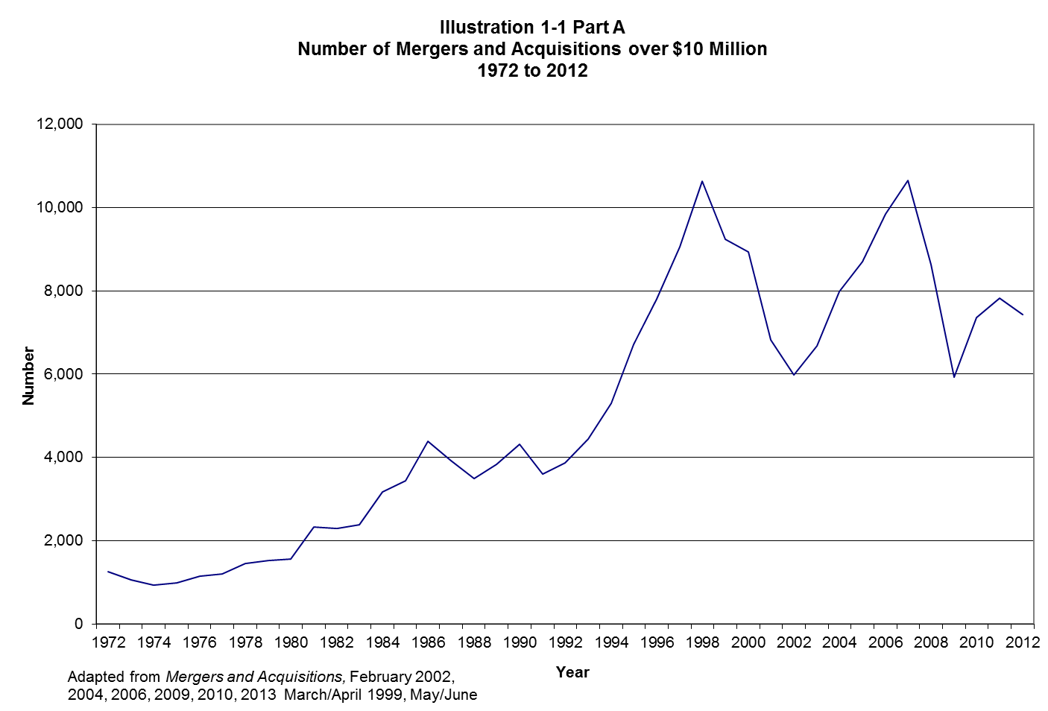

1.2 NATURE OF THE COMBINATION

- Nature of the combination
- In a friendly combination, the boards of directors of the potential combining companies negotiate mutually agreeable terms of a proposed combination. The proposal is then submitted to the stockholders of the involved companies for approval.
- An unfriendly (hostile) combination results when the board of directors of a company targeted for acquisition resists the combination. A formal tender offer enables the acquiring firm to deal directly with individual shareholders.

- Defense tactics
Resistance often involves various moves by the target company. Whether or not such defenses are ultimately beneficial to shareholders remains a controversial issue.
  - Poison pill: Issuing stock rights to existing shareholders enabling them to purchase additional shares at a price below market value, but exercisable only in the event of a potential takeover.
Example: Cisco creates "poison pill" to block takeovers
by James Niccolai
http://www.computerworld.com/

Cisco Systems, Inc. said yesterday that its board of directors has approved a shareholder rights plan designed to protect the networking company's investors in the event of a hostile takeover bid.

Known in the business world as a "poison pill," the plan is a strategic maneuver to make the company's stock less attractive to potential bidders and to encourage bidders to solicit offerings through the company's board of directors, the San Jose, Calif., company said. A company spokeswoman said Cisco isn't currently the target of a takeover bid, but added that such plans aren't uncommon at large corporations.

Under the plan, Cisco shareholders would have the right to acquire for half price one share in the company for each share held as of June 22. The plan would kick in if a person or company acquires or announces an offer to acquire 15% or more of the company's common stock, Cisco said.

  - Greenmail: The purchase of any shares held by the would-be acquiring company at a price substantially in excess of their fair value. The purchased shares are then held as treasury stock or retired.
  - White knight or white squire: Encouraging a third firm more acceptable to the target company management to acquire or merge with the target company.

  - Pac-man defense: Attempting an unfriendly takeover of the would-be acquiring company.

  - Selling the crown jewels: The sale of valuable assets to others to make the firm less attractive to the would-be acquirer. The negative aspect is that the firm, if it survives, is left without some important assets.

  - Leveraged buyouts: The purchase of a controlling interest in the target firm by its managers and third party investors, who usually incur substantial debt in the process and subsequently take the firm private. The bonds issued often take the form of high interest, high risk “junk” bonds.

1.3 BUSINESS COMBINATIONS: WHY? WHY NOT?

A. A company may expand in several ways. Some firms concentrate on internal expansion. For other firms external expansion is the goal; a company may achieve significant cost savings as a result of external expansion. In addition to rapid expansion, the business combination method, or external expansion, has several other potential advantages over internal expansion:

- Operating synergies may take a variety of forms. In the case of vertical mergers (a merger between a supplier and a customer), synergies may result from the elimination of certain costs related to negotiation, bargaining, and coordination between the parties. In the case of a horizontal merger (a merger between competitors), potential synergies include the combination of sales forces, facilities, outlets, etc., and the elimination of unnecessary duplication in costs.

- Combination may enable a company to compete more effectively in the international marketplace.
- Business combinations are sometimes entered into to take advantage of income tax laws. The opportunity to file a consolidated tax return may allow profitable corporations’ tax liability to be reduced by the losses of unprofitable affiliates.

- Diversification resulting from a merger offers a number of advantages, including increased flexibility, an internal capital market, an increase in the firm’s debt capacity, more protection from competitors over proprietary information, and sometimes a more effective utilization of the organization’s resources.

- Divestitures accounted for over 30% of the merger and acquisitions activity in each quarter from 1995 into mid-1998. Shedding divisions that are not part of a company’s core business became common during this period. In some cases the divestitures may be viewed as “undoing” or “redoing” past acquisitions.

B. Notwithstanding its apparent advantages, business combination may not always be the best means of expansion.
- An overriding emphasis on rapid growth may result in the pyramiding of one company on another without sufficient management control over the resulting conglomerate. Unsuccessful or incompatible combinations may lead to future divestitures.
- In order to avoid large dilutions of equity, some companies have relied on the use of various debt and preferred stock instruments to finance expansion, only to find themselves unable to provide the required debt service during a period of decreasing economic activity. The junk bond market used to finance many of the mergers in the 1980s had essentially collapsed by the end of that decade.
- Business combinations may destroy, rather than create, value in some instances.

1.4 BUSINESS COMBINATIONS: HISTORICAL PERSPECTIVE

    - In the United States there have been three fairly distinct periods characterized by many business mergers, consolidations, and other forms of combinations: 1880-1904; 1905-1930; and 1945-present.
- 1880-1904, huge holding companies or trusts were created by investment bankers seeking to establish monopoly control over certain industries. This type of combination is generally called horizontal integration because it involves the combination of companies within the same industry.
- 1905-1930, business combination activity of this period, fostered by the federal government during World War I, was encouraged to obtain greater standardization of materials and parts and to discourage price competition. After the war, these combinations were efforts to obtain better integration of operations, reduce costs, and improve competitive positions rather than attempts to establish monopoly control over an industry. This type of combination is called vertical integration because it involves the combination of a company with its suppliers or customers.
- 1945-present, the third period has exhibited rapid growth in merger activity since the mid-1960s, and even more rapid since the 1980s. Some observers have called this activity "merger mania.'' Illustration 1-1 presents a rough graph of the level of merger activity from 1972 to 2008 in number of deals, and from 1979 to 2008 in dollar volume. Illustration 1-2 presents summary statistics on the level of activity for the year 2008 by industry sector for acquisitions with purchase prices valued in excess of $10 million.

Illustration 1-2
10 Most Active Industries (Domestic Deals) by Number and Value of Transactions in 2012
 | Number of Deals |  |  |  |  | Value of Deals
 |  | Number |  | % of all |  |  | Value | % of Total
Industry | Rank | of Deals |  | M&A Deals |  | Rank | ($ billions) | M&A Value
Business Services | 1 | 957 |  | 18.8% |  | 8 | 24.9 | 4.0%
Software | 2 | 428 |  | 8.4% |  | 7 | 28.8 | 4.6%
Real Estate | 3 | 307 |  | 6.0% |  | 4 | 35.7 | 5.7%
Health Services | 4 | 300 |  | 5.9% |  | 3 | 45.0 | 7.2%
Oil & Gas | 5 | 210 |  | 4.1% |  | 2 | 67.0 | 10.7%
Insurance | 6 | 171 |  | 3.4% |  | 10 | 41.6 | 6.6%
Commercial Banks | 7 | 169 |  | 3.3% |  | - | 31.0 | 4.9%
Investment and commodity firms | 8 | 146 |  | 2.9% |  | 9 | 22.2 | 3.5%
Measuring, Medical & Photographic Equipment | 9 | 140 |  | 2.7% |  | 6 | 30.8 | 4.9%
Wholesale Trade - durable goods | 10 | 139 |  | 2.7% |  | - | 25.8 | 4.1%
Drugs | - | 83 |  | 1.6% |  | 5 | 32.6 | 5.2%
Electric, Gas, and Water Distributions | - | 83 |  | 1.6% |  | 1 | 116.6 | 18.6%
Adapted from Mergers & Acquisitions, February 2013 p. 37.

    - This most recent period can be further subdivided to focus on trends of particular decades or subperiods.
- From the 1950s to the 1970s most mergers were conglomerate mergers. Here the primary motivation for combination was often to diversify business risk
- The 1980s were characterized by a relaxation in antitrust enforcement during the Reagan administration and by the emergence of high-yield junk bonds to finance acquisitions. The dominant type of acquisition during this period and into the 1990s has been strategic acquisitions claiming to benefit from operating synergies. A temporary decline in activity near the end of the 1980s may be traced to the collapse of the junk bond market and to an economic recession.
- By the mid-1990s the credit markets had recovered, and the upsurge in mergers renewed to greater levels than ever before. Deregulation undoubtedly played a role in the popularity of combinations in the 1990s. Although recent years have witnessed few deals blocked due to antitrust enforcement. On May 13, 1998, the United States government announced its intent to appoint a panel of economic advisors to evaluate the impact of merger activity on the economy.
- During the early 2000s, merger activity began to decline, however the merger frenzy returned with steady growth from 2003 to 2006. Eighteen percent of all deals were in the service sector in 2005. By the end of 2008, a decline in merger activity was a direct result of the decline in the economy. In August 2011, the Justice Department sued to halt AT&T’s acquisition of T-Mobile due to competition concerns.

  - Terminology and Types of Combinations

    - From an accounting perspective, the distinction that is most important at this stage is between an asset acquisition and a stock acquisition. An asset acquisition involves the purchase of all of the acquired company’s net assets, whereas a stock acquisition involves the attainment of control via purchase of a controlling interest in the stock of the acquired company.
    - A statutory merger results when one company acquires all the net assets of one or more other companies through an exchange of stock, payment of cash or other property, or the issue of debt instruments (or a combination of these methods). Thus, if A Company acquires B Company in a statutory merger, the combination is often expressed as
Statutory Merger
A Company
B Company
A Company
+ =

- A statutory consolidation results when a new corporation is formed to acquire two or more other corporations through an exchange of voting stock; the acquired corporations then cease to exist as separate legal entities. Thus, if C Company is formed to consolidate A Company and B Company, the combination is generally expressed as

Statutory Consolidation
C Company
B Company
A Company
+ =
- A stock acquisition occurs when one corporation pays cash or issues stock or debt for all or part of the voting stock of another company, and the acquired company remains intact as a separate legal entity. Thus, if A Company acquires 50% of the voting stock of B Company), a parent - subsidiary relationship results. Consolidated financial statements (explained in later chapters) are prepared and the business combination is often expressed as

Consolidated Financial Statements
Consolidated
Financial
Statements of
A Company and
B Company
Financial
Statements of
B Company
Financial
Statements of
A Company

+ =

1.6 TAKEOVER PREMIUMS

A takeover premium is the term applied to the excess of the amount offered, or agreed upon, in an acquisition over the prior stock price of the acquired firm.

1.7 AVOIDING THE PITFALLS BEFORE THE DEAL

To consider the potential impact on a firm’s earnings realistically, the acquiring firm’s managers and advisors must exercise due diligence in considering the information presented to them. Some of the factors to beware include:

  - Be cautious in interpreting any percentages presented by the selling company.
  - Don’t neglect to include assumed liabilities in the assessment of the cost of the merger. In addition to liabilities that are on the books of the acquired firm, be aware of the possibility of less obvious liabilities.
  - Watch out for the impact on earnings of the allocation of expenses and the effects of production increases, standard cost variances, LIFO liquidations, and by-product sales.
D. Note any nonrecurring items which may have artificially or temporarily boosted earnings. In addition to nonrecurring gains or revenues, look for recent changes in estimates, accrual levels, and methods.
E. Be careful of CEO egos.

1.8 DETERMINING PRICE AND METHOD OF PAYMENT IN BUSINESS COMBINATIONS

Whether an acquisition is structured as an asset acquisition or a stock acquisition, the acquiring firm must choose to finance the combination with cash, stock, or debt (or some combination).

  - When a business combination is effected through an open-market acquisition of stock, no particular problems arise in connection with determining price or method of payment. Price is determined by the normal functioning of the stock market, and payment is generally in cash, although some or all of the cash may have to be raised by the acquiring company through debt or equity issues.
  - When a business combination is effected by a stock swap, or exchange of securities, both price and method of payment problems arise. In this case, the price is expressed in terms of a stock exchange ratio, which is generally defined as the number of shares of the acquiring company to be exchanged for each share of the acquired company, and constitutes a negotiated price. It is important to understand that each constituent of the combination makes two kinds of contributions to the new entity -- net assets and future earnings. The accountant often becomes deeply involved in the determination of the values of these contributions.

1.9 alternative concepts of consolidated financial statements

A. Parent Company Concept:

The parent company concept emphasizes the interests of the parent's shareholders. As a result, the consolidated financial statements reflected those stockholder interests in the parent itself, plus their undivided interests in the net assets of the parent's subsidiaries.

B. Economic Unit Concept:

The economic unit concept emphasizes control of the whole by a single management. As a result, under this concept, consolidated financial statements are intended to provide information about a group of legal entities - a parent company and its subsidiaries - operating as a single unit. In its most recent pronouncements, FASB has opted to adopt this concept, and the 4th edition chapters (2 through 9) are based on the economic unit concept.

C. Noncontrolling Interest

- Under the economic unit concept, a noncontrolling interest is a part of the ownership equity in the entire economic unit.

- Under the parent company concept, the nature and classification of a noncontrolling interest are unclear.

D. Consolidated Net Income

- Under the parent company concept, consolidated net income consists of the realized combined income of the parent company and its subsidiaries after deducting noncontrolling interest in income; that is, the noncontrolling interest in income is deducted as an expense item in determining consolidated net income.

- Under the economic unit concept, consolidated net income consists of the total realized combined income of the parent company and its subsidiaries. The total combined income is then allocated proportionately to the noncontrolling interest and the controlling interest. Noncontrolling interest in income is considered an allocated portion of consolidated net income, rather than an element in the determination of consolidated net income.

E. Consolidated Balance Sheet Values

- Under the parent company concept, the value assigned to the net assets should not exceed cost to the parent company.

2. Under the economic unit concept, on the date of acquisition, the net assets of the subsidiary are included in the consolidated financial statements at their book value plus the entire difference between their fair value and their book value.

F. Elimination of Unrealized Intercompany Profit

The elimination methods associated with these two points of view are generally referred to as total (100%) elimination and partial elimination.

Note: this issue is unlikely to mean much to students at this point in their study, and may be returned to after chapter 6. It is included here, nonetheless, for the sake of thoroughness and because the discussion is fairly intuitive.

- Partial elimination is consistent with the parent company concept.

- Total elimination is consistent with the economic unit concept.

- Current and Past Practice
- Current (and past) practice follows neither the parent company nor the economic unit concept entirely. The differences in practice relate primarily to the classification of noncontrolling interest and the total elimination of unrealized intercompany profits in assets acquired from an affiliate. However, as previously stated, the expectation is that the economic entity concept will be followed in the future.
- Current accounting standards require the total elimination of unrealized intercompany profit in assets acquired from affiliated companies, regardless of the percentage of ownership.

1.11 FASB Codification (source of GAAP)

- On July 1, 2009, the Financial Accounting Standards Board (FASB) launches the FASB Accounting Standards Codification (ASC) as the single source of authoritative non-governmental U.S. generally accepted accounting principles (GAAP).

- The GAAP Codification starts with 9 very general topics: General Principles, Presentation, Assets, Liabilities, Equity, Revenues, Expenses, Broad Transactions, and Industry. These general topics are then divided into 90 specific general topics. Each specific topic is divided into subtopics. Subtopics contain the sections and the paragraphs with the accounting guidance.

appendix 1A - Evaluating firm performance

- The appendix provides a structured ratio analysis that can be used to evaluate firm performance.

- The structured approach begins with return on equity (ROE). This ratio can be decomposed into two ratios: Return on Assets (ROA) and Leverage.

- Return on assets can be decomposed into the profit margin ratio (Net income divided by sales) and the asset turnover ratio (Sales divided by assets).

- The two primary decompositions are shown graphically on the next page.

