Solution and Answer Guide
Jeffrey D. Camm, James J. Cochran, Michael J. Fry, Jeffrey W. Ohlmann, Business
Analytics, 2024, 9780357902202; Chapter 1: Introduction to Business Analytics
Table of Contents
Problems 1

Problems
- Quality versus Low Cost. Car manufacturer Lexus competes in the luxury car category and is known for its quality. The decision to compete on quality rather than low cost is an example of what type of decision: strategic, tactical, or operational? Explain. LO 1
Solution
Because it concerns the overall direction of the company, the decision to be a luxury brand is a strategic decision. Tactical and operational decisions should support this strategic decision. For example, using only the highest quality materials would be a tactical decision that supports a luxury brand. An example of an operational decision would be to always offer a free loaner car when the car is serviced.
- Package Delivery. Every day, logistics companies like United Parcel Service (UPS) must decide how to route their trucks, that is, the order in which to deliver the packages that have been loaded on a truck. UPS developed a system called On-Road Integrated Optimization and Navigation (ORION) which dynamically routes its trucks based on packages on the truck and traffic conditions. It is estimated that ORION saves UPS about 10 million gallons of fuel per year. Is the decision of how to route a ruck a strategic, tactical, or operational decision? Explain. LO 1
Solution
Because how to route a truck depends on the packages that need to be delivered that day, the decision of how to route a truck is an operational decision.
- Airline Decisions. JetBlue is a major U.S. airline that ranked seventh in the United States in 2021 based on number of passengers carried. JetBlue has 270 aircraft and services 104 destinations. Consider three decisions below that an airline like JetBlue must make. For each decision, tell if it is strategic, tactical, or operational and explain. LO 1
a. Which crew should be assigned to a given flight?
b. Should we compete on low cost or quality?
c. What type of aircraft should we purchase?
Solution
a. Which crew should be assigned to a given flight is a decision that needs to be made daily, so it is an operational decision.
b. To compete on low cost versus quality sets the direction of the airline, so it is s strategic decision.
c. The type of aircraft to purchase is not a daily decision, but one that does concern how the airline will achieve its strategy. So, the type of aircraft to purchase is a tactical decision. For example, a low-cost strategy might be best supported tactically by purchasing planes that have no first-class seats.
- Choosing A College. Millions of high school graduates decide annually to enroll in a college or university. Many factors can influence a student’s choice of where to enroll. List the five steps of the decision-making process and discuss each step of the process, where the decision to be made is choosing which college to attend. LO 2
Solution
- Identify and define the problem. Choosing where to enroll, given the set of schools to which the student gained admission, is the decision to be made.
- Determine the criteria that will be used to evaluate alternative solutions. Criteria to be considered might include, cost, amount of financial aid received, location, and academic reputation of the school.
- Determine the set of alternative solutions. The set of alternative solutions from which to choose is the set of colleges and universities that granted the student admission.
- Evaluate the alternatives. Using the importance the student places on each of the factors listed in step 2, evaluate each offer of admission.
- Choose an alternative. Based on the evaluation in step 4, the student can rank order the schools offering admission, trade off the pros and cons for each school for each factor, and choose to enroll in the school ranked number one.
- Package Delivery (Revisited). Consider again the ORION system discussed in problem 2. Is ORION an example of descriptive, predictive, or prescriptive analytics? Explain.
LO 3
Solution
ORION provides a course of action (the route to the next delivery spot), so it is an example of prescriptive analytics.
- Quality Control for Boxes of Cereal. A control chart is a graphical tool to help determine if a process is in control or out of control. The following figure shows a control chart for a production line that fills boxes of cereal. Based on past data, we can calculate the mean weight of a box of cereal when the process is in control. The mean weight is 16.05 ounces. We can also calculate control limits, an upper control limit (UCL) and a lower control limit (LCL). New samples are collected over time and the data indicates that the process is in control so long as the new sample weights are between UCL and LCL. As shown in the chart, only sample 5 is outside of the control limits. LO 3
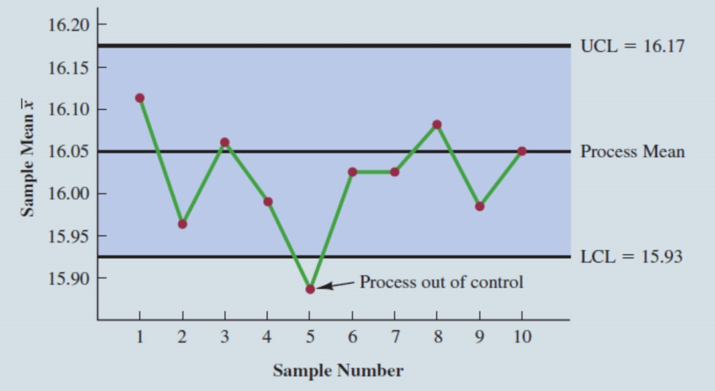
a. Is the control chart an example of descriptive, predictive, or prescriptive analytics?
b. Suppose the control cart is part of a data dashboard and the chart is combined with a rule that does the following. If four consecutive sample mean weights are outside of the control limits, the production line is automatically stopped, and a message appears on the dashboard. The message says “The production line is stopped. The process may be out of control. Please inspect the fill machine.” Is this new enhanced control chart combined with a rule an example of descriptive, predictive, or prescriptive analytics?
Solution
- The control chart simply describes the production data, so it is descriptive analytics.
- The new enhanced control chart combines a descriptive tool (the chart) with a rule that causes a course of action to take place. Hence, the new rule-based system is an example of prescriptive analytics.
- Amazon Books. An example of a response from Amazon when this textbook you are reading was chosen online, is given below. It indicates that some people who purchased this text also tended to purchase The World Is Flat, Fundamentals of Corporate Finance, and Strategic Marketing Management. In this application of analytics, is Amazon using descriptive, predictive, or prescriptive analytics? Explain. LO 3
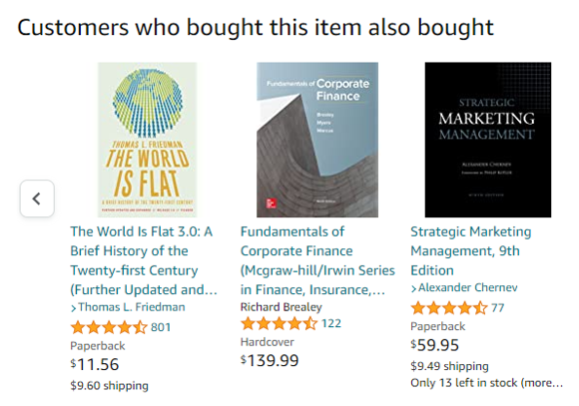
Solution
Amazon is describing other books that tend to be purchased with the text Business Analytics, based on past consumer purchases. Therefore, this is an example of descriptive analytics.
- Employee Retention. Human Resource (HR) Analytics or People analytics are terms used for the use of analytics to manage a company’s workforce. Google, Microsoft, and Walmart, for example, use people analytics to help retain their best people, ensure a diverse workforce, and better understand the strengths and areas needing improvement. LO 3, 4
a. One application of people analytics is to build a model that estimates the probability of an employee departing the company within the next six months. Inputs to the model could be market demand for the skills the person possesses, how long the person has been with the company, and a major life event recently occurring for the person (for example, divorce). Is this type of model descriptive, predictive, or prescriptive? Explain.
b. How could you use the model described in part (a) to help improve the workforce?
Solution
- Since the model estimates a probability, that is, how likely it is that a person will depart the company in the next six months, it is an example of predictive analytics. It predicts how likely a person is to depart in the next 6 months.
- The predictive model could be used to improve the workforce by applying a rule to the model to make it prescriptive. For example, a rule might be “for a high-performing employee, if the estimated probability of departure is greater than 0.4, proactively give a 10% increase in salary to that person, with the hope that the person will likely stay.”
- Supermarket Checkout Lanes. A supermarket has been experiencing long lines during peak periods of the day. The problem is noticeably worse on certain days of the week, and the peak periods are sometimes different according to the day of the week. There are usually enough workers on the job to open all checkout lanes. The problem is knowing when to call some of the workers stocking shelves up to the front of the store to work the checkout lanes. LO 4
a. How could analytics be used to help the supermarket?
b. What data would be needed?
Solution
- Analytics could prove helpful by providing a predictive model that estimates the expected number of shoppers and how long they are expected to shop before checking out, by day of week and time of day. For example, the model might predict that for a given supermarket location, from 5:00 p.m. to 5:15 p.m. on a Wednesday, 37 shoppers are expected with 80% of them shopping for less than 6 minutes. This predictive model could be used to know when more checkout workers need to be called to the front of the store to ensure lines do not grow too long.
- The following data would need to be collected over time with special considerations for holidays: the number of people who enter the store and how long they shop before checking out by day of week and time of day. This data could be collected by observation, but would more likely be collected electronically through sensors that would also maintain the anonymity of the shoppers.
- Pricing Subcompact Rental Cars. Setting the right price for a product is an important business decision. Price the product too high and demand could be too low. Set the price too low, demand may be high, but we are potentially leaving money on the table because the revenue per unit is low. Pricing analytics involves finding the right trade-off between the price charged and demand so as to maximize revenue. Suppose we need to set the price for renting a subcompact automobile for one day. Let us outline the decision process:
1. Identify and define the problem. We need to set a price per day for a midsize rental car.
2. Determine the criteria that will be used to evaluate alternative solutions. Our goal in setting the price is to maximize revenue.
3. Determine the set of alternative solutions. Based on historical data and the competition, we will consider a broad price range from $10 per day to $60 per day.
4. Evaluate the alternatives. We will evaluate proposed prices based on the expected revenue per day.
5. Choose an alternative. We will choose the price that maximizes expected revenue.
We can use data and analytics to complete steps 4 and 5 of the decision process.
LO 3, 4
a. Based on historical or test market data, we can estimate a model that gives expected revenue as a function of price, as shown below. The dots represent the data (price and demand combinations) and the estimated model is the line in the chart: Demand = –1.4028 (Price) + 102.65. For example, for the price of $35 Demand = –1.4028(35) + 102.65 = 53.552 vehicles. So, we estimate that at a price of $35 per day, the demand will be about 54 vehicles. Is this estimated equation, a descriptive, predictive, or prescriptive model? Explain.
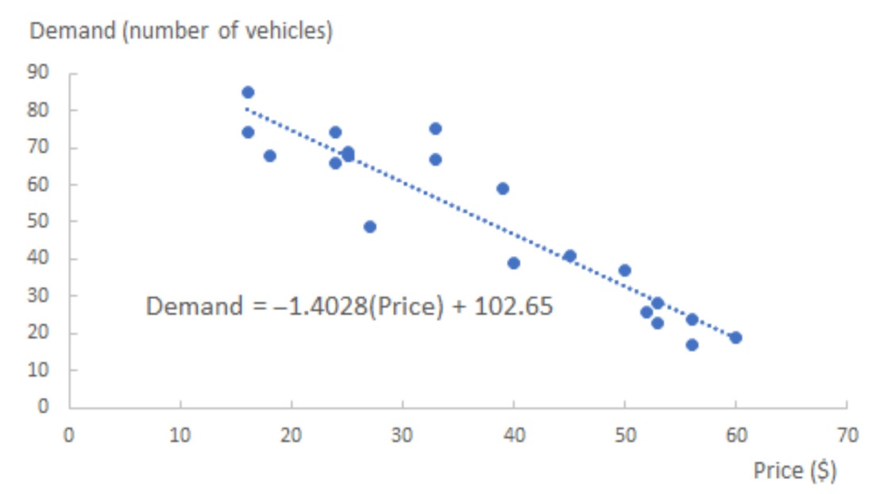
Our goal (step 5) is to find the price that maximizes expected revenue. Revenue = demand x price which is (–1.4028(Price) + 102.65) x (Price) = –1.40228(Price)² + 102.65(Price). The revenue as a function of price is shown below for $10 increments of price.
b. What is the price that maximizes revenue?
c. Is step 5, visually expecting the revenue function to find a revenue-maximizing price, descriptive, predictive, or prescriptive analytics? Explain.
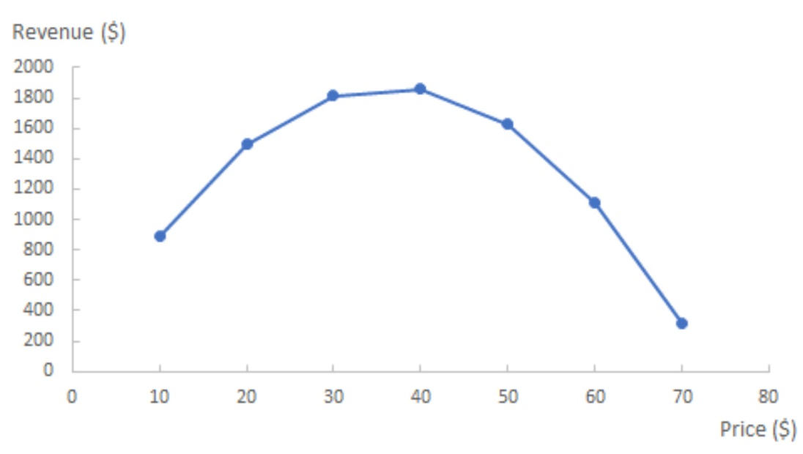
Solution
- The estimated equation is a predictive model because it predicts the quantity demanded based on the price per day of the rental car.
- Based on the chart of revenue, since the peak of the curve is at a price of $40,
it appears that the optimal price is $40. The estimated maximum revenue is
(–1.4028(Price) + 102.65) x (Price) = (–1.4028(40) + 102.65)(40) = $1861.52.
- By visually finding the price that maximizes revenue and using that price to maximize revenue, we are performing prescriptive analytics, as we are recommending a course of action (setting the price at $40).

