Solutions Manual

to accompany

Company Accounting 10e

prepared by

Ken Leo
John Hoggett
John Sweeting
Jeffrey Knapp
Sue McGowan
© John Wiley & Sons Australia, Ltd 2015

Chapter 1 – Nature and regulation of companies

REVIEW QUESTIONS

1. Outline the advantages of incorporation over other forms of organisation such as partnerships.

The corporate form of organisation permits individuals to have "limited liability". This confers on shareholders a limit on their liability in the event of a winding up of the company to the amount (if any) unpaid on their shares. (S516).
In the case of a partnership no such limitation applies (unless the partnership specifically adopts limited liability) and the insolvency of one or more partners can result in other solvent partners having to contribute any losses and debts out of their own private assets.

2. Distinguish between a proprietary company and a public company.

A public company is one in which there is usually a substantial public interest in that the ownership of the company's share capital is widely spread. Public companies are entitled to raise capital through a share issue by issuing a disclosure document which entitles them to have their shares or debentures etc. listed on a stock exchange, such as the Australian Securities Exchange, to facilitate transferability.
Proprietary companies on the other hand have specific limitations in terms of the amount and restrictions on its fundraising activities.
Specific features of a proprietary company include the need to have a share capital (unlike a public company which may be limited by guarantee and not merely shares):
- a requirement to have at least one shareholder and only one director (three directors for a public company) and not more than 50 shareholders (not including employee shareholders)
- not required to restrict the transfer of its shares (however it may elect to do so)
- the use of the designation "Pty" or “Proprietary” in its name
- a requirement not to engage in any fundraising activity which would require it to lodge a disclosure document with ASIC.

3. Distinguish between a large and a small proprietary company. What are the implications of being classified large rather than small?

A small proprietary company is defined in Section 45A of Corporations Act 2001, as amended, as one which meets 2 of the following three criteria:
- consolidated annual revenue less than $25 million#
- consolidated gross assets at the end of the financial year is less than $12.5 million#
- the companies and the entities it controls have fewer than 50 employees^ at the end of the financial year.
#These figures must be determined in accordance with accounting standards
^ Part-time employees measured at appropriate fraction of full-time

If these criteria are not met the company will be a large proprietary company.

Small proprietary companies do not have to prepare formal financial statements or have them audited. However, they must keep sufficient accounting records to allow preparation and audit of accounts if either 5% of their voting shareholders or ASIC request this to be done. Large proprietary companies, must prepare financial reports in accordance with accounting standards, have them audited, send them to shareholders and lodge them with ASIC (Section 292)

4. Outline the special features of a no liability company.

Companies engaged in the more speculative area of mining exploration are most often registered as no liability. Such companies have NL at the end of the company name and have the advantage of being more attractive to potential investors as unlike companies limited by the unpaid amount on their shares; there is no such liability on the part of shareholders to contribute to the debts and liabilities of the companies.

5. What is the purpose of a certificate of registration?

A certificate of registration is issued by ASIC as a part of the registration procedure. Provided the company complies with S117 of the Corporations Act, ASIC will:
- give the company an ACN Number
- register the company
- issue a certificate that states the company's name, ACN No. etc.
Once registered, the company is capable of performing all the functions of a corporate body.

6. What are replaceable rules and how do they differ from a constitution?

Replaceable rules are the set of internal rules (contained in the Corporations Act) governing the conduct of its operations between the company and its member directors and between members themselves [see example of such rules in ch 1 Section 1.3.3].
If the rules are not adopted by the company then they must draw up a constitution which will cover much of the same issues covered by the replacement rules but may be extended or modified by the promoters of the company.
7. Outline the main features and purpose of a disclosure document.

A disclosure document, particularly the prospectus, contains all the information necessary for investors to make an informed assessment of the company's future prospects and other relevant matters including:
- rights and liabilities attaching to securities
- financial position, performance and prospects of the body issuing the securities
- interests of each director, proposed director, promoter, stockbroker and their professional advisers in any property acquired or proposed to be acquired with the funds derived from the securities issue.
- whether the securities issued will be quoted on a Stock Exchange.

8. In administering a company, the Corporations Act requires the keeping of various books, registers and records. Outline these and briefly discuss their content.

There are a range of records required to be maintained by a company including:
• Minute books of the proceedings and decisions made at all directors’ and shareholders’ meetings as well as all resolutions passed without a meeting (s. 251A). If the company is a proprietary company with only one director, any declarations by this director must be minuted.
• Financial records that will enable financial statements to be prepared and audited from time to time in accordance with the Act (ss. 286, 292, 302 and 303).
• Register of members, or share register, giving each member’s name and address, and the date on which the entry of the member’s name is made on the register. If the company has a share capital, the register must also show the date on which an allotment of shares takes place, the number of shares in each allotment, the shares held by each member, the class of shares held, the share numbers (if any), the amount paid on the shares, and whether or not the shares are fully paid (s. 169).
• Register of option holders to record the names and addresses of the holders of options over the shares of a company. The register must include the number and description of the shares over which options were granted, details of any event that must happen before the options can be exercised, and any consideration for the grant of the options and for the exercise of the options (s. 170). Copies of documents which grant an option over shares must be kept with this register.
• Register of debenture holders to record each debenture holder’s name and address, and the amount of the debentures held (s. 171).

9. Outline the differences between shares and debentures.

Ordinary shares attract no fixed rate of dividend, carry voting rights and may participate in surplus assets and profits of the company – they represent ownership of x% of the company. Ordinary shares are classified as equity. The company may issue shares either fully paid or partly paid (s. 254A). If partly paid shares are issued, the shareholder is liable to pay calls on the shares (except in the case of no liability companies).

A company also has the right to issue preference shares, but may only do so either if there is a statement in its constitution setting out the rights of these shareholders or if these rights have been approved by a special resolution of the company.
Not all preference shares are the same. Classification of preference shares as equity or liabilities depends on the rights and features of the shares – judgment is required re which classification is appropriate. For example, redeemable, cumulative 10% preference shares, which are to be redeemed on a set date, are definitely liabilities. Preference shares redeemable at the option of the company may or may not be liabilities, depending on the probability of the company redeeming them.
Debentures are issued by the company raise funds but are borrowings, not equity. Debentures may be secured. A trust deed/trustee must be established to protect the rights of debenture holders.

10. What are the main reasons for the development of accounting regulations?

The history of accounting regulation had its origins in the industrialised European settlement of the late 18th century. The social, political and economic changes which occurred saw the gradual decline of the importance of family enterprises and the separation of ownership from control as the control of entities was delegated by owners to agents. The growth in the number and size of 'joint stock companies in the late nineteenth century prompted the rise of disclosure although, initially, this focused on stewardship. The greater complexity of organisations in the mid to late twentieth century and twenty-first century gradually resulted in disclosure requirements developing into a more sophisticated form of financial reporting, which remains an ongoing process.

11. Explain the difference between accounting standards, interpretations and the accounting framework.

Accounting conceptual framework
Provide broad/general principles that provide guidance in preparation of general purpose financial reports. These are not mandatory.

For example:
The Framework (para.7) provides general information about what is included in a financial report/ a complete set of financial statements:
- Financial statements form part of the process of financial reporting. A complete set of financial statements normally includes a balance sheet, an income statement, a statement of cash flows and a statement of changes in equity, and those notes and other statements and explanatory material that are an integral part of the financial statements. They may also include supplementary schedules and information based on or derived from, and expected to be read with, such statements. Such schedules and supplementary information may deal, for example, with financial information about industrial and geographical segments and disclosures about the effects of changing prices. Financial statements do not, however, include such items as reports by directors, statements by the chairman, discussion and analysis by management and similar items that may be included in an annual or interim report.

The Framework (para. 49) provides definitions of basic elements to be included in measuring the financial position such as:

(a) An asset is a resource controlled by the entity as a result of past events and from which future economic benefits are expected to flow to the entity.
Accounting standards can be defined as:
‘a technical pronouncement that sets out the required accounting for particular types of transactions and events’ (AASB, 2014).

Hence these provide specific requirements for a particular area of financial reporting. These are required to be complied with via corporations law.
For example:

AASB 101 Presentation of Financial Statements specifies that particular assets or liabilities must be included on the face of the statement of financial position itself (such as intangibles).

AASB 102 Inventories (para 9) specifies thatNinventories shall be measured at the lower of cost and net realisable value.
Interpretations provide guidance on urgent financial reporting issues. These are required to be complied with via AASB 1048. The AASB is responsible for developing both Australian equivalents of IFRIC Interpretations and domestic Interpretations, thereby replacing the former Urgent Issues Group (UIG).

As stated by AASB (2014):

AASB and UIG Interpretations are listed in Accounting Standard AASB 1048 Interpretation of Standards, giving them authority under the Corporations Act 2001 alongside the Standards. Interpretations are mandatory for members of CPA Australia, The Institute of Chartered Accountants in Australia and the Institute of Public Accountants, and as such must be consistently applied in the preparation and presentation of general purpose financial statements. Interpretations may also be given authority by other legislative or regulatory bodies.

For example:
Interpretation 132 specifies the treatment of costs incurred in building Internet web sites.

Interpretation 1031 relates to issues re GST and, for example, specifies that (in general)
“Revenues, expenses and assets shall be recognised net of the amount of goods and services tax (GST)” (para 6)

12. Does a company have to comply with accounting standards in order to show a ‘true and fair view’ of its financial affairs? Discuss.

Before the early 1990s, the directors of a company could elect not to comply with an accounting standard issued by the AASB if they believed the particular standards would cause the accounts not to present a true and fair view. This 'true and fair override' no longer exists and directors must now comply with applicable accounting standards and add any additional information in the notes to the financial statements if they believe adherence to the standards does not present a true and fair view. Compliance with standards therefore has become the norm, resulting in an increased interest, both positive and negative, in the requirements of accounting standards by different lobby groups, particularly among those required to prepare financial statements.

As noted above, in Australia due to Corporations law requirements for the companies we are considering, the accounting standards must be complied with, even if the resulting financial statements and notes do not provide a true and fair view. Additional information is required if compliance does not result in a true and fair view. The requirements for this additional information are in AASB 101.
You should note that the current international accounting standards (in limited circumstances and with extensive disclosure provisions) do provide for a true and fair ‘override’ (i.e. a true and fair override allows companies to depart from accounting standards where compliance with these would not provide a true and fair view). Although the Australian equivalent, AASB 101, includes this override provision ( in para 19) this is in effect negated for Australian companies as Aus19.1 states:

Aus19.1 In relation to paragraph 19, the following shall not depart from a requirement in an Australian Accounting Standard:
- entities required to prepare financial reports under Part 2M.3 of the Corporations Act;
- private and public sector not-for-profit entities; and
- entities applying Australian Accounting Standards – Reduced Disclosure Requirements.

13. What are the current arrangements for setting accounting standards in Australia?

The AASB under the auspices of the Financial Reporting Council is entrusted with the task of making accounting standards both for the purposes of the Corporations Act and for the public and not-for-profit sectors in Australia. [See Figure 1.1 in section 1.7.4].

14. Distinguish between the following organisations and their roles in the regulation of financial reporting in Australia:
• the Financial Reporting Council (FRC)
• the Australian Accounting Standards Board (AASB)
• the International Accounting Standards Board (IASB)
• the IFRS Interpretations Committee
• the Australian Securities and Investments Commission (ASIC)
• the Australian Securities Exchange (ASX)
• the Asian-Oceanic Standard Setters Group (AOSSG).

Financial Reporting Council (FRC)
The main role of the FRC is to act as an overseer and advisory body to the standard setter, the AASB. The main functions of the FRC under the ASIC Act 2001, s. 225, are to:
• oversee the process for setting accounting standards and give the Minister reports and advice on that process
• appoint AASB and AUASB members (other than the chair)
• approve and monitor the AASB’s and AUASB’s priorities, business plan, budget and staffing arrangements
• determine the AASB’s and AUASB’s broad strategic direction
• give the AASB and AUASB directions, advice or feedback on matters of general policy and procedures
• monitor the development of international accounting and auditing standards and the standards that apply in major international financial centres, and
– further the development of a single set of accounting standards and auditing standards for worldwide use with appropriate regard to international developments
– promote the adoption of international best practice accounting standards and auditing standards in the Australian standard-setting process if this is in the best interests of both the private and public sectors of the Australian economy
• monitor the operation of accounting and auditing standards to ensure their continued relevance and their effectiveness in achieving their objectives in respect of both the private and public sectors of the Australian economy, as well as the effectiveness of the AASB’s consultative arrangements
• seek contributions towards the costs of the Australian accounting and auditing standard-setting process
• monitor and periodically review the level of funding and funding arrangements for the AASB and AUASB
• establish appropriate consultative mechanisms
• advance and promote the objectives of standard setting as specified in the Act
• perform any other functions that the Minister confers on the FRC by written notice to the chair.
A major policy direction of the FRC that has affected the agenda of the AASB is the formalisation of a policy of adopting the accounting standards of the International Accounting Standards Board (IASB) for application to reporting periods beginning on or after 1 January 2005. (This includes also the adoption of Interpretations issued by the IFRS Interpretations Committee for use in the Australian context.)

Australian Accounting Standards Board (AASB)

The functions of the AASB, according to s. 227(1) of the ASIC Act 2001, are to:
• develop a conceptual framework (not having the force of an accounting standard) for the purpose of evaluating proposed accounting standards and international standards
• make accounting standards for the purpose of the Corporations Act
• formulate accounting standards for other purposes, e.g. for non-companies, the public sector and the not-for-profit sector
• participate in and contribute to the development of a single set of accounting standards for worldwide use
• advance and promote the main objectives of developing accounting standards.
The AASB must develop accounting standards not only for the corporate sector but also for other sectors, such as the public sector and the not-for-profit sector. The objectives of developing accounting standards are:
(1) to facilitate the development of accounting standards that require the provision of financial information that:
• allows users to make and evaluate decisions about allocating scarce resources
• helps directors to discharge their obligations in relation to financial reporting
• is relevant to assessing performance, financial position, financing and investment
• is relevant and reliable
• facilitates comparability
• is readily understandable.
(2) to facilitate the Australian economy by:
• reducing the cost of capital
• enabling Australian entities to compete effectively overseas
• having accounting standards that are clearly stated and easy to understand.
(3) to maintain investor confidence in the Australian economy (including its capital markets).
In performing its functions, the AASB is required to follow the broad strategic directions determined by the FRC. The AASB may formulate accounting standards which are of general or limited application, in that the Board may specify the entities, time, place or circumstance to which the standard applies. Furthermore, as long as it is practicable to do so, the AASB is required to conduct a cost–benefit analysis of the impact of a proposed accounting standard before making or formulating the standard. However, the cost–benefit analysis is not necessary where the standard is being made or formulated by issuing the text of an international standard.
The AASB conducts its meetings in a forum open to the public, which (hopefully) increases faith in the due process system of standard setting.

In line with the FRC’s main function of overseeing the process of setting accounting standards, the AASB is required to adopt international financial reporting standards (IFRSs) as issued by the IASB.
Besides issuing accounting standards that are equivalent to the IASB’s standards, the AASB has continued to issue accounting standards relevant to the public sector, as well as accounting standards that relate solely to the Australian legal environment.

International Accounting Standards Board (IASB)

On its website, the IASB states that it is an:

… independent standard-setting body of the IFRS Foundation. Its members … are responsible for the development and publication of IFRSs, including the IFRS for SMEs and for approving Interpretations of IFRSs as developed by the IFRS Interpretations Committee... All meetings of the IASB are held in public and webcast. In fulfilling its standard-setting duties the IASB follows a thorough, open and transparent due process of which the publication of consultative documents, such as discussion papers and exposure drafts, for public comment is an important component. The IASB engages closely with stakeholders around the world, including investors, analysts, regulators, business leaders, accounting standard-setters and the accountancy profession

In 2013 the constitution of the IFRS foundation and IASB was revised to include the following primary objectives:

(a) to develop, in the public interest, a single set of high quality, understandable, enforceable and globally accepted financial reporting standards based upon clearly articulated principles. These standards should require high quality, transparent and comparable information in financial statements and other financial reporting to help investors, other participants in the world’s capital markets and other users of financial information make economic decisions.
(b) to promote the use and rigorous application of those standards.
(c) in fulfilling the objectives associated with (a) and (b), to take account of, as appropriate, the needs of a range of sizes and types of entities in diverse economic settings.
(d) to promote and facilitate adoption of International Financial Reporting Standards (IFRSs), being the standards and interpretations issued by the IASB, through the convergence of national accounting standards and IFRSs. (IFRS Foundation Constitution, para 2)

Following the direction given by the FRC in 2002, the AASB has adopted the IFRSs issued by the IASB as from 1 January 2005. Hence, the financial statements prepared by Australian companies are comparable with those prepared by entities in other countries which also have adopted IASB standards. This should allow for greater understanding of financial statements worldwide, and lead to a more efficient flow of capital across national boundaries.
The IASB has signed an agreement with the Financial Accounting Standards Board (FASB), the body responsible for issuing accounting standards in the United States. The agreement requires both bodies to work together towards convergence of global accounting standards. The aim is to agree on high-quality solutions to existing and future accounting issues. If such agreement could be reached, potentially there would be one set of global accounting standards. The Securities and Exchange Commission (SEC) in the United States, despite proposing a ‘roadmap’ to consider whether and how US companies could begin using the IFRSs by 2014, has yet to make a final decision.

IFRS Interpretations Committee

The IFRS Interpretations Committee has the task of reviewing on a timely basis, within the context of existing international accounting standards and the IASB framework, accounting issues that are likely to receive divergent or unacceptable treatment in the absence of authoritative guidance, with a view to reaching consensus as to the appropriate accounting treatment. The Interpretations Committee considers issues of reasonably widespread importance, and not issues of concern to only a small set of enterprises. The interpretations cover:
• newly identified financial reporting issues not specifically dealt with in IFRSs
• issues where unsatisfactory or conflicting interpretations have developed, or seem likely to develop in the absence of authoritative guidance, with a view to reaching a consensus on the appropriate treatment.
The AASB has adopted the Interpretations issued by the IFRS Interpretations Committee for use by Australian companies as from 1 January 2005, and modifies them if necessary for the not-for-profit sector in Australia.

Australian Securities and Investments Commission (ASIC)

The ASIC is an independent government body set up to enforce and administer the Corporations Act and financial services laws to protect consumers, investors and creditors. ASIC regulates and informs the public about Australian companies, financial markets, financial services organisations and professionals who deal and advise in investments, superannuation, insurance, deposit taking and credit. The Australian Securities and Investments Commission Act 2001 requires ASIC to:
• uphold the law uniformly, effectively and quickly
• promote confident and informed participation by investors and consumers in the financial system
• make information about companies and other bodies available to the public
• improve the performance of the financial system and the entities within it.
One of the roles of ASIC is to reduce fraud and unfair practices in financial markets and financial products so that consumers can use them confidently and companies and markets can operate effectively. In an accounting context, as part of its role, ASIC also attempts to ensure that a company’s financial statements lodged with it under the requirements of the Corporations Act comply with accounting standards, if applicable.

Australian Securities Exchange (ASX).

The ASX is a public company operating Australia’s share markets. It oversees both the shares and future exchanges. In an accounting context, it is particularly concerned with improving the disclosure of information in the financial reports of companies listed with it on the various stock exchanges throughout Australia. It exercises its influence by way of the Listing Rules — a set of rules with which companies must comply if they wish to be listed, and remain listed, on the stock exchange.

Asian-Oceanic Standard Setters Group (AOSSG)

The AOSSG is an interest group of several standard setters, based in Asian and Oceanic countries, for the purpose of commenting (lobbying) on accounting standards set by the IASB. Its Memorandum of Understanding specified the following objectives:
- Promoting the adoption of and convergence with IFRS by jurisdictions in the region
- Promoting consistent application of IFRS in the region
- Coordinating input from the region to the technical activities of the IASB
- Cooperating with governments and regulators and other regional and international organisations to improve the quality of financial reporting.

15. To which entities do accounting standards apply? Discuss the nature of a reporting entity, and consider reasons for the concept being replaced.

Accounting standards apply to the general-purpose financial statements/reports of entities which are “reporting entities” and also to those entities which decide to prepare general-purpose financial statements even if they are not reporting entities.

The AASB, in SAC 1, provided the following definition of a reporting entity:

Reporting entities are all entities (including economic entities) in respect of which it is reasonable to expect the existence of users who rely on the entity’s general purpose financial report for information that will be useful to them for making and evaluating decisions about the allocation of scarce resources.

All reporting entities are subject to accounting standards when preparing their general-purpose financial statements. Entities such as small proprietary companies, family trusts, partnerships, sole traders and wholly owned subsidiaries of Australian reporting entities will normally not be required to prepare general purpose statements in accordance with accounting standards.

The introduction of the IASB’s differential reporting requirements for Small and Medium-Sized Entities shifted the focus from whether an entity is/is not a reporting entity to whether the entity is required to prepare a general-purpose financial statement/report and is publicly accountable.

However as noted in the text the Australian differential reporting requirements for Small and Medium-Sized Entities have retained the primacy of the reporting entity concept in determining which entities are required to prepare GPFRs. Public accountability is used to determine which entities are permitted to use the Reduced Disclosure Regime. The RDR involves recognition and measurement requirements of full IFRSs (Tier 1), as already adopted in Australia, but with disclosures substantially reduced (Tier 2) in comparison with those required under full IFRSs.

As noted in the text the introduction of the RDR in Australia represents only the first stage in considering differential reporting and rationalization of reporting requirements in Australia and in the next stage the AASB is expected to consider a shift from the reporting entity concept to GPFRs as:
- the IFRSs which Australia has adopted apply to GPFRs rather than reporting entities, and,
- internationally the reporting entity concept is used to determine the boundaries of the entity being reported on rather than the entity required to provide GPFRs.

The nature of the reporting entity is that the question to be asked by preparers of financial reports in deciding whether they are a reporting entity (and hence need to prepare a GPFR) is: Is it reasonable to expect the existence of users who depend on GPFRs for making and evaluating economic decisions? This will also be impacted by who are considered ‘users’. As the text notes the reporting entity concept in SAC1, and in the Framework, was very broad. In 2010 the IASB and the FASB issued Exposure Draft ED193 Conceptual Framework for Financial Reporting: The Reporting Entity which redefined ‘reporting entity’ to include a more restricted set of users (namely existing and potential investors, lenders and other creditors).The text also discusses the three main features of a reporting entity as per ED 193. However, it is important to note these features and not always sufficient when identifying a reporting entity.

16. Investigate the nature of the Reduced Disclosure Regime (RDR), and outline the implications of applying the RDR in Australia.

The RDR has been established in Australia since the release of AASB 1053 in June 2010. This has resulted in a two-tier reporting system in Australia, as outlined in table 1.1 on p. 29 of the text. Hence, all entities which prepare general-purpose financial statements are required to comply fully with IFRSs issued by the IASB; however, only those entities on Tier 2 have reduced disclosure requirements. The implications are:
- that more entities will be required to comply with full IFRSs, than would be required under the SME arrangements developed by the IASB which has issued a stand-alone accounting standard, IFRS for SMEs, that ‘replaces’ the full suite of IFRSs for such entities.
- The GPFRs of any Australian company will need to apply the same recognition and measurement principles and options.

17. Would compliance with IFRS’s ensure compliance with Australian Accounting Standards? Give reasons for your answer.

Whilst Australia has largely adopted the IFRS’s, compliance with IFRSs alone would not ensure compliance with Australian Accounting Standards as:
1. As noted above for SMEs the IASB have issued a separate standard that includes changes to recognition and measurement requirements for some items. The Australian Reduced Disclosures Regime does not alter these recognition and measurement requirements. Hence entities complying with IFRS for SMEs would not comply with Australian Accounting Standards.
2. There are some Australian accounting standards (and interpretations) where there is no IFRS equivalent (for example, AASB 1054 Australian Additional Disclosures).

CASE STUDIES

Case study 1 Legal rights and obligations of a small business

Visit the website of the Australian Government’s Attorney-General’s Department dealing with the law (www.comlaw.gov.au) and find the Corporations Act 2001. Assuming that you are the director of a small proprietary company, find the ‘small business guide’ and learn of your rights and obligations under the Act for managing your business. Prepare a brief report for the tutorial class.

The Small Business Guide in the Corporations Act can be found following Section 111J.
The guide summarises the main rules in the Corporations Act (the Corporations Act 2001) that apply to proprietary companies limited by shares—the most common type of company used by small business. The guide gives a general overview of the Corporations Act as it applies to those companies and directs readers to the operative provisions in the Corporations Act.
Students, in their capacity as would-be directors, are required to present a report to the class, summarising the requirements of the Guide. Such topics to be covered include:
- The meaning of registration, including shareholders’ and directors’ liabilities
- Rules for internal management of a company
- Company structure and setting up a new company
- Continuing obligations once the company is set up
- Company directors, secretaries and shareholders
- Who can sign company documents
- Funding the company’s operations
- Returns to shareholders
- Annual financial reports and audit
- Disagreements within the company
- Companies in financial trouble

Case study 2 The AASB

Visit the AASB website (www.aasb.gov.au) and find out the following items:
• Who is the Chair of the AASB?
• Who are the members, and which organisations do they represent?
• Which accounting standards have been issued in the past year?
• Why are there differences in the numbering systems for current accounting standards (e.g. AASB x, AASB xxx and AASB xxxx)?
• What current projects (if any) is the AASB working on in cooperation with the IASB?

Assuming that you already have access to the AASB website:

Chairman of the AASB
Go to AASB Board, then Current Board Members .Current chair is Kevin Stevenson

Members of the AASB and organisations represented
Stay in the same location and the names and organisations represented on the AASB are all shown. Don’t forget to include the observers as well. Comment: too many men?? Any academics on the board?

Accounting standards issued in the past year:
On the AASB website, go to Quick Links, then Table of Standards. Read from Table 1 all of the standards issued in the last year.

Different numbering systems for standards
See Pronouncements for information, plus section 1.7.4 in the text.
AASB x represent those standards adopted by the AASB from the IFRSs of the IASB
AASB xxx represent those standards adopted by the AASB from the IASs of the IASB and its predecessor the IASC
AASB xxxx represent those standards issued exclusively by the AASB for companies in the Australian context
In addition, the AAS standards consist of standards issued by the AASB for special organisations e.g. superannuation plans, government
(The numbering system is also set out in tabular format at the For Students link; go to About the AASB then For Students).

Current projects
On the AASB website, go to Work in Progress, then Projects. It would appear that there are no specific projects at the moment being worked on by the AASB in cooperation with the IASB. The AASB is one of several standard setting boards that liaise with the IASB and merely provide submissions to the IASB on various topics. See also AASB Submissions to the IASB on the website. Also check the News section and Latest News on the website.

Case study 3 Setting up a company

Visit the website of the Australian Securities and Investments Commission (www.asic.gov.au) and find the form(s) that you must complete to start a company, assuming that you wish to set up a small proprietary company to take over your current successful business, which has been operating as a partnership (with three partners) in the past.

On the website of the ASIC, go to Download forms, select the form 201 for Registering a company. Students should print the form and fill it out as if they wish to set up a proprietary company, with more than one owner shareholder.

Case study 4 The IASB

Visit the website of the International Accounting Standards Board (www.ifrs.org) or the Financial Accounting Standards Board (www.fasb.org) and find and report to the class on the following pieces of information:
• Joint Update Note from the IASB and FASB on Accounting Convergence July 2012
• the accounting standards being changed as a result of the international convergence moves
• the membership of the IASB and which countries the members come from
• the goals of the IASB.
- Joint Update Note from the IASB and FASB on Accounting Convergence July 2012

On the IASB website, go to IFRS, then Use around the world, then Jurisdictional and International MoUs, and finally click on United States in the Jurisdiction table to gain access to “Convergence with US GAAP”.
Alternatively visit the website of the FASB, go to Quicklinks, and then International Convergence. Report on the latest information available from these sites, which are updated regularly.

- Which accounting standards have or are being changed as a result of international convergence moves

The update report contains 3 tables that provide status and changes as a result of short term, long term and longer term priority convergence projects. These are replicated below.

Short Term Convergence Projects
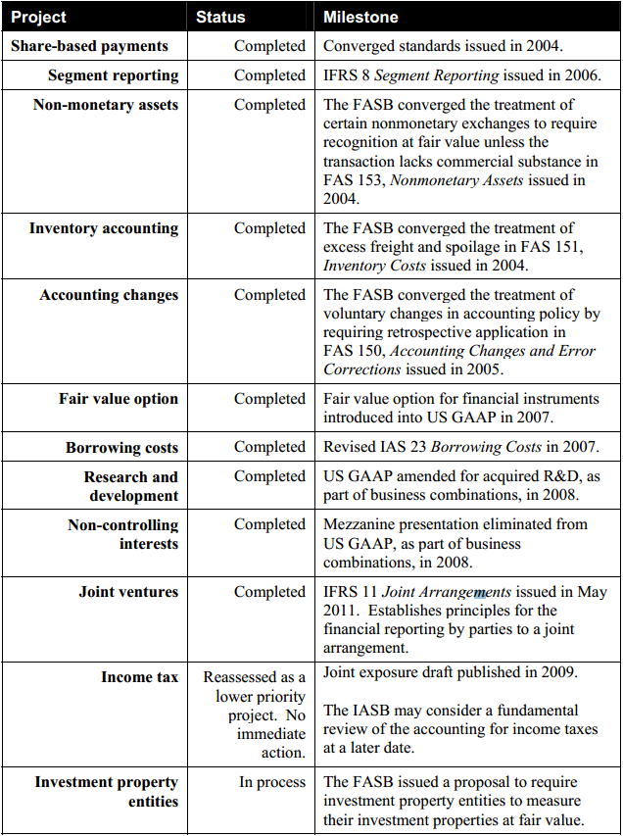

Source: Hoogervorst, Hans, and Seidman, Leslie F., IASB-FASB Update Report to the FSB Plenary on Accounting Convergence, 5 April 2012, p.3
Long Term Convergence Projects
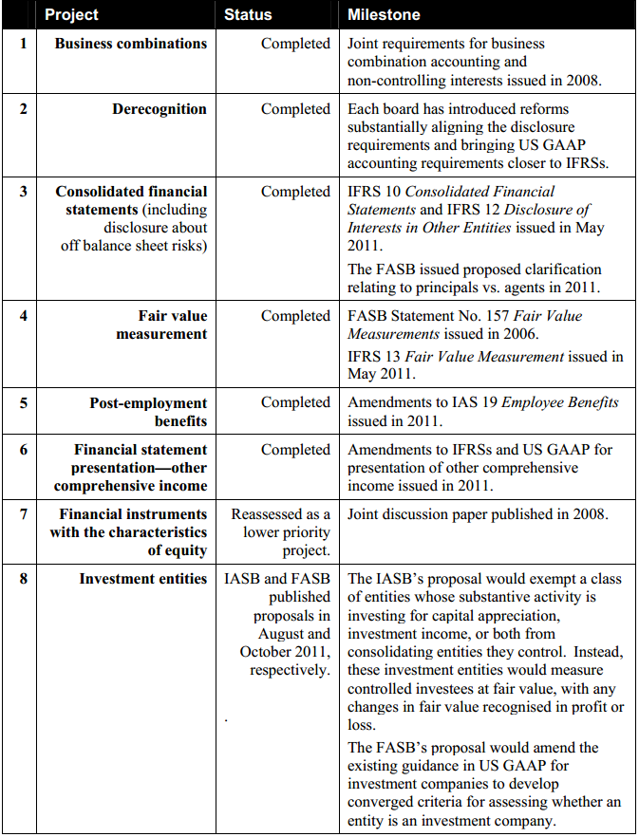
Source: Hoogervorst, Hans, and Seidman, Leslie F., IASB-FASB Update Report to the FSB Plenary on Accounting Convergence, 5 April 2012, p.4
Longer Term Priority Convergence Projects
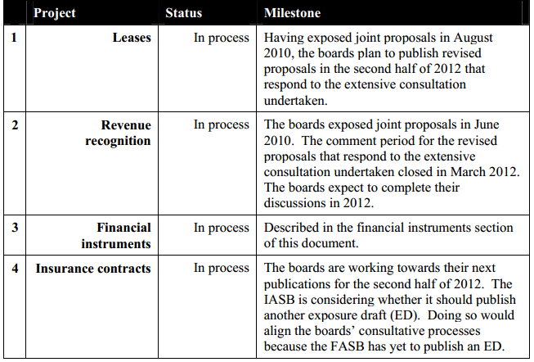
Source: Hoogervorst, Hans, and Seidman, Leslie F., IASB-FASB Update Report to the FSB Plenary on Accounting Convergence, 5 April 2012, p.5
- Membership of IASB and member countries

Go to the IASB website and see, About us. Click on About the organisation and there you will find the information about the Chairman, the Vice-Chairman and all members of the IASB, and the countries from which they came by reading each person’s information sheet.

- Goals of the IASB

Go to the IASB website and see About us. Click on About the organisation and there you will find the IASB objectives. On this page you can also access a 7 page guide ‘Who we are and what we do’ from the Related Information link.

Case study 5 ASIC

Visit the website of the Australian Securities and Investments Commission (www.asic.gov.au) and find out and report to the class on the following:
• what ASIC is and its role
• the tips given to prospective shareholders regarding the reading of a company’s prospectus
• a list of the policy statements and practice notes issued by ASIC
• ‘What’s new’ on the website.

1. ASIC and its role

On the ASIC website, go to About ASIC and look up Our Role

2. Tips to prospective shareholders re prospectuses

From within the About ASIC menu, go to ASIC and consumers. From there, access Go to MoneySmart, then Tools & Resources, and Check ASIC lists, then Check a Prospectus. The ASIC has information about prospectuses which changes quite regularly. See what tips you can find about prospectuses, assuming that you are a prospective investor.

3. Regulatory guides issued

From ASIC’s home page, go to Publications and then to Regulatory Documents. The regulatory guides are accessible here.

4. What’s new

See ASIC’s home page, and What’s New features on the home page.

Case study 6 FRC

Visit the website of the Financial Reporting Council (www.frc.gov.au) and locate its strategic plan and report to the class on the following:

- What is the key purpose of the strategic plan?

There is a separate link on the FRC homepage to information about the strategic plan. Click on this and open the strategic plan for 2013-16.

As this document notes, the FRC’s objectives are to facilitate the development of high quality accounting standards, auditing and assurance standards, and related guidance. The FRC aims to achieve these objectives by developing task forces for specific areas of interest.

- Identify and outline the four sources of complexity in financial reporting that the Managing Complexity in Financial Reporting Task Force outlined in its report to the FRC in May 2012.

  - Increasingly complex business operations
  - Complexities in the regulatory framework
  - Changing attitudes of businesses and stakeholders
  - Developments in Integrated Reporting

You should also outline the nature of and purpose of the project, any recommendations or progress made.

This report can be found on the website by going to the Reports section, then Other Reports.

