Chapter 1 Introduction to Corporate Finance

Chapter Outline [PowerPoint Slide 1–1]

- What is Corporate Finance?
- Corporate Securities as Contingent Claims on Total Firm Value
- The Corporate Firm
- Goals of the Corporate Firm
- Financial Institutions, Financial Markets, and the Corporation
- Trends in Financial Markets and Management
- Outline of the Text
In the first class session you should hand out the course syllabus and describe the content of the course. If you plan to use a financial calculator, your students should acquire and learn to use the calculator as soon as possible.
The topics addressed in this chapter include:
- The forms of business organization.
- The objective of the firm and the financial manager.
- Control of the modern corporation.
- The Financial Markets
- An outline of the course.
Note: If Financial Accounting serves as a prerequisite for your Financial Management course (and your university has a policy of honoring prerequisites), Chapter 2 serves as a review chapter rather than new material. In that situation, you may wish to cover Chapter 2 before Chapters 7 and 8, or skip it entirely.
What is Corporate Finance? [PowerPoint Slides 1–2, 1-3, 1-4,1-5,1-6 &1-7]

PowerPoint Slide 1–2 makes a good question on test one; for some reason it really separates the “A” students from everyone else. The balance sheet model of the firm (Figure 1–1) is replicated and animated in PowerPoint
Slides 1–3 and 1–4: Going through these slides effectively introduces the course content as the three major questions of corporate finance: the capital structure question, the capital budgeting question, and net working capital investment decision (or if you prefer, short–term financial planning).
Going through the cells in the organizational chart in Figure 1.3 of the text (reprinted an animated in PowerPoint Slides 1-5 and 1-6) is a convenient way to give students a brief overview of the course content. It also provides the instructor with an opportunity to describe a number of career paths for finance students.

The broad categories can be summarized with two concrete responsibilities [PowerPoint Slide 1-7]:

- Selecting value creating projects
- Buy assets that generate more cash than they cost

- Making smart financing decisions
- Sell bonds, shares and other financial instruments that raise more cash than they cost

Cash Flows between the Firm and the Financial Markets [PowerPoint Slides 1–8 & 1-9]

The cash flow relationships illustrated in Figure 1.4 of the text (reprinted an animated in PowerPoint Slide 1–8 describe the value of real assets and financial assets. It also highlights how value is created and is a good place to introduce the valuation principles.
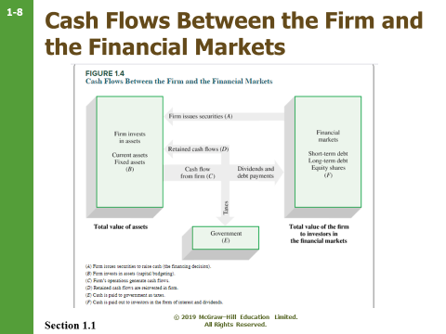

The important elements of the corporate goal are the size, timing, and riskiness of expected future after–tax cash flows [PowerPoint Slide 1-9]. The principles of valuation suggest that these three elements are summarized in the stock price of the firm.

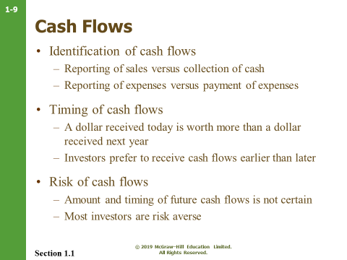

Lecture Tip: It is an important reminder for students to reiterate that Net Income and Cash Flow can be extremely different values for various reasons, some of which are non-cash expenses (e.g., depreciation, amortization), revenue recognition principles, and credit policies.

Debt and Equity as Contingent Claims [PowerPoint Slides 1–10, 1-11 & 1–12]

We use text Figure 1.5 [repeated below in PowerPoint Slide 1-11] to describe debt and equity claims as contingent claims on the total firm value. The most important concept stems from the following characteristics of equity and debt claims:
- The promised payoff to debtholders is fixed, but depends on firm value in financial exigency.
- Debtholders get paid before stockholders.
- Due to limited liability, stockholders are not required to “guarantee” that debtholders receive their full promised amount, F.
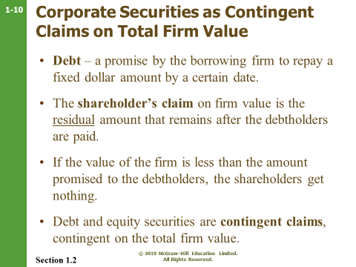
Therefore, payoffs to stockholders are contingent upon the value of the firm (X). If the value of the firm is less than the promised payoff to debtholders (X < F), stockholders receive nothing.
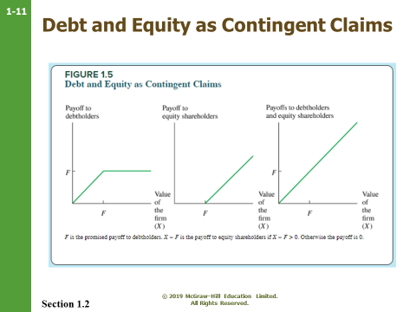

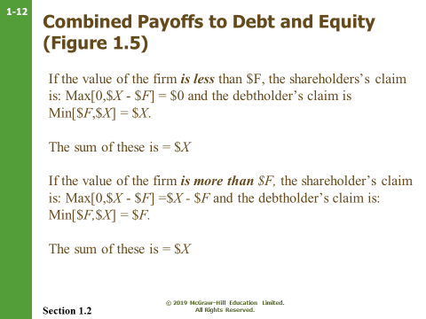

The Form of Business Organization [PowerPoint Slide 1–13]

All students have been introduced to the forms of business organization in some pre–requisite course. Here you may wish to focus the discussion on issues concerning liability, control and taxation for the four forms of business organization: sole proprietorships, partnerships, corporation and income trusts.
Sole Proprietorship

Ask students to imagine going into business tutoring one of the prerequisite courses. This may be a good time to smoke out students inappropriately enrolled in your course if they haven’t met the prerequisites.
- Owned by one person
- Inexpensive to form
- Income taxed as personal income
- Unlimited liability for business debts
- Limited life
- Equity limited to owner's personal wealth

Partnership

In a General Partnership, all partners have unlimited liability. In a Limited Partnership, at least one partner is a general partner with unlimited liability. Limited partners generally do not participate in management.

- Inexpensive to form
- Income taxed as personal income
- General partners have unlimited liability
- Limited life
- Management control resides with general partners
- Difficult to transfer ownership
We cover the substantial restrictions on transferability of partnership shares by pointing out that being partners with someone is not unlike being married to them—with the exception that if you want a divorce you have the additional burden of finding a suitable replacement spouse for your former partner. Usually gets a huge laugh.
- Difficult to raise large amounts of capital

Corporation

- Separate legal entity
- Limited owner liability
- Ownership is easily transferred
- Unlimited life
- Taxed at the corporate rate
- Greater access to the financial markets

Income Trusts

- Separate legal entity
- Limited owner liability – although has yet to be tested in the courts. Some provinces are further ahead in this decision than others. This issue has also caused many institutional investors from investing in trusts.
- Ownership is easily transferred
- Limited life – trusts are set up with a limited life.
- All distributions to unitholders are tax deductible so that the trust can have no taxable income. The income flows through to the unitholders and is taxed at the appropriate rates, depending on the nature of the income (business, interest, or capital gains).
- Greater access to the financial markets
- Unitholders expect that all available cash flows will be distributed out.

The Goal of the Corporate Firm [PowerPoint Slide 1–19]

The goal of the corporate firm is the central theme that links all the topics of this course. This is also a good time to get participation from students by asking them to suggest what these goals might be. Some typical responses are:
- Maximize profits
- Minimize costs
- Maximize sales or market share
- Maintain steady earnings growth
- Survive in business
- Social responsibility
- Be the best on some other measure (quality of product, whatever)

Usually the students’ consensus is that from a business perspective, maximizing profit should be the goal, if for no other reason than it is a necessary condition to achieve other goals. This is a good time to ask students to define profit:

- Accounting profit or after–tax cash flow
- Short–term or long–term profit
- How much risk is acceptable to achieve the desired profit level

Modern Finance Theory assumes that the objective of the firm is to maximize the wealth of the stockholders. If this primary goal (i.e. maximizing stockholder wealth) is defined correctly, all the objectives listed above can be accomplished.
Lecture Tip: The late Roberto Goizueta, former chairman and CEO of the Coca-Cola Company, wrote an essay entitled “Why Share-Owner Value?,” that appeared in the firm’s 1996 annual report. It is an excellent introduction to the goal of financial management at any level. It may also be useful to discuss how Mr. Goizueta’s vision transferred to the stock market’s valuation of the company.
A subsequent article also illustrates the difference in strategy between Coca-Cola and Pepsi-Co during Mr. Goizueta’s tenure: “How Coke is Kicking Pepsi’s Can,” Fortune, October 28, 1996.
Coke focused on soft drinks while Pepsi-Co diversified into other areas. Pepsi-Co’s goal was to double revenues every 5 years, while Mr. Goizueta focused on return on investment and stock price. The article states that Goizueta "has created more wealth for stockholders than any other CEO in history.” In mid-1996, Pepsi-Co sold at 23 times earnings with return on equity of about 23% and Coke sold at 36 times earnings with a return on equity of around 55%. The article goes on to discuss the differing strategies in more detail. It provides a nice validation of Mr. Goizueta’s remarks in his letter to the shareholders.
Lecture Tip: The validity of this goal assumes “investor rationality”. In other words, investors in the aggregate prefer more dollars to fewer and less risk to more. Rational investors will act as risk-averse, return-seekers in making their purchase and sale decisions, and, given different levels of risk aversion and wealth preferences, the only single goal suitable for all shareholders is the maximization of their wealth (which is represented by their holdings of the firm’s common stock). However, the prevalence of “social responsibility” funds may make for an interesting discussion, as would the increasing focus on behavioral finance and the impact of investor emotions on trading behavior.

Ethics Note: Any number of ethical issues can be introduced for discussion. One particularly good opener to this topic that many students can relate to is the issue of the responsibility of the managers and stockholders of tobacco firms. Is it ethical to sell a product that is known to be addictive and dangerous to the health of the user even when used as intended? Is the fact that the product is legal relevant? Do recent court decisions against the companies matter? What about the way companies choose to market their product? Are these issues relevant to financial managers?

The Set–of–Contracts Perspective [PowerPoint Slide 1-20]

From the Set–of–Contracts Perspective, the corporation is defined as a legal framework of contracts. The three most important contracts are:
- The debt's–claim on the firm's assets and cash flow.
- The equity's claim on the firm's residual assets and cash flow.
- The shareholders' contract with the management team to run the company on their behalf.

Conflicts of interest, especially in times of financial distress, are present between shareholders, debtholders, management, and other stakeholders in the firm (including employees, suppliers, customers, and creditors). Conflicts of interest can also arise within each of these groups. For example, some shareholders may believe that the firm should invest only in ecologically responsible projects while others care only about increasing their wealth. Conflicts between classes of debt such as subordinated debt and unsubordinated debt are especially prevalent in times of financial distress.
Agency Costs [PowerPoint Slide 1-21]

Agency costs refer to the costs of resolving the conflicts of interest between managers and shareholders. Agency problems are “costly” because shareholders have to expense resources (either in the form of direct monitoring, or providing incentives such as stock options) to motivate management to act in shareholders’ best interests. At the heart of agency problems is the separation of equity ownership from managerial control.
PowerPoint Slide 1–22 lists management goals that may be different from shareholders goals

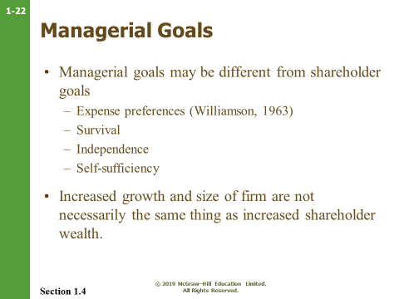
The Corporation: Separation of Ownership and Control [PowerPoint Slide 1–23]

The figure below [animated in PowerPoint Slide 1–23] shows the various participants in the firm. Use it as a guide to discuss issues relating to the control of the modern corporation.
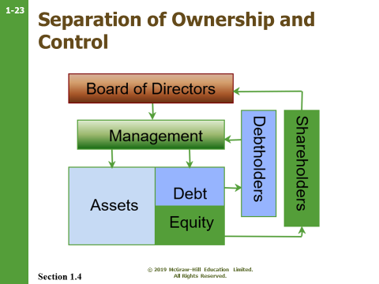
Separation of ownership and control is a characteristic of most large corporations where management is responsible for the day–to–day operations of the firm while owners (shareholders) have limited input. Conflicts arise when the goals of management differ from the goals of shareholders. Of course, there are always exceptions to the rule.
Two studies of the ways in which shareholder and manager goals can diverge are:

1. Oliver Williamson ("Managerial Discretion and Business Behavior," American Economic Review 1963) suggests that managers have expense preference because perquisites such as company cars and office furniture have more value to managers than to shareholders.
2. Gordon Donaldson (Managing Corporate Wealth: The Operations of a Comprehensive Financial Goals System, Praeger Publishers, 1984) suggests three motives underlie managers' actions: a) survival, b) independence, and c) self–sufficiency. Donaldson concludes that these motives lead managers to maximize corporate wealth – the wealth over which they have control.
Do Shareholders Control Managerial Behavior? [PowerPoint Slide 1–24]

This section discusses how shareholders can/may control management. This is a good opportunity to introduce recent developments in corporate control, such as institutional shareholders and the trend towards indirect stock ownership through pension and mutual funds. These topics often generate lively discussions, especially if you can use a M&A example from a local company.

Control Devices Available to Shareholders [PowerPoint Slide 1-25]

Following are the typical ways through which shareholders align their goals with those of management:
- Managerial incentives:
- Incentives such as performance plans linked to accounting income (or, even better, EVA) or equity participation through stock options help to bring the objectives of management more into line with those of the shareholders.
- Takeovers:
- Takeovers can be a shareholder's best friend if they (or the threat of their existence) force management to work in the shareholders' interests.
- The voting mechanism and corporate governance:
- The corporate charter often determines how difficult it is to replace the management team through the board of directors (this is addressed in depth in the chapter on Mergers and Acquisitions).
- The labor market for managers:
- Managers have a strong incentive to work in the shareholders' interests if they can be easily replaced.

Lecture Tip: A 1993 study performed at the Harvard Business School indicates that the total return to shareholders is closely related to the nature of CEO compensation. Specifically, higher returns were achieved by CEOs whose pay packages included more option and stock components. (See The Wall Street Journal, November 12, 1993, p. B1). However, this may not even be the best way to encourage managers to act in the stockholders’ best interest.
Stern Stewart & Company has developed a tool called EVA®, which measures how much “economic value” is being added to a corporation by management decisions. According to Stern-Stewart’s web site (www.sternstewart.com), companies that tie management compensation to EVA® significantly outperform competitors that do not. They are conducting ongoing studies to measure this performance, but the preliminary data indicate that the stock returns for these companies have outperformed their competitors by a significant amount.
Both of these examples illustrate that carefully crafted compensation packages can reduce the conflict between management and stockholders. However, the option backdating scandal may provide a point of discussion for possible downfalls of such approaches.

Lecture Tip: According to The National Center for Employee Ownership, broad based stock option plans have increased dramatically, not only for technology firms, but also for non-tech firms such as Starbucks and the Gap. Some firms have found a way to provide stock-based incentive to employees without giving them equity ownership at all. As reported in the October 26, 1998, issue of Fortune, “phantom stock” is used by private companies such as Kinko’s and Mary Kay, Inc., as well as public companies, to provide employees with an incentive to work harder. Generally, an employee is awarded “shares” on a bonus basis, and the share values increase if the value of the business increases. (For a private firm, this means obtaining outside appraisals of value based on earnings multiples, etc.) At some future point, the employee has the right to cash in his “shares.”

Stakeholders [PowerPoint Slide 26] are other groups, besides stockholders, that have a vested interest in the firm and potentially have claims on the firm’s cash flows. Theys can include creditors, employees, customers and the government.

Lecture Tip: A good practioner-oriented discussion of the impact of stakeholders on decision-making is found in a 1987 Wall Street Journal article by Charles Exley, Jr., then-chairman and president of NCR Corp. The thrust of Mr. Exley’s comments is that giving more consideration to the interests of non-stockholder stakeholders is good business and results in the decentralization of management. Frequently, a discussion of stakeholder interests (as opposed to a discussion exclusively geared toward stockholder interests) leads to a better understanding of the nature of the corporate form of organization, the role of the corporation in society (and the question of “corporate social responsibility”), as well as the role of contracting in the labor and financial markets.

Ethics Note: A discussion of stakeholder interests leads very nicely into a discussion of ethical decision making. Theories of ethical behavior focus on the rights of all parties affected by a decision, not just one or two. The “utilitarian” model defines an action as acceptable if it maximizes the benefit, or minimizes the harm, to stakeholders in the aggregate. The “golden rule” model deems a decision ethical if all stakeholders are treated as the decision maker would wish to be treated. Finally, the Kantian “basic rights” model defines acceptable actions as those that minimize the violation of stakeholders’ rights.

Lecture Tip: The antitrust case against Microsoft can generate a healthy discussion of ethical behavior, innovation and the government’s role in monitoring business practices. The basic idea behind the case is that: (1) Microsoft stifled competition by imposing stiff penalties on computer manufacturers that chose to install operating systems other than Windows on some of their machines; (2) Microsoft tried to put Netscape out of business by incorporating Internet Explorer into the operating system; and (3) Microsoft has an unfair advantage in the applications programming area because their programmers have access to the source code for the operating system. There were other issues as well, but these were the major ones. The Judge in the case originally found that Microsoft did violate antitrust laws and that they continued to operate in a monopolistic fashion. He ordered the break-up of Microsoft into an “operating system” company and an “applications” company. The Judge also ordered that Microsoft allow programmers from the Company’s competitors to come to a secured location and view the source code for Microsoft Windows. Microsoft contended that this would allow other companies to determine the direction that Microsoft is moving with their software and eliminate the competitive advantage that their research and development has afforded the company. The case was appealed and Microsoft was still found in violation of antitrust laws, but not to the extent found in the original case.

The Final Judgment was issued on November 12, 2002 and has the following components: (1) Microsoft cannot retaliate against an Original Equipment Manufacturer (OEM) if the OEM “is or is contemplating developing, distributing, promoting, using, selling or licensing any software that competes with Microsoft Platform Software” or ships a computer with more than one operating system; (2) Microsoft must publish and use a consistent licensing agreement schedule with all covered OEMs; (3) Microsoft cannot restrict OEMs from selling computers that include competing products, display competing product icons on the desktop, and launch competing products when a Microsoft application would normally be launched; (4) Microsoft must allow Independent Software Vendors (ISVs), Independent Hardware Vendors (ISDs), Internet Access Providers (IAPs), Internet Content Providers (ICPs) and OEMs access to Windows Operating System Product source code as necessary to develop products that will work effectively with the operating system – these companies must demonstrate why they need access and they are limited to access to that code that is required for “interoperating” with the operating system; and (5) Microsoft is not required to disclose any intellectual property rights related to security or that is designed to prevent software piracy.
The Final Judgment called for the appointment of a technical committee that will assist in the enforcement and compliance with the judgment and Microsoft was required to appoint an internal compliance officer to make sure that all employees of the firm understand and comply with the judgment. Reports on compliance are routinely filed with the Department of Justice and can be found, along with the Final Judgment, at http://www.usdoj.gov/atr/cases/ms_index.htm.

Financial Markets and Institutions [PowerPoint Slides 1–27 to 1–31]

Depending on the focus of the course, this section can either be skimmed over or extensively reviewed. Our experience is that students are always keenly interested in financial markets and institutions and are happy to spend time on this material, especially if they have not yet had an investments course.

Financial Institutions
Intermediaries – Financial institutions make funds available to firms from the funds placed in their trust by investors. Examples of financial institutions or intermediaries include: chartered banks, trust companies, investment dealers, insurance companies, and mutual funds.
Indirect finance – Funds are supplied to demanders through a financial intermediary. One example is a bank loan
Direct finance – Funds are supplied to demanders directly from suppliers – with no financial intermediary. One example is a bond issue directly to the end bondholder.
Money versus Capital Markets
Money markets – The market in which short–term (1 year or less) securities are bought and sold. It is a dealer market, i.e., dealers buy and sell from their inventories.
Capital market – The market for long–term debt and equity shares. It is primarily a brokered market, i.e., brokers match up buyers and sellers.

Primary versus Secondary Markets
Primary market – Refers to the original sale of securities. Public offer, OSC registration, underwriters are part of this market.
Secondary market – Refers to the resale of securities. Stock exchanges (Toronto Stock Exchange, Montreal Exchange..) and the over–the–counter (OTC) are parts of this market.
Listing – Stocks that trade on an exchange are said to be listed.

Trends in Financial Markets and Management [PowerPoint Slides 1–32 & 1-33]

Prior to concluding the lecture, some instructors enjoy discussing new trends in financial management. We have listed a couple of areas of interest.

- Integration and Globalization
- Increased Volatility
- Financial engineering – the creation of new securities or financial processes which help to reduce risk, lower financing costs and/or minimize taxes.
- Advances in Computer Technology have created e–business bringing new challenges for the financial Manager. They have also created opportunities to combine different types of financial institutions to take advantage of economies of scale and scope.
- Regulatory Dialectic

An Outline of the Text [PowerPoint Slide 1–34]

Ask the students to imagine they are the CFO of a company with $2 billion in excess cash: “What can the firm do with this excess cash?” The list that results provides a survey of corporate finance topics.
- Invest in a new project or upgrade existing facilities
- Find an acquisition candidate
- Invest in financial assets
- Repay debt
- Repurchase shares of stock
- Pay a dividend

We try to relate these options to the three big questions in corporate finance:
- The capital budgeting question;
- The capital structure question; and
- Financial planning / short–term finance.
Which wraps up the lecture right where we started.

