Chapter 1: The Role of Accounting Information
in Ethical Management Decision Making

Chapter Overview

This chapter lays a foundation for several topics that are pervasive throughout the textbook. Students are not likely to fully understand this material at the beginning of the course; their understanding should improve as the course progresses.

The chapter introduces a framework for management decision making (Exhibit 1.1) that helps students understand the role of cost accounting in measuring, monitoring, and motivating performance. It will also help them in future chapters understand why and how factors such as professional competencies and strategies affect managers’ decisions. The framework is formally reviewed and expanded upon in Chapter 19 with the introduction of the balanced scorecard.

A unique aspect of this text is its focus on uncertainties, biases, and quality of information. This chapter explains why business decisions are often made under a “cloud of uncertainty.” Many students in the course have little understanding of business uncertainty or how it affects the quality of decisions; they tend to believe that “good” managers should always be capable of making the “right” decision. In other words, they do not understand that true uncertainty exists or that it varies across settings. Chapter 1 also introduces manager bias and discusses how information can be used in a distorted way. The concepts of uncertainty and bias are then combined into a discussion of information and decision quality. It is very difficult for most students to understand that some information is of higher quality than other information and how information quality affects the quality of decisions. Therefore, these topics are introduced in the first chapter and are emphasized throughout the text.

Chapter 1 introduces relevant versus irrelevant cash flows for decision making. This topic is central to the course and is addressed repeatedly in future chapters.

Steps for Better Thinking, a decision-making model, is introduced in Appendix 1B. It is not necessary for professors to focus on this model when they teach the course; its use is optional.

A framework for ethical decision making is introduced and illustrated. The framework is designed to help students address ethical scenarios that do not have simplistic, “correct” solutions. Instead, students are asked to address ambiguities, conflicts of interests, and value judgments. All chapters in the text include an ethical dilemma (Focus on Ethical Decision-Making) and one or more ethical decision-making homework problems.

Chapter In Brief

Managers use cost accounting information to help make different types of decisions, including decisions related to developing organizational strategies, creating operating plans, and monitoring and motivating organizational performance. Managers make higher-quality decisions by using higher-quality relevant information and decision-making practices. When making decisions, managers need to recognize ethical dilemmas and consider the well-being of others and society.

This Chapter Addresses the following Learning Objectives:

LO1: Describe the process of strategic management and decision making.
LO2: Identify the types of control systems that managers use.
LO3: Explain the role of accounting information in strategic management.
LO4: Explain the information systems and information that is relevant for decision making.
LO5: Describe how business risk affects management decision making.
LO6: Appreciate how biases affect management decision making.
LO7: Determine how managers make higher quality decisions.
LO8: Explain the importance of ethical decision making.
Lecture Notes

Teaching note
Consider introducing the course by summarizing the Apple case from the beginning of Chapter 1. Students find this case interesting, and it provides an opportunity to discuss a range of topics including uncertainties, biases, and the quality of decisions.

LO1: Describe the process of strategic management and decision making.

The strategic management process requires an understanding of organizational:
- Vision
- Core Competencies
- Strategies
- Operating Plans
- Actual Operations

Exhibit 1.1 demonstrates the relationship of each component.

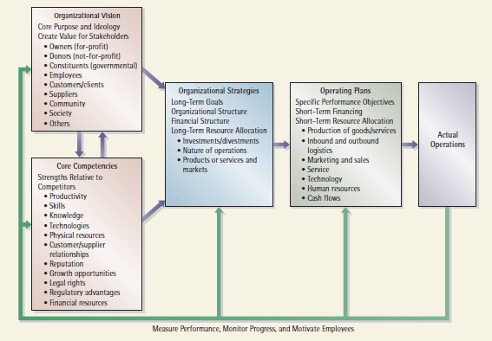

To have an effective management control system it is necessary to also include a feedback loop. Exhibit 1.7 provides an example of a feedback loop.

Exercise 1.21 or 1.22 could be used in class to help students understand the various components.

LO2: Identify the types of control systems that managers use.

Levers of Control
- Belief Systems
- Boundary Systems
- Diagnostic Control Systems
- Interactive Systems

Exercises 1.26 or 1.28 could be used as an in-class exercise to explore control systems.

LO3: Explain the role of accounting information in strategic management.

Introduce terminology:
Cost accounting
Management accounting
Financial accounting
Strategic cost management

Students may be confused with regard to similarities and differences concerning management versus financial accounting. The main point of this section is to differentiate between the users of financial accounting versus the users of management accounting.

A brief history of cost accounting helps to give the students some perspective on management accounting and its critical role in strategic management.

Problem 1.40 provides a useful scenario for the discussion of the role of accounting information in strategic decision making.

LO4: Explain the information systems and information that is relevant for decision making.

Relevant information
Helps decision makers evaluate and choose among alternative courses of action
Must:
(1) Concern the future
(2) Vary with the action taken
Includes incremental (avoidable) cash flows

Irrelevant information
Not useful for decision making
Includes unavoidable cash flows

Exercise 1.25 can be used to introduce the topic of relevant information. This problem also introduces the importance of qualitative factors (people’s preferences), and has students consider their biases and control for those biases when giving advice.

Teaching note
Students tend to think that bias occurs because bad people intentionally manipulate numbers. Because they do not fully understand that there is uncertainty in information and that judgment is used in developing nearly all information, they see bias as intentional. Exercise 1.25 helps them understand that people’s preferences are actually biases. They need a great deal of practice at identifying biases in different situations. This problem gives them a good start because they can easily recognize these types of preferences and then relate them to biases.

Alternatively, you may walk the students through the Snow-Blade Snowboards example in the text (pages 14-15). Be sure they understand how to distinguish between relevant and irrelevant cash flows.

LO5: Describe how business risk affects management decision making.

Risk Management – the process of enterprise risk management (ERM) may use any of the four control levers identified above. An effective ERM process will identify and mitigate risks in some or all of these areas:
- Economic and Financial
- Political and Social
- Reputation
- Weather
- Environmental and Man-made
- Psychopathic, Criminal and Terrorist
- Informational and Operational
- People, Legal, Health and Other

Problem 1.32 combines relevant costs, risk, and bias – providing an opportunity to discuss with students the interaction all of these components

LO6: Appreciate how biases affect management decision making.

Some are types of bias are of particular concern, these are:
- Information bias
- Cognitive bias
- Predisposition bias

Self-Study Problem 1-3 on page 19 is useful as a basis for class discussion regarding this topic.

LO7: Determine how managers make higher quality decisions.

Discuss the components of Exhibit 1.13.

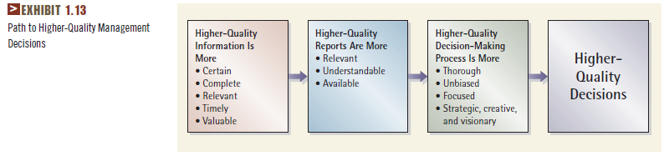

Teaching Note
Students often have difficulty with the material in Exhibit 1.13. If they fail to adequately understand uncertainties, then it will be impossible for them to understand how uncertainties and other factors affect decision quality. Here is a quick assessment you can perform to gauge how well your students understand uncertainties:

Name a business with which your students are familiar, such as a restaurant near campus, or a widely-known company such as Maple Leaf Foods or Canadian Tire. Give your students 2 minutes to list on a piece of paper reasons why the managers of this business cannot know for certain what their sales will be next month. Collect the pieces of paper and scan them before the next class session.

Students who write answers that seem to be “clueless” or off-point may be unable to understand the question; these students often lack a basic understanding of uncertainties in business. Most students will provide 1-3 valid reasons; they need to work on expanding their understanding. Students with an acceptable understanding of uncertainties should be able to list more than 5 reasons, and some may list as many as 10-15. In general, students who list a larger number of valid uncertainties will do a better job on problems requiring analysis than other students.

You may or may not want to devote class time to discussing Steps for Better Thinking. A detailed understanding of this model is not necessary for success in the course. However, if you would like to explicitly teach the model, Exhibit 1B.1 in Appendix 1B is a good reference. The approach can be discussed in reference to the opening Apple example.
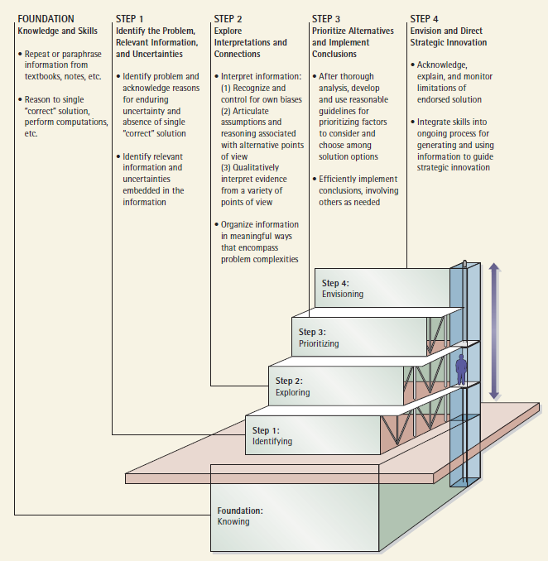

Teaching Note (Exhibit 1B.1)
Steps for Better Thinking is portrayed as a set of steps because strong performance in the lower-level skills sets the stage for strong performance in the higher-level skills. Conversely, if the lower-level skills are weak, then the entire structure will also be weak.

Student abilities often vary from school to school. However, research suggests that a large proportion of students in a typical junior-level cost accounting course are likely to struggle with Step 1 skills. Even graduate-level students sometimes struggle with Step 1 skills. Most cost accounting students are likely to have at least some ability with Step 1 skills, but are likely to struggle with Step 2 skills. In most programs, only a small proportion of students are likely to have strong Step 1 and Step 2 skills.

LO8: Explain the importance of ethical decision making.

Introduce components of ethical decision making (Exhibit 1.14)

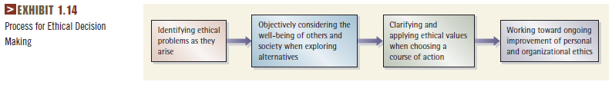

Individual and Organizational Obligation

Fraudulent Financial Reporting
- Decreases organizational market value
- Decreases value of accounting profession

Rewards of Ethical Behaviour
- Integrity
- Reputation
- Self-respect
- Social welfare

Exercise 1.26 or 1.29 could be used as an in-class exercise or as homework for analyzing ethical dilemmas.

Recommended Homework

Exercise 1.25 requires a relatively easy relevant cost calculation, and it also incorporates uncertainties. This would be a good problem for undergraduate students. Problem 1.28 requires students to explore the quality of information; it would work best with more advanced students.

Exercise 1.23 (relatively easy) or Problem 1.34 or 1.38 (both moderately difficult) could be used to focus on relevant information for decision making. These problems incorporate numerical calculations as well as qualitative factors.

Mini-Case 1.50 could be used to help students focus on information beyond traditional financial accounting. Students will find this problem interesting because it also addresses ethical issues surrounding Walmart and its in-store research using RFID technology.

Chapter 1 Key Terms Quiz Name ___________________

______________ 1. Organizational success increases when employees understand the organization’s core values and work collectively to achieve them.
______________ 2. Core purpose and ideology of an organization, which guides the organization’s overall direction and approaches toward various stakeholder groups.
______________ 3. Specific short-term decisions that shape the organization’s day-to-day activities such as drawing cash from a bank line of credit, hiring an employee, or ordering materials.
______________ 4. Process of gathering, summarizing, and reporting information used internally by managers to make decisions; includes measurement of costs as well as other financial and non-financial information.
______________ 5. Document that presents information for use outside an organization, such as financial statements, news releases, inventory reports for suppliers, tax returns, and regulatory reports.
______________ 6. Cash flows that occur under one course of action or decision alternative, but not under another.
______________ 7. Preconceived notions that are adopted without careful thought; cause decision makers to ignore weaknesses in their preferred course of action and prevent them from adequately exploring alternatives.
______________ 8. An organization’s strengths relative to competitors.
______________ 9. The various actions taken and results achieved over a period of time, including customer orders received, revenues earned, number of employees hired, costs incurred, units of goods or services produced, cash received and paid, etc.
______________ 10. Expansion of management accounting to simultaneous focus on reducing costs and strengthening an organization’s strategic position.
______________ 11. Knowledge, facts, data, or factors that help the decision maker evaluate and choose among alternative courses of action; concern the future and vary with the action taken.
______________ 12. Cash flows that occur regardless of which course of action or decision alternative is chosen.
Chapter 1 Key Terms Quiz (continued)

______________ 13. Tactics that managers use to take advantage of core competencies while working toward the organizational vision; guide long-term decisions such as the proportion of financing through debt and equity, types of goods and services offered, and investments in property, plant, and equipment.
______________ 14. A technique or method for determining the cost of a project, process, or thing, with costs determined through direct measurement, arbitrary assignment, or systematic and rational allocation.
______________ 15. Document that presents information for use only inside an organization, such as a capital budget, analysis of a potential acquisition, operating and other budgets, bonus computations, and analysis of supplier quality.
______________ 16. Knowledge, facts, data, factors, or issues that do not help the decision maker evaluate and choose among alternative courses of action; do not vary with the action taken.
______________ 17. Managers often use one or more of the four levers of control to ensure that management’s risk policies are followed, and to monitor the environment for changes in business risk.
______________ 18. Refers to the characteristics of a decision that affect the likelihood of achieving a positive outcome.

Answers to Key Terms Quiz
1. Belief systems
2. Organizational vision
3. Operating plans
4. Management accounting
5. External report
6. Relevant cash flows, avoidable cash flows, or incremental cash flows
7. Biases
8. Organizational core competencies
9. Actual operations
10. Strategic cost management
11. Relevant information
12. Irrelevant cash flows or unavoidable cash flows
13. Organizational strategies
14. Cost accounting
15. Internal report
16. Irrelevant information
17. Risk management
18. Decision quality

Additional Resources for This Chapter

Available on Both Student and Instructor Web Sites:
Chapter summaries
Videos
Interactive problems
Checklist of key figures
Web quiz
PowerPoint slides (2 sets)

Available on the Instructor Web Site:
Solutions manual
Clicker questions
PowerPoint slides
Additional problems
Test bank

