Chapter 1
Introduction

Practice Questions

Consolidate

Problem 1.8
A stock when it is first issued provides funds for a company. Is the same true of an exchange-traded stock option? Discuss.

An exchange-traded stock option provides no funds for the company. It is a security sold by one investor to another. The company is not involved. By contrast, a stock when it is first issued is sold by the company to investors and does provide funds for the company.

Australian companies may also issue company options. These are listed on the stock exchange along with the stock, with call options allowing the purchaser to buy new stock in the company at the option expiration date. With a mining company, the option premium could be used to fund the exploration stage of a new mine while the issue of new shares at option expiration could be used to fund development of the mine ready for extraction.

Problem 1.9
Explain why a futures contract can be used for either speculation or hedging.

If an investor has an exposure to the price of an asset, he or she can hedge with futures contracts. If the investor will gain when the price decreases and lose when the price increases, a long futures position will hedge the risk. If the investor will lose when the price decreases and gain when the price increases, a short futures position will hedge the risk. Thus either a long or a short futures position can be entered into for hedging purposes.

If the investor has no exposure to the price of the underlying asset, entering into a futures contract is speculation. If the investor takes a long position, he or she gains when the asset’s price increases and loses when it decreases. If the investor takes a short position, he or she loses when the asset’s price increases and gains when it decreases.

Problem 1.10
An investor writes a December put option with a strike price of $30. The price of the option is $4. Under what circumstances does the investor make a gain?

The investor makes a gain if the price of the stock is above $26 at the time of exercise. If we ignore the time value of money, the option writer receives the $4 option price immediately on selling the option.

The option will not be exercised if the stock price is greater than $30 as the buyer of the option is better off selling on the stock market than exercising their put option. In this case the option writer keeps the $4.

If the stock price is less than $30, then the option buyer will exercise the option and the option writer makes a profit or loss of ($4+S-$30) where S is the stock price.

If the stock price falls to $26, then there is neither profit nor loss as
($4+$26-$30) = 0.

If the stock price falls below $26, then the option writer takes a loss of ($4+S-$30). For example, if the stock price was $10 when the option is exercised then the loss is $16 ($4+$10-$30).

Problem 1.11
The Australian Securities Exchange offers a futures contract on 10-year Commonwealth Treasury bonds. Characterise the investors likely to use this contract.

Portfolio managers and bond investors could use futures contracts for hedging. A short position in the 10-year bond futures contract would be used by bond portfolio managers to hedge bond price risk. If bond prices fall then a short futures contract generates a profit that will offset the loss made on the bond portfolio.

A merchant bank could take a long position in the futures contract if it were seeking to finance pension liabilities into the future but was concerned about interest rate movements up to the time it is ready to invest. The bank could use futures contracts to lock in interest rates today for the few months until they are ready to make their bond investment. A long 10-year bond futures position will rise in value when interest rates fall, thus covering the bank against losses from lower interest rates in the future, were they to prevail on maturity of the futures contract.

Speculators could also use futures contracts for speculation. Suppose that a speculator believes interest rates will rise. In this case, the speculator could take a short position in 10-year bond futures contracts. If interest rates rise, the bond yield will increase and the bond price will decrease leading to a profit on the short bond futures contract position.

Problem 1.12
A company knows that it is due to receive a certain amount of a foreign currency in four months. What type of option contract is appropriate for hedging?

A long position in a four-month put option can provide insurance against the exchange rate falling below the strike price. It ensures that the foreign currency can be sold for at least the strike price.

Problem 1.13
‘Options and futures are zero-sum games.’ What do you think is meant by this statement?

The statement means that the gain (loss) to the party with the short position is equal to the loss (gain) to the party with the long position. In total, the gain to all parties is zero.

Development

Problem 1.14
Suppose you own 5,000 shares that are worth $25 each. How can put options be used to provide you with insurance against a decline in the value of your holding over the next four months?

You should buy 50 put option contracts (each option contract covers 100 shares) with a strike price of $25 and an expiration date in four months. If at the end of four months the stock price proves to be less than $25, you can exercise the options and sell the shares for $25 each.

Problem 1.15
A wheat farmer expects to have 100 metric tonnes of Western Australian wheat to sell in three months. The Western Australian wheat futures contract on the Australian Securities Exchange is for the delivery of 20 metric tonnes of wheat. How can the farmer use the contract for hedging? From the farmer’s viewpoint, what are the pros and cons of hedging?

The farmer can short 5 contracts that have 3 months to maturity. If the price of wheat falls, the gain on the futures contract will offset the loss on the sale of the wheat. If the price of wheat rises, the gain on the sale of the wheat will be offset by the loss on the futures contract. Using futures contracts to hedge has the advantage that it can at no cost reduce risk to almost zero. Its disadvantage is that the farmer no longer gains from favourable movements in wheat prices.

Problem 1.16
Suppose that a March call option on a stock with a strike price of $50 costs $2.50 and is held until March. Under what circumstances will the holder of the option make a gain? Under what circumstances will the option be exercised? Draw a diagram showing how the profit on a long position in the option depends on the stock price at the maturity of the option.

The holder of the option will gain if the price of the stock is above $52.50 in March. (This ignores the time value of money.) The option will be exercised if the price of the stock is above $50.00 in March. The profit as a function of the stock price is shown in Figure S1.1.

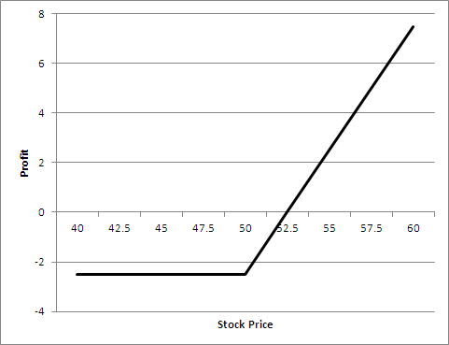

Figure S1.1: Profit from long position in Problem 1.16

Problem 1.17
Suppose that a June put option on a stock with a strike price of $60 costs $4 and is held until June. Under what circumstances will the holder of the option make a gain? Under what circumstances will the option be exercised? Draw a diagram showing how the profit on a short position in the option depends on the stock price at the maturity of the option.

The seller of the option will lose if the price of the stock is below $56.00 in June. (This ignores the time value of money.) The option will be exercised if the price of the stock is below $60.00 in June. The profit as a function of the stock price is shown in Figure S1.2.

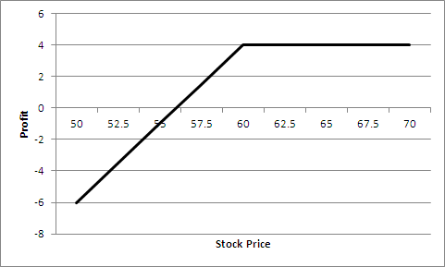

Figure S1.2: Profit from short position in Problem 1.17

Problem 1.18
It is May and a trader writes a September call option with a strike price of $20. The stock price is $18 and the option price is $2. Describe the investor’s cash flows if the option is held until September and the stock price is $25 at this time.

The trader has an inflow of $2 in May and an outflow of $5 in September. The $2 is the cash received from the sale of the option. The $5 is the result of the option being exercised. The investor has to buy the stock for $25 in September and sell it to the purchaser of the option for $20.

Problem 1.19

An airline executive has argued: ‘There is no point in our using oil futures. There is just as much chance that the price of oil in the future will be less than the futures price as there is that it will be greater than this price.’ Discuss the executive’s viewpoint.
It may well be true that there is just as much chance that the price of oil in the future will be above the futures price as that it will be below the futures price. This means that the use of a futures contract for speculation would be like betting on whether a coin comes up heads or tails. But it might make sense for the airline to use futures for hedging rather than speculation. The futures contract then has the effect of reducing risks. It can be argued that an airline should not expose its shareholders to risks associated with the future price of oil when there are contracts available to hedge the risks.

Problem 1.20
A trader enters into a short forward contract on 100 million yen. The forward exchange rate is $0.0080 per yen. How much does the trader gain or lose if the exchange rate at the end of the contract is: (a) $0.0074 per yen, (b) $0.0091 per yen?
- The trader sells 100 million yen for $0.0080 per yen when the exchange rate is $0.0074 per yen. The gain is millions of dollars or $60,000.
- The trader sells 100 million yen for $0.0080 per yen when the exchange rate is $0.0091 per yen. The loss is millions of dollars or $110,000.

Problem 1.21
A trader enters into a short greasy wool futures contract when the futures price is 1,170 cents per kg. The contract is for the delivery of 2,000 kgs clean weight. How much does the trader gain or lose if the greasy wool at the end of the contract is: (a) 1,150 cents per kg, (b) 1,190 cents per kg?
- The trader sells for 1,170 cents per kg something that is worth 1,150 cents per kg. Gain = ($11.70-$11.50) x 2,000 = $400.
- The trader sells for 1,170 cents per kg something that is worth 1,190 cents per kg. Loss = ($11.70-$11.90) x 2,000 = $400.

Problem 1.22
An Australian company expects to have to pay 1 million Canadian dollars in six months. Explain how the exchange rate risk can be hedged using: (a) a forward contract, (b) an option.
The company could enter into a long forward contract to buy 1 million Canadian dollars in six months. This would have the effect of locking in an exchange rate equal to the current forward exchange rate. Alternatively the company could buy a call option giving it the right (but not the obligation) to purchase 1 million Canadian dollars at a certain exchange rate in six months. This would provide insurance against a strong Canadian dollar in six months while still allowing the company to benefit from a weak Canadian dollar at that time.

Problem 1.23
It is July 2010. A mining company has just discovered a small deposit of gold. It will take six months to construct the mine. The gold will then be extracted on a more or less continuous basis for one year. Futures contracts on gold are available on the New York Mercantile Exchange. There are delivery months every two months from August 2010 to December 2011. Each contract is for the delivery of 100 ounces. Discuss how the mining company might use futures markets for hedging.
The mining company can estimate its production on a month-by-month basis. It can then short futures contracts to lock in the price received for the gold. For example, if a total of 3,000 ounces are expected to be produced in September 2010 and October 2010, the price received for this production can be hedged by shorting a total of 30 October 2010 contracts.

Assignment questions

Problem 1.24 (Excel file)
Trader A enters into a forward contract to buy gold for $1,000 an ounce in one year. Trader B buys a call option to buy gold for $1,000 an ounce in one year. The cost of the option is $100 an ounce. What is the difference between the positions of the traders? Show the profit per ounce as a function of the price of gold in one year for the two traders.

Trader A makes a profit of S_{T} ̶ 1,000 and Trader B makes a profit of max(S_{T} ̶ 1,000, 0) –100 where S_{T} is the price of gold in one month. Trader A does better if S_{T} is above $900 as indicated in Figure S1.3.

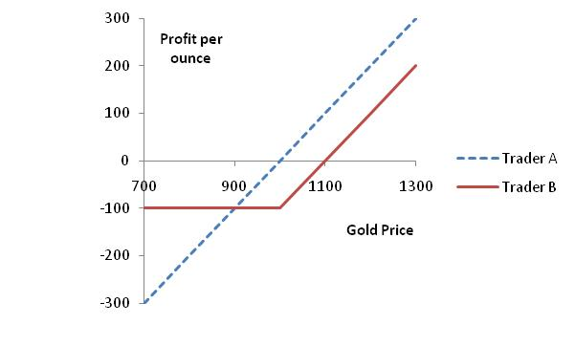
Figure S1.3: Profit to Trader A and Trader B in Problem 1.24

Problem 1.25
In March, a US investor instructs a broker to sell one July put option contract on a stock. The stock price is $42 and the strike price is $40. The option price is $3. Explain what the investor has agreed to. Under what circumstances will the trade prove to be profitable? What are the risks?

The investor has agreed to buy 100 shares of the stock for $40 in July (or earlier) if the party on the other side of the transaction chooses to sell. The trade will prove profitable if the option is not exercised or if the stock price is above $37 at the time of exercise. The risk to the investor is that the stock price plunges to a low level. For example, if the stock price drops to $1 by July (unlikely but possible), the investor loses $3,600. This is because the put options are exercised and $40 is paid for 100 shares when the value per share is $1. This leads to a loss of $3,900, which is offset by the premium of $300 received for the options.

Problem 1.26
An Australian company knows it will have to pay 3 million euros in three months. The current exchange rate is 1.4500 dollars per euro. Discuss how forward and options contracts can be used by the company to hedge its exposure.

The company could enter into a forward contract obligating it to buy 3 million euros in three months for a fixed price (the forward price). The forward price will be close to but not exactly the same as the current spot price of 1.4500. An alternative would be to buy a call option giving the company the right but not the obligation to buy 3 million euros for a particular exchange rate (the strike price) in three months. The use of a forward contract locks in, at no cost, the exchange rate that will apply in three months. The use of a call option provides, at a cost, insurance against the exchange rate being higher than the strike price.

Problem 1.27 (Excel file)
A stock price is $29. An investor buys one call option contract on the stock with a strike price of $30 and sells a call option contract on the stock with a strike price of $32.50. The market prices of the options are $2.75 and $1.50, respectively. The options have the same maturity date. Describe the investor's position.

This is known as a bull spread and will be discussed in Chapter 11. The profit is shown in Figure S1.4.

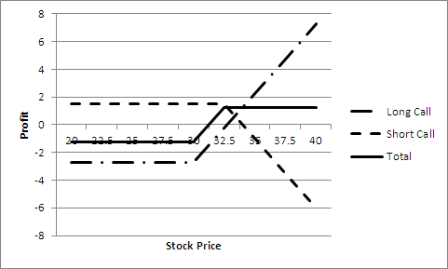

Figure S1.4: Profit in Problem 1.27

Problem 1.28
The price of gold is currently $800 per ounce. Forward contracts are available to buy or sell gold at $1,000 for delivery in one year. An arbitrageur can borrow money at 10% per annum. What should the arbitrageur do? Assume that the cost of storing gold is zero and that gold provides no income.
The arbitrageur should borrow money to buy a certain number of ounces of gold today and short forward contracts on the same number of ounces of gold for delivery in one year. This means that gold is purchased for $800 per ounce and sold for $1,000 per ounce. Assuming the cost of borrowed funds is less than 25% per annum this generates a riskless profit.

Problem 1.29
Discuss how foreign currency options can be used for hedging in the situation described in Example 1.1 so that: (a) ImportCo is guaranteed that its exchange rate will be less than 0.98257, and (b) ExportCo is guaranteed that its exchange rate will be at least 0.98223.

ImportCo can buy call options on USD 10,000,000 with a strike price of 0.98257. This will ensure that it never pays more than AUD 9,825,700 for the USD it requires. (USD 10,000,000x0.98257)

ExportCo can buy put options on USD 30,000,000 with a strike price of 0.98223. This will ensure that the price received for the USD will be above AUD 29,466,900 (USD 30,000,000x0.98223)

Problem 1.30
The current price of a stock is $94, and three-month European call options with a strike price of $95 currently sell for $4.70. An investor who feels that the price of the stock will increase is trying to decide between buying 100 shares and buying 2,000 call options (20 contracts). Both strategies involve an investment of $9,400. What advice would you give? How high does the stock price have to rise for the option strategy to be more profitable?
Assume that the option contract is for 100 shares. The investment in call options entails higher risks but can lead to higher returns. If the stock price stays at $94, an investor who buys call options loses $9,400 whereas an investor who buys shares neither gains nor loses anything. If the stock price rises to $120, the investor who buys call options gains

An investor who buys shares gains

The strategies are equally profitable if the stock price rises to a level, S, where
or

The option strategy is therefore more profitable if the stock price rises above $100.

Problem 1.31
On 7 January 2011, an investor owns 1,000 BHP shares. As indicated in Table 1.2, the share price is $44.60 and an April put option with a strike price of $44 costs $1.61. The investor is comparing two alternatives to limit downside risk. The first involves buying one April put option contract with a strike price of $44. The second involves instructing a broker to sell the 1,000 shares as soon as BHP’s price reaches $44. Discuss the advantages and disadvantages of the two strategies.

The second alternative involves what is known as a stop or stop-loss order. It costs nothing and ensures that $44,000, or close to $44,000, is realised for the holding in the event the stock price ever falls to $44. The put option contract costs $1,610 and guarantees that the holding can be sold for $44,000 any time up to April. If the stock price falls marginally below $44 and then rises the option will not be exercised, but the stop-loss order will lead to the holding being liquidated. There are some circumstances where the put option alternative leads to a better outcome and some circumstances where the stop-loss order leads to a better outcome. If the stock price ends up below $44, the stop-loss order alternative leads to a better outcome because the cost of the option is avoided. If the stock price falls to $40 in March and then rises to $45 by April, the put option alternative leads to a better outcome. The investor is paying $1,610 for the chance to benefit from this second type of outcome.

Problem 1.32
A trader buys a European call option and sells a European put option. The options have the same underlying asset, strike price and maturity. Describe the trader’s position. Under what circumstances does the price of the call equal the price of the put?

The trader has a long European call option with strike price and a short European put option with strike price . Suppose the price of the underlying asset at the maturity of the option is . If , the call option is exercised by the investor and the put option expires worthless. The payoff from the portfolio is . If , the call option expires worthless and the put option is exercised against the investor. The cost to the investor is . Alternatively we can say that the payoff to the investor is (a negative amount). In all cases, the payoff is, the same as the payoff from the forward contract. The trader’s position is equivalent to a forward contract with delivery price.

Suppose thatis the forward price. If , the forward contract that is created has zero value. Because the forward contract is equivalent to a long call and a short put, this shows that the price of a call equals the price of a put when the strike price is F.

