Chapter 1 Environment and Theoretical Structure of
Financial Accounting

Question 1–1
Financial accounting is concerned with providing relevant financial information about various kinds of organizations to different types of external users. The primary focus of financial accounting is on the financial information provided by profit-oriented companies to their present and potential investors and creditors.

Question 1–2
Resources are efficiently allocated if they are given to enterprises that will use them to provide goods and services desired by society and not to enterprises that will waste them. The capital markets are the mechanism that fosters this efficient allocation of resources.

Question 1–3
Two extremely important variables that must be considered in any investment decision are the expected rate of return and the uncertainty or risk of that expected return.

Question 1–4
In the long run, a company will be able to provide investors and creditors with a rate of return only if it can generate a profit. That is, it must be able to use the resources provided to it to generate cash receipts from selling a product or service that exceed the cash disbursements necessary to provide that product or service.

Question 1–5
The primary objective of financial accounting is to provide investors and creditors with information that will help them make investment and credit decisions.

Question 1–6
Net operating cash flows are the difference between cash receipts and cash disbursements during a period of time from transactions related to providing goods and services to customers. Net operating cash flows may not be a good indicator of future cash flows because, by ignoring uncompleted transactions, they may not match the accomplishments and sacrifices of the period.

Answers to Questions (continued)

Question 1–7
GAAP (generally accepted accounting principles) are a dynamic set of both broad and specific guidelines that a company should follow in measuring and reporting the information in their financial statements and related notes. It is important that all companies follow GAAP so that investors can compare financial information across companies to make their resource allocation decisions.

Question 1–8
In 1934, Congress created the SEC and gave it the job of setting accounting and reporting standards for companies whose securities are publicly traded. The SEC has retained the power, but has relied on private sector bodies to create the standards. The current private sector body responsible for setting accounting standards is the FASB.

Question 1–9
Auditors are independent, professional accountants who examine financial statements to express an opinion. The opinion reflects the auditors’ assessment of the statements' fairness, which is determined by the extent to which they are prepared in compliance with GAAP. The auditor adds credibility to the financial statements, which increases the confidence of capital market participants relying on that information.

Answers to Questions (continued)

Question 1–10
On July 30, 2002, President Bush signed into law the Sarbanes-Oxley Act of 2002. The most dramatic change to federal securities laws since the 1930s, the Act radically redesigns federal regulation of public company corporate governance and reporting obligations. It also significantly tightens accountability standards for directors and officers, auditors, securities analysts, and legal counsel. Student opinions as to the relative importance of the key provisions of the act will vary. Key provisions in the order of presentation in the text are:
- Creation of an Oversight Board
- Corporate executive accountability
- Nonaudit services
- Retention of work papers
- Auditor rotation
- Conflicts of interest
- Hiring of auditor
- Internal control

Question 1–11
New accounting standards, or changes in standards, can have significant differential effects on companies, investors and creditors, and other interest groups by causing redistribution of wealth. There also is the possibility that standards could harm the economy as a whole by causing companies to change their behavior.

Question 1–12
The FASB undertakes a series of elaborate information gathering steps before issuing an accounting standard to determine consensus as to the preferred method of accounting, as well as to anticipate adverse economic consequences.

Question 1–13
The purpose of the conceptual framework is to guide the Board in developing accounting standards by providing an underlying foundation and basic reasoning on which to consider merits of alternatives. The framework does not prescribe GAAP.

Answers to Questions (continued)

Question 1–14
Relevance and faithful representation are the primary qualitative characteristics that make information decision-useful. Relevant information will possess predictive and/or confirmatory value. Faithful representation is the extent to which there is agreement between a measure or description and the phenomenon it purports to represent.

Question 1–15
The components of relevant information are predictive value, confirmatory value and materiality. The components of faithful representation are completeness, neutrality, and freedom from error.

Question 1–16
The benefit from providing accounting information is increased decision usefulness. If the information is relevant and possesses faithful representation, it will improve the decisions made by investors and creditors. However, there are costs to providing information that include costs to gather, process, and disseminate that information. There also are costs to users in interpreting the information as well as possible adverse economic consequences that could result from disclosing information. Information should not be provided unless the benefits exceed the costs.

Question 1–17
Information is material if it is deemed to have an effect on a decision made by a user. The threshold for materiality will depend principally on the relative dollar amount of the transaction being considered. One consequence of materiality is that GAAP need not be followed in measuring and reporting a transaction if that transaction is not material. The threshold for materiality has been left to subjective judgment.
Answers to Questions (continued)

Question 1–18
1. Assets are probable future economic benefits obtained or controlled by a particular entity as a result of past transactions or events.
2. Liabilities are probable future sacrifices of economic benefits arising from present obligations of a particular entity to transfer assets or provide services to other entities in the future as a result of past transactions.
3. Equity is the residual interest in the assets of any entity that remains after deducting its liabilities.
4. Investments by owners are increases in equity resulting from transfers of resources, usually cash, to a company in exchange for ownership interest.
5. Distributions to owners are decreases in equity resulting from transfers to owners.
6. Revenues are inflows of assets or settlements of liabilities from delivering or producing goods, rendering services, or other activities that constitute the entity’s ongoing major or central operations.
7. Expenses are outflows or other using up of assets or incurrences of liabilities during a period from delivering or producing goods, rendering services, or other activities that constitute the entity’s ongoing major or central operations.
8. Gains are defined as increases in equity from peripheral or incidental transactions of an entity.
9. Losses represent decreases in equity arising from peripheral or incidental transactions of an entity.
10. Comprehensive income is defined as the change in equity of an entity during a period from nonowner transactions.

Question 1–19
The four basic assumptions underlying GAAP are (1) the economic entity assumption, (2) the going concern assumption, (3) the periodicity assumption, and (4) the monetary unit assumption.

Question 1–20
The going concern assumption means that, in the absence of information to the contrary, it is anticipated that a business entity will continue to operate indefinitely. This assumption is important to many broad and specific accounting principles such as the historical cost principle.

Answers to Questions (continued)

Question 1–21
The periodicity assumption relates to needs of external users to receive timely financial information. This assumption requires that the economic life of a company be divided into artificial periods for financial reporting. Companies usually report to external users at least once a year.

Question 1–22
Four accounting practices, often referred to as principles, that guide accounting practice are (1) revenue recognition, (2) expense recognition, (3) mixed-attribute measurement (including historical cost), and (4) full disclosure.

Question 1–23
Two advantages to basing valuation on historical cost are (1) historical cost provides important cash flow information since it represents the cash or cash equivalent paid for an asset or received in exchange for the assumption of a liability, and (2) historical cost valuation is the result of an exchange transaction between two independent parties and the agreed upon exchange value is, therefore, objective and possesses a high degree of verifiability.

Question 1–24
Companies recognize revenue when goods or services are transferred to customers. However, no revenue is recognized if it isn’t probable that the seller will collect the amounts it’s entitled to receive. The amount of revenue recognized is the amount the company expects to be entitled to receive in exchange for those goods or services. Revenue is recognized at a point in time or over a period of time, depending on when goods or services are transferred to customers. So, revenue for the sale of most goods is recognized upon delivery, but revenue for services like renting apartments or lending money is recognized over time as those services are provided.

Answers to Questions (continued)

Question 1–25
The four different approaches to implementing expense recognition are:
1. Recognizing an expense based on an exact cause-and-effect relationship between a revenue and expense event. Cost of goods sold is an example of an expense recognized by this approach.
2. Recognizing an expense by identifying the expense with the revenues recognized in a specific time period. Office salaries are an example of an expense recognized by this approach.
3. Recognizing an expense by a systematic and rational allocation to specific time periods. Depreciation is an example of an expense recognized by this approach.
4. Recognizing expenses in the period incurred, without regard to related revenues. Advertising is an example of an expense recognized by this approach.

Question 1–26
In addition to the financial statement elements arrayed in the basic financial statements, information is disclosed by means of parenthetical or modifying comments, notes, and supplemental schedules and tables.

Question 1–27
GAAP prioritizes the inputs companies should use when determining fair value. The highest and most desirable inputs, Level 1, are quoted market prices in active markets for identical assets or liabilities. Level 2 inputs are other than quoted prices that are observable, including quoted prices for similar assets or liabilities in active or inactive markets and inputs that are derived principally from observable related market data. Level 3 inputs, the least desirable, are inputs that reflect the entity’s own assumptions about the assumptions market participants would use in pricing the asset or liability based on the best information available in the circumstances.

Question 1–28
Common measurement attributes are historical cost, net realizable value, current cost, present value, and fair value.

Answers to Questions (concluded)

Question 1–29
Under the revenue/expense approach, revenues and expenses are considered primary, and assets, liabilities, and equities are secondary in the sense of being recognized at the time and amount necessary to achieve proper revenue and expense recognition. Under the asset/liability approach, assets and liabilities are considered primary, and revenues and expenses are secondary in the sense of being recognized at the time and amount necessary to allow recognition and measurement of assets and liabilities as required by their definitions.

Question 1–30
Under IFRS, the conceptual framework provides guidance to accounting standard setters but also provides GAAP when more specific accounting standards do not provide guidance.

Question 1–31
The International Accounting Standards Board (IASB) is responsible for determining IFRS. The IASB is funded by the IFRS Foundation. .

Question 1–32
The SEC staff’s Final Staff Report concludes that it is not feasible for the U.S. to simply adopt IFRS, given (1) a need for the U.S. to have strong influence on the standard setting process and insure that standards meet U.S. needs, (2) the high costs to companies of converting to IFRS, and (3) the fact that many laws, regulations and private contracts reference U.S. GAAP.

BRIEF Exercises

Brief Exercise 1–1
Revenues ($340,000 + 60,000) $400,000
Expenses:
Rent ($40,000 ÷ 2) (20,000)
Salaries (120,000)
Utilities ($50,000 + 2,000) (52,000)
Net income $208,000

Brief Exercise 1–2
- Liabilities
- Assets
- Revenues
- Losses
Brief Exercise 1–3
- The periodicity assumption
- The economic entity assumption
- Revenue recognition
- Expense recognition
Brief Exercise 1–4
- Expense recognition
- The historical cost (original transaction value) principle
- The economic entity assumption
Brief Exercise 1–5
1. Disagree — The full disclosure principle
2. Agree — The periodicity assumption
3. Disagree — Expense recognition
4. Agree — Revenue recognition
Brief Exercise 1–6
1. Obtains funding for the IFRS standard setting process: IFRS Foundation
2. Determines IFRS: International Accounting Standards Board (IASB)
3. Oversees the IFRS Foundation: Monitoring Board
4. Provides input about the standard setting agenda: IFRS Advisory Council.
5. Provides implementation guidance about relatively narrow issues: IFRS Interpretations Committee.

Exercises
Exercise 1–1
Requirement 1

 | Pete, Pete, and Roy
 | Operating Cash Flow
 | Year 1 | Year 2
Cash collected | $160,000 | $190,000
Cash disbursements:
Salaries | (90,000) | (100,000)
Utilities | (30,000) | (40,000)
Purchase of insurance policy | (60,000) | - 0 -
Net operating cash flow | $(20,000) | $ 50,000
Requirement 2

 | Pete, Pete, and Roy
 | Income Statements
 | Year 1 | Year 2
Revenues | $170,000 | $220,000
Expenses:
Salaries | (90,000) | (100,000)
Utilities | (35,000) | (35,000)
Insurance | (20,000) | (20,000)
Net Income | $ 25,000 | $ 65,000
Requirement 3
Year 1: Amount billed to clients $170,000
Less: Cash collected (160,000)
Ending accounts receivable $ 10,000

Year 2: Beginning accounts receivable $ 10,000
Plus: Amounts billed to clients 220,000
$230,000
Less: Cash collected (190,000)
Ending accounts receivable $ 40,000

Exercise 1–2
Requirement 1

 | Year 2 | Year 3
Revenues | $350,000 | $450,000
Expenses:
Rent ($80,000 ÷ 2) | (40,000) | (40,000)
Salaries | (140,000) | (160,000)
Utilities | (30,000) | (40,000)
Advertising | (25,000) | (20,000)*
Net Income | $115,000 | $190,000
Requirement 2
Amount owed at the end of year one $ 5,000
Advertising costs incurred in year two 25,000
30,000
Amount paid in year two (15,000)
Liability at the end of year two 15,000
Less cash paid in year three (35,000)
Advertising expense in year three $20,000*

Exercise 1–3
Requirement 1
FASB ASC 820: “Fair Value Measurements and Disclosures”
Requirement 2
The specific citation that describes the information that companies must disclose about the use of fair value to measure assets and liabilities for recurring measurements is FASB ASC 820–10–50: “Fair Value Measurements and Disclosures-Overall-Disclosures.”
Exercise 1–4
The FASB Accounting Standards Codification represents the single source of authoritative U.S. generally accepted accounting principles. The specific citation for each of the following items is:

  - The topic number for business combinations:
FASB ASC 805: “Business Combinations.”

  - The topic number for related-party disclosures:
FASB ASC 850: “Related Party Disclosures.”

  - The topic, subtopic, and section number for the initial measurement of internal-use software:
FASB ASC 350–40–30: “Intangibles–Goodwill and Other–Internal–Use Software–Initial Measurement.”

  - The topic, subtopic, and section number for the subsequent measurement of asset retirement obligations:
FASB ASC 410–20–35: “Asset Retirement and Environmental Obligations–Asset Retirement Obligations–Subsequent Measurement.”

  - The topic, subtopic, and section number for the recognition of stock compensation:
FASB ASC 718–10–25: “Compensation–Stock Compensation–Overall–
Recognition.”

Exercise 1–5
Organization Group
1. Securities and Exchange Commission Users
2. Financial Executives International Preparers
3. American Institute of Certified Public Accountants Auditors
4. Institute of Management Accountants Preparers
5. Association of Investment Management and Research Users

Exercise 1–6

1. Liability
2. Distribution to owners
3. Revenue
4. Assets, liabilities and equity
5. Comprehensive income
6. Gain
7. Loss
8. Equity
9. Asset
10. Net income
11. Investment by owner
12. Expense

Exercise 1–7

List A List B

o 1. Predictive value a. Decreases in equity resulting from transfers to owners.
h 2. Relevance b. Requires consideration of the costs and value of information.
g 3. Timeliness c. Important for making interfirm comparisons.
a 4. Distribution to owners d. Applying the same accounting practices over time.
j 5. Confirmatory value e. Users understand the information in the context of the
decision being made.
e 6. Understandability f. Agreement between a measure and the phenomenon
it purports to represent.
n 7. Gain g. Information is available prior to the decision.
f 8. Faithful representation h. Pertinent to the decision at hand.
k 9. Comprehensive income i. Implies consensus among different measurers.
p 10. Materiality j. Information confirms expectations.
c 11. Comparability k. The change in equity from nonowner transactions.
m 12. Neutrality l. The process of admitting information into financial statements.
l 13. Recognition m. The absence of bias.
d 14. Consistency n. Increases in equity from peripheral or incidental
transactions of an entity.
b 15. Cost effectiveness o. Information is useful in predicting the future.
i 16. Verifiability p. Concerns the relative size of an item and its effect on decisions.
Exercise 1–8

1. Materiality
2. Neutrality
3. Consistency
4. Timeliness
5. Predictive value and/or confirmatory value
6. Faithful representation
7. Comparability (Consistency)
8. Cost effectiveness

Exercise 1–9

List A List B

d 1. Expense recognition a. The enterprise is separate from its owners and other entities.
g 2. Periodicity assumption b. A common denominator is the dollar.
e 3. Historical cost principle c. The entity will continue indefinitely.
i 4. Materiality d. Record expenses in the period the related revenue is recognized.
h 5. Revenue recognition e. The original transaction value upon acquisition.
c 6. Going concern assumption f. All information that could affect decisions should be reported.
b 7. Monetary unit assumption g. The life of an enterprise can be divided into artificial time periods.
a 8. Economic entity assumption h. Criteria usually satisfied for products at point of sale.
f 9. Full-disclosure principle i. Concerns the relative size of an item and its effect on decisions.
Exercise 1–10

1. The economic entity assumption
2. The periodicity assumption
3. Expense recognition (also the going concern assumption)
4. The historical cost (original transaction value) principle
5. Revenue recognition
6. The going concern assumption
7. Materiality

Exercise 1–11

1. The historical cost (original transaction value) principle
2. The periodicity assumption
3. Revenue recognition
4. The economic entity assumption
5. Expense recognition; materiality
- The full disclosure principle

Exercise 1–12

1. Disagree — Monetary unit assumption
2. Disagree — Full disclosure principle
3. Agree — Expense recognition
4. Disagree — Historical cost (original transaction value) principle
5. Agree — Revenue recognition
6. Agree — Materiality
7. Disagree — Periodicity assumption

Exercise 1–13

1. Disagree — This is a violation of the historical cost (original
transaction value) principle.
2. Disagree — This is a violation of the economic entity assumption.
3. Disagree — This is a violation of appropriate revenue recognition.
4. Agree — The company is conforming to appropriate expense
recognition.
5. Agree — The company is conforming to the full disclosure principle.
6. Disagree — This is a violation of the periodicity assumption.
Exercise 1–14

Statement Concept
1. d. Monetary unit assumption
2. h. Full-disclosure principle
3. g. Expense recognition
4. e. Historical cost principle
5. c. Periodicity assumption
6. a. Economic entity assumption
7. i. Cost effectiveness
8. j. Materiality
9. f. Conservatism
10. b. Going concern assumption

Exercise 1–15

1. b
2. d
3. c
4. d
5. b
6. b

Decision Makers’ Perspective cases

Judgment Case 1–1
Requirement 1
The SEC has more authority than the FASB with respect to standard setting. In the 1934 Securities Act, Congress gave the SEC the job of setting accounting and reporting standards for companies whose securities are publicly traded. However, the SEC, a government-appointed body, always has accomplished the task of setting accounting standards by relying on the private sector, currently the FASB. It is important to understand that the SEC retains the power to set standards. If the SEC does not agree with a particular standard promulgated by the private sector, it can, and has in the past, required a change in the standard.
Requirement 2
1. SEC employees may not have the expertise necessary to set accounting standards.
2. By relying on a private sector body to set standards, the cost of setting accounting standards is not borne by taxpayers.
3. By relying on a private sector body to set standards, standards may gain greater acceptance than if dictated by a public (government) body.
4. The SEC now has a buffer group between itself and concerned constituents. The SEC avoids criticism if a mistake is made by the FASB.

Research Case 1–2
Requirement 1
The 1933 Act has two basic objectives:
1. To require that investors be provided with material information concerning securities offered for public sale; and
2. To prevent misrepresentation, deceit, and other fraud in the sale of securities.
Requirement 2
EDGAR:
EDGAR, the Electronic Data Gathering, Analysis, and Retrieval system, performs automated collection, validation, indexing, acceptance, and forwarding of submissions by companies and others who are required by law to file forms with the U.S. Securities and Exchange Commission. Publicly traded domestic companies use EDGAR to make the majority of their filings. Form 10-K, or 10-KSB, which includes the annual report, is required to be filed on EDGAR. Foreign companies are not required to file on EDGAR, but some of these companies do so voluntarily.
Research Case 1–3
Requirement 1
7 - As of the time this book was printed, the FASB had seven members.
Requirement 2
1 - As of the time this book was printed, the FASB had 1 academic member, Christine Botosan. By custom the FASB has had an academic member as one of the seven members of the Board.
Requirement 3
The mission of the Financial Accounting Standards Board is to establish and improve standards of financial accounting and reporting for the guidance and education of the public, including issuers, auditors, and users of financial information.
Requirement 4
The FASB receives many requests for action on various financial accounting and reporting topics from all segments of a diverse constituency, including the SEC. The auditing profession is sensitive to emerging trends in practice, and consequently it is a frequent source of requests. Overall, requests for action include both new topics and suggested review or reconsideration of existing pronouncements.
The FASB is alert to trends in financial reporting through observation of published reports, liaison with interested organizations, and from recommendations from and discussions with the Emerging Issues Task Force. In addition, the staff receives many technical inquiries by letter and by telephone, which may provide evidence that a particular topic, or aspect of an existing pronouncement, has become a problem. The FASB also is alert to changes in the financial reporting environment
that may be brought about by new legislation or regulatory decisions.
The Board turns to many other organizations and groups for advice and information on various matters, including its agenda. Among the groups with which liaison is maintained are the Financial Accounting Standards Advisory Council, the Accounting Standards Executive Committee and Auditing Standards Board of the AICPA, and the appropriate committees of such organizations as the Association for Investment Management and Research (AIMPR), Financial Executives International (FEI), Institute of Management Accountants (IMA), and Robert Morris Associates.

Research Case 1–4
Requirement 1
14 - The IASB has 14 Board members.
Requirement 2
London, United Kingdom
Requirement 3
The IASB is committed to developing, in the public interest, a single set of high-quality, understandable, and enforceable global accounting standards that require transparent and comparable information in general purpose financial statements. In addition, the IASB cooperates with national accounting standard-setters to achieve convergence in accounting standards around the world.

Communication Case 1–5

In the long run, a company will be able to provide investors with a return only if it can generate a profit. That is, it must be able to use the resources provided by investors and creditors to generate cash receipts from selling a product or service that exceed the cash disbursements necessary to provide that product or service. If this excess cash can be generated, the marketplace is implicitly saying that society’s resources have been efficiently allocated. The marketplace is assigning a value to the product or service that exceeds the value assigned to the resources used to produce that product or service. Pollution costs to society should be borne by the company/individual causing the costs to be incurred. If they are, and the pollution-causing company can still generate a profit, then society’s resources are still being allocated efficiently. From this perspective, it appears that information on pollution costs is relevant information to financial statement users.
However, even though this information might be relevant, it would not possess faithful representation. For example, how could we objectively measure the costs to society of dumping hazardous waste into a river? Fish and other river-life will die, drinking water will contain more pollutants, and the river will be a less desirable place for recreation. Some of these costs can be quantified (estimated), but others can’t.
It is important that each student actively participate in the process of arriving at a solution. Domination by one or two individuals should be discouraged. Students should be encouraged to contribute to the group discussion by (a) offering information on relevant issues, and (b) clarifying or modifying ideas already expressed, or (c) suggesting alternative direction.

Communication Case 1–6

Suggested Grading Concepts and Grading Scheme:

Content (70%)
30 Briefly outlines the standard setting process.
Role of FASB, SEC.
The process.

20 Explains the meaning of economic consequences.

20 Discusses the need to balance accounting
considerations and economic consequences.

70 points

Writing (30%)
6 Terminology and tone appropriate to the audience of
a business journal.

12 Organization permits ease of understanding.
Introduction that states purpose.
Paragraphs that separate main points.

12 English
Sentences grammatically clear and well organized,
concise.
Word selection.
Spelling.
Grammar and punctuation.

30 points

Ethics Case 1–7
Requirement 1
Company executives. It is the responsibility of management to apply GAAP appropriately.
Requirement 2
No. While auditors are paid by the company, they must be an independent party to help ensure that management has in fact appropriately applied GAAP in preparing the company’s financial statements.
Requirement 3
Yes. Some feel that it is impossible for an auditor to give an independent opinion on a company’s financial statements because the auditors’ fees for performing the audit are paid by the company. In addition to the audit fee, some perceive independence is further impaired when the auditors are paid to provide additional services to the company.
Requirement 4
The standard audit arrangement can jeopardize independence by leaving auditors vulnerable to the following pressures:
1. Pressure from management to bias the audit opinion by threatening to withhold audit fee payment, to hire another audit firm, or to assign tax preparation work to another audit firm.
2. Pressure from management to bias the audit opinion by providing an expensive gift or an outright bribe to the auditor. Auditors should refuse all but nominal gifts from their clients.
3. Pressure to bias the audit opinion in favor of the client because the auditor, or family member, has a financial interest in the client beyond the audit fee. The interest could be in the form of an investment or a loan to or from the client.
4. Pressure to bias the audit opinion in favor of the client because the auditor, or family member, has current or future employment or is in a position of influence with the client.
5. An unfavorable opinion may provoke a lawsuit by investors and other injured parties against both the company and the auditors. Fear of litigation may prompt the auditors to give a favorable or clean opinion, when misleading information exists in the financial statements.

Judgment Case 1–8
Requirement 1
The two primary qualitative characteristics of accounting information are relevance and faithful representation.

Requirement 2
No, GAAP does not routinely require disclosure of forecasts. The qualities of relevance and faithful representation often can conflict, requiring a trade-off between them. A forecast of a financial variable may possess a high degree of relevance to investors and creditors. However, a forecast necessarily contains subjectivity in the estimation of future events. Since a forecast is involved, information could be more easily biased and may contain material errors. Therefore, generally accepted accounting principles do not require companies to provide forecasts of financial variables.

Judgment Case 1–9
Requirement 1
The cost effectiveness constraint governs whether the FASB should require companies to provide additional financial information.

Requirement 2
The cost effectiveness constraint is discussed in Concepts Statement No. 8.

Requirement 3
The costs could include increased information-gathering, processing and dissemination costs to the companies affected, increased interpreting costs to users, and adverse economic consequences to the companies, their investors, creditors, employees, other interest groups as well as to society as a whole.

Requirement 4
The FASB undertakes a series of elaborate information gathering steps before issuing a substantive accounting standard. These steps include open hearings, deliberations, and requests for written comments. These steps provide information to the FASB as to the possible benefits and costs of the new standard.

Judgment Case 1–10

Disagree. Wolf has been paid, so collectibility is not a concern. However, Wolf performs its rental service over time, and at the beginning of the period has not yet fulfilled its obligation to its renters to provide rent services. Under accrual accounting, revenue should be recognized over the rental period, not at the beginning of the period.

Real World Case 1–11
Requirement 1
a. Total net revenues = $ 15,516 million
b. Total operating expenses = $ 4,449 million
c. Net income (earnings) = $ 676 million
d. Total assets = $ 7,610 million
e. Total stockholders' equity = $ 2,904 million

Requirement 2
The balance sheet reports 399 million shares of common stock issued and outstanding as of January 28, 2017.

Requirement 3
Yes, GAP Inc. presents more than one year of data, The presentation of more than one year facilitates the ability of investors and creditors to compare the profitability of the company over time. This, in turn, provides important information for predicting future results.

Judgment Case 1–12
Requirement 1
Pro-convergence arguments include:
- U.S. financial markets would be more attractive to companies with uniform accounting standards.
- More comparable financial statements are easier for users.
- Less costly information systems to prepare financial statements for multi-national companies.
- Cooperation with the rest of the world is good. Cooperating on accounting standards could facilitate progress on other political dimensions.
- Preference for principles-based reporting under IFRS.
- One common set of standards makes it easier for employers to obtain accountants from other countries or to locate accounting operations in other parts of the world.
- Balancing of political interests (which could temper effect of U.S. political environment).
Requirement 2
Anti-convergence arguments include:
- Regulatory requirements (like Sarbanes-Oxley) are more important than accounting standards for discouraging use of U.S. capital markets.
- Actual comparability depends on regulatory enforcement and how IFRS is applied in particular countries; could make financial statements seem more comparable than they really are.
- For local companies, transition to IFRS would be expensive.
- May be difficult to cooperate with the rest of the world when standards don’t favor U.S. interests. How will U.S. Congress react when the French are pressuring the IASB to obtain accounting favorable to them?
- Rules-based U.S. regime has developed because companies and their auditors want protection against litigation and regulators. If switch for IFRS, companies and their auditors will want implementation guidance that preserves the rules.
- IASB is more vulnerable to political pressure from various governments like the EU.

DATA ANALYTICS case
Your Tableau analysis should produce the following charts:

(a) the trend of net operating cash flows 2012–2021:

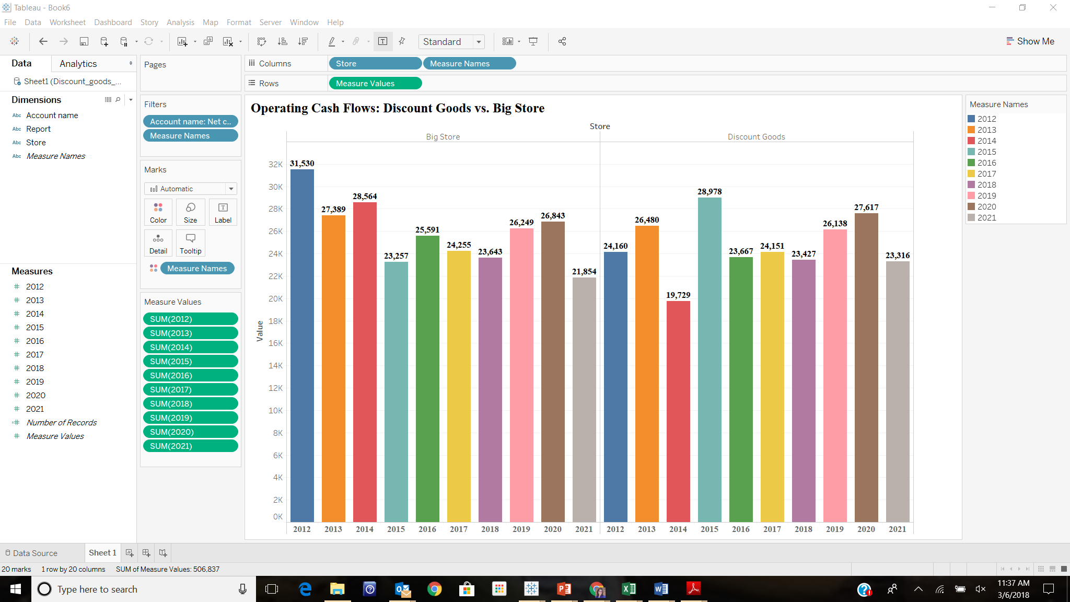

(b) the trend of net income 2012–2021:

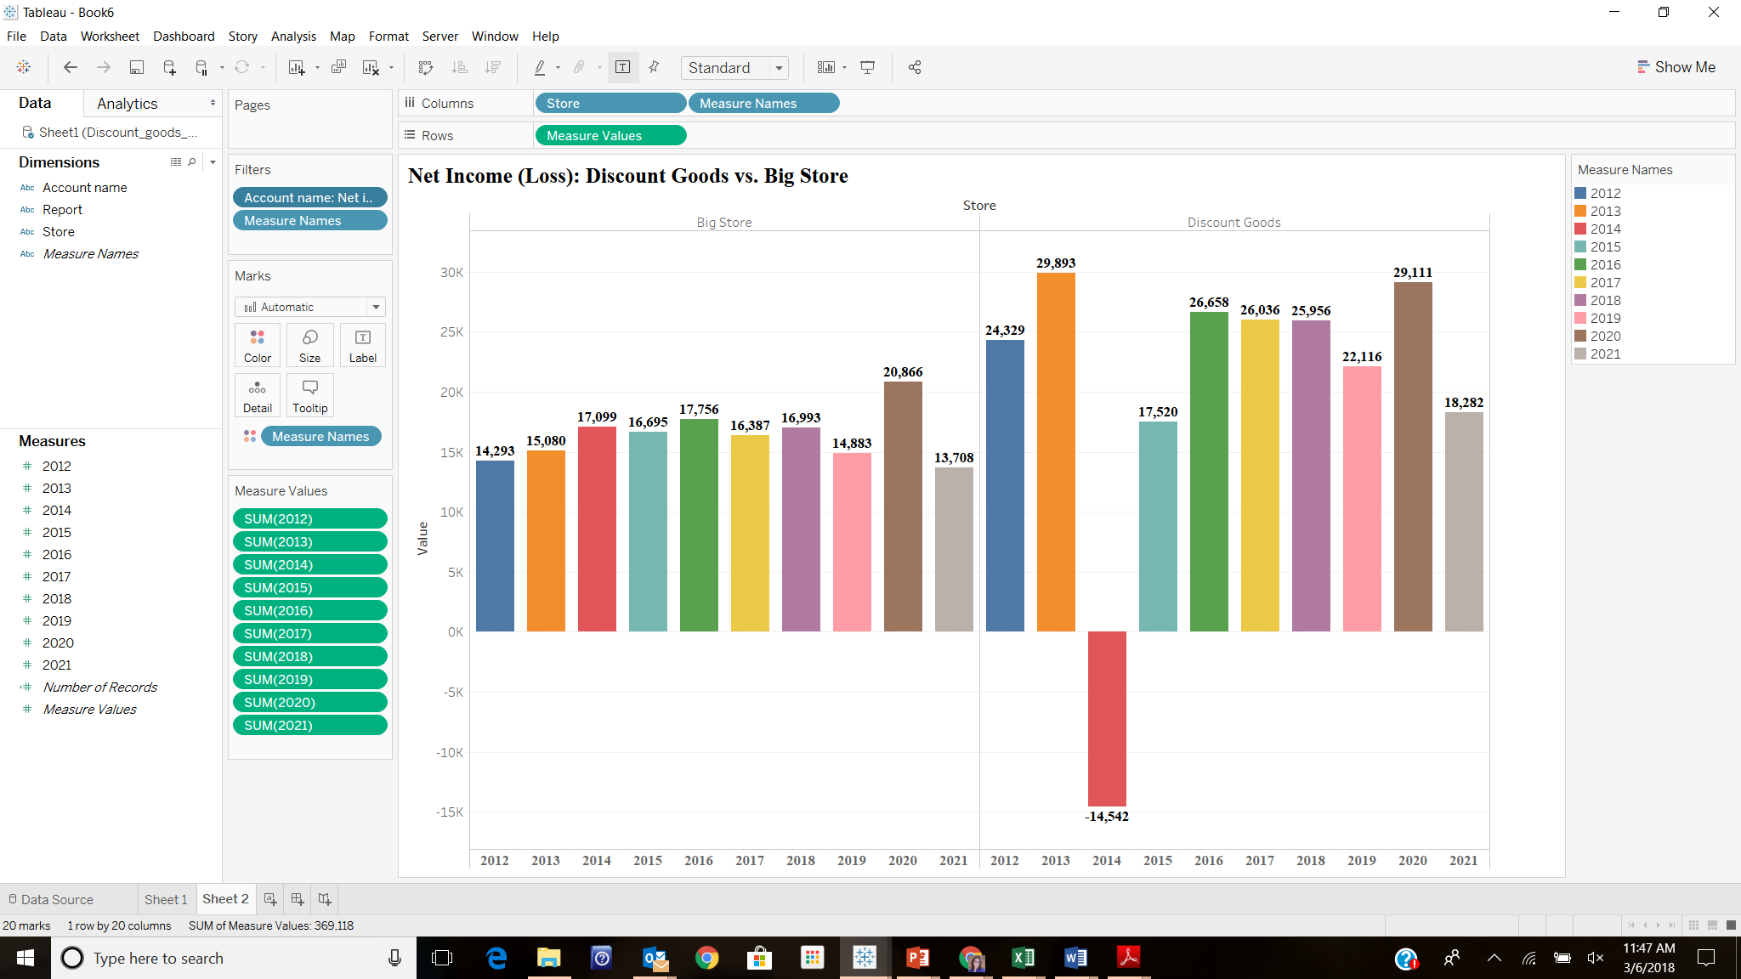

Data Analytics Case (concluded)
Requirement 1

One of the companies reported a huge loss on its income statement related to a foreign expatriation of properties in one of the years. Which company, which year, and what was the amount of net income or net loss that resulted for the year?

Discount Goods in 2014 reported a net loss of ($14,542) million.
Requirement 2

What was the amount of net operating cash flow for the company reporting the loss in the year of the loss?
Net operating cash flow for Discount Goods was $19,729 million in the year of the loss.
Requirement 3

Which company reported the largest percentage change in net operating cash flows between 2012 and 2021 and what was the percentage change?
Big Store reported the largest percentage change in net operating cash flows between 2012 and 2021. The percentage change was -31%.
(21,854 - 31,530) / 31,530
Requirement 4

Which company reported the largest percentage change in net income between 2012 and 2021 and what was the percentage change?
Discount Goods reported the largest percentage change in net income between 2012 and 2021. The percentage change was -25%.
(18,282 - 24,329) / 24,329

Continuing cases
Target Case
Requirement 1
a. Total revenues = $71,879 million
b. Income from current operations = $ 2,928 million
c. Net income or net loss = $ 2,934 million
d. Total assets = $38,999 million
e. Total equity = $11, 709 million
Requirement 2
Target’s basic earnings per share was $5.36.
Requirement 3
Target’s fiscal year end is February 3, 2018. The accounting profession and the SEC encourage companies to adopt a fiscal year that corresponds to a natural business year, ending when a company’s business cycle is at its lowest point. December 31 is in the hectic holiday shopping season at a time when stores are processing Christmas returns and offering after-holiday and New Year’s sales, so it clearly is not at a low point in the business cycle. February 3 occurs after the holiday shopping season concludes, so it makes sense for Target to use that date as its fiscal year end.
Requirement 4
a. Target’s auditor is Ernst & Young LLP.
b. Target received a “clean” (unmodified) audit opinion. Specifically: “In our opinion, the financial statements referred to above present fairly, in all material respects, the consolidated financial position of Target Corporation and subsidiaries at February 3, 2018 and January 28, 2017, and the consolidated results of their operations and their cash flows for each of the three years in the period ended February 3, 2018, in conformity with U.S. generally accepted accounting principles.”

Air France–KLM Case
Requirement 1
a. Total revenues = € 25,784 million
b. Income from current operations = € 1,488 million
c. Net income (AF equity holders) = € (275) million
d. Total assets = € 24,408 million
e. Total equity = € 3,015 million

Requirement 2
AF’s basic earnings per share was €(0.81).

