CHAPTER 1

INTRODUCTION: WHAT IS INTERNATIONAL BUSINESS?
Instructor’s Manual by Marta Szabo White, Ph.D.

I. LECTURE STARTER/LAUNCHER
■ Consider having everyone in class introduce themselves. One way to initiate introductions is distribute random pages torn from business magazines in which each person receives one page. Next, each student circles words on the page that describe him/her. In groups of two or three, each student shares the rationale behind each word that he/she circled. Finally, one of the group members introduces another group member to the class. This process enables students to immediately know at least one other student in the class. The circled words and explanations are often humorous and serve as icebreakers during your first classroom encounter.

■ globalEDGE™ (globaledge.msu.edu) assembles a collection of tools and games that will allow you to compare countries on a variety of statistical indicators, rank countries based on these indicators, and test your knowledge of country capitals from around the world.

Get Insights By Country:

http://globaledge.msu.edu/Global-Insights/By/country
Currency Converter: http://globaledge.msu.edu/countries/currencyconverter.asp
Country Comparator:
http://globaledge.msu.edu/Comparator
Ranking Countries:
http://globaledge.msu.edu/global-resources/resource/5128
Countries Capital Memory:
http://globaledge.msu.edu/Knowledge-Tools
IB Knowledge Check :
http://globaledge.msu.edu/Global-Resources

■ Under Country Insights click on a region, then select a country, Zimbabwe for example.
http://globaledge.msu.edu/Countries/Zimbabwe
Everyone in the class should be assigned a different country. Each student is then responsible for becoming an expert on that country. Twice during the term, each student could report on their country, and summarize a newspaper article published in their country, i.e. an International Newspaper Memorandum assignment.

■ Another exciting way to introduce your students to International Business is the CIA Maps from the CIA World Factbook, which provides an interactive and fun tool to introduce to international business:
https://www.cia.gov/library/publications/the-world-factbook/
https://www.cia.gov/library/publications/cia-maps-publications/index.html

■ Another great way to introduce student to the world of international business is to direct them to the BBC website:
http://news.bbc.co.uk/1/hi/country_profiles/default.stm

■ Comic relief- Humorous (possibly offensive) introduction to IB 2:09 minutes
Catherine Tate- Translator

http://www.youtube.com/watch?v=ma8Vwkpx5y8

II. LEARNING OBJECTIVES AND THE OPENING VIGNETTE

LEARNING OBJECTIVES
In this chapter, you will learn about:

1. What is international business?
2. What are the key concepts in international business?
3. How does international business differ from domestic business?
4. Who participates in international business?
5. Why do firms internationalize?
6. Why study international business?

Key Themes

■ This chapter is the introduction to the text, as well as to the foundation concepts. The first part of this text (chapters 1-10) explores globalization from a macro, environmental level, while the second part (chapters 11-20) examines international business from a more micro, organizational level. The fundamental concepts introduced in Chapter 1 are central to both macro and micro perspectives for understanding international business. Thus, these basic concepts permeate the entire text, and students should be well-acquainted with them.
■ In this chapter, use a macro lens to introduce students to some of the fundamental international business concepts.
■ International business refers to the trade and investment activities by companies across national borders. Globalization of markets refers to ongoing economic integration and growing interdependency of countries worldwide. Stress the dramatic growth in world trade, which now exceeds some $10 trillion annually.
■ There are two ways to invest internationally- passively (portfolio investment -financial assets) or actively (foreign direct investment- capital, technology, labor, land, plant and equipment).
■ Also important are importing (global sourcing)-buying products/services from abroad and bringing them back to the home country. Exporting- manufacturing a product or service in one country and selling it to another.
■ Address the broader questions of:
◘ Why firms go international? Primarily to increase sales and profits!
◘ What is the difference between internationalization and globalization? Former- Expansion of international business activities vs. Latter- Integration, interdependency & interconnectedness of internationalization (the 4 I’s) Example: Increasing exports vs. Sourcing value-chain activities strategically around the globe to leverage factor efficiencies
◘ How international business is different from domestic business: Complexity and Risks (4)
◘ Who participates in international business-
Multinational Enterprise (MNE)
Small and Medium-sized Enterprise (SME)
Born Global - entrepreneurial firm that is international from inception
◘ Why you should study international business- Competitive advantage- for you and your firm!
■ Note that international business is both a cause and a result of increasing national prosperity.

Teaching Tips
■ In this chapter, use a broad brush approach in generating excitement about the importance of international business activity. Ask students to examine their clothing, watches, cell phones, i-phones, i-pods and report where in the world each item was manufactured. This discussion underscores what Julie in the opening vignette experiences, as well as the profound and pervasive impact that globalization has had on all of us.

■ Next, ask students what they would like to do professionally after they graduate. Once they respond, ask if they can accomplish that successfully without understanding international business and the impact of global trends on their industry and business? Of course the answer is a resounding NO!!!

Commentary on the Opening Vignette:
FACEBOOK: A GLOBAL PHENOMENON

Key message

Facebook, a social networking platform, serves both personal and business needs. Founded in 2004 by Mark Zuckerberg and his Harvard University classmates, Facebook underscores the economic, political, and personal interconnectedness among countries, companies, and consumers.

Uniqueness of the situation described
■ What is striking about this vignette is that by the time the reader finishes this vignette, Facebook usage will have again jumped exponentially- globally, users spend more than 700 billion minutes every month on Facebook; one of every eight people on the planet- about one billion users- has a Facebook account.

■ Half of all U.S. residents have a Facebook account, some 70% of Facebook users live outside the United States and speak over 75 languages.

Classroom discussion
■ This example illustrates how the global economy has permeated our everyday lives.
■ International business activity is increasingly complex. It impacts our everyday lives - shopping, listening to music, watching a movie, or surfing the Internet- involves international business transactions that connect us to the global economy, and influences quality of life, standard of living, and economic well-being.
■ Facebook’s vision mirrors this activity by empowering individuals, mapping the social relationships among them, and creating a new system for exchanging information that many find indispensable.
■ Mode of Entry:
◘ FDI- foreign direct investment establishing offices around the world.
■ In which countries is it especially popular?
◘ France, Italy, Japan, and the United Kingdom. It is the fastest growing social networking site in Indonesia and is establishing a loyal user base throughout Africa.
■ Which countries have banned Facebook at one time or another:
◘ China, Egypt, Iran, Pakistan, Saudi Arabia
■ Revenue generation:
◘ Advertising- Brand awareness
■ Who are Facebook’s competitors?
◘ Google and Microsoft
■ Competitive Advantage:
◘ Precise information on user interests, which is priceless to brand managers in a world of targeted advertising.
■ Specific country examples (India, France, Sweden, Japan, Australia, & Poland) enrich the overall theme: the Facebook phenomenon illustrates how converging lifestyles, modern communications technology, and imaginative entrepreneurship are facilitating the emergence of global enterprises.
■ Use this vignette as a springboard for the first teaching tip offered above.
■ Also ask students to update the Facebook saga since its Initial Public Offering (IPO) on May 18, 2012.

III. DETAILED CHAPTER OUTLINE
WHAT IS INTERNATIONAL BUSINESS?
■ International business refers to cross-border trade and investment activities by firms.
■ Primarily, individual firms engage in international business, but governments and international agencies also conduct international business activities.

■ Exhibit 1.1- Six Key Dimensions of International Business

1] Globalization of markets
2] International trade
3] International investment
4] Risks
5] Participants: Firms, distribution channel intermediaries, facilitators, and governments.
6] International entry strategies, including exporting and direct investment

■ Globalization of markets (or the globalization of economies) refers to ongoing economic integration and growing interdependency of countries worldwide.

■ The Facebook phenomenon is a notable expression of this.

■ Integration/interdependence/interconnectedness are central to globalization, which has resulted in the widespread diffusion of products, technology, and knowledge worldwide.

■ Internationalization refers to the tendency of companies to systematically increase the international dimension of their business activities.

■ Macro perspective (trend) - globalization of markets means intense economic interconnectedness between/among countries.

Market globalization is characterized by several related trends:
◘ Cross-border transactions- unprecedented growth rates - from $100 billion per year in1960 to current numbers of $14 trillion annually
◘ Trade = Substantial international flows of capital, technology, and knowledge
◘ Development of highly sophisticated global financial systems to facilitate the cross-border flows of products, money, technology, and knowledge.
◘ Greater collaboration among nations through multilateral regulatory agencies such as the World Trade Organization (WTO: www.wto.org) and the International Monetary Fund (IMF: www.imf.org)

■ Micro perspective (focus) - firm level, activity- Value-Chain Perspective -Firms conduct value-adding activities on a global scale, i.e. organize, source, manufacture, market, etc.
■ This text focuses primarily on the international business activities of the individual firm.
■ Globalization both compels and facilitates companies to expand abroad; international expansion is easier for companies small and large due to market and product globalization.
■ A “level playing field” has made cross-border activities appealing to all types of firms- large and small; manufacturing and service sectors (e.g. banking, transportation, engineering, insurance, advertising, and retailing).
■ Globalization impacts everyone, as evidenced by the recent global financial crisis (2008). The economic contagion, or interconnectedness, was underscored as the crisis began in the U.S. and rapidly spread to U.S. trade partners, eventually impacting Canada, Mexico, Japan, China, and the world. This manifestation illustrates the integration and interdependency of national economies throughout the world.

WHAT ARE THE KEY CONCEPTS IN INTERNATIONAL BUSINESS?
■ International trade and investment are the most conventional forms of international business transactions.

International Trade
■ Cross-border exchange of products (merchandise) and services (intangibles) typically through exporting and importing
■ Exporting (outbound activity) - entry strategy involving the sale of products/ services to customers located abroad.
■ Importing (global sourcing; inbound activity) - the procurement of products/services from foreign suppliers for consumption in the home country or a third country
■ Exporting and importing may include both intermediate (raw materials and components) and finished products.

International Investment
■ Cross-border investment is the transfer of assets to another country or the acquisition of assets in that country.
■ The factors of production (assets) include capital, technology, managerial talent, and manufacturing infrastructure.
■ Trade = products and services cross-national borders.
■ Cross-border investment = the firm itself crosses borders.

Two Types of International Investment:
■ International portfolio investment (typically short-term) is the passive ownership of foreign securities such as stocks and bonds for the purpose of generating financial returns.
■ Foreign direct investment (FDI) (typically long-term) is a foreign-market entry strategy that gives investors partial or full ownership of a productive enterprise. The firm establishes a physical presence abroad through the acquisition of productive assets such as capital, technology, labor, land, plant, and equipment.

The Nature of International Trade
■ Macro-International Trade: Aggregate export and import flows of products and services between nations.
■ Micro-International Business: Cross-border transactions of an individual business enterprise.
■ Gross domestic product (GDP) is the total value of products and services produced in a country during a year.
■ Exhibit 1.2 contrasts the growth of world GDP and world exports since 1970.
■ Due to the global recession, world trade declined in 2009, ending a 27-year boom period. Globalization is manifested, however, in export growth outpacing domestic production and world exports growing more than thirty-fold, while world GDP grew only tenfold
■ Trade did revive sharply and returned to normal levels by 2012.
■ The exponential growth of cross-border trade relative to world GDP is due in part to advanced economies such as Canada and the U.S. sourcing to low-cost locations, e.g. China and Mexico.
■ The rapid integration of world economies is fueled by factors such as the advances in information and transportation technologies, decline of trade barriers, e.g. tariffs, liberalization of markets, privatization, and the remarkable vitality of emerging market economies.

■ Exhibit 1.3 identifies the leading nations involved in international merchandise trade- both exports and imports (not including services).

■ During the recent global recession, China surpassed the U.S. as the world’s leading exporter and is the leading country in terms of the absolute value of total merchandise trade. Trade accounts for about 51% of its GDP.

■ For other economies, merchandise trade is a much larger component of economic activity: e.g. Belgium (169%), Netherlands (139%), and South Korea (88%).
■ Entrepôt economies (intermediate depot; exports = imports): Singapore, Hong Kong, and Malaysia export more than 100% of their respective GDPs.
■ Such countries import a large volume of products, some of which they process into higher value-added products and some they simply re-export to other destinations.

The Nature of International Investment
■ Foreign Direct Investment (FDI) - (asset ownership and long time frame) is the ultimate commitment-level of internationalization, and thus this text focuses primarily on FDI (most common mode of entry strategy) as opposed to International Portfolio investment.
■ Motivations for firm FDI: (Notice how these fit into the value chain)
(1) Primary Activity: Set up manufacturing/assembly facilities to produce products/services;
(2) Primary Activity: Open a sales/representative office to conduct marketing or distribution activities; or
(3) Support Activity: Establish a regional headquarters- a new legal business entity, recognized by the host country and subject to its regulations.

■ FDI and Competitive Advantage:
Large, resourceful companies with substantial international operations are better able to leverage FDI to:

- Manufacture/assemble products in low-cost labor countries (or other resources), i.e. China, India, Russia, Brazil, and Mexico:
■ Example-
◘ Ford invested some $3 billion to build a new car factory in Mexico to manufacture Fiesta automobiles.

- Global challengers originating in rapidly developing economies invest in western markets:
■ Examples-
◘ Turkish company Yildiz (2008) acquired the premium chocolate maker Godiva from U.S.-based Campbell Soup Company in a deal valued at $850 million.
◘ India's Mittal Steel Co. acquired the Belgium-based Arcelor SA in August 2006, creating a $38 billion conglomerate -- the world's largest steel company.
◘ Russian oil and gas firm Lukos established thousands of service stations in the U.S. and Europe.

■ Exhibit 1.4 shows the dramatic growth of FDI since the 1980s.
■ September 11, 2001 interrupted FDI inflows with the worldwide panic that ensued following the terrorist attacks in the United States; then interrupted again in 2008 by the global recession.
■ Advanced (Developed) economies = Japan, Australia, Canada, the United States, and most countries in Western Europe.
■ Developing economies = Parts of Africa, Asia, and Latin America. Of particular significance is the growth of FDI into developing economies despite widespread poverty, lower incomes, less-developed industrial bases, and less investment capital than advanced economies.
■ World trade and investment is directly linked to improving the lives of billions.
■ Developing economies collectively comprise a substantial and growing proportion of international trade and investment.

Services as Well as Products

■ Key international players: Tangible merchandise (products) and intangibles (services- e.g. banks, consulting firms, hotels, airlines, construction companies, retailers, etc.).
■ International trade in services accounts for about one quarter of all global trade and is growing faster than products, however the value of merchandise trade is still much greater than the value of services trade.
■ Challenges unique to services:
◘ Not all services can be exported.
◘ Physical presence in host country is a prerequisite for many services.
■ Approximately $2 trillion worth of services are sold abroad every year
■ Exhibit 1.5 identifies the leading countries in total international services trade, including both exports and imports.
■ Larger, developed economies account for the greatest proportion of services- as services typically comprise more than 2/3 of the GDPs of these countries..
■ EBay- the giant Internet retailer earned $11 billion in 2011, of which more than 50% came from international sales.
■ EBay expanded to India, China, Korea, and Europe in anticipation of most of its future revenue growth coming from abroad.
■ When developing its business in India, eBay acquired the Mumbai-based e-retailer Baazee
■ Exhibit 1.6 (great chart) illustrates the diversity of service sectors that are internationalizing.

The International Financial Services Sector
■ Banking and financial services are the most active cross-border services.
■ Explosive growth of global capital markets is attributed to:

(1) Internationalization Banks/Financial institutions → increased amount of cheap, local investment capital, stimulating local financial markets and encouraging savings
(2) International Flow of Money → into pension funds and portfolio investments

■ Developing economies- banks/financial institutions have fostered economic activity by increasing the availability of local investment capital, which stimulates the development of financial markets and encourages savings.

■ International banking is prospering- Return on Equity:
◘ Saudi Arabia exceeds 20%
◘ U.S. it is 15 %
◘ France and Germany it is less
■ Citibank, Deutsche Bank, BNP Paribas, and other international banks are thriving because of higher oil prices, consumer banking boom, and low taxes.
■ Banks bypass Islamic rules against paying interest by structuring loans as partnerships.
■ 2008- collapse of the U.S. housing mortgage market – turmoil for international banks
◘ Worldwide impact of crisis b/c many U.S. mortgages had been “securitized,” bundled and sold as investment instruments in global financial markets.

■ 2012- several European Union nations experienced debt crises, which affected the stability of the region’s single currency, the euro.
◘ Perfect Storm- These events coincided with a sharp decline in the global financial sector, forcing banks worldwide to lay off thousands of workers.

HOW DOES INTERNATIONAL BUSINESS DIFFER FROM DOMESTIC BUSINESS?
■ Complexity- Macro forces differ from country to country; economic conditions, national culture, legal, and political systems vary by country.
■ Risk- Uncontrollable variables- over which the firm has little or no control
■ Foreign environments involve new risks that firms must manage.
■ Facebook (opening vignette)- exemplifies how distinctive conditions in each country require firms to adapt their products and approaches from country to country.

The Four Risks of International Business
■ Exhibit 1.7 summarizes the four major risks: cross-cultural risk, country risk, currency risk, and commercial risk.

Cross-Cultural Risk
■ Differences in language, lifestyles, attitudes, mindsets, customs, and religion.
■ Cross-cultural literacy is critical so as not to jeopardize culturally-valued mindsets or behaviors.
■ Cultural blunders hinder the effectiveness of foreign managers.
■ Language- critical dimension of culture- a window to people’s values
■ Language differences impede effective communication.
■ Cultural differences may lead to inappropriate business strategies.

Country Risk or Political Risk
■ Differences in host country political, legal, and economic environments may adversely impact firm profitability.
■ Government intervention: restricts market access; imposes bureaucratic procedures hindering business transactions; and limits the amount of earned income that firms may repatriate from foreign operations- varies by country.
■ Economic freedom differs among nations- The 2010 Index of Economic Freedom from the Heritage Foundation ranks Hong Kong, Singapore, and Australia as the top three in terms of having the highest levels of economic freedom, see: (http://www.heritage.org). Ireland also ranks high on a liberal economic environment; whereas China and Russia are the opposite- government regularly intervenes in business.
■ Critical Legal Dimensions: Laws, regulations, and indigenous factors e.g. property rights, intellectual property protection, product liability, taxation policies, inflation, national debt, and unbalanced international trade may encumber firm operations and performance.
■ 2009 - Global financial crisis plunged many nations into a deep recession.

Currency or Financial Risk
■ Risk of adverse exchange rate fluctuations
(Exchange rates- the value of one currency in terms of another).
■ Inflation and other harmful economic conditions create uncertainty of returns due to the growing interconnectedness of national economies.
■ When international transactions are conducted in more than one national currency → currency risk.
■ The value of a firm’s earnings may be substantially reduced when currencies fluctuate significantly,

Commercial Risk
■ Poor development/execution of business strategies, tactics or procedures, e.g. partnering selections, market entry timing, pricing, product features, and promotional themes
■ Failures in international markets are far more costly than domestic business blunders.
■ Commercial risk is often affected by currency risk because fluctuating exchange rates can affect various types of business deals.

Risks: Always Present but Manageable
■ These types of risks are omnipresent in international business.
■ Managers need to understand their implications, anticipate them, and take proactive actions to reduce adverse effects.
■ Examples of extremely challenging risks:
◘ 2008- The global financial crisis spread to banks and insurance firms in Asia, Europe, and elsewhere. Many countries experienced deflation and severe declines in consumer confidence and spending power.
◘ 2009- Sharp reductions in international commerce and shipping
◘ 2012- Little improvement- financial crises prolonged by high government debt in the advanced economies
◘ Central banks worldwide sought to rally national economies by injecting billions of dollars into their financial systems.
◘ 1998- The East Asian economic crisis generated substantial commercial, currency, and country risks- several East Asian countries lost currency values of between 35% and 70%, leading to the collapse of national stock markets, deepening trade deficits, and suspension of normal business activity. Political and social unrest surged to Indonesia, Malaysia, South Korea, Thailand, and the Philippines.

Ethical Connections
■ Fashion industry- hundreds of factory workers die annually from dangerous working conditions.
◘Thousands of garment workers develop deadly lung diseases from constant exposure to crystalline silica used to sandblast jeans to give them the worn, vintage look.
◘ While illegal in Europe and the U.S., such production methods are still widely used in low-income countries from where the jeans are then distributed to affluent consumers worldwide.

WHO PARTICIPATES IN INTERNATIONAL BUSINESS?
■ Focal firms are those companies that directly initiate and implement international business activity.

Two Types: MNE and SME

Multinational Enterprise (MNE)
Also known as Multinational Corporation (MNC)
■ In addition to a home office and substantial resources, an MNE owns a worldwide network of subsidiaries and affiliates located in multiple countries.
■ Multinational enterprises have historically been the most important type of focal firm; add value in multiple countries through subsidiary affiliates, leveraging R&D, procurement, manufacturing, and marketing activities to exploit economic advantages.

■ Examples-
◘ Alcon- Swiss pharmaceutical firm that established major R&D facilities in the U.S., leveraging local talent in the chemicals sector
◘ Verizon Wireless- located much of its technical support operations in India, taking advantage of high-quality, low-cost customer support personnel
◘ Royal Dutch Shell - owns several oil refineries and nearly 2,000 gasoline stations in Canada.
■ Affiliates- Network of subsidiaries that the MNE collaborates with

■ Typical MNEs - Barclays, Caterpillar, Disney, DHL, Four Seasons Hotels, Samsung, Unilever, Vodafone, and Nippon Life Insurance.
■ Recently, the largest MNEs have been firms in the oil industry (such as Exxon-Mobil and Royal Dutch Shell) and the automotive industry (General Motors and Honda), as well as retailing (Walmart).

■ Exhibit 1.8 (great chart) provides a geographic distribution of the world's leading MNEs, drawn from Fortune’s Global 500 list- concentrated in mostly advanced economies.
■ The U.S. is home to 133 of the top 500 MNEs, a number that has declined over time as other countries’ firms increase in size.
■ Japan has the second-most MNEs (68 firms), closely followed by China (61- most of these are state-owned by the Chinese government, which provides them substantial advantages). Europe is home to many top MNEs in France (35 firms), Germany (34 firms), and the United Kingdom (30 firms).

■ The EU collectively has more top 500 firms than the U.S.

■ Global Challengers from Emerging Market Countries: New Contenders- Large MNEs have begun to appear in emerging market countries, such as China, Mexico, and Russia- leveraging home-country natural resources and low-cost labor and posing legitimate competitive challenges for advanced economy- incumbents in world markets.
■ Examples-
◘ The Mexican firm Cemex is one the world’s largest cement producers.
◘ Russia’s Lukoil has big ambitions in the global energy sector.
◘ In China, Mobile dominates the cell phone industry in Asia.

Small and Medium-sized Enterprise (SME)
■ SME is a company with 500 or fewer employees (250 or fewer in the EU).
■ Small firms comprise 90% - 95% of all firms in most economies.
■ With globalization, more and more SMEs participate in exporting, licensing, and global sourcing.
■ Small firms:
◘ Are the drivers for innovation.
◘ Account for one-third of exports from Asia; a quarter of the exports from
the affluent countries in Europe and North America
◘ Contribute more than 50% of total national exports in Italy, South Korea, and China.

■ Born-global firms
Young, entrepreneurial SMEs that initiate international business from inception, and are found in both advanced economies, e.g. Australia and Japan, as well as emerging markets, such as China and India.
■ International business complexities are considerably more challenging for SMEs than MNEs- requires specialized knowledge, commitment of resources, and considerable time to develop foreign business partnerships

■ SME Strategies for success:
(1) SMEs are more innovative, adaptable, and have quicker response times.
(2) SMEs are better able to serve niche markets.
(3) Smaller firms can better leverage new information and communication technologies, e.g. the Internet.
(4) Due to limited resources, SMEs tend to minimize fixed investments costs and outsource, e.g. FedEx and DHL.
(5) Smaller firms tend to flourish on private knowledge that they cultivate through their cross-border knowledge networks and international social capital.

GLOBAL TREND
DIESEL: A Smaller Firm’s Smashing International Success

■ This global trend profiles Diesel, an SME founded in Italy that eventually grew into a large firm with annual sales of more than US$500 million (85% of which comes from abroad), some 3,000 employees, distribution to over 80 countries, 400 company-owned stores from Paris to Miami to Tokyo, 1,500 new designs every 6 months, and a first-mover in launching an Internet presence and launching a recent marketing partnership with Adidas. In 2010 Diesel opened its first stores in Mumbai, aiming to have more than 30 stores in India by 2015. Their international success has been propelled with some controversial advertising. Diesel represents a classic success story in international business by a smaller firm. Diesel's fashions are a gas.

Non-governmental Organizations (NGOs)
■ Non-profit international organizations include charitable groups and non-governmental organizations (NGOs).
■ They serve special causes- education, research, health care, human development, and the natural environment.

■ Examples: (Nonprofit Organizations)
◘ Bill and Melinda Gates Foundation
◘ CARE- dedicated to reducing poverty
◘ British Wellcome Trust- supports health and education
■ Examples: (MNE- operating charitable foundations)
◘ GlaxoSmithKline (GSK)-
● Canada, France, Italy, Romania, Spain & U.S
● Barretstown-Ireland and L’Envol (France) for seriously-ill children
● Slovakian children- promotes healthy eating/exercise
● Spain- healthcare for homeless children
● Russia- Children with disabilities
● Ethiopia- reduction of preventable children’s’ diseases
● Vietnam- birthing support

WHY DO FIRMS INTERNATIONALIZE?
Firms internationalize seeking growth and profit opportunities to enhance competitive advantage.
■ Proactive (Strategic) motive - tap foreign market opportunities and/or acquire new knowledge.
■ Reactive motive- serve a key customer that has expanded abroad.

Nine specific motives:
1. Seek growth opportunities through market diversification.
2. Earn higher margins and profits.
3. Gain new ideas about products, services, and business methods.
4. Better serve key customers who have relocated abroad.
5. Locate closer to supply sources, benefit from global sourcing advantages, or gain flexibility in product sourcing.
6. Gain access to lower-cost or better-value factors of production.
7. Develop economies of scale in sourcing, production, marketing, and R&D.
8. Confront international competitors more effectively or thwart the growth of competition in the home market.
9. Invest in a potentially rewarding relationship with a foreign partner.

WHY STUDY INTERNATIONAL BUSINESS?
This may be considered from various perspectives: global economy, national economy, the firm, and managerial levels.

Facilitator of the Global Economy and Interconnectedness
■ Since the General Agreement on Tariffs and Trade (GATT) (1947), following World War II, international business has transformed the world with unprecedented growth in trade and investment.
■ 1980s: Political/Economic transformations of Emerging Markets (some 30 countries) have given new impetus to worldwide economic interconnectedness.
■ Fast-growth developing economies- Brazil, Russia, India, and China [BRICs] - have registered substantial market liberalization, privatization, and industrialization, fueling global economic transformation.
■ Emerging markets- Located on every continent; home to the largest proportion of world population and participate increasingly in foreign trade.
■ Facebook- numerous emerging markets, including China, India, and Poland

■ Two MEGATRENDS underlying the changing business landscape- globalization and technology
◘ Globalization- accelerates the development of the latest technologies.
◘ Technology- facilitates globalization to progress more rapidly.

■ The Internet/e-commerce and production/process technologies make international business a viable, cost-efficient, and increasingly imperative mandate for firms of all sizes and resource levels.
■ Technological advances both accelerate and are accelerated by globalization.

Contributor to National Economic Well-Being
■ International business promotes economic prosperity through efficient resource allocation, increased consumer options, and world interconnectedness.
■ Governments are increasingly opening their borders to foreign trade and investment.
■ International trade is a pivotal engine for job creation.
◘ It is estimated that every $1 billion increase in exports creates more than
20,000 new jobs.
◘ Cross-border trade directly supports at least 12 million U.S. jobs.
◘ One of every seven dollars of U.S. sales is made abroad.
◘ One of every three U.S. farm acres and one of every six U.S. jobs is
producing for export markets.
◘ On average, exporting firms create jobs faster and provide better pay than non-exporting firms.

■ International business is both a cause and a result of increasing national prosperity.
■ International trade and investment result in:
◘ Free market exchange of products, services, capital, and technology.
◘ Reduced poverty in developing economies; increased affluence in rapidly growing economies
● Nations once suffering from economic stagnation are now increasingly prosperous- e.g., China, India, and Eastern European nations
◘ Improved literacy, nutrition, and health care
◘ Reduced cross-border conflicts as countries lean towards freedom and democracy- international business may usher in a new era of global relations.
◘ Integrated world economies- Examples:

● European Union (EU) –
■ Transforming Europe into a new powerhouse in global trade

● North American Free Trade Agreement (NAFTA) –
■ 1994: Following the launch of NAFTA, the volume of trade among the three countries increased dramatically, improving living standards for millions- a market of 450 million consumers.
■ NAFTA led to substantially higher wages and higher employment rates.

● Dominican Republic Central American Free Trade Agreement ■ (DR-CAFTA) - New accord among the U.S., Costa Rica, El Salvador, Guatemala, Honduras, Nicaragua, and the Dominican Republic was recently launched.

A Competitive Advantage for the Firm
■ To sustain a competitive advantage in the global economy, firms must participate in cross-border business and acquire the necessary skills, knowledge, and competence.
■ Examples-
◘ Procter & Gamble sells shampoo, disposable diapers, and other consumer products in more than 150 countries
◘ MTV broadcasts its programming in some 140 countries.
◘ Nestlé sells its food and beverage products worldwide, obtaining nearly all its revenue from foreign operations.

■ Global Sourcing- Firms secure cost-effective factor inputs by establishing manufacturing in emerging markets like Malaysia, Mexico, and Poland, or sourcing from foreign suppliers.
■ Examples-
◘ Microsoft cuts the costs of its operations by having much of its software written in India.
◘. Renault achieves efficiency by assembling cars at low-cost factories in Romania.

■ Critical Resource Access- International business also allows firms to access critical resources that may be unavailable at home.
■ Reduced Costs: new product development, after-sales service, access to foreign sources of information/knowledge that yield future R&D, improved production/administrative processes, and other innovations.
■ Broader Options- opportunities to make globally strategic moves and countermoves that help the firm compete more effectively with rivals.

A Competitive Advantage for You
■ Every day we are all impacted by a variety of international business transactions.
■ Traveling abroad leads to exciting challenges and learning experiences.
■ Global managers of the world’s leading corporations fashioned their managerial skills in international business.
■ In this text you will learn about the merits of gaining international business proficiency, through the experiences of people like you, in a special feature called Recent Grad in IB.

Recent Grad in IB: Ashley Lumb
International Marketing Specialist
■ Ashley’s international experience was an impressive asset to prospective employers in the U.S.
■ Success factors in working abroad were hard work and networking.

An Opportunity for Global Corporate Citizenship
■ With trade barriers declining and global power increasing, environments are increasingly characterized by limited resources, vulnerable human conditions, and stakeholder consciousness.
■ Corporate citizenship dictates that companies consider stakeholders in decision-making and develop socially responsible policies and practices.
■ This means employing both economic and social goals; transcending legal requirements by proactively implementing ethical standards.
■ Large corporations like Walmart, Unilever, and Sony have annual revenues larger than the GDPs of many of the nations in which they do business.
■ The globalization of thousands of firms negatively impacts the natural environment, e.g. pollution (BP oil spill in the Gulf of Mexico; Royal Dutch Shell’s oil refining operations in Nigeria).
■ Large banks and international investment brokers have disrupted the economies of nations with aggressive currency trading or by manipulating stock markets, e.g. MNEs abruptly withdrawing invested capital.
■ Human rights violations- Some MNEs ignore human rights and basic labor standards by establishing factories in countries that pay low wages with substandard working conditions, e.g. Nike in Asia.
■ Building factories abroad often leads to job losses in the home country.
■ National governments and international institutions such as the World Trade Organization are working to improve environmental, financial, and labor standards around the world.
■ 2006: Example - Power of society –the news of Dubai Ports World possibly operating some U.S. ports hit the media; societal disapproval forced Congress to swiftly squelch the deal.
■ Proactive development and implementation of Corporate Social Responsibility (CSR) –
Examples:
◘ Starbucks will only sell coffee from Rain Forest Alliance certified
growers (www.rainforest-alliance.org).
◘ Philips, Unilever, and Walmart have signed on for sustainable
development practices.
◘ McDonald’s purchases beef from farmers certified for animal welfare and environmental standards.
◘ McDonald’s sells only organic milk in Austria, Germany, Sweden, and the United Kingdom.
■ CSR is global and strategic. It must be embedded into global firms at their strategic levels if international corporate citizenship is to be achieved and sustained. Chapter 5 is devoted to this important topic.

IV. CLOSING CASE

INTERNATIONALIZATION AT HARLEY-DAVIDSON

● Summary [Identifying key issues]

■ The fundamental concepts introduced in Chapter 1 are central to both macro (chapters 1-11) and micro (chapters 12-20) perspectives for understanding international business. In this introductory chapter, the Harley-Davidson case illustrates why firms pursue international strategies and how international and domestic businesses differ. With maturing key markets in North America, Europe, and Japan, coupled with falling trade barriers, growing consumer affluence, and flourishing capitalism in emerging markets, the only major U.S. manufacturer of heavyweight motorcycles must expand globally to survive.

The following Learning Objectives are emphasized:
1] What is international business?
2] How does international business differ from domestic business?

3] Why do firms internationalize?

OVERVIEW

Harley-Davidson (HOG) offers 35 Harley models through a global network of nearly 1,500 dealers with $5.6 billion in 2008 sales. Harley operates in two business segments:

89% of total revenues 11% of total revenues
■ Motorcycles (80%) ■ Financial Services
■ Related Products (20%)

■ From a shed with Harley Davidson Motor Company scrawled across it in 1903, four men- William Harley and the Davidson brothers-Walter, William, and Arthur- produced the first Harley Davidson motorcycle. Today, Harley-Davidson Motor Company and Buell Motorcycle Company collectively operate eight production/assembly facilities in the U.S., Brazil, and Australia.

■ Dominating half of the U.S. market and a third of the global one, Harley-Davidson remains the premier manufacturer of heavyweight motorcycles with heavyweight motorcycles accounting for 55% of the U.S. motorcycle market in 2008. Harley’s share of the heavyweight market was 45.5% and 48.7% in 2008 and 2007, respectively.

FOUR KEY SEGMENTS OF THE U.S. AND INTERNATIONAL HEAVYWEIGHT MOTORCYCLE INDUSTRY

[1] Standard (2% of the U.S. market; 19% of the European market)

[2] Performance (15% of the U.S. market; 41% of the European market)

[3] Custom (48% of the U.S. market; 13% of the European market)

[4] Touring (35% of the U.S. market; 26% of the European market)

■ In the U.S., Harley competes primarily in the custom and touring segments, which accounted for 84% of the total U.S. heavyweight market in 2008.
■ The U.S. heavyweight market is about five times the size of the European market (48.7% vs. 9.7%) and skewed to the performance and standard segments. Germany poses the largest market, followed by Italy, with the UK, France, and Spain comprising smaller markets.

■ The European market is fragmented due to country differences and the diversity of European preferences. This coupled with their functional rather than recreational focus, the narrow European streets and high speed limits; there is greater demand for the standard and performance motorcycle segments.

GLOBAL EXPANSION

■ Global markets demonstrate significant growth opportunities, while the domestic motorcycle industry is increasingly saturated. Still, 75% of Harley’s sales originate domestically. The two most significant segments are Europe, where HOG has grown to 9.6% market share in 2007, and Canada where Harley had a 39.0% market share in 2007. Harley has a dominant global market share of 33% in a growing industry.
■ The key to Harley’s sustainable growth is global expansion, driven by: [1] heightened focus/international investment, [2] appeal to performance-based international markets, [3] sophisticated, improved, larger dealer networks, [4] geographic expansion, and [5] strategic control of distribution.

■The international revenue mix has increased from 16.3% in 2002 to 26.5% in 2007 with Europe (13.8% of sales), Japan (4% of sales), Canada (4% of sales), Australia (2.8% of sales), and other (1.9% of sales).

COMPETITORS

The market for heavyweight motorcycles is concentrated with the top five players- Harley-Davidson, Honda, Suzuki, Yamaha, and Kawasaki- controlling 92% of the market. U.S. manufacturers include about 60 companies with $6 billion in total annual revenues. Harley’s exports, which amount to 30% of their sales, are excluded from this figure.

OPPORTUNITIES

■ Tariff Protection

In 1983 Harley-Davidson sought and received tariff protection from the Reagan administration to help combat Japanese imports. Harley-Davidson reversed its near bankruptcy by implementing Japanese management techniques, updating manufacturing methods, improving quality, and expanding model offerings. HOG requested the tariff to be removed one year early, went public for the second time in 1986, and by the following year, had control of 25% of the U.S. heavyweight-motorcycle market, up from 16% in 1985.

■ Innovation
WWI created a demand for U.S. motorcycles overseas that made foreign sales important. During the 1920s, Harley-Davidson was a leader in innovative engineering, introducing models with a front brake and the "teardrop" gas tank that became part of the Harley legacy.

HOW DOES INTERNATIONAL BUSINESS DIFFER FROM DOMESTIC BUSINESS?
Complexity and Risk
The Four Risks in Internationalization: Cross-cultural risk, Country risk, Currency or financial risk, and Commercial risk

RISKS/ CHALLENGES

■ Commercial Risk: International/Domestic Business Risk- Changing Emission Standards
Climate change concerns will lead to tailpipe emission limits, which will eventually require product design strategies to meet the new regulatory requirements.

■ Cross-Cultural Translation of HOG Mystique
Considering the cross-cultural risk category, one of Harley’s global challenges is their American icon branding, which may also represent the negative side of globalization. A negative image emerged during the 1950s-1970s, that of Hell’s Angels or outlaw motorcyclists, as captured by some Hollywood films. Does the HOG brand translate internationally?

■ Country Risk: Chinese Market
With the opening of its third dealership in China during 2008, Harley faced a large and potentially risky market.

■ Currency or Financial Risk: International Risk from Global Economic Contagion-
The severity of the world economic recession has significantly impacted discretionary purchases. This is exacerbated by a maturing industry which has resulted in a deceleration of domestic Harley sales.

■ Currency or Financial Risk: Harley-Davidson Financial Services [HDFS] - Interest Rate/Credit Exposure

Access to capital markets is becoming increasingly challenging as the U.S. economy faces major revitalization efforts in domestic capital markets, with anticipated global ripple effects.

■ Currency or Financial Risk: Strong U.S. Dollar
In 2008, 33.2% of Harley’s revenue was international in origin. Unlike 2008, which witnessed a 1.7% and 2.6% favorable impact on sales and operating profit, respectively, 2009 was expected to witness a 1.6% and 2.4% negative impact, due to a strengthening dollar.

■ Commercial Risk: Market Penetration
As most of Harley’s core baby-boomer market is currently 44-62 years old, their peak riding years may be behind them.

OPPORTUNITIES

■ Growth Markets: Canada, Japan, Australia, Latin America (Brazil - Largest Market)

■ Under-Penetrated Markets: Women and ethnic groups

■ Riders Edge Program: Community Outreach

Focused on new riders- an exemption from the state written/riding test may be earned upon the satisfactory completion of this controlled course offered through Harley dealers.

GLOBAL CITIZENSHIP

■ Environmental Sustainability

Harley-Davidson Motor Company and Buell Motorcycle Company are addressing climate change by preparing for the transition to a lower-carbon economy. Harley-Davidson boasts of decreasing GHG (Greenhouse Gas) emissions by 5,193 metric tons between 2004 and 2006.

■ Regulatory Analysis: Developing Federal, State, and International GHG Regulations
Emerging political and regulatory policies will soon result in new technical standards for the motorcycle industry. Currently, Taiwan is the only country where motorcycles are required to comply with a fuel economy standard.

■ European Union and Japanese Directives
Both the European Union (EU) (with a 2015 timeframe) and Japan are developing CO2 regulations for motorcycles. In October 2005, the first of its kind, and with no cost to the consumer, Harley-Davidson, Japan voluntarily launched a motorcycle recycling program.

THE FUTURE
■ The recent global recession hurt Harley as discretionary income fell around the world.
■ For Harley, the question remains as to how to best position itself given the declining world demand in some markets and burgeoning demand in others.
■ Management believes the keys to sustainable growth will be:
◘ Heightened focus on foreign markets
◘ Appeal to lighter-weight, performance-based markets
◘ Improved and larger dealer networks
◘ Strategic control of distribution

■ Through enhanced distribution networks and a multidomestic international strategy that underscores local market preferences, Harley delivers culturally-responsive experiences in 72 countries.
■ Harley also needs to balance production and sales for domestic and international markets.
■ To diversify its revenue streams and reduce its dependence on U.S. sales, Harley wants to increase its international business.
■ Its CEO believes the ideal sales mix is 60% in the U.S. and 40% internationally, but the company is struggling to achieve this goal.

● SUGGESTED SOLUTIONS TO CASE QUESTIONS

1. What is the nature of the international business environments Harley faces? What types of risk does the firm face?
■ Domestic and international environment: complex and risky
■ All FOUR types of risks in international business are present:

Cross-cultural Risk
Harley-Davidson Motor Company and Buell Motorcycle Company collectively operate eight production/assembly facilities in the U.S., Brazil, and Australia, with a global network of nearly 1,500 dealers. Key markets are in North America, Europe, and Japan. The first Beijing Harley dealership was established in 2006. Growth Markets: Canada, Japan, Australia, Latin America (Brazil - Largest Market).

■ Translation of HOG Mystique
Considering the cross-cultural risk category, one of Harley’s global challenges is their American icon branding, which may also represent the negative side of globalization. A negative image emerged during the 1950s-1970s, that of Hell’s Angels or outlaw motorcyclists, as captured by some Hollywood films. Does the HOG brand translate internationally?
■ Differences in language, lifestyles, mindsets, customs, and religion of a national culture.
■ Cultural blunders can hinder effectiveness of managers in working with foreign business partners.
■ Language is a critical dimension of culture- it is a window to people’s values and living conditions.
■ Language differences impede effective communication and cause misunderstandings.
■ Cultural differences may lead to inappropriate business strategies and ineffective relations with customers.

Country Risk (also known as political risk)
■ Chinese Market- With the opening of its third dealership in China during 2008, Harley faced a large and potentially risky market.
■ Differences in host country political, legal, and economic regimes may adversely impact firm profitability.
■ Also, laws, regulations, and indigenous factors e.g. property rights, intellectual-property protection, product liability, taxation policies, inflation, national debt, and unbalanced international trade may encumber firm operations and performance.
■ Government intervention: restricts market access; imposes bureaucratic procedures hindering business transactions; and limits the amount of earned income that firms may repatriate from foreign operations.
■ Economic freedom differs among nations- Hong Kong, Singapore, and Ireland are known as having the highest levels of economic freedom, see:
(http://www.heritage.org).

Currency or Financial Risk
■ International Risk from Global Economic Contagion-
The severity of the world economic recession has significantly impacted discretionary purchases. This is exacerbated by a maturing industry which has resulted in a deceleration of domestic Harley sales.

■ Harley-Davidson Financial Services [HDFS] - Interest Rate/Credit Exposure

Access to capital markets is becoming increasingly challenging as the U.S. economy faces major revitalization efforts in domestic capital markets, with anticipated global ripple effects.
■ Strong U.S. Dollar
In 2008, 33.2% of Harley’s revenue was international in origin. Unlike 2008, which witnessed a 1.7% and 2.6% favorable impact on sales and operating profit, respectively, 2009 was expected to witness a 1.6% and 2.4% negative impact, due to a strengthening dollar.
■ Risk of adverse exchange rate fluctuations, inflation, and other harmful economic conditions create uncertainty of returns.
■ When currencies fluctuate significantly, the value of the firm’s assets, liabilities, and/or operating income may be substantially reduced.

Commercial Risk
With Harley’s global expansion, the following acquisition/ joint venture/ innovation strategies would be subject to commercial risk:
■ China- three Harley dealerships
■ In a 2006 vertical acquisition, Harley acquired Castalloy, its Australian wheel and hub supplier.
■In 2008, HOG acquired MV Augusta (Cagiva brand), a premier Italian sport motorcycle producer, which provided a gateway to the European motorcycle market and accelerated Harley's exposure to younger buyers.

■ International/Domestic Business Risk- Changing Emission Standards
Climate change concerns will lead to tailpipe emission limits, which will eventually require product design strategies to meet the new regulatory requirements.
■ Market Penetration
As most of Harley’s core baby-boomer market is currently 44-62 years old, their peak riding years may be behind them.
■ Poor formulation/implementation in terms of partnering selections, market entry timing, pricing, product features, and promotional themes result in commercial risk.
■ Failures in international markets are far more costly than domestic business blunders.

2. How can Harley benefit from expanding abroad? What types of advantages can the firm obtain? What advantages acquired abroad can help Harley improve its performance in its home market?
■ Harley has reduced its costs of R&D, manufacturing, and service by sourcing plants and other operations in lower-cost locations such as Brazil and closer to target markets in order to minimize distribution costs, e.g. Australia.
■ Harley could be the exemplar of how internationalization revives declining sales and optimizes cost structures by developing international value chains that minimize expenses, leading to higher profits.
■ The key to Harley’s sustainable growth is global expansion.

3. How can Harley effectively compete with rivals from Japan and Europe? What strategies should management apply to grow the firm’s sales in those regions?

■ The Harley icon is a powerful weapon. Advertising strategy should underscore its immense global branding, yet employ local people.

■ Harley can leverage global efficiencies in terms of technology, production, and distribution. However, tailoring motorcycle preferences to local markets is also paramount.

■ The European market is fragmented due to country differences and the diversity of European preferences. Due to narrow European streets, high speed limits, and a functional rather than recreational focus, there is a greater demand for the standard and performance motorcycle segments in Europe.
■ International expansion into Asia could be hindered by strict emissions standards, high tariffs, and cheaper Asian reproductions of the Harley brand.

■ However, if Harley were to collaborate with a Japanese partner, this mode of entry would enable market knowledge and branding economies with that partner. Additionally, Harley’s organic structure of three interlocking circles- (1) Create Demand Circle, (2) Produce Products Circle, and a (3) Support Circle with the Leadership/Strategy Council in the center- would fit well with the Japanese culture than a more traditional structure.

■ This industry demands an integrated approach – global yet with a local/regional focus.

4. Competitors such as Lifan and Zongshen are beginning to emerge from China, where they enjoy competitive advantages like low-cost labor and extensive experience with emerging markets. How can Harley compete against such firms? Should Harley more aggressively pursue emerging markets such as Brazil, China, and India? If so, what strategies will help it succeed in those markets?
■ Global incumbents must leverage their advantages in terms of global efficiencies in order to compete with global challengers indigenous to emerging, host markets.
■ After China joined the World Trade Organization in 2001, import restrictions, quotas, and tariffs dropped substantially against foreign motorcycle manufacturers.
■ Partnering through strategic alliances affords immense networking opportunities and market expertise otherwise unavailable to a new entrant.
■ Competing with Lifan and Zongshen, China's emerging competitors, presents both challenges and opportunities. Harley may take the offensive and compete even more aggressively in competitors’ domestic markets and/or implement a more defensive strategy in their own home market. Either way, innovation and market research will be cardinal.
■ Promote and leverage the HOG experience so that it clearly translates internationally, and in fact turns into a global competitive advantage.
■ An interesting assignment for students would be to divide the class into small groups and assign a Harley Chinese competitor to each group. Each group should briefly research the competitor in terms of strategy, international markets, market share in China, and any other interesting facts. This can be done during class as most students will attend class with their laptops. Use websites such as: globaledge.msu.edu and Hoover’s database to report their findings.

Should Harley more aggressively pursue emerging markets such as Brazil, China, and India? If so, what strategies will help Harley succeed in those markets?

■ One of the fundamental reasons for pursuing international markets is to rejuvenate the product life-cycle (Vernon). Other reasons include (1) Seeking growth opportunities through market diversification; (2) Earning higher profits; (3) Capitalizing on new products, services, and business models; (4) Leveraging global sourcing advantages; (5) Accessing lower-cost or better-value production factors; (6) Developing production or marketing economies of scale; (7) Thwarting foreign competition; (8) Investing in foreign strategic alliances/foreign direct investment. Considering these reasons for economic expansion, coupled with maturing markets in developed countries, emerging markets provide growth opportunities for the motorcycle industry, among others. Pursuing emerging markets such as Brazil, China and India make perfect sense, especially if Harley were to source production to these low-cost locations. Foreign direct investment through production initiatives would be an investment in the community, resulting in job creation and thus sending an important message to stakeholders.

5. Evaluate Harley’s environmental sustainability initiatives in the evolving regulatory environment on global greenhouse gas. What advantages does Harley gain by attempting to produce environmentally safe and sustainable products?

■ Like automobiles, motorcycles pollute the natural environment, and Harley is vulnerable to regulatory sanctions because it manufactures very large bikes.
■ Most of Harley’s greenhouse gas (GHG) emissions emanate from its manufacturing plants, and management is moving to reduce pollution, as well as energy and water usage, as part of an integrated sustainability strategy.
■ HOG is also addressing climate change by preparing for the transition to a lower-carbon economy.
■ California and Taiwan have recently imposed rigorous new GHG standards on motorcycles.
■ Japan and various European countries are developing similar new standards aimed at GHG reduction.
■ Harley is attempting to stay ahead of evolving regulations. In 2005, they launched a motorcycle recycling program in Japan.
■ These actions and its recycling program help align Harley’s actions with stakeholder expectations and strengthen the brand, which is in fact Harley’s competitive advantage.

FOR INSTRUCTOR’s POWERPOINT:

U.S. MARKET DOMINANCE AND INTERNATIONAL EXPANSION
DOMESTIC MARKET SHARE

Dominating half of the U.S. market and a third of the global one, Harley-Davidson remains the premier manufacturer of heavyweight motorcycles, with heavyweight motorcycles accounting for 55% of the U.S. motorcycle market in 2008. Harley’s share of the heavyweight market was 45.5% and 48.7% in 2008 and 2007, respectively.

Harley’s true competitors are other heavyweight manufacturers. A specialized firm, Harley-Davidson competes with more diversified firms such as Honda and Suzuki, which have greater financial resources and less reliance on motorcycle sales; for example, Honda’s motorcycle sales only comprise 12% of total revenue. Harley Davidson is the largest domestic Heavyweight Motorcycle Manufacturer by a wide margin, as depicted in the following U.S. market share charts:

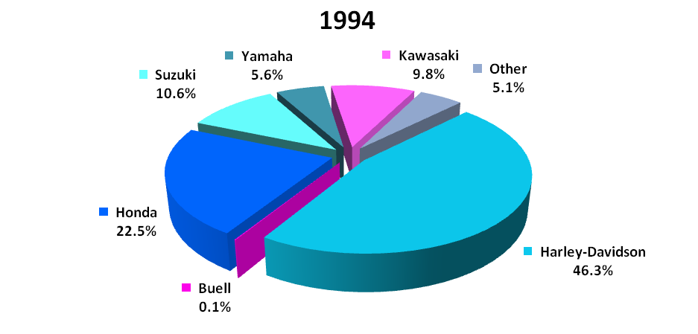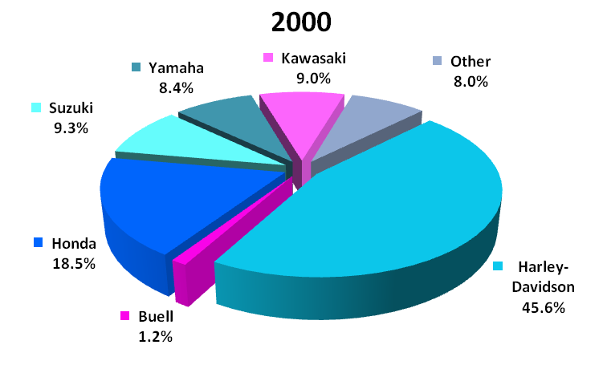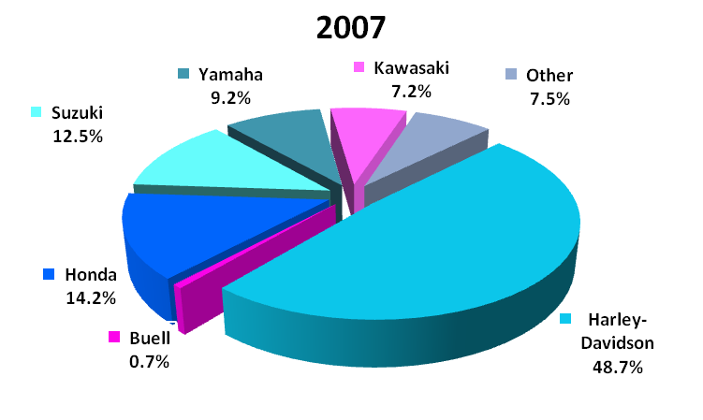

Source: Mohsenian,Dara, Ruma Mukerji, and Kevin M. Grundy (2008). Harley-Davidson. J.P. Morgan, North America Equity Research. 07 October, 2008.

GLOBAL EXPANSION

Global markets demonstrate significant growth opportunities, while the domestic motorcycle industry is increasingly saturated. Still, 75% of Harley’s sales originate domestically. The two most significant segments are Europe, where HOG has grown to 9.6% market share in 2007, and Canada where Harley had a 39.0% market share in 2007. Harley has a dominant global market share of 33% in a growing industry.

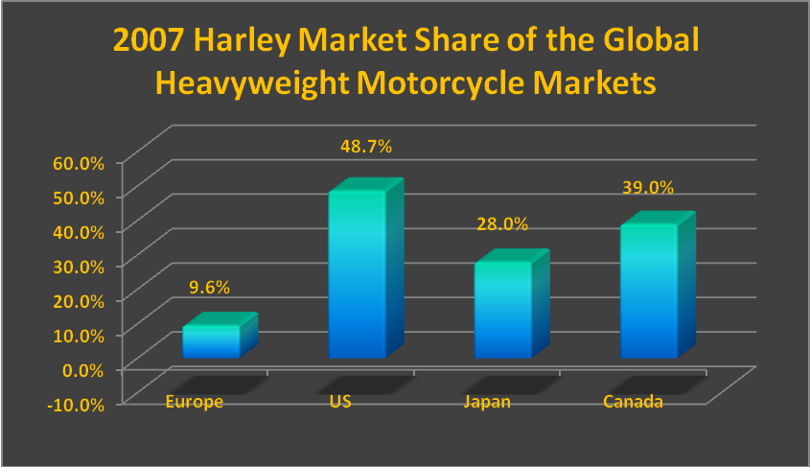

Source: Mohsenian,Dara, Ruma Mukerji, and Kevin M. Grundy (2008). Harley-Davidson. J.P. Morgan, North America Equity Research. 07 October, 2008.

International sales enjoyed revenue growth of 27% in 2007:

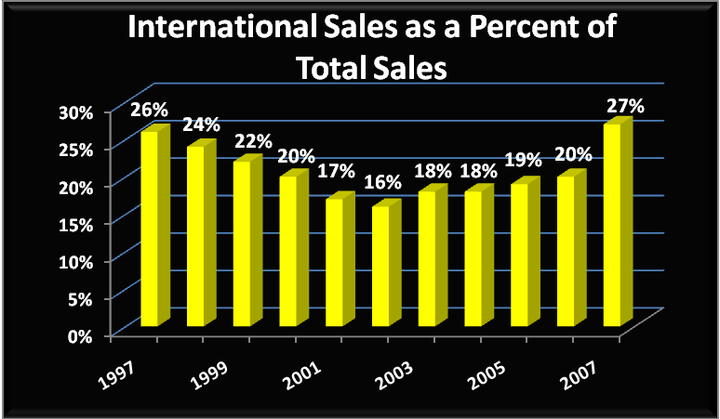

Source: Mohsenian,Dara, Ruma Mukerji, and Kevin M. Grundy (2008). Harley-Davidson. J.P. Morgan, North America Equity Research. 07 October, 2008.

The international revenue mix has increased from 16.3% in 2002 to 26.5% in 2007, with Europe (13.8% of sales), Japan (4% of sales), Canada (4% of sales), Australia (2.8% of sales), and other (1.9% of sales). This shift to international markets is depicted below:

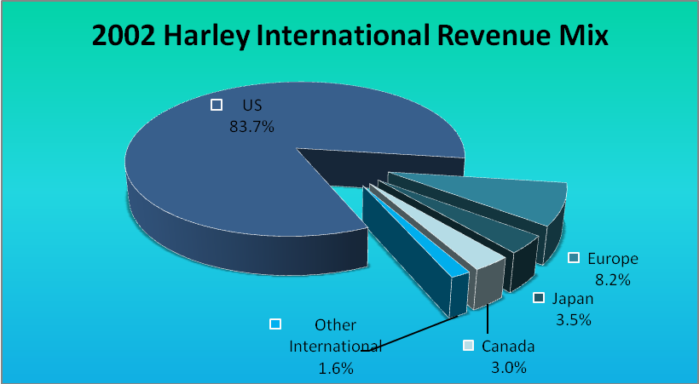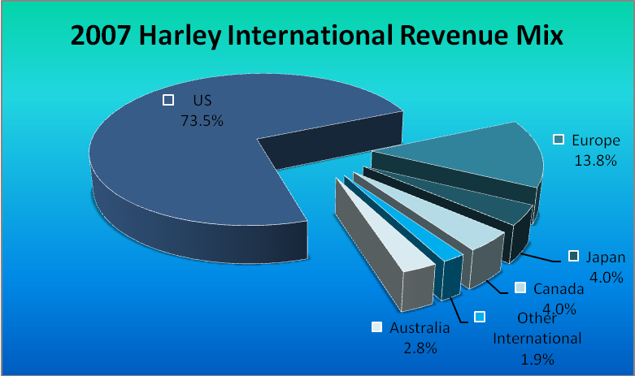

Source: Mohsenian,Dara, Ruma Mukerji, and Kevin M. Grundy (2008). Harley-Davidson. J.P. Morgan, North America Equity Research. 07 October, 2008.
Harley’s European business is managed through its Oxford, England subsidiary with sales offices in the UK, France, Germany, Italy, Netherlands, Spain, and Switzerland and in 2008 a new South Africa sales office. Sales grew most rapidly in Europe with an 18.5% five-year CAGR (Compound Annual Growth Rate), 9.9% in Japan, 13.7% in Canada, and 32.3% in other international regions.

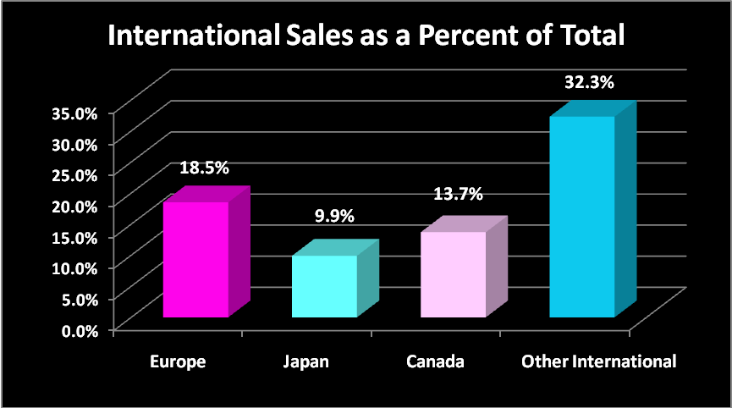

Source: Mohsenian,Dara, Ruma Mukerji, and Kevin M. Grundy (2008). Harley-Davidson. J.P. Morgan, North America Equity Research. 07 October, 2008.

Fragmented European Market
The European market is fragmented due to country differences and unique preferences. In 2008, Harley launched its first exclusively European high-performance bike, the XR1200. Europe comprises 52% of 2007 international sales and 13.8% of total sales. European revenue growth has been impressive at 27.2% in 2007 and market share in the European Heavyweight Motorcycle category jumped from 7.7% in 2002 to 9.6% in 2007. Industry leader, Suzuki was at 16.5%, BMW at 15.1%, Yamaha at 13.6%, Honda at 12.3%, and Kawasaki at 11.3%.

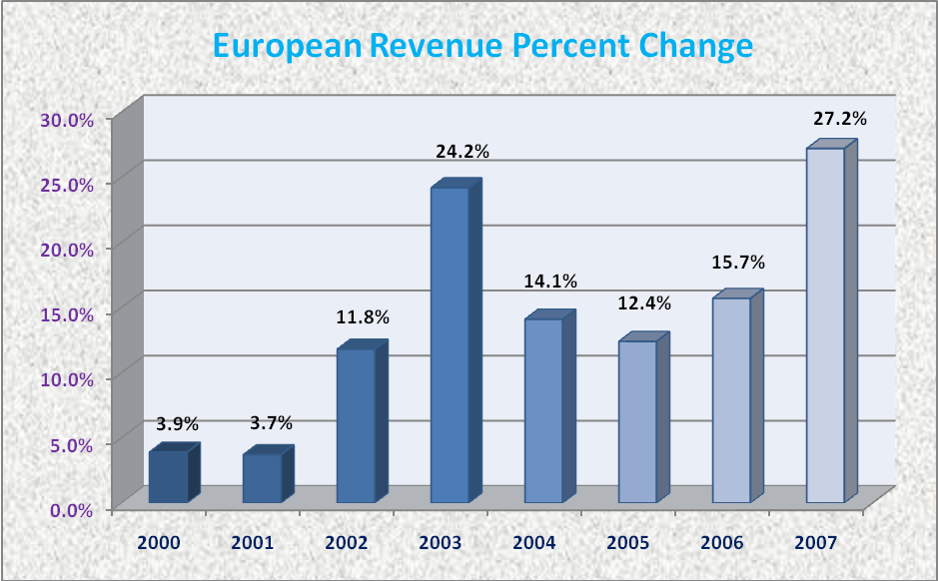

Source: Mohsenian,Dara, Ruma Mukerji, and Kevin M. Grundy (2008). Harley-Davidson. J.P. Morgan, North America Equity Research. 07 October, 2008.

The European Heavyweight Motorcycle market share is splintered with Harley steadily gaining momentum as depicted in the next sets of charts.

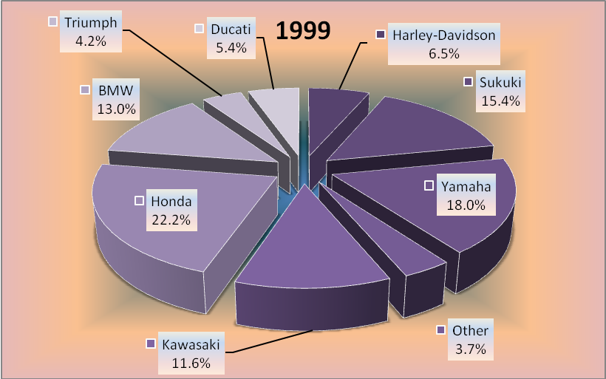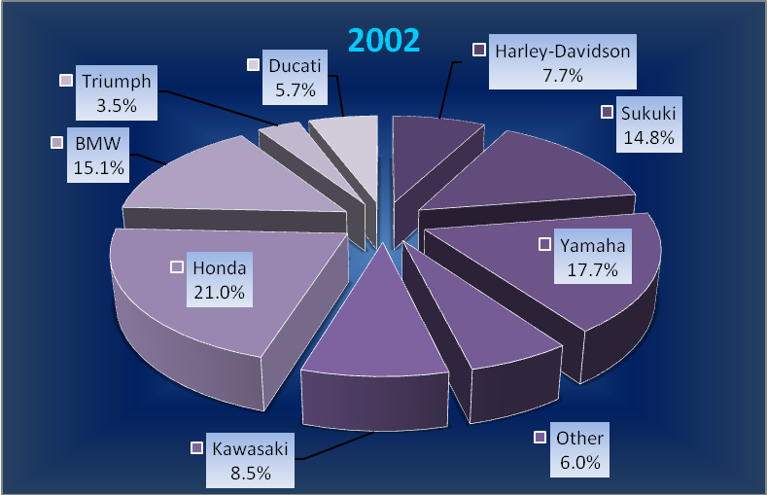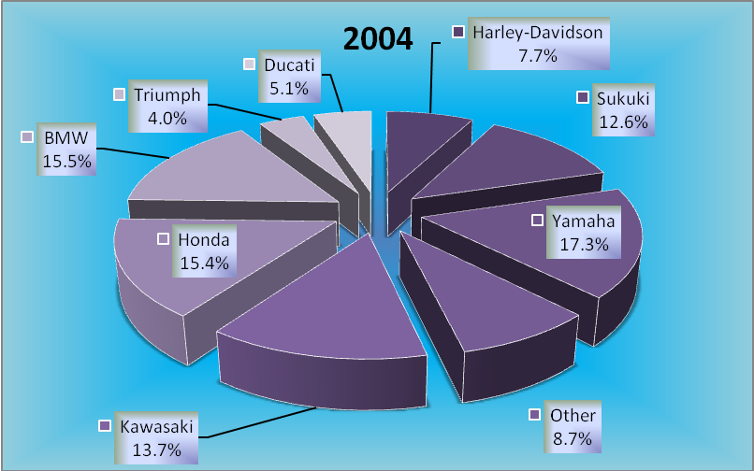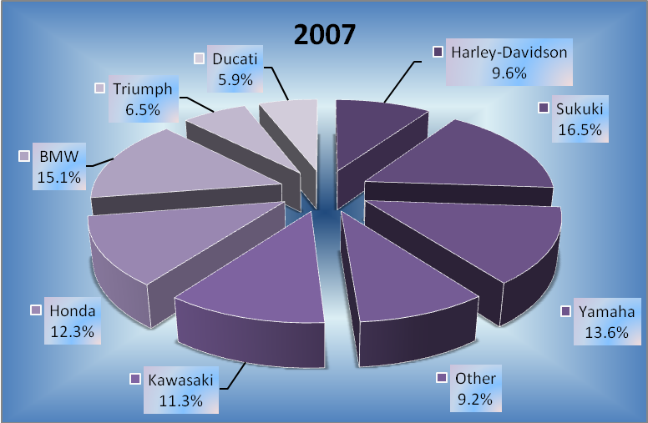

Source: Mohsenian,Dara, Ruma Mukerji, and Kevin M. Grundy (2008). Harley-Davidson. J.P. Morgan, North America Equity Research. 07 October, 2008.
The diversity of European preferences, coupled with a functional rather than recreational focus, narrow European streets, and high speed limits lead to a greater demand for the standard and performance motorcycle segments, as illustrated below:

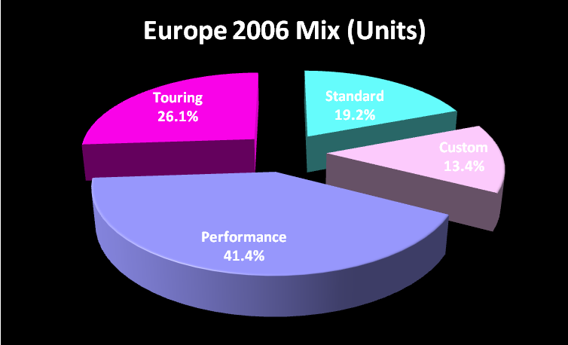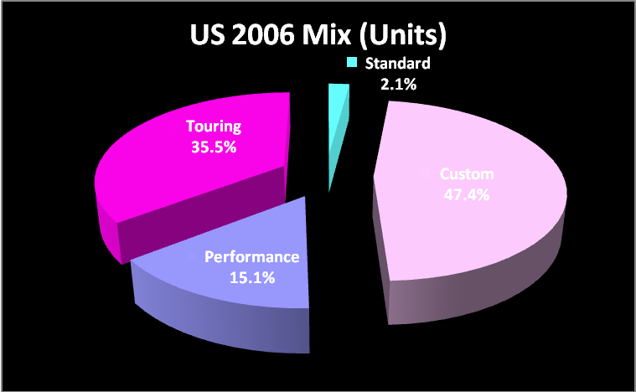

Source: Mohsenian,Dara, Ruma Mukerji, and Kevin M. Grundy (2008). Harley-Davidson. J.P. Morgan, North America Equity Research. 07 October, 2008.

Acknowledgements: With many thanks to Casey Long, Business Liaison Librarian at Georgia State University for her proficiency and research assistance. Also thank you to David McConico for his Excel graphing expertise.

V. END OF CHAPTER QUESTIONS
● TEST YOUR COMPREHENSION

- Distinguish between international business and globalization of markets.

International business refers to the performance of trade and investment activities by firms across national borders.
Globalization of markets is the ongoing economic integration and growing interdependency of countries worldwide. International business is characterized by international trade and investment.

- What is the difference between exporting and foreign direct investment?

Level of commitment
■ Exporting is the sale of products/services to customers located abroad.
■ Foreign direct investment (typically long-term) gives investors partial or full ownership of a company or productive assets such as capital, technology, labor, land, plant, and equipment .

- What makes international business different from domestic business?

Internationalization affords certain opportunities that are unavailable to domestic businesses.
Opportunities:
International business affords competitive advantages for the firm, which may yield superior performance through:
■ Maximizing returns
■ Attaining global scale economies
■ Resource acquisition ease and cost
■ Enhanced competitiveness
■ Knowledge transfer
At the same time, threats are also more pronounced:

Threats:
Complexity and risk.
Complexity is due to the interrelatedness and layering of numerous political, social, and economic systems.
Risk consists of the four types of omnipresent risks in international business-
■ Cross-cultural risk
■ Country risk
■ Currency or financial risk
■ Commercial risk

- What are the various types of risks that firms face when they conduct international business?

Cross-cultural risk
■ Differences in language, lifestyles, attitudes, customs, and religion, where a cultural miscommunication jeopardizes a culturally-valued mindset or behavior.
■ Cultural blunders hinder the effectiveness of foreign managers.
■ Language- critical dimension of culture- a window to people’s values
■ Language differences impede effective communication.
■ Cultural differences may lead to suboptimal business strategies.

Country risk (also known as political risk)
■ Differences in host country political, legal, and economic regimes may adversely impact firm profitability.
■ Also, laws, regulations, and indigenous factors e.g. property rights, intellectual-property protection, product liability, taxation policies, inflation, national debt, and unbalanced international trade may encumber firm operations and performance.
■ Government intervention: restricts market access; imposes bureaucratic procedures hindering business transactions; and limits the amount of earned income that firms may repatriate from foreign operations.
■ Economic freedom differs among nations- Hong Kong, Singapore, and Ireland are known as having the highest levels of economic freedom, see:
(http://www.heritage.org).

Currency or financial risk
■ Risk of adverse exchange rate fluctuations, inflation, and other harmful economic conditions creates uncertainty of returns.
■ When currencies fluctuate significantly, the value of the firm’s assets, liabilities, and/or operating income may be substantially reduced

Commercial risk
■ Less than optimal formulation and/or implementation of strategies, tactics, or procedures, e.g. partnering selections, market entry timing, pricing, product features, and promotional themes
■ Failures in international markets are far more costly than domestic business blunders.

Risks: Always present but manageable
■ The four types of risks in international business are omnipresent.

- Who are the major participants in international business?

■ Focal firm- firms that initiate and implement international business activities
■ Distribution channel intermediary- [Ch.3] distributors and retailers that provide distribution services in international markets.
■ Facilitator or support firm- [Ch.3] freight forwarders and banks that assist the focal firms with specialized needs

- What is the difference between a multi-national enterprise (MNE) and a small and medium-sized enterprise (SME)?

Multinational Enterprise (MNE):
■ Multinational enterprises are the most important type of focal firm; add value in multiple countries through a network of subsidiaries; leverage manufacturing, R&D, procurement, and marketing activities to yield the most economic sense.
■ In addition to a home office, an MNE owns a worldwide network of subsidiaries.
■ Exhibit 1.8 provides a geographic distribution of the world's leading MNEs. The size of each circle represents total MNE revenues per country.

Small and Medium-sized Enterprise (SME):
■ SME is a company with 500 or fewer employees.
■ Small firms comprise 90% - 95% of all firms in most economies.
■ Increasingly more SMEs participate in exporting, licensing, and global sourcing.
■ Small firms:
◘ Are the drivers for innovation.
◘ Account for one-third of exports from Asia; a quarter of the exports from the affluent countries in Europe and North America.
◘ Contribute more than 50% of total national exports in Italy, South Korea, and China.
■ Born-global firms- young, entrepreneurial SMEs that initiate international business from inception and are found in both advanced economies as well as emerging markets such as China and India.
■ International business complexities are considerably more challenging for SMEs than MNEs.
■ SME Strategies for success:
(1) SMEs are often more innovative and adaptable.
(2) SMEs are better able to serve niche markets.
(3) Smaller firms can better leverage the Internet.
(4) Due to limited resources, SMEs tend to minimize fixed costs and outsource.
(5) Smaller firms tend to flourish on private knowledge that they cultivate through their knowledge networks and international social capital.

- What are some of the key motivations for firms to engage in international business?

Firms internationalize by seeking growth and profit opportunities to enhance competitive advantage. Specifically:
A. Increase sales by seeking new markets and market diversification.
B. Earn higher margins and profits.
C. Better serve key markets or customers who have relocated abroad.
D. Get access to lower-cost or better-value factors of production.
E. Locate closer to supply sources, benefit from global sourcing advantages, or gain flexibility in the sourcing of products.
F. Develop economies of scale in production, marketing, and other activities.
G. Confront global competitors more effectively and/or thwart the growth of domestic competition.
H. Invest in a potentially rewarding relationship with a foreign partner.
I. Gain new ideas about products, services, and business approaches.

- Why should you care about international business?

A Competitive Advantage
■ Julie, the student in the opening vignette, is touched everyday by a variety of global business transactions.
■ She is considering a career in international business because she has grasped its importance and growing role in the world.
■ Working across national cultures exposes managers to a range of enlightening experiences, new knowledge, novel ways of seeing the world, and unusual challenges.
■ Managers with extensive international experience are more self-confident, cosmopolitan, and have positioned themselves for unique professional development opportunities

● APPLY YOUR UNDERSTANDING

1. Richard Bendix is the marketing manager at a firm that makes and sells high-quality prefabricated houses. He believes there is little difference between his home-country market and foreign markets, and that he can use the same methods for selling in Asia or Latin America as he does in his home country. Write a memo in which you explain to Richard the differences between domestic and international business. Explain the risks and other differences that Richard's firm will likely encounter if it expanded abroad.
TO: Richard
FROM: Myself
DATE: 07/07/12
RE: International vs. Domestic Business- Differences, Opportunities & Threats

Differences:
■ Complexity- Environmental forces differ from country to country; economic conditions, political systems, laws, and regulations, and national culture vary according to nation.
■ Risk- Each of these factors introduces an element of risk for the firm.

Opportunities: Internationalization affords certain opportunities that are unavailable to domestic businesses, which may lead to competitive advantages and superior performance:
■ Maximizing returns
■ Attaining global scale economies
■ Resource acquisition ease and cost
■ Enhanced competitiveness
■ Knowledge transfer
At the same time, threats are also more pronounced:

Threats:
Complexity and risk.
Complexity is due to the interrelatedness and layering of numerous political, social, and economic systems.
Risk consists of the four types of omnipresent risks in international business-
■ Cross-cultural risk
■ Country risk
■ Currency or financial risk
■ Commercial risk

2. Suppose that after graduation you get a job with Cottonwood Corporation, a small firm that does business only in its domestic market. You have just completed coursework in international business, are aware of various business opportunities abroad, and believe that Cottonwood should internationalize. Write a memo to your boss in which you explain why your company should pursue international business. What are the benefits to Cottonwood of venturing abroad? Explain why firms internationalize.

Your memo should include:
Cottonwood Corporation should internationalize to expand growth and profit opportunities in order to build competitive advantage. Specifically:
A. Increase sales by seeking new markets and market diversification.
B. Earn higher margins and profits.
C. Better serve key markets or customers who have relocated abroad.
D. Get access to lower-cost or better-value factors of production.
E. Locate closer to supply sources, benefit from global sourcing advantages, or gain flexibility in the sourcing of products.
F. Develop economies of scale in production, marketing, and other activities.
G. Confront global competitors more effectively and/or thwart the growth of domestic competition.
H. Invest in a potentially rewarding relationship with a foreign partner.
I. Gain new ideas about products, services, and business approaches.

Due diligence mandates that a risk assessment also be conducted. Risk consists of the four types of omnipresent risks in international business-
■ Cross-cultural risk
■ Country risk
■ Currency or financial risk
■ Commercial risk

3. You have become the president of the International Business Club at your school. You are trying to recruit new members and find that many students do not recognize the importance of international business or the career opportunities available to them. You decide to give a presentation on this theme. Prepare an outline of a presentation in which you explain what types of companies participate in international business, why students should study international business, and what career opportunities they might find.

Your presentation should include:
Who Participates In International Business?
■ Focal firm- firms that initiate and implement international business activities.
■ Distribution channel intermediary- [Ch.3] distributors and retailers that provide distribution services in international markets.
■ Facilitator or support firm- [Ch.3] freight forwarders and banks that assist the focal firms with specialized needs.

Multinational Enterprise (MNE)
■ Multinational enterprises are the most important type of focal firm; add value in multiple countries through a network of subsidiaries; leverage manufacturing, R&D, procurement, and marketing activities to yield the most economic sense.
■ In addition to a home office, an MNE owns a worldwide network of subsidiaries.
■ Exhibit 1.8 provides a geographic distribution of the world's leading MNEs.

Small and Medium-sized Enterprise (SME)
■ SME is a company with 500 or fewer employees.
■ Small firms comprise 90% - 95% of all firms in most economies.
■ Increasingly more SMEs participate in exporting, licensing, and global sourcing.
■ Small firms:
◘ Are the drivers for innovation.
◘ Account for one-third of exports from Asia; a quarter of the exports from the affluent countries in Europe and North America
◘ Contribute more than 50% of total national exports in Italy, South Korea, and China.
■ Born-global firms- young, entrepreneurial SMEs that initiate international business from inception and are found in both advanced economies as well as emerging markets such as China and India.
■ International business complexities are considerably more challenging for SMEs than MNEs.
■ SME strategies for success:
(1) SMEs are often more innovative and adaptable.
(2) SMEs are better able to serve niche markets.
(3) Smaller firms can better leverage the Internet.
(4) Due to limited resources, SMEs tend to minimize fixed costs and outsource.
(5) Smaller firms tend to flourish on private knowledge that they cultivate through their knowledge networks and international social capital.

Why Study International Business?
A Competitive Advantage
■ The role of international business grows daily in importance and impact.
■ Cross-national experiences expose managers to diversity, new knowledge, novel ways of seeing the world, and unusual challenges.
■ Managers with extensive international experience are typically more self-confident and cosmopolitan and are positioned for unique professional development opportunities. They essentially have a competitive advantage over others.

● GlobalEDGE™ INTERNET EXERCISES http://globaledge.msu.edu

1. You can gain valuable insights into international business by examining how countries compare to each other. Various research groups and international agencies systematically examine economic, political, and other features of nations. Visit globalEDGE™ Knowledge Tools, scroll down and click on “Interactive Rankings”. Then select “Countries”. You will find dozens of criteria ranking countries based on: GDP per capita; Education - literacy rate; People – population total; People – population density; Health – mortality rate; Energy – electricity production; Infrastructure – mobile cellular subscriptions; Infrastructure – roads total network; Trade and Investment – foreign direct investment net inflows; and many other factors. Choose the ranking criteria that interest you most. Then, examine the following three countries: Germany, India, and South Africa. Based on your analysis, explain why they rank where they do. Do their relative positions make sense to you? Does each country seem like a good place to do business? Why or why not? Hint: Evaluate countries on a “per capita” basis by dividing each criterion by the country’s population.

The question can be answered in various ways. A hypothetical answer is given below, using country rankings based on data from the CIA World Factbook. Germany, India, and South Africa are compared based on the following:

Country | GDP (ppp) US$ million | GDP real growth rate (%) | GDP per capita (ppp) US$/person | Industrial production growth rate | Inflation Rate (%)
Germany | 3,058,600 | 3.7 | 37,400 | 8.0 | 1.1
India | 4,421,000 | 6.8 | 3,700 | 4.8 | 8.9
South Africa | 528,200 | 2.8 | 10,500 | 2.5 | 4.3

■ India and South Africa are emerging markets. Germany is an advanced economy. Thus, Germany is ranked first in GDP per capita and industrial production growth rate; second in both GDP and GDP real growth rate after India; and had the lowest inflation rate. India is ranked first in GDP and GDP real growth rate; second in industrial production growth rate; last in GDP per capita and highest on inflation rate. South Africa ranks last in GDP, GDP real growth rate, and industrial production growth rate, but it had the second highest inflation rate and the second highest GDP per capita.

■ As an advanced economy, it stands to reason that Germany would have the highest GDP and GDP per capita relative to India and South Africa. But it does not. India has a higher GDP than Germany. However, when population is taken into account, note that India has the second highest population in the world after China; this is reflected in its GDP per capita- roughly one-tenth of Germany’s.

■ With a well-developed infrastructure (transportation, information and communication, power, etc.), Germany is poised to accentuate its information and communications technologies position relative to other advanced economies. However, there is ‘less room’ for growth in its economy, which is partly explained by its low real growth rate in GDP and high industrial production rate. The country’s inflation rate of 1.1% compares favorably among the three countries. Moreover, each German euro bought more goods and services with such a low inflation rate relative to the purchasing power of the rupee and the rand in the respective countries.

■ India’s emerging economy experienced a hefty real growth rate in GDP and GDP real growth rate compared to Germany. India is a large emerging economy both in population (about 1.22 billion) and GDP. On the other hand, its low per capita GDP indicates relatively low economic wealth among its citizens, which is partly explained by the low industrial production. While the country’s per capita GDP for the relevant period may be lowest among the three countries, it is poised to increase as the economy grows.

■ South Africa’s inflation was the second highest among the three countries compared; it is still low for an emerging economy. With GDP at US$528.2 billion, it is small in comparison to Germany’s developed economy, but it compares favorably with that of India when GDP per capita is considered.

2. In this chapter, we reviewed the four major risks that firms face in international business: cross-cultural risk, country risk, currency risk, and commercial risk. Identify one or more countries that interest you, then visit globalEDGE™ and research the countries to uncover examples of each of the four types of risks. For example, China is characterized by various cultural differences and a national government that tends to intervene in business. Research by entering the country name into the search engine. Visit “Country Insights” and “Market Potential Index”. Illustrate each risk with examples.

This can be answered in various ways. One example is the Czech Republic.
■ Cross-cultural risk: One of the main business cultural differences between U.S. businesspeople, for example, and those in the Czech Republic is the ‘urgency’ of making a sale. While the typical American “let’s get down to business” approach is effective domestically, Czechs are more reserved and will have reservations about this way of doing business. They prefer to get to know a potential U.S. business partner’s background and company and will be offended by too much emphasis on an immediate sales pitch.
■ Country risk: Although the Czech Republic has made various improvements, its tax, labor, environment, and health and safety laws are considered to discourage inward foreign investment. Research reveals that domestic and foreign investors perceive that government bureaucracy and unnecessary red tape remain a source of frustration. Moreover, it is not uncommon for investors to experience delays and potentially corruption, especially in the company registration process and in changes to corporate structure.
■ Currency risk: Inflation in the Czech Republic has been running at about 2%. Although low by most standards, volatility in this rate directly affects the value of the koruna (crown) (CZK) against the US dollar and the euro. Given that the country will not adopt the euro until at least 2012, U.S. and Euro zone companies that do business with Czech Republic firms will experience higher or lower cost as the CZK rises or falls in value relative to the dollar and the euro.
■ Commercial risk: Agents and distributors in the Czech Republic expect exclusivity in representing a foreign company’s product or service according published reports. Research reveals that many Czech Republic agents and distributors are undercapitalized and understaffed but still represent a wide diversity of foreign products. Thus foreign exporters and manufacturers should be careful to avoid weak partners by negotiating an agreement that ties exclusivity to performance via a time limitation on the agent/distributor agreement or an escape clause to terminate the partnership for nonperformance.

3. You have recently been hired by a smaller firm that is beginning to expand internationally. When first starting out, most firms choose exporting as their main foreign market entry strategy. However, no one in your firm knows how to conduct exporting. Therefore, your boss has given you an assignment: Prepare a presentation for your coworkers on how to engage in exporting. Using globalEDGE™, find and review a “Guide to Exporting” that you can use to create your presentation.

A presentation on how to export would include some or all of the following topics:
■ Understanding Exporting
◘ Assess and develop export knowledge in the firm; evaluate the importance of exporting, its pros and cons as well as the firm’s strengths and weaknesses
◘ Explain the role that trade-related data will play in the company’s export decision
■ Ensure the Basics of Exporting are met prior to Execution
◘ Do a preliminary screening and select a country or region
◘ Conduct an industry market potential analysis
◘ Select a foreign partner and structure the relationship
◘ Conduct a company sales potential analysis
■ Evaluate our Company’s Ability to Export
◘ Understand how Assessment of Company Readiness to Export (CORE) software can assist with assessing our export capability
◘ Prepare for defensive competition
◘ Assess top management’s commitment to the company’s export capability
◘ Assess the significance of company and product readiness as they influence our export capability
■ Preparing a Budget for Exporting
◘ Assess the effects of foreign exchange rates on the company’s export budgeting
◘ Understand how to control the export budget
◘ Explore the areas where standard cost can be applied
■ Assessing Export Cost
◘ Compose a list of export cost elements
◘ Perform a cost-volume-profit analysis with different tools
◘ Assess the important factors involved in costing a product for an overseas market(s)
■ Understanding Export Documentation
◘ Identify and understand the mandatory documents for exporting
◘ Understand documents such as a bill of lading, commercial invoice, and packing list
◘ Understand significant financial exchange documents such as the bill of exchange, sight draft, and time draft
◘ Assess the pros and cons of the letter of credit’s value in the exporting process
■ Export Financing
◘ Assess the effective use of methods of payments and insurance
◘ Evaluate the details of international countertrade
◘ Assess the details of private and non-private financing
■ Export Marketing and Logistics
◘ Explain the necessity of an export marketing plan and information required to prepare it.
◘ Assess movement and storage options for exporting the company’s products that include understanding warehouse location, and inventory levels
◘ Assess the requirements for effective export pricing

