Chapter 13
National Income Accounting and
the Balance of Payments

■ Chapter Organization
The National Income Accounts.
National Product and National Income.
Capital Depreciation and International Transfers.
Gross Domestic Product.
National Income Accounting for an Open Economy.
Consumption.
Investment.
Government Purchases.
The National Income Identity for an Open Economy.
An Imaginary Open Economy.
The Current Account and Foreign Indebtedness.
Saving and the Current Account.
Private and Government Saving.
Case Study: The Mystery of the Missing Deficit.
The Balance of Payments Accounts.
Examples of Paired Transactions.
The Fundamental Balance of Payments Identity.
The Current Account, Once Again.
The Capital Account.
The Financial Account.
Statistical Discrepancy.
Official Reserve Transactions.
Case Study: The Assets and Liabilities of the World’s Biggest Debtor.

Summary

■ Chapter Overview
This chapter introduces the international macroeconomics section of the text. The chapter begins with a brief discussion of the focus of international macroeconomics. You may want to contrast the type of topics studied in international trade, such as the determinants of the patterns of trade and the gains from trade, with the issues studied in international finance, which include unemployment, savings, trade imbalances, and money and the price level. You can then “preview” the manner in which the theory taught in this section of the course will enable students to better understand important and timely issues such as the U.S. trade deficit, the experience with international economic coordination, the European Economic and Monetary Union, and the financial crises in Asia and other developing countries.
The core of this chapter is a presentation of national income accounting theory and balance of payments accounting theory. A solid understanding of these topics proves useful in other parts of this course when students need to understand concepts such as the intertemporal nature of the current account or the way in which net export earnings are required to finance external debt. Students will have had some exposure to closed economy national income accounting theory in previous economics courses. You may want to stress that GNP can be considered the sum of expenditures on final goods and services or, alternatively, the sum of payments to domestic factors of production. You may also want to explain that separating GNP into different types of expenditures allows us to focus on the different determinants of consumption, investment, government spending, and net exports.
The relationships among the current account, savings, investment, and the government budget deficit should be emphasized. It may be useful to draw an analogy between the net savings of an individual and the net savings of a country to reinforce the concept of the current account as the net savings of an economy. Extending this analogy, you may compare the net dissavings of many students when they are in college, acquiring human capital, and the net dissavings of a country that runs a current account deficit to build up its capital stock. You may also want to contrast a current account deficit that reflects a lot of investment with a current account deficit that reflects a lot of consumption to make the point that all current account deficits are not the same nor do they all warrant the same amount of concern. Balance of payments accounting will be new to students. The text stresses the double-entry bookkeeping aspect of balance of payments accounting. The 2015 U.S. balance of payments accounts provide a concrete example of these accounts.
Note that the book uses the new current/financial/capital account definitions. The old capital account is now the financial account. The current account is the same except that unilateral asset transfers (debt forgiveness or immigrants moving wealth with them) are now in the new capital account. Credits and debits are marked in the same manner; if money comes into a country, it is a credit. A description of the changes along with revised estimates for 1982–1998 can be found in the article by Christopher Bach (see references). These changes were made in conjunction with the IMF’s new standards. A description of these new standards can be found in the Survey of Current Business article listed at the end of the references.
The chapter also includes a discussion of official reserve transactions. You may want to stress that, from the standpoint of financing the current account, these official capital flows play the same role as other financial flows. You may also briefly mention that there are additional macroeconomic implications of central-bank foreign asset transactions. A detailed discussion of these effects will be presented in Chapter 18.
The chapter concludes with a case study examining the foreign assets and liabilities of the United States. A breakdown of the different components of the U.S. international investment position is presented. Of particular importance is that although the United States is the world’s largest debtor, American debt relative to American GDP is significantly lower than many other countries. The chapter also includes a discussion of how the value of a nation’s foreign debt may be affected by exchange rate changes, a nice segue into the next chapter relating exchange rates and the asset market.

■ Answers to Textbook Problems
1. The reason for including only the value of final goods and services in GNP, as stated in the question, is to avoid the problem of double counting. Double counting will not occur if intermediate imports are subtracted and intermediate exported goods are added to GNP accounts. Consider the sale of U.S. steel to Toyota and to General Motors. The steel sold to General Motors should not be included in GNP because the value of that steel is subsumed in the cars produced in the United States. The value of the steel sold to Toyota will not enter the national income accounts in a more finished state because the value of the Toyota goes toward Japanese GNP. The value of the steel should be subtracted from GNP in Japan because U.S. factors of production receive payment for it. Thus, we do want to count imports of intermediate goods (as a negative), to avoid double counting both domestic and foreign production.

2. Equation 13-2 can be written as CA = (Sp − I) + (T − G). Higher U.S. barriers to imports may have little or no impact upon private savings, investment, and the budget deficit. If there were no effect on these variables, then the current account would not improve with the imposition of tariffs or quotas. It is possible to tell stories in which the effect on the current account goes either way. For example, investment could rise in industries protected by the tariff, worsening the current account. (Indeed, tariffs are sometimes justified by the alleged need to give ailing industries a chance to modernize their plant and equipment.) On the other hand, investment might fall in industries that face a higher cost of imported intermediate goods as a result of the tariff. In general, permanent and temporary tariffs have different effects. The point of the question is that a prediction of the manner in which policies affect the current account requires a general-equilibrium, macroeconomic analysis.
3. a. The purchase of the German stock is a debit in the U.S. financial account. There is a corresponding credit in the U.S. financial account when the American pays with a check on his Swiss bank account because his claims on Switzerland fall by the amount of the check. This is a case in which an American trades one foreign asset for another.
b. Again, there is a U.S. financial account debit as a result of the purchase of a German stock by an American. The corresponding credit in this case occurs when the German seller deposits the U.S. check in his German bank and that bank lends the money to a German importer (in which case the credit will be in the U.S. current account) or to an individual or corporation that purchases a U.S. asset (in which case the credit will be in the U.S. financial account). Ultimately, there will be some action taken by the bank, which results in a credit in the U.S. balance of payments.
c. The foreign exchange intervention by the Korean government involves the sale of a U.S. asset, the dollars it holds in the United States, and thus represents a debit item in the U.S. financial account. The Korean citizens who buy the dollars may use them to buy American goods, which would be an American current account credit, or an American asset, which would be an American financial account credit.
d. Suppose the company issuing the traveler’s check uses a checking account in France to make payments. When this company pays the French restaurateur for the meal, its payment represents a debit in the U.S. current account. The company issuing the traveler’s check must sell assets (depleting its checking account in France) to make this payment. This reduction in the French assets owned by that company represents a credit in the American financial account.
e. There is no credit or debit in either the financial or the current account because there has been no market transaction.
f. There is no recording in the U.S. Balance of Payments of this offshore transaction.

4. The purchase of the answering machine is a current account debit for New York and a current account credit for New Jersey. When the New Jersey Company deposits the money in its New York bank, there is a financial account credit for New York and a corresponding debit for New Jersey. If the transaction is in cash, then the corresponding debit for New Jersey and credit for New York also show up in their financial accounts. New Jersey acquires dollar bills (an import of assets from New York and, therefore, a debit item in its financial account); New York loses the dollars (an export of dollar bills and, thus, a financial account credit). Notice that this last adjustment is analogous to what would occur under a gold standard (see Chapter 18).
5. a. Because non-central bank financial inflows fell short of the current account deficit by $500 million, the balance of payments of Pecunia (official settlements balance) was $500 million. The country as a whole somehow had to finance its $1 billion current account deficit, so Pecunia’s net foreign assets fell by $1 billion.
b. By dipping into its foreign reserves, the central bank of Pecunia financed the portion of the country’s current account deficit not covered by private financial inflows. Only if foreign central banks had acquired Pecunian assets could the Pecunian central bank have avoided using
$500 million in reserves to complete the financing of the current account. Thus, Pecunia’s central bank lost $500 million in reserves, which would appear as an official financial inflow (of the same magnitude) in the country’s balance of payments accounts.
c. If foreign official capital inflows to Pecunia were $600 million, the central bank now increased its foreign assets by $100 million. Put another way, the country needed only $1 billion to cover its current account deficit, but $1.1 billion flowed into the country (500 million private and 600 million from foreign central banks). The Pecunian central bank must, therefore, have used the extra $100 million in foreign borrowing to increase its reserves. The balance of payments is still −$500 million, but this now comprises $600 million in foreign central banks purchasing Pecunia assets and $100 million of Pecunia’s central bank purchasing foreign assets, as opposed to Pecunia selling $500 million in assets. Purchases of Pecunian assets by foreign central banks enter their countries’ balance of payments accounts as outflows, which are debit items. The rationale is that the transactions result in foreign payments to the Pecunians who sell the assets.
d. Along with noncentral bank transactions, the accounts would show an increase in foreign official reserve assets held in Pecunia of $600 million (a financial account credit, or inflow) and an increase Pecunian official reserve assets held abroad of $100 million (a financial account debit, or outflow).
6. A current account deficit or surplus is a situation that may be unsustainable in the long run. There are instances in which a deficit may be warranted, for example to borrow today to improve productive capacity in order to have a higher national income tomorrow. But for any period of current account deficit, there must be a corresponding period in which spending falls short of income (i.e., a current account surplus) in order to pay the debts incurred to foreigners. In the absence of unusual investment opportunities, the best path for an economy may be one in which consumption, relative to income, is smoothed out over time.
The reserves of foreign currency held by a country’s central bank change with nonzero values of its official settlements balance. Central banks use their foreign currency reserves to influence exchange rates. A depletion of foreign reserves may limit the central bank’s ability to influence or peg the exchange rate. For some countries (particularly developing countries), central-bank reserves may be important as a way of allowing the economy to maintain consumption or investment when foreign borrowing is difficult. A high level of reserves may also perform a signaling role by convincing potential foreign lenders that the country is creditworthy. The balance of payments of a reserve-currency center (such as the United States under the Bretton Woods system) raises special issues that are best postponed until Chapter 19.
7. The official settlements balance, also called the balance of payments, shows the net change in international reserves held by U.S. government agencies, such as the Federal Reserve and the Treasury, relative to the change in dollar reserves held by foreign government agencies. This account provides a partial picture of the extent of intervention in the foreign exchange market. For example, suppose the Bundesbank purchases dollars and deposits them in its Eurodollar account in a London bank. Although this transaction is a form of intervention, it would not appear in the official settlements balance of the United States. Instead, when the London bank credits this deposit in its account in the United States, this transaction will appear as a private financial flow.
  - A country could have a current account deficit and a balance of payments surplus at the same time if the financial and capital account surpluses exceeded the current account deficit. Recall that the balance of payments surplus equals the current account surplus plus the financial account surplus plus the capital account surplus. If, for example, there is a current account deficit of $100 million, but there are large capital inflows and the financial account surplus is $102 million, then there will be a $2 million balance of payments surplus.
This problem can be used as an introduction to intervention (or lack thereof) in the foreign exchange market, a topic taken up in more detail in Chapter 18. The government of the United States did not intervene in any appreciable manner in the foreign exchange markets in the first half of the 1980s. The “textbook” consequence of this is a balance of payments of zero, while the actual figures showed a slight balance of payments surplus between 1982 and 1985. These years were also marked by large current account deficits. Thus, the financial inflows into the United States between 1982 and 1985 exceeded the current account deficits in those years.
9. If both assets and liabilities pay 5%, then the net payments on the net foreign debt would be 1.25%. While not trivial, this is probably not too bad a burden. At 100% net foreign debt-to-GDP ratio, the net payments are 5%. At this point, the payments may be a substantial drain on the economy. When the interest payments on debt exceed a country’s economic growth rate, this debt is unsustainable.
10. The United States receives a substantially higher rate of return on its assets held abroad than foreigners are earning on U.S. assets. One reason is that a substantial amount of foreign assets are in low-interest-rate Treasury bills.
11. The case study states that U.S. foreign assets are equal to 129% of GDP and foreign liabilities are equal to 148% of GDP. Furthermore, 70% of U.S. foreign assets are in foreign currencies, and 100% of U.S. foreign liabilities are in dollars. From the foreign perspective, foreigners hold U.S. assets equal to 148% of U.S. GDP, and these are all in dollars. A 10% depreciation of the dollar would reduce the value of these foreign assets by 0.1 × 1 × 1.48 = 14.8%. Foreign liabilities are equal to 129% of GDP, but only 30% of these liabilities are in dollars. Thus, a 10% depreciation of the dollar would reduce foreign liabilities by 0.1 × 0.3 × 1.29 = 3.9%. Thus, the net effect of a 10% dollar depreciation is a 10.9% reduction in the net foreign wealth of foreign countries.
12. To incorporate capital gains or losses, one would have to consider these valuation changes as part of national income. We would thus change Equation 13-1 to read:
Y = C + I + G + X – M + “GAIN”.
where “GAIN” is defined as the net capital gain on net foreign assets. Although such an adjustment would more directly measure the change in net foreign assets, it would not be as useful a measure of the income of a country. Nonrealized gains do not show up as income, nor do they provide the means to finance consumption or investment. So, it would be misleading to count this in the current account. In addition, it is most likely not done because of the difficulty of making these measurements. Many of the investments do not have clear market prices, making them difficult to value.
  - Collecting data on the U.S. international investment position and nominal GDP over the period 1976–2012 allows us to generate the following chart:
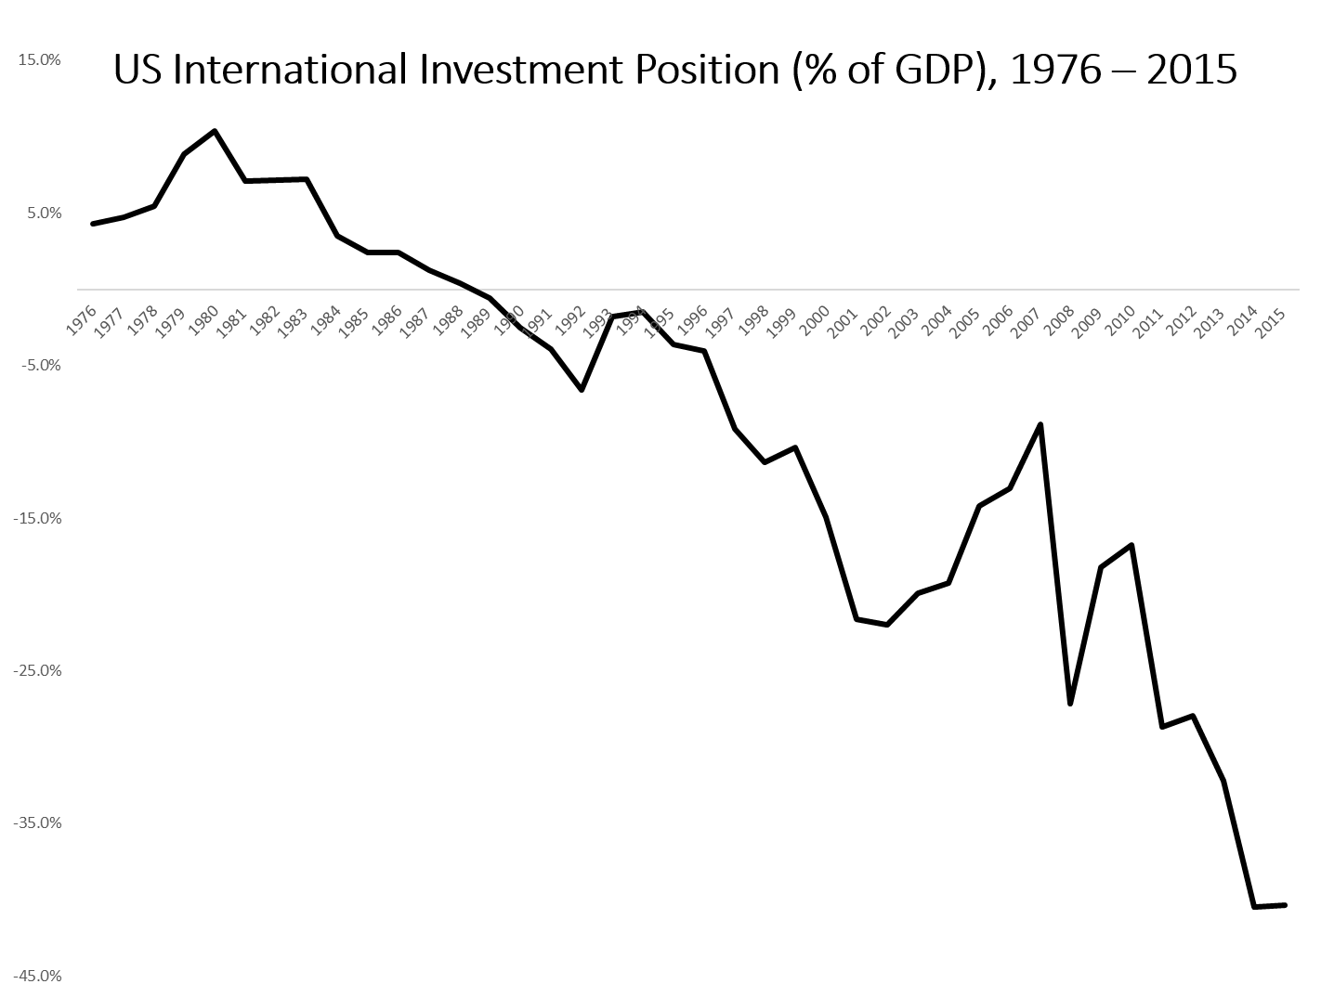
As the U.S. current account has been negative since 1980, it should not be surprising that the U.S. international investment position has been declining since 1980. To finance a current account deficit, a country must borrow from abroad. Thus, every year a country runs a current account deficit, its international indebtedness grows. Though the value of US foreign assets and liabilities may change from year to year with fluctuations in the value of the dollar, the total quantity of debt has been increasing for each year the United States runs a current account deficit. The only surprising thing about this chart is how much longer the United States will be able to maintain its current account deficit.

■ References
Christopher Bach. “U.S. International Transactions, Revised Estimates for 1982–1998.” Survey of Current Business 79 (July 1999), pp. 60–74.
“The International Monetary Fund’s New Standards for Economic Statistics.” Survey of Current Business 76 (October 1996), pp. 37–47.

