**Chapter 1**

**Information Systems and People**

**Learning Objectives**

1. Describe the main roles that information systems play in organizations.
2. Compare the terms *data*, *information*, and *knowledge,* and describe three characteristics that make information valuable.
3. Describe the four main components of an information system and the role that each plays.
4. Identify several research areas that are studied in the discipline of management information systems (MIS).
5. Provide examples of how business, nonprofit, and government managers, as well as information technology departments, depend on information systems knowledge.
6. Explain how information systems present both promises and perils, and pose ethical questions.

**Solutions to Chapter Review Questions**

**1-1. What are the six primary roles of information systems in organizations? How are information systems used in each context?**

Information systems play critical roles in (1) managing operations, (2) supporting customer interactions, (3) making decisions, (4) collaborating on teams, (5) gaining competitive advantage, and (6) improving individual productivity.

In operations management, information systems are used to manage assets and inventories; track employee payroll, taxes, benefits, and timesheets; process transactions; track accounts payable and accounts receivable; procure goods and services; and pay suppliers. Information systems that support customer interactions include customer relationship management systems, web-based front offices, online self-service applications, modern point-of-sale systems and self-service checkouts. Information systems support data-driven decision making by using both internal organizational data and external data from partners, suppliers and public sources. Smart managers use aggregated data to identify trends and patterns rather than rely on gut instincts.

Collaboration and teamwork have considerable support from information systems such as web applications that enable virtual meeting spaces and social networking sites. Microsoft’s SharePoint is an example of information technology that supports project teams with document management, shared calendars, and communication features. The innovative use of an information system can provide a competitive advantage until competitors jump on the bandwagon. Consider how Apple’s iPhone got the jump on smartphone competitors with Siri, the intelligent personal assistant. The selection of information systems and technology to improve personal productivity ranges from use of email and smartphones to word processing programs and contact databases. The challenge for most people is to pick easy-to-use software and devices that integrate with existing applications.

**1-2. How is data different from information? How is information different from knowledge? What are examples of each?**

Data refers to individual facts or pieces of information, and information refers to data or facts that are assembled and analyzed to add meaning and usefulness. A patient’s temperature reading is one piece of data; however, when combined with other pieces of data in a patient records information system, it becomes information that is useful for diagnostic purposes. Aggregated with data from other patients, it can be further refined and analyzed to become knowledge of a flu outbreak that is even more useful.

**1-3. What are the three characteristics that make information valuable? Why is each a critical attribute of information?**

The three characteristics that make information valuable are timeliness, accuracy, and completeness. Timeliness is a critical attribute for certain kinds of information, such as stock prices. Accuracy is a critical attribute for some information, such as a patient’s temperature reading. On the other hand, extreme accuracy may not be necessary for certain kinds of information, such as a competitor’s price for a rival product. Completeness is a critical attribute for some information, such as a patient’s list of current medications. In the context of a marketing survey, complete information adds value as a means to avoid bias or spin.

**1-4. What are the four components of an information system? Describe each component. What are the five functions that these components provide?**

The four components of an information system are (1) people, (2) technology, (3) processes, and (4) data. People interact with information systems in various roles such as systems analysis and developers, managers, users, customers, and contributors. Information technology includes hardware, software, and telecommunications equipment. Business processes are activities designed to achieve a task, such as automatically generating form letters to students. Data are facts represented by values, which have meaning in a certain context. Data may be numbers, character strings, or symbols. These four components are used to collect, process, manage, analyze, and distribute information.

**1-5. How are information systems important to managers in a variety of functional business units? What are examples of ways that information systems are important to the success of a marketing department, a human resources department, and a small business owner?**

Information systems are important to business managers because they support the company’s business activities throughout every functional department. Information systems are used to streamline processes, reduce costs, increase revenue, or support a strategic initiative. A marketing department uses information systems to develop data-driven marketing strategies, analyze ROI for marketing campaigns, and leverage social networking trends to create interest in the company’s products. A human resources department uses information systems to deliver online learning programs to reach more employees. A small business owner can take advantage of the decline in cost for many information systems, such as inexpensive intelligent dialing software that enables call center staff to more efficiently reach mobile phone customers.

**1-6. What are the functional areas that are common to most information technology departments?**

Common functional areas in an information systems department include end-user support and help desk, systems administration, data center operations, enterprise systems, and telecommunications and network services.

**1-7. What is the role of the chief information officer?**

The chief information officer (CIO) oversees the IT department, and helps to shape the organization’s strategic goals and ensure that the information systems support them. The CIO might report directly to the CEO or the vice president of finance and administration.

**1-8. How do information systems offer promises to organizations? What are some of the perils of information systems? What are some of the ethical questions associated with the use of information systems?**

Students should be able to discuss how information systems offer promises to organizations by giving them the opportunity or the possibility to change the way they operate. The perils of information systems include the increased risk of privacy breaches and amplification effects that result from interconnected systems. A number of ethical questions are associated with the use of information systems: Who is responsible for the damage caused by a privacy breach? Who is responsible when false, damaging, or illegal videos are shared on the Internet? Is it unethical to broadcast an email message received by mistake?

**Solutions to Projects and Discussion Questions**

1. **As customers, students, patients, taxpayers, and citizens, we are surrounded by information systems that support customer interactions. Identify and describe two such systems that you have used. Briefly, describe the types of customer interactions you have experienced with these systems and compare what you found to be important features of each one. Are there features or function that you would change or add to either system?**

Answers will vary, as the object of this question is to prompt the student to consider features of an information system. An example is a student registration system that allows students to browse class offerings, review course descriptions and required textbooks, and register for classes.

1. **Web conferencing has been available for many years. In this market space, products from Adobe, Cisco, Citrix, IBM, and Microsoft compete with lower-cost or free web-conferencing applications from AnyMeeting, Yugma, and others. What are some of the advantages of using a virtual meeting space? Are there disadvantages? Search the web to learn more about online meeting rooms and prepare a 5-minute presentation of your findings.**

The benefits of virtual meetings include saved time and money, increased productivity, increased meeting participation, and the ability to record meetings for presentation at a later date. On the other hand, virtual meeting participants may be less likely to build strong, personal relationships, and they may be more likely to experience distractions and engage in multi-tasking (i.e., checking email) during the meeting. Acquiring the necessary technology and training in the use of that technology are additional drawbacks of virtual meetings.

1. **Information systems play a very large role in decision making, and many would argue that you can always use more information to make better decisions. But sometimes digging deeply for more information leads to troubling ethical dilemmas. Visit 23andme.com, the website of a company that offers to read your DNA from saliva for $99 and provide reports about disease risk factors, ancestral lineage, and more. If you learn of a significant health risk, should you tell siblings who chose not to investigate their own DNA? Should you tell your fiancée? List what factors should be taken into account when making decisions about whether to obtain information like this, and how to use it.**

Answers to this question will vary based on the student’s perspective and experience. Potential factors that students may identify are the physical and psychological health of their friends and family, their own physical and psychological health, and potential impact to past and future relationships.

1. **One way to be more productive and manage time efficiently, is to use the calendar feature of your email system. If you use Microsoft Outlook, visit Microsoft.com and search for “Outlook tutorial” or search the Internet for an Outlook “how to” web page to learn how to set up your calendar. Then create a calendar for the semester that shows class times as well as test dates and project due dates. Which reminder option did you select for class times? Which reminder option did you select for project due dates? Briefly, describe several benefits of using the Outlook calendar feature.**

Answers will vary, as the object of this question is to require students to work with software that enhances productivity. At a minimum, students should be able to list several benefits of the Outlook calendar feature that include the ability to mark items such as appointments, meetings, or all-day events, and specify items as recurring or one-time events. The scheduling option is used to invite others to a meeting. Reminders can be set anywhere from 15 minutes up to 5 days prior to an appointment.

1. **Although Internet users bemoan its annoying popup ads, Netflix has grown to more than 80 million customers who can stream movies and TV episodes to any Internet-connected device or request DVDs by mail. Describe Netflix in terms of (1) the types of information technology it uses and (2) its customer-facing business processes.**

Answers supplied by students will vary, but generally should be drawn from chapter information contained in Section 4: The Components of an Information System. Answers should include brief statements relating to people, technology, processes, and data.

1. **Consider the information that is maintained by a bank. In addition to customer records, the bank maintains records on accounts and loans. Figure 1-20 and Figure 1-21 (below) are two examples of database tables for a regional bank. How might this data be aggregated and analyzed to create information and knowledge?**

**Figure 1-20**

Customers table

|  |  |  |  |  |  |
| --- | --- | --- | --- | --- | --- |
| **CustomerID** | **Name** | **Address** | **City** | **State** | **Zip** |
| 100001 | Don Baker | 1215 E. New York | Aurora | IL | 60504 |
| 100002 | Yuxiang Jiang | 1230 Douglas Road | Oswego | IL | 60543 |
| 100003 | Emily Brown | 632 Fox Valley Road | Aurora | IL | 60504 |
| 100004 | Mario Sanchez | 24 E. Ogden | Naperville | IL | 60563 |

**Figure 1-21**

Accounts table

|  |  |  |  |  |
| --- | --- | --- | --- | --- |
| **CustomerID** | **AccountNumber** | **AccountType** | **DateOpened** | **Balance** |
| 100001 | 4875940 | Checking | 10/19/1971 | 2500.00 |
| 100001 | 1660375 | Savings | 08/10/1973 | 1200.00 |
| 100002 | 1783032 | Savings | 05/15/1987 | 500.00 |
| 100002 | 4793289 | Checking | 05/15/1987 | 3200.00 |
| 100003 | 6213690 | Checking | 02/14/1996 | 6700.00 |
| 100004 | 1890571 | Savings | 10/16/2007 | 5300.00 |
| 100004 | 8390126 | Checking | 12/02/2008 | 2700.00 |

Answers will vary but the student should be able to provide several examples. For instance, the student may discuss how customer data may be aggregated with account data to create information such as a table showing customers in zip code 60504 having a savings account, and how customer data and account data may be aggregated and analyzed to create higher-level knowledge such as which customers may be prospects for a CD savings account or a consumer loan.

1. **Parking is a problem at many universities across the United States. Is it a problem on your campus? Describe the business process to acquire a parking pass at your school. Can you get a parking pass online? Can you get one in person? How does your process compare to that of a smaller school that uses a paper form to apply for a parking permit? How can that organization use an information system to improve this business process? Can you think of a business process at your college or university that can be improved with an information system?**

Answers will vary depending on the business process evaluated. Students should be able to provide a comprehensive description of the process they use to acquire a parking pass and a comparison to the process used at a smaller school. They may identify a process they have experienced that can be improved or eliminated with the help of information systems.

1. **A typical information technology department is comprised of common functional areas, and each requires skills and competencies unique to that area. Search the web or visit an online job search site such as careerbuilder.com or monster.com to learn more about the IT functional areas described in Figure 1-15. Select two functional areas and compare job postings for each. In a brief report, contrast the differences in education, experience, and technical certification that are required for each job.**

Answers will vary depending on the websites accessed. Job titles generally should be drawn from information contained in Figure 1-16. Students may identify network and security certifications such as CCNA (Cisco Certified Network Associate), CCNP (Cisco Certified Network Professional), and CompTIA’s A+, Network+, and Security+ certifications.

1. **In June, 2010, a security breach in the AT&T network exposed the email addresses of 114,000 Apple iPad 3G owners, many of whom are well-known business executives. The list of subscribers that were impacted by the breach included Diane Sawyer of *ABC News*, New York City Mayor Michael Bloomberg, and former White House Chief of Staff and Chicago Mayor Rahm Emanuel. Work in a small group with classmates to consider the severity of this leak of private information. In this case, is the severity of the breach measured by the number of affected individuals or by the high-profile status of some of the subscribers? What criteria are best for judging the severity of a data leak? Prepare a brief summary of your group discussion.**

Answers will vary but students should weigh the factors that they consider important in judging the scope of the damage, and defend their criteria. The extent of harm done directly and indirectly should be considered, whether or not high profile individuals are involved.

1. **Information systems are fundamental to the success of every functional business unit within an organization, from marketing to manufacturing to finance. Work in a small group with classmates to share your career choice and discuss how information systems support processes within your field. Can you name types of software applications that are used in your chosen career?**

Answers will vary depending on students’ career choices. Students should discuss how information systems support processes within a given field in the context of the different roles information systems play in different organizations. Accounting majors may identify QuickBooks or Peachtree accounting programs. Marketing majors may identify email marketing or Internet marketing software programs. Information technology majors may identify project management software programs.

**Solutions to Application Exercises**

**1-19. Excel Application: Manpower Planning Spreadsheet**

**Precision Products specializes in custom-manufactured metal parts. The production manager has asked you to create an Excel spreadsheet to help manage operations. The company needs a way to calculate staffing requirements (number of employees) based on different levels of production. The five manufacturing operations are fabrication, welding, machining, assembly, and packaging. One unit of production requires 1.5 hours for fabrication, 2.25 hours for welding, 0.7 hours for machining, 3.2 hours for assembly, and 0.5 hours for packaging. Create the Excel spreadsheet shown in Figure 1-18 to calculate the weekly manpower required, at 40 hours per week, for production levels of 200, 300, 400, and 500 units. How does the total required for each level of production change if Precision Products operates a 45-hour production schedule?**

In the file Excel Ch01Ex01, students should go to the cell containing 40 (Weekly Manpower) hours and change it to 45; the formula would then recalculate the Total Manpower amount.

**Figure 1-18**

Managing operations at Precision Products using Excel.

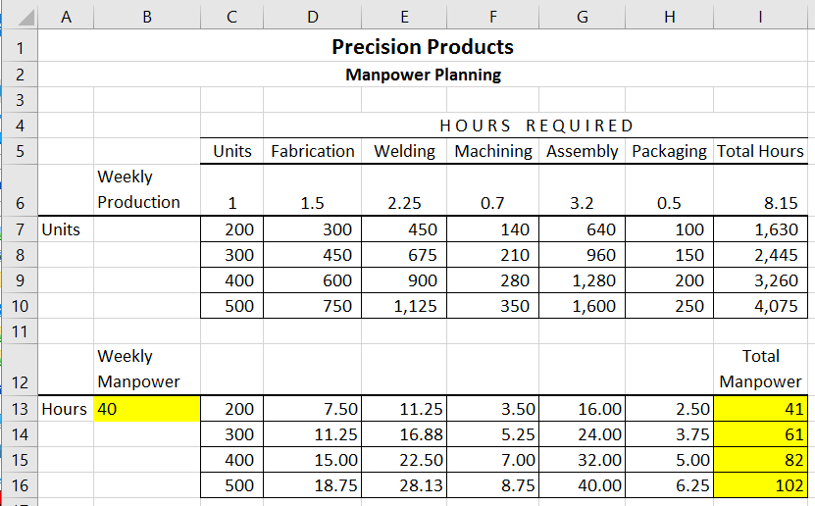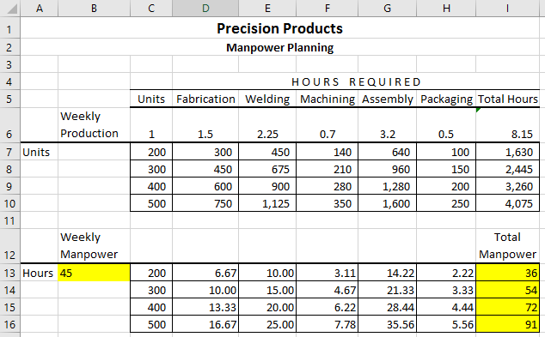

**1-20. Access Application: Information Systems in Business**

**Seconds Later, a clothing consignment shop, is fast becoming a favorite place to shop. The owner has asked you to create an Access database to help manage inventory. Download and import the information provided in the spreadsheet Ch01Ex02 to create a database with two tables (Consignors and Items). The owner wants you to add a calculated field to the items table that shows the net selling price after he has paid the commission to the consignors. Start with two reports: an Inventory Report and a Consignor Report. The Inventory Report summarizes the inventory by item type. This report will include the number of items and the total selling price for each item type, plus the total sales value of each inventory type. It will also include the total potential commission to be earned if all items are sold. The Consignor Report will list the total number of items and the total selling price and commission to be paid for each consignor. What other reports could you make with this data that would be useful to the owner?**

Students should produce an Access database with two tables by importing data from the Excel file named Ch01Ex02. In Access 2010, you can create table fields that calculate values. In Access 2007, calculated fields are created in a query. Students should create queries to produce the Inventory Report and the Consignor Report, using the Property sheet caption field to name the columns and the format function to show values as currency.



**Solutions to Case Study Questions**

**Case 1—Nasdaq’s Information Challenges: Facebook’s Botched Public Opening and High-Frequency Trading**

**1-21. How has Nasdaq’s business benefited from the use of information systems?**

The purpose of the first two questions for this case is to have students consider how information systems (IS) can transform an organization. Nasdaq is a technology company that would not be possible without IS. IS enabled Nasdaq to enter the trading market even after the NYSE was well established, to offer customers a full range of trading services even as a relatively new organization, and to achieve an advantage in speed compared with other exchanges. Further, IS are a source of revenue growth for Nasdaq, as Nasdaq has sold its technology to other countries and the IT department directly supports Nasdaq’s new business strategies.

**1-22. What risks do information systems pose for Nasdaq OMX’s business?**

The purpose of this question is to have students give a balanced consideration to the risks of IS as well as the benefits of IS. The benefits of IS were addressed in question 1 above, and this question addresses risks. One risk is that IS lowers the cost of doing business for all firms in an industry, which is likely to lead to lower prices. Nasdaq must manage this risk by finding ways to remain profitable even in an environment of lower prices. A second risk is that IS can contribute to high market volatility, which could lead to a loss of investor confidence and cause instability for the entire industry. To manage this risk, Nasdaq would want to be involved in the creation of industry-wide technical and trading standards to achieve greater stability.

**1-23. This chapter discusses the value of information. What types of information are handled through Nasdaq systems, what are the key characteristics of this information, and how do Nasdaq customers use this information to create value?**

The purpose of this question is to have students focus on the “information” aspect of IS. The most critical components of information handled through Nasdaq systems are the security name, price, seller, buyer, and time of the trade. One interesting characteristic is that this information is constantly changing. For example, from one moment to the next, the price of a security will change and the seller willing to sell the security at that price will change. Nasdaq customers create value based on access to timely information, as a customer may want to buy at a certain price, sell at a certain price, or transact on an exchange with a certain level of commission.

**1-24. What does the example of Goldman Sachs paying to locate its server in the Nasdaq data center say about the relationship between information systems and physical operations?**

The purpose of this question is to help students understand the relationship between technical considerations and physical operations. This theme will surface in several cases throughout the textbook. Given the importance of timeliness to Nasdaq customers (see question 3 above), even with high-speed IS there is a small benefit in response time based on server location and the distance the information must travel to confirm trades. Trades are conducted within nanoseconds so any delays due to physical distance might be costly. Goldman Sachs is willing to pay a premium for server location, which represents yet another IS revenue source for Nasdaq. Even in automated operations, students will need to understand where physical location may still make a difference for firms, workers, and customers.

**Case 2—Breaking News: Twitter’s Growing Role in Emergencies and Disaster Communications.**

**1-25. What are the potential benefits of Twitter and other social media for emergency and disaster communications?**

The purpose of the first two questions for this case is to have students consider how IS can transform a public service. Although emergency and disaster communications have developed through the years based on existing technologies (such as an air horn for a tornado watch, or the Federal Emergency Alert System [EAS] through television and radio), new technologies such as Twitter and social media offer potential benefits for these communications. For example, social media enable emergency and disaster communications to originate from multiple locations at the same time (while an air horn or a news reporter operates from only one location at a time). Social media also enable emergency and disaster communications to be constantly updated in real-time.

**1-26. What are the potential risks of using Twitter and other social media for emergency and disaster communications?**

The purpose of this question is to have students give a balanced consideration to the risks of IS as well as the benefits of IS. The benefits of IS were addressed in question 1 above, and this question addresses risks. One risk is that the IT and telecommunications infrastructure on which social media operates could be overloaded or cease to operate in a disaster. For example, on September 11, 2001 many mobile phone circuits in large cities were overloaded by excessive demand. To manage this risk, providers would need to look at the robustness of their infrastructure in the face of peak demand, and the flexibility of infrastructure to reroute traffic if some nodes are damaged. A second risk is that because various individual citizens are preparing updates, the updates may vary in depth and accuracy. Management of this risk will be discussed in the next question.

**1-27.** **What types of education would be necessary at the user level to make Twitter and other social media more effective for emergency and disaster communications?**

The purpose of this question is to have students consider the value chain in social media. As social media begins to play a role in functions (such as public safety) that were previously handled by firms, students need to understand how the related value chains may be impacted. The key objectives of educating citizens on the use of social media in emergencies would be to reduce variability and increase quality and timeliness of communications. Accordingly, it would be useful to educate citizens on basic principles (such as syntax) of using social media for emergency communications. It is also important to remind citizens to issue genuine communications, and to prioritize urgent communications during an emergency or disaster.

**1-28. What would need to happen on the part of aid organizations and traditional media for Twitter and other social media to be effective in emergency and disaster communications?**

The purpose of this question is for students to continue the discussion from question 3 and consider the value chain implications of using social media for emergency and disaster communications. Although citizens may originate the communications, aid organizations and traditional media would still need to monitor the communications, integrate the communications, and prioritize the communications so that appropriate action can be taken. Aid organizations also need to coordinate directly with each other to ensure that they do not duplicate efforts in the response, and that they allocate resources efficiently to address all important areas in a timely manner.

**Solutions to E-Project Questions**

**E-Project 1—Analyzing the May 6 “Flash Crash” with Excel Charts**

**1-29. Download the Ch01_AAPL Excel file, which contains the high, low, and closing prices for Apple Computers between May 3 and May 14. (AAPL is the ticker symbol for Apple.) Open the file to see how the data are arranged in columns, with the first row showing the column headers.**

**a) What was the closing price for Apple on May 6?**

On May 6, the closing price for Apple stock was $60.75 per share.

**b) What was the volume of trading for this stock on May 6?**

On May 6, 28,560,400 shares of Apple stock were traded.

**1-30. Create a line graph from the AAPL data, in which the dates are on the *x*-axis (horizontal), and the stock prices are on the vertical *y-*axis. Include the opening price, high, low, and closing price on the graph. Add a title to the top of your chart.**

The line graph would appear as follows:



**1-31. Download Expedia stock prices (ticker symbol EXPE) for the same time period (May 3–May 14, 2010) from http://finance.yahoo.com. (Click on Historical Prices, under QUOTES.)**

**a) Create a line graph to compare the Low and Closing prices for Apple stock and Expedia stock. You do not need to include Open and High prices on this graph.**

The line graph would appear as follows:



**b) How do you compare the activity on those two stocks?**

Apple experienced a significant intraday price decline (Low stock price) on May 6 during the “flash crash,” while Expedia did not experience a significant decline that day.

**E-Project 2—Gathering, Visualizing, and Evaluating Reports from Twitter and Other Sources During a Disaster**

**Download the Excel file called “Ch01_OilSpill,” which contains sample reports, and answer the following questions:**

**1-32. First, select columns B through F and reformat them with the word “wrap,” so you can easily see the actual comments people sent in.**

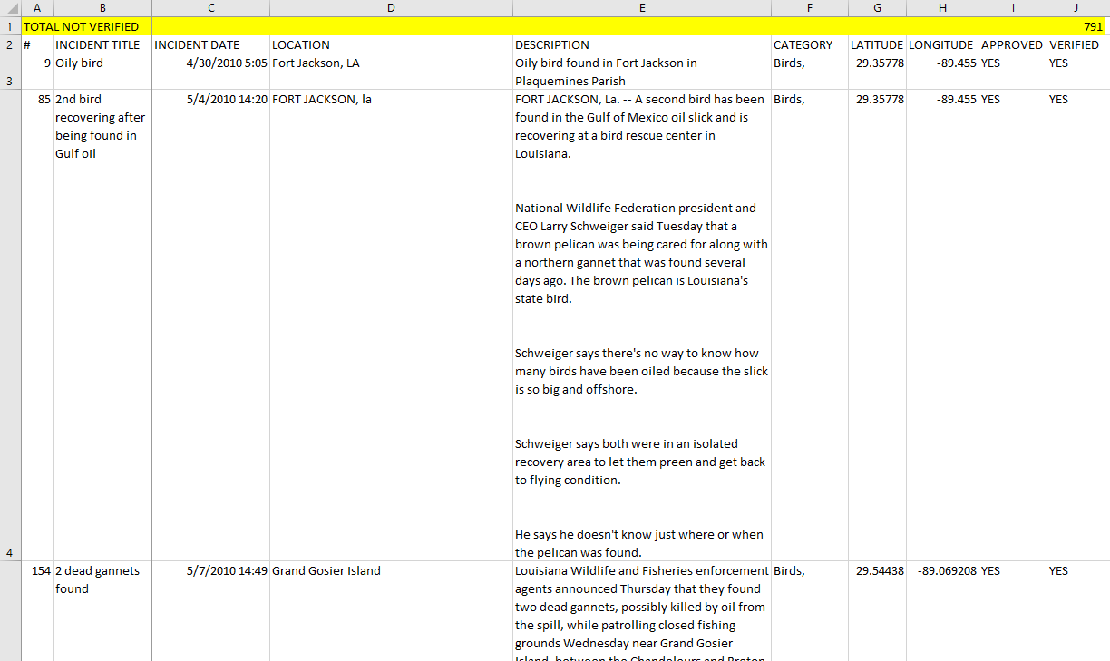

Using word “wrap,” the spreadsheet should now appear consistent with the sample of title and first two lines of data below:

**1-33. Suppose you have a friend who lives in Bay Champagne. First sort the table by LOCATION, and scroll down to Bay Champagne. How many reports do you find using this strategy? Why would this approach be limited in terms of its ability to find all the events that may have affected your friend?**

Eight reports were found. This search strategy is limited for at least two reasons. First, a user may miscount the number of rows when data is sorted. Second, it is possible that Bay Champagne may be mistyped for other entries (for example, “Champagne Bay”) and may not show next to the other eight Bay Champagne entries in the spreadsheet.

**1-34. For crisis management, timeliness is important, but so is accuracy. How many reports in this sample were not verified (NO in the Verified column)? You can use Excel’s ‘countif’ function to determine the number of NO and YES responses. What is the percentage of total reports that have not been verified?**

The verified column indicates that 791 out of 2464 reports (32.1 percent) have not been verified.

**1-35. Sort the file by CATEGORY then by LOCATION. Take a look at the reports that are categorized as Health Effects in Grand Isle. Why do you think many of these reports are not verified?**

Many reports of Health Effects in Grand Isle involve internal symptoms (such as coughing or difficulty breathing) that may be more difficult to verify during a reporting visit. This may be partly because the symptom may not manifest during the reporting visit, and partly because the report data collection involved verbal interviews rather than medical examinations.