Chapter 1  
Introduction

# Review Questions

1.1-1 The rapid development of the discipline began in the 1940’s and 1950’s.

1.1-2 The traditional name given to the discipline is operations research.

1.1-3 A management science study provides an analysis and recommendations, based on the quantitative factors involved in the problem, as input to the managers.

1.1-4 Management science is based strongly on some scientific fields, including mathematics and computer science. It also draws upon the social sciences, especially economics.

1.1-5 A decision support system is an interactive computer-based system that aids managerial decision-making. The system draws current data from databases or management information systems and then solves the various versions of the model specified by the manager.

1.1-6 Many managerial problems revolve around such quantitative factors as production quantities, revenues, costs, the amounts available of needed resources, etc.

1.2-1 The production and sales volume needs to exceed the break-even point to make it worthwhile to introduce a product.

1.2-2 The number of watches produced cannot be less than 0, nor should it exceed the number that can be sold. Also, the objective is to make the decision that maximizes the company’s profit.

1.2-3 The purpose of what-if analysis is to check the effect on the recommendations of a model if the estimates turn out to be wrong.

1.2-4 Simply enter a variety of new values and see what happens.

1.2-5 The MIN(*a*, *b*) function gives the minimum of *a* and *b*.

1.2-6 The IF(*a*, *b*, *c*) function returns *b* if *a* is true, otherwise it returns *c*.

# Problems

1.1 If *Q* units are produced per month, then  
 Monthly Profit = $0 {if *Q* = 0} and –$20,000 + ($20 – $10)*Q* {if *Q* > 0}.  
Break-even point = $20,000 / ($20 – $10) = 2000, so it will be profitable to produce if Q > 2000.

1.2 a) $40,000

b) $15.

c) $15.

1.3 a) Let *Q* be the number of units produced and sold. Then  
 Monthly Profit = $0 {if *Q* = 0} and –$500,000 + ($35 – $15)*Q* {if *Q* > 0}.  
 Break-even point = $500,000 / ($35 – $15) = 25,000.

b) Let *Q* be the number produced and *s* the number that can be sold. Then  
 Profit = [0 if *Q* = 0] and [-$500,000 + $35 * MIN(*Q*, *s*) – $15*Q* if *Q* > 0].

c)



d) *Q* ≤ *s*.

1.4 a) $30,000,000

b) $1,666.67

c) $1,333.33

1.5 a)



b) Break-even point = ($10,000,000) / ($1700 – $1300) = 25,000.

c) Maximize Profit = $0 {if *Q* = 0} and –$10,000,000 + $400*Q* {if *Q* > 0}  
subject to 0 ≤ *Q* ≤ *s*.

d)



e)



1.6 a) Jennifer must decide how much to ship from each plant (A and B) to each retail outlet (1 and 2). Let *xˆj* = amount to ship from plant *i* (for *i* = A, B) to each retail outlet *j* (for *j* = 1, 2).

b) Shipping Cost = $700*xA1* + $400*xA2* + $800*xB1* + $600*xB2*

c) *xA1* + *xA2* = 30; *xB1* + *xB2* ≤ 500; *xA1* + *xB1* = 40; *xA2* + *xB2* ≥ 25; all *xij* ≥ 0.

d) Minimize Shipping Cost = $700*xA1* + $400*xA2* + $800*xB1* + $600*xB2*subject to  
 *xA1* + *xA2* = 30  
 *xB1* + *xB2* ≤ 500  
 *xA1* + *xB1* = 40  
 *xA2* + *xB2* ≥ 25  
and  
 all *xij* ≥ 0

e) Jennifer should ship all of Retail Outlet 2’s 25 units from Plant A because it is $200 cheaper than from Plant B. Retail Outlet 1 should get all it can from Plant A (5 units) because it is $100 cheaper than from Plant B. The remaining 35 units should come from Plant B. The decision variables would be *xA1* = 5, *xA2* = 25, *xB1* = 35, *xB2* = 0.

1.7 a)  
  
They should produce the motors internally.



b) Break-even point = $1,000,000 / ($2,000 - $1,600) = 2,500.

1.8 a)



b) The make option appears to be better ($20,000,000 profit for the *make option* vs. $17,500,000 profit for the *buy option*).

c) *Q* = number of watches to produce for sale.  
Make Option: Profit = $0 {if *Q* = 0} and –$10,000,000 + $1,000*Q* {if *Q* > 0}.  
Buy Option: Profit = $0 {if *Q* = 0} and –$5,000,000 + $750*Q* {if *Q* > 0}.  
  
Incremental profit from choosing make option rather than buy option  
 = $0 {if *Q*=0} and  
 = –$5,000,000 + $1,000*Q* – $750*Q* = –$5,000,000 + $250*Q* {if *Q* > 0}.  
  
Mathematical model:  
Now interpret *Q* as the number to produce with the make option. The model is to find the value of *Q* so as to  
  
Maximize Incremental Profit  
 = $0 {if *Q*=0} and  
 = –$5,000,000 + $250*Q* {if *Q* > 0}  
  
subject to  
 *Q* ≤ *s* (sales forecast)  
 *Q* ≥ 0.

d)



e) Make-option cost = $10,000,000 + $1000*Q*  
Buy-option cost = $5,000,000 + $1250*Q*  
Break-even point = $5,000,000 / ($1250 – $1000) = 20,000 units.

f)  
  
If *s* ≤ 20,000, then set *Q* = 0 (so buy instead of make).  
If *s* > 20,000, then set *Q* = *s* (so make option with *Q* = *s*).  
Since *s* = 30,000, use make option and produce 30,000 watches.



1.9 An answer for the selected application can be found by referring to the corresponding question in the chapter indicated in Table 1.1 and then reading its answer in this Solutions Manual.

1.10 Find the answers as described above for Problem 1.9.

1.11 This article describes the dramatic story of how management science (referred to as operations research or OR in the article) played a fundamental role in enabling the Federal Express Corporation (FedEx) to become the world’s largest express transportation company. The five major reasons why management science has been so successful at FedEx are described on pages 33-34 of the article. Here is one way of summarizing the reasons.

(1) Because of the high levels of interdependencies among the parts of the FedEx business, its route structures and operations are amenable to modeling and analysis.

(2) Throughout the history of the company, the founder and CEO has strongly supported using management science to help deal with issues of crucial importance to the firm.

(3) From the beginning, the management science team used practical (not esoteric) modeling to focus on issues that were crucial to the business.

(4) Through continual dialogues, the management science team and executive management jointly arrived at shared understandings of the trade-offs and compromises needed to achieve the company’s overall corporate goals.

(5) The management science team constantly updated the relevant facts and assumptions for its analysis.

# Case

1.1 a&b) The break-even quantity is 100 units.



c) Profit = [0 if *Q* = 0] and [-$250,000 + $4500 * MIN(*Q*, *s*) – $2000 * *Q* if *Q* > 0].

d)



e) Break-even point = $250,000 / ($4500 – $2000) = 100, so it will be profitable to produce if Q > 100.

f) The fixed cost of designing and setting up the production facility can be as high as $750,000 before it becomes unprofitable to produce the clocks.

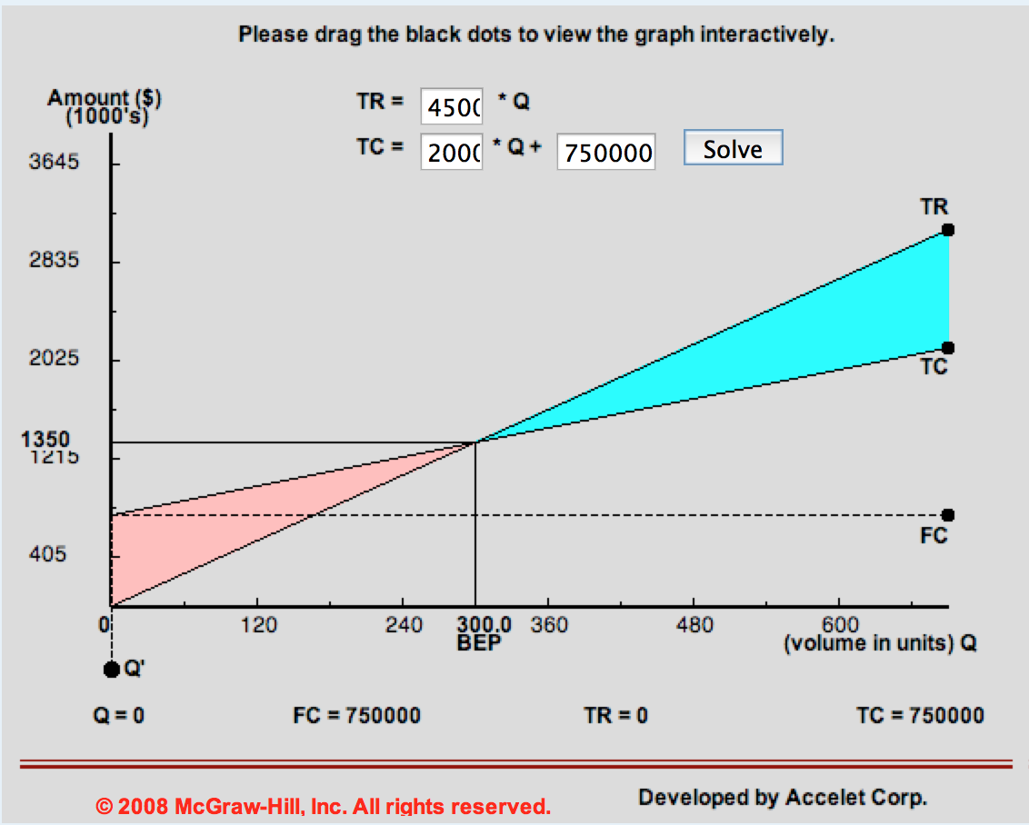

g) The production cost can be as high as $3,666.67 before it becomes unprofitable to produce the clocks.

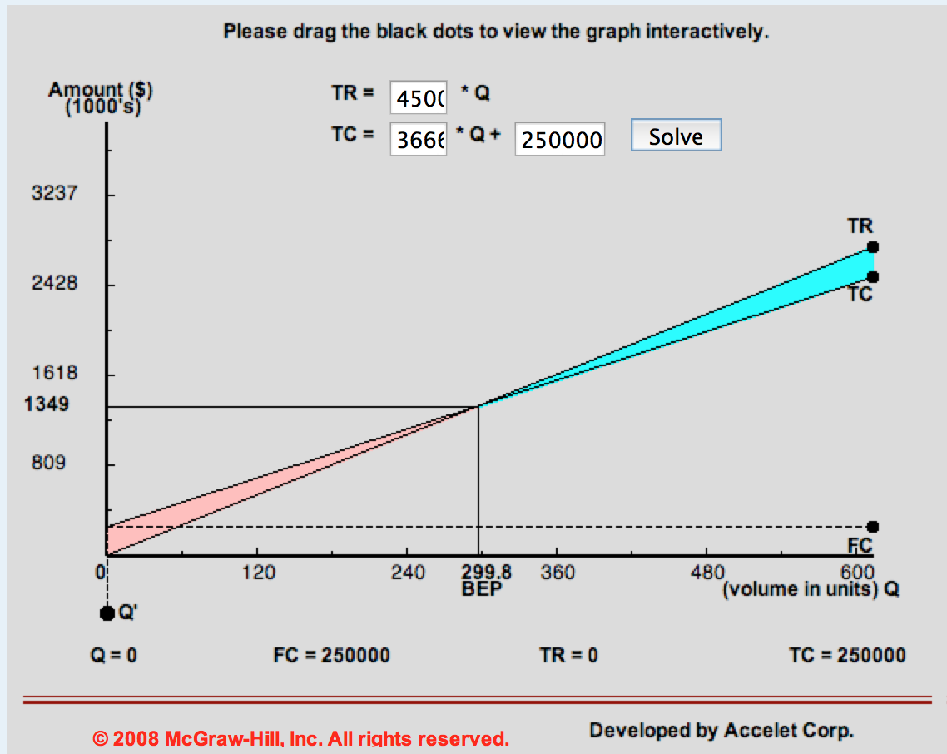

h) If the design and setup cost were 50% higher ($375,000) and the production cost were 50% higher ($3000), then the break-even point would be 250. With a sales forecast of 300, it would still be profitable to produce the clocks.

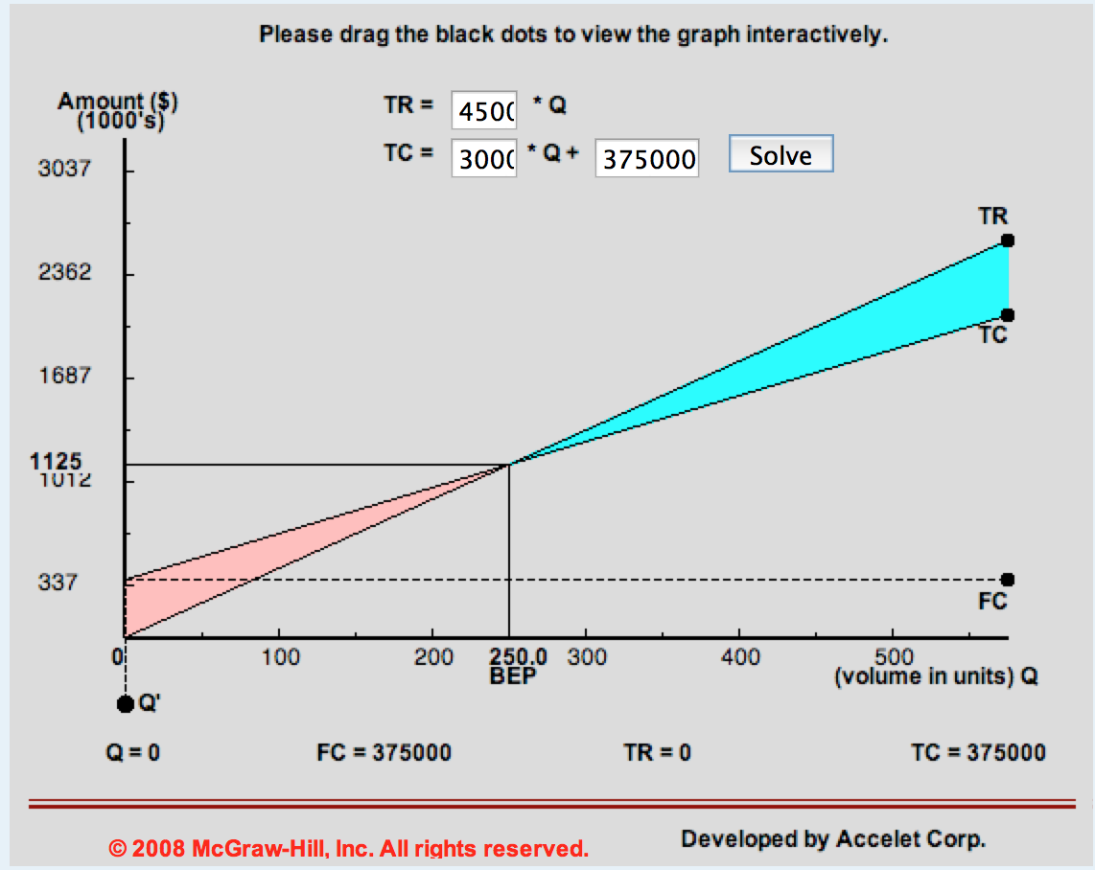

i) The selling price can be as low as $2833.34 and it would still be profitable to produce the clocks.

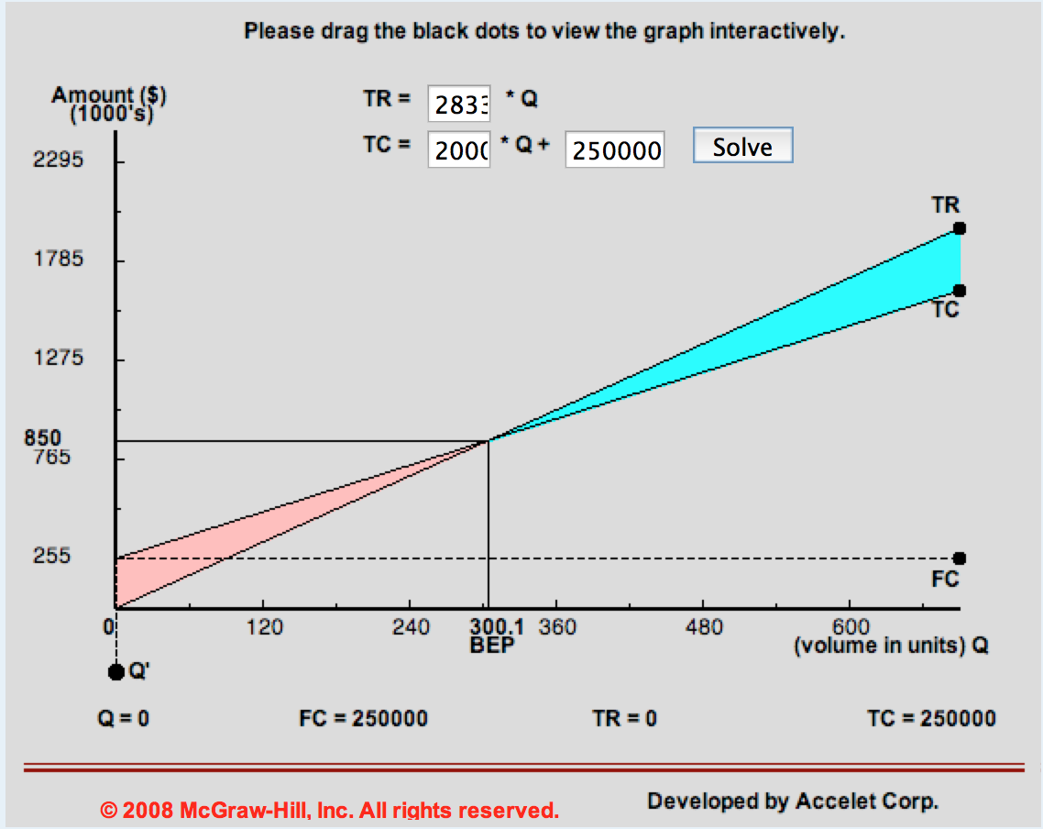

j) Profit = $4500 * (200) - $2000 * $300 - $250,000 = $50,000. Yes it would still be profitable.