_____________________________________

Part Seven

An Introduction to Macroeconomics
_____________________________________

This Part of the book provides an introduction to macroeconomics. Instructors who are pressed for time can probably have students read Chapter 19 independently. It is an introductory chapter that does not contain any significant ideas not examined in more detail later in the text. The chapter is also almost exclusively descriptive as opposed to analytical. For these reasons, students can read the chapter to whet their appetite for what is to come. Chapter 20, which examines the measurement of national income, is core material and should be discussed in class.
***
It is worth emphasizing at the outset which general approach to macroeconomics is taken in this textbook.
Broadly speaking, there are two different streams of research in macroeconomics, even though the researchers in the two groups are generally interested in understanding the same macroeconomic phenomena. The first group of researchers takes an approach to macroeconomics that is based explicitly on microeconomic foundations. These economists build models of the economy that are populated by workers, consumers, and firms, all of whom are assumed to be optimizers – that is, individuals are assumed to maximize their utility and firms are assumed to maximize their profits. Having explicitly modelled these agents' optimization problems, and their resulting choices for work effort, consumption, and investment, the economists proceed to aggregate the choices of these agents to arrive at the model's values for aggregate employment, consumption, output, and so on.
The second group of researchers builds macroeconomic models based only implicitly on these same micro foundations. Although they often analyze the behaviour of individuals and firms, they do not formally aggregate their behaviour to derive the aggregate relationships in their models. Instead, these economists construct their models by using aggregate relationships for consumption, investment, and employment, each of which has been subjected to extensive empirical testing and is assumed to represent collectively the behaviour of the many firms and consumers in the economy.
A second difference between these two general approaches relates to the assumptions regarding the flexibility of wages and prices. Economists using the first approach usually assume that wages and prices are flexible and thus adjust quickly to clear their respective markets. In contrast, economists using the second approach usually assume that because of the nature of well-established institutions in both labour and product markets, such as labour unions, long-term employment contracts, or costs associated with changing prices, wages and prices are slow to adjust, and thus markets can be in disequilibrium for longer periods of time.
This textbook follows the second approach to macroeconomic analysis. The macro model we begin building in Chapter 21 is not formally derived from the behaviour of optimizing firms and consumers, although the macro relationships we introduce are well motivated by micro economic behaviour. Moreover, the model begins in its simplest version by assuming no wage and price flexibility. But as we gradually make the model more complicated and also more realistic, we introduce some wage and price flexibility. In later chapters we will see that the degree of wage and price flexibility is crucial in determining how the economy responds to shocks of various kinds, including changes in government policy. We will also see that our macroeconomic model is sufficiently versatile that we can use it to illustrate the case of perfect wage/price flexibility as a special case.
***
Chapter 19 begins with a brief discussion of how the experience of the recent global financial crisis underlines the importance of understanding central macro relationships. The chapter then proceeds through introductory discussions of national income, the price level and inflation, employment and unemployment, productivity, interest rates and credit flows, the exchange rate, and international trade. There are several interesting boxes throughout these introductory discussions that deal with the definitions or construction of the various macroeconomic variables. The chapter’s final section emphasizes that the major macroeconomic issues generally fit into one of two categories: long-run economic growth and short-run economic fluctuations. Importantly, questions of appropriate fiscal and monetary policies enter both categories.
Chapter 20 examines the measurement of national income. Here we emphasize the circular flow of income and expenditure, and discuss how this idea lies at the heart of the national income and product accounts. We stress that there are three ways to measure national income, all of which must give the same answer: the sum of values added; the sum of expenditures; and the sum of factor incomes. This chapter also discusses the distinction between real and nominal measures of national income, and thus presents the basics of the (implicit) GDP deflator. The chapter ends with the discussion––one we think should be emphasized in class––of things not included in conventional measures of national income. Students should be made aware of the fact that, although measures of national income do a pretty good job of measuring the flow of marketed output in the economy, they do not measure (and nor are they designed to measure) overall welfare or well-being. It is easy to think of examples where GDP rises but overall welfare declines.
___________________________________________

Chapter 19: What Macroeconomics Is All About
___________________________________________

The chapter begins with a brief discussion of how the experience of the recent global financial crisis underlines the importance of understanding central macro relationships. We then turn to a simple comparison of macroeconomics and microeconomics. Students who have just finished a study of microeconomics should be referred back to Chapter 3 for a quick review of the difference.
The remainder of the chapter is devoted to a study of key macroeconomic variables. Potential and actual GDP, the labour force, employment, unemployment, the price level and inflation, productivity, interest rates and credit flows, and the exchange rate are defined and their behaviour over the last few decades examined. We also include a discussion of why policymakers are concerned with each of these variables. This chapter is designed to make students think about why the performance of these variables matters.
The chapter’s final section stresses that most major macroeconomic issues generally fit into one of two categories: long-run growth and short-run fluctuations. Importantly, questions of appropriate fiscal and monetary policies enter in both categories.

Answers to Study Exercises

Question 1
a) Gross Domestic Product (GDP); product; income
b) value terms (dollars)
c) prices; quantities
d) potential output
e) actual GDP; potential GDP; actual GDP; potential GDP; actual GDP; potential GDP

Question 2
a) working (employed); not working but looking for work (unemployed); unemployed; labour force
b) frictional unemployment; structurally
c) 137; 37 percent
d) (125.1 – 122.5)/(122.5) = 2.6/122.5 = 2.1 percent
e) interest rate
f) minus
g) exchange rate
h) rise; fall

Question 3
a) The output gap is equal to (Y–Y*). When expressed as a percentage of potential output we have (Y–Y*)/Y*. The output gaps for the nine years in the table are:
2008: gap = (1168–1188)/1188 = -20/1188 = –1.7%
2009: gap = (1184–1196)/1196 = -12/1196 = –1.0%
2010: gap = (1197–1205)/1205 = -8/1205 = –0.7%
2011: gap = (1211–1215)/1215 = -4/1215 = –0.3%
2012: gap = (1225–1225)/1225 = 0/1225 = 0.0%
2013: gap = (1240–1236)/1236 = 4/1236 = 0.3%
2014: gap = (1253–1247)/1247 = 6/1247 = 0.5%
2015: gap = (1262–1258)/1258 = 4/1258 = 0.3%
2016: gap = (1270–1270)/1270 = 0/1270 = 0.0%
b) Potential GDP is the level of output produced when all factors of production are being used at their normal rates. Output can exceed potential when labour works overtime or when capital and land are used more intensively than normal.
c) A recessionary output gap only requires Y to be below Y*. It does not require Y to actually fall. When Y does fall, we usually say there is a recession. In the data shown, GDP rises steadily, so there is no recession (but there is a recessionary output gap from 2008 through 2011).
d) When the economy is at “full employment”, with GDP equal to potential GDP, we often say that the unemployment rate is at its “natural rate”. GDP equals potential GDP in two years—2012 and 2016. In both years the unemployment rate is 7.6%. So the natural rate of unemployment is 7.6%. When unemployment is at its natural rate, the only unemployment is frictional and structural. There is no cyclical (or deficient demand) unemployment.

Question 4
a) During booms, the prospects of finding a job improve, and this may lead people who are currently outside the labour force to enter the labour force and begin searching for jobs.
b) Even if employment is rising during a boom, the entry of new job searchers into the labour market, who are counted as unemployed workers, may actually lead to an increase in the measured unemployment rate.
c) If discouraged unemployed workers leave the labour force, the measured unemployment rate will tend to fall.
d) This is not obviously true. The unemployment rate could fall because of a reduction in unemployment and a rise in employment (with a constant labour force). In this case, most people would see this as clearly positive. But if employment is constant and discouraged workers leave the labour force, the measured unemployment rate will fall even though there is little positive in this situation. For this reason, many economists prefer to focus on the pattern of employment rather than the unemployment rate.

Question 5
The unemployment rate is equal to the number of people unemployed divided by the number of people in the labour force (which is itself equal to the number employed plus the number unemployed).
a) Unemployment rate = 1.5 million / 20 million = 7.5%.
b) Number unemployed = 16 million – 14 million = 2 million. Unemployment rate = 2 million / 16 million = 12.5%.
c) Labour force = 900,000 + 2.25 million = 3,150,000. Unemployment rate = 900,000 / 3,150,000 = 28.6%.
d) Unemployment rate = 500,000 / 8.2 million = 6.1%.

Question 6
Output per worker is GDP/L, where GDP is output and L is the number of workers. Clearly, GDP can rise even though GDP/L may fall. Algebraically, this will happen if L is rising faster than GDP. In the absence of technical change, this outcome may simply reflect the diminishing returns to labour. Over a ten-year period, however, this is probably only possible if the rate of technical progress is small or if the rate of increase in the other factors of production (especially capital) is small. Is this good for the economy? Overall living standards depend on the amount of output per person, rather than on the amount of total output. A decline in output per worker, if sustained over many years, is probably undesirable because average material living standards will be declining.

Question 7
a) The rate of inflation for the current year is equal to the percentage change in the CPI from the previous year to the current year. The CPI in the current year is equal to the CPI from the previous year times one plus the current year’s rate of inflation (expressed as a growth rate). The missing data are:
2004: inflation = (104.7 – 102.8)/102.8 = 0.0185 = 1.85%
2005: inflation = (107.0 – 104.7)/104.7 = 0.0220 = 2.20%
2006: CPI = (107.0)(1.020) = 109.1
2007: CPI = (109.1)(1.021) = 111.4
2009: inflation = (114.4 – 114.1)/114.1 = 0.0026 = 0.26%
2010: CPI = (114.4)(1.018) = 116.5

2012: inflation = (121.6 - 119.9)/119.9 = 1.4%
2013: CPI = (121.6)(1.012) = 123.1
2014: inflation = (125.7 – 123.1)/123.1 = 2.1%
b) The CPI never falls (in annual data) between 2003 and 2014 and thus average prices (as shown) never fall. Average prices come closest to being stable in the year with the lowest rate of inflation—from 2008 to 2009, the inflation rate was only 0.26%.
c) The rate of inflation is the closest to being stable between 2006 and 2007, 2.0% and 2.1% respectively.
d) See the diagram below. With the price level on the vertical axis, a stable price level is shown by a line with zero slope—a horizontal line. A stable rate of inflation, however, is shown by a line that is not only upward sloping but with ever-increasing slope. This is because a constant percentage change in the price level means that in each successive year the price level increases by more and more in absolute terms. For example, with a 10% rate of inflation, the price level progresses from 100 to 110 to 121 to 133.1 to 146.4 to 161.1 to 177.2 to 194.9 etc.

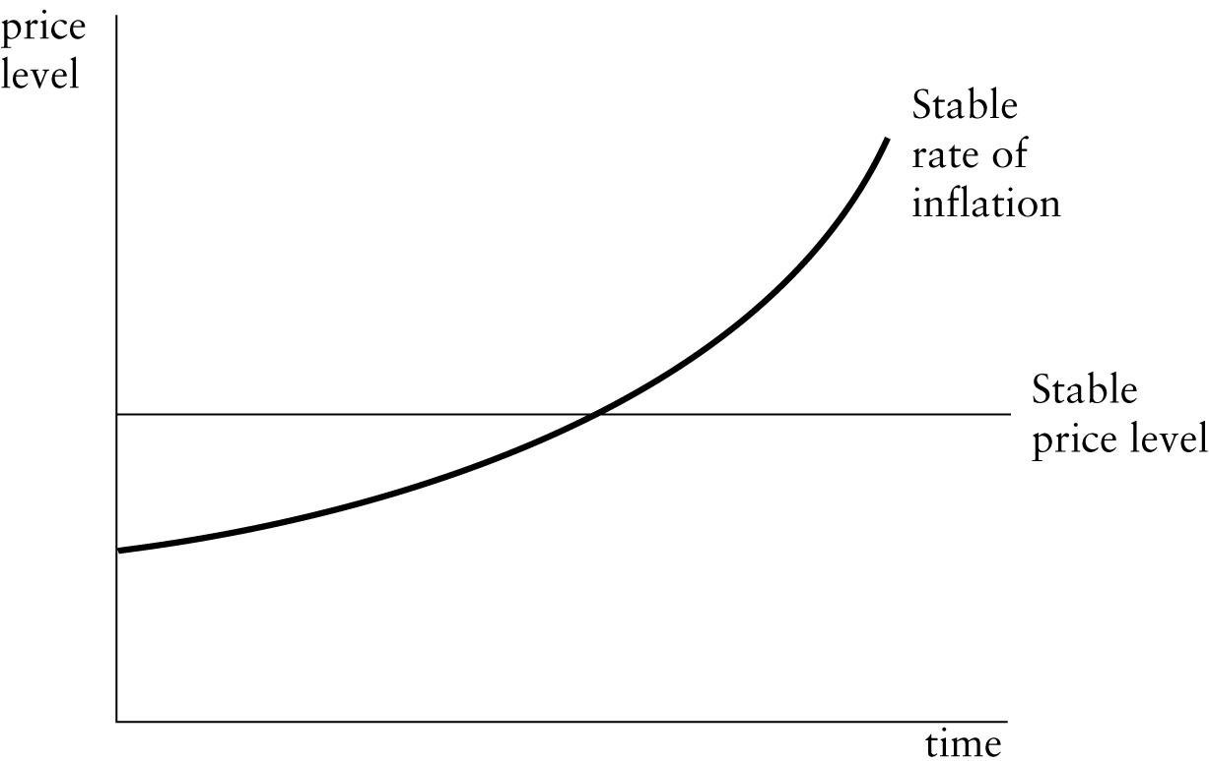

Question 8
These data are drawn from The Economist, in February 2015.
a) The real interest rate is technically defined to be the nominal interest rate minus the expected rate of inflation. But if expectations of the future are determined by the current inflation rate, then the real interest rate is equal to the nominal interest rate minus the current inflation rate. The real rates (r, in percent per year) for the various countries are:
Australia: r = 2.60 – 1.7 = 0.90
Canada: r = 1.47 – 1.5 = - 0.03
Euro area: r = 0.38 – -0.6 = 0.98
Japan: r = 0.39 – 2.4 = -2.01
Switzerland: r = 0.05 – -0.5 = 0.55
UK: r = 1.75 – 0.3 = 1.45
USA: r = 1.10 – 0.8 = 0.30
b) Lenders seek the highest real rate of return (assuming that the risk of default and exchange-rate changes is held constant). The highest real interest rate in February of 2015 was available in the UK.
c) Borrowers seek the lowest real rate of return (assuming that the risk of exchange-rate changes is held constant). The lowest real interest rate in February of 2015 was in Japan (where the real interest rate was negative).

Question 9
These data are drawn from The Economist in June of 2012.

 | Canadian-Dollar Exchange Rate
Currency | June 2012 | June 2011
U.S. dollar | 1.03 | 0.98
Japanese yen | 0.013 | 0.012
British pound | 1.58 | 1.61
Swedish krona | 0.14 | 0.16
Euro | 1.29 | 1.44

a) To see which currencies appreciated relative to the Canadian dollar, we need to see the currencies for which the Canadian exchange rate increased — because this means that it took more Canadian dollars to purchase one unit of these foreign currencies in 2012 than in 2011. The answers are: the U.S. dollar and the Japanese yen appreciated against the Canadian dollar during this time period.
b) By the same logic (in the opposite direction), the British pound, the Swedish krona, and the euro all depreciated against the Canadian dollar between June 2011 and June 2012 — during this period, the number of Canadian dollars required to purchase one unit of these foreign currencies fell.
c) From June 2011 to June 2012, the Canadian dollar depreciated against the U.S. dollar. Over the same period, the Canadian dollar also depreciated against the yen. But what happened to the U.S. dollar relative to the yen?
Begin with June 2011.
1 $ Cdn = 0.98 $U.S. but also 1 $ Cdn = 83.33 Japanese yen.
Thus 0.98 $ U.S. = 83.33 Japanese yen. Thus 1 $ U.S. = 85.03 yen in June 2011.
Now do the same for June 2012.
1 $ Cdn = 1.03 $ U.S. but also 1 $ Cdn = 76.92 Japanese yen.
Thus 1.03 $ U.S. = 76.92 Japanese yen. Thus 1 $ U.S. = 74.68 yen in June 2012.
So from June 2011 to June 2012, the U.S. dollar depreciated (by about 13 percent) relative to the Japanese yen.

Question 10
It is important to realize that the exchange rate is simply a price and, like changes in the prices of other goods, a change in the exchange rate will typically be good for some people and bad for others. The question relates to a weakening of the Canadian dollar, meaning a depreciation of the Canadian dollar and thus a rise in the exchange rate (where we define the exchange rate to be the Canadian-dollar price of one unit of foreign currency). A depreciation of the Canadian dollar is good for anybody who wants to sell goods, services, or assets to foreigners because the weak Canadian dollar makes these products less expensive in the eyes of foreign buyers. The depreciation is bad for those who are buying foreign goods, for the weaker dollar implies a higher Canadian-dollar price of foreign goods.
It is also important to think about why the exchange rate changes and how the cause of the change determines whether it is “good” or “bad” for the Canadian economy overall. For example, a reduction in the world’s demand for Canadian goods will lead to a depreciation of the Canadian dollar. This depreciation may be good for some exporters (of the goods that are still in demand) but will clearly be bad for exporters as a group.
*****

