Appendix a
Linear programming Using THE EXCEL SOLVER
1. Excel Solution
 | X | Y | Total
Decision | 6 | 0
Profit | $3 | $1 | $18
 |  |  | Resources
 | X | Y | Used |  | Capacity
A | 12 | 14 | 72 | <= | 85
B | 3 | 2 | 18 | <= | 18
C |  | 1 | 0 | <= | 4

Graphical solution--the problem requested the Excel solution, but the following graphical solution is provided for classroom use if desired.
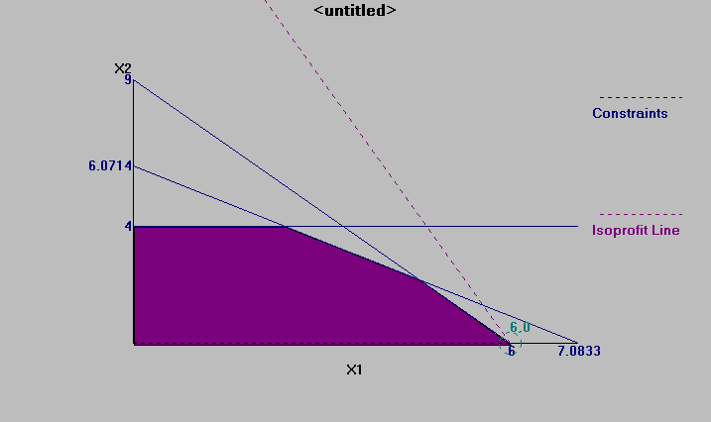
2.
 | A | B | Total
Decision | 15 | 10
Cost | $2 | $4 | $70
 |  |  | Resources
 | A | B | Used |  | Capacity
A | 4 | 6 | 120 | >= | 120
B | 2 | 6 | 90 | >= | 72
C |  | 1 | 10 | >= | 10

Graphical solution--the problem requested the Excel solution, but the following graphical solution is provided for classroom use if desired.
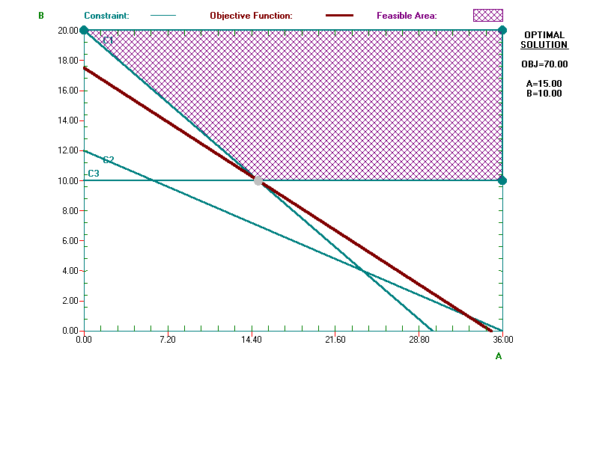
3. a. Maximize Z = 20X₁ + 6X₂ + 8X₃
s.t. 8X₁ + 2X₂ + 3X₃ < 800
4X₁ + 3X₂ < 480
2X₁ + X₃ < 320
X₃ < 80
X₁ , X₂ , X₃ > 0
b. Excel solution
 | X1 | X2 | X3 | Total
Decision | 45 | 100 | 80
Profit | $20 | $6 | $8 | $2,140
 |  |  |  | Resources
 | X1 | X2 | X3 | Used |  | Capacity
Milling | 8 | 2 | 3 | 800 | <= | 800
Lathes | 4 | 3 |  | 480 | <= | 480
Grinders | 2 |  | 1 | 170 | <= | 320
Sales |  |  | 1 | 80 | <= | 80

- Solution is X₁ = 45 S₁ = 0 Z = $2140
X₂ = 100 S₂ = 0
X₃ = 80 S₃ = 150
S₄ = 0
- S₁ = 0 implies milling machines at capacity
S₂ = 0 implies lathes at capacity
S₃ = 150 implies grinders not at capacity, with 150 hours available
S₄ = 0 implies that X₃ is at maximum sales capacity
- The shadow price for the milling machine department is $2.25 per hour. Since it only cost $1.50 per hour to work overtime in this department, it is worthwhile to do so. The allowable increase in overtime is 400; however, only 200 hours are available. Therefore, it is recommended that 200 hours of overtime in the milling machine department be used.

4. a.
Let A = pounds of food A
B = pounds of food B
Minimize : z = .75A + .15B
s.t. 600A + 900B < 3,600 Maximum calories
600A + 900B > 1,800 Minimum calories
200A + 700B < 1,400 Maximum starch
400A + 100B > 400 Minimum protein
A < 2 Maximum amount of A

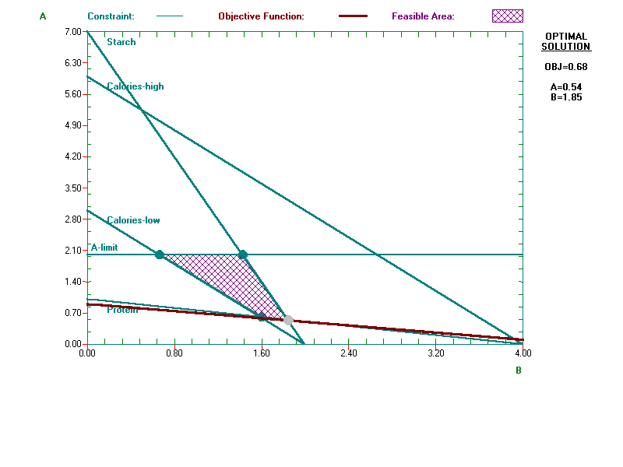
5. Add constraint 100B < 150, and change objective function to z = 1.75A + 2.50B
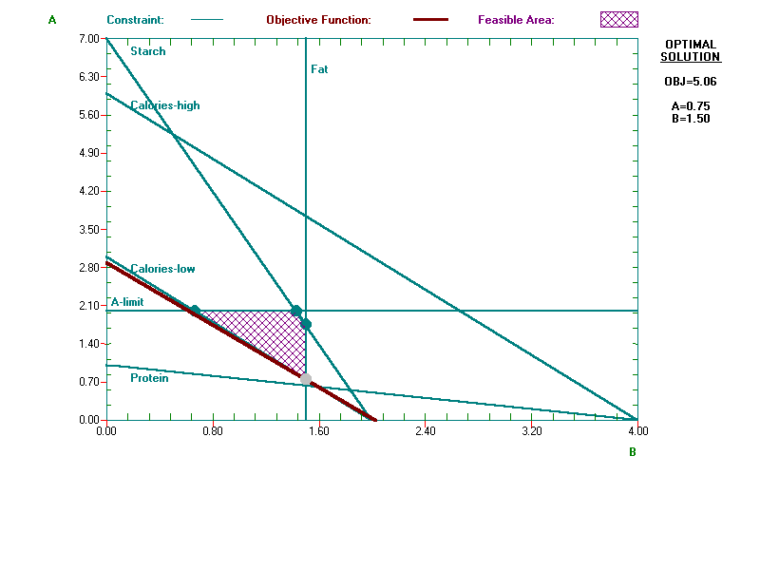
6. a.
Let A = gallons of fuel A to mix
B = gallons of fuel B to mix
Minimize z = 1.20A + 0.90B
s.t. A + B > 3,000 fuel demand
A + B < 4,000 Maximum storage
A < 2,000 Maximum fuel A available
B < 4,000 Maximum fuel B available
10A - 5B > 0 Blend 80 octane minimum*
A, B > 0 *Note, blend constraint can be stated as (90A + 75B)/(A + B) > 80
b.
 | A | B | Total
Decision | 1000 | 2000 | 3000
Cost | $1.20 | $.90 | $3,000
 |  |  | Resources
 | A | B | Used |  | Capacity
Min demand | 1 | 1 | 3000 | >= | 3000
Max Storage | 1 | 1 | 3000 | <= | 4000
Max Fuel A | 1 |  | 1000 | <= | 2000
Max Fuel B |  | 1 | 2000 | <= | 4000
Blend | 10 | -5 | 0 | > | 0

Graphical solution--the problem requested the Excel solution, but the following graphical solution is provided for classroom use if desired.
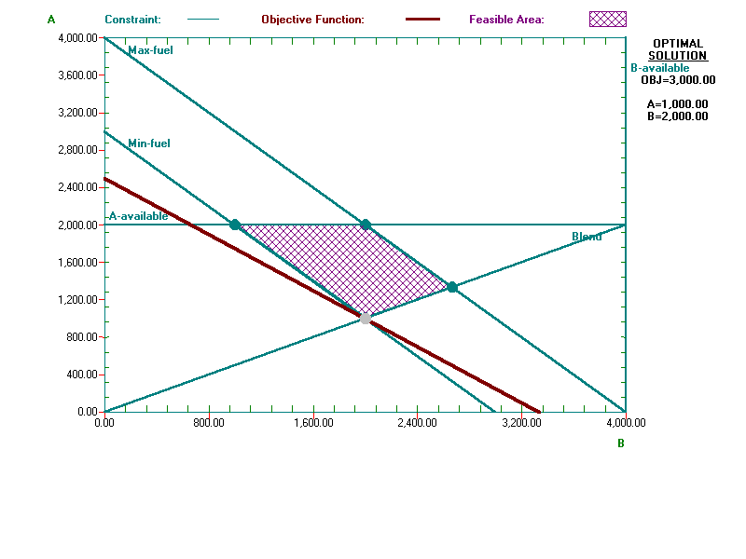
7. Let: F = dollars spent on food
S = dollars spent on shelter
E = dollars spent on entertainment
Maximize Z = 2F + 3S + 5E
s.t. F + S + E < 1500 Total Budget
F + S < 1000 Maximum on Food and Shelter
S < 700 Maximum on Shelter alone
E < 300 Maximum on Entertainment
 | F | S | E | Total
Decision | 300 | 700 | 300
Profit | 2 | 3 | 5 | 4,200
 |  |  |  | Resources
 | X₁ | X₂ | X₃ | Used |  | Capacity
total budget | 1 | 1 | 1 | 1300 | <= | 1500
$ on food and shelter | 1 | 1 |  | 1000 | <= | 1000
$ on shelter |  | 1 |  | 700 | <= | 700
$ on entertainment |  |  | 1 | 300 | <= | 300

8. Produce 50 barrels of Expansion Draft and 50 barrels of Burning River. The total revenue will be $1400.

 | Expansion Draft | Burning River | Total
Decision | 50 | 50
Sales | $20 | $8 | $1400
 |  |  | Resources
 | X₁ | X₂ | Used |  | Capacity
Corn | 8 | 2 | 500 | <= | 500
Rice | 0 | 6 | 300 | <= | 300
Hops | 4 | 3 | 350 | <= | 400

9. Run zone for 6 hours and man for 4 hours at a cost of $384.

 | Zone | Man | Total
Decision | 6 | 4
Cost | $48 | $24 | $384
 |  |  | Processes
 | X₁ | X₂ | Produced |  | Demand
BCP1 | 3 | 1 | 22 | >= | 20
BCP2 | 1 | 1 | 10 | >= | 10
BCP3 | 1 | 0 | 6 | >= | 6

10. She should plant 700 acres in corn and 100 acres in soybeans.

 | Corn | Soybeans | Wheat | Total
Decision | 700 | 100 | 0 | 800
Profit per acre | $2,000 | $2,500 | $3,000 | $1,650,000
 |  |  |  | Resources
 | Corn | Soybeans | Wheat | Used |  | Capacity
Labor (workers) | 0.1 | 0.3 | 0.2 | 100 | <= | 100
Fertilizer (tons) | 0.2 | 0.1 | 0.4 | 150 | <= | 150
Acres Planted | 1 | 1 | 1 | 800 | <= | 900

