# Chapter 2

2.1 Nominal: Occupation, undergraduate major. Ordinal: Rating of university professor, Taste test ratings. Interval: age, income

2.2 a Interval

b Interval

c Nominal

d Ordinal

2.3 a Interval

b Nominal

c Ordinal

d Interval

e Interval

2.4 a Nominal

b Interval

c Nominal

d Interval

e Ordinal

2.5 a Interval

b Interval

c Nominal

d Interval

e Nominal

2.6 a Interval

b Interval

c Nominal

d Ordinal

e Interval

2.7 a Interval

b Nominal

c. Nominal

d Interval

e Interval

f Ordinal

2.8 a Interval

b Ordinal

c Nominal

d Ordinal

2.9 a Interval

b Nominal

c Nominal

2.10 a Ordinal

b Ordinal

c Ordinal

2.11

2.12

2.13

2.14



2.15



2.16

2.17

2.18

2.19

Residential



Non-Residential



2.20 a.

b.

c. The bar chart provides the frequencies and the pie chart displays the relative frequencies.

2.21

Males



Females



2.22



2.23



2.24



2.25



2.26



2.27



2.28



2.29 a Newspaper Frequency Relative Frequency

Daily News 141 .39

Post 128 .36

Times 32 .09

WSJ 59 .16

b



The Daily News and the Post dominate the market

2.30a Degree Frequency

BA 88

BBA 37

B Eng 51

B Sc 24

Other 30

b.



c



d. About 4 applicants in 10 have the BA degree, about one-fifth have a BEng. and one-sixth have a BBA.

2.31a



b



c Dell is most popular with 40% proportion, followed by other, 26%, IBM, 21% and Compaq, 13%.

2.32 a Software Frequency

Excel 34

Minitab 17

SAS 3

SPSS 4

Other 12

b



c Excel is the choice of about half the sample, one-quarter have opted for Minitab, and a small fraction chose SAS and SPSS.

2.33



2.34

Three out of four Americans are White. Note that the survey did not separate Hispanics.

2.35

Half of American adults finished high school only. More than one-third received some kind of post-secondary education.

2.36

Almost half the sample is married and about one out of four were never married.

2.37

Nine of out of 10 Americans classify themselves as middle or working class.

2.38

Three out of four Americans are White.

2.39

Half of American adults finished high school only. More than one-third received some kind of post-secondary education.

2.40

The “Less than high school” category has remained constant, while the number of college graduates has increased.

2.41

The state and local consumption has increased rapidlycompared to the other categories.

2.42 Australian Energy Sources



New Zealand Energy Sources



The dominant source in Australia is coal. In New Zealand it is oil.

2.43

Street crime has decreased while all the other categories have remained constant.

2.44



Universities 1 and 2 are similar and quite dissimilar from universities 3 and 4, which also differ. The two nominal variables appear to be related.

2.45

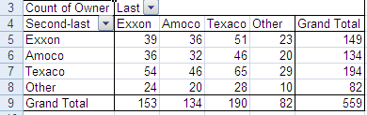

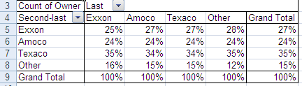

The column proportions are similar; the two nominal variables appear to be unrelated. There does not appear to be any brand loyalty.

2.46

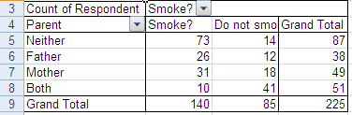

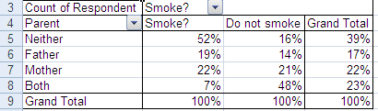

The two variables are related.

2.47

There are large differences between men and women in terms of the reason for unemployment.

2.48

The number of prescriptions filled by all stores except independent drug stores has increased.

2.49



There appears to be differences between female and male students in their choice of light beer.

2.50



More than 40% rate the food as less than good.

2.51



2.52 Canada



United States



There are considerable differences between the two countries.

2.53



More students disagree than agree.

2.54



Customers with children rated the restaurant more highly than did customers with no children.

2.55



There is a great deal of variation between countries. Moreover some countries tax manufacturers more and some countries tax services more. The United States has the highest corporate tax rates.

2.56

The United States owes a lot of money to many lenders.

2.57



Males and females differ in their areas of employment. Females tend to choose accounting marketing/sales and males opt for finance.

b



Area and job satisfaction are related. Graduates who work in finance and general management appear to be more satisfied than those in accounting, marketing/sales, and others.