Chapter 1 – From Beginning to End: An Overview of Systems Analysis and Design

Solutions to End-of-Chapter Problems

Review Questions
1. What is the difference between an information system and a computer application?
Usually a computer application is a single computer program that may or may not be connected to a database. An information system is normally multiple computer programs that are connected to a database and thus provide as output various types and quantities of information.
2. What is the purpose of systems analysis? Why is it important?
The purpose of systems analysis is to enable the system developer to understand the user's requirements. Without a good analysis of the user's needs and requirements the new system will be inadequate in its solution or erroneous in its implementation.
3. What is the difference between systems analysis and systems design?
Systems analysis is to determine the “what” the new system should do. It is discovery and understanding. Systems design is to determine “how” the new system should be built. It is structure and architecture.
4. What is a project?
A project is a planned undertaking that has a beginning and an end and which usually produces some predefined result. It is often managed with a schedule or list of required activities.
5. What is the purpose of the system development life cycle (SDLC)?
It provides a framework, including methodologies, models, tools and techniques, to build and deploy an information system. Its purpose is to provide structure and organization to the development process.
6. What are the six core processes for software systems development?
1. Identify the problem. 2. Plan and monitor the project. 3. Discover and understand the requirements. 4. Design the system components. 5. Build, test, and integrate the system components. 6. Finalize testing and deploy the solution.
7. What is meant by Agile Development and iterative development?
Agile development is a philosophy of systems development that emphasizes flexibility to handle changing requirements during the development project. Iterative development is a broader term that defines several iterations of defining and building the new system. It is an approach to incrementally build a new system. Agile development is one methodology that supports iterative development.
8. What is the purpose of a System Vision Document?
The System Vision Document is a brief statement which describes the overall objective of the new system. Its purpose is to provide basic information about the need and solution approach to assist the client in deciding whether to approve a development project.
9. What is the difference between a system and a subsystem?
A system usually consists of a complete solution that functions by itself. A subsystem is an identifiable and partitioned portion of the system. A subsystem usually is not an independent entity but functions within the context of the entire system.
10. What is the purpose of a Work Breakdown Structure?
The purpose of a Work Breakdown Structure is to identify all the tasks, e.g. the work, that must be accomplished for a project.
11. What are the components of a Work Breakdown Structure? What does it show?
It usually contains a list of all the tasks that must be done, along with an estimate of how much work each task will require. It provides a comprehensive list of the work to be done. It is the basis for building a project schedule.
12. What information is provided by use cases or a use case diagram?
Use cases, either in a list format or a diagram format, show all of the user functions that the new system must support.
13. What information is provided by a domain class diagram?
A domain class diagram identifies all of the “things” that must be remembered and tracked by the new system. In essence the class diagram will be used to design and build the database for the new system.
14. How do a use case diagram and a class diagram drive the system development process?
The use case diagram defines the processes (e.g. functions) of the new system and the class diagram defines the data of the new system. Each system consists of processes and information, so these two diagrams define what must be done.
15. What is an activity diagram? What does it show?
An activity diagram is also a “workflow” diagram. It shows the flow of steps that a user, working with a system, follows to complete a business process or use case.
16. How does an activity diagram help in user-interface design?
An activity diagram shows the interactions between a user and the system. Those interactions must be supported by the user interface.
17. What is the purpose of software component design?
Software component design is used to define the overall structure of the new system. It defines the major components of the new system and how they relate to each other.
18. What new information is provided in a design class diagram (more than a domain class diagram)?
A design class diagram is an extension of a class diagram and it shows how the attributes become data fields with type information. It also identifies the methods of a class. It also shows which classes have visibility to other classes to access their methods.
19. What are the steps of system testing?
System testing consists of 1. create the test data, 2. conduct the tests, 3. Identify and document the errors, 4. Fix the errors. This process repeats until the number of errors is minimal or acceptable.
20. What is the purpose of user acceptance testing?
User acceptance testing is to allow the users to verify that the system performs in a manner that does in fact solve the business problem. The system should not only provide correct answers, but it should provide answers for all the issues identified during analysis.
21. Why is it a good practice to divide a project into separate iterations?
Separate iterations allow the project to be partitioned into smaller chunks of work that can be managed and controlled better. It also provides intermediate deliverables so that both the project team and the users can ascertain if the new system is going to solve the business problems.
22. What should be the primary objective of each iteration?
The objective of an iteration should be to produce a portion of the solution system. Usually this means that some working piece of the system is design, coded, and tested. Sometimes it also allows portions of the final solution to be deployed early.

Problems and Exercises
None for Chapter 1.

Solutions to End-of-Chapter Cases

Chapter Case: Keeping Track of Your Geocaching Outings
Wayne's Geocaching System
Solutions

Table of Contents

Assignment D0: System Vision Document

Assignment D1: Work Breakdown Structure

Assignment D2: Use case and Class diagrams

Assignment D3: Workflow diagram and screen layout

Assignment D4: Database design and system structure

Assignment D5: Programming approach

Assignment D6: Final testing and deployment issues

Wayne's Geocaching System

Assignment D0-1: System Vision Document

Description

Wayne Johansen has become an active fan of geocaching and would like to keep track of all of his geocaching activities. Rather than use one of the free or commercial web sites, he would like to have his own geocaching system on his own computer. The system will need to have to support several different geocaching types of activities, including listing interesting geocaches and trips that Wayne would like to do, also geocaches that he has found and trips he has taken. In addition, since Wayne also would like to create his own geocaches, he would like to be able to create and describe his own geocaches and track those that he has posted for public use.

This system is essentially a information tracking system. It will need its own database to keep track of all of the information about his activities and his geocaches. For this first version, since he did not know a lot about computers, he decided it would be best just to have a system built to run on his laptop.

System Capabilities

The new system should do the following:
- Keep track of interesting geocach locations that have not been located yet
- Keep track of geocaches that have been located
- Record detailed and ancillary information about located geocaches
- Keep track of new geocaches that are being created by Wayne
- Keep track of posted geocaches that Wayne has posted to geocaching sites
- Provide summary information (reports) about Wayne geocache activities

Application Benefits

This system should provide the following benefits to Wayne:
- Enable Wayne to easily track all of his geocaching trips and find
- Enable Wayne to easily create and post new geocaches
- Allow Wayne to share his geocaching interests with other friends
- Allow Wayne to update his geocaching information while traveling with his laptop

Wayne's Geocaching System

Assignment D1-1: Definition of Iterations

Solutions will vary depending on what the student chooses. The important issue is that the student has thought through and decided on a solution.

One possible solution

Divide the system by functionality. Iteration one will be to capture information about geocaches that Wayne has completed. Iteration two will be to allow Wayne to create and post his own geocaching information.

Assignment D1-2: Work Breakdown Structure

I. Discover and analyze Wayne's needs to record completed geocaches
1. Wayne and his brother meet together to view geocaching websites and discuss Wayne's desires.
2. Identify the information that Wayne wants to keep.
3. Identify the use cases to capture and store that information.
4. Develop workflows for the identified use cases.
II. Design the components of the solution
1. Design the database tables.
2. Design the input and output screens.
3. Design the configuration for the laptop software application.
4. Design the program details
III. Program the system
1. Create the database.
2. Write the computer program (includes both user interface and database updating).
IV. Test it and use it
1. Test it with good data and bad data (check the validation).
2. Wayne test it with some of his real data.
3. Turn it over to Wayne to use.

Wayne's Geocaching System

Solutions will vary. The important thing is that the student has some solution elements. The details of the use case diagram and the class diagram will vary tremendously, e.g. which attributes to identify.

Assignment D2-1 and D2-3: Use case diagram

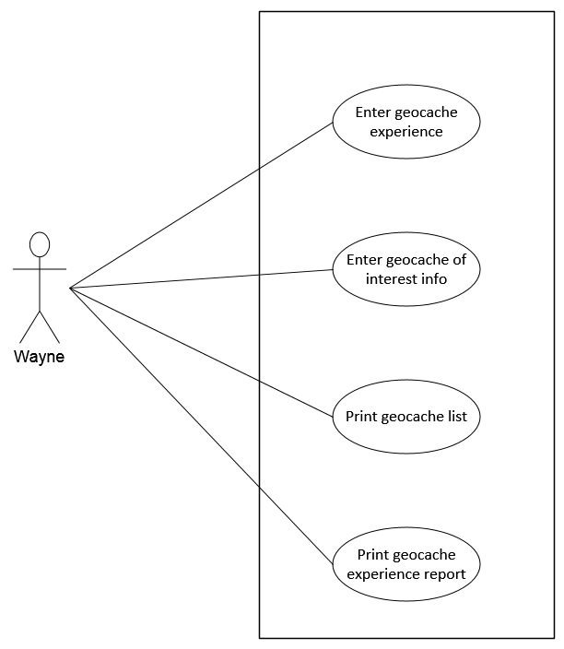

Assignments D2-2 and D2-4: Class diagram

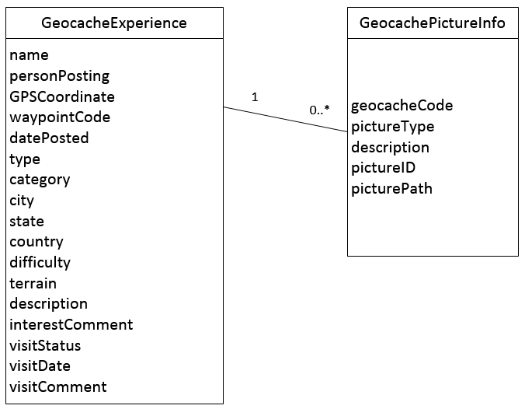
Wayne's Geocaching System

Assignment D3-1: Steps for use case

Use Case: Enter geocache of interest info
Steps:
1. Enter basic geocache information from source information
2. Review information
3. Enter reason for interest in comments

Assignment D3-2: Workflow diagram

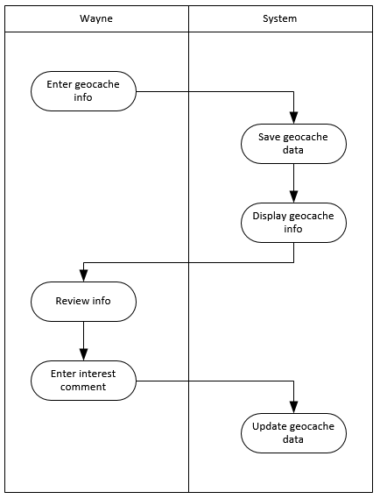

Assignment D3-3: Screen Layout

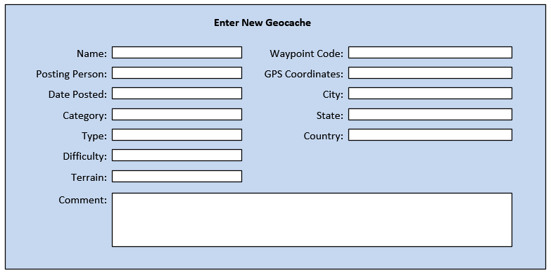
Wayne's Geocaching System

Assignment D4-1: Preliminary database design
Table: GeocchingExperience | Table: GeocachePhoto
cacheID: integer, auto-increment, {key}  cacheName: string {index}  personName: string  gpsCoord: string  waypointCode: string {index}  datePosted: date  type: string  category: string  city: string  state: string  country: string  difficulty: string  terrain: string  description: string  interestComment: string  visitStatus: string  visitDate: date  visitComment: string | ImageID: integer, GUID, {key}  cacheID: integer, {foreign key}  pictureType: string  description: string  directoryPath: string

Assignment D4-2: Desktop or browser solution
Answers will vary.
Desktop reasons:
Pros:
- Single machine with easy deployment
- Single database location
- Easy to build
- Secure
- Easier to build automated interface to download data to computer
Cons:
- Cannot access from multiple locations
- Not easy to share data with others (future use/growth)

Browser reasons:
Pros:
- Can access from multiple locations
- Can share information with others
Cons:
- Always needs internet access
- Browser may limit information display
- Requires a server somewhere (uptime?)
- Security is more complex – may require login functionality
- Formatting reports is usually more complex via browser

Wayne's Geocaching System

Assignment D5-1: Programming Approach

Answers will vary: Issues include compiled versus interpreted languages, experience, available tools and IDEs, etc.

Assignment D6-1: Programmer testing and user testing

Answers will vary:
Programmer testing:
- Tends to test only good data
- Tends to test with artificial data
- Tends to do limited testing
- Cannot always verify answers are correct
- Tends to test for crashes versus correctness
- Cannot always test various combinations
User testing:
- Tends to test/use in complex ways
- Tends to use more complex data
- Tends to make mistakes
- Can test based on work procedures

Assignment D6-2: Deployment Issues

Answers will vary, especially whether a desktop or browser based solution was chosen.

Desktop:
- Operating System issues
- Set up database
- Startup script to start database engine
- How to backup/restore data
- Paths and libraries for image storage
- Compiled/linked (e.g. binary) version versus interpreted language
Browser:
- Same issues as desktop, except must be decided for server.
- Where/how to deploy server (home based or hosted)
- Domain name and address, possibly require virtual server
- Login functions
- Security issues for hacking and posting inappropriate data

Assignment D6-3: Multiple user site - Deployment Issues
- Same issues as browser based listed above
- Where and how to host the site
- How to build for multiple browsers
- Growth and scalability

