Chapter 01
Financial Statements and Business Decisions

True / False Questions
1. | A business entity's accounting system creates financial accounting reports which are provided to external decision makers.  True False

2. | Business managers utilize managerial accounting reports to plan and manage the daily operations.  True False

3. | The balance sheet includes assets, liabilities, and stockholders' equity as of a point in time.  True False

4. | Revenue is recognized within the income statement during the period in which cash is collected.  True False

5. | Total assets are $37,500, total liabilities are $20,000 and common stock is $10,000; therefore, retained earnings are $7,500.  True False

6. | The income statement is a measure of an entity's economic performance for a period of time.  True False

7. | The accounting equation states that Assets = Liabilities + Stockholders' Equity.  True False

8. | A decision maker who wants to understand a company's financial statements must carefully read the notes to the financial statements because these disclosures provide useful supplemental information.  True False

9. | The financial statement that shows an entity's economic resources and claims against those resources is the balance sheet.  True False

10. | Stockholders' equity on the balance sheet includes common stock and retained earnings.  True False

11. | The amount of cash paid by a business for dividends would be reported as an operating activity cash flow on the statement of cash flows.  True False

12. | A company's retained earnings balance increased $50,000 last year; therefore, net income last year must have been $50,000.  True False

13. | The statement of stockholders' equity explains the change in the retained earnings balance caused by stockholder investments and dividend declarations.  True False

14. | The Financial Accounting Standards Board (FASB) has been given the authority by the Securities and Exchange Commission (SEC) to develop generally accepted accounting principles.  True False

15. | In the United States, the Securities and Exchange Commission (SEC) is considering requiring the use of International Financial Reporting Standards (IFRS) by U.S. companies for their financial reporting in the U.S.  True False

16. | The primary responsibility for the content of the financial statements lies with the external auditor.  True False

17. | An audit is an examination of the financial statements provided by management to ensure that they represent what they claim and to make sure that they are in compliance with generally accepted accounting principles.  True False

18. | The auditor can be held liable for malpractice in situations where the investors suffered losses while relying on the financial statements.  True False

19. | One of the advantages of a corporation when compared to a partnership is the limited liability of the owners.  True False

20. | Due to the relationships among financial statements, the statement of stockholders' equity links the income statement to the balance sheet.  True False

Multiple Choice Questions
21. | Which of the following describes the primary objective of the balance sheet?  A. To measure the net income of a business up to a particular point in time.  B. To report the difference between cash inflows and cash outflows for the period.  C. To report the financial position of the reporting entity at a particular point in time.  D. To report the market value of assets, liabilities, and stockholders' equity at a particular point in time.

22. | During the fiscal year ended 2014, a company had revenues of $400,000, cost of goods sold of $280,000, and an income tax rate of 30 percent on income before income taxes. What was the company's 2014 net income?  A. $120,000.  B. $36,000.  C. $84,000.  D. $400,000.

23. | Atlantic Corporation reported the following amounts at the end of the first year of operations: common stock $200,000; sales revenue $800,000; total assets $600,000; dividends declared $40,000; and total liabilities $320,000. What are Atlantics' retained earnings at the end of the year and what amount of expenses were incurred during the year?  A. Retained earnings are $80,000 and expenses incurred totaled $680,000.  B. Retained earnings are $80,000 and expenses incurred totaled $720,000.  C. Retained earnings are $280,000 and expenses incurred totaled $480,000.  D. Retained earnings are $280,000 and expenses incurred totaled $520,000.

24. | Which of the following best describes the balance sheet?  A. It includes a listing of assets at their market values.  B. It includes a listing of assets, liabilities, and stockholders' equity at their market values.  C. It provides information pertaining to a company's assets and the claims against sources of financing for those assets.  D. It provides information pertaining to a company's liabilities for a period of time.

25. | Which of the following statements is correct?  A. Assets on the balance sheet include retained earnings.  B. Retained earnings includes common stock.  C. The balance sheet equation states that assets equal liabilities.  D. A corporation's net income does not necessarily equal its net cash flow from operations.

26. | Which of the following correctly describes the various financial statements?  A. An income statement covers a period of time.  B. The cash flow statement is a financial statement at a specific point in time.  C. The balance sheet is a financial statement that covers a period of time.  D. The statement of stockholders' equity is a financial statement at a specific point in time.

27. | Which of the following accounts would not be reported on the balance sheet?  A. Retained earnings.  B. Inventory.  C. Accounts payable.  D. Dividends.

28. | Which of the following would not be found on the statement of cash flows?  A. Cost flow from manufacturing activities.  B. Cash flow from operating activities.  C. Cash flow from investing activities.  D. Cash flow from financing activities.

29. | Which of the following accounts is not a liability on the balance sheet?  A. Retained earnings.  B. Notes payable.  C. Accounts payable.  D. Interest payable.

30. | What financial statement would you look at to determine the dividends declared by a business?  A. Income statement.  B. Statement of stockholders' equity.  C. Statement of cash flows.  D. Balance sheet.

31. | Which financial statement would you utilize to determine whether a company will be able to pay liabilities which are due in 30 days?  A. Income statement.  B. Balance sheet.  C. Statement of stockholders' equity.  D. Statement of cash flows.

32. | Which of the following is considered to be an expense on the income statement?  A. Accounts payable.  B. Notes payable.  C. Wages payable.  D. Cost of goods sold.

33. | Which of the following best describes assets?  A. They are equal to liabilities minus stockholders' equity.  B. They are considered to be the economic resources of the business.  C. They are all reported on the balance sheet at their current market value.  D. They equal financing provided by creditors.

34. | Which of the following accounts would be reported as assets on the balance sheet?  A. Cash, accounts payable, and notes payable.  B. Cash, retained earnings, and accounts receivable.  C. Cash, accounts receivable, and inventories.  D. Inventories, property and equipment, and common stock.

35. | Which of the following statements describes the balance sheet?  A. It reports a company's revenues and expenses.  B. Assets are generally reported on the balance sheet at the cost incurred to acquire them.  C. Stockholders' equity includes only retained earnings.  D. It reports a company's cash flow from operations.

36. | Which of the following best describes liabilities and stockholders' equity?  A. They are the sources of financing an entity's assets.  B. They are the economic resources used by a business entity.  C. They are reported on the income statement.  D. They both increase when assets increase.

37. | Which of the following equations is the balance sheet equation?  A. Assets + Liabilities = Stockholders' Equity.  B. Assets + Stockholder's Equity = Liabilities.  C. Assets = Liabilities + Stockholders' Equity.  D. Assets = Liabilities + Common Stock.

38. | Willie Company's retained earnings increased $20,000 during 2014. What was Willie's 2014 net income or loss given that Willie declared $25,000 of dividends during 2014?  A. Net income was $5,000.  B. Net income was $45,000.  C. Net loss was $45,000.  D. Net loss was $5,000.

39. | Which of the following are the components of stockholders' equity on the balance sheet?  A. Common stock and liabilities.  B. Common stock and assets.  C. Retained earnings and dividends.  D. Common stock and retained earnings.

40. | Which financial statement would you use to determine a company's earnings performance during an accounting period?  A. Balance sheet.  B. Statement of stockholders' equity.  C. Income statement.  D. Statement of cash flows.

41. | Which of the following equations best describes the income statement?  A. Assets - Liabilities = Stockholders' Equity.  B. Net income = Revenues + Expenses.  C. Net income = Revenues - Expenses.  D. Retained earnings = Net Income + Dividends.

42. | Lena Company has provided the following data (ignore income taxes):  2014 revenues were $99,000.  2014 expenses were $47,800.  Dividends declared and paid during 2014 totaled $9,500.  Total assets at December 31, 2014 were $177,000.  Total liabilities at December 31, 2014 were $89,000.  Common stock at December 31, 2014 was $28,000.  Which of the following is correct?  A. 2014 net income was $41,700.  B. Total stockholders' equity at December 31, 2014 was $236,000.  C. Retained earnings at December 31, 2014 were $60,000.  D. Retained earnings at December 31, 2014 were $41,700.

43. | Lena Company has provided the following data (ignore income taxes):  2014 revenues were $99,000.  2014 expenses were $47,800.  Dividends declared and paid during 2014 totaled $9,500.  Total assets at December 31, 2014 were $177,000.  Total liabilities at December 31, 2014 were $89,000.  Common stock at December 31, 2014 was $28,000.  Which of the following is not correct?  A. 2014 net income was $51,200.  B. Total stockholders' equity at December 31, 2014 was $88,000.  C. Total liabilities and stockholders' equity at December 31, 2014 was $177,000.  D. Retained earnings on December 31, 2014 were $41,700.

44. | Madrid Company has provided the following data (ignore income taxes):  2014 revenues were $77,500.  2014 net income was $33,900.  Dividends declared and paid during 2014 totaled $5,700.  Total assets at December 31, 2014 were $217,000.  Total stockholders' equity at December 31, 2014 was $123,000.  Retained earnings at December 31, 2014 were $83,000.  Which of the following is not correct?  A. 2014 expenses were $43,600.  B. Total liabilities at December 31, 2014 were $94,000.  C. Retained earnings increased $33,900 during 2014.  D. Common stock at December 31, 2014 was $40,000.

45. | Madrid Company has provided the following data (ignore income taxes):  2014 revenues were $77,500.  2014 net income was $33,900.  Dividends declared and paid during 2014 totaled $5,700.  Total assets at December 31, 2014 were $217,000.  Total stockholders' equity at December 31, 2014 was $123,000.  Retained earnings at December 31, 2014 were $83,000.  Which of the following is correct?  A. 2014 expenses were $37,900.  B. Total liabilities at December 31, 2014 were $11,000.  C. Retained earnings increased $28,200 during 2014.  D. Common stock at December 31, 2014 was $206,000.

46. | Which of the following is the amount of revenue reported on the income statement of a retail company?  A. The cash collected from customers during the current period.  B. Both cash and credit sales for the period.  C. Cash sales for the period and collections from customers.  D. Cash sales and stockholders' investments.

47. | On January 1, 2014, Miller Corporation had retained earnings of $8,000,000. During 2014, Miller reported net income of $1,500,000, declared dividends of $500,000, and issued common stock for $1,000,000. What were Miller's retained earnings on December 31, 2014?  A. $7,000,000.  B. $9,500,000.  C. $9,000,000.  D. $7,500,000.

48. | What are the categories of cash flows that appear on a statement of cash flows?  A. Cash flows from investing, financing, and service activities.  B. Cash flows from operating, production, and internal activities.  C. Cash flows from financing, production, and growth activities.  D. Cash flows from operating, investing, and financing activities.

49. | When would a company report a net loss on the income statement?  A. When revenues are less than the sum of expenses plus dividends during an accounting period.  B. If assets decreased during an accounting period.  C. If liabilities increased during an accounting period.  D. When expenses exceeded revenues for an accounting period.

50. | Which of the following describes the amount of insurance expense reported on the income statement?  A. The amount of cash paid for insurance in the current period.  B. The amount of cash paid for insurance in the current period less any unpaid insurance at the end of the period.  C. The amount of insurance used up (incurred) in the current period to help generate revenue.  D. The amount of cash paid for insurance that is reported within the statement of cash flows.

51. | Which of the following would immediately cause a change in a corporation's retained earnings?  A. Net income or net loss and declaration of dividends.  B. Declaration of dividends and issuance of common stock to new stockholders.  C. Net income and issuance of stock to new stockholders.  D. Declaration of dividends and purchase of new machinery.

52. | Which of the following describes the operating activities section of a cash flow statement?  A. It provides information about how operations have been financed.  B. It provides information pertaining to dividend payments to stockholders.  C. It provides information with respect to a company's ability to generate cash flows to pay for goods and services.  D. It provides the net increase or decrease in cash during the period.

53. | Within which of the following would you find the inventory method(s) being used by a business entity?  A. Balance sheet.  B. Income statement.  C. Notes to the financial statements.  D. Headings of the financial statements.

54. | At the beginning of 2014, a corporation had assets of $270,000 and liabilities of $160,000. During 2014, assets increased $25,000 and liabilities increased $5,000. What was stockholders' equity on December 31, 2014?  A. $140,000.  B. $130,000.  C. $190,000.  D. $80,000.

55. | During 2014, Canton Company's assets increased $95,500 and the liabilities decreased $17,300. Canton Company's stockholders' equity at December 31, 2014 was $211,500. What amount was stockholders' equity at January 1, 2014?  A. $98,700.  B. $324,300.  C. $133,300.  D. $289,700.

56. | How are creditor and investor claims reported on a balance sheet?  A. The claims of creditors are liabilities and those of investors are assets.  B. The claims of both creditors and investors are liabilities, but only the claims of investors are considered to be long-term.  C. The claims of creditors are reported as liabilities while the claims of investors are recorded as stockholders' equity.  D. The claims of creditors and investors are considered to be essentially equivalent.

57. | In what order would the items on the balance sheet appear?  A. Assets, retained earnings, liabilities, and common stock.  B. Common stock, retained earnings, liabilities, and assets.  C. Assets, liabilities, common stock, and retained earnings.  D. Common stock, assets, liabilities, and retained earnings.

58. | Which of the following would most likely increase retained earnings?  A. An increase in expenses.  B. An increase in revenues.  C. Declaring a cash dividend.  D. Issuing additional common stock.

59. | A company's retained earnings increased $375,000 last year and its assets increased $973,000. The company declared a $79,000 cash dividend during the year. What was last year's net income?  A. $296,000.  B. $375,000.  C. $454,000.  D. $519,000.

60. | Which of the following items is reported as an expense on the income statement?  A. Dividends declared.  B. Cost of goods sold.  C. Dividends paid.  D. Accounts payable.

61. | Which of the following has primary responsibility to develop Generally Accepted Accounting Principles?  A. Financial Accounting Standards Board.  B. Company Executives.  C. Securities & Exchange Commission.  D. Public Company Accounting Oversight Board.

62. | Which of the following has the legal authority to determine financial reporting in the United States?  A. Financial Accounting Standards Board.  B. American Accounting Association.  C. Securities & Exchange Commission.  D. Public Company Accounting Oversight Board.

63. | Which of the following is not reported as a liability on a balance sheet?  A. Income taxes payable.  B. Common stock.  C. Accounts payable.  D. Dividends declared.

64. | Which of the following transactions increases both cash and net income?  A. Cash receipts from a bank loan.  B. Cash receipts from sale of common stock.  C. Cash receipts from customers for services provided.  D. Cash receipts from cost of goods sold.

65. | Which of the following is not an alternate title for the Statement of Income?  A. Income Statement.  B. Statement of Net Income.  C. Statement of Operations.  D. Statement of Income.

66. | A calendar year reporting company preparing its annual financial statements should use the phrase "As of December 31,2014" in the heading of which financial statements?  A. On all of the required financial statements.  B. On only the income statement.  C. On the income statement and balance sheet, but not the statement of cash flows.  D. On the balance sheet only.

67. | Which of the following properly describes the impact on the financial statements when a company borrows $20,000 from a local bank?  A. Net income increases $20,000.  B. Assets decrease $20,000.  C. Stockholders' equity increases $20,000.  D. Liabilities increase $20,000.

68. | Which of the following would not be reported in the operating activities section of a cash flow statement?  A. Cash paid for dividends to stockholders.  B. Cash paid for interest expense.  C. Cash paid for employee wages.  D. Cash received from customers.

69. | Which of the following would be reported in the financing activities section of a cash flow statement?  A. Cash paid for dividends to stockholders.  B. Cash paid for interest expense.  C. Cash paid to acquire equipment.  D. Cash received from sale of investments.

70. | Which of the following would be reported in the investing activities section of a cash flow statement?  A. Cash received from customers.  B. Cash received from the issue of common stock.  C. Cash paid to repay a bank loan.  D. Cash paid to acquire common stock of another company.

71. | Which of the following statements is correct?  A. The payment of a cash dividend reduces net income.  B. Cash received from issuing common stock to stockholders is reported as a financing activity cash flow within the statement of cash flows.  C. Providing services to a customer on account does not impact net income.  D. Interest payments are reported within the statement of cash flows as a financing activity.

72. | Husky Company has provided the following information for its most recent year of operation:  Cash collected from customers totaled $89,300.  Cash borrowed from banks totaled $31,700.  Cash paid to employees for salaries totaled $32,100.  Cash received from selling Husky common stock to stockholders totaled $41,000.  Cash payments to banks for repayment of money borrowed totaled $7,500.  Cash paid to suppliers totaled $12,500.  Land costing $25,000 was sold for $25,000 cash.  Cash paid for dividends to stockholders totaled $3,300.  How much was Husky's cash flow from operating activities?  A. $47,600.  B. $44,700.  C. $41,400.  D. $37,200.

73. | Husky Company has provided the following information for its most recent year of operation:  Cash collected from customers totaled $89,300.  Cash borrowed from banks totaled $31,700.  Cash paid to employees for salaries totaled $32,100.  Cash received from selling Husky common stock to stockholders totaled $41,000.  Cash payments to banks for repayment of money borrowed totaled $7,500.  Cash paid to suppliers totaled $9,600.  Land costing $25,000 was sold for $25,000 cash.  Cash paid for dividends to stockholders totaled $3,300.  How much was Husky's cash flow from financing activities?  A. $72,700.  B. $59,000.  C. $65,200.  D. $61,900.

74. | Sparty Corporation has provided the following information for its most recent year of operation:  Revenues earned were $97,000, of which $9,000 were uncollected at the end of the year.  Operating expenses incurred were $39,000, of which $7,000 were unpaid at the end of the year.  Dividends declared were $11,000, of which $3,000 were unpaid at the end of the year.  Income tax expense is $17,400.  What is the amount of net income reported on Sparty's income statement?  A. $32,900.  B. $39,300.  C. $33,600.  D. $40,600.

75. | Which of the following statements is correct?  A. Revenues are reported on the income statement regardless of whether the customer has paid for the goods or services.  B. Expenses are reported on the income statement during the period that they are paid for.  C. Net income includes a deduction for dividend payments made to stockholders.  D. Net income normally equals the net cash generated by operations.

76. | During 2014, Rock Company's cash balance increased from $79,000 to $91,300. Rock's net cash flow from operating activities was $37,300 and its net cash flow from financing activities was $11,100. How much was Rock's net cash flow from investing activities?  A. A net cash flow of $42,900.  B. A net cash flow of ($36,100).  C. A net cash flow of $60,700.  D. A net cash flow of ($60,700).

77. | Which of the following statements is false?  A. A positive net income results in an increase in retained earnings.  B. The ending retained earnings balance from the statement of retained earnings is reported on the balance sheet.  C. The change in the cash balance on the statement of cash flows added to the beginning cash balance equals the ending cash balance.  D. The dividends reported on the statement of retained earnings are also reported as dividend expense on the income statement.

78. | Which of the following is not a consequence to a company resulting from the issuance of their financial statements?  A. The effect on the selling price of their stock.  B. The providing of information to their competitors.  C. The effect on bonus payments to its employees.  D. The providing of information to their auditors.

79. | Which of the following statements pertaining to the audit function is incorrect?  A. The primary responsibility for the information in the financial statements lies with the auditors.  B. The audit report describes the auditor's opinion of the fairness of the financial statements.  C. An audit ensures that the financial statements conform to generally accepted accounting principles.  D. The auditor does not examine every transaction an entity incurred.

80. | The International Accounting Standards Board has worked to develop global accounting standards known as  A. Generally accepted accounting principles.  B. Globally accepted financial standards.  C. International financial reporting standards.  D. Generally accepted international financial standards.

81. | An examination of the financial statements of a business to ensure that they conform to generally accepted accounting principles is called  A. A certification.  B. An audit.  C. A verification.  D. A validation.

82. | Which of the following best describes the purpose of an audit?  A. To prove the accuracy of an entity's financial statements.  B. To lend credibility to an entity's financial statements.  C. To audit every transaction that an entity entered into.  D. To establish that a corporation's stock is a sound investment.

83. | Why does a company hire independent auditors?  A. To guarantee the accuracy of both annual and quarterly financial statements.  B. To verify the accounting accuracy of every transaction entered into.  C. To report on the fairness of financial statement presentation.  D. The auditors are responsible for the content of the financial statements.

84. | Why is the CPA's role in performing audits important to our economic system?  A. The auditors provide direct financial advice to potential investors.  B. The auditors have the primary responsibility for the information contained in financial statements.  C. The auditors issue reports on the accuracy of each financial transaction.  D. The audit of financial statements helps investors and others to know that they can rely on the information presented in the financial statements.

85. | Which of the following is not one of the three steps taken by a corporation to assure the accuracy of its records?  A. Implementing a system of controls over the company's records and assets.  B. Hiring an independent auditor to report on the fairness of the financial statements.  C. Hiring a financial analyst to ensure the actual results of operations are similar to planned results.  D. Forming a committee made up of board of directors' members to oversee the integrity of the corporation's system of controls and the hiring of the independent auditors.

86. | Which of the following groups has primary responsibility for the information contained in the financial statements?  A. The company's management.  B. The company's auditors.  C. The company's investors.  D. SEC.

87. | Which private sector body was given the primary responsibility to determine detailed auditing standards?  A. Financial Accounting Standards Board.  B. Securities & Exchange Commission.  C. Public Company Accounting Oversight Board.  D. American Institute of Certified Public Accountants.

88. | Which of the following is not a formal requirement to become a licensed certified public accountant (CPA)?  A. A college education.  B. Professional experience.  C. Membership in the American Institute of Certified Public Accountants (AICPA).  D. A professional examination.

89. | Which of the following is a disadvantage of a corporation when compared to a partnership?  A. The stockholders have limited liability.  B. The corporation is treated as a separate legal entity from the stockholders.  C. The corporation and its stockholders are subject to double taxation.  D. The corporation must account for the transactions of the business as separate and apart from those of the owners.

90. | Which of the following statements is true about a sole proprietorship?  A. The owner and the business are separate legal entities but not separate accounting entities.  B. The owner and the business are separate accounting entities but not separate legal entities.  C. The owner and the business are separate legal entities and separate accounting entities.  D. Most large businesses in this country are organized as sole proprietorships.

91. | For a business organized as a general partnership, which statement is true?  A. The owners and the business are separate legal entities.  B. Each partner is potentially responsible for the debts of the business.  C. Formation of a partnership requires getting a charter from the state of incorporation.  D. A partnership is not considered to be a separate accounting entity.

92. | Which of the following would not be reported on a statement of stockholders' equity?  A. Dividend payments.  B. Net income.  C. Beginning retained earnings.  D. Ending retained earnings.

93. | Which of the following statements is true?  A. The statement of stockholders' equity always reports the same amount of dividend payments, as does the statement of cash flows.  B. The statement of cash flows has a relationship with the balance sheet.  C. Dividends paid are reported on the statement of cash flows as an operating cash flow and on the income statement as a financing cash flow.  D. Net income is reported on the income statement but not on the statement of stockholders' equity.

94. | The declaration of a $5,000 dividend by JLH Company would be reported on which of JLH's financial statements?  A. The income statement only.  B. The statement of stockholders' equity.  C. The balance sheet only.  D. The statement of cash flows.

95. | Which of the following transactions affects both retained earnings and net income?  A. The payment of a cash dividend.  B. The recording of revenue for services provided.  C. The issue of stock in exchange for cash.  D. The borrowing of money from a bank.

96. | Which of the following transactions affects both the income statement and the statement of cash flows?  A. Selling stock in exchange for cash.  B. Declaring and paying a cash dividend.  C. Selling a product to a customer which creates an account receivable.  D. Paying employee wages as they are earned.

97. | Which of the following would not be found within the investing activities section of the statement of cash flows?  A. Cash paid to purchase a building for manufacturing facilities.  B. Cash received from the sale of common stock to stockholders.  C. Cash received from the sale of equipment used in manufacturing a product.  D. Cash paid to purchase land.

98. | Which of the following is primarily responsible for the information provided in the financial statements?  A. Chief Executive Officer.  B. External Auditors.  C. Board of Directors.  D. Internal Accounting Staff.

99. | Which of the following does not represent a professional accounting certification?  A. Certified Management Accountant.  B. Certified Public Accountant.  C. Certified Internal Auditor.  D. Certified Tax Accountant.

Essay Questions
100. | Determine the missing amounts for each independent case below. Assume the amounts given are at the end of the company's first year of operation.  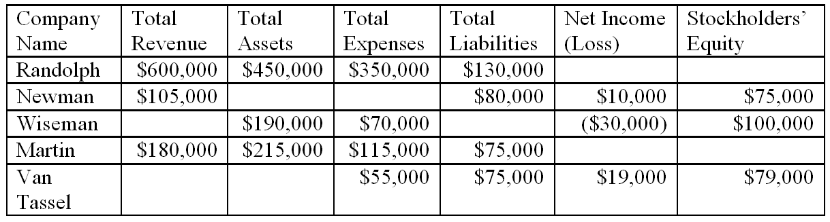

101. | Gail's Greenhouse, Inc., a small retail store that sells houseplants, started business on January 1, 2014. At the end of January 2014, the following information was available:  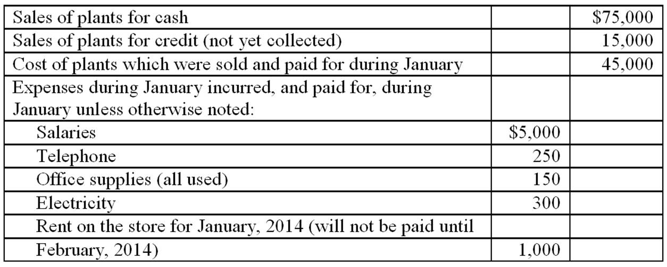  Requirements:  A. Using the above information, prepare the income statement for Gail's Greenhouse for the month ended January 31, 2014.  B. What is the amount of cash flows provided by operating activities to be presented on the statement of cash flows?

102. | Indicate on which financial statement you would expect to find each of the following. If an item can be found on more than one statement, list each statement.  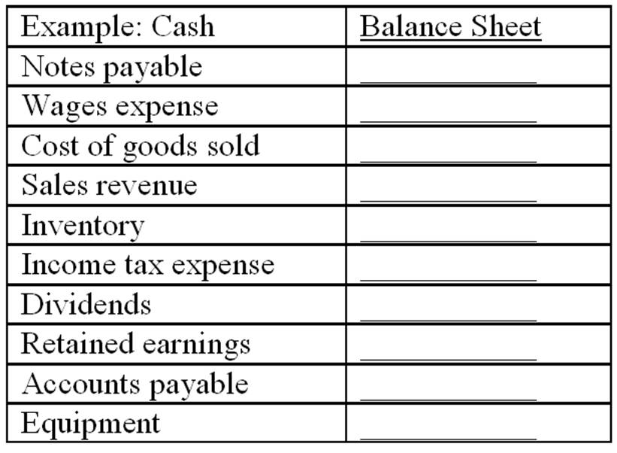

103. | For each of the following items that appear on the balance sheet, identify each as an asset (A), liability (L), or element of stockholders' equity (SE). For any item that would not appear on the balance sheet, write the letter, N.  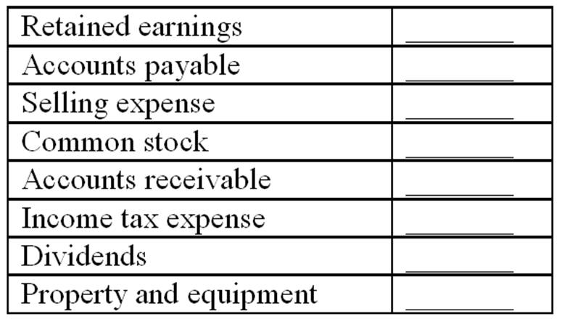

104. | Rose Corporation began operations at the start of 2014. During 2014, it made cash and credit sales totaling $500,000 and collected $420,000 in cash from its customers. It purchased inventory costing $250,000, paid $15,000 for dividends and the cost of goods sold was $210,000. Also, the corporation incurred the following expenses during 2014:  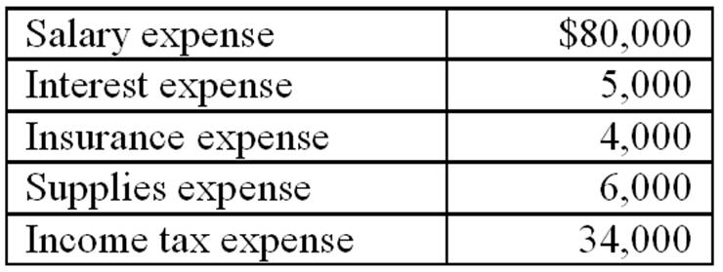  Requirements:  1. Prepare an income statement showing revenues, expenses, income before income taxes, income tax expense, and net income for the year ended December 31, 2014.  2. Based on the above information, what is the amount of accounts receivable on the balance sheet prepared as of December 31, 2014?  3. Based on the above information, what is the amount of retained earnings on the balance sheet prepared as of December 31, 2014?

105. | Cosmos Corporation was established on December 31, 2013, by a group of investors who invested a total of $1,000,000 for shares of the new corporation's common stock. During the month of January 2014, Cosmos provided services to customers for which the total revenue was $100,000. Of this amount, $10,000 had not been collected by the end of January. Cosmos recorded salary expense of $20,000, of which 90% had been paid by the end of the month; rent expense of $5,000, which had been paid on January 1; and other expenses of $12,000, which had been paid by check. On January 31, 2014, Cosmos purchased a van by paying cash of $30,000. There were no other transactions that affected cash.  Requirements:  1. In which section of the statement of cash flows would the amount of cash paid for rent be reported?  2. In which section of the statement of cash flows would the amount of cash paid for the van purchase be reported?  3. By how much did Cosmos's cash increase or decrease during January 2014?  4. What was Cosmos's net income or net loss (after income tax expense) for the month of January 2014? The income tax expense was $18,900.  5. Explain why the net increase or decrease in cash for a business generally will be different than the net income, or net loss, for the same period.

106. | Parker Pool Supply, Inc. reported the following items for the year ended December 31, 2014:  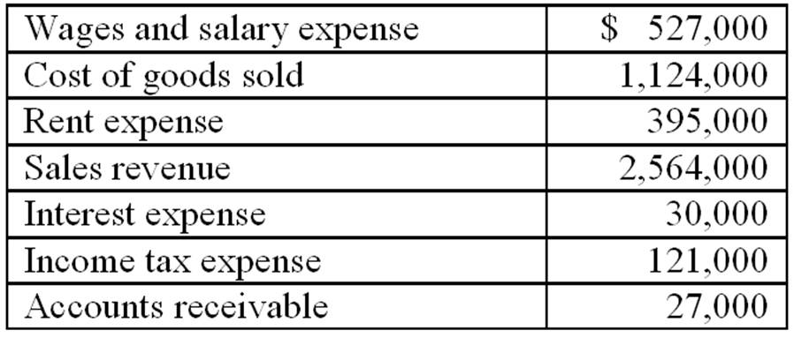  Requirement:  Prepare an income statement for the year ended December 31, 2014.

107. | National Shops, Inc. reported the following amounts on its balance sheet as of December 31, 2014:  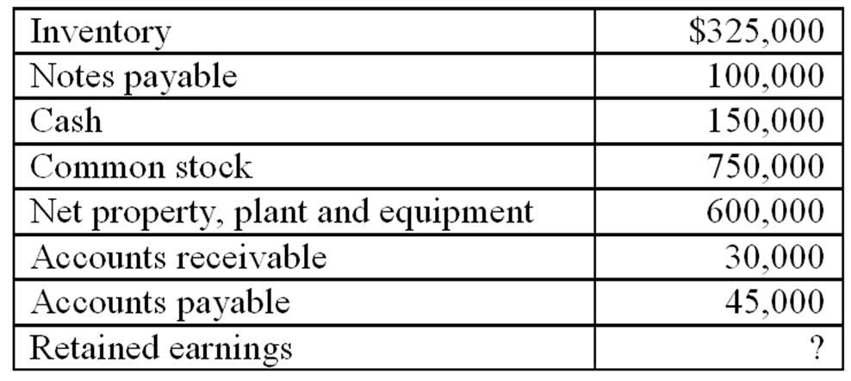  Requirements:  1. What is the amount of National's total assets as of December 31, 2014?  2. Identify the items listed above that are liabilities.  3. What is the amount of National's retained earnings as of December 31, 2014?  4. Prepare a balance sheet for National as of December 31, 2014.  5. National wishes to purchase merchandise from your company on account. The amount of the purchases would probably be about $10,000 per month, and the terms would require National to make payment in full within 30 days. Would you recommend that your company grant credit to National under these terms? Explain the reasoning for your response.

108. | During 2014, Winterset Company performed services for which customers paid or promised to pay $587,000. Of this amount, $552,000 had been collected by year-end. Winterset paid $340,000 in cash for employee wages and owed the employees $15,000 at the end of the year for work that had been done but had not paid for. Winterset paid interest expense of $3,000 and $195,000 for other service expenses. The income tax rate was 35%, and income taxes had not yet been paid at the end of the year. Winterset declared and paid dividends of $20,000. There were no other transactions that affected cash.  Requirements:  1. What was the amount of the increase or decrease in cash during the year?  2. Prepare an income statement for Winterset for the year.  3. At the beginning of 2014, Winterset's retained earnings were $90,000. Prepare a statement of stockholders' equity with only a column for retained earnings.

109. | Alfred Company manufactures men's clothing. During 2014, the company reported the following items that affected cash. Indicate whether each of these items is a cash flow from operating activities (O), investing activities (I), or financing activities (F).  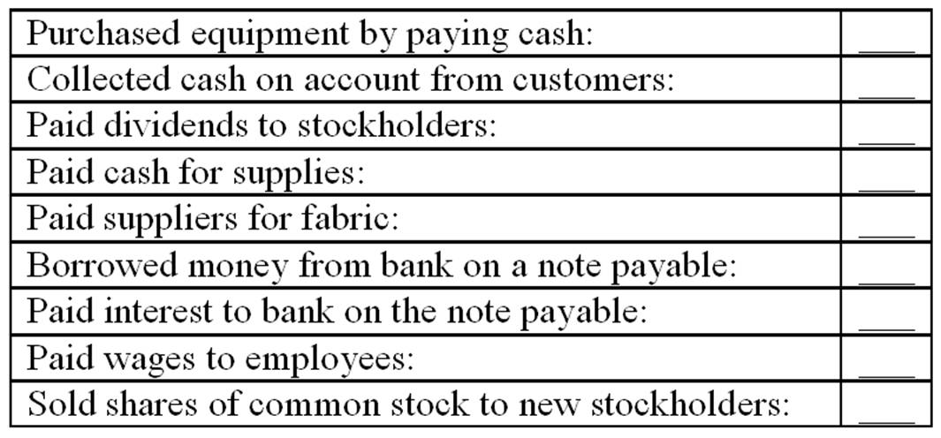

110. | Fulton Company was established at the beginning of 2014 when several investors paid a total of $200,000 to purchase Fulton common stock. No additional investments in common stock were made during the year. By December 31, 2014, Fulton had cash on hand of $45,000, office equipment of $40,000, inventory of $156,000, and accounts payable of $10,000. Sales for the year were $812,000. Of this amount, customers still owed $20,000. Fulton paid dividends of $25,000 to its stockholders during 2014.  Requirements:  1. Based on the information above, prepare a balance sheet for Fulton Company as of December 31, 2014. In the process of preparing the balance sheet, you must calculate the ending balance in retained earnings.  2. Prepare a statement of stockholders' equity for the year ended December 31, 2014.  3. What was the amount of Fulton's net income for 2014?  4. Was Fulton successful during its first year in operation? Explain your answer.

111. | For Glad Rags Shops, the following information is available for the year ended December 31, 2014:  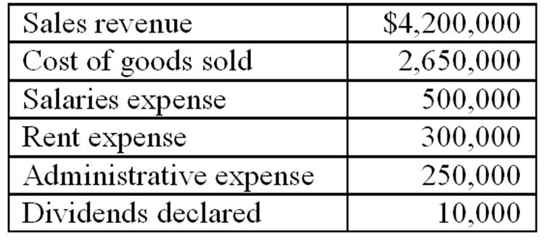  The income tax is $150,000.  Requirement:  Prepare an income statement for Glad Rags Shops.

112. | Baseline Corporation was formed two years ago to manufacture fitness equipment. It has been profitable and is growing rapidly. It currently has 150 stockholders and 90 employees; most of the employees own at least a few shares of Baseline's common stock. The company has received financing from two banks. It will sell additional shares of common stock within the next three months and will also seek additional loans and hire new employees to support its continued growth.  Requirement:  1. Explain who relies on the information in financial statements prepared by Baseline Corporation.  2. Why is compliance with generally accepted accounting principles and accuracy in accounting important for Baseline?  3. A new accountant who tried to prepare Baseline's financial statements at the end of the current year made several errors. For each of the following items, indicate whether the income statement and balance sheet are affected by the error, and also the amount by which the respective financial statement is affected. (For example, an error might cause revenues and net income on the income statement and retained earnings and accounts receivable and assets on the balance sheet to be overstated by x dollars). Ignore the effects of income taxes.  a. The company had sales for cash of $3,000,000. It also had sales on account of $1,800,000 that had been collected by the end of the year, and sales on account of $200,000 that are expected to be collected early the following year. The accountant reported total sales revenue of $4,800,000.  b. The company had total inventories of $600,000 at the end of the year. Of this amount, inventory reported at $30,000 was obsolete and will have to be scrapped. The balance sheet prepared by the accountant showed total inventories of $600,000.  c. The company has a bank loan for which interest expense during the year of $10,000 will be paid early in January of the next year. The accountant recorded neither the interest expense nor the interest payable.  d. An insurance policy was listed as an asset of $6,000 at the beginning of the year. The entire amount of the policy was for the current year and the policy has expired. The accountant took no action to recognize the expiration of the policy.

113. | Larson Company ends its recent year of operations with $3,500,000 in retained earnings. During the year Larson's net income exceeded its dividend declarations by $200,000. Larson's dividend declarations were $25,000 greater than the dividend payments. How much was Larson Company's beginning retained earnings?

114. | As of January 1, 2014, a corporation had assets of $340,000 and liabilities of $120,000. During 2014, assets increased $45,000 and liabilities increased $15,000. What was stockholders' equity at December 31, 2014?

115. | Laker Company has provided the following information for its most recent year of operation:  Cash collected from customers totaled $99,300.  Cash borrowed from banks totaled $42,700.  Cash paid to employees totaled $23,300.  Cash paid for interest totaled $3,100.  Cash received from selling an investment in Husky stock totaled $73,000.  Cash payments to banks for repayment of money borrowed totaled $9,700.  Cash paid for operating expenses totaled $11,200.  Land costing $75,000 was sold for $75,000 cash.  Cash paid for dividend payments to stockholders totaled $7,700.  How much was Laker's net cash flow from financing activities?

116. | Laker Company has provided the following information for its most recent year of operation:  Cash collected from customers totaled $99,300.  Cash borrowed from banks totaled $42,700.  Cash paid to employees totaled $23,300.  Cash paid for interest totaled $3,100.  Cash received from selling an investment in Husky stock totaled $73,000.  Cash payments to banks for repayment of money borrowed totaled $9,700.  Cash paid for operating expenses totaled $11,200.  Land costing $75,000 was sold for $75,000 cash.  Cash paid for dividend payments to stockholders totaled $7,700.  How much was Laker's net cash flow from investing activities?

117. | Laker Company has provided the following information for its most recent year of operation:  Cash collected from customers totaled $99,300.  Cash borrowed from banks totaled $42,700.  Cash paid to employees totaled $23,300.  Cash paid for interest totaled $3,100.  Cash received from selling an investment in Husky stock totaled $73,000.  Cash payments to banks for repayment of money borrowed totaled $9,700.  Cash paid for operating expenses totaled $11,200.  Land costing $75,000 was sold for $75,000 cash.  Cash paid for dividend payments to stockholders totaled $7,700.  How much was Laker's net cash flow from operating activities?

118. | During 2014, Rock Company's cash balance increased from $57,000 to $94,300. Rock's net cash flow from operating activities was $26,900 and its net cash flow from financing activities was $13,700. How much was Rock's net cash flow from investing activities?

119. | Moss Company has provided the following data:  2014 revenues were $87,500.  2014 expenses were $43,900.  Dividends declared and paid by Moss during 2014 totaled $15,700.  Total assets on December 31, 2014 were $227,000.  Total stockholders' equity on December 31, 2014 was $133,000.  Common stock on December 31, 2014 was $93,000.  What was the beginning retained earnings balance?

120. | Describe the roles of the Securities & Exchange Commission and The Financial Accounting Standards Board with respect to the development of Generally Accepted Accounting Principles.

121. | Describe the elements of the balance sheet equation.

122. | Describe the role of a company's management and the external auditors in the accounting communication process.

123. | What is the objective of the cash flow statement? Describe the three cash flow classifications that are reported within the cash flow statement.

124. | How is net income in the income statement different than cash flow from operating activities in the cash flow statement?

Chapter 01 Financial Statements and Business Decisions Answer Key

True / False Questions
1. | A business entity's accounting system creates financial accounting reports which are provided to external decision makers.  TRUE  The accounting system collects financial data and produces reports used by both internal decision makers and external decision makers.

AACSB: Reflective Thinking
AICPA BB: Critical Thinking
AICPA FN: Measurement
Blooms: Remember
Difficulty: 1 Easy
Learning Objective: 01-01 Recognize the information conveyed in each of the four basic financial statements and the way that it is used by different decision makers (investors; creditors; and managers).
Topic Area: Understanding the Business

2. | Business managers utilize managerial accounting reports to plan and manage the daily operations.  TRUE  Managerial accounting reports are for internal use to assist managers with day-to-day operations. Unlike financial accounting reports, managerial reports are for internal use.

AACSB: Reflective Thinking
AICPA BB: Critical Thinking
AICPA FN: Measurement
Blooms: Remember
Difficulty: 1 Easy
Learning Objective: 01-01 Recognize the information conveyed in each of the four basic financial statements and the way that it is used by different decision makers (investors; creditors; and managers).
Topic Area: Understanding the Business

3. | The balance sheet includes assets, liabilities, and stockholders' equity as of a point in time.  TRUE  The balance sheet reports the amount of assets, liabilities, and stockholders' equity of an entity at a point in time.  The balance sheet is referred to as a financial position statement; listing assets, liabilities, and equity accounts as of a specific date.

AACSB: Reflective Thinking
AICPA BB: Critical Thinking
AICPA FN: Measurement
Blooms: Remember
Difficulty: 1 Easy
Learning Objective: 01-01 Recognize the information conveyed in each of the four basic financial statements and the way that it is used by different decision makers (investors; creditors; and managers).
Topic Area: The Four Basic Financial Statements: An Overview

4. | Revenue is recognized within the income statement during the period in which cash is collected.  FALSE  Revenue is recognized within the income statement during the period in which revenue is earned.

AACSB: Reflective Thinking
AICPA BB: Critical Thinking
AICPA FN: Measurement
Blooms: Remember
Difficulty: 1 Easy
Learning Objective: 01-01 Recognize the information conveyed in each of the four basic financial statements and the way that it is used by different decision makers (investors; creditors; and managers).
Topic Area: The Four Basic Financial Statements: An Overview

5. | Total assets are $37,500, total liabilities are $20,000 and common stock is $10,000; therefore, retained earnings are $7,500.  TRUE  $37,500 = $20,000 + $10,000 + X; X = $7,500

AACSB: Analytic
AICPA BB: Critical Thinking
AICPA FN: Measurement
Blooms: Apply
Difficulty: 2 Medium
Learning Objective: 01-01 Recognize the information conveyed in each of the four basic financial statements and the way that it is used by different decision makers (investors; creditors; and managers).
Topic Area: The Four Basic Financial Statements: An Overview

6. | The income statement is a measure of an entity's economic performance for a period of time.  TRUE  The income statement reports the performance of a business during the accounting period.

AACSB: Reflective Thinking
AICPA BB: Critical Thinking
AICPA FN: Measurement
Blooms: Remember
Difficulty: 1 Easy
Learning Objective: 01-01 Recognize the information conveyed in each of the four basic financial statements and the way that it is used by different decision makers (investors; creditors; and managers).
Topic Area: The Four Basic Financial Statements: An Overview

7. | The accounting equation states that Assets = Liabilities + Stockholders' Equity.  TRUE  The accounting equation, also known as the balance sheet equation, states that Assets = Liabilities + Stockholders' Equity.

AACSB: Reflective Thinking
AICPA BB: Critical Thinking
AICPA FN: Measurement
Blooms: Remember
Difficulty: 1 Easy
Learning Objective: 01-01 Recognize the information conveyed in each of the four basic financial statements and the way that it is used by different decision makers (investors; creditors; and managers).
Topic Area: The Four Basic Financial Statements: An Overview

8. | A decision maker who wants to understand a company's financial statements must carefully read the notes to the financial statements because these disclosures provide useful supplemental information.  TRUE  The notes provide supplemental information necessary to fully understand the financial statements.

AACSB: Reflective Thinking
AICPA BB: Critical Thinking
AICPA FN: Measurement
Blooms: Remember
Difficulty: 1 Easy
Learning Objective: 01-01 Recognize the information conveyed in each of the four basic financial statements and the way that it is used by different decision makers (investors; creditors; and managers).
Topic Area: The Four Basic Financial Statements: An Overview

9. | The financial statement that shows an entity's economic resources and claims against those resources is the balance sheet.  TRUE  The balance sheet contains assets (economic resources), liabilities (claims against those resources), and stockholders' equity.

AACSB: Reflective Thinking
AICPA BB: Critical Thinking
AICPA FN: Measurement
Blooms: Remember
Difficulty: 1 Easy
Learning Objective: 01-01 Recognize the information conveyed in each of the four basic financial statements and the way that it is used by different decision makers (investors; creditors; and managers).
Topic Area: The Four Basic Financial Statements: An Overview

10. | Stockholders' equity on the balance sheet includes common stock and retained earnings.  TRUE  The stockholders' equity section of the balance sheet represents financing provided by owners of the business (common stock) and earnings (retained earnings).

AACSB: Reflective Thinking
AICPA BB: Critical Thinking
AICPA FN: Measurement
Blooms: Remember
Difficulty: 1 Easy
Learning Objective: 01-01 Recognize the information conveyed in each of the four basic financial statements and the way that it is used by different decision makers (investors; creditors; and managers).
Topic Area: The Four Basic Financial Statements: An Overview

11. | The amount of cash paid by a business for dividends would be reported as an operating activity cash flow on the statement of cash flows.  FALSE  Dividends are reported on the statement of retained earnings. On the statement of cash flows, dividends are reported as a financing activity.

AACSB: Reflective Thinking
AICPA BB: Critical Thinking
AICPA FN: Measurement
Blooms: Remember
Difficulty: 1 Easy
Learning Objective: 01-01 Recognize the information conveyed in each of the four basic financial statements and the way that it is used by different decision makers (investors; creditors; and managers).
Topic Area: The Four Basic Financial Statements: An Overview

12. | A company's retained earnings balance increased $50,000 last year; therefore, net income last year must have been $50,000.  FALSE  Retained earnings is increased by net income and decreased by dividends. Therefore, we would need to know the dividend amount was zero in this situation to make the above statement true.

AACSB: Reflective Thinking
AICPA BB: Critical Thinking
AICPA FN: Measurement
Blooms: Understand
Difficulty: 2 Medium
Learning Objective: 01-01 Recognize the information conveyed in each of the four basic financial statements and the way that it is used by different decision makers (investors; creditors; and managers).
Topic Area: The Four Basic Financial Statements: An Overview

13. | The statement of stockholders' equity explains the change in the retained earnings balance caused by stockholder investments and dividend declarations.  FALSE  Beginning retained earnings + net income - dividends = ending retained earnings

AACSB: Reflective Thinking
AICPA BB: Critical Thinking
AICPA FN: Measurement
Blooms: Remember
Difficulty: 1 Easy
Learning Objective: 01-01 Recognize the information conveyed in each of the four basic financial statements and the way that it is used by different decision makers (investors; creditors; and managers).
Topic Area: The Four Basic Financial Statements: An Overview

14. | The Financial Accounting Standards Board (FASB) has been given the authority by the Securities and Exchange Commission (SEC) to develop generally accepted accounting principles.  TRUE  Previously the Securities and Exchange Commission worked with organizations of professional accountants to develop generally accepted accounting principles; today this is a responsibility of the Financial Accounting Standards Board.

AACSB: Reflective Thinking
AICPA BB: Critical Thinking
AICPA FN: Measurement
Blooms: Remember
Difficulty: 1 Easy
Learning Objective: 01-02 Identify the role of generally accepted accounting principles (GAAP) in determining financial statement content and how companies ensure the accuracy of their financial statements.
Topic Area: GAAP
Topic Area: Responsibilities for the Accounting Communication Process

15. | In the United States, the Securities and Exchange Commission (SEC) is considering requiring the use of International Financial Reporting Standards (IFRS) by U.S. companies for their financial reporting in the U.S.  TRUE  The SEC is considering requiring U.S. companies to adopt International Financial Reporting Standards for their financial reporting.

AACSB: Diversity
AICPA BB: Global
AICPA FN: Measurement
Blooms: Remember
Difficulty: 1 Easy
Learning Objective: 01-02 Identify the role of generally accepted accounting principles (GAAP) in determining financial statement content and how companies ensure the accuracy of their financial statements.
Topic Area: GAAP
Topic Area: Responsibilities for the Accounting Communication Process

16. | The primary responsibility for the content of the financial statements lies with the external auditor.  FALSE  Primary responsibility for the information in the financial statements lies with management.

AACSB: Reflective Thinking
AICPA BB: Critical Thinking
AICPA FN: Reporting
Blooms: Remember
Difficulty: 1 Easy
Learning Objective: 01-02 Identify the role of generally accepted accounting principles (GAAP) in determining financial statement content and how companies ensure the accuracy of their financial statements.
Topic Area: Ensuring the Accuracy of Financial Statements
Topic Area: Responsibilities for the Accounting Communication Process

17. | An audit is an examination of the financial statements provided by management to ensure that they represent what they claim and to make sure that they are in compliance with generally accepted accounting principles.  TRUE  This is the definition of an audit.

AACSB: Reflective Thinking
AICPA BB: Legal
AICPA FN: Reporting
Blooms: Remember
Difficulty: 1 Easy
Learning Objective: 01-02 Identify the role of generally accepted accounting principles (GAAP) in determining financial statement content and how companies ensure the accuracy of their financial statements.
Topic Area: Ensuring the Accuracy of Financial Statements
Topic Area: Responsibilities for the Accounting Communication Process

18. | The auditor can be held liable for malpractice in situations where the investors suffered losses while relying on the financial statements.  TRUE  If it is determined that the independent CPA committed malpractice, the CPA may be held liable for losses suffered by investors who relied on the financial statements.

AACSB: Reflective Thinking
AICPA BB: Legal
AICPA FN: Risk Analysis
Blooms: Remember
Difficulty: 1 Easy
Learning Objective: 01-02 Identify the role of generally accepted accounting principles (GAAP) in determining financial statement content and how companies ensure the accuracy of their financial statements.
Topic Area: Ensuring the Accuracy of Financial Statements
Topic Area: Responsibilities for the Accounting Communication Process

19. | One of the advantages of a corporation when compared to a partnership is the limited liability of the owners.  TRUE  In a partnership each partner has unlimited liability; in a corporation the stockholders have limited liability.

AACSB: Reflective Thinking
AICPA BB: Legal
AICPA FN: Decision Making
Blooms: Remember
Difficulty: 1 Easy
Learning Objective: Supplement A Types of Business Entities
Topic Area: Types of Business Entities

20. | Due to the relationships among financial statements, the statement of stockholders' equity links the income statement to the balance sheet.  TRUE  Net income is reported on the statement of stockholders' equity as an increase in retained earnings. The ending retained earnings balance is reported on the balance sheet.

AACSB: Reflective Thinking
AICPA BB: Critical Thinking
AICPA FN: Measurement
Blooms: Understand
Difficulty: 1 Easy
Learning Objective: 01-01 Recognize the information conveyed in each of the four basic financial statements and the way that it is used by different decision makers (investors; creditors; and managers).
Topic Area: The Four Basic Financial Statements: An Overview

Multiple Choice Questions
21. | Which of the following describes the primary objective of the balance sheet?  A. To measure the net income of a business up to a particular point in time.  B. To report the difference between cash inflows and cash outflows for the period.  C. To report the financial position of the reporting entity at a particular point in time.  D. To report the market value of assets, liabilities, and stockholders' equity at a particular point in time.  The balance sheet reports the amount of assets, liabilities, and stockholders' equity (financial position) of an accounting entity at a particular point in time. These positions are reported at historical cost, not market value.

AACSB: Reflective Thinking
AICPA BB: Critical Thinking
AICPA FN: Measurement
Blooms: Understand
Difficulty: 1 Easy
Learning Objective: 01-01 Recognize the information conveyed in each of the four basic financial statements and the way that it is used by different decision makers (investors; creditors; and managers).
Topic Area: The Four Basic Financial Statements: An Overview

22. | During the fiscal year ended 2014, a company had revenues of $400,000, cost of goods sold of $280,000, and an income tax rate of 30 percent on income before income taxes. What was the company's 2014 net income?  A. $120,000.  B. $36,000.  C. $84,000.  D. $400,000.  ($400,000 - $280,000) = Income before income taxes $120,000.  Income tax expense = 30% × $120,000 = $36,000.  Net income = $120,000 - $36,000 = $84,000

AACSB: Analytic
AICPA BB: Critical Thinking
AICPA FN: Measurement
Blooms: Apply
Difficulty: 3 Hard
Learning Objective: 01-01 Recognize the information conveyed in each of the four basic financial statements and the way that it is used by different decision makers (investors; creditors; and managers).
Topic Area: The Four Basic Financial Statements: An Overview

23. | Atlantic Corporation reported the following amounts at the end of the first year of operations: common stock $200,000; sales revenue $800,000; total assets $600,000; dividends declared $40,000; and total liabilities $320,000. What are Atlantics' retained earnings at the end of the year and what amount of expenses were incurred during the year?  A. Retained earnings are $80,000 and expenses incurred totaled $680,000.  B. Retained earnings are $80,000 and expenses incurred totaled $720,000.  C. Retained earnings are $280,000 and expenses incurred totaled $480,000.  D. Retained earnings are $280,000 and expenses incurred totaled $520,000.  Stockholders' equity ($600,000 -$320,000) = Contributed capital ($200,000) + Retained earnings ($80,000).  Retained earnings ($80,000) = Net income ($120,000 - Dividends ($40,000).  Net income ($120,000) = Sales Revenue ($800,000) - Expenses ($680,000).

AACSB: Analytic
AICPA BB: Critical Thinking
AICPA FN: Measurement
Blooms: Apply
Difficulty: 3 Hard
Learning Objective: 01-01 Recognize the information conveyed in each of the four basic financial statements and the way that it is used by different decision makers (investors; creditors; and managers).
Topic Area: The Four Basic Financial Statements: An Overview

24. | Which of the following best describes the balance sheet?  A. It includes a listing of assets at their market values.  B. It includes a listing of assets, liabilities, and stockholders' equity at their market values.  C. It provides information pertaining to a company's assets and the claims against sources of financing for those assets.  D. It provides information pertaining to a company's liabilities for a period of time.  The balance sheet reports the economic resources (assets), and the liabilities and stockholders' equity (financing sources) at their historical costs.

AACSB: Reflective Thinking
AICPA BB: Critical Thinking
AICPA FN: Measurement
Blooms: Remember
Difficulty: 1 Easy
Learning Objective: 01-01 Recognize the information conveyed in each of the four basic financial statements and the way that it is used by different decision makers (investors; creditors; and managers).
Topic Area: The Four Basic Financial Statements: An Overview

25. | Which of the following statements is correct?  A. Assets on the balance sheet include retained earnings.  B. Retained earnings includes common stock.  C. The balance sheet equation states that assets equal liabilities.  D. A corporation's net income does not necessarily equal its net cash flow from operations.  Revenue is recorded as it is earned, not necessarily when the cash from the sales is collected. Expenses are recorded when incurred in generating revenue regardless of when cash is expended.

AACSB: Reflective Thinking
AICPA BB: Critical Thinking
AICPA FN: Measurement
Blooms: Understand
Difficulty: 2 Medium
Learning Objective: 01-01 Recognize the information conveyed in each of the four basic financial statements and the way that it is used by different decision makers (investors; creditors; and managers).
Topic Area: The Four Basic Financial Statements: An Overview

26. | Which of the following correctly describes the various financial statements?  A. An income statement covers a period of time.  B. The cash flow statement is a financial statement at a specific point in time.  C. The balance sheet is a financial statement that covers a period of time.  D. The statement of stockholders' equity is a financial statement at a specific point in time.  The income statement reports the performance of a business during the accounting period.

AACSB: Reflective Thinking
AICPA BB: Critical Thinking
AICPA FN: Measurement
Blooms: Remember
Difficulty: 1 Easy
Learning Objective: 01-01 Recognize the information conveyed in each of the four basic financial statements and the way that it is used by different decision makers (investors; creditors; and managers).
Topic Area: The Four Basic Financial Statements: An Overview

27. | Which of the following accounts would not be reported on the balance sheet?  A. Retained earnings.  B. Inventory.  C. Accounts payable.  D. Dividends.  Dividends are reported on the statement of retained earnings.

AACSB: Reflective Thinking
AICPA BB: Critical Thinking
AICPA FN: Measurement
Blooms: Remember
Difficulty: 1 Easy
Learning Objective: 01-01 Recognize the information conveyed in each of the four basic financial statements and the way that it is used by different decision makers (investors; creditors; and managers).
Topic Area: The Four Basic Financial Statements: An Overview

28. | Which of the following would not be found on the statement of cash flows?  A. Cost flow from manufacturing activities.  B. Cash flow from operating activities.  C. Cash flow from investing activities.  D. Cash flow from financing activities.  The statement of cash flows includes cash flows from operating, investing, and financing activities.

AACSB: Reflective Thinking
AICPA BB: Critical Thinking
AICPA FN: Measurement
Blooms: Remember
Difficulty: 1 Easy
Learning Objective: 01-01 Recognize the information conveyed in each of the four basic financial statements and the way that it is used by different decision makers (investors; creditors; and managers).
Topic Area: The Four Basic Financial Statements: An Overview

29. | Which of the following accounts is not a liability on the balance sheet?  A. Retained earnings.  B. Notes payable.  C. Accounts payable.  D. Interest payable.  Retained earnings is reported on the balance sheet as a component of stockholders' equity.

AACSB: Reflective Thinking
AICPA BB: Critical Thinking
AICPA FN: Measurement
Blooms: Remember
Difficulty: 1 Easy
Learning Objective: 01-01 Recognize the information conveyed in each of the four basic financial statements and the way that it is used by different decision makers (investors; creditors; and managers).
Topic Area: The Four Basic Financial Statements: An Overview

30. | What financial statement would you look at to determine the dividends declared by a business?  A. Income statement.  B. Statement of stockholders' equity.  C. Statement of cash flows.  D. Balance sheet.  Beginning retained earnings + net income - dividends = ending retained earnings.

AACSB: Reflective Thinking
AICPA BB: Critical Thinking
AICPA FN: Measurement
Blooms: Remember
Difficulty: 1 Easy
Learning Objective: 01-01 Recognize the information conveyed in each of the four basic financial statements and the way that it is used by different decision makers (investors; creditors; and managers).
Topic Area: The Four Basic Financial Statements: An Overview

31. | Which financial statement would you utilize to determine whether a company will be able to pay liabilities which are due in 30 days?  A. Income statement.  B. Balance sheet.  C. Statement of stockholders' equity.  D. Statement of cash flows.  The balance sheet includes the current assets and current liabilities account balances.

AACSB: Reflective Thinking
AICPA BB: Critical Thinking
AICPA FN: Measurement
Blooms: Remember
Difficulty: 1 Easy
Learning Objective: 01-01 Recognize the information conveyed in each of the four basic financial statements and the way that it is used by different decision makers (investors; creditors; and managers).
Topic Area: The Four Basic Financial Statements: An Overview

32. | Which of the following is considered to be an expense on the income statement?  A. Accounts payable.  B. Notes payable.  C. Wages payable.  D. Cost of goods sold.  Income statements begin with sales less cost of goods sold.

AACSB: Reflective Thinking
AICPA BB: Critical Thinking
AICPA FN: Measurement
Blooms: Remember
Difficulty: 1 Easy
Learning Objective: 01-01 Recognize the information conveyed in each of the four basic financial statements and the way that it is used by different decision makers (investors; creditors; and managers).
Topic Area: The Four Basic Financial Statements: An Overview

33. | Which of the following best describes assets?  A. They are equal to liabilities minus stockholders' equity.  B. They are considered to be the economic resources of the business.  C. They are all reported on the balance sheet at their current market value.  D. They equal financing provided by creditors.  Assets include but are not limited to cash, inventory, and land. These are considered to be economic resources of a business.

AACSB: Reflective Thinking
AICPA BB: Critical Thinking
AICPA FN: Measurement
Blooms: Remember
Difficulty: 1 Easy
Learning Objective: 01-01 Recognize the information conveyed in each of the four basic financial statements and the way that it is used by different decision makers (investors; creditors; and managers).
Topic Area: The Four Basic Financial Statements: An Overview

34. | Which of the following accounts would be reported as assets on the balance sheet?  A. Cash, accounts payable, and notes payable.  B. Cash, retained earnings, and accounts receivable.  C. Cash, accounts receivable, and inventories.  D. Inventories, property and equipment, and common stock.  Assets are considered to be the economic resources of a business. Cash, accounts receivable, and inventories (inventory) are all considered to be economic resources.

AACSB: Reflective Thinking
AICPA BB: Critical Thinking
AICPA FN: Measurement
Blooms: Remember
Difficulty: 1 Easy
Learning Objective: 01-01 Recognize the information conveyed in each of the four basic financial statements and the way that it is used by different decision makers (investors; creditors; and managers).
Topic Area: The Four Basic Financial Statements: An Overview

35. | Which of the following statements describes the balance sheet?  A. It reports a company's revenues and expenses.  B. Assets are generally reported on the balance sheet at the cost incurred to acquire them.  C. Stockholders' equity includes only retained earnings.  D. It reports a company's cash flow from operations.  The balance sheet generally reports assets, liabilities, and stockholders' equity at the initial cost incurred to acquire them.

AACSB: Reflective Thinking
AICPA BB: Critical Thinking
AICPA FN: Measurement
Blooms: Remember
Difficulty: 1 Easy
Learning Objective: 01-01 Recognize the information conveyed in each of the four basic financial statements and the way that it is used by different decision makers (investors; creditors; and managers).
Topic Area: The Four Basic Financial Statements: An Overview

36. | Which of the following best describes liabilities and stockholders' equity?  A. They are the sources of financing an entity's assets.  B. They are the economic resources used by a business entity.  C. They are reported on the income statement.  D. They both increase when assets increase.  Liabilities are a source of financing from creditors. Stockholders' equity is a source of financing from stockholders.

AACSB: Reflective Thinking
AICPA BB: Critical Thinking
AICPA FN: Measurement
Blooms: Remember
Difficulty: 2 Medium
Learning Objective: 01-01 Recognize the information conveyed in each of the four basic financial statements and the way that it is used by different decision makers (investors; creditors; and managers).
Topic Area: The Four Basic Financial Statements: An Overview

37. | Which of the following equations is the balance sheet equation?  A. Assets + Liabilities = Stockholders' Equity.  B. Assets + Stockholder's Equity = Liabilities.  C. Assets = Liabilities + Stockholders' Equity.  D. Assets = Liabilities + Common Stock.  A balance sheet has two sides: the left side is assets and the right side has both liabilities and stockholders' equity. The total balance from each side must equal each other. Thus, Assets = Liabilities + Stockholders' Equity.

AACSB: Reflective Thinking
AICPA BB: Critical Thinking
AICPA FN: Measurement
Blooms: Remember
Difficulty: 1 Easy
Learning Objective: 01-01 Recognize the information conveyed in each of the four basic financial statements and the way that it is used by different decision makers (investors; creditors; and managers).
Topic Area: The Four Basic Financial Statements: An Overview

38. | Willie Company's retained earnings increased $20,000 during 2014. What was Willie's 2014 net income or loss given that Willie declared $25,000 of dividends during 2014?  A. Net income was $5,000.  B. Net income was $45,000.  C. Net loss was $45,000.  D. Net loss was $5,000.  The increase in retained earnings ($20,000) equals net income ($45,000) less dividends ($25,000).

AACSB: Analytic
AICPA BB: Critical Thinking
AICPA FN: Measurement
Blooms: Apply
Difficulty: 2 Medium
Learning Objective: 01-01 Recognize the information conveyed in each of the four basic financial statements and the way that it is used by different decision makers (investors; creditors; and managers).
Topic Area: The Four Basic Financial Statements: An Overview

39. | Which of the following are the components of stockholders' equity on the balance sheet?  A. Common stock and liabilities.  B. Common stock and assets.  C. Retained earnings and dividends.  D. Common stock and retained earnings.  Stockholders' equity indicates the amount of financing provided by owners of the business and earnings not distributed to owners.

AACSB: Reflective Thinking
AICPA BB: Critical Thinking
AICPA FN: Measurement
Blooms: Remember
Difficulty: 1 Easy
Learning Objective: 01-01 Recognize the information conveyed in each of the four basic financial statements and the way that it is used by different decision makers (investors; creditors; and managers).
Topic Area: The Four Basic Financial Statements: An Overview

40. | Which financial statement would you use to determine a company's earnings performance during an accounting period?  A. Balance sheet.  B. Statement of stockholders' equity.  C. Income statement.  D. Statement of cash flows.  The income statement reports the company's financial performance over an accounting period.

AACSB: Reflective Thinking
AICPA BB: Critical Thinking
AICPA FN: Measurement
Blooms: Understand
Difficulty: 1 Easy
Learning Objective: 01-01 Recognize the information conveyed in each of the four basic financial statements and the way that it is used by different decision makers (investors; creditors; and managers).
Topic Area: The Four Basic Financial Statements: An Overview

41. | Which of the following equations best describes the income statement?  A. Assets - Liabilities = Stockholders' Equity.  B. Net income = Revenues + Expenses.  C. Net income = Revenues - Expenses.  D. Retained earnings = Net Income + Dividends.  The income statement equation is revenues - expenses = net income.

AACSB: Reflective Thinking
AICPA BB: Critical Thinking
AICPA FN: Measurement
Blooms: Remember
Difficulty: 1 Easy
Learning Objective: 01-01 Recognize the information conveyed in each of the four basic financial statements and the way that it is used by different decision makers (investors; creditors; and managers).
Topic Area: The Four Basic Financial Statements: An Overview

42. | Lena Company has provided the following data (ignore income taxes):  2014 revenues were $99,000.  2014 expenses were $47,800.  Dividends declared and paid during 2014 totaled $9,500.  Total assets at December 31, 2014 were $177,000.  Total liabilities at December 31, 2014 were $89,000.  Common stock at December 31, 2014 was $28,000.  Which of the following is correct?  A. 2014 net income was $41,700.  B. Total stockholders' equity at December 31, 2014 was $236,000.  C. Retained earnings at December 31, 2014 were $60,000.  D. Retained earnings at December 31, 2014 were $41,700.  Stockholders' equity ($177,000 - $89,000) = Common stock ($28,000) + Retained earnings ($60,000).

AACSB: Analytic
AICPA BB: Critical Thinking
AICPA FN: Measurement
Blooms: Apply
Difficulty: 3 Hard
Learning Objective: 01-01 Recognize the information conveyed in each of the four basic financial statements and the way that it is used by different decision makers (investors; creditors; and managers).
Topic Area: The Four Basic Financial Statements: An Overview

43. | Lena Company has provided the following data (ignore income taxes):  2014 revenues were $99,000.  2014 expenses were $47,800.  Dividends declared and paid during 2014 totaled $9,500.  Total assets at December 31, 2014 were $177,000.  Total liabilities at December 31, 2014 were $89,000.  Common stock at December 31, 2014 was $28,000.  Which of the following is not correct?  A. 2014 net income was $51,200.  B. Total stockholders' equity at December 31, 2014 was $88,000.  C. Total liabilities and stockholders' equity at December 31, 2014 was $177,000.  D. Retained earnings on December 31, 2014 were $41,700.  Stockholders' equity ($177,000 - $89,000) = Common stock ($28,000) + Retained earnings ($60,000).

AACSB: Analytic
AICPA BB: Critical Thinking
AICPA FN: Measurement
Blooms: Apply
Difficulty: 3 Hard
Learning Objective: 01-01 Recognize the information conveyed in each of the four basic financial statements and the way that it is used by different decision makers (investors; creditors; and managers).
Topic Area: The Four Basic Financial Statements: An Overview

44. | Madrid Company has provided the following data (ignore income taxes):  2014 revenues were $77,500.  2014 net income was $33,900.  Dividends declared and paid during 2014 totaled $5,700.  Total assets at December 31, 2014 were $217,000.  Total stockholders' equity at December 31, 2014 was $123,000.  Retained earnings at December 31, 2014 were $83,000.  Which of the following is not correct?  A. 2014 expenses were $43,600.  B. Total liabilities at December 31, 2014 were $94,000.  C. Retained earnings increased $33,900 during 2014.  D. Common stock at December 31, 2014 was $40,000.  Retained earnings increased $28,200 because net income ($33,900) was greater than dividends ($5,700).

AACSB: Analytic
AICPA BB: Critical Thinking
AICPA FN: Measurement
Blooms: Apply
Difficulty: 3 Hard
Learning Objective: 01-01 Recognize the information conveyed in each of the four basic financial statements and the way that it is used by different decision makers (investors; creditors; and managers).
Topic Area: The Four Basic Financial Statements: An Overview

45. | Madrid Company has provided the following data (ignore income taxes):  2014 revenues were $77,500.  2014 net income was $33,900.  Dividends declared and paid during 2014 totaled $5,700.  Total assets at December 31, 2014 were $217,000.  Total stockholders' equity at December 31, 2014 was $123,000.  Retained earnings at December 31, 2014 were $83,000.  Which of the following is correct?  A. 2014 expenses were $37,900.  B. Total liabilities at December 31, 2014 were $11,000.  C. Retained earnings increased $28,200 during 2014.  D. Common stock at December 31, 2014 was $206,000.  Retained earnings increased $28,200 because net income ($33,900) was greater than dividends ($5,700).

AACSB: Analytic
AICPA BB: Critical Thinking
AICPA FN: Measurement
Blooms: Apply
Difficulty: 3 Hard
Learning Objective: 01-01 Recognize the information conveyed in each of the four basic financial statements and the way that it is used by different decision makers (investors; creditors; and managers).
Topic Area: The Four Basic Financial Statements: An Overview

46. | Which of the following is the amount of revenue reported on the income statement of a retail company?  A. The cash collected from customers during the current period.  B. Both cash and credit sales for the period.  C. Cash sales for the period and collections from customers.  D. Cash sales and stockholders' investments.  Revenue for a retail company includes all sales earned during the accounting period, both cash and credit.

AACSB: Reflective Thinking
AICPA BB: Critical Thinking
AICPA FN: Measurement
Blooms: Understand
Difficulty: 2 Medium
Learning Objective: 01-01 Recognize the information conveyed in each of the four basic financial statements and the way that it is used by different decision makers (investors; creditors; and managers).
Topic Area: The Four Basic Financial Statements: An Overview

47. | On January 1, 2014, Miller Corporation had retained earnings of $8,000,000. During 2014, Miller reported net income of $1,500,000, declared dividends of $500,000, and issued common stock for $1,000,000. What were Miller's retained earnings on December 31, 2014?  A. $7,000,000.  B. $9,500,000.  C. $9,000,000.  D. $7,500,000.  Ending retained earnings ($9,000,000) = Beginning retained earnings ($8,000,000) + Net income ($1,500,000) - Dividends ($500,000).

AACSB: Analytic
AICPA BB: Critical Thinking
AICPA FN: Measurement
Blooms: Apply
Difficulty: 2 Medium
Learning Objective: 01-01 Recognize the information conveyed in each of the four basic financial statements and the way that it is used by different decision makers (investors; creditors; and managers).
Topic Area: The Four Basic Financial Statements: An Overview

48. | What are the categories of cash flows that appear on a statement of cash flows?  A. Cash flows from investing, financing, and service activities.  B. Cash flows from operating, production, and internal activities.  C. Cash flows from financing, production, and growth activities.  D. Cash flows from operating, investing, and financing activities.  The statement of cash flows has three sections: cash flows from 1) Operations 2) Investing and 3) Financing.

AACSB: Reflective Thinking
AICPA BB: Critical Thinking
AICPA FN: Measurement
Blooms: Remember
Difficulty: 1 Easy
Learning Objective: 01-01 Recognize the information conveyed in each of the four basic financial statements and the way that it is used by different decision makers (investors; creditors; and managers).
Topic Area: The Four Basic Financial Statements: An Overview

49. | When would a company report a net loss on the income statement?  A. When revenues are less than the sum of expenses plus dividends during an accounting period.  B. If assets decreased during an accounting period.  C. If liabilities increased during an accounting period.  D. When expenses exceeded revenues for an accounting period.  Net income or loss is equal to revenues less expenses. If expenses exceed revenues, a business would report a net loss.

AACSB: Reflective Thinking
AICPA BB: Critical Thinking
AICPA FN: Measurement
Blooms: Understand
Difficulty: 1 Easy
Learning Objective: 01-01 Recognize the information conveyed in each of the four basic financial statements and the way that it is used by different decision makers (investors; creditors; and managers).
Topic Area: The Four Basic Financial Statements: An Overview

50. | Which of the following describes the amount of insurance expense reported on the income statement?  A. The amount of cash paid for insurance in the current period.  B. The amount of cash paid for insurance in the current period less any unpaid insurance at the end of the period.  C. The amount of insurance used up (incurred) in the current period to help generate revenue.  D. The amount of cash paid for insurance that is reported within the statement of cash flows.  The income statement reports expenses as they are incurred for the accounting period.

AACSB: Reflective Thinking
AICPA BB: Critical Thinking
AICPA FN: Measurement
Blooms: Understand
Difficulty: 1 Easy
Learning Objective: 01-01 Recognize the information conveyed in each of the four basic financial statements and the way that it is used by different decision makers (investors; creditors; and managers).
Topic Area: The Four Basic Financial Statements: An Overview

51. | Which of the following would immediately cause a change in a corporation's retained earnings?  A. Net income or net loss and declaration of dividends.  B. Declaration of dividends and issuance of common stock to new stockholders.  C. Net income and issuance of stock to new stockholders.  D. Declaration of dividends and purchase of new machinery.  Beginning retained earnings + net income - dividends = ending retained earnings.

AACSB: Reflective Thinking
AICPA BB: Critical Thinking
AICPA FN: Measurement
Blooms: Understand
Difficulty: 1 Easy
Learning Objective: 01-01 Recognize the information conveyed in each of the four basic financial statements and the way that it is used by different decision makers (investors; creditors; and managers).
Topic Area: The Four Basic Financial Statements: An Overview

52. | Which of the following describes the operating activities section of a cash flow statement?  A. It provides information about how operations have been financed.  B. It provides information pertaining to dividend payments to stockholders.  C. It provides information with respect to a company's ability to generate cash flows to pay for goods and services.  D. It provides the net increase or decrease in cash during the period.  Cash flows from operating activities are cash flows directly related to earning income.

AACSB: Reflective Thinking
AICPA BB: Critical Thinking
AICPA FN: Measurement
Blooms: Remember
Difficulty: 1 Easy
Learning Objective: 01-01 Recognize the information conveyed in each of the four basic financial statements and the way that it is used by different decision makers (investors; creditors; and managers).
Topic Area: The Four Basic Financial Statements: An Overview

53. | Within which of the following would you find the inventory method(s) being used by a business entity?  A. Balance sheet.  B. Income statement.  C. Notes to the financial statements.  D. Headings of the financial statements.  The notes provide information behind the numbers that allow the user to completely understand the financial statements.

AACSB: Reflective Thinking
AICPA BB: Critical Thinking
AICPA FN: Measurement
Blooms: Remember
Difficulty: 1 Easy
Learning Objective: 01-01 Recognize the information conveyed in each of the four basic financial statements and the way that it is used by different decision makers (investors; creditors; and managers).
Topic Area: The Four Basic Financial Statements: An Overview

54. | At the beginning of 2014, a corporation had assets of $270,000 and liabilities of $160,000. During 2014, assets increased $25,000 and liabilities increased $5,000. What was stockholders' equity on December 31, 2014?  A. $140,000.  B. $130,000.  C. $190,000.  D. $80,000.  Assets at December 31, 2014 ($270,000 + $25,000) = $295,000. Liabilities at December 31, 2014 ($160,000 + $5,000) = $165,000. Assets $295,000 = Liabilities $165,000 + SE; Solve for Stockholders Equity at December 31, 2014 = $130,000.

AACSB: Analytic
AICPA BB: Critical Thinking
AICPA FN: Measurement
Blooms: Apply
Difficulty: 2 Medium
Learning Objective: 01-01 Recognize the information conveyed in each of the four basic financial statements and the way that it is used by different decision makers (investors; creditors; and managers).
Topic Area: The Four Basic Financial Statements: An Overview

55. | During 2014, Canton Company's assets increased $95,500 and the liabilities decreased $17,300. Canton Company's stockholders' equity at December 31, 2014 was $211,500. What amount was stockholders' equity at January 1, 2014?  A. $98,700.  B. $324,300.  C. $133,300.  D. $289,700.  Stockholders' equity ($98,700) at January 1, 2014 = Stockholders equity ($211,500) at December 31, 2014 - the increase in stockholders' equity ($95,500 + 17,300) during 2014.

AACSB: Analytic
AICPA BB: Critical Thinking
AICPA FN: Measurement
Blooms: Apply
Difficulty: 3 Hard
Learning Objective: 01-01 Recognize the information conveyed in each of the four basic financial statements and the way that it is used by different decision makers (investors; creditors; and managers).
Topic Area: The Four Basic Financial Statements: An Overview

56. | How are creditor and investor claims reported on a balance sheet?  A. The claims of creditors are liabilities and those of investors are assets.  B. The claims of both creditors and investors are liabilities, but only the claims of investors are considered to be long-term.  C. The claims of creditors are reported as liabilities while the claims of investors are recorded as stockholders' equity.  D. The claims of creditors and investors are considered to be essentially equivalent.  Liabilities and Stockholders' Equity are the sources of financing for the firm's economic resources. Creditors' claims are reported as liabilities while investors' claims are reported as stockholders' equity.

AACSB: Reflective Thinking
AICPA BB: Critical Thinking
AICPA FN: Measurement
Blooms: Remember
Difficulty: 1 Easy
Learning Objective: 01-01 Recognize the information conveyed in each of the four basic financial statements and the way that it is used by different decision makers (investors; creditors; and managers).
Topic Area: The Four Basic Financial Statements: An Overview

57. | In what order would the items on the balance sheet appear?  A. Assets, retained earnings, liabilities, and common stock.  B. Common stock, retained earnings, liabilities, and assets.  C. Assets, liabilities, common stock, and retained earnings.  D. Common stock, assets, liabilities, and retained earnings.  The balance sheet order is assets, liabilities, and stockholders' equity. Stockholders' equity includes common stock and retained earnings.

AACSB: Reflective Thinking
AICPA BB: Critical Thinking
AICPA FN: Measurement
Blooms: Remember
Difficulty: 1 Easy
Learning Objective: 01-01 Recognize the information conveyed in each of the four basic financial statements and the way that it is used by different decision makers (investors; creditors; and managers).
Topic Area: The Four Basic Financial Statements: An Overview

58. | Which of the following would most likely increase retained earnings?  A. An increase in expenses.  B. An increase in revenues.  C. Declaring a cash dividend.  D. Issuing additional common stock.  Net income increases retained earnings. Increased revenue, given a fixed expense amount, would increase net income.

AACSB: Reflective Thinking
AICPA BB: Critical Thinking
AICPA FN: Measurement
Blooms: Understand
Difficulty: 1 Easy
Learning Objective: 01-01 Recognize the information conveyed in each of the four basic financial statements and the way that it is used by different decision makers (investors; creditors; and managers).
Topic Area: The Four Basic Financial Statements: An Overview

59. | A company's retained earnings increased $375,000 last year and its assets increased $973,000. The company declared a $79,000 cash dividend during the year. What was last year's net income?  A. $296,000.  B. $375,000.  C. $454,000.  D. $519,000.  The $375,000 increase in retained earnings = Net income ($454,000) - Dividends ($79,000).

AACSB: Analytic
AICPA BB: Critical Thinking
AICPA FN: Measurement
Blooms: Apply
Difficulty: 2 Medium
Learning Objective: 01-01 Recognize the information conveyed in each of the four basic financial statements and the way that it is used by different decision makers (investors; creditors; and managers).
Topic Area: The Four Basic Financial Statements: An Overview

60. | Which of the following items is reported as an expense on the income statement?  A. Dividends declared.  B. Cost of goods sold.  C. Dividends paid.  D. Accounts payable.  Income statements begin with sales less cost of goods sold. Cost of goods sold is an expense.

AACSB: Reflective Thinking
AICPA BB: Critical Thinking
AICPA FN: Measurement
Blooms: Remember
Difficulty: 2 Medium
Learning Objective: 01-01 Recognize the information conveyed in each of the four basic financial statements and the way that it is used by different decision makers (investors; creditors; and managers).
Topic Area: The Four Basic Financial Statements: An Overview

61. | Which of the following has primary responsibility to develop Generally Accepted Accounting Principles?  A. Financial Accounting Standards Board.  B. Company Executives.  C. Securities & Exchange Commission.  D. Public Company Accounting Oversight Board.  The Securities and Exchange Commission has charged the Financial Accounting Standards Board with developing Generally Accepted Accounting Principles.

AACSB: Reflective Thinking
AICPA BB: Legal
AICPA FN: Measurement
Blooms: Remember
Difficulty: 1 Easy
Learning Objective: 01-02 Identify the role of generally accepted accounting principles (GAAP) in determining financial statement content and how companies ensure the accuracy of their financial statements.
Topic Area: GAAP
Topic Area: Responsibilities for the Accounting Communication Process

62. | Which of the following has the legal authority to determine financial reporting in the United States?  A. Financial Accounting Standards Board.  B. American Accounting Association.  C. Securities & Exchange Commission.  D. Public Company Accounting Oversight Board.  The Securities and Exchange Commission is the government agency that determines the financial statements that public companies must provide to stockholders.

AACSB: Reflective Thinking
AICPA BB: Legal
AICPA FN: Measurement
Blooms: Remember
Difficulty: 1 Easy
Learning Objective: 01-02 Identify the role of generally accepted accounting principles (GAAP) in determining financial statement content and how companies ensure the accuracy of their financial statements.
Topic Area: GAAP
Topic Area: Responsibilities for the Accounting Communication Process

63. | Which of the following is not reported as a liability on a balance sheet?  A. Income taxes payable.  B. Common stock.  C. Accounts payable.  D. Dividends declared.  Common stock is a component of stockholders' equity on the balance sheet.

AACSB: Reflective Thinking
AICPA BB: Critical Thinking
AICPA FN: Measurement
Blooms: Remember
Difficulty: 1 Easy
Learning Objective: 01-01 Recognize the information conveyed in each of the four basic financial statements and the way that it is used by different decision makers (investors; creditors; and managers).
Topic Area: The Four Basic Financial Statements: An Overview

64. | Which of the following transactions increases both cash and net income?  A. Cash receipts from a bank loan.  B. Cash receipts from sale of common stock.  C. Cash receipts from customers for services provided.  D. Cash receipts from cost of goods sold.  Net income is the result of revenues less cost of goods sold and other expenses. Cash receipts from customers increases revenue, which flows through to an increase in net income. Cash receipts also increase the cash account.

AACSB: Reflective Thinking
AICPA BB: Critical Thinking
AICPA FN: Measurement
Blooms: Understand
Difficulty: 2 Medium
Learning Objective: 01-01 Recognize the information conveyed in each of the four basic financial statements and the way that it is used by different decision makers (investors; creditors; and managers).
Topic Area: The Four Basic Financial Statements: An Overview

65. | Which of the following is not an alternate title for the Statement of Income?  A. Income Statement.  B. Statement of Net Income.  C. Statement of Operations.  D. Statement of Income.  The financial statement representing revenues, expenses, and net income is not titled a Statement of Net Income.

AACSB: Reflective Thinking
AICPA BB: Critical Thinking
AICPA FN: Measurement
Blooms: Remember
Difficulty: 2 Medium
Learning Objective: 01-01 Recognize the information conveyed in each of the four basic financial statements and the way that it is used by different decision makers (investors; creditors; and managers).
Topic Area: The Four Basic Financial Statements: An Overview

66. | A calendar year reporting company preparing its annual financial statements should use the phrase "As of December 31,2014" in the heading of which financial statements?  A. On all of the required financial statements.  B. On only the income statement.  C. On the income statement and balance sheet, but not the statement of cash flows.  D. On the balance sheet only.  The balance sheet is a snapshot of a company's assets, liabilities, and stockholders' equity at a specific point in time.

AACSB: Reflective Thinking
AICPA BB: Critical Thinking
AICPA FN: Measurement
Blooms: Remember
Difficulty: 1 Easy
Learning Objective: 01-01 Recognize the information conveyed in each of the four basic financial statements and the way that it is used by different decision makers (investors; creditors; and managers).
Topic Area: The Four Basic Financial Statements: An Overview

67. | Which of the following properly describes the impact on the financial statements when a company borrows $20,000 from a local bank?  A. Net income increases $20,000.  B. Assets decrease $20,000.  C. Stockholders' equity increases $20,000.  D. Liabilities increase $20,000.  The amount borrowed needs to be repaid, and the local bank is a creditor; therefore, liabilities are increased by the amount of the loan.

AACSB: Reflective Thinking
AICPA BB: Critical Thinking
AICPA FN: Measurement
Blooms: Analyze
Difficulty: 2 Medium
Learning Objective: 01-01 Recognize the information conveyed in each of the four basic financial statements and the way that it is used by different decision makers (investors; creditors; and managers).
Topic Area: The Four Basic Financial Statements: An Overview

68. | Which of the following would not be reported in the operating activities section of a cash flow statement?  A. Cash paid for dividends to stockholders.  B. Cash paid for interest expense.  C. Cash paid for employee wages.  D. Cash received from customers.  Cash paid for dividends to stockholders is not a cash flow directly related to earning income; therefore, it is not reported in the operating activities section of the cash flow statement.

AACSB: Reflective Thinking
AICPA BB: Critical Thinking
AICPA FN: Measurement
Blooms: Remember
Difficulty: 2 Medium
Learning Objective: 01-01 Recognize the information conveyed in each of the four basic financial statements and the way that it is used by different decision makers (investors; creditors; and managers).
Topic Area: The Four Basic Financial Statements: An Overview

69. | Which of the following would be reported in the financing activities section of a cash flow statement?  A. Cash paid for dividends to stockholders.  B. Cash paid for interest expense.  C. Cash paid to acquire equipment.  D. Cash received from sale of investments.  The financing activities section of the statement of cash flows reflects cash received and paid out as a result of financing the business. Cash paid for dividends to stockholders is part of this section because stockholders are a component of the financing of a business.

AACSB: Reflective Thinking
AICPA BB: Critical Thinking
AICPA FN: Measurement
Blooms: Remember
Difficulty: 2 Medium
Learning Objective: 01-01 Recognize the information conveyed in each of the four basic financial statements and the way that it is used by different decision makers (investors; creditors; and managers).
Topic Area: The Four Basic Financial Statements: An Overview

70. | Which of the following would be reported in the investing activities section of a cash flow statement?  A. Cash received from customers.  B. Cash received from the issue of common stock.  C. Cash paid to repay a bank loan.  D. Cash paid to acquire common stock of another company.  Cash flows from investing include cash flows related to the purchase and sale of a company's assets. Acquiring common stock of another company is considered an investment, which is an asset.

AACSB: Reflective Thinking
AICPA BB: Critical Thinking
AICPA FN: Measurement
Blooms: Remember
Difficulty: 2 Medium
Learning Objective: 01-01 Recognize the information conveyed in each of the four basic financial statements and the way that it is used by different decision makers (investors; creditors; and managers).
Topic Area: The Four Basic Financial Statements: An Overview

71. | Which of the following statements is correct?  A. The payment of a cash dividend reduces net income.  B. Cash received from issuing common stock to stockholders is reported as a financing activity cash flow within the statement of cash flows.  C. Providing services to a customer on account does not impact net income.  D. Interest payments are reported within the statement of cash flows as a financing activity.  Issuing common stock is a financing activity and the cash received as a result of this is reported in the financing section of the statement of cash flows.

AACSB: Reflective Thinking
AICPA BB: Critical Thinking
AICPA FN: Measurement
Blooms: Remember
Difficulty: 2 Medium
Learning Objective: 01-01 Recognize the information conveyed in each of the four basic financial statements and the way that it is used by different decision makers (investors; creditors; and managers).
Topic Area: The Four Basic Financial Statements: An Overview

72. | Husky Company has provided the following information for its most recent year of operation:  Cash collected from customers totaled $89,300.  Cash borrowed from banks totaled $31,700.  Cash paid to employees for salaries totaled $32,100.  Cash received from selling Husky common stock to stockholders totaled $41,000.  Cash payments to banks for repayment of money borrowed totaled $7,500.  Cash paid to suppliers totaled $12,500.  Land costing $25,000 was sold for $25,000 cash.  Cash paid for dividends to stockholders totaled $3,300.  How much was Husky's cash flow from operating activities?  A. $47,600.  B. $44,700.  C. $41,400.  D. $37,200.  $44,700 = $89,300 - $32,100 - $12,500.

AACSB: Analytic
AICPA BB: Critical Thinking
AICPA FN: Measurement
Blooms: Apply
Difficulty: 3 Hard
Learning Objective: 01-01 Recognize the information conveyed in each of the four basic financial statements and the way that it is used by different decision makers (investors; creditors; and managers).
Topic Area: The Four Basic Financial Statements: An Overview

73. | Husky Company has provided the following information for its most recent year of operation:  Cash collected from customers totaled $89,300.  Cash borrowed from banks totaled $31,700.  Cash paid to employees for salaries totaled $32,100.  Cash received from selling Husky common stock to stockholders totaled $41,000.  Cash payments to banks for repayment of money borrowed totaled $7,500.  Cash paid to suppliers totaled $9,600.  Land costing $25,000 was sold for $25,000 cash.  Cash paid for dividends to stockholders totaled $3,300.  How much was Husky's cash flow from financing activities?  A. $72,700.  B. $59,000.  C. $65,200.  D. $61,900.  $61,900 = $31,700 + $41,000 - $7,500 - $3,300.

AACSB: Analytic
AICPA BB: Critical Thinking
AICPA FN: Measurement
Blooms: Apply
Difficulty: 3 Hard
Learning Objective: 01-01 Recognize the information conveyed in each of the four basic financial statements and the way that it is used by different decision makers (investors; creditors; and managers).
Topic Area: The Four Basic Financial Statements: An Overview

74. | Sparty Corporation has provided the following information for its most recent year of operation:  Revenues earned were $97,000, of which $9,000 were uncollected at the end of the year.  Operating expenses incurred were $39,000, of which $7,000 were unpaid at the end of the year.  Dividends declared were $11,000, of which $3,000 were unpaid at the end of the year.  Income tax expense is $17,400.  What is the amount of net income reported on Sparty's income statement?  A. $32,900.  B. $39,300.  C. $33,600.  D. $40,600.  $40,600 = $97,000 - $39,000 - $17,400.

AACSB: Analytic
AICPA BB: Critical Thinking
AICPA FN: Measurement
Blooms: Apply
Difficulty: 2 Medium
Learning Objective: 01-01 Recognize the information conveyed in each of the four basic financial statements and the way that it is used by different decision makers (investors; creditors; and managers).
Topic Area: The Four Basic Financial Statements: An Overview

75. | Which of the following statements is correct?  A. Revenues are reported on the income statement regardless of whether the customer has paid for the goods or services.  B. Expenses are reported on the income statement during the period that they are paid for.  C. Net income includes a deduction for dividend payments made to stockholders.  D. Net income normally equals the net cash generated by operations.  Accrual accounting requires revenues to be reported when they are earned.

AACSB: Reflective Thinking
AICPA BB: Critical Thinking
AICPA FN: Measurement
Blooms: Understand
Difficulty: 2 Medium
Learning Objective: 01-01 Recognize the information conveyed in each of the four basic financial statements and the way that it is used by different decision makers (investors; creditors; and managers).
Topic Area: The Four Basic Financial Statements: An Overview

76. | During 2014, Rock Company's cash balance increased from $79,000 to $91,300. Rock's net cash flow from operating activities was $37,300 and its net cash flow from financing activities was $11,100. How much was Rock's net cash flow from investing activities?  A. A net cash flow of $42,900.  B. A net cash flow of ($36,100).  C. A net cash flow of $60,700.  D. A net cash flow of ($60,700).  The change in cash is $91,300 - $79,000 = $12,300 = Net cash flow from operating activities $37,300 +/- Net cash flow from investing activities + Net cash flow from financing activities $11,100; $12,300 = $37,300 +/- X + $11,100. X = Investing activities = -$36,100.

AACSB: Analytic
AICPA BB: Critical Thinking
AICPA FN: Measurement
Blooms: Apply
Difficulty: 2 Medium
Learning Objective: 01-01 Recognize the information conveyed in each of the four basic financial statements and the way that it is used by different decision makers (investors; creditors; and managers).
Topic Area: The Four Basic Financial Statements: An Overview

77. | Which of the following statements is false?  A. A positive net income results in an increase in retained earnings.  B. The ending retained earnings balance from the statement of retained earnings is reported on the balance sheet.  C. The change in the cash balance on the statement of cash flows added to the beginning cash balance equals the ending cash balance.  D. The dividends reported on the statement of retained earnings are also reported as dividend expense on the income statement.  Dividends are not an expense and therefore are not reported on the income statement.

AACSB: Reflective Thinking
AICPA BB: Critical Thinking
AICPA FN: Measurement
Blooms: Understand
Difficulty: 2 Medium
Learning Objective: 01-01 Recognize the information conveyed in each of the four basic financial statements and the way that it is used by different decision makers (investors; creditors; and managers).
Topic Area: The Four Basic Financial Statements: An Overview

78. | Which of the following is not a consequence to a company resulting from the issuance of their financial statements?  A. The effect on the selling price of their stock.  B. The providing of information to their competitors.  C. The effect on bonus payments to its employees.  D. The providing of information to their auditors.  Providing information to their auditors is a step towards the issue of their financial statements and not a consequence of issuing their financial statements.

AACSB: Reflective Thinking
AICPA BB: Critical Thinking
AICPA FN: Risk Analysis
Blooms: Remember
Difficulty: 1 Easy
Learning Objective: 01-02 Identify the role of generally accepted accounting principles (GAAP) in determining financial statement content and how companies ensure the accuracy of their financial statements.
Topic Area: Responsibilities for the Accounting Communication Process

79. | Which of the following statements pertaining to the audit function is incorrect?  A. The primary responsibility for the information in the financial statements lies with the auditors.  B. The audit report describes the auditor's opinion of the fairness of the financial statements.  C. An audit ensures that the financial statements conform to generally accepted accounting principles.  D. The auditor does not examine every transaction an entity incurred.  The primary responsibility for the information in the financial statements lies with the management.

AACSB: Reflective Thinking
AICPA BB: Critical Thinking
AICPA FN: Reporting
Blooms: Remember
Difficulty: 1 Easy
Learning Objective: 01-02 Identify the role of generally accepted accounting principles (GAAP) in determining financial statement content and how companies ensure the accuracy of their financial statements.
Learning Objective: Supplement B Employment in the Accounting Profession Today
Topic Area: Employment in the Accounting Profession Today
Topic Area: Ensuring the Accuracy of Financial Statements
Topic Area: Responsibilities for the Accounting Communication Process

80. | The International Accounting Standards Board has worked to develop global accounting standards known as  A. Generally accepted accounting principles.  B. Globally accepted financial standards.  C. International financial reporting standards.  D. Generally accepted international financial standards.  Global convergence of accounting standards is being facilitated by the adoption of international financial reporting standards. These standards are developed by the International Accounting Standards Board.

AACSB: Diversity
AICPA BB: Global
AICPA FN: Measurement
Blooms: Remember
Difficulty: 1 Easy
Learning Objective: 01-02 Identify the role of generally accepted accounting principles (GAAP) in determining financial statement content and how companies ensure the accuracy of their financial statements.
Topic Area: GAAP
Topic Area: Responsibilities for the Accounting Communication Process

81. | An examination of the financial statements of a business to ensure that they conform to generally accepted accounting principles is called  A. A certification.  B. An audit.  C. A verification.  D. A validation.  The technical term for the examination of the financial statements to ensure that they represent what they claim to and conform with generally accepted accounting principles is an audit.

AACSB: Reflective Thinking
AICPA BB: Critical Thinking
AICPA FN: Reporting
Blooms: Remember
Difficulty: 1 Easy
Learning Objective: 01-02 Identify the role of generally accepted accounting principles (GAAP) in determining financial statement content and how companies ensure the accuracy of their financial statements.
Learning Objective: Supplement B Employment in the Accounting Profession Today
Topic Area: Employment in the Accounting Profession Today
Topic Area: Ensuring the Accuracy of Financial Statements
Topic Area: Responsibilities for the Accounting Communication Process

82. | Which of the following best describes the purpose of an audit?  A. To prove the accuracy of an entity's financial statements.  B. To lend credibility to an entity's financial statements.  C. To audit every transaction that an entity entered into.  D. To establish that a corporation's stock is a sound investment.  An audit is an independent review of an entity's financial statements. The result of an audit is an audit report that lends credibility to these financial statements.

AACSB: Reflective Thinking
AICPA BB: Critical Thinking
AICPA FN: Reporting
Blooms: Remember
Difficulty: 2 Medium
Learning Objective: 01-02 Identify the role of generally accepted accounting principles (GAAP) in determining financial statement content and how companies ensure the accuracy of their financial statements.
Learning Objective: Supplement B Employment in the Accounting Profession Today
Topic Area: Employment in the Accounting Profession Today
Topic Area: Ensuring the Accuracy of Financial Statements
Topic Area: Responsibilities for the Accounting Communication Process

83. | Why does a company hire independent auditors?  A. To guarantee the accuracy of both annual and quarterly financial statements.  B. To verify the accounting accuracy of every transaction entered into.  C. To report on the fairness of financial statement presentation.  D. The auditors are responsible for the content of the financial statements.  The role of auditors is to review the financial statements and issue an opinion on the fairness of these statements.

AACSB: Reflective Thinking
AICPA BB: Critical Thinking
AICPA FN: Reporting
Blooms: Remember
Difficulty: 1 Easy
Learning Objective: 01-02 Identify the role of generally accepted accounting principles (GAAP) in determining financial statement content and how companies ensure the accuracy of their financial statements.
Learning Objective: Supplement B Employment in the Accounting Profession Today
Topic Area: Employment in the Accounting Profession Today
Topic Area: Ensuring the Accuracy of Financial Statements
Topic Area: Responsibilities for the Accounting Communication Process

84. | Why is the CPA's role in performing audits important to our economic system?  A. The auditors provide direct financial advice to potential investors.  B. The auditors have the primary responsibility for the information contained in financial statements.  C. The auditors issue reports on the accuracy of each financial transaction.  D. The audit of financial statements helps investors and others to know that they can rely on the information presented in the financial statements.  The CPA conducting the audit, and issuing the report, is independent of the reporting entity and therefore allows the users of financial statements to rely on these statements.

AACSB: Reflective Thinking
AICPA BB: Critical Thinking
AICPA FN: Reporting
Blooms: Remember
Difficulty: 2 Medium
Learning Objective: 01-02 Identify the role of generally accepted accounting principles (GAAP) in determining financial statement content and how companies ensure the accuracy of their financial statements.
Learning Objective: Supplement B Employment in the Accounting Profession Today
Topic Area: Employment in the Accounting Profession Today
Topic Area: Ensuring the Accuracy of Financial Statements
Topic Area: Responsibilities for the Accounting Communication Process

85. | Which of the following is not one of the three steps taken by a corporation to assure the accuracy of its records?  A. Implementing a system of controls over the company's records and assets.  B. Hiring an independent auditor to report on the fairness of the financial statements.  C. Hiring a financial analyst to ensure the actual results of operations are similar to planned results.  D. Forming a committee made up of board of directors' members to oversee the integrity of the corporation's system of controls and the hiring of the independent auditors.  The three steps to ensure the accuracy of records include implementing a system of controls, hiring external auditors, and having a board of directors with an audit committee. A financial analyst does not provide services that help a corporation assure the accuracy of its records.

AACSB: Reflective Thinking
AICPA BB: Critical Thinking
AICPA FN: Risk Analysis
Blooms: Remember
Difficulty: 2 Medium
Learning Objective: 01-02 Identify the role of generally accepted accounting principles (GAAP) in determining financial statement content and how companies ensure the accuracy of their financial statements.
Topic Area: Ensuring the Accuracy of Financial Statements
Topic Area: Responsibilities for the Accounting Communication Process

86. | Which of the following groups has primary responsibility for the information contained in the financial statements?  A. The company's management.  B. The company's auditors.  C. The company's investors.  D. SEC.  The primary responsibility for the information in the financial statements lies with management.

AACSB: Reflective Thinking
AICPA BB: Legal
AICPA FN: Risk Analysis
Blooms: Remember
Difficulty: 2 Medium
Learning Objective: 01-02 Identify the role of generally accepted accounting principles (GAAP) in determining financial statement content and how companies ensure the accuracy of their financial statements.
Topic Area: Ensuring the Accuracy of Financial Statements
Topic Area: Responsibilities for the Accounting Communication Process

87. | Which private sector body was given the primary responsibility to determine detailed auditing standards?  A. Financial Accounting Standards Board.  B. Securities & Exchange Commission.  C. Public Company Accounting Oversight Board.  D. American Institute of Certified Public Accountants.  The Public Company Accounting Oversight Board in consultation with the SEC sets standards for the audits of public companies.

AACSB: Reflective Thinking
AICPA BB: Legal
AICPA FN: Reporting
Blooms: Remember
Difficulty: 1 Easy
Learning Objective: 01-02 Identify the role of generally accepted accounting principles (GAAP) in determining financial statement content and how companies ensure the accuracy of their financial statements.
Topic Area: GAAP
Topic Area: Responsibilities for the Accounting Communication Process

88. | Which of the following is not a formal requirement to become a licensed certified public accountant (CPA)?  A. A college education.  B. Professional experience.  C. Membership in the American Institute of Certified Public Accountants (AICPA).  D. A professional examination.  The American Institute of Certified Public Accountants requires all of its members to adhere to a professional code of ethics and professional auditing standards. A CPA may be a member but membership is not required in order to become a CPA.

AACSB: Ethics
AICPA BB: Legal
AICPA FN: Reporting
Blooms: Remember
Difficulty: 1 Easy
Learning Objective: Supplement B Employment in the Accounting Profession Today
Topic Area: Employment in the Accounting Profession Today

89. | Which of the following is a disadvantage of a corporation when compared to a partnership?  A. The stockholders have limited liability.  B. The corporation is treated as a separate legal entity from the stockholders.  C. The corporation and its stockholders are subject to double taxation.  D. The corporation must account for the transactions of the business as separate and apart from those of the owners.  A corporation's income is subject to double taxation; it is taxed when it is earned and again when it is distributed to stockholders as dividends.

AACSB: Reflective Thinking
AICPA BB: Legal
AICPA FN: Risk Analysis
Blooms: Remember
Difficulty: 1 Easy
Learning Objective: Supplement A Types of Business Entities
Topic Area: Types of Business Entities

90. | Which of the following statements is true about a sole proprietorship?  A. The owner and the business are separate legal entities but not separate accounting entities.  B. The owner and the business are separate accounting entities but not separate legal entities.  C. The owner and the business are separate legal entities and separate accounting entities.  D. Most large businesses in this country are organized as sole proprietorships.  A sole proprietorship is an unincorporated business owned by one person. Legally, the business and the owner are not separate entities; however, the owner and business are separate accounting entities.

AACSB: Reflective Thinking
AICPA BB: Legal
AICPA FN: Risk Analysis
Blooms: Remember
Difficulty: 1 Easy
Learning Objective: Supplement A Types of Business Entities
Topic Area: Types of Business Entities

91. | For a business organized as a general partnership, which statement is true?  A. The owners and the business are separate legal entities.  B. Each partner is potentially responsible for the debts of the business.  C. Formation of a partnership requires getting a charter from the state of incorporation.  D. A partnership is not considered to be a separate accounting entity.  Legally, each partner in a general partnership is responsible for the debts of the business. In this case, each general partner has unlimited liability.

AACSB: Reflective Thinking
AICPA BB: Legal
AICPA FN: Risk Analysis
Blooms: Remember
Difficulty: 1 Easy
Learning Objective: Supplement A Types of Business Entities
Topic Area: Types of Business Entities

92. | Which of the following would not be reported on a statement of stockholders' equity?  A. Dividend payments.  B. Net income.  C. Beginning retained earnings.  D. Ending retained earnings.  The statement of stockholders' equity reports dividends declared. The statement of cash flows reports dividend payments.

AACSB: Reflective Thinking
AICPA BB: Critical Thinking
AICPA FN: Measurement
Blooms: Remember
Difficulty: 2 Medium
Learning Objective: 01-01 Recognize the information conveyed in each of the four basic financial statements and the way that it is used by different decision makers (investors; creditors; and managers).
Topic Area: The Four Basic Financial Statements: An Overview

93. | Which of the following statements is true?  A. The statement of stockholders' equity always reports the same amount of dividend payments, as does the statement of cash flows.  B. The statement of cash flows has a relationship with the balance sheet.  C. Dividends paid are reported on the statement of cash flows as an operating cash flow and on the income statement as a financing cash flow.  D. Net income is reported on the income statement but not on the statement of stockholders' equity.  The change in cash on the statement of cash flows is added to the beginning balance of cash on the balance sheet. The result will equal the end-of-year balance in cash.

AACSB: Reflective Thinking
AICPA BB: Critical Thinking
AICPA FN: Measurement
Blooms: Understand
Difficulty: 2 Medium
Learning Objective: 01-01 Recognize the information conveyed in each of the four basic financial statements and the way that it is used by different decision makers (investors; creditors; and managers).
Topic Area: The Four Basic Financial Statements: An Overview

94. | The declaration of a $5,000 dividend by JLH Company would be reported on which of JLH's financial statements?  A. The income statement only.  B. The statement of stockholders' equity.  C. The balance sheet only.  D. The statement of cash flows.  Dividends declared are reported on the statement of stockholders' equity, as a component of retained earnings.

AACSB: Reflective Thinking
AICPA BB: Critical Thinking
AICPA FN: Measurement
Blooms: Remember
Difficulty: 1 Easy
Learning Objective: 01-01 Recognize the information conveyed in each of the four basic financial statements and the way that it is used by different decision makers (investors; creditors; and managers).
Topic Area: The Four Basic Financial Statements: An Overview

95. | Which of the following transactions affects both retained earnings and net income?  A. The payment of a cash dividend.  B. The recording of revenue for services provided.  C. The issue of stock in exchange for cash.  D. The borrowing of money from a bank.  Recording of revenue increases net income, which in turn increases retained earnings.

AACSB: Reflective Thinking
AICPA BB: Critical Thinking
AICPA FN: Measurement
Blooms: Understand
Difficulty: 2 Medium
Learning Objective: 01-01 Recognize the information conveyed in each of the four basic financial statements and the way that it is used by different decision makers (investors; creditors; and managers).
Topic Area: The Four Basic Financial Statements: An Overview

96. | Which of the following transactions affects both the income statement and the statement of cash flows?  A. Selling stock in exchange for cash.  B. Declaring and paying a cash dividend.  C. Selling a product to a customer which creates an account receivable.  D. Paying employee wages as they are earned.  Paying an employee wages as they are earned results in an expense being recognized (income statement) and a cash outflow (statement of cash flows).

AACSB: Reflective Thinking
AICPA BB: Critical Thinking
AICPA FN: Measurement
Blooms: Remember
Difficulty: 2 Medium
Learning Objective: 01-01 Recognize the information conveyed in each of the four basic financial statements and the way that it is used by different decision makers (investors; creditors; and managers).
Topic Area: The Four Basic Financial Statements: An Overview

97. | Which of the following would not be found within the investing activities section of the statement of cash flows?  A. Cash paid to purchase a building for manufacturing facilities.  B. Cash received from the sale of common stock to stockholders.  C. Cash received from the sale of equipment used in manufacturing a product.  D. Cash paid to purchase land.  Cash received from the sale of common stock is a financing activity. Investing activities involve the purchase of the company's productive assets.

AACSB: Reflective Thinking
AICPA BB: Critical Thinking
AICPA FN: Measurement
Blooms: Remember
Difficulty: 2 Medium
Learning Objective: 01-01 Recognize the information conveyed in each of the four basic financial statements and the way that it is used by different decision makers (investors; creditors; and managers).
Topic Area: The Four Basic Financial Statements: An Overview

98. | Which of the following is primarily responsible for the information provided in the financial statements?  A. Chief Executive Officer.  B. External Auditors.  C. Board of Directors.  D. Internal Accounting Staff.  Primary responsibility for the information in the financial statements lies with management. Management is represented by the highest officer of the company and the highest financial officer.

AACSB: Reflective Thinking
AICPA BB: Critical Thinking
AICPA FN: Risk Analysis
Blooms: Remember
Difficulty: 1 Easy
Learning Objective: 01-02 Identify the role of generally accepted accounting principles (GAAP) in determining financial statement content and how companies ensure the accuracy of their financial statements.
Topic Area: Ensuring the Accuracy of Financial Statements
Topic Area: Responsibilities for the Accounting Communication Process

99. | Which of the following does not represent a professional accounting certification?  A. Certified Management Accountant.  B. Certified Public Accountant.  C. Certified Internal Auditor.  D. Certified Tax Accountant.  There is no professionally recognized accounting certification known as a Certified Tax Accountant.

AACSB: Reflective Thinking
AICPA BB: Critical Thinking
AICPA FN: Reporting
Blooms: Remember
Difficulty: 1 Easy
Learning Objective: Supplement B Employment in the Accounting Profession Today
Topic Area: Employment in the Accounting Profession Today

Essay Questions
100. | Determine the missing amounts for each independent case below. Assume the amounts given are at the end of the company's first year of operation.  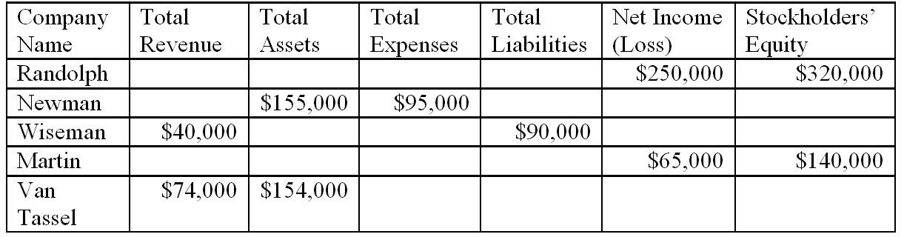

AACSB: Analytic
AICPA BB: Critical Thinking
AICPA FN: Measurement
Blooms: Apply
Difficulty: 2 Medium
Learning Objective: 01-01 Recognize the information conveyed in each of the four basic financial statements and the way that it is used by different decision makers (investors; creditors; and managers).
Topic Area: The Four Basic Financial Statements: An Overview

101. | Gail's Greenhouse, Inc., a small retail store that sells houseplants, started business on January 1, 2014. At the end of January 2014, the following information was available:  Requirements:  A. Using the above information, prepare the income statement for Gail's Greenhouse for the month ended January 31, 2014.  B. What is the amount of cash flows provided by operating activities to be presented on the statement of cash flows?  A. 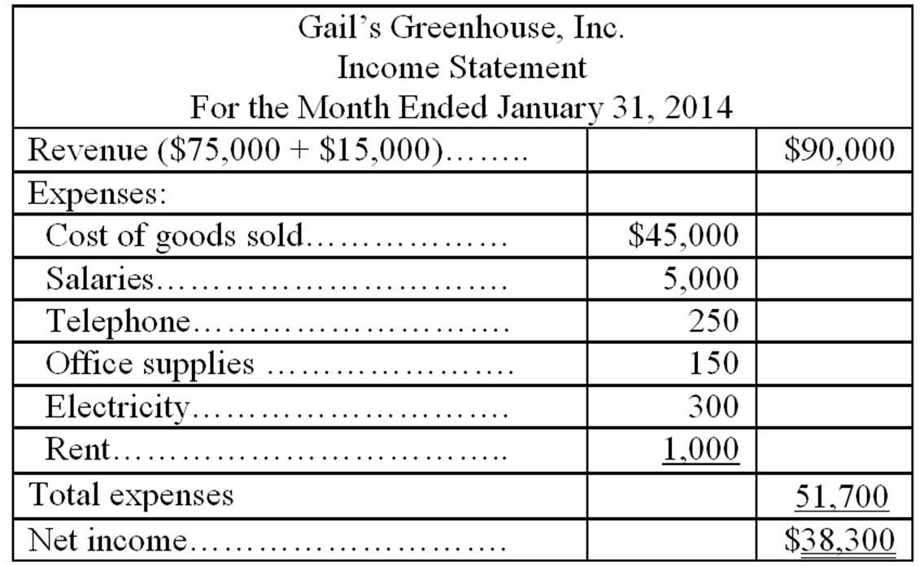  B. $38,300 - 15,000 + 1,000 = $24,300 or $75,000 - 45,000 - 5,000 - 250 - 150 - 300 = $24,300

AACSB: Analytic
AICPA BB: Critical Thinking
AICPA FN: Measurement
Blooms: Apply
Difficulty: 3 Hard
Learning Objective: 01-01 Recognize the information conveyed in each of the four basic financial statements and the way that it is used by different decision makers (investors; creditors; and managers).
Topic Area: The Four Basic Financial Statements: An Overview

102. | Indicate on which financial statement you would expect to find each of the following. If an item can be found on more than one statement, list each statement.  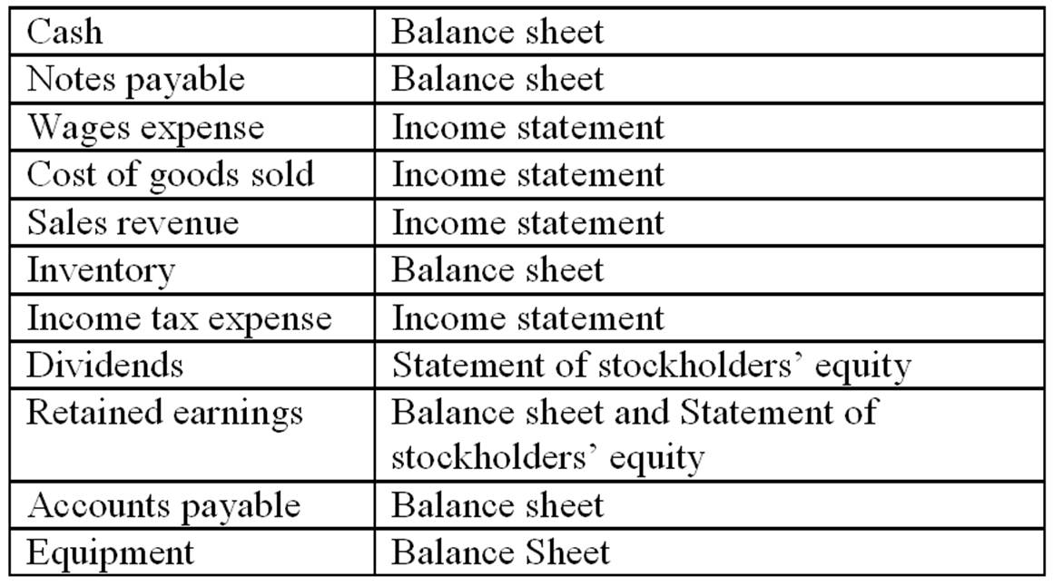

AACSB: Reflective Thinking
AICPA BB: Critical Thinking
AICPA FN: Measurement
Blooms: Remember
Difficulty: 1 Easy
Learning Objective: 01-01 Recognize the information conveyed in each of the four basic financial statements and the way that it is used by different decision makers (investors; creditors; and managers).
Topic Area: The Four Basic Financial Statements: An Overview

103. | For each of the following items that appear on the balance sheet, identify each as an asset (A), liability (L), or element of stockholders' equity (SE). For any item that would not appear on the balance sheet, write the letter, N.  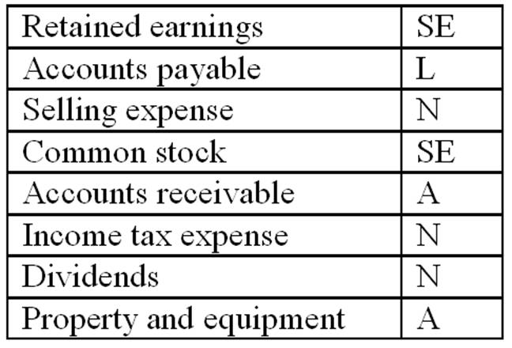

AACSB: Reflective Thinking
AICPA BB: Critical Thinking
AICPA FN: Measurement
Blooms: Remember
Difficulty: 1 Easy
Learning Objective: 01-01 Recognize the information conveyed in each of the four basic financial statements and the way that it is used by different decision makers (investors; creditors; and managers).
Topic Area: The Four Basic Financial Statements: An Overview

104. | Rose Corporation began operations at the start of 2014. During 2014, it made cash and credit sales totaling $500,000 and collected $420,000 in cash from its customers. It purchased inventory costing $250,000, paid $15,000 for dividends and the cost of goods sold was $210,000. Also, the corporation incurred the following expenses during 2014:  Requirements:  1. Prepare an income statement showing revenues, expenses, income before income taxes, income tax expense, and net income for the year ended December 31, 2014.  2. Based on the above information, what is the amount of accounts receivable on the balance sheet prepared as of December 31, 2014?  3. Based on the above information, what is the amount of retained earnings on the balance sheet prepared as of December 31, 2014?  1 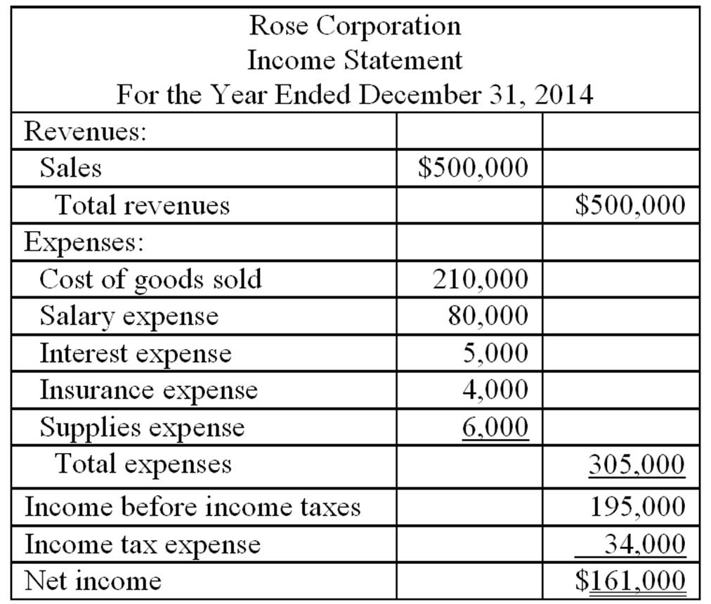  2. $500,000 - 420,000 = $80,000 Accounts receivable at the end of the year.  3. $0 beginning balance + $161,000 net income - $15,000 dividends = $146,000 Retained earnings at the end of the year.

AACSB: Analytic
AICPA BB: Critical Thinking
AICPA FN: Measurement
Blooms: Apply
Difficulty: 3 Hard
Learning Objective: 01-01 Recognize the information conveyed in each of the four basic financial statements and the way that it is used by different decision makers (investors; creditors; and managers).
Topic Area: The Four Basic Financial Statements: An Overview

105. | Cosmos Corporation was established on December 31, 2013, by a group of investors who invested a total of $1,000,000 for shares of the new corporation's common stock. During the month of January 2014, Cosmos provided services to customers for which the total revenue was $100,000. Of this amount, $10,000 had not been collected by the end of January. Cosmos recorded salary expense of $20,000, of which 90% had been paid by the end of the month; rent expense of $5,000, which had been paid on January 1; and other expenses of $12,000, which had been paid by check. On January 31, 2014, Cosmos purchased a van by paying cash of $30,000. There were no other transactions that affected cash.  Requirements:  1. In which section of the statement of cash flows would the amount of cash paid for rent be reported?  2. In which section of the statement of cash flows would the amount of cash paid for the van purchase be reported?  3. By how much did Cosmos's cash increase or decrease during January 2014?  4. What was Cosmos's net income or net loss (after income tax expense) for the month of January 2014? The income tax expense was $18,900.  5. Explain why the net increase or decrease in cash for a business generally will be different than the net income, or net loss, for the same period.  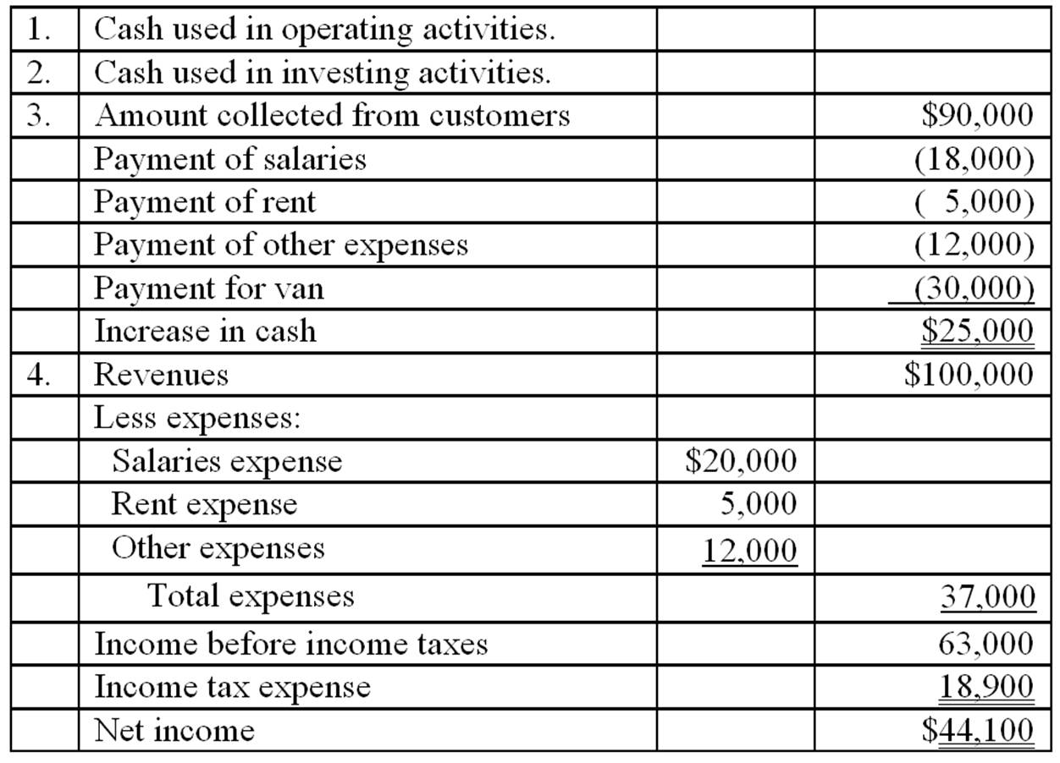  5. Net income or net loss for a period is equal to revenues minus expenses; it is not equal to the change in cash. Revenues are reported on the income statement when earned (or when the goods or services are sold to the customer), which may be before or after the period in which cash is received from the customer. Expenses are reported on the income statement when incurred (or in the period they are used to earn revenues). Again, the payment of cash may occur before or after the period when an expense appears on the income statement.

AACSB: Analytic
AACSB: Communication
AICPA BB: Critical Thinking
AICPA FN: Measurement
Blooms: Apply
Difficulty: 3 Hard
Learning Objective: 01-01 Recognize the information conveyed in each of the four basic financial statements and the way that it is used by different decision makers (investors; creditors; and managers).
Topic Area: The Four Basic Financial Statements: An Overview

106. | Parker Pool Supply, Inc. reported the following items for the year ended December 31, 2014:  Requirement:  Prepare an income statement for the year ended December 31, 2014.  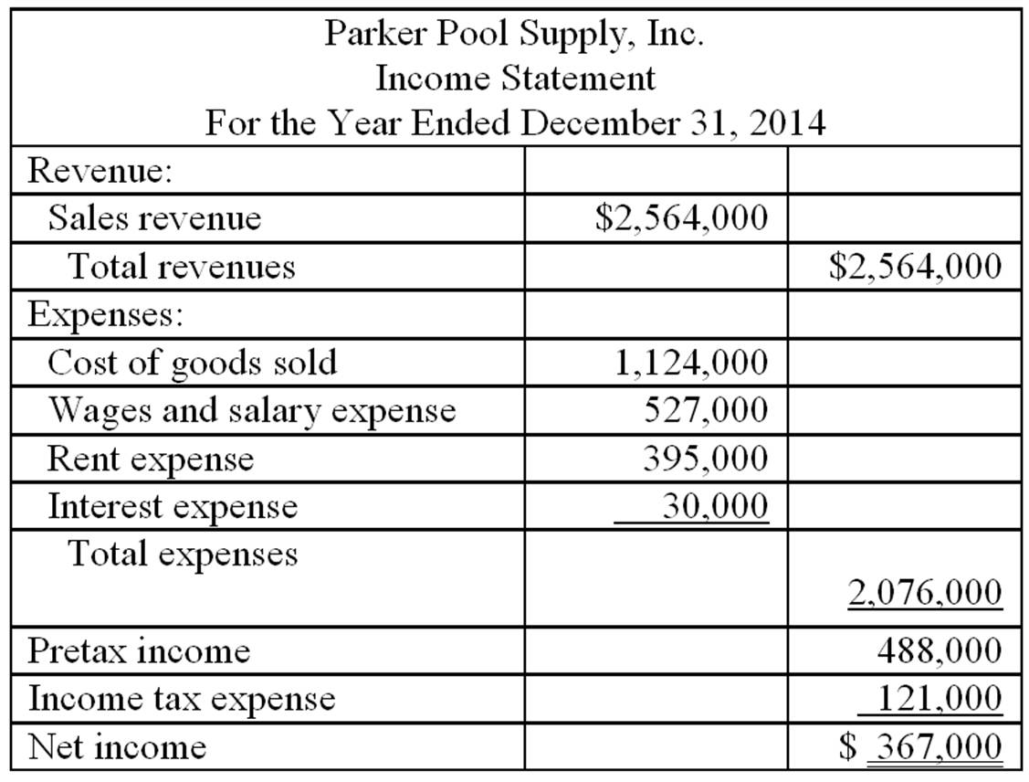  Note: Accounts receivable of $27,000 would appear on the balance sheet, not the income statement.

AACSB: Analytic
AICPA BB: Critical Thinking
AICPA FN: Measurement
Blooms: Apply
Difficulty: 2 Medium
Learning Objective: 01-01 Recognize the information conveyed in each of the four basic financial statements and the way that it is used by different decision makers (investors; creditors; and managers).
Topic Area: The Four Basic Financial Statements: An Overview

107. | National Shops, Inc. reported the following amounts on its balance sheet as of December 31, 2014:  Requirements:  1. What is the amount of National's total assets as of December 31, 2014?  2. Identify the items listed above that are liabilities.  3. What is the amount of National's retained earnings as of December 31, 2014?  4. Prepare a balance sheet for National as of December 31, 2014.  5. National wishes to purchase merchandise from your company on account. The amount of the purchases would probably be about $10,000 per month, and the terms would require National to make payment in full within 30 days. Would you recommend that your company grant credit to National under these terms? Explain the reasoning for your response.  1. Total assets = $325,000 + 150,000 + 600,000 + 30,000 = $1,105,000  2. Liabilities: Accounts payable and Notes payable.  3. Assets = Liabilities + Stockholders' equity  $1,105,000 = (100,000 + 45,000 + Stockholders' equity)  Stockholders' equity = $960,000 = Contributed capital ($750,000) + retained earnings ($210,000)  4. 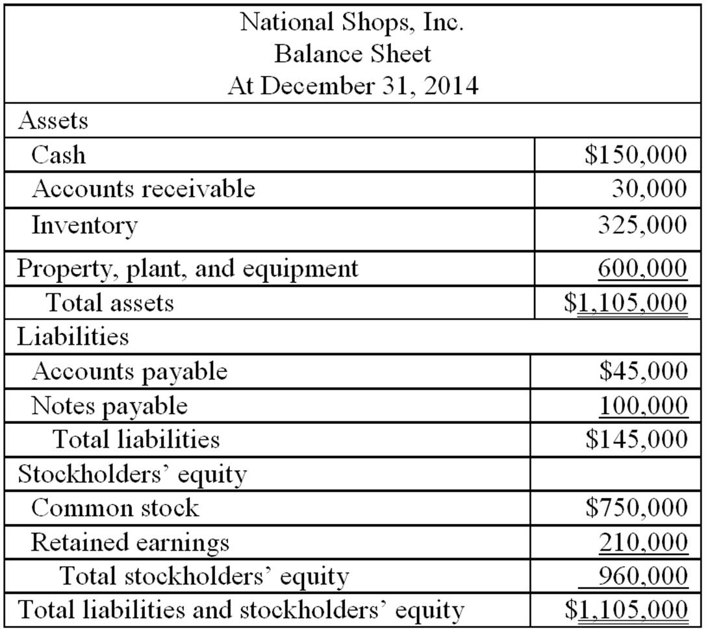  5. The balance sheet of National Shops shows that the company is capable of paying its short-term liabilities. There is cash of $150,000, more than enough to settle the accounts payable of $45,000. I would recommend that my company grant credit to National Shops.

AACSB: Analytic
AACSB: Communication
AICPA BB: Critical Thinking
AICPA FN: Decision Making
AICPA FN: Measurement
Blooms: Analyze
Blooms: Apply
Difficulty: 3 Hard
Learning Objective: 01-01 Recognize the information conveyed in each of the four basic financial statements and the way that it is used by different decision makers (investors; creditors; and managers).
Topic Area: The Four Basic Financial Statements: An Overview

108. | During 2014, Winterset Company performed services for which customers paid or promised to pay $587,000. Of this amount, $552,000 had been collected by year-end. Winterset paid $340,000 in cash for employee wages and owed the employees $15,000 at the end of the year for work that had been done but had not paid for. Winterset paid interest expense of $3,000 and $195,000 for other service expenses. The income tax rate was 35%, and income taxes had not yet been paid at the end of the year. Winterset declared and paid dividends of $20,000. There were no other transactions that affected cash.  Requirements:  1. What was the amount of the increase or decrease in cash during the year?  2. Prepare an income statement for Winterset for the year.  3. At the beginning of 2014, Winterset's retained earnings were $90,000. Prepare a statement of stockholders' equity with only a column for retained earnings.  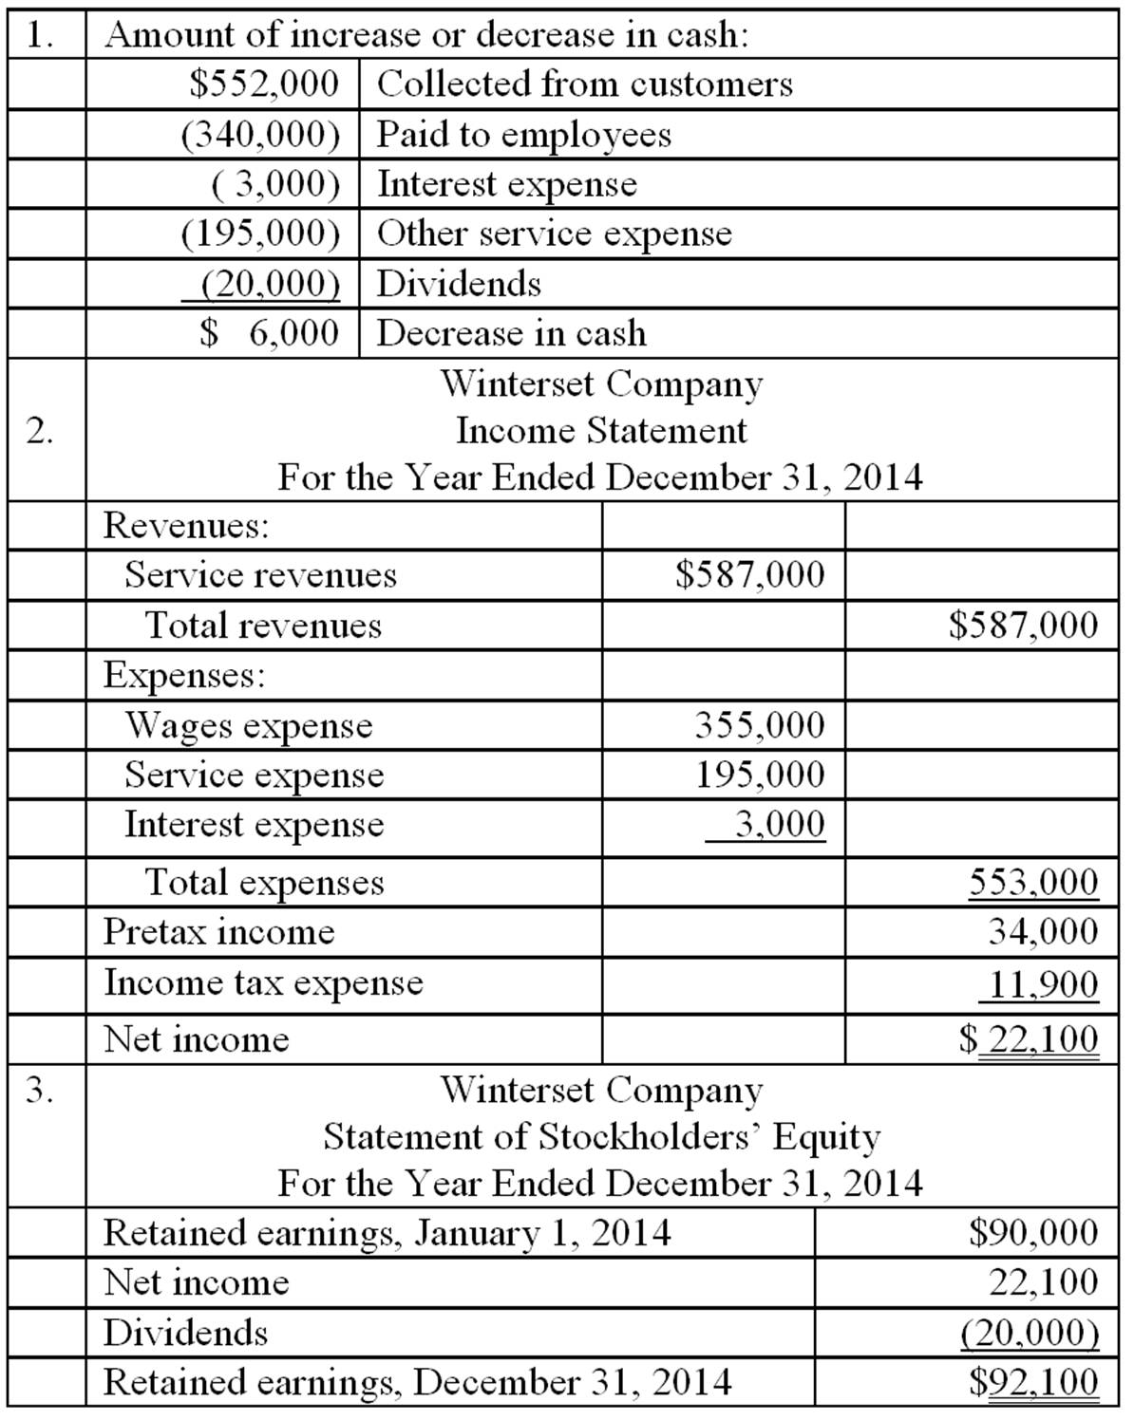

AACSB: Analytic
AICPA BB: Critical Thinking
AICPA FN: Measurement
Blooms: Apply
Difficulty: 3 Hard
Learning Objective: 01-01 Recognize the information conveyed in each of the four basic financial statements and the way that it is used by different decision makers (investors; creditors; and managers).
Topic Area: The Four Basic Financial Statements: An Overview

109. | Alfred Company manufactures men's clothing. During 2014, the company reported the following items that affected cash. Indicate whether each of these items is a cash flow from operating activities (O), investing activities (I), or financing activities (F).  Purchased equipment by paying cash: I  Collected cash on account from customers: O  Paid dividends to stockholders: F  Paid cash for supplies: O  Paid suppliers for fabric: O  Borrowed money from bank on a note payable: F  Paid interest to bank on the note payable: O  Paid wages to employees: O  Sold shares of common stock to new stockholders: F

AACSB: Reflective Thinking
AICPA BB: Critical Thinking
AICPA FN: Measurement
Blooms: Remember
Difficulty: 2 Medium
Learning Objective: 01-01 Recognize the information conveyed in each of the four basic financial statements and the way that it is used by different decision makers (investors; creditors; and managers).
Topic Area: The Four Basic Financial Statements: An Overview

110. | Fulton Company was established at the beginning of 2014 when several investors paid a total of $200,000 to purchase Fulton common stock. No additional investments in common stock were made during the year. By December 31, 2014, Fulton had cash on hand of $45,000, office equipment of $40,000, inventory of $156,000, and accounts payable of $10,000. Sales for the year were $812,000. Of this amount, customers still owed $20,000. Fulton paid dividends of $25,000 to its stockholders during 2014.  Requirements:  1. Based on the information above, prepare a balance sheet for Fulton Company as of December 31, 2014. In the process of preparing the balance sheet, you must calculate the ending balance in retained earnings.  2. Prepare a statement of stockholders' equity for the year ended December 31, 2014.  3. What was the amount of Fulton's net income for 2014?  4. Was Fulton successful during its first year in operation? Explain your answer.  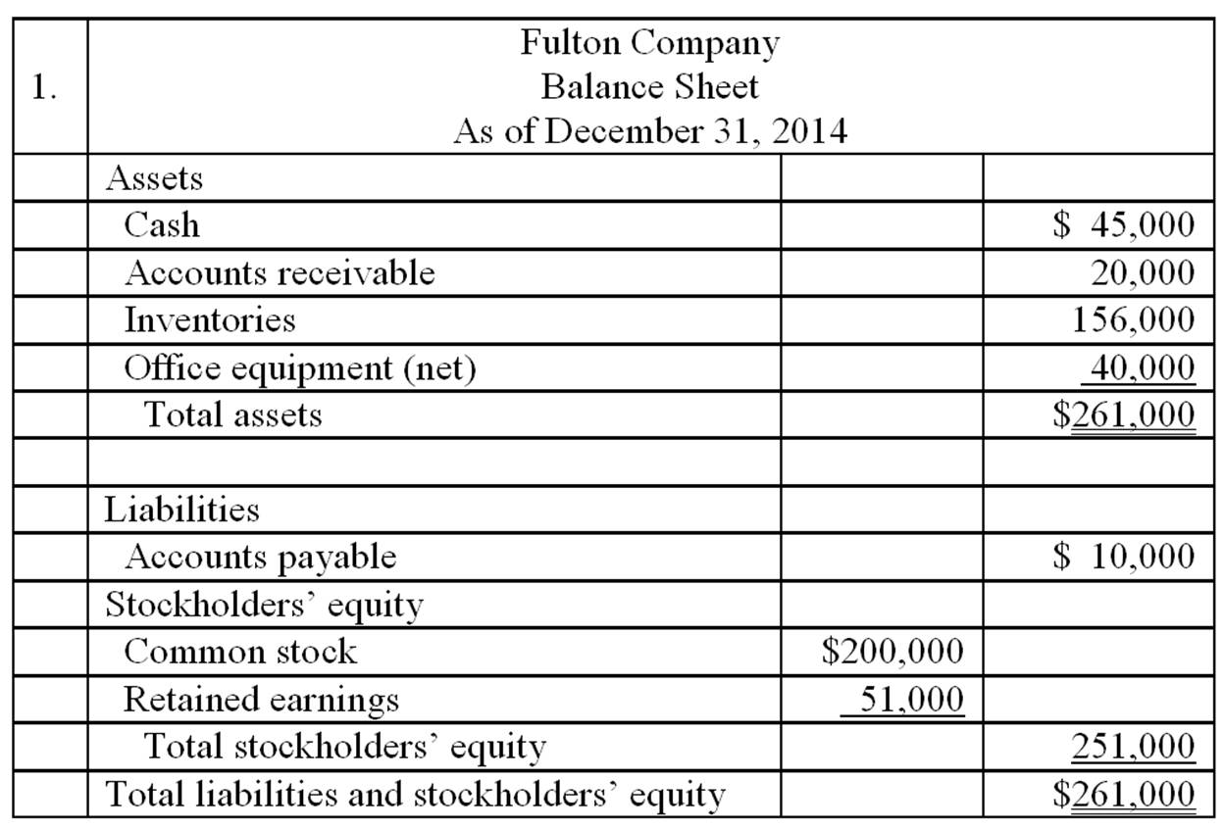  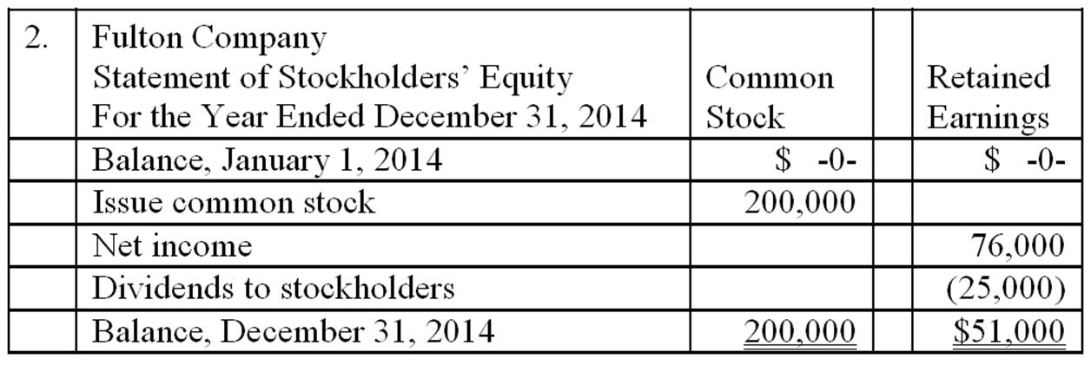  3. $76,000 (see statement of stockholders' equity above)  4. Yes, Fulton's first year was successful. The company earned a positive amount of income; many new companies have losses during their early years of operations. Also, it was able to pay dividends to its stockholders. At the end of the first year, the company has just $10,000 in liabilities. It appears to be in sound financial condition.

AACSB: Analytic
AACSB: Communication
AICPA BB: Critical Thinking
AICPA FN: Decision Making
AICPA FN: Measurement
Blooms: Analyze
Blooms: Apply
Difficulty: 3 Hard
Learning Objective: 01-01 Recognize the information conveyed in each of the four basic financial statements and the way that it is used by different decision makers (investors; creditors; and managers).
Topic Area: The Four Basic Financial Statements: An Overview

111. | For Glad Rags Shops, the following information is available for the year ended December 31, 2014:  The income tax is $150,000.  Requirement:  Prepare an income statement for Glad Rags Shops.  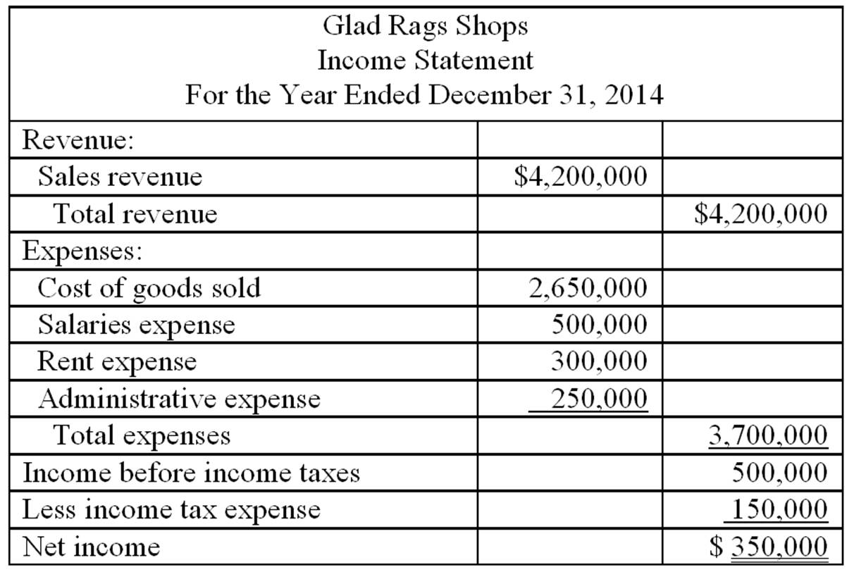  Note: Dividends declared of $10,000 would appear on the statement of stockholders' equity, not the income statement.

AACSB: Analytic
AICPA BB: Critical Thinking
AICPA FN: Measurement
Blooms: Apply
Difficulty: 2 Medium
Learning Objective: 01-01 Recognize the information conveyed in each of the four basic financial statements and the way that it is used by different decision makers (investors; creditors; and managers).
Topic Area: The Four Basic Financial Statements: An Overview

112. | Baseline Corporation was formed two years ago to manufacture fitness equipment. It has been profitable and is growing rapidly. It currently has 150 stockholders and 90 employees; most of the employees own at least a few shares of Baseline's common stock. The company has received financing from two banks. It will sell additional shares of common stock within the next three months and will also seek additional loans and hire new employees to support its continued growth.  Requirement:  1. Explain who relies on the information in financial statements prepared by Baseline Corporation.  2. Why is compliance with generally accepted accounting principles and accuracy in accounting important for Baseline?  3. A new accountant who tried to prepare Baseline's financial statements at the end of the current year made several errors. For each of the following items, indicate whether the income statement and balance sheet are affected by the error, and also the amount by which the respective financial statement is affected. (For example, an error might cause revenues and net income on the income statement and retained earnings and accounts receivable and assets on the balance sheet to be overstated by x dollars). Ignore the effects of income taxes.  a. The company had sales for cash of $3,000,000. It also had sales on account of $1,800,000 that had been collected by the end of the year, and sales on account of $200,000 that are expected to be collected early the following year. The accountant reported total sales revenue of $4,800,000.  b. The company had total inventories of $600,000 at the end of the year. Of this amount, inventory reported at $30,000 was obsolete and will have to be scrapped. The balance sheet prepared by the accountant showed total inventories of $600,000.  c. The company has a bank loan for which interest expense during the year of $10,000 will be paid early in January of the next year. The accountant recorded neither the interest expense nor the interest payable.  d. An insurance policy was listed as an asset of $6,000 at the beginning of the year. The entire amount of the policy was for the current year and the policy has expired. The accountant took no action to recognize the expiration of the policy.  1. Various external decision makers rely on the financial statements of a corporation. For Baseline, these decision makers include the bankers who have loaned money to the company. These creditors would monitor the performance of Baseline to estimate the likelihood that Baseline will be able to repay existing loans when they come due, and to decide whether to make additional loans to Baseline in the future. Current stockholders would want to review Baseline's financial statements to decide whether they wanted to continue to own Baseline's stock. Potential stockholders and creditors would use the information to decide whether they wanted to purchase Baseline's common stock or loan money to the company in the future. Baseline anticipates hiring additional workers in the near future; potential employees might use information in the financial statements to evaluate the company as an employer.  2. Compliance with generally accepted accounting principles and accuracy in accounting are important to Baseline because they are important to the people who use Baseline's financial statements. To maintain the credibility of its financial statements, Baseline must comply with GAAP and must ensure the accuracy of its accounting records.  3. a. On the income statement, revenues and net income are understated by $200,000. On the balance sheet, accounts receivable and retained earnings are understated by $200,000.  b. On the balance sheet, inventory and retained earnings are overstated by $30,000. On the income statement, expenses are understated and the net income is overstated by $30,000.  c. On the income statement, expenses are understated and net income is overstated by $10,000. On the balance sheet, interest payable is understated and retained earnings are overstated by $10,000.  d. On the balance sheet, prepaid insurance and retained earnings are overstated by $6,000. On the income statement, expenses are understated and net income is overstated by $6,000.

AACSB: Analytic
AACSB: Communication
AICPA BB: Critical Thinking
AICPA FN: Measurement
AICPA FN: Risk Analysis
Blooms: Analyze
Blooms: Apply
Blooms: Understand
Difficulty: 3 Hard
Learning Objective: 01-01 Recognize the information conveyed in each of the four basic financial statements and the way that it is used by different decision makers (investors; creditors; and managers).
Learning Objective: 01-02 Identify the role of generally accepted accounting principles (GAAP) in determining financial statement content and how companies ensure the accuracy of their financial statements.
Topic Area: GAAP
Topic Area: Responsibilities for the Accounting Communication Process
Topic Area: The Four Basic Financial Statements: An Overview

113. | Larson Company ends its recent year of operations with $3,500,000 in retained earnings. During the year Larson's net income exceeded its dividend declarations by $200,000. Larson's dividend declarations were $25,000 greater than the dividend payments. How much was Larson Company's beginning retained earnings?  Beginning retained earnings = $3,300,000 = $3,500,000 - $200,000.

AACSB: Analytic
AICPA BB: Critical Thinking
AICPA FN: Measurement
Blooms: Apply
Difficulty: 3 Hard
Learning Objective: 01-01 Recognize the information conveyed in each of the four basic financial statements and the way that it is used by different decision makers (investors; creditors; and managers).
Topic Area: The Four Basic Financial Statements: An Overview

114. | As of January 1, 2014, a corporation had assets of $340,000 and liabilities of $120,000. During 2014, assets increased $45,000 and liabilities increased $15,000. What was stockholders' equity at December 31, 2014?  Assets at December 31, 2014 ($340,000 + $45,000) = $385,000. Liabilities at December 31, 2014 ($120,000 + $15,000) = $135,000. Assets $385,000 = Liabilities $135,000 + SE; Solve for Stockholders Equity at December 31, 2014 = $250,000.

AACSB: Analytic
AICPA BB: Critical Thinking
AICPA FN: Measurement
Blooms: Apply
Difficulty: 2 Medium
Learning Objective: 01-01 Recognize the information conveyed in each of the four basic financial statements and the way that it is used by different decision makers (investors; creditors; and managers).
Topic Area: The Four Basic Financial Statements: An Overview

115. | Laker Company has provided the following information for its most recent year of operation:  Cash collected from customers totaled $99,300.  Cash borrowed from banks totaled $42,700.  Cash paid to employees totaled $23,300.  Cash paid for interest totaled $3,100.  Cash received from selling an investment in Husky stock totaled $73,000.  Cash payments to banks for repayment of money borrowed totaled $9,700.  Cash paid for operating expenses totaled $11,200.  Land costing $75,000 was sold for $75,000 cash.  Cash paid for dividend payments to stockholders totaled $7,700.  How much was Laker's net cash flow from financing activities?  Net cash flow from financing activities = $25,300 = $42,700 - $9,700 - $7,700.

AACSB: Analytic
AICPA BB: Critical Thinking
AICPA FN: Measurement
Blooms: Apply
Difficulty: 2 Medium
Learning Objective: 01-01 Recognize the information conveyed in each of the four basic financial statements and the way that it is used by different decision makers (investors; creditors; and managers).
Topic Area: The Four Basic Financial Statements: An Overview

116. | Laker Company has provided the following information for its most recent year of operation:  Cash collected from customers totaled $99,300.  Cash borrowed from banks totaled $42,700.  Cash paid to employees totaled $23,300.  Cash paid for interest totaled $3,100.  Cash received from selling an investment in Husky stock totaled $73,000.  Cash payments to banks for repayment of money borrowed totaled $9,700.  Cash paid for operating expenses totaled $11,200.  Land costing $75,000 was sold for $75,000 cash.  Cash paid for dividend payments to stockholders totaled $7,700.  How much was Laker's net cash flow from investing activities?  Net cash flow from investing activities = $148,000 = $73,000 + $75,000.

AACSB: Analytic
AICPA BB: Critical Thinking
AICPA FN: Measurement
Blooms: Apply
Difficulty: 2 Medium
Learning Objective: 01-01 Recognize the information conveyed in each of the four basic financial statements and the way that it is used by different decision makers (investors; creditors; and managers).
Topic Area: The Four Basic Financial Statements: An Overview

117. | Laker Company has provided the following information for its most recent year of operation:  Cash collected from customers totaled $99,300.  Cash borrowed from banks totaled $42,700.  Cash paid to employees totaled $23,300.  Cash paid for interest totaled $3,100.  Cash received from selling an investment in Husky stock totaled $73,000.  Cash payments to banks for repayment of money borrowed totaled $9,700.  Cash paid for operating expenses totaled $11,200.  Land costing $75,000 was sold for $75,000 cash.  Cash paid for dividend payments to stockholders totaled $7,700.  How much was Laker's net cash flow from operating activities?  Net cash flow from operating activities = $61,700 = $99,300 - $23,300 - $3,100 - $11,200.

AACSB: Analytic
AICPA BB: Critical Thinking
AICPA FN: Measurement
Blooms: Apply
Difficulty: 2 Medium
Learning Objective: 01-01 Recognize the information conveyed in each of the four basic financial statements and the way that it is used by different decision makers (investors; creditors; and managers).
Topic Area: The Four Basic Financial Statements: An Overview

118. | During 2014, Rock Company's cash balance increased from $57,000 to $94,300. Rock's net cash flow from operating activities was $26,900 and its net cash flow from financing activities was $13,700. How much was Rock's net cash flow from investing activities?  The change in cash is $94,300 - $57,000 = $37,300 = Net cash flow from operating activities $26,900 +/- Net cash flow from investing activities + Net cash flow from financing activities $13,700; $37,300 = $26,900 +/- X + $13,700. X = Investing activities = -$3,300.

AACSB: Analytic
AICPA BB: Critical Thinking
AICPA FN: Measurement
Blooms: Apply
Difficulty: 2 Medium
Learning Objective: 01-01 Recognize the information conveyed in each of the four basic financial statements and the way that it is used by different decision makers (investors; creditors; and managers).
Topic Area: The Four Basic Financial Statements: An Overview

119. | Moss Company has provided the following data:  2014 revenues were $87,500.  2014 expenses were $43,900.  Dividends declared and paid by Moss during 2014 totaled $15,700.  Total assets on December 31, 2014 were $227,000.  Total stockholders' equity on December 31, 2014 was $133,000.  Common stock on December 31, 2014 was $93,000.  What was the beginning retained earnings balance?  Stockholders' equity ($133,000) = Contributed capital ($93,000) + Ending retained earnings ($40,000). Beginning retained earnings ($12,100) = Ending retained earnings ($40,000) - Net income ($87,500 - $43,900) + Dividends ($15,700).

AACSB: Analytic
AICPA BB: Critical Thinking
AICPA FN: Measurement
Blooms: Apply
Difficulty: 2 Medium
Learning Objective: 01-01 Recognize the information conveyed in each of the four basic financial statements and the way that it is used by different decision makers (investors; creditors; and managers).
Topic Area: The Four Basic Financial Statements: An Overview

120. | Describe the roles of the Securities & Exchange Commission and The Financial Accounting Standards Board with respect to the development of Generally Accepted Accounting Principles.  The SEC was created though the Securities Acts of 1933 and 1934 to develop accounting guidelines for publicly traded companies. The SEC has given the FASB the authority to develop GAAP.

AACSB: Communication
AICPA BB: Legal
AICPA FN: Measurement
Blooms: Remember
Difficulty: 1 Easy
Learning Objective: 01-02 Identify the role of generally accepted accounting principles (GAAP) in determining financial statement content and how companies ensure the accuracy of their financial statements.
Topic Area: Responsibilities for the Accounting Communication Process

121. | Describe the elements of the balance sheet equation.  The balance sheet equation states that assets equal liabilities plus stockholders' equity. Assets are a firm's economic resources such as cash, supplies, inventory, and equipment. Liabilities are a firm's debts such as accounts payable and notes payable. Stockholders' equity consists of common stock and retained earnings.

AACSB: Communication
AICPA BB: Critical Thinking
AICPA FN: Measurement
Blooms: Remember
Difficulty: 1 Easy
Learning Objective: 01-01 Recognize the information conveyed in each of the four basic financial statements and the way that it is used by different decision makers (investors; creditors; and managers).
Topic Area: The Four Basic Financial Statements: An Overview

122. | Describe the role of a company's management and the external auditors in the accounting communication process.  Management is primarily responsible for the content of their company's financial reporting. The external auditors' opinion reports on the fairness of the financial statements while reasonably assuring that they represent what they claim to represent and that they conform to GAAP.

AACSB: Communication
AICPA BB: Critical Thinking
AICPA FN: Risk Analysis
Blooms: Remember
Difficulty: 1 Easy
Learning Objective: 01-01 Recognize the information conveyed in each of the four basic financial statements and the way that it is used by different decision makers (investors; creditors; and managers).
Topic Area: Management Responsibility and the Demand for Auditing

123. | What is the objective of the cash flow statement? Describe the three cash flow classifications that are reported within the cash flow statement.  The objective of the cash flow statement is to explain the change in the cash balance during a particular time period. The operating activities section describes the cash flows that resulted from normal profit seeking activities. The investing activities section describes cash flows resulting from acquisition and disposition of long-term assets and investments. The financing activities section describes the cash flows resulting from issuance and retirement of long-term debt and equity.

AACSB: Communication
AICPA BB: Critical Thinking
AICPA FN: Measurement
Blooms: Remember
Difficulty: 1 Easy
Learning Objective: 01-01 Recognize the information conveyed in each of the four basic financial statements and the way that it is used by different decision makers (investors; creditors; and managers).
Topic Area: The Four Basic Financial Statements: An Overview

124. | How is net income in the income statement different than cash flow from operating activities in the cash flow statement?  Net income is based on the accrual concept of accounting and is not based on cash flows or cash basis accounting. This means that revenues and expenses are recognized even if they were paid in cash in a prior period or have not yet been paid by the end of the reporting period. Cash flow from operating activities is cash flow based on actual cash receipts and cash payments during the accounting period.

AACSB: Communication
AICPA BB: Critical Thinking
AICPA FN: Measurement
Blooms: Remember
Difficulty: 1 Easy
Learning Objective: 01-01 Recognize the information conveyed in each of the four basic financial statements and the way that it is used by different decision makers (investors; creditors; and managers).
Topic Area: The Four Basic Financial Statements: An Overview

