Chapter 01
Overview of Financial Statement Analysis

Multiple Choice Questions
1. | Which of the following is likely to be the most informative source if you were interested in a company's business plan or strategy?  A. Auditor's letter  B. Management discussion and analysis  C. Proxy statement  D. Footnotes

2. | Which of the following would not be considered a source of financing?  A. Notes receivable  B. Common stockholders' equity  C. Retained earnings  D. Debentures

3. | Wilco Company reports the following:  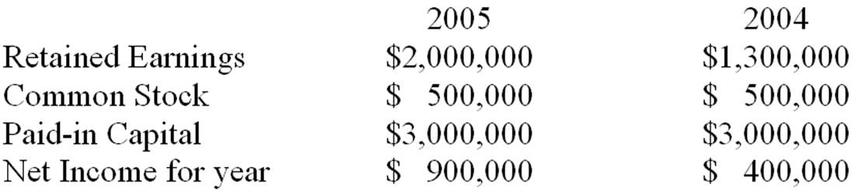  Dividend payout ratio for 2005 was:  A. 27%.  B. 12%.  C. 22.2%.  D. Not determinable

4. | If a company receives an unqualified audit opinion it means the auditors:  A. did not complete a full audit and therefore do not feel qualified to give an opinion on financial statements.  B. are providing assurance that the company will remain financially viable for at least the next year.  C. are providing assurance that the company's financial statements fairly present company's financial performance and position.  D. are providing assurance that the company's financial statements are free from misstatement, fraudulent accounting and fairly indicate future performance.

5. | The Management Discussion and Analysis Section of an annual report:  A. is required by the SEC.  B. is optional but normally included in the annual report.  C. is required by the SEC only if the company has suffered from unfavorable trends or there are significant uncertainty concerning liquidity of the company.  D. is required by the SEC only if they have a qualified audit opinion.

You are analyzing a large stable company. For the year ending 12/31/05 the company reported earnings of $58,900 and book value at the end of 2005 was $371,700. You expect earnings to grow at 5% a year in perpetuity, and the dividend payout ratio of 70% to continue. The company borrows at 8%, and has a cost of equity of 12%. The company has 25,000 shares outstanding.

6. | What is your estimate of price per share using the dividend discount model at 12/31/05?  A. $20.62  B. $21.65  C. $23.56  D. $24.74

7. | What is your estimate of price using the residual income valuation model at 12/31/05?  A. $20.62  B. $21.65  C. $23.56  D. $24.72

8. | Which of the following is not a common tool used in financial statement analysis?  A. Random walk analysis  B. Ratio analysis  C. Common-size statement analysis  D. Credit analysis

9. | A common-size income statement would typically be prepared by dividing:  A. all items on income statement in Year t by their corresponding value in Year t-1.  B. all items on income statement in Year t by their corresponding balance sheet accounts in Year t.  C. all items on income statement in Year t by net income in Year t-1.  D. all items on income statement in Year t by sales in Year t.

10. | When conducting comparative analysis by reviewing consecutive balance sheets:  A. all items on the balance sheet in Year t must be divided by their corresponding value in Year t-1 and subtract 1 to calculate the percentage change.  B. all items on the balance sheet in Year t-1 must be subtracted from their corresponding value in Year t to calculate the dollar change.  C. all items on the balance sheet in Year t must be divided by net income in Year t-1 to calculate the percentage change.  D. Both A and B are correct.

You have prepared a trend series for Company XYZ for three years, 2004-2006 inclusive, using 2004 as the base year. Below are selected data.
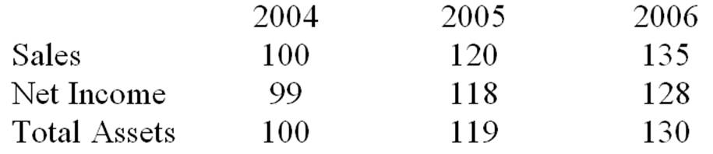

11. | From the above information, you can infer that:  A. rate of sales growth has decreased.  B. net income to sales (return on sales) is increasing over time.  C. asset turnover is decreasing over time.  D. None of the above

12. | Which of the following statements is incorrect?  A. Net income in 2006 increased by 29.29% compared to 2004.  B. XYZ's net income to sales (return on sales) is higher in 2006 as compared to 2004.  C. XYZ's net income to sales (return on sales) is lower in 2005 as compared to 2004.  D. Assets have increased over time.

Part of the demonstration, if you need more samples, please contact the customer service

From qidiantiku.com

