Chapter 01
The Equity Method of Accounting for Investments

Multiple Choice Questions
1. | Gaw Company owns 15% of the common stock of Trace Corporation and used the fair-value method to account for this investment. Trace reported net income of $110,000 for 2013 and paid dividends of $60,000 on October 1, 2013. How much income should Gaw recognize on this investment in 2013?  A. $16,500.  B. $9,000.  C. $25,500.  D. $7,500.  E. $50,000.

2. | Yaro Company owns 30% of the common stock of Dew Co. and uses the equity method to account for the investment. During 2013, Dew reported income of $250,000 and paid dividends of $80,000. There is no amortization associated with the investment. During 2013, how much income should Yaro recognize related to this investment?  A. $24,000.  B. $75,000.  C. $99,000.  D. $51,000.  E. $80,000.

3. | On January 1, 2013, Pacer Company paid $1,920,000 for 60,000 shares of Lennon Co.'s voting common stock which represents a 45% investment. No allocation to goodwill or other specific account was made. Significant influence over Lennon was achieved by this acquisition. Lennon distributed a dividend of $2.50 per share during 2013 and reported net income of $670,000. What was the balance in the Investment in Lennon Co. account found in the financial records of Pacer as of December 31, 2013?  A. $2,040,500.  B. $2,212,500.  C. $2,260,500.  D. $2,171,500.  E. $2,071,500.

4. | A company should always use the equity method to account for an investment if:  A. It has the ability to exercise significant influence over the operating policies of the investee.  B. It owns 30% of another company's stock.  C. It has a controlling interest (more than 50%) of another company's stock.  D. The investment was made primarily to earn a return on excess cash.  E. It does not have the ability to exercise significant influence over the operating policies of the investee.

5. | On January 1, 2011, Dermot Company purchased 15% of the voting common stock of Horne Corp. On January 1, 2013, Dermot purchased 28% of Horne's voting common stock. If Dermot achieves significant influence with this new investment, how must Dermot account for the change to the equity method?  A. It must use the equity method for 2013 but should make no changes in its financial statements for 2012 and 2011.  B. It should prepare consolidated financial statements for 2013.  C. It must restate the financial statements for 2012 and 2011 as if the equity method had been used for those two years.  D. It should record a prior period adjustment at the beginning of 2013 but should not restate the financial statements for 2012 and 2011.  E. It must restate the financial statements for 2012 as if the equity method had been used then.

6. | During January 2012, Wells, Inc. acquired 30% of the outstanding common stock of Wilton Co. for $1,400,000. This investment gave Wells the ability to exercise significant influence over Wilton. Wilton's assets on that date were recorded at $6,400,000 with liabilities of $3,000,000. Any excess of cost over book value of Wells' investment was attributed to unrecorded patents having a remaining useful life of ten years.  In 2012, Wilton reported net income of $600,000. For 2013, Wilton reported net income of $750,000. Dividends of $200,000 were paid in each of these two years. What was the reported balance of Wells' Investment in Wilson Co. at December 31, 2013?  A. $1,609,000.  B. $1,485,000.  C. $1,685,000.  D. $1,647,000.  E. $1,054,300.

7. | On January 1, 2013, Bangle Company purchased 30% of the voting common stock of Sleat Corp. for $1,000,000. Any excess of cost over book value was assigned to goodwill. During 2013, Sleat paid dividends of $24,000 and reported a net loss of $140,000. What is the balance in the investment account on December 31, 2013?  A. $950,800.  B. $958,000.  C. $836,000.  D. $990,100.  E. $956,400.

8. | On January 1, 2013, Jordan Inc. acquired 30% of Nico Corp. Jordan used the equity method to account for the investment. On January 1, 2014, Jordan sold two-thirds of its investment in Nico. It no longer had the ability to exercise significant influence over the operations of Nico. How should Jordan have accounted for this change?  A. Jordan should continue to use the equity method to maintain consistency in its financial statements.  B. Jordan should restate the prior years' financial statements and change the balance in the investment account as if the fair-value method had been used since 2013.  C. Jordan has the option of using either the equity method or the fair-value method for 2013 and future years.  D. Jordan should report the effect of the change from the equity to the fair-value method as a retrospective change in accounting principle.  E. Jordan should use the fair-value method for 2014 and future years but should not make a retrospective adjustment to the investment account.

9. | Tower Inc. owns 30% of Yale Co. and applies the equity method. During the current year, Tower bought inventory costing $66,000 and then sold it to Yale for $120,000. At year-end, only $24,000 of merchandise was still being held by Yale. What amount of intra-entity inventory profit must be deferred by Tower?  A. $6,480.  B. $3,240.  C. $10,800.  D. $16,200.  E. $6,610.

10. | On January 4, 2013, Watts Co. purchased 40,000 shares (40%) of the common stock of Adams Corp., paying $800,000. There was no goodwill or other cost allocation associated with the investment. Watts has significant influence over Adams. During 2013, Adams reported income of $200,000 and paid dividends of $80,000. On January 2, 2014, Watts sold 5,000 shares for $125,000. What was the balance in the investment account after the shares had been sold?  A. $848,000.  B. $742,000.  C. $723,000.  D. $761,000.  E. $925,000.

11. | On January 3, 2013, Austin Corp. purchased 25% of the voting common stock of Gainsville Co., paying $2,500,000. Austin decided to use the equity method to account for this investment. At the time of the investment, Gainsville's total stockholders' equity was $8,000,000. Austin gathered the following information about Gainsville's assets and liabilities:  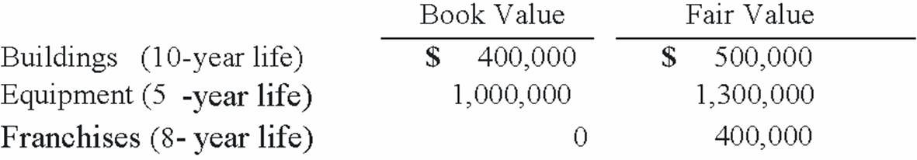  For all other assets and liabilities, book value and fair value were equal. Any excess of cost over fair value was attributed to goodwill, which has not been impaired.  What is the amount of goodwill associated with the investment?  A. $500,000.  B. $200,000.  C. $0.  D. $300,000.  E. $400,000.

12. | On January 3, 2013, Austin Corp. purchased 25% of the voting common stock of Gainsville Co., paying $2,500,000. Austin decided to use the equity method to account for this investment. At the time of the investment, Gainsville's total stockholders' equity was $8,000,000. Austin gathered the following information about Gainsville's assets and liabilities:  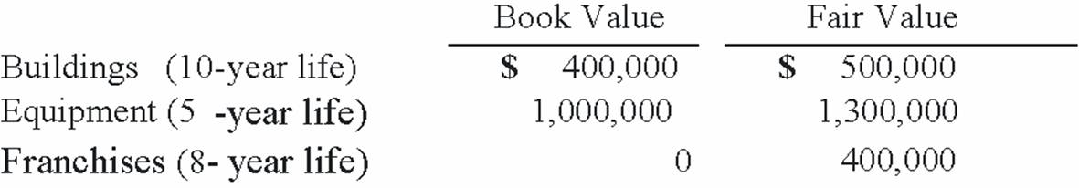  For all other assets and liabilities, book value and fair value were equal. Any excess of cost over fair value was attributed to goodwill, which has not been impaired.  For 2013, what is the total amount of excess amortization for Austin's 25% investment in Gainsville?  A. $27,500.  B. $20,000.  C. $30,000.  D. $120,000.  E. $70,000.

13. | Club Co. appropriately uses the equity method to account for its investment in Chip Corp. As of the end of 2013, Chip's common stock had suffered a significant decline in fair value, which is expected to be recovered over the next several months. How should Club account for the decline in value?  A. Club should switch to the fair-value method.  B. No accounting because the decline in fair value is temporary.  C. Club should decrease the balance in the investment account to the current value and recognize a loss on the income statement.  D. Club should not record its share of Chip's 2013 earnings until the decline in the fair value of the stock has been recovered.  E. Club should decrease the balance in the investment account to the current value and recognize an unrealized loss on the balance sheet.

14. | An upstream sale of inventory is a sale:  A. between subsidiaries owned by a common parent.  B. with the transfer of goods scheduled by contract to occur on a specified future date.  C. in which the goods are physically transported by boat from a subsidiary to its parent.  D. made by the investor to the investee.  E. made by the investee to the investor.

15. | Atlarge Inc. owns 30% of the outstanding voting common stock of Ticker Co. and has the ability to significantly influence the investee's operations and decision making. On January 1, 2013, the balance in the Investment in Ticker Co. account was $402,000. Amortization associated with the purchase of this investment is $8,000 per year. During 2013, Ticker earned income of $108,000 and paid cash dividends of $36,000. Previously in 2012, Ticker had sold inventory costing $28,800 to Atlarge for $48,000. All but 25% of this merchandise was consumed by Atlarge during 2012. The remainder was used during the first few weeks of 2013. Additional sales were made to Atlarge in 2013; inventory costing $33,600 was transferred at a price of $60,000. Of this total, 40% was not consumed until 2014.  What amount of equity income would Atlarge have recognized in 2013 from its ownership interest in Ticker?  A. $19,792.  B. $27,640.  C. $22,672.  D. $24,400.  E. $21,748.

16. | Atlarge Inc. owns 30% of the outstanding voting common stock of Ticker Co. and has the ability to significantly influence the investee's operations and decision making. On January 1, 2013, the balance in the Investment in Ticker Co. account was $402,000. Amortization associated with the purchase of this investment is $8,000 per year. During 2013, Ticker earned income of $108,000 and paid cash dividends of $36,000. Previously in 2012, Ticker had sold inventory costing $28,800 to Atlarge for $48,000. All but 25% of this merchandise was consumed by Atlarge during 2012. The remainder was used during the first few weeks of 2013. Additional sales were made to Atlarge in 2013; inventory costing $33,600 was transferred at a price of $60,000. Of this total, 40% was not consumed until 2014.  What was the balance in the Investment in Ticker Co. account at the end of 2013?  A. $401,136.  B. $413,872.  C. $418,840.  D. $412,432.  E. $410,148.

17. | On January 1, 2013, Deuce Inc. acquired 15% of Wiz Co.'s outstanding common stock for $62,400 and categorized the investment as an available-for-sale security. Wiz earned net income of $96,000 in 2013 and paid dividends of $36,000. On January 1, 2014, Deuce bought an additional 10% of Wiz for $54,000. This second purchase gave Deuce the ability to significantly influence the decision making of Wiz. During 2014, Wiz earned $120,000 and paid $48,000 in dividends. As of December 31, 2014, Wiz reported a net book value of $468,000. For both purchases, Deuce concluded that Wiz Co.'s book values approximated fair values and attributed any excess cost to goodwill.  On Deuce's December 31, 2014 balance sheet, what balance was reported for the Investment in Wiz Co. account?  A. $139,560.  B. $143,400.  C. $310,130.  D. $186,080.  E. $182,250.

18. | On January 1, 2013, Deuce Inc. acquired 15% of Wiz Co.'s outstanding common stock for $62,400 and categorized the investment as an available-for-sale security. Wiz earned net income of $96,000 in 2013 and paid dividends of $36,000. On January 1, 2014, Deuce bought an additional 10% of Wiz for $54,000. This second purchase gave Deuce the ability to significantly influence the decision making of Wiz. During 2014, Wiz earned $120,000 and paid $48,000 in dividends. As of December 31, 2014, Wiz reported a net book value of $468,000. For both purchases, Deuce concluded that Wiz Co.'s book values approximated fair values and attributed any excess cost to goodwill.  What amount of equity income should Deuce have reported for 2014?  A. $30,000.  B. $16,420.  C. $38,340.  D. $18,000.  E. $32,840.

19. | In a situation where the investor exercises significant influence over the investee, which of the following entries is not actually posted to the books of the investor?  1) Debit to the Investment account, and a Credit to the Equity in Investee Income account.  2) Debit to Cash (for dividends received from the investee), and a Credit to Dividend Revenue.  3) Debit to Cash (for dividends received from the investee), and a Credit to the Investment account.  A. Entries 1 and 2.  B. Entries 2 and 3.  C. Entry 1 only.  D. Entry 2 only.  E. Entry 3 only.

20. | All of the following would require use of the equity method for investments except:  A. material intra-entity transactions.  B. investor participation in the policy-making process of the investee.  C. valuation at fair value.  D. technological dependency.  E. significant control.

21. | All of the following statements regarding the investment account using the equity method are true except:  A. The investment is recorded at cost.  B. Dividends received are reported as revenue.  C. Net income of investee increases the investment account.  D. Dividends received reduce the investment account.  E. Amortization of fair value over cost reduces the investment account.

22. | A company has been using the fair-value method to account for its investment. The company now has the ability to significantly control the investee and the equity method has been deemed appropriate. Which of the following statements is true?  A. A cumulative effect change in accounting principle must occur.  B. A prospective change in accounting principle must occur.  C. A retrospective change in accounting principle must occur.  D. The investor will not receive future dividends from the investee.  E. Future dividends will continue to be recorded as revenue.

23. | A company has been using the equity method to account for its investment. The company sells shares and does not continue to have significant control. Which of the following statements is true?  A. A cumulative effect change in accounting principle must occur.  B. A prospective change in accounting principle must occur.  C. A retrospective change in accounting principle must occur.  D. The investor will not receive future dividends from the investee.  E. Future dividends will continue to reduce the investment account.

24. | An investee company incurs an extraordinary loss during the period. The investor appropriately applies the equity method. Which of the following statements is true?  A. Under the equity method, the investor only recognizes its share of investee's income from continuing operations.  B. The extraordinary loss would reduce the value of the investment.  C. The extraordinary loss should increase equity in investee income.  D. The extraordinary loss would not appear on the income statement but would be a component of comprehensive income.  E. The loss would be ignored but shown in the investor's notes to the financial statements.

25. | How should a permanent loss in value of an investment using the equity method be treated?  A. The equity in investee income is reduced.  B. A loss is reported the same as a loss in value of other long-term assets.  C. The investor's stockholders' equity is reduced.  D. No adjustment is necessary.  E. An extraordinary loss would be reported.

26. | Under the equity method, when the company's share of cumulative losses equals its investment and the company has no obligation or intention to fund such additional losses, which of the following statements is true?  A. The investor should change to the fair-value method to account for its investment.  B. The investor should suspend applying the equity method until the investee reports income.  C. The investor should suspend applying the equity method and not record any equity in income of investee until its share of future profits is sufficient to recover losses that have not previously been recorded.  D. The cumulative losses should be reported as a prior period adjustment.  E. The investor should report these losses as extraordinary items.

27. | When an investor sells shares of its investee company, which of the following statements is true?  A. A realized gain or loss is reported as the difference between selling price and original cost.  B. An unrealized gain or loss is reported as the difference between selling price and original cost.  C. A realized gain or loss is reported as the difference between selling price and carrying value.  D. An unrealized gain or loss is reported as the difference between selling price and carrying value.  E. Any gain or loss is reported as part as comprehensive income.

28. | When applying the equity method, how is the excess of cost over book value accounted for?  A. The excess is allocated to the difference between fair value and book value multiplied by the percent ownership of current assets.  B. The excess is allocated to the difference between fair value and book value multiplied by the percent ownership of total assets.  C. The excess is allocated to the difference between fair value and book value multiplied by the percent ownership of net assets.  D. The excess is allocated to goodwill.  E. The excess is ignored.

29. | After allocating cost in excess of book value, which asset or liability would not be amortized over a useful life?  A. Cost of goods sold.  B. Property, plant, & equipment.  C. Patents.  D. Goodwill.  E. Bonds payable.

30. | Which statement is true concerning unrealized profits in intra-entity inventory transfers when an investor uses the equity method?  A. The investee must defer upstream ending inventory profits.  B. The investee must defer upstream beginning inventory profits.  C. The investor must defer downstream ending inventory profits.  D. The investor must defer downstream beginning inventory profits.  E. The investor must defer upstream beginning inventory profits.

31. | Which statement is true concerning unrealized profits in intra-entity inventory transfers when an investor uses the equity method?  A. The investor and investee make reciprocal entries to defer and realize inventory profits.  B. The same adjustments are made for upstream and downstream transfers.  C. Different adjustments are made for upstream and downstream transfers.  D. No adjustments are necessary.  E. Adjustments will be made only when profits are known upon sale to outsiders.

32. | On January 1, 2012, Dawson, Incorporated, paid $100,000 for a 30% interest in Sacco Corporation. This investee had assets with a book value of $550,000 and liabilities of $300,000. A patent held by Sacco having a book value of $10,000 was actually worth $40,000 with a six year remaining life. Any goodwill associated with this acquisition is considered to have an indefinite life. During 2012, Sacco reported income of $50,000 and paid dividends of $20,000 while in 2013 it reported income of $75,000 and dividends of $30,000. Assume Dawson has the ability to significantly influence the operations of Sacco.  The amount allocated to goodwill at January 1, 2012, is  A. $25,000.  B. $13,000.  C. $9,000.  D. $16,000.  E. $10,000.

33. | On January 1, 2012, Dawson, Incorporated, paid $100,000 for a 30% interest in Sacco Corporation. This investee had assets with a book value of $550,000 and liabilities of $300,000. A patent held by Sacco having a book value of $10,000 was actually worth $40,000 with a six year remaining life. Any goodwill associated with this acquisition is considered to have an indefinite life. During 2012, Sacco reported income of $50,000 and paid dividends of $20,000 while in 2013 it reported income of $75,000 and dividends of $30,000. Assume Dawson has the ability to significantly influence the operations of Sacco.  The equity in income of Sacco for 2012, is  A. $9,000.  B. $13,500.  C. $15,000.  D. $7,500.  E. $50,000.

34. | On January 1, 2012, Dawson, Incorporated, paid $100,000 for a 30% interest in Sacco Corporation. This investee had assets with a book value of $550,000 and liabilities of $300,000. A patent held by Sacco having a book value of $10,000 was actually worth $40,000 with a six year remaining life. Any goodwill associated with this acquisition is considered to have an indefinite life. During 2012, Sacco reported income of $50,000 and paid dividends of $20,000 while in 2013 it reported income of $75,000 and dividends of $30,000. Assume Dawson has the ability to significantly influence the operations of Sacco.  The equity in income of Sacco for 2013, is  A. $22,500.  B. $21,000.  C. $12,000.  D. $13,500.  E. $75,000.

35. | On January 1, 2012, Dawson, Incorporated, paid $100,000 for a 30% interest in Sacco Corporation. This investee had assets with a book value of $550,000 and liabilities of $300,000. A patent held by Sacco having a book value of $10,000 was actually worth $40,000 with a six year remaining life. Any goodwill associated with this acquisition is considered to have an indefinite life. During 2012, Sacco reported income of $50,000 and paid dividends of $20,000 while in 2013 it reported income of $75,000 and dividends of $30,000. Assume Dawson has the ability to significantly influence the operations of Sacco.  The balance in the Investment in Sacco account at December 31, 2012, is  A. $100,000.  B. $112,000.  C. $106,000.  D. $107,500.  E. $140,000.

36. | On January 1, 2012, Dawson, Incorporated, paid $100,000 for a 30% interest in Sacco Corporation. This investee had assets with a book value of $550,000 and liabilities of $300,000. A patent held by Sacco having a book value of $10,000 was actually worth $40,000 with a six year remaining life. Any goodwill associated with this acquisition is considered to have an indefinite life. During 2012, Sacco reported income of $50,000 and paid dividends of $20,000 while in 2013 it reported income of $75,000 and dividends of $30,000. Assume Dawson has the ability to significantly influence the operations of Sacco.  The balance in the Investment in Sacco account at December 31, 2013, is  A. $119,500.  B. $125,500.  C. $116,500.  D. $118,000.  E. $100,000.

37. | Dodge, Incorporated acquires 15% of Gates Corporation on January 1, 2013, for $105,000 when the book value of Gates was $600,000. During 2013 Gates reported net income of $150,000 and paid dividends of $50,000. On January 1, 2014, Dodge purchased an additional 25% of Gates for $200,000. Any excess cost over book value is attributable to goodwill with an indefinite life. The fair-value method was used during 2013 but Dodge has deemed it necessary to change to the equity method after the second purchase. During 2014 Gates reported net income of $200,000 and reported dividends of $75,000.  The income reported by Dodge for 2013 with regard to the Gates investment is  A. $7,500.  B. $22,500.  C. $15,000.  D. $100,000.  E. $150,000.

38. | Dodge, Incorporated acquires 15% of Gates Corporation on January 1, 2013, for $105,000 when the book value of Gates was $600,000. During 2013 Gates reported net income of $150,000 and paid dividends of $50,000. On January 1, 2014, Dodge purchased an additional 25% of Gates for $200,000. Any excess cost over book value is attributable to goodwill with an indefinite life. The fair-value method was used during 2013 but Dodge has deemed it necessary to change to the equity method after the second purchase. During 2014 Gates reported net income of $200,000 and reported dividends of $75,000.  The income reported by Dodge for 2014 with regard to the Gates investment is  A. $80,000.  B. $30,000.  C. $50,000.  D. $15,000.  E. $75,000.

39. | Dodge, Incorporated acquires 15% of Gates Corporation on January 1, 2013, for $105,000 when the book value of Gates was $600,000. During 2013 Gates reported net income of $150,000 and paid dividends of $50,000. On January 1, 2014, Dodge purchased an additional 25% of Gates for $200,000. Any excess cost over book value is attributable to goodwill with an indefinite life. The fair-value method was used during 2013 but Dodge has deemed it necessary to change to the equity method after the second purchase. During 2014 Gates reported net income of $200,000 and reported dividends of $75,000.  Which adjustment would be made to change from the fair-value method to the equity method?  A. A debit to additional paid-in capital for $15,000.  B. A credit to additional paid-in capital for $15,000.  C. A debit to retained earnings for $15,000.  D. A credit to retained earnings for $15,000.  E. A credit to a gain on investment.

40. | Dodge, Incorporated acquires 15% of Gates Corporation on January 1, 2013, for $105,000 when the book value of Gates was $600,000. During 2013 Gates reported net income of $150,000 and paid dividends of $50,000. On January 1, 2014, Dodge purchased an additional 25% of Gates for $200,000. Any excess cost over book value is attributable to goodwill with an indefinite life. The fair-value method was used during 2013 but Dodge has deemed it necessary to change to the equity method after the second purchase. During 2014 Gates reported net income of $200,000 and reported dividends of $75,000.  The balance in the investment account at December 31, 2014, is  A. $370,000.  B. $355,000.  C. $305,000.  D. $400,000.  E. $105,000.

41. | Clancy Incorporated, sold $210,000 of its inventory to Reid Company during 2013 for $350,000. Reid sold $224,000 of this merchandise in 2013 with the remainder to be disposed of during 2014. Assume Clancy owns 30% of Reid and applies the equity method.  What journal entry will be recorded at the end of 2013 to defer the unrealized intra-entity profits?  A. Entry A.  B. Entry B.  C. Entry C.  D. Entry D.  E. No entry is necessary.

42. | Clancy Incorporated, sold $210,000 of its inventory to Reid Company during 2013 for $350,000. Reid sold $224,000 of this merchandise in 2013 with the remainder to be disposed of during 2014. Assume Clancy owns 30% of Reid and applies the equity method.  What journal entry will be recorded in 2014 to realize the intra-entity profit that was deferred in 2013?  A. Entry A.  B. Entry B.  C. Entry C.  D. Entry D.  E. No entry is necessary.

43. | On January 1, 2012, Mehan, Incorporated purchased 15,000 shares of Cook Company for $150,000 giving Mehan a 15% ownership of Cook. On January 1, 2013 Mehan purchased an additional 25,000 shares (25%) of Cook for $300,000. This last purchase gave Mehan the ability to apply significant influence over Cook. The book value of Cook on January 1, 2012, was $1,000,000. The book value of Cook on January 1, 2013, was $1,150,000. Any excess of cost over book value for this second transaction is assigned to a database and amortized over five years.  Cook reports net income and dividends as follows. These amounts are assumed to have occurred evenly throughout the years:  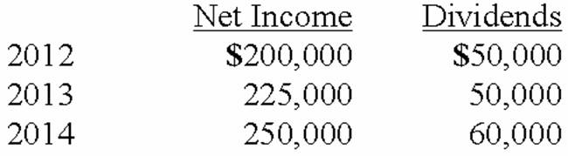  On April 1, 2014, just after its first dividend receipt, Mehan sells 10,000 shares of its investment.  What is the balance in the investment account at December 31, 2012?  A. $150,000.  B. $172,500.  C. $180,000.  D. $157,500.  E. $170,000.

44. | On January 1, 2012, Mehan, Incorporated purchased 15,000 shares of Cook Company for $150,000 giving Mehan a 15% ownership of Cook. On January 1, 2013 Mehan purchased an additional 25,000 shares (25%) of Cook for $300,000. This last purchase gave Mehan the ability to apply significant influence over Cook. The book value of Cook on January 1, 2012, was $1,000,000. The book value of Cook on January 1, 2013, was $1,150,000. Any excess of cost over book value for this second transaction is assigned to a database and amortized over five years.  Cook reports net income and dividends as follows. These amounts are assumed to have occurred evenly throughout the years:  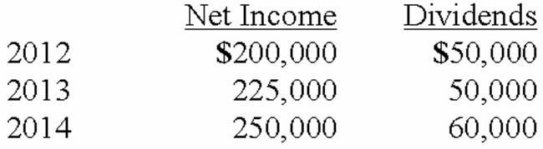  On April 1, 2014, just after its first dividend receipt, Mehan sells 10,000 shares of its investment.  How much income did Mehan report from Cook during 2012?  A. $30,000.  B. $22,500.  C. $7,500.  D. $0.  E. $50,000.

45. | On January 1, 2012, Mehan, Incorporated purchased 15,000 shares of Cook Company for $150,000 giving Mehan a 15% ownership of Cook. On January 1, 2013 Mehan purchased an additional 25,000 shares (25%) of Cook for $300,000. This last purchase gave Mehan the ability to apply significant influence over Cook. The book value of Cook on January 1, 2012, was $1,000,000. The book value of Cook on January 1, 2013, was $1,150,000. Any excess of cost over book value for this second transaction is assigned to a database and amortized over five years.  Cook reports net income and dividends as follows. These amounts are assumed to have occurred evenly throughout the years:  On April 1, 2014, just after its first dividend receipt, Mehan sells 10,000 shares of its investment.  How much income did Mehan report from Cook during 2013?  A. $90,000.  B. $110,000.  C. $67,500.  D. $87,500.  E. $78,750.

46. | On January 1, 2012, Mehan, Incorporated purchased 15,000 shares of Cook Company for $150,000 giving Mehan a 15% ownership of Cook. On January 1, 2013 Mehan purchased an additional 25,000 shares (25%) of Cook for $300,000. This last purchase gave Mehan the ability to apply significant influence over Cook. The book value of Cook on January 1, 2012, was $1,000,000. The book value of Cook on January 1, 2013, was $1,150,000. Any excess of cost over book value for this second transaction is assigned to a database and amortized over five years.  Cook reports net income and dividends as follows. These amounts are assumed to have occurred evenly throughout the years:  On April 1, 2014, just after its first dividend receipt, Mehan sells 10,000 shares of its investment.  What was the balance in the investment account at December 31, 2013?  A. $517,500.  B. $537,500.  C. $520,000.  D. $540,000.  E. $211,250.

47. | On January 1, 2012, Mehan, Incorporated purchased 15,000 shares of Cook Company for $150,000 giving Mehan a 15% ownership of Cook. On January 1, 2013 Mehan purchased an additional 25,000 shares (25%) of Cook for $300,000. This last purchase gave Mehan the ability to apply significant influence over Cook. The book value of Cook on January 1, 2012, was $1,000,000. The book value of Cook on January 1, 2013, was $1,150,000. Any excess of cost over book value for this second transaction is assigned to a database and amortized over five years.  Cook reports net income and dividends as follows. These amounts are assumed to have occurred evenly throughout the years:  On April 1, 2014, just after its first dividend receipt, Mehan sells 10,000 shares of its investment.  What was the balance in the investment account at April 1, 2014 just before the sale of shares?  A. $468,281.  B. $468,750.  C. $558,375.  D. $616,000.  E. $624,375.

48. | On January 1, 2012, Mehan, Incorporated purchased 15,000 shares of Cook Company for $150,000 giving Mehan a 15% ownership of Cook. On January 1, 2013 Mehan purchased an additional 25,000 shares (25%) of Cook for $300,000. This last purchase gave Mehan the ability to apply significant influence over Cook. The book value of Cook on January 1, 2012, was $1,000,000. The book value of Cook on January 1, 2013, was $1,150,000. Any excess of cost over book value for this second transaction is assigned to a database and amortized over five years.  Cook reports net income and dividends as follows. These amounts are assumed to have occurred evenly throughout the years:  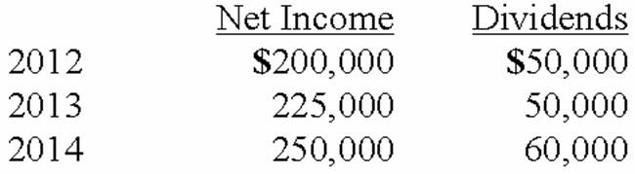  On April 1, 2014, just after its first dividend receipt, Mehan sells 10,000 shares of its investment.  How much of Cook's net income did Mehan report for the year 2014?  A. $61,750.  B. $81,250.  C. $72,500.  D. $59,250.  E. $75,000.

49. | On January 4, 2012, Harley, Inc. acquired 40% of the outstanding common stock of Bike Co. for $2,400,000. This investment gave Harley the ability to exercise significant influence over Bike. Bike's assets on that date were recorded at $10,500,000 with liabilities of $4,500,000. There were no other differences between book and fair values.  During 2012, Bike reported net income of $500,000. For 2013, Bike reported net income of $800,000. Dividends of $300,000 were paid in each of these two years.  How much income did Harley report from Bike for 2012?  A. $120,000.  B. $200,000.  C. $300,000.  D. $320,000.  E. $500,000.

50. | On January 4, 2012, Harley, Inc. acquired 40% of the outstanding common stock of Bike Co. for $2,400,000. This investment gave Harley the ability to exercise significant influence over Bike. Bike's assets on that date were recorded at $10,500,000 with liabilities of $4,500,000. There were no other differences between book and fair values.  During 2012, Bike reported net income of $500,000. For 2013, Bike reported net income of $800,000. Dividends of $300,000 were paid in each of these two years.  How much income did Harley report from Bike for 2013?  A. $120,000.  B. $200,000.  C. $300,000.  D. $320,000.  E. $500,000.

51. | On January 4, 2012, Harley, Inc. acquired 40% of the outstanding common stock of Bike Co. for $2,400,000. This investment gave Harley the ability to exercise significant influence over Bike. Bike's assets on that date were recorded at $10,500,000 with liabilities of $4,500,000. There were no other differences between book and fair values.  During 2012, Bike reported net income of $500,000. For 2013, Bike reported net income of $800,000. Dividends of $300,000 were paid in each of these two years.  What was the reported balance of Harley's Investment in Bike Co. at December 31, 2012?  A. $880,000.  B. $2,400,000.  C. $2,480,000.  D. $2,600,000.  E. $2,900,000.

52. | On January 4, 2012, Harley, Inc. acquired 40% of the outstanding common stock of Bike Co. for $2,400,000. This investment gave Harley the ability to exercise significant influence over Bike. Bike's assets on that date were recorded at $10,500,000 with liabilities of $4,500,000. There were no other differences between book and fair values.  During 2012, Bike reported net income of $500,000. For 2013, Bike reported net income of $800,000. Dividends of $300,000 were paid in each of these two years.  What was the reported balance of Harley's Investment in Bike Co. at December 31, 2013?  A. $2,400,000.  B. $2,480,000.  C. $2,500,000.  D. $2,600,000.  E. $2,680,000.

53. | On January 1, 2013, Anderson Company purchased 40% of the voting common stock of Barney Company for $2,000,000, which approximated book value. During 2013, Barney paid dividends of $30,000 and reported a net loss of $70,000.  What is the balance in the investment account on December 31, 2013?  A. $1,900,000.  B. $1,960,000.  C. $2,000,000.  D. $2,016,000.  E. $2,028,000.

54. | On January 1, 2013, Anderson Company purchased 40% of the voting common stock of Barney Company for $2,000,000, which approximated book value. During 2013, Barney paid dividends of $30,000 and reported a net loss of $70,000.  What amount of equity income would Anderson recognize in 2013 from its ownership interest in Barney?  A. $12,000 income.  B. $12,000 loss.  C. $16,000 loss.  D. $28,000 income.  E. $28,000 loss.

55. | Luffman Inc. owns 30% of Bruce Inc. and appropriately applies the equity method. During the current year, Bruce bought inventory costing $52,000 and then sold it to Luffman for $80,000. At year-end, all of the merchandise had been sold by Luffman to other customers. What amount of unrealized intercompany profit must be deferred by Luffman?  A. $0.  B. $8,400.  C. $28,000.  D. $52,000.  E. $80,000.

56. | On January 3, 2013, Roberts Company purchased 30% of the 100,000 shares of common stock of Thomas Corporation, paying $1,500,000. There was no goodwill or other cost allocation associated with the investment. Roberts has significant influence over Thomas. During 2013, Thomas reported income of $300,000 and paid dividends of $100,000. On January 4, 2014, Roberts sold 15,000 shares for $800,000.  What was the balance in the investment account before the shares were sold?  A. $1,560,000.  B. $1,600,000.  C. $1,700,000.  D. $1,800,000.  E. $1,860,000.

57. | On January 3, 2013, Roberts Company purchased 30% of the 100,000 shares of common stock of Thomas Corporation, paying $1,500,000. There was no goodwill or other cost allocation associated with the investment. Roberts has significant influence over Thomas. During 2013, Thomas reported income of $300,000 and paid dividends of $100,000. On January 4, 2014, Roberts sold 15,000 shares for $800,000.  What is the gain/loss on the sale of the 15,000 shares?  A. $0  B. $10,000 gain.  C. $12,000 loss.  D. $15,000 loss.  E. $20,000 gain.

58. | On January 3, 2013, Roberts Company purchased 30% of the 100,000 shares of common stock of Thomas Corporation, paying $1,500,000. There was no goodwill or other cost allocation associated with the investment. Roberts has significant influence over Thomas. During 2013, Thomas reported income of $300,000 and paid dividends of $100,000. On January 4, 2014, Roberts sold 15,000 shares for $800,000.  What is the balance in the investment account after the sale of the 15,000 shares?  A. $750,000.  B. $760,000.  C. $780,000.  D. $790,000.  E. $800,000.

59. | On January 3, 2013, Roberts Company purchased 30% of the 100,000 shares of common stock of Thomas Corporation, paying $1,500,000. There was no goodwill or other cost allocation associated with the investment. Roberts has significant influence over Thomas. During 2013, Thomas reported income of $300,000 and paid dividends of $100,000. On January 4, 2014, Roberts sold 15,000 shares for $800,000.  What is the appropriate journal entry to record the sale of the 15,000 shares?  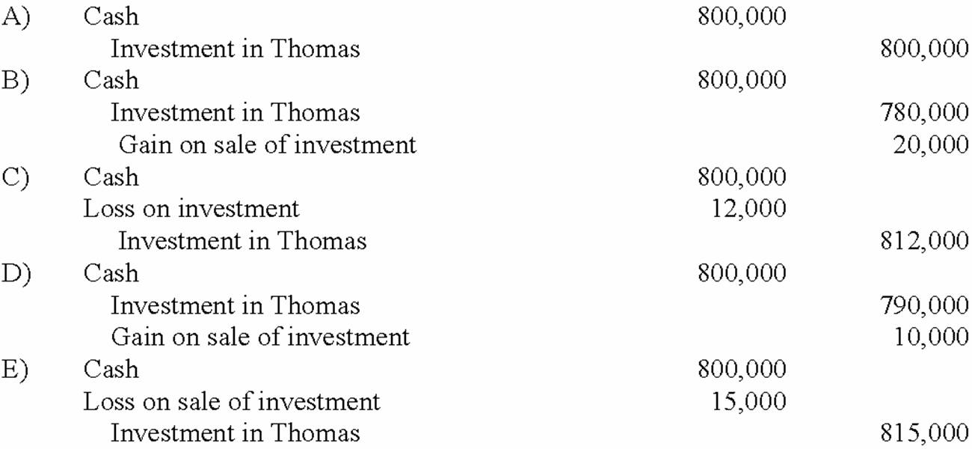  A. A Above.  B. B Above.  C. C Above.  D. D Above.  E. E Above.

60. | On January 4, 2013, Mason Co. purchased 40,000 shares (40%) of the common stock of Hefly Corp., paying $560,000. At that time, the book value and fair value of Hefly's net assets was $1,400,000. The investment gave Mason the ability to exercise significant influence over the operations of Hefly. During 2013, Hefly reported income of $150,000 and paid dividends of $40,000. On January 2, 2014, Mason sold 10,000 shares for $150,000.  What was the balance in the investment account before the shares were sold?  A. $520,000.  B. $544,000.  C. $560,000.  D. $604,000.  E. $620,000.

61. | On January 4, 2013, Mason Co. purchased 40,000 shares (40%) of the common stock of Hefly Corp., paying $560,000. At that time, the book value and fair value of Hefly's net assets was $1,400,000. The investment gave Mason the ability to exercise significant influence over the operations of Hefly. During 2013, Hefly reported income of $150,000 and paid dividends of $40,000. On January 2, 2014, Mason sold 10,000 shares for $150,000.  What is the gain/loss on the sale of the 10,000 shares?  A. $20,000 gain.  B. $10,000 gain.  C. $1,000 gain.  D. $1,000 loss.  E. $10,000 loss.

62. | On January 4, 2013, Mason Co. purchased 40,000 shares (40%) of the common stock of Hefly Corp., paying $560,000. At that time, the book value and fair value of Hefly's net assets was $1,400,000. The investment gave Mason the ability to exercise significant influence over the operations of Hefly. During 2013, Hefly reported income of $150,000 and paid dividends of $40,000. On January 2, 2014, Mason sold 10,000 shares for $150,000.  What is the balance in the investment account after the sale of the 10,000 shares?  A. $390,000.  B. $420,000.  C. $453,000.  D. $454,000.  E. $465,000.

63. | On January 4, 2013, Mason Co. purchased 40,000 shares (40%) of the common stock of Hefly Corp., paying $560,000. At that time, the book value and fair value of Hefly's net assets was $1,400,000. The investment gave Mason the ability to exercise significant influence over the operations of Hefly. During 2013, Hefly reported income of $150,000 and paid dividends of $40,000. On January 2, 2014, Mason sold 10,000 shares for $150,000.  What is the appropriate journal entry to record the sale of the 10,000 shares?  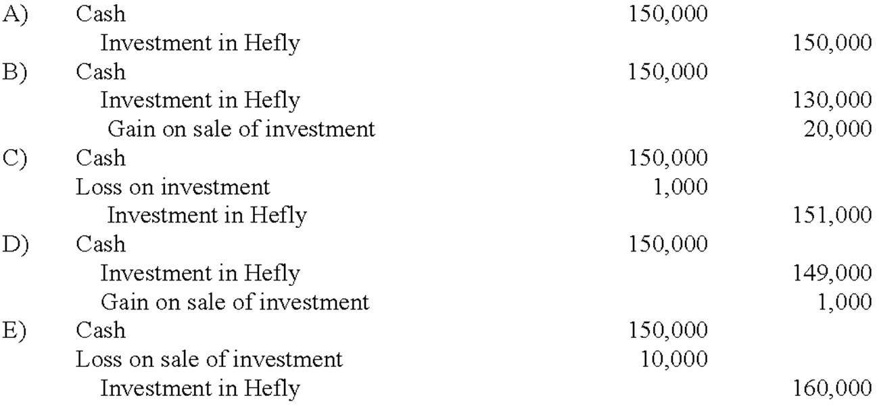  A. A Above  B. B Above  C. C Above  D. D Above  E. E Above

64. | On January 4, 2013, Bailey Corp. purchased 40% of the voting common stock of Emery Co., paying $3,000,000. Bailey properly accounts for this investment using the equity method. At the time of the investment, Emery's total stockholders' equity was $5,000,000. Bailey gathered the following information about Emery's assets and liabilities whose book values and fair values differed:  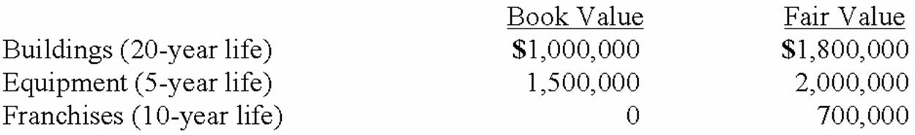  Any excess of cost over fair value was attributed to goodwill, which has not been impaired. Emery Co. reported net income of $400,000 for 2013, and paid dividends of $200,000 during that year.  What is the amount of the excess of purchase price over book value?  A. $(2,000,000).  B. $800,000.  C. $1,000,000.  D. $2,000,000.  E. $3,000,000.

65. | On January 4, 2013, Bailey Corp. purchased 40% of the voting common stock of Emery Co., paying $3,000,000. Bailey properly accounts for this investment using the equity method. At the time of the investment, Emery's total stockholders' equity was $5,000,000. Bailey gathered the following information about Emery's assets and liabilities whose book values and fair values differed:  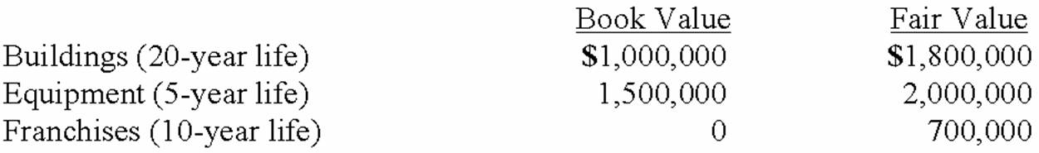  Any excess of cost over fair value was attributed to goodwill, which has not been impaired. Emery Co. reported net income of $400,000 for 2013, and paid dividends of $200,000 during that year.  How much goodwill is associated with this investment?  A. $(500,000).  B. $0.  C. $100,000.  D. $200,000.  E. $2,000,000.

66. | On January 4, 2013, Bailey Corp. purchased 40% of the voting common stock of Emery Co., paying $3,000,000. Bailey properly accounts for this investment using the equity method. At the time of the investment, Emery's total stockholders' equity was $5,000,000. Bailey gathered the following information about Emery's assets and liabilities whose book values and fair values differed:  Any excess of cost over fair value was attributed to goodwill, which has not been impaired. Emery Co. reported net income of $400,000 for 2013, and paid dividends of $200,000 during that year.  What is the amount of excess amortization expense for Bailey's investment in Emery for the first year?  A. $0.  B. $84,000.  C. $100,000.  D. $160,000.  E. $400,000.

67. | On January 1, 2013, Jackie Corp. purchased 30% of the voting common stock of Rob Co., paying $2,000,000. Jackie properly accounts for this investment using the equity method. At the time of the investment, Rob's total stockholders' equity was $3,000,000. Jackie gathered the following information about Rob's assets and liabilities whose book values and fair values differed:  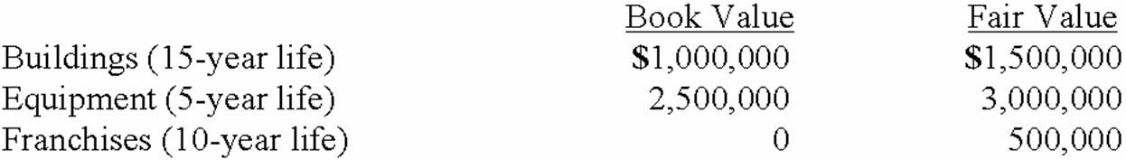  Any excess of cost over fair value was attributed to goodwill, which has not been impaired. Rob Co. reported net income of $300,000 for 2013, and paid dividends of $100,000 during that year.  What is the amount of the excess of purchase price over book value?  A. $(1,000,000.)  B. $400,000.  C. $800,000.  D. $1,000,000.  E. $1,100,000.

68. | On January 1, 2013, Jackie Corp. purchased 30% of the voting common stock of Rob Co., paying $2,000,000. Jackie properly accounts for this investment using the equity method. At the time of the investment, Rob's total stockholders' equity was $3,000,000. Jackie gathered the following information about Rob's assets and liabilities whose book values and fair values differed:  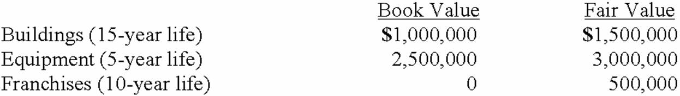  Any excess of cost over fair value was attributed to goodwill, which has not been impaired. Rob Co. reported net income of $300,000 for 2013, and paid dividends of $100,000 during that year.  How much goodwill is associated with this investment?  A. $(500,000.)  B. $0.  C. $650,000.  D. $1,000,000.  E. $2,000,000.

69. | On January 1, 2013, Jackie Corp. purchased 30% of the voting common stock of Rob Co., paying $2,000,000. Jackie properly accounts for this investment using the equity method. At the time of the investment, Rob's total stockholders' equity was $3,000,000. Jackie gathered the following information about Rob's assets and liabilities whose book values and fair values differed:  Any excess of cost over fair value was attributed to goodwill, which has not been impaired. Rob Co. reported net income of $300,000 for 2013, and paid dividends of $100,000 during that year.  What is the amount of excess amortization expense for Jackie Corp's investment in Rob Co. for year 2013?  A. $0.  B. $30,000.  C. $40,000.  D. $55,000.  E. $60,000.

70. | On January 1, 2013, Jackie Corp. purchased 30% of the voting common stock of Rob Co., paying $2,000,000. Jackie properly accounts for this investment using the equity method. At the time of the investment, Rob's total stockholders' equity was $3,000,000. Jackie gathered the following information about Rob's assets and liabilities whose book values and fair values differed:  Any excess of cost over fair value was attributed to goodwill, which has not been impaired. Rob Co. reported net income of $300,000 for 2013, and paid dividends of $100,000 during that year.  What is the balance in Jackie Corp's Investment in Rob Co. account at December 31, 2013?  A. $2,000,000.  B. $2,005,000.  C. $2,060,000.  D. $2,090,000.  E. $2,200,000.

71. | Acker Inc. bought 40% of Howell Co. on January 1, 2012 for $576,000. The equity method of accounting was used. The book value and fair value of the net assets of Howell on that date were $1,440,000. Acker began supplying inventory to Howell as follows:  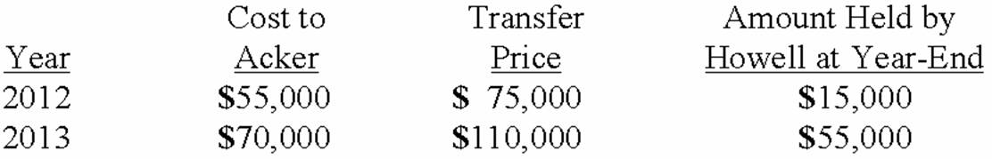  Howell reported net income of $100,000 in 2012 and $120,000 in 2013 while paying $40,000 in dividends each year.  What is the amount of unrealized intra-entity inventory profit to be deferred on December 31, 2012?  A. $1,600.  B. $4,000.  C. $8,000.  D. $15,000.  E. $20,000.

72. | Acker Inc. bought 40% of Howell Co. on January 1, 2012 for $576,000. The equity method of accounting was used. The book value and fair value of the net assets of Howell on that date were $1,440,000. Acker began supplying inventory to Howell as follows:  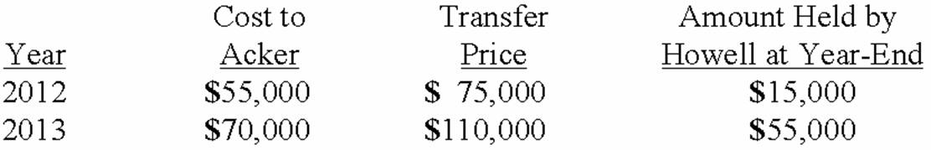  Howell reported net income of $100,000 in 2012 and $120,000 in 2013 while paying $40,000 in dividends each year.  What is the amount of unrealized intra-entity inventory profit to be deferred on December 31, 2013?  A. $1,600.  B. $8,000.  C. $15,000.  D. $20,000.  E. $40,000.

73. | Acker Inc. bought 40% of Howell Co. on January 1, 2012 for $576,000. The equity method of accounting was used. The book value and fair value of the net assets of Howell on that date were $1,440,000. Acker began supplying inventory to Howell as follows:  Howell reported net income of $100,000 in 2012 and $120,000 in 2013 while paying $40,000 in dividends each year.  What is the Equity in Howell Income that should be reported by Acker in 2012?  A. $10,000.  B. $24,000.  C. $36,000.  D. $38,400.  E. $40,000.

74. | Acker Inc. bought 40% of Howell Co. on January 1, 2012 for $576,000. The equity method of accounting was used. The book value and fair value of the net assets of Howell on that date were $1,440,000. Acker began supplying inventory to Howell as follows:  Howell reported net income of $100,000 in 2012 and $120,000 in 2013 while paying $40,000 in dividends each year.  What is the balance in Acker's Investment in Howell account at December 31, 2012?  A. $576,000.  B. $598,400.  C. $614,400.  D. $606,000.  E. $616,000.

75. | Acker Inc. bought 40% of Howell Co. on January 1, 2012 for $576,000. The equity method of accounting was used. The book value and fair value of the net assets of Howell on that date were $1,440,000. Acker began supplying inventory to Howell as follows:  Howell reported net income of $100,000 in 2012 and $120,000 in 2013 while paying $40,000 in dividends each year.  What is the Equity in Howell Income that should be reported by Acker in 2013?  A. $32,000.  B. $41,600.  C. $48,000.  D. $49,600.  E. $50,600.

76. | Acker Inc. bought 40% of Howell Co. on January 1, 2012 for $576,000. The equity method of accounting was used. The book value and fair value of the net assets of Howell on that date were $1,440,000. Acker began supplying inventory to Howell as follows:  Howell reported net income of $100,000 in 2012 and $120,000 in 2013 while paying $40,000 in dividends each year.  What is the balance in Acker's Investment in Howell account at December 31, 2013?  A. $624,000.  B. $636,000.  C. $646,000.  D. $656,000.  E. $666,000.

77. | Cayman Inc. bought 30% of Maya Company on January 1, 2013 for $450,000. The equity method of accounting was used. The book value and fair value of the net assets of Maya on that date were $1,500,000. Maya began supplying inventory to Cayman as follows:  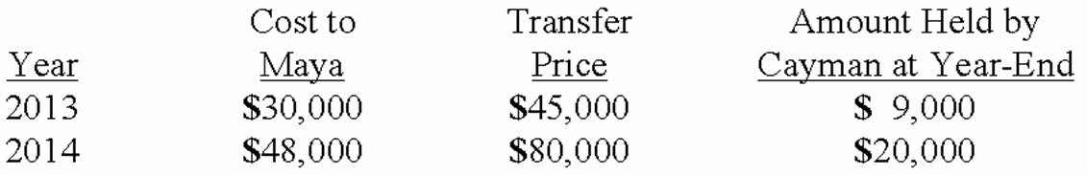  Maya reported net income of $100,000 in 2013 and $120,000 in 2014 while paying $40,000 in dividends each year.  What is the amount of unrealized intra-entity inventory profit to be deferred on December 31, 2013?  A. $900.  B. $3,000.  C. $4,500.  D. $6,000.  E. $9,000.

78. | Cayman Inc. bought 30% of Maya Company on January 1, 2013 for $450,000. The equity method of accounting was used. The book value and fair value of the net assets of Maya on that date were $1,500,000. Maya began supplying inventory to Cayman as follows:  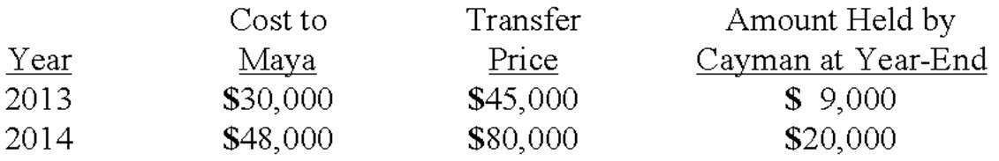  Maya reported net income of $100,000 in 2013 and $120,000 in 2014 while paying $40,000 in dividends each year.  What is the amount of unrealized inventory profit to be deferred on December 31, 2014?  A. $1,500.  B. $2,400.  C. $3,600.  D. $4,000.  E. $8,000.

79. | Cayman Inc. bought 30% of Maya Company on January 1, 2013 for $450,000. The equity method of accounting was used. The book value and fair value of the net assets of Maya on that date were $1,500,000. Maya began supplying inventory to Cayman as follows:  Maya reported net income of $100,000 in 2013 and $120,000 in 2014 while paying $40,000 in dividends each year.  What is the Equity in Maya Income that should be reported by Cayman in 2013?  A. $17,100.  B. $18,000.  C. $25,500.  D. $29,100.  E. $30,900.

80. | Cayman Inc. bought 30% of Maya Company on January 1, 2013 for $450,000. The equity method of accounting was used. The book value and fair value of the net assets of Maya on that date were $1,500,000. Maya began supplying inventory to Cayman as follows:  Maya reported net income of $100,000 in 2013 and $120,000 in 2014 while paying $40,000 in dividends each year.  What is the balance in Cayman's Investment in Maya account at December 31, 2013?  A. $463,500.  B. $467,100.  C. $468,000.  D. $468,900.  E. $480,000.

81. | Cayman Inc. bought 30% of Maya Company on January 1, 2013 for $450,000. The equity method of accounting was used. The book value and fair value of the net assets of Maya on that date were $1,500,000. Maya began supplying inventory to Cayman as follows:  Maya reported net income of $100,000 in 2013 and $120,000 in 2014 while paying $40,000 in dividends each year.  What is the Equity in Maya Income that should be reported by Cayman in 2014?  A. $34,200.  B. $34,800.  C. $34,500.  D. $36,000.  E. $37,800.

82. | Cayman Inc. bought 30% of Maya Company on January 1, 2013 for $450,000. The equity method of accounting was used. The book value and fair value of the net assets of Maya on that date were $1,500,000. Maya began supplying inventory to Cayman as follows:  Maya reported net income of $100,000 in 2013 and $120,000 in 2014 while paying $40,000 in dividends each year.  What is the balance in Cayman's Investment in Maya account at December 31, 2014?  A. $488,700.  B. $489,600.  C. $492,000.  D. $494,400.  E. $514,500.

83. | Which of the following results in a decrease in the investment account when applying the equity method?  A. Dividends paid by the investor.  B. Net income of the investee.  C. Net income of the investor.  D. Unrealized gain on intra-entity inventory transfers for the current year.  E. Purchase of additional common stock by the investor during the current year.

84. | Which of the following results in an increase in the investment account when applying the equity method?  A. Unrealized gain on intra-entity inventory transfers for the prior year.  B. Unrealized gain on intra-entity inventory transfers for the current year.  C. Dividends paid by the investor.  D. Dividends paid by the investee.  E. Sale of a portion of the investment during the current year.

85. | Which of the following results in a decrease in the Equity in Investee Income account when applying the equity method?  A. Dividends paid by the investor.  B. Net income of the investee.  C. Unrealized gain on intra-entity inventory transfers for the current year.  D. Unrealized gain on intra-entity inventory transfers for the prior year.  E. Extraordinary gain of the investee.

86. | Which of the following results in an increase in the Equity in Investee Income account when applying the equity method?  A. Amortizations of purchase price over book value on date of purchase.  B. Amortizations, since date of purchase, of purchase price over book value on date of purchase.  C. Extraordinary gain of the investor.  D. Unrealized gain on intra-entity inventory transfers for the prior year.  E. Sale of a portion of the investment at a loss.

87. | Renfroe, Inc. acquires 10% of Stanley Corporation on January 1, 2012, for $90,000 when the book value of Stanley was $1,000,000. During 2012, Stanley reported net income of $215,000 and paid dividends of $50,000. On January 1, 2013, Renfroe purchased an additional 30% of Stanley for $325,000. Any excess of cost over book value is attributable to goodwill with an indefinite life. During 2013, Renfroe reported net income of $320,000 and paid dividends of $50,000.  How much is the adjustment to the Investment in Stanley Corporation for the change from the fair-value method to the equity method on January 1, 2013?  A. A debit of $16,500.  B. A debit of $21,500.  C. A debit of $90,000.  D. A debit of $165,000.  E. There is no adjustment.

88. | Renfroe, Inc. acquires 10% of Stanley Corporation on January 1, 2012, for $90,000 when the book value of Stanley was $1,000,000. During 2012, Stanley reported net income of $215,000 and paid dividends of $50,000. On January 1, 2013, Renfroe purchased an additional 30% of Stanley for $325,000. Any excess of cost over book value is attributable to goodwill with an indefinite life. During 2013, Renfroe reported net income of $320,000 and paid dividends of $50,000.  What is the balance in the Investment in Stanley Corporation on December 31, 2013?  A. $415,000.  B. $512,500.  C. $523,000.  D. $539,500.  E. $544,500.

89. | On January 4, 2012, Trycker, Inc. acquired 40% of the outstanding common stock of Inkblot Co. for $2,400,000. This investment gave Trycker the ability to exercise significant influence over Inkblot. Inkblot's assets on that date were recorded at $8,000,000 with liabilities of $2,000,000. There were no other differences between book and fair values.  During 2012, Inkblot reported net income of $500,000 and paid dividends of $300,000. The fair value of Inkblot at December 31, 2012 is $7,000,000. Trycker elects the fair value option for its investment in Inkblot.  How are dividends received from Inkblot reflected in Trycker's accounting records for 2012?  A. Reduce investment in Inkblot by $280,000.  B. Increase Investment in Inkblot by $280,000.  C. Reduce Investment in Inkblot by $120,000.  D. Increase Investment in Inkblot by $120,000.  E. Increase Dividend Income by $120,000.

90. | On January 4, 2012, Trycker, Inc. acquired 40% of the outstanding common stock of Inkblot Co. for $2,400,000. This investment gave Trycker the ability to exercise significant influence over Inkblot. Inkblot's assets on that date were recorded at $8,000,000 with liabilities of $2,000,000. There were no other differences between book and fair values.  During 2012, Inkblot reported net income of $500,000 and paid dividends of $300,000. The fair value of Inkblot at December 31, 2012 is $7,000,000. Trycker elects the fair value option for its investment in Inkblot.  At what amount will Inkblot be reflected in Trycker's December 31, 2012 balance sheet?  A. $2,400,000.  B. $2,280,000.  C. $2,480,000.  D. $2,800,000.  E. $7,000,000.

Essay Questions
91. | For each of the following numbered situations below, select the best letter answer concerning accounting for investments:  (A.) Increase the investment account.  (B.) Decrease the investment account.  (C.) Increase dividend revenue.  (D.) No adjustment necessary.  (1.) Income reported by 40% owned investee.  (2.) Income reported by 10% owned investee.  (3.) Loss reported by 40% owned investee.  (4.) Loss reported by 10% investee.  (5.) Change from fair-value method to equity method. Prior income exceeded dividends.  (6.) Change from fair-value method to equity method. Prior income was less than dividends.  (7.) Change from equity method to fair-value method. Prior income exceeded dividends.  (8.) Change from equity method to fair-value method. Prior income was less than dividends.  (9.) Dividends received from 40% investee.  (10.) Dividends received from 10% investee.  (11.) Purchase of additional shares of investee.  (12.) Unrealized ending intra-entity inventory profits using the equity method.

92. | Jarmon Company owns twenty-three percent of the voting common stock of Kaleski Corp. Jarmon does not have the ability to exercise significant influence over the operations of Kaleski. What method should Jarmon use to account for its investment in Kaleski?

93. | Idler Co. has an investment in Cowl Corp. for which it uses the equity method. Cowl has suffered large losses for several years, and the balance in the investment account has been reduced to zero. How should Idler account for this investment?

94. | Which types of transactions, exchanges, or events would indicate that an investor has the ability to exercise significant influence over the operations of an investee?

95. | You are auditing a company that owns twenty percent of the voting common stock of another corporation and uses the equity method to account for the investment. How would you verify that the equity method is appropriate in this case?

96. | How does the use of the equity method affect the investor's financial statements?

97. | What is the primary objective of the equity method of accounting for an investment?

98. | What is the justification for the timing of recognition of income under the equity method?

99. | What argument could be made against the equity method?

100. | How would a change be made from the equity method to the fair value method of accounting for investments?

101. | How should an investor account for, and report, an investee's extraordinary income or loss?

102. | When should an investor not use the equity method for an investment of 21% in another corporation?

103. | What is the primary objective of the fair value method of accounting for an investment?

104. | How would a change be made from the fair value method to the equity method of accounting for investments?

105. | When the fair value option is elected for application to an investment in which the investor has significant influence over the investee, how would the investor reflect the use of the fair value option in its balance sheet and in its income statement?

Short Answer Questions
106. | Charlie Co. owns 30% of the voting common stock of Turf Services Inc. Charlie uses the equity method to account for its investment. On January 1, 2013, the balance in the investment account was $624,000. During 2013, Turf Services reported net income of $120,000 and paid dividends of $30,000. What is the balance in the investment account as of December 31, 2013?

107. | Tinker Co. owns 25% of the common stock of Harbor Co. and uses the equity method to account for the investment. During 2013, Harbor reported income of $120,000 and paid dividends of $40,000. Harbor owns a building with a useful life of twenty years which is undervalued by $80,000.  Required:  Prepare a schedule to show the equity income Tinker should recognize for 2013 related to this investment.

108. | Aqua Corp. purchased 30% of the common stock of Marcus Co. by paying $500,000. Of this amount, $50,000 is associated with goodwill.  Required:  Prepare the journal entry to record Aqua's investment.

109. | On January 2, 2013, Heinreich Co. paid $500,000 for 25% of the voting common stock of Jones Corp. At the time of the investment, Jones had net assets with a book value and fair value of $1,800,000. During 2013, Jones incurred a net loss of $60,000 and paid dividends of $100,000. Any excess cost over book value is attributable to goodwill with an indefinite life.  Required:  1) Prepare a schedule to show the amount of goodwill from Heinrich's investment in Jones.  2) Prepare a schedule to show the balance in Heinreich's investment account at December 31, 2013.

110. | On January 3, 2013, Jenkins Corp. acquired 40% of the outstanding common stock of Bolivar Co. for $1,200,000. This acquisition gave Jenkins the ability to exercise significant influence over the investee. The book value of the acquired shares was $950,000. Any excess cost over the underlying book value was assigned to a patent that was undervalued on Bolivar's balance sheet. This patent has a remaining useful life of ten years. For the year ended December 31, 2013, Bolivar reported net income of $312,000 and paid cash dividends of $96,000.  Required:  Prepare a schedule to show the balance Jenkins should report as its Investment in Bolivar Co. at December 31, 2013.

111. | On January 1, 2013, Spark Corp. acquired a 40% interest in Cranston Inc. for $250,000. On that date, Cranston's balance sheet disclosed net assets of $430,000. During 2013, Cranston reported net income of $100,000 and paid cash dividends of $30,000. Spark sold inventory costing $40,000 to Cranston during 2013 for $50,000. Cranston used all of this merchandise in its operations during 2013. Any excess cost over fair value is attributable to an unamortized trademark with a 20 year remaining life.  Required:  Prepare all of Spark's journal entries for 2013 to apply the equity method to this investment.

112. | Wathan Inc. sold $180,000 in inventory to Miller Co. during 2012, for $270,000. Miller resold $108,000 of this merchandise in 2012 with the remainder to be disposed of during 2013.  Required:  Assuming Wathan owns 25% of Miller and applies the equity method, prepare the journal entry Wathan should have recorded at the end of 2012 to defer the unrealized intra-entity inventory profit.

113. | Jager Inc. holds 30% of the outstanding voting shares of Kinson Co. and appropriately applies the equity method of accounting. Amortization associated with this investment equals $11,000 per year. For 2013, Kinson reported earnings of $100,000 and paid cash dividends of $40,000. During 2013, Kinson acquired inventory for $62,400, which was then sold to Jager for $96,000. At the end of 2013, Jager still held some of this inventory at its transfer price of $50,000.  Required:  Determine the amount of Equity in Investee Income that Jager should have reported for 2013.

114. | On January 2, 2012, Hull Corp. paid $516,000 for 24% (48,000 shares) of the outstanding common stock of Oliver Co. Hull used the equity method to account for the investment. At the end of 2012, the balance in the investment account was $620,000. On January 2, 2013, Hull sold 12,000 shares of Oliver stock for $12 per share. For 2013, Oliver reported income of $118,000 and paid dividends of $30,000.  Required:  (A.) Prepare the journal entry to record the sale of the 12,000 shares.  (B.) After the sale has been recorded, what is the balance in the investment account?  (C.) What percentage of Oliver Co. stock does Hull own after selling the 12,000 shares?  (D.) Because of the sale of stock, Hull can no longer exercise significant influence over the operations of Oliver. What effect will this have on Hull's accounting for the investment?  (E.) Prepare Hull's journal entries related to the investment for the rest of 2013.

115. | On January 1, 2013, Jolley Corp. paid $250,000 for 25% of the voting common stock of Tige Co. On that date, the book value of Tige was $850,000. A building with a carrying value of $160,000 was actually worth $220,000. The building had a remaining life of twenty years. Tige owned a trademark valued at $90,000 over cost that was to be amortized over 20 years.  During 2013, Tige sold to Jolley inventory costing $60,000, at a markup of 50% on cost. At the end of the year, Jolley still owned some of these goods with a transfer price of $33,000. Jolly uses a perpetual inventory system.  Tige reported net income of $200,000 during 2013. This amount included an extraordinary gain of $35,000. Tige paid dividends totaling $40,000.  Required:  Prepare all of Jolley's journal entries for 2013 in relation to Tige Co. Assume the equity method is appropriate for use.

116. | On January 1, 2012, Pond Co. acquired 40% of the outstanding voting common shares of Ramp Co. for $700,000. On that date, Ramp reported assets and liabilities with book values of $2.2 million and $700,000, respectively. A building owned by Ramp had an appraised value of $300,000, although it had a book value of only $120,000. This building had a 12-year remaining life and no salvage value. It was being depreciated on the straight-line basis.  Ramp generated net income of $300,000 in 2012 and a loss of $120,000 in 2013. In each of these two years, Ramp paid a cash dividend of $70,000 to its stockholders.  During 2012, Ramp sold inventory to Pond that had an original cost of $60,000. The merchandise was sold to Pond for $96,000. Of this balance, $72,000 was resold to outsiders during 2012 and the remainder was sold during 2013. In 2013, Ramp sold inventory to Pond for $180,000. This inventory had cost only $108,000. Pond resold $120,000 of the inventory during 2013 and the rest during 2014.  Required:  For 2012 and then for 2013, calculate the equity income to be reported by Pond for external reporting purposes.

117. | Pursley, Inc. acquires 10% of Ritz Corporation on January 3, 2012, for $80,000 when the book value of Ritz was $800,000. During 2012 Ritz reported net income of $125,000 and paid dividends of $30,000. On January 1, 2013, Pursley purchased an additional 20% of Ritz for $325,000, giving Pursley the ability to significantly influence the operating policies of Ritz. Any excess of cost over book value is attributable to goodwill with an indefinite life. What journal entry(ies) is(are) required on January 1, 2013?

118. | Steven Company owns 40% of the outstanding voting common stock of Nicole Corp. and has the ability to significantly influence the investee's operations. On January 3, 2013, the balance in the Investment in Nicole Corp. account was $503,000. Amortization associated with this acquisition is $12,000 per year. During 2013, Nicole earned net income of $120,000 and paid cash dividends of $40,000. Previously in 2012, Nicole had sold inventory costing $35,000 to Steven for $50,000. All but 25% of that inventory had been sold to outsiders by Steven during 2012. Additional sales were made to Steven in 2013 at a transfer price of $75,000 that had cost Nicole $54,000. Only 10% of the 2013 purchases had not been sold to outsiders by the end of 2013.  What amount of unrealized intra-entity inventory profit should be deferred by Steven at December 31, 2012?

119. | Steven Company owns 40% of the outstanding voting common stock of Nicole Corp. and has the ability to significantly influence the investee's operations. On January 3, 2013, the balance in the Investment in Nicole Corp. account was $503,000. Amortization associated with this acquisition is $12,000 per year. During 2013, Nicole earned net income of $120,000 and paid cash dividends of $40,000. Previously in 2012, Nicole had sold inventory costing $35,000 to Steven for $50,000. All but 25% of that inventory had been sold to outsiders by Steven during 2012. Additional sales were made to Steven in 2013 at a transfer price of $75,000 that had cost Nicole $54,000. Only 10% of the 2013 purchases had not been sold to outsiders by the end of 2013.  What amount of unrealized intra-entity profit should be deferred by Steven at December 31, 2013?

120. | Steven Company owns 40% of the outstanding voting common stock of Nicole Corp. and has the ability to significantly influence the investee's operations. On January 3, 2013, the balance in the Investment in Nicole Corp. account was $503,000. Amortization associated with this acquisition is $12,000 per year. During 2013, Nicole earned net income of $120,000 and paid cash dividends of $40,000. Previously in 2012, Nicole had sold inventory costing $35,000 to Steven for $50,000. All but 25% of that inventory had been sold to outsiders by Steven during 2012. Additional sales were made to Steven in 2013 at a transfer price of $75,000 that had cost Nicole $54,000. Only 10% of the 2013 purchases had not been sold to outsiders by the end of 2013.  What amount of equity income would Steven have recognized in 2013 from its ownership interest in Nicole?

121. | Steven Company owns 40% of the outstanding voting common stock of Nicole Corp. and has the ability to significantly influence the investee's operations. On January 3, 2013, the balance in the Investment in Nicole Corp. account was $503,000. Amortization associated with this acquisition is $12,000 per year. During 2013, Nicole earned net income of $120,000 and paid cash dividends of $40,000. Previously in 2012, Nicole had sold inventory costing $35,000 to Steven for $50,000. All but 25% of that inventory had been sold to outsiders by Steven during 2012. Additional sales were made to Steven in 2013 at a transfer price of $75,000 that had cost Nicole $54,000. Only 10% of the 2013 purchases had not been sold to outsiders by the end of 2013.  What was the balance in the Investment in Nicole Corp. account at December 31, 2013?

Chapter 01 The Equity Method of Accounting for Investments Answer Key

Multiple Choice Questions
1. | Gaw Company owns 15% of the common stock of Trace Corporation and used the fair-value method to account for this investment. Trace reported net income of $110,000 for 2013 and paid dividends of $60,000 on October 1, 2013. How much income should Gaw recognize on this investment in 2013?  A. $16,500.  B. $9,000.  C. $25,500.  D. $7,500.  E. $50,000.  $60,000 × .15 = $9,000

AACSB: Analytic
AICPA BB: Critical Thinking
AICPA FN: Measurement
Accessibility: Keyboard Navigation
Blooms: Apply
Difficulty: 1 Easy
Learning Objective: 01-01 Describe in general the various methods of accounting for an investment in equity shares of another company.
Topic: The Reporting of Investments in Corporate Equity Securities

2. | Yaro Company owns 30% of the common stock of Dew Co. and uses the equity method to account for the investment. During 2013, Dew reported income of $250,000 and paid dividends of $80,000. There is no amortization associated with the investment. During 2013, how much income should Yaro recognize related to this investment?  A. $24,000.  B. $75,000.  C. $99,000.  D. $51,000.  E. $80,000.  $250,000 × .30 = $75,000

AACSB: Analytic
AICPA BB: Critical Thinking
AICPA FN: Measurement
Accessibility: Keyboard Navigation
Blooms: Apply
Difficulty: 1 Easy
Learning Objective: 01-02 Identify the sole criterion for applying the equity method of accounting and guidance in assessing whether the criterion is met.
Topic: Criteria for Utilizing the Equity Method

3. | On January 1, 2013, Pacer Company paid $1,920,000 for 60,000 shares of Lennon Co.'s voting common stock which represents a 45% investment. No allocation to goodwill or other specific account was made. Significant influence over Lennon was achieved by this acquisition. Lennon distributed a dividend of $2.50 per share during 2013 and reported net income of $670,000. What was the balance in the Investment in Lennon Co. account found in the financial records of Pacer as of December 31, 2013?  A. $2,040,500.  B. $2,212,500.  C. $2,260,500.  D. $2,171,500.  E. $2,071,500.  $1,920,000 + ($670,000 × .45) - ($2.50 × 60,000) = $2,071,500

AACSB: Analytic
AICPA BB: Critical Thinking
AICPA FN: Measurement
Accessibility: Keyboard Navigation
Blooms: Apply
Difficulty: 2 Medium
Learning Objective: 01-02 Identify the sole criterion for applying the equity method of accounting and guidance in assessing whether the criterion is met.
Topic: Criteria for Utilizing the Equity Method

4. | A company should always use the equity method to account for an investment if:  A. It has the ability to exercise significant influence over the operating policies of the investee.  B. It owns 30% of another company's stock.  C. It has a controlling interest (more than 50%) of another company's stock.  D. The investment was made primarily to earn a return on excess cash.  E. It does not have the ability to exercise significant influence over the operating policies of the investee.

AACSB: Reflective thinking
AICPA BB: Critical Thinking
AICPA FN: Measurement
Accessibility: Keyboard Navigation
Blooms: Remember
Difficulty: 1 Easy
Learning Objective: 01-01 Describe in general the various methods of accounting for an investment in equity shares of another company.
Topic: The Reporting of Investments in Corporate Equity Securities

5. | On January 1, 2011, Dermot Company purchased 15% of the voting common stock of Horne Corp. On January 1, 2013, Dermot purchased 28% of Horne's voting common stock. If Dermot achieves significant influence with this new investment, how must Dermot account for the change to the equity method?  A. It must use the equity method for 2013 but should make no changes in its financial statements for 2012 and 2011.  B. It should prepare consolidated financial statements for 2013.  C. It must restate the financial statements for 2012 and 2011 as if the equity method had been used for those two years.  D. It should record a prior period adjustment at the beginning of 2013 but should not restate the financial statements for 2012 and 2011.  E. It must restate the financial statements for 2012 as if the equity method had been used then.

AACSB: Analytic
AICPA BB: Critical Thinking
AICPA FN: Measurement
Accessibility: Keyboard Navigation
Blooms: Understand
Difficulty: 2 Medium
Learning Objective: 01-03 Prepare basic equity method journal entries for an investor and describe the financial reporting for equity method investments.
Topic: Equity Method Accounting Procedures

6. | During January 2012, Wells, Inc. acquired 30% of the outstanding common stock of Wilton Co. for $1,400,000. This investment gave Wells the ability to exercise significant influence over Wilton. Wilton's assets on that date were recorded at $6,400,000 with liabilities of $3,000,000. Any excess of cost over book value of Wells' investment was attributed to unrecorded patents having a remaining useful life of ten years.  In 2012, Wilton reported net income of $600,000. For 2013, Wilton reported net income of $750,000. Dividends of $200,000 were paid in each of these two years. What was the reported balance of Wells' Investment in Wilson Co. at December 31, 2013?  A. $1,609,000.  B. $1,485,000.  C. $1,685,000.  D. $1,647,000.  E. $1,054,300.  $6,400,000 - $3,000,000 = $3,400,000 × 30% = $1,020,000  $1,400,000 - $1,020,000 = $380,000/10yrs = $38,000 Unrecorded Patents Amortization  $1,400,000 + $180,000 + $225,000 - $60,000 - $60,000 - $38,000 - $38,000 = $1,609,000

AACSB: Analytic
AICPA BB: Critical Thinking
AICPA FN: Measurement
Accessibility: Keyboard Navigation
Blooms: Apply
Difficulty: 3 Hard
Learning Objective: 01-04 Allocate the cost of an equity method investment and compute amortization expense to match revenues recognized from the investment to the excess of investor cost over investee book value.
Topic: Excess of Investment Cost Over Book Value Acquired

7. | On January 1, 2013, Bangle Company purchased 30% of the voting common stock of Sleat Corp. for $1,000,000. Any excess of cost over book value was assigned to goodwill. During 2013, Sleat paid dividends of $24,000 and reported a net loss of $140,000. What is the balance in the investment account on December 31, 2013?  A. $950,800.  B. $958,000.  C. $836,000.  D. $990,100.  E. $956,400.  $1,000,000 - $42,000 - $7,200 = $950,800

AACSB: Analytic
AICPA BB: Critical Thinking
AICPA FN: Measurement
Accessibility: Keyboard Navigation
Blooms: Apply
Difficulty: 2 Medium
Learning Objective: 01-02 Identify the sole criterion for applying the equity method of accounting and guidance in assessing whether the criterion is met.
Topic: Criteria for Utilizing the Equity Method

8. | On January 1, 2013, Jordan Inc. acquired 30% of Nico Corp. Jordan used the equity method to account for the investment. On January 1, 2014, Jordan sold two-thirds of its investment in Nico. It no longer had the ability to exercise significant influence over the operations of Nico. How should Jordan have accounted for this change?  A. Jordan should continue to use the equity method to maintain consistency in its financial statements.  B. Jordan should restate the prior years' financial statements and change the balance in the investment account as if the fair-value method had been used since 2013.  C. Jordan has the option of using either the equity method or the fair-value method for 2013 and future years.  D. Jordan should report the effect of the change from the equity to the fair-value method as a retrospective change in accounting principle.  E. Jordan should use the fair-value method for 2014 and future years but should not make a retrospective adjustment to the investment account.

AACSB: Analytic
AICPA BB: Critical Thinking
AICPA FN: Measurement
Accessibility: Keyboard Navigation
Blooms: Understand
Difficulty: 2 Medium
Learning Objective: 01-03 Prepare basic equity method journal entries for an investor and describe the financial reporting for equity method investments.
Topic: Equity Method Accounting Procedures

9. | Tower Inc. owns 30% of Yale Co. and applies the equity method. During the current year, Tower bought inventory costing $66,000 and then sold it to Yale for $120,000. At year-end, only $24,000 of merchandise was still being held by Yale. What amount of intra-entity inventory profit must be deferred by Tower?  A. $6,480.  B. $3,240.  C. $10,800.  D. $16,200.  E. $6,610.  $120,000 - $66,000 = $54,000  $24,000/$120,000 = 20% × $54,000 = $10,800 × 30% = $3,240

AACSB: Analytic
AICPA BB: Critical Thinking
AICPA FN: Measurement
Accessibility: Keyboard Navigation
Blooms: Apply
Difficulty: 2 Medium
Learning Objective: 01-06 Describe the rationale and computations to defer unrealized gains on intra-entity inventory transfers until the goods are either consumed or sold to outside parties.
Topic: Deferral of Unrealized Profits in Inventory

10. | On January 4, 2013, Watts Co. purchased 40,000 shares (40%) of the common stock of Adams Corp., paying $800,000. There was no goodwill or other cost allocation associated with the investment. Watts has significant influence over Adams. During 2013, Adams reported income of $200,000 and paid dividends of $80,000. On January 2, 2014, Watts sold 5,000 shares for $125,000. What was the balance in the investment account after the shares had been sold?  A. $848,000.  B. $742,000.  C. $723,000.  D. $761,000.  E. $925,000.  $800,000 + $80,000 - $32,000 = $848,000 - (5,000/40,000 × $848,000) = $742,000

AACSB: Analytic
AICPA BB: Critical Thinking
AICPA FN: Measurement
Accessibility: Keyboard Navigation
Blooms: Apply
Difficulty: 3 Hard
Learning Objective: 01-04 Allocate the cost of an equity method investment and compute amortization expense to match revenues recognized from the investment to the excess of investor cost over investee book value.
Learning Objective: 01-05d Understand the financial reporting consequences for sales of equity method investments.
Topic: Excess of Investment Cost Over Book Value Acquired
Topic: Reporting the Sale of an Equity Investment

11. | On January 3, 2013, Austin Corp. purchased 25% of the voting common stock of Gainsville Co., paying $2,500,000. Austin decided to use the equity method to account for this investment. At the time of the investment, Gainsville's total stockholders' equity was $8,000,000. Austin gathered the following information about Gainsville's assets and liabilities:  For all other assets and liabilities, book value and fair value were equal. Any excess of cost over fair value was attributed to goodwill, which has not been impaired.  What is the amount of goodwill associated with the investment?  A. $500,000.  B. $200,000.  C. $0.  D. $300,000.  E. $400,000.  Blgs $500,000 - $400,000 = $100,000 FV > BV  Equipment $1,300,000 - $1,000,000 = $300,000 FV > BV  Franchises $400,000 - 0 = $400,000 FV > BV  $100,000 + $300,000 + $400,000 = $800,000 × 25% = $200,000 Identifiable Excess Paid  $8,000,000 × 25% = $2,000,000 BV  ($2,500,000 Paid) - ($2,000,000 BV) = ($500,000 FV > BV) - ($200,000 Identifiable Excess Paid) = $300,000 Unidentifiable Excess Paid (Goodwill)

AACSB: Analytic
AICPA BB: Critical Thinking
AICPA FN: Measurement
Blooms: Apply
Difficulty: 3 Hard
Learning Objective: 01-04 Allocate the cost of an equity method investment and compute amortization expense to match revenues recognized from the investment to the excess of investor cost over investee book value.
Topic: Excess of Investment Cost Over Book Value Acquired

12. | On January 3, 2013, Austin Corp. purchased 25% of the voting common stock of Gainsville Co., paying $2,500,000. Austin decided to use the equity method to account for this investment. At the time of the investment, Gainsville's total stockholders' equity was $8,000,000. Austin gathered the following information about Gainsville's assets and liabilities:  For all other assets and liabilities, book value and fair value were equal. Any excess of cost over fair value was attributed to goodwill, which has not been impaired.  For 2013, what is the total amount of excess amortization for Austin's 25% investment in Gainsville?  A. $27,500.  B. $20,000.  C. $30,000.  D. $120,000.  E. $70,000.  $500,000 - $400,000 = $100,000/10yrs = $10,000  $1,300,000 - $1,000,000 = $300,000/5yrs = $60,000  $400,000 - 0 = $400,000/8yrs = $50,000  $10,000 + $60,000 + $50,000 = $120,000 × 25% = $30,000

AACSB: Analytic
AICPA BB: Critical Thinking
AICPA FN: Measurement
Blooms: Apply
Difficulty: 3 Hard
Learning Objective: 01-04 Allocate the cost of an equity method investment and compute amortization expense to match revenues recognized from the investment to the excess of investor cost over investee book value.
Topic: Excess of Investment Cost Over Book Value Acquired

13. | Club Co. appropriately uses the equity method to account for its investment in Chip Corp. As of the end of 2013, Chip's common stock had suffered a significant decline in fair value, which is expected to be recovered over the next several months. How should Club account for the decline in value?  A. Club should switch to the fair-value method.  B. No accounting because the decline in fair value is temporary.  C. Club should decrease the balance in the investment account to the current value and recognize a loss on the income statement.  D. Club should not record its share of Chip's 2013 earnings until the decline in the fair value of the stock has been recovered.  E. Club should decrease the balance in the investment account to the current value and recognize an unrealized loss on the balance sheet.

AACSB: Reflective thinking
AICPA BB: Critical Thinking
AICPA FN: Measurement
Accessibility: Keyboard Navigation
Blooms: Remember
Difficulty: 1 Easy
Learning Objective: 01-03 Prepare basic equity method journal entries for an investor and describe the financial reporting for equity method investments.
Topic: Equity Method Accounting Procedures

14. | An upstream sale of inventory is a sale:  A. between subsidiaries owned by a common parent.  B. with the transfer of goods scheduled by contract to occur on a specified future date.  C. in which the goods are physically transported by boat from a subsidiary to its parent.  D. made by the investor to the investee.  E. made by the investee to the investor.

AACSB: Reflective thinking
AICPA BB: Critical Thinking
AICPA FN: Measurement
Accessibility: Keyboard Navigation
Blooms: Remember
Difficulty: 1 Easy
Learning Objective: 01-06 Describe the rationale and computations to defer unrealized gains on intra-entity inventory transfers until the goods are either consumed or sold to outside parties.
Topic: Deferral of Unrealized Profits in Inventory

15. | Atlarge Inc. owns 30% of the outstanding voting common stock of Ticker Co. and has the ability to significantly influence the investee's operations and decision making. On January 1, 2013, the balance in the Investment in Ticker Co. account was $402,000. Amortization associated with the purchase of this investment is $8,000 per year. During 2013, Ticker earned income of $108,000 and paid cash dividends of $36,000. Previously in 2012, Ticker had sold inventory costing $28,800 to Atlarge for $48,000. All but 25% of this merchandise was consumed by Atlarge during 2012. The remainder was used during the first few weeks of 2013. Additional sales were made to Atlarge in 2013; inventory costing $33,600 was transferred at a price of $60,000. Of this total, 40% was not consumed until 2014.  What amount of equity income would Atlarge have recognized in 2013 from its ownership interest in Ticker?  A. $19,792.  B. $27,640.  C. $22,672.  D. $24,400.  E. $21,748.  2013 Income $108,000 × 30% = $32,400  2012 Inventory Profit Realized $48,000 - $28,800 = $19,200 × 25% = $4,800 × 30% = $1,440  2013 Inventory Profit Deferred $60,000 - $33,600 = $26,400 × 40% = $10,560 × 30% = $3,168  2013 Purchase Amortization $8,000  $32,400 + $1,440 - $3,168 - $8,000 = $22,672 Equity Income 2013

AACSB: Analytic
AICPA BB: Critical Thinking
AICPA FN: Measurement
Accessibility: Keyboard Navigation
Blooms: Apply
Difficulty: 3 Hard
Learning Objective: 01-02 Identify the sole criterion for applying the equity method of accounting and guidance in assessing whether the criterion is met.
Learning Objective: 01-04 Allocate the cost of an equity method investment and compute amortization expense to match revenues recognized from the investment to the excess of investor cost over investee book value.
Learning Objective: 01-06 Describe the rationale and computations to defer unrealized gains on intra-entity inventory transfers until the goods are either consumed or sold to outside parties.
Topic: Criteria for Utilizing the Equity Method
Topic: Deferral of Unrealized Profits in Inventory
Topic: Excess of Investment Cost Over Book Value Acquired

16. | Atlarge Inc. owns 30% of the outstanding voting common stock of Ticker Co. and has the ability to significantly influence the investee's operations and decision making. On January 1, 2013, the balance in the Investment in Ticker Co. account was $402,000. Amortization associated with the purchase of this investment is $8,000 per year. During 2013, Ticker earned income of $108,000 and paid cash dividends of $36,000. Previously in 2012, Ticker had sold inventory costing $28,800 to Atlarge for $48,000. All but 25% of this merchandise was consumed by Atlarge during 2012. The remainder was used during the first few weeks of 2013. Additional sales were made to Atlarge in 2013; inventory costing $33,600 was transferred at a price of $60,000. Of this total, 40% was not consumed until 2014.  What was the balance in the Investment in Ticker Co. account at the end of 2013?  A. $401,136.  B. $413,872.  C. $418,840.  D. $412,432.  E. $410,148.  2013 Beginning Balance = $402,000  2013 Income Recognized = $22,672  2013 Dividend Received = ($36,000 × 30%) = $10,800  2013 Ending Balance = ($402,000 + $22,672 - $10,800) = $413,872

AACSB: Analytic
AICPA BB: Critical Thinking
AICPA FN: Measurement
Accessibility: Keyboard Navigation
Blooms: Apply
Difficulty: 3 Hard
Learning Objective: 01-02 Identify the sole criterion for applying the equity method of accounting and guidance in assessing whether the criterion is met.
Learning Objective: 01-04 Allocate the cost of an equity method investment and compute amortization expense to match revenues recognized from the investment to the excess of investor cost over investee book value.
Learning Objective: 01-06 Describe the rationale and computations to defer unrealized gains on intra-entity inventory transfers until the goods are either consumed or sold to outside parties.
Topic: Criteria for Utilizing the Equity Method
Topic: Deferral of Unrealized Profits in Inventory
Topic: Excess of Investment Cost Over Book Value Acquired

17. | On January 1, 2013, Deuce Inc. acquired 15% of Wiz Co.'s outstanding common stock for $62,400 and categorized the investment as an available-for-sale security. Wiz earned net income of $96,000 in 2013 and paid dividends of $36,000. On January 1, 2014, Deuce bought an additional 10% of Wiz for $54,000. This second purchase gave Deuce the ability to significantly influence the decision making of Wiz. During 2014, Wiz earned $120,000 and paid $48,000 in dividends. As of December 31, 2014, Wiz reported a net book value of $468,000. For both purchases, Deuce concluded that Wiz Co.'s book values approximated fair values and attributed any excess cost to goodwill.  On Deuce's December 31, 2014 balance sheet, what balance was reported for the Investment in Wiz Co. account?  A. $139,560.  B. $143,400.  C. $310,130.  D. $186,080.  E. $182,250.  2013 Purchase = $62,400  2013 Income = ($96,000 × 15%) = $14,400  2013 Dividend = ($36,000 × 15%) = $5,400  2014 Purchase = $54,000  2014 Income = ($120,000 × 25%) = $30,000  2014 Dividend = ($48,000 × 25%) = $12,000  Ending 2014 Balance = ($62,400 + $14,400 - $5,400 + $54,000 + $30,000 - $12,000) = $143,400

AACSB: Analytic
AICPA BB: Critical Thinking
AICPA FN: Measurement
Accessibility: Keyboard Navigation
Blooms: Apply
Difficulty: 3 Hard
Learning Objective: 01-02 Identify the sole criterion for applying the equity method of accounting and guidance in assessing whether the criterion is met.
Learning Objective: 01-03 Prepare basic equity method journal entries for an investor and describe the financial reporting for equity method investments.
Topic: Criteria for Utilizing the Equity Method
Topic: Equity Method Accounting Procedures

18. | On January 1, 2013, Deuce Inc. acquired 15% of Wiz Co.'s outstanding common stock for $62,400 and categorized the investment as an available-for-sale security. Wiz earned net income of $96,000 in 2013 and paid dividends of $36,000. On January 1, 2014, Deuce bought an additional 10% of Wiz for $54,000. This second purchase gave Deuce the ability to significantly influence the decision making of Wiz. During 2014, Wiz earned $120,000 and paid $48,000 in dividends. As of December 31, 2014, Wiz reported a net book value of $468,000. For both purchases, Deuce concluded that Wiz Co.'s book values approximated fair values and attributed any excess cost to goodwill.  What amount of equity income should Deuce have reported for 2014?  A. $30,000.  B. $16,420.  C. $38,340.  D. $18,000.  E. $32,840.  2014 Income = ($120,000 × 25%) = $30,000

AACSB: Analytic
AICPA BB: Critical Thinking
AICPA FN: Measurement
Accessibility: Keyboard Navigation
Blooms: Apply
Difficulty: 2 Medium
Learning Objective: 01-02 Identify the sole criterion for applying the equity method of accounting and guidance in assessing whether the criterion is met.
Topic: Criteria for Utilizing the Equity Method

19. | In a situation where the investor exercises significant influence over the investee, which of the following entries is not actually posted to the books of the investor?  1) Debit to the Investment account, and a Credit to the Equity in Investee Income account.  2) Debit to Cash (for dividends received from the investee), and a Credit to Dividend Revenue.  3) Debit to Cash (for dividends received from the investee), and a Credit to the Investment account.  A. Entries 1 and 2.  B. Entries 2 and 3.  C. Entry 1 only.  D. Entry 2 only.  E. Entry 3 only.

AACSB: Reflective thinking
AICPA BB: Critical Thinking
AICPA FN: Measurement
Accessibility: Keyboard Navigation
Blooms: Remember
Difficulty: 2 Medium
Learning Objective: 01-03 Prepare basic equity method journal entries for an investor and describe the financial reporting for equity method investments.
Topic: Equity Method Accounting Procedures

20. | All of the following would require use of the equity method for investments except:  A. material intra-entity transactions.  B. investor participation in the policy-making process of the investee.  C. valuation at fair value.  D. technological dependency.  E. significant control.

AACSB: Reflective thinking
AICPA BB: Critical Thinking
AICPA FN: Measurement
Accessibility: Keyboard Navigation
Blooms: Remember
Difficulty: 1 Easy
Learning Objective: 01-01 Describe in general the various methods of accounting for an investment in equity shares of another company.
Topic: The Reporting of Investments in Corporate Equity Securities

21. | All of the following statements regarding the investment account using the equity method are true except:  A. The investment is recorded at cost.  B. Dividends received are reported as revenue.  C. Net income of investee increases the investment account.  D. Dividends received reduce the investment account.  E. Amortization of fair value over cost reduces the investment account.

AACSB: Reflective thinking
AICPA BB: Critical Thinking
AICPA FN: Measurement
Accessibility: Keyboard Navigation
Blooms: Remember
Difficulty: 1 Easy
Learning Objective: 01-02 Identify the sole criterion for applying the equity method of accounting and guidance in assessing whether the criterion is met.
Topic: Criteria for Utilizing the Equity Method

22. | A company has been using the fair-value method to account for its investment. The company now has the ability to significantly control the investee and the equity method has been deemed appropriate. Which of the following statements is true?  A. A cumulative effect change in accounting principle must occur.  B. A prospective change in accounting principle must occur.  C. A retrospective change in accounting principle must occur.  D. The investor will not receive future dividends from the investee.  E. Future dividends will continue to be recorded as revenue.

AACSB: Reflective thinking
AICPA BB: Critical Thinking
AICPA FN: Measurement
Accessibility: Keyboard Navigation
Blooms: Understand
Difficulty: 2 Medium
Learning Objective: 01-05a Understand the financial reporting consequences for a change to the equity method.
Topic: Reporting a Change to the Equity Method

23. | A company has been using the equity method to account for its investment. The company sells shares and does not continue to have significant control. Which of the following statements is true?  A. A cumulative effect change in accounting principle must occur.  B. A prospective change in accounting principle must occur.  C. A retrospective change in accounting principle must occur.  D. The investor will not receive future dividends from the investee.  E. Future dividends will continue to reduce the investment account.

AACSB: Reflective thinking
AICPA BB: Critical Thinking
AICPA FN: Measurement
Accessibility: Keyboard Navigation
Blooms: Understand
Difficulty: 2 Medium
Learning Objective: 01-05d Understand the financial reporting consequences for sales of equity method investments.
Topic: Reporting the Sale of an Equity Investment

24. | An investee company incurs an extraordinary loss during the period. The investor appropriately applies the equity method. Which of the following statements is true?  A. Under the equity method, the investor only recognizes its share of investee's income from continuing operations.  B. The extraordinary loss would reduce the value of the investment.  C. The extraordinary loss should increase equity in investee income.  D. The extraordinary loss would not appear on the income statement but would be a component of comprehensive income.  E. The loss would be ignored but shown in the investor's notes to the financial statements.

AACSB: Reflective thinking
AICPA BB: Critical Thinking
AICPA FN: Measurement
Accessibility: Keyboard Navigation
Blooms: Understand
Difficulty: 2 Medium
Learning Objective: 01-03 Prepare basic equity method journal entries for an investor and describe the financial reporting for equity method investments.
Topic: Equity Method Accounting Procedures

25. | How should a permanent loss in value of an investment using the equity method be treated?  A. The equity in investee income is reduced.  B. A loss is reported the same as a loss in value of other long-term assets.  C. The investor's stockholders' equity is reduced.  D. No adjustment is necessary.  E. An extraordinary loss would be reported.

AACSB: Reflective thinking
AICPA BB: Critical Thinking
AICPA FN: Measurement
Accessibility: Keyboard Navigation
Blooms: Remember
Difficulty: 3 Hard
Learning Objective: 01-05c Understand the financial reporting consequences for investee losses.
Topic: Reporting Investee Losses

26. | Under the equity method, when the company's share of cumulative losses equals its investment and the company has no obligation or intention to fund such additional losses, which of the following statements is true?  A. The investor should change to the fair-value method to account for its investment.  B. The investor should suspend applying the equity method until the investee reports income.  C. The investor should suspend applying the equity method and not record any equity in income of investee until its share of future profits is sufficient to recover losses that have not previously been recorded.  D. The cumulative losses should be reported as a prior period adjustment.  E. The investor should report these losses as extraordinary items.

AACSB: Reflective thinking
AICPA BB: Critical Thinking
AICPA FN: Measurement
Accessibility: Keyboard Navigation
Blooms: Understand
Difficulty: 3 Hard
Learning Objective: 01-05b Understand the financial reporting consequences for investee other comprehensive income.
Topic: Reporting Investee Other Comprehensive Income and Irregular Items

27. | When an investor sells shares of its investee company, which of the following statements is true?  A. A realized gain or loss is reported as the difference between selling price and original cost.  B. An unrealized gain or loss is reported as the difference between selling price and original cost.  C. A realized gain or loss is reported as the difference between selling price and carrying value.  D. An unrealized gain or loss is reported as the difference between selling price and carrying value.  E. Any gain or loss is reported as part as comprehensive income.

AACSB: Reflective thinking
AICPA BB: Critical Thinking
AICPA FN: Measurement
Accessibility: Keyboard Navigation
Blooms: Understand
Difficulty: 2 Medium
Learning Objective: 01-05d Understand the financial reporting consequences for sales of equity method investments.
Topic: Reporting the Sale of an Equity Investment

28. | When applying the equity method, how is the excess of cost over book value accounted for?  A. The excess is allocated to the difference between fair value and book value multiplied by the percent ownership of current assets.  B. The excess is allocated to the difference between fair value and book value multiplied by the percent ownership of total assets.  C. The excess is allocated to the difference between fair value and book value multiplied by the percent ownership of net assets.  D. The excess is allocated to goodwill.  E. The excess is ignored.

AACSB: Reflective thinking
AICPA BB: Critical Thinking
AICPA FN: Measurement
Accessibility: Keyboard Navigation
Blooms: Remember
Difficulty: 2 Medium
Learning Objective: 01-04 Allocate the cost of an equity method investment and compute amortization expense to match revenues recognized from the investment to the excess of investor cost over investee book value.
Topic: Excess of Investment Cost Over Book Value Acquired

29. | After allocating cost in excess of book value, which asset or liability would not be amortized over a useful life?  A. Cost of goods sold.  B. Property, plant, & equipment.  C. Patents.  D. Goodwill.  E. Bonds payable.

AACSB: Reflective thinking
AICPA BB: Critical Thinking
AICPA FN: Measurement
Accessibility: Keyboard Navigation
Blooms: Remember
Difficulty: 1 Easy
Learning Objective: 01-04 Allocate the cost of an equity method investment and compute amortization expense to match revenues recognized from the investment to the excess of investor cost over investee book value.
Topic: Excess of Investment Cost Over Book Value Acquired

30. | Which statement is true concerning unrealized profits in intra-entity inventory transfers when an investor uses the equity method?  A. The investee must defer upstream ending inventory profits.  B. The investee must defer upstream beginning inventory profits.  C. The investor must defer downstream ending inventory profits.  D. The investor must defer downstream beginning inventory profits.  E. The investor must defer upstream beginning inventory profits.

AACSB: Reflective thinking
AICPA BB: Critical Thinking
AICPA FN: Measurement
Accessibility: Keyboard Navigation
Blooms: Understand
Difficulty: 2 Medium
Learning Objective: 01-06 Describe the rationale and computations to defer unrealized gains on intra-entity inventory transfers until the goods are either consumed or sold to outside parties.
Topic: Deferral of Unrealized Profits in Inventory

31. | Which statement is true concerning unrealized profits in intra-entity inventory transfers when an investor uses the equity method?  A. The investor and investee make reciprocal entries to defer and realize inventory profits.  B. The same adjustments are made for upstream and downstream transfers.  C. Different adjustments are made for upstream and downstream transfers.  D. No adjustments are necessary.  E. Adjustments will be made only when profits are known upon sale to outsiders.

AACSB: Reflective thinking
AICPA BB: Critical Thinking
AICPA FN: Measurement
Accessibility: Keyboard Navigation
Blooms: Understand
Difficulty: 2 Medium
Learning Objective: 01-06 Describe the rationale and computations to defer unrealized gains on intra-entity inventory transfers until the goods are either consumed or sold to outside parties.
Topic: Deferral of Unrealized Profits in Inventory

32. | On January 1, 2012, Dawson, Incorporated, paid $100,000 for a 30% interest in Sacco Corporation. This investee had assets with a book value of $550,000 and liabilities of $300,000. A patent held by Sacco having a book value of $10,000 was actually worth $40,000 with a six year remaining life. Any goodwill associated with this acquisition is considered to have an indefinite life. During 2012, Sacco reported income of $50,000 and paid dividends of $20,000 while in 2013 it reported income of $75,000 and dividends of $30,000. Assume Dawson has the ability to significantly influence the operations of Sacco.  The amount allocated to goodwill at January 1, 2012, is  A. $25,000.  B. $13,000.  C. $9,000.  D. $16,000.  E. $10,000.  Beginning 2012 Asset Value = ($550,000 + $30,000) = $580,000  Beginning 2012 Liabilities = $300,000  Beginning 2012 Equity = ($580,000 - $300,000) = $280,000  Equity Purchased at Fair Value = ($280,000 × 30%) = $84,000  Price Paid - Equity Purchased = Goodwill $100,000 - $84,000 = $16,000

AACSB: Analytic
AICPA BB: Critical Thinking
AICPA FN: Measurement
Accessibility: Keyboard Navigation
Blooms: Apply
Difficulty: 2 Medium
Learning Objective: 01-04 Allocate the cost of an equity method investment and compute amortization expense to match revenues recognized from the investment to the excess of investor cost over investee book value.
Topic: Excess of Investment Cost Over Book Value Acquired

33. | On January 1, 2012, Dawson, Incorporated, paid $100,000 for a 30% interest in Sacco Corporation. This investee had assets with a book value of $550,000 and liabilities of $300,000. A patent held by Sacco having a book value of $10,000 was actually worth $40,000 with a six year remaining life. Any goodwill associated with this acquisition is considered to have an indefinite life. During 2012, Sacco reported income of $50,000 and paid dividends of $20,000 while in 2013 it reported income of $75,000 and dividends of $30,000. Assume Dawson has the ability to significantly influence the operations of Sacco.  The equity in income of Sacco for 2012, is  A. $9,000.  B. $13,500.  C. $15,000.  D. $7,500.  E. $50,000.  2012 Equity Income = ($50,000 × 30%) = $15,000  2012 Excess Patent Amortization = (($30,000/6 = $5,000) × 30%) = $1,500  $15,000 - $1,500 = $13,500

AACSB: Analytic
AICPA BB: Critical Thinking
AICPA FN: Measurement
Accessibility: Keyboard Navigation
Blooms: Apply
Difficulty: 2 Medium
Learning Objective: 01-04 Allocate the cost of an equity method investment and compute amortization expense to match revenues recognized from the investment to the excess of investor cost over investee book value.
Topic: Excess of Investment Cost Over Book Value Acquired

34. | On January 1, 2012, Dawson, Incorporated, paid $100,000 for a 30% interest in Sacco Corporation. This investee had assets with a book value of $550,000 and liabilities of $300,000. A patent held by Sacco having a book value of $10,000 was actually worth $40,000 with a six year remaining life. Any goodwill associated with this acquisition is considered to have an indefinite life. During 2012, Sacco reported income of $50,000 and paid dividends of $20,000 while in 2013 it reported income of $75,000 and dividends of $30,000. Assume Dawson has the ability to significantly influence the operations of Sacco.  The equity in income of Sacco for 2013, is  A. $22,500.  B. $21,000.  C. $12,000.  D. $13,500.  E. $75,000.  2013 Equity Income = ($75,000 × 30%) = $22,500  2013 Excess Patent Amortization = (($30,000/6 = $5,000) × 30%) = $1,500  $22,500 - $1,500 = $21,000

AACSB: Analytic
AICPA BB: Critical Thinking
AICPA FN: Measurement
Accessibility: Keyboard Navigation
Blooms: Apply
Difficulty: 2 Medium
Learning Objective: 01-04 Allocate the cost of an equity method investment and compute amortization expense to match revenues recognized from the investment to the excess of investor cost over investee book value.
Topic: Excess of Investment Cost Over Book Value Acquired

35. | On January 1, 2012, Dawson, Incorporated, paid $100,000 for a 30% interest in Sacco Corporation. This investee had assets with a book value of $550,000 and liabilities of $300,000. A patent held by Sacco having a book value of $10,000 was actually worth $40,000 with a six year remaining life. Any goodwill associated with this acquisition is considered to have an indefinite life. During 2012, Sacco reported income of $50,000 and paid dividends of $20,000 while in 2013 it reported income of $75,000 and dividends of $30,000. Assume Dawson has the ability to significantly influence the operations of Sacco.  The balance in the Investment in Sacco account at December 31, 2012, is  A. $100,000.  B. $112,000.  C. $106,000.  D. $107,500.  E. $140,000.  $100,000 + $13,500 - ($20,000 × 30%) = $107,500

AACSB: Analytic
AICPA BB: Critical Thinking
AICPA FN: Measurement
Accessibility: Keyboard Navigation
Blooms: Apply
Difficulty: 2 Medium
Learning Objective: 01-04 Allocate the cost of an equity method investment and compute amortization expense to match revenues recognized from the investment to the excess of investor cost over investee book value.
Topic: Excess of Investment Cost Over Book Value Acquired

36. | On January 1, 2012, Dawson, Incorporated, paid $100,000 for a 30% interest in Sacco Corporation. This investee had assets with a book value of $550,000 and liabilities of $300,000. A patent held by Sacco having a book value of $10,000 was actually worth $40,000 with a six year remaining life. Any goodwill associated with this acquisition is considered to have an indefinite life. During 2012, Sacco reported income of $50,000 and paid dividends of $20,000 while in 2013 it reported income of $75,000 and dividends of $30,000. Assume Dawson has the ability to significantly influence the operations of Sacco.  The balance in the Investment in Sacco account at December 31, 2013, is  A. $119,500.  B. $125,500.  C. $116,500.  D. $118,000.  E. $100,000.  $107,500 + $21,000 - ($30,000 × 30%) = $119,500

AACSB: Analytic
AICPA BB: Critical Thinking
AICPA FN: Measurement
Accessibility: Keyboard Navigation
Blooms: Apply
Difficulty: 3 Hard
Learning Objective: 01-04 Allocate the cost of an equity method investment and compute amortization expense to match revenues recognized from the investment to the excess of investor cost over investee book value.
Topic: Excess of Investment Cost Over Book Value Acquired

37. | Dodge, Incorporated acquires 15% of Gates Corporation on January 1, 2013, for $105,000 when the book value of Gates was $600,000. During 2013 Gates reported net income of $150,000 and paid dividends of $50,000. On January 1, 2014, Dodge purchased an additional 25% of Gates for $200,000. Any excess cost over book value is attributable to goodwill with an indefinite life. The fair-value method was used during 2013 but Dodge has deemed it necessary to change to the equity method after the second purchase. During 2014 Gates reported net income of $200,000 and reported dividends of $75,000.  The income reported by Dodge for 2013 with regard to the Gates investment is  A. $7,500.  B. $22,500.  C. $15,000.  D. $100,000.  E. $150,000.  $7,500 = Dividends received in 2013

AACSB: Analytic
AICPA BB: Critical Thinking
AICPA FN: Measurement
Accessibility: Keyboard Navigation
Blooms: Apply
Difficulty: 2 Medium
Learning Objective: 01-01 Describe in general the various methods of accounting for an investment in equity shares of another company.
Topic: The Reporting of Investments in Corporate Equity Securities

38. | Dodge, Incorporated acquires 15% of Gates Corporation on January 1, 2013, for $105,000 when the book value of Gates was $600,000. During 2013 Gates reported net income of $150,000 and paid dividends of $50,000. On January 1, 2014, Dodge purchased an additional 25% of Gates for $200,000. Any excess cost over book value is attributable to goodwill with an indefinite life. The fair-value method was used during 2013 but Dodge has deemed it necessary to change to the equity method after the second purchase. During 2014 Gates reported net income of $200,000 and reported dividends of $75,000.  The income reported by Dodge for 2014 with regard to the Gates investment is  A. $80,000.  B. $30,000.  C. $50,000.  D. $15,000.  E. $75,000.  $200,000 × 40% = $80,000

AACSB: Analytic
AICPA BB: Critical Thinking
AICPA FN: Measurement
Accessibility: Keyboard Navigation
Blooms: Apply
Difficulty: 2 Medium
Learning Objective: 01-03 Prepare basic equity method journal entries for an investor and describe the financial reporting for equity method investments.
Topic: Equity Method Accounting Procedures

39. | Dodge, Incorporated acquires 15% of Gates Corporation on January 1, 2013, for $105,000 when the book value of Gates was $600,000. During 2013 Gates reported net income of $150,000 and paid dividends of $50,000. On January 1, 2014, Dodge purchased an additional 25% of Gates for $200,000. Any excess cost over book value is attributable to goodwill with an indefinite life. The fair-value method was used during 2013 but Dodge has deemed it necessary to change to the equity method after the second purchase. During 2014 Gates reported net income of $200,000 and reported dividends of $75,000.  Which adjustment would be made to change from the fair-value method to the equity method?  A. A debit to additional paid-in capital for $15,000.  B. A credit to additional paid-in capital for $15,000.  C. A debit to retained earnings for $15,000.  D. A credit to retained earnings for $15,000.  E. A credit to a gain on investment.  $22,500 - $7,500 = $15,000 CR to R/E

AACSB: Analytic
AICPA BB: Critical Thinking
AICPA FN: Measurement
Accessibility: Keyboard Navigation
Blooms: Apply
Difficulty: 3 Hard
Learning Objective: 01-03 Prepare basic equity method journal entries for an investor and describe the financial reporting for equity method investments.
Topic: Equity Method Accounting Procedures

40. | Dodge, Incorporated acquires 15% of Gates Corporation on January 1, 2013, for $105,000 when the book value of Gates was $600,000. During 2013 Gates reported net income of $150,000 and paid dividends of $50,000. On January 1, 2014, Dodge purchased an additional 25% of Gates for $200,000. Any excess cost over book value is attributable to goodwill with an indefinite life. The fair-value method was used during 2013 but Dodge has deemed it necessary to change to the equity method after the second purchase. During 2014 Gates reported net income of $200,000 and reported dividends of $75,000.  The balance in the investment account at December 31, 2014, is  A. $370,000.  B. $355,000.  C. $305,000.  D. $400,000.  E. $105,000.  $105,000 + $22,500 - $7,500 = $120,000 Balance 2013 Year End  $120,000 + $200,000 + $80,000 - $30,000 = $370,000 Balance 2014 Year End

AACSB: Analytic
AICPA BB: Critical Thinking
AICPA FN: Measurement
Accessibility: Keyboard Navigation
Blooms: Apply
Difficulty: 2 Medium
Learning Objective: 01-03 Prepare basic equity method journal entries for an investor and describe the financial reporting for equity method investments.
Topic: Equity Method Accounting Procedures

41. | Clancy Incorporated, sold $210,000 of its inventory to Reid Company during 2013 for $350,000. Reid sold $224,000 of this merchandise in 2013 with the remainder to be disposed of during 2014. Assume Clancy owns 30% of Reid and applies the equity method.  What journal entry will be recorded at the end of 2013 to defer the unrealized intra-entity profits?  A. Entry A.  B. Entry B.  C. Entry C.  D. Entry D.  E. No entry is necessary.  $350,000 - $210,000 = $140,000 × (1 - ($224,000/$350,000)) = $50,400 × 30% = $15,120 Profit deferred by reduction <CR> in the Investment in Reid Account

AACSB: Analytic
AICPA BB: Critical Thinking
AICPA FN: Measurement
Blooms: Apply
Difficulty: 3 Hard
Learning Objective: 01-06 Describe the rationale and computations to defer unrealized gains on intra-entity inventory transfers until the goods are either consumed or sold to outside parties.
Topic: Deferral of Unrealized Profits in Inventory

42. | Clancy Incorporated, sold $210,000 of its inventory to Reid Company during 2013 for $350,000. Reid sold $224,000 of this merchandise in 2013 with the remainder to be disposed of during 2014. Assume Clancy owns 30% of Reid and applies the equity method.  What journal entry will be recorded in 2014 to realize the intra-entity profit that was deferred in 2013?  A. Entry A.  B. Entry B.  C. Entry C.  D. Entry D.  E. No entry is necessary.  Reversal of the previous deferral entry in 2013, thus recognizing the profit in 2014 income

AACSB: Analytic
AICPA BB: Critical Thinking
AICPA FN: Measurement
Blooms: Apply
Difficulty: 3 Hard
Learning Objective: 01-06 Describe the rationale and computations to defer unrealized gains on intra-entity inventory transfers until the goods are either consumed or sold to outside parties.
Topic: Deferral of Unrealized Profits in Inventory

43. | On January 1, 2012, Mehan, Incorporated purchased 15,000 shares of Cook Company for $150,000 giving Mehan a 15% ownership of Cook. On January 1, 2013 Mehan purchased an additional 25,000 shares (25%) of Cook for $300,000. This last purchase gave Mehan the ability to apply significant influence over Cook. The book value of Cook on January 1, 2012, was $1,000,000. The book value of Cook on January 1, 2013, was $1,150,000. Any excess of cost over book value for this second transaction is assigned to a database and amortized over five years.  Cook reports net income and dividends as follows. These amounts are assumed to have occurred evenly throughout the years:  On April 1, 2014, just after its first dividend receipt, Mehan sells 10,000 shares of its investment.  What is the balance in the investment account at December 31, 2012?  A. $150,000.  B. $172,500.  C. $180,000.  D. $157,500.  E. $170,000.  $150,000; The Initial Investment in Cook Company

AACSB: Analytic
AICPA BB: Critical Thinking
AICPA FN: Measurement
Blooms: Apply
Difficulty: 1 Easy
Learning Objective: 01-01 Describe in general the various methods of accounting for an investment in equity shares of another company.
Topic: The Reporting of Investments in Corporate Equity Securities

44. | On January 1, 2012, Mehan, Incorporated purchased 15,000 shares of Cook Company for $150,000 giving Mehan a 15% ownership of Cook. On January 1, 2013 Mehan purchased an additional 25,000 shares (25%) of Cook for $300,000. This last purchase gave Mehan the ability to apply significant influence over Cook. The book value of Cook on January 1, 2012, was $1,000,000. The book value of Cook on January 1, 2013, was $1,150,000. Any excess of cost over book value for this second transaction is assigned to a database and amortized over five years.  Cook reports net income and dividends as follows. These amounts are assumed to have occurred evenly throughout the years:  On April 1, 2014, just after its first dividend receipt, Mehan sells 10,000 shares of its investment.  How much income did Mehan report from Cook during 2012?  A. $30,000.  B. $22,500.  C. $7,500.  D. $0.  E. $50,000.  $7,500 Dividends Received

AACSB: Analytic
AICPA BB: Critical Thinking
AICPA FN: Measurement
Blooms: Apply
Difficulty: 2 Medium
Learning Objective: 01-01 Describe in general the various methods of accounting for an investment in equity shares of another company.
Topic: The Reporting of Investments in Corporate Equity Securities

45. | On January 1, 2012, Mehan, Incorporated purchased 15,000 shares of Cook Company for $150,000 giving Mehan a 15% ownership of Cook. On January 1, 2013 Mehan purchased an additional 25,000 shares (25%) of Cook for $300,000. This last purchase gave Mehan the ability to apply significant influence over Cook. The book value of Cook on January 1, 2012, was $1,000,000. The book value of Cook on January 1, 2013, was $1,150,000. Any excess of cost over book value for this second transaction is assigned to a database and amortized over five years.  Cook reports net income and dividends as follows. These amounts are assumed to have occurred evenly throughout the years:  On April 1, 2014, just after its first dividend receipt, Mehan sells 10,000 shares of its investment.  How much income did Mehan report from Cook during 2013?  A. $90,000.  B. $110,000.  C. $67,500.  D. $87,500.  E. $78,750.  $225,000 × 40% = $90,000  $300,000 - $287,500 = $12,500/5 = $2,500  $90,000 - $2,500 = $87,500

AACSB: Analytic
AICPA BB: Critical Thinking
AICPA FN: Measurement
Blooms: Apply
Difficulty: 2 Medium
Learning Objective: 01-03 Prepare basic equity method journal entries for an investor and describe the financial reporting for equity method investments.
Topic: Equity Method Accounting Procedures

46. | On January 1, 2012, Mehan, Incorporated purchased 15,000 shares of Cook Company for $150,000 giving Mehan a 15% ownership of Cook. On January 1, 2013 Mehan purchased an additional 25,000 shares (25%) of Cook for $300,000. This last purchase gave Mehan the ability to apply significant influence over Cook. The book value of Cook on January 1, 2012, was $1,000,000. The book value of Cook on January 1, 2013, was $1,150,000. Any excess of cost over book value for this second transaction is assigned to a database and amortized over five years.  Cook reports net income and dividends as follows. These amounts are assumed to have occurred evenly throughout the years:  On April 1, 2014, just after its first dividend receipt, Mehan sells 10,000 shares of its investment.  What was the balance in the investment account at December 31, 2013?  A. $517,500.  B. $537,500.  C. $520,000.  D. $540,000.  E. $211,250.  $150,000 + $30,000 - $7,500 = $172,500 Balance 2012 Year End  $172,500 + $300,000 + ($90,000 - $2,500) - $20,000 = $540,000 Balance 2013 Year End

AACSB: Analytic
AICPA BB: Critical Thinking
AICPA FN: Measurement
Blooms: Apply
Difficulty: 3 Hard
Learning Objective: 01-03 Prepare basic equity method journal entries for an investor and describe the financial reporting for equity method investments.
Topic: Equity Method Accounting Procedures

47. | On January 1, 2012, Mehan, Incorporated purchased 15,000 shares of Cook Company for $150,000 giving Mehan a 15% ownership of Cook. On January 1, 2013 Mehan purchased an additional 25,000 shares (25%) of Cook for $300,000. This last purchase gave Mehan the ability to apply significant influence over Cook. The book value of Cook on January 1, 2012, was $1,000,000. The book value of Cook on January 1, 2013, was $1,150,000. Any excess of cost over book value for this second transaction is assigned to a database and amortized over five years.  Cook reports net income and dividends as follows. These amounts are assumed to have occurred evenly throughout the years:  On April 1, 2014, just after its first dividend receipt, Mehan sells 10,000 shares of its investment.  What was the balance in the investment account at April 1, 2014 just before the sale of shares?  A. $468,281.  B. $468,750.  C. $558,375.  D. $616,000.  E. $624,375.  $540,000 + ($25,000 - $625) - $6,000 = $558,375  2014 Begin Investment Acct Balance + (40% of 1st Qtr Income - 1st Qtr Amort) - 1st Qtr Div

AACSB: Analytic
AICPA BB: Critical Thinking
AICPA FN: Measurement
Blooms: Apply
Difficulty: 3 Hard
Learning Objective: 01-05d Understand the financial reporting consequences for sales of equity method investments.
Topic: Reporting the Sale of an Equity Investment

48. | On January 1, 2012, Mehan, Incorporated purchased 15,000 shares of Cook Company for $150,000 giving Mehan a 15% ownership of Cook. On January 1, 2013 Mehan purchased an additional 25,000 shares (25%) of Cook for $300,000. This last purchase gave Mehan the ability to apply significant influence over Cook. The book value of Cook on January 1, 2012, was $1,000,000. The book value of Cook on January 1, 2013, was $1,150,000. Any excess of cost over book value for this second transaction is assigned to a database and amortized over five years.  Cook reports net income and dividends as follows. These amounts are assumed to have occurred evenly throughout the years:  On April 1, 2014, just after its first dividend receipt, Mehan sells 10,000 shares of its investment.  How much of Cook's net income did Mehan report for the year 2014?  A. $61,750.  B. $81,250.  C. $72,500.  D. $59,250.  E. $75,000.  (First Qtr Income × 40%) + (2nd thru 4th Qtr Income × 30%)  $25,000 + $56,250 = $81,250

AACSB: Analytic
AICPA BB: Critical Thinking
AICPA FN: Measurement
Blooms: Apply
Difficulty: 3 Hard
Learning Objective: 01-05a Understand the financial reporting consequences for a change to the equity method.
Topic: Reporting a Change to the Equity Method

49. | On January 4, 2012, Harley, Inc. acquired 40% of the outstanding common stock of Bike Co. for $2,400,000. This investment gave Harley the ability to exercise significant influence over Bike. Bike's assets on that date were recorded at $10,500,000 with liabilities of $4,500,000. There were no other differences between book and fair values.  During 2012, Bike reported net income of $500,000. For 2013, Bike reported net income of $800,000. Dividends of $300,000 were paid in each of these two years.  How much income did Harley report from Bike for 2012?  A. $120,000.  B. $200,000.  C. $300,000.  D. $320,000.  E. $500,000.  $500,000 × 40% = $200,000

AACSB: Analytic
AICPA BB: Critical Thinking
AICPA FN: Measurement
Accessibility: Keyboard Navigation
Blooms: Apply
Difficulty: 2 Medium
Learning Objective: 01-02 Identify the sole criterion for applying the equity method of accounting and guidance in assessing whether the criterion is met.
Topic: Criteria for Utilizing the Equity Method

50. | On January 4, 2012, Harley, Inc. acquired 40% of the outstanding common stock of Bike Co. for $2,400,000. This investment gave Harley the ability to exercise significant influence over Bike. Bike's assets on that date were recorded at $10,500,000 with liabilities of $4,500,000. There were no other differences between book and fair values.  During 2012, Bike reported net income of $500,000. For 2013, Bike reported net income of $800,000. Dividends of $300,000 were paid in each of these two years.  How much income did Harley report from Bike for 2013?  A. $120,000.  B. $200,000.  C. $300,000.  D. $320,000.  E. $500,000.  $800,000 × 40% = $320,000

AACSB: Analytic
AICPA BB: Critical Thinking
AICPA FN: Measurement
Accessibility: Keyboard Navigation
Blooms: Apply
Difficulty: 2 Medium
Learning Objective: 01-02 Identify the sole criterion for applying the equity method of accounting and guidance in assessing whether the criterion is met.
Topic: Criteria for Utilizing the Equity Method

51. | On January 4, 2012, Harley, Inc. acquired 40% of the outstanding common stock of Bike Co. for $2,400,000. This investment gave Harley the ability to exercise significant influence over Bike. Bike's assets on that date were recorded at $10,500,000 with liabilities of $4,500,000. There were no other differences between book and fair values.  During 2012, Bike reported net income of $500,000. For 2013, Bike reported net income of $800,000. Dividends of $300,000 were paid in each of these two years.  What was the reported balance of Harley's Investment in Bike Co. at December 31, 2012?  A. $880,000.  B. $2,400,000.  C. $2,480,000.  D. $2,600,000.  E. $2,900,000.  $2,400,000 + $200,000 - $120,000 = $2,480,000

AACSB: Analytic
AICPA BB: Critical Thinking
AICPA FN: Measurement
Accessibility: Keyboard Navigation
Blooms: Apply
Difficulty: 2 Medium
Learning Objective: 01-02 Identify the sole criterion for applying the equity method of accounting and guidance in assessing whether the criterion is met.
Topic: Criteria for Utilizing the Equity Method

52. | On January 4, 2012, Harley, Inc. acquired 40% of the outstanding common stock of Bike Co. for $2,400,000. This investment gave Harley the ability to exercise significant influence over Bike. Bike's assets on that date were recorded at $10,500,000 with liabilities of $4,500,000. There were no other differences between book and fair values.  During 2012, Bike reported net income of $500,000. For 2013, Bike reported net income of $800,000. Dividends of $300,000 were paid in each of these two years.  What was the reported balance of Harley's Investment in Bike Co. at December 31, 2013?  A. $2,400,000.  B. $2,480,000.  C. $2,500,000.  D. $2,600,000.  E. $2,680,000.  $2,480,000 + $320,000 - $120,000 = $2,680,000

AACSB: Analytic
AICPA BB: Critical Thinking
AICPA FN: Measurement
Accessibility: Keyboard Navigation
Blooms: Apply
Difficulty: 2 Medium
Learning Objective: 01-02 Identify the sole criterion for applying the equity method of accounting and guidance in assessing whether the criterion is met.
Topic: Criteria for Utilizing the Equity Method

53. | On January 1, 2013, Anderson Company purchased 40% of the voting common stock of Barney Company for $2,000,000, which approximated book value. During 2013, Barney paid dividends of $30,000 and reported a net loss of $70,000.  What is the balance in the investment account on December 31, 2013?  A. $1,900,000.  B. $1,960,000.  C. $2,000,000.  D. $2,016,000.  E. $2,028,000.  $2,000,000 - $28,000 - $12,000 = $1,960,000

AACSB: Analytic
AICPA BB: Critical Thinking
AICPA FN: Measurement
Accessibility: Keyboard Navigation
Blooms: Apply
Difficulty: 2 Medium
Learning Objective: 01-02 Identify the sole criterion for applying the equity method of accounting and guidance in assessing whether the criterion is met.
Topic: Criteria for Utilizing the Equity Method

54. | On January 1, 2013, Anderson Company purchased 40% of the voting common stock of Barney Company for $2,000,000, which approximated book value. During 2013, Barney paid dividends of $30,000 and reported a net loss of $70,000.  What amount of equity income would Anderson recognize in 2013 from its ownership interest in Barney?  A. $12,000 income.  B. $12,000 loss.  C. $16,000 loss.  D. $28,000 income.  E. $28,000 loss.  $70,000 Loss × 40% = $28,000 Loss

AACSB: Analytic
AICPA BB: Critical Thinking
AICPA FN: Measurement
Accessibility: Keyboard Navigation
Blooms: Apply
Difficulty: 2 Medium
Learning Objective: 01-02 Identify the sole criterion for applying the equity method of accounting and guidance in assessing whether the criterion is met.
Topic: Criteria for Utilizing the Equity Method

55. | Luffman Inc. owns 30% of Bruce Inc. and appropriately applies the equity method. During the current year, Bruce bought inventory costing $52,000 and then sold it to Luffman for $80,000. At year-end, all of the merchandise had been sold by Luffman to other customers. What amount of unrealized intercompany profit must be deferred by Luffman?  A. $0.  B. $8,400.  C. $28,000.  D. $52,000.  E. $80,000.  $80,000 - $52,000 = $28,000 Income Recognized; None Deferred

AACSB: Analytic
AICPA BB: Critical Thinking
AICPA FN: Measurement
Accessibility: Keyboard Navigation
Blooms: Apply
Difficulty: 1 Easy
Learning Objective: 01-06 Describe the rationale and computations to defer unrealized gains on intra-entity inventory transfers until the goods are either consumed or sold to outside parties.
Topic: Deferral of Unrealized Profits in Inventory

56. | On January 3, 2013, Roberts Company purchased 30% of the 100,000 shares of common stock of Thomas Corporation, paying $1,500,000. There was no goodwill or other cost allocation associated with the investment. Roberts has significant influence over Thomas. During 2013, Thomas reported income of $300,000 and paid dividends of $100,000. On January 4, 2014, Roberts sold 15,000 shares for $800,000.  What was the balance in the investment account before the shares were sold?  A. $1,560,000.  B. $1,600,000.  C. $1,700,000.  D. $1,800,000.  E. $1,860,000.  $1,500,000 + $90,000 - $30,000 = $1,560,000

AACSB: Analytic
AICPA BB: Critical Thinking
AICPA FN: Measurement
Accessibility: Keyboard Navigation
Blooms: Apply
Difficulty: 2 Medium
Learning Objective: 01-05d Understand the financial reporting consequences for sales of equity method investments.
Topic: Reporting the Sale of an Equity Investment

57. | On January 3, 2013, Roberts Company purchased 30% of the 100,000 shares of common stock of Thomas Corporation, paying $1,500,000. There was no goodwill or other cost allocation associated with the investment. Roberts has significant influence over Thomas. During 2013, Thomas reported income of $300,000 and paid dividends of $100,000. On January 4, 2014, Roberts sold 15,000 shares for $800,000.  What is the gain/loss on the sale of the 15,000 shares?  A. $0  B. $10,000 gain.  C. $12,000 loss.  D. $15,000 loss.  E. $20,000 gain.  $1,560,000 × (15,000/30,000) = $780,000 Cost of Shares Sold  $800,000 Sales Price - $780,000 Cost of Shares Sold = $20,000 Gain on Sale of Shares

AACSB: Analytic
AICPA BB: Critical Thinking
AICPA FN: Measurement
Accessibility: Keyboard Navigation
Blooms: Apply
Difficulty: 2 Medium
Learning Objective: 01-05d Understand the financial reporting consequences for sales of equity method investments.
Topic: Reporting the Sale of an Equity Investment

58. | On January 3, 2013, Roberts Company purchased 30% of the 100,000 shares of common stock of Thomas Corporation, paying $1,500,000. There was no goodwill or other cost allocation associated with the investment. Roberts has significant influence over Thomas. During 2013, Thomas reported income of $300,000 and paid dividends of $100,000. On January 4, 2014, Roberts sold 15,000 shares for $800,000.  What is the balance in the investment account after the sale of the 15,000 shares?  A. $750,000.  B. $760,000.  C. $780,000.  D. $790,000.  E. $800,000.  $1,560,000 × (15,000/30,000) = $780,000 Cost of shares Sold  $1,560,000 - $780,000 Cost of Shares Sold = $780,000 Balance in the Investment Account

AACSB: Analytic
AICPA BB: Critical Thinking
AICPA FN: Measurement
Accessibility: Keyboard Navigation
Blooms: Apply
Difficulty: 2 Medium
Learning Objective: 01-05d Understand the financial reporting consequences for sales of equity method investments.
Topic: Reporting the Sale of an Equity Investment

59. | On January 3, 2013, Roberts Company purchased 30% of the 100,000 shares of common stock of Thomas Corporation, paying $1,500,000. There was no goodwill or other cost allocation associated with the investment. Roberts has significant influence over Thomas. During 2013, Thomas reported income of $300,000 and paid dividends of $100,000. On January 4, 2014, Roberts sold 15,000 shares for $800,000.  What is the appropriate journal entry to record the sale of the 15,000 shares?  A. A Above.  B. B Above.  C. C Above.  D. D Above.  E. E Above.  $20,000 Gain is Only shown in Option B

AACSB: Analytic
AICPA BB: Critical Thinking
AICPA FN: Measurement
Blooms: Apply
Difficulty: 3 Hard
Learning Objective: 01-05d Understand the financial reporting consequences for sales of equity method investments.
Topic: Reporting the Sale of an Equity Investment

60. | On January 4, 2013, Mason Co. purchased 40,000 shares (40%) of the common stock of Hefly Corp., paying $560,000. At that time, the book value and fair value of Hefly's net assets was $1,400,000. The investment gave Mason the ability to exercise significant influence over the operations of Hefly. During 2013, Hefly reported income of $150,000 and paid dividends of $40,000. On January 2, 2014, Mason sold 10,000 shares for $150,000.  What was the balance in the investment account before the shares were sold?  A. $520,000.  B. $544,000.  C. $560,000.  D. $604,000.  E. $620,000.  $560,000 + ($150,000 × 40%) - ($40,000 × 40%) = $604,000

AACSB: Analytic
AICPA BB: Critical Thinking
AICPA FN: Measurement
Accessibility: Keyboard Navigation
Blooms: Apply
Difficulty: 2 Medium
Learning Objective: 01-05d Understand the financial reporting consequences for sales of equity method investments.
Topic: Reporting the Sale of an Equity Investment

61. | On January 4, 2013, Mason Co. purchased 40,000 shares (40%) of the common stock of Hefly Corp., paying $560,000. At that time, the book value and fair value of Hefly's net assets was $1,400,000. The investment gave Mason the ability to exercise significant influence over the operations of Hefly. During 2013, Hefly reported income of $150,000 and paid dividends of $40,000. On January 2, 2014, Mason sold 10,000 shares for $150,000.  What is the gain/loss on the sale of the 10,000 shares?  A. $20,000 gain.  B. $10,000 gain.  C. $1,000 gain.  D. $1,000 loss.  E. $10,000 loss.  $604,000 × (10,000/40,000) = $151,000 Cost of Shares Sold  $150,000 Sales Price - $151,000 Cost of Shares Sold = $1,000 Loss on Sale of Shares

AACSB: Analytic
AICPA BB: Critical Thinking
AICPA FN: Measurement
Accessibility: Keyboard Navigation
Blooms: Apply
Difficulty: 3 Hard
Learning Objective: 01-05d Understand the financial reporting consequences for sales of equity method investments.
Topic: Reporting the Sale of an Equity Investment

62. | On January 4, 2013, Mason Co. purchased 40,000 shares (40%) of the common stock of Hefly Corp., paying $560,000. At that time, the book value and fair value of Hefly's net assets was $1,400,000. The investment gave Mason the ability to exercise significant influence over the operations of Hefly. During 2013, Hefly reported income of $150,000 and paid dividends of $40,000. On January 2, 2014, Mason sold 10,000 shares for $150,000.  What is the balance in the investment account after the sale of the 10,000 shares?  A. $390,000.  B. $420,000.  C. $453,000.  D. $454,000.  E. $465,000.  $604,000 - $151,000 = $453,000

AACSB: Analytic
AICPA BB: Critical Thinking
AICPA FN: Measurement
Accessibility: Keyboard Navigation
Blooms: Apply
Difficulty: 3 Hard
Learning Objective: 01-05d Understand the financial reporting consequences for sales of equity method investments.
Topic: Reporting the Sale of an Equity Investment

63. | On January 4, 2013, Mason Co. purchased 40,000 shares (40%) of the common stock of Hefly Corp., paying $560,000. At that time, the book value and fair value of Hefly's net assets was $1,400,000. The investment gave Mason the ability to exercise significant influence over the operations of Hefly. During 2013, Hefly reported income of $150,000 and paid dividends of $40,000. On January 2, 2014, Mason sold 10,000 shares for $150,000.  What is the appropriate journal entry to record the sale of the 10,000 shares?  A. A Above  B. B Above  C. C Above  D. D Above  E. E Above  $1,000 Loss only shown in Option C

AACSB: Analytic
AICPA BB: Critical Thinking
AICPA FN: Measurement
Blooms: Apply
Difficulty: 3 Hard
Learning Objective: 01-05d Understand the financial reporting consequences for sales of equity method investments.
Topic: Reporting the Sale of an Equity Investment

64. | On January 4, 2013, Bailey Corp. purchased 40% of the voting common stock of Emery Co., paying $3,000,000. Bailey properly accounts for this investment using the equity method. At the time of the investment, Emery's total stockholders' equity was $5,000,000. Bailey gathered the following information about Emery's assets and liabilities whose book values and fair values differed:  Any excess of cost over fair value was attributed to goodwill, which has not been impaired. Emery Co. reported net income of $400,000 for 2013, and paid dividends of $200,000 during that year.  What is the amount of the excess of purchase price over book value?  A. $(2,000,000).  B. $800,000.  C. $1,000,000.  D. $2,000,000.  E. $3,000,000.  $5,000,000 × 40% = $2,000,000 BV for 40% of the Shares  $3,000,000 Price Paid - $2,000,000 BV = $1,000,000 Excess

AACSB: Analytic
AICPA BB: Critical Thinking
AICPA FN: Measurement
Blooms: Apply
Difficulty: 2 Medium
Learning Objective: 01-04 Allocate the cost of an equity method investment and compute amortization expense to match revenues recognized from the investment to the excess of investor cost over investee book value.
Topic: Excess of Investment Cost Over Book Value Acquired

65. | On January 4, 2013, Bailey Corp. purchased 40% of the voting common stock of Emery Co., paying $3,000,000. Bailey properly accounts for this investment using the equity method. At the time of the investment, Emery's total stockholders' equity was $5,000,000. Bailey gathered the following information about Emery's assets and liabilities whose book values and fair values differed:  Any excess of cost over fair value was attributed to goodwill, which has not been impaired. Emery Co. reported net income of $400,000 for 2013, and paid dividends of $200,000 during that year.  How much goodwill is associated with this investment?  A. $(500,000).  B. $0.  C. $100,000.  D. $200,000.  E. $2,000,000.  $800,000 Blgs + $500,000 Equipt + $700,000 Franchises = $2,000,000 FV > BV of Assets  $2,000,000 × 40% = $800,000 FV Identified to Purchaser  $1,000,000 Price Paid - $800,000 FV > BV = $200,000 Excess Unidentified (Goodwill)

AACSB: Analytic
AICPA BB: Critical Thinking
AICPA FN: Measurement
Blooms: Apply
Difficulty: 2 Medium
Learning Objective: 01-04 Allocate the cost of an equity method investment and compute amortization expense to match revenues recognized from the investment to the excess of investor cost over investee book value.
Topic: Excess of Investment Cost Over Book Value Acquired

66. | On January 4, 2013, Bailey Corp. purchased 40% of the voting common stock of Emery Co., paying $3,000,000. Bailey properly accounts for this investment using the equity method. At the time of the investment, Emery's total stockholders' equity was $5,000,000. Bailey gathered the following information about Emery's assets and liabilities whose book values and fair values differed:  Any excess of cost over fair value was attributed to goodwill, which has not been impaired. Emery Co. reported net income of $400,000 for 2013, and paid dividends of $200,000 during that year.  What is the amount of excess amortization expense for Bailey's investment in Emery for the first year?  A. $0.  B. $84,000.  C. $100,000.  D. $160,000.  E. $400,000.  $800,000/20 = $40,000 per year Blgs × 40% = $16,000  $500,000/5 = $100,000 per year Equipt × 40% = $40,000  $700,000/10 = $70,000 per year Franchises × 40% = $28,000  $16,000 + $40,000 + $28,000 = $84,000 Annual Excess Amortization

AACSB: Analytic
AICPA BB: Critical Thinking
AICPA FN: Measurement
Blooms: Apply
Difficulty: 3 Hard
Learning Objective: 01-04 Allocate the cost of an equity method investment and compute amortization expense to match revenues recognized from the investment to the excess of investor cost over investee book value.
Topic: Excess of Investment Cost Over Book Value Acquired

67. | On January 1, 2013, Jackie Corp. purchased 30% of the voting common stock of Rob Co., paying $2,000,000. Jackie properly accounts for this investment using the equity method. At the time of the investment, Rob's total stockholders' equity was $3,000,000. Jackie gathered the following information about Rob's assets and liabilities whose book values and fair values differed:  Any excess of cost over fair value was attributed to goodwill, which has not been impaired. Rob Co. reported net income of $300,000 for 2013, and paid dividends of $100,000 during that year.  What is the amount of the excess of purchase price over book value?  A. $(1,000,000.)  B. $400,000.  C. $800,000.  D. $1,000,000.  E. $1,100,000.  $2,000,000 - ($3,000,000 × 30%) = $1,100,000 Price Paid > BV

AACSB: Analytic
AICPA BB: Critical Thinking
AICPA FN: Measurement
Blooms: Apply
Difficulty: 2 Medium
Learning Objective: 01-04 Allocate the cost of an equity method investment and compute amortization expense to match revenues recognized from the investment to the excess of investor cost over investee book value.
Topic: Excess of Investment Cost Over Book Value Acquired

68. | On January 1, 2013, Jackie Corp. purchased 30% of the voting common stock of Rob Co., paying $2,000,000. Jackie properly accounts for this investment using the equity method. At the time of the investment, Rob's total stockholders' equity was $3,000,000. Jackie gathered the following information about Rob's assets and liabilities whose book values and fair values differed:  Any excess of cost over fair value was attributed to goodwill, which has not been impaired. Rob Co. reported net income of $300,000 for 2013, and paid dividends of $100,000 during that year.  How much goodwill is associated with this investment?  A. $(500,000.)  B. $0.  C. $650,000.  D. $1,000,000.  E. $2,000,000.  $500,000 Blgs + $500,000 Equipt + $500,000 Franchises = ($1,500,000 FV > BV) × 30% = $450,000  ($1,100,000 Total > BV) - ($450,000 Identified) = $650,000 Unidentified (Goodwill)

AACSB: Analytic
AICPA BB: Critical Thinking
AICPA FN: Measurement
Blooms: Apply
Difficulty: 2 Medium
Learning Objective: 01-04 Allocate the cost of an equity method investment and compute amortization expense to match revenues recognized from the investment to the excess of investor cost over investee book value.
Topic: Excess of Investment Cost Over Book Value Acquired

69. | On January 1, 2013, Jackie Corp. purchased 30% of the voting common stock of Rob Co., paying $2,000,000. Jackie properly accounts for this investment using the equity method. At the time of the investment, Rob's total stockholders' equity was $3,000,000. Jackie gathered the following information about Rob's assets and liabilities whose book values and fair values differed:  Any excess of cost over fair value was attributed to goodwill, which has not been impaired. Rob Co. reported net income of $300,000 for 2013, and paid dividends of $100,000 during that year.  What is the amount of excess amortization expense for Jackie Corp's investment in Rob Co. for year 2013?  A. $0.  B. $30,000.  C. $40,000.  D. $55,000.  E. $60,000.  $500,000/15 = $33,333 per year Blgs × 30% = $10,000  $500,000/5 = $100,000 per year Equipt × 30% = $30,000  $500,000/10 = $50,000 per year Franchises × 30% = $15,000  $10,000 + $30,000 + $15,000 = $55,000 Annual Excess Amortization

AACSB: Analytic
AICPA BB: Critical Thinking
AICPA FN: Measurement
Blooms: Apply
Difficulty: 3 Hard
Learning Objective: 01-04 Allocate the cost of an equity method investment and compute amortization expense to match revenues recognized from the investment to the excess of investor cost over investee book value.
Topic: Excess of Investment Cost Over Book Value Acquired

70. | On January 1, 2013, Jackie Corp. purchased 30% of the voting common stock of Rob Co., paying $2,000,000. Jackie properly accounts for this investment using the equity method. At the time of the investment, Rob's total stockholders' equity was $3,000,000. Jackie gathered the following information about Rob's assets and liabilities whose book values and fair values differed:  Any excess of cost over fair value was attributed to goodwill, which has not been impaired. Rob Co. reported net income of $300,000 for 2013, and paid dividends of $100,000 during that year.  What is the balance in Jackie Corp's Investment in Rob Co. account at December 31, 2013?  A. $2,000,000.  B. $2,005,000.  C. $2,060,000.  D. $2,090,000.  E. $2,200,000.  $2,000,000 + ($300,000 × 30%) - ($100,000 × 30%) - $55,000 = $2,005,000

AACSB: Analytic
AICPA BB: Critical Thinking
AICPA FN: Measurement
Blooms: Apply
Difficulty: 3 Hard
Learning Objective: 01-04 Allocate the cost of an equity method investment and compute amortization expense to match revenues recognized from the investment to the excess of investor cost over investee book value.
Topic: Excess of Investment Cost Over Book Value Acquired

71. | Acker Inc. bought 40% of Howell Co. on January 1, 2012 for $576,000. The equity method of accounting was used. The book value and fair value of the net assets of Howell on that date were $1,440,000. Acker began supplying inventory to Howell as follows:  Howell reported net income of $100,000 in 2012 and $120,000 in 2013 while paying $40,000 in dividends each year.  What is the amount of unrealized intra-entity inventory profit to be deferred on December 31, 2012?  A. $1,600.  B. $4,000.  C. $8,000.  D. $15,000.  E. $20,000.  $75,000 - $55,000 = $20,000 × ($15,000/$75,000) = $4,000 × 40% = $1,600 Deferred Profit

AACSB: Analytic
AICPA BB: Critical Thinking
AICPA FN: Measurement
Blooms: Apply
Difficulty: 2 Medium
Learning Objective: 01-06 Describe the rationale and computations to defer unrealized gains on intra-entity inventory transfers until the goods are either consumed or sold to outside parties.
Topic: Deferral of Unrealized Profits in Inventory

72. | Acker Inc. bought 40% of Howell Co. on January 1, 2012 for $576,000. The equity method of accounting was used. The book value and fair value of the net assets of Howell on that date were $1,440,000. Acker began supplying inventory to Howell as follows:  Howell reported net income of $100,000 in 2012 and $120,000 in 2013 while paying $40,000 in dividends each year.  What is the amount of unrealized intra-entity inventory profit to be deferred on December 31, 2013?  A. $1,600.  B. $8,000.  C. $15,000.  D. $20,000.  E. $40,000.  $110,000 - $70,000 = $40,000 × ($55,000/$110,000) = $20,000 × 40% = $8,000 Deferred Profit

AACSB: Analytic
AICPA BB: Critical Thinking
AICPA FN: Measurement
Blooms: Apply
Difficulty: 2 Medium
Learning Objective: 01-06 Describe the rationale and computations to defer unrealized gains on intra-entity inventory transfers until the goods are either consumed or sold to outside parties.
Topic: Deferral of Unrealized Profits in Inventory

73. | Acker Inc. bought 40% of Howell Co. on January 1, 2012 for $576,000. The equity method of accounting was used. The book value and fair value of the net assets of Howell on that date were $1,440,000. Acker began supplying inventory to Howell as follows:  Howell reported net income of $100,000 in 2012 and $120,000 in 2013 while paying $40,000 in dividends each year.  What is the Equity in Howell Income that should be reported by Acker in 2012?  A. $10,000.  B. $24,000.  C. $36,000.  D. $38,400.  E. $40,000.  $100,000 × 40% = $40,000 - ($1,600 Deferred Inventory Profit) = $38,400

AACSB: Analytic
AICPA BB: Critical Thinking
AICPA FN: Measurement
Blooms: Apply
Difficulty: 2 Medium
Learning Objective: 01-06 Describe the rationale and computations to defer unrealized gains on intra-entity inventory transfers until the goods are either consumed or sold to outside parties.
Topic: Deferral of Unrealized Profits in Inventory

74. | Acker Inc. bought 40% of Howell Co. on January 1, 2012 for $576,000. The equity method of accounting was used. The book value and fair value of the net assets of Howell on that date were $1,440,000. Acker began supplying inventory to Howell as follows:  Howell reported net income of $100,000 in 2012 and $120,000 in 2013 while paying $40,000 in dividends each year.  What is the balance in Acker's Investment in Howell account at December 31, 2012?  A. $576,000.  B. $598,400.  C. $614,400.  D. $606,000.  E. $616,000.  $576,000 + ($100,000 × 40%) - ($40,000 × 40%) - ($1,600 Deferred Profit) = $598,400

AACSB: Analytic
AICPA BB: Critical Thinking
AICPA FN: Measurement
Blooms: Apply
Difficulty: 2 Medium
Learning Objective: 01-06 Describe the rationale and computations to defer unrealized gains on intra-entity inventory transfers until the goods are either consumed or sold to outside parties.
Topic: Deferral of Unrealized Profits in Inventory

75. | Acker Inc. bought 40% of Howell Co. on January 1, 2012 for $576,000. The equity method of accounting was used. The book value and fair value of the net assets of Howell on that date were $1,440,000. Acker began supplying inventory to Howell as follows:  Howell reported net income of $100,000 in 2012 and $120,000 in 2013 while paying $40,000 in dividends each year.  What is the Equity in Howell Income that should be reported by Acker in 2013?  A. $32,000.  B. $41,600.  C. $48,000.  D. $49,600.  E. $50,600.  $120,000 × 40% = $48,000 + ($1,600 in 2012 Recognized Inventory Profit) - ($8,000 in 2013 Deferred Inventory Profit) = $41,600

AACSB: Analytic
AICPA BB: Critical Thinking
AICPA FN: Measurement
Blooms: Apply
Difficulty: 3 Hard
Learning Objective: 01-06 Describe the rationale and computations to defer unrealized gains on intra-entity inventory transfers until the goods are either consumed or sold to outside parties.
Topic: Deferral of Unrealized Profits in Inventory

76. | Acker Inc. bought 40% of Howell Co. on January 1, 2012 for $576,000. The equity method of accounting was used. The book value and fair value of the net assets of Howell on that date were $1,440,000. Acker began supplying inventory to Howell as follows:  Howell reported net income of $100,000 in 2012 and $120,000 in 2013 while paying $40,000 in dividends each year.  What is the balance in Acker's Investment in Howell account at December 31, 2013?  A. $624,000.  B. $636,000.  C. $646,000.  D. $656,000.  E. $666,000.  ($598,400 Balance 2012) + ($41,600 Income from 2013) - ($16,000 Dividend from 2013) = $624,000

AACSB: Analytic
AICPA BB: Critical Thinking
AICPA FN: Measurement
Blooms: Apply
Difficulty: 3 Hard
Learning Objective: 01-06 Describe the rationale and computations to defer unrealized gains on intra-entity inventory transfers until the goods are either consumed or sold to outside parties.
Topic: Deferral of Unrealized Profits in Inventory

77. | Cayman Inc. bought 30% of Maya Company on January 1, 2013 for $450,000. The equity method of accounting was used. The book value and fair value of the net assets of Maya on that date were $1,500,000. Maya began supplying inventory to Cayman as follows:  Maya reported net income of $100,000 in 2013 and $120,000 in 2014 while paying $40,000 in dividends each year.  What is the amount of unrealized intra-entity inventory profit to be deferred on December 31, 2013?  A. $900.  B. $3,000.  C. $4,500.  D. $6,000.  E. $9,000.  $45,000 - $30,000 = $15,000 × ($9,000/$45,000) = $3,000 × 30% = $900 Deferred Profit

AACSB: Analytic
AICPA BB: Critical Thinking
AICPA FN: Measurement
Blooms: Apply
Difficulty: 2 Medium
Learning Objective: 01-06 Describe the rationale and computations to defer unrealized gains on intra-entity inventory transfers until the goods are either consumed or sold to outside parties.
Topic: Deferral of Unrealized Profits in Inventory

78. | Cayman Inc. bought 30% of Maya Company on January 1, 2013 for $450,000. The equity method of accounting was used. The book value and fair value of the net assets of Maya on that date were $1,500,000. Maya began supplying inventory to Cayman as follows:  Maya reported net income of $100,000 in 2013 and $120,000 in 2014 while paying $40,000 in dividends each year.  What is the amount of unrealized inventory profit to be deferred on December 31, 2014?  A. $1,500.  B. $2,400.  C. $3,600.  D. $4,000.  E. $8,000.  $80,000 - $48,000 = $32,000 × ($20,000/$80,000) = $8,000 × 30% = $2,400 Deferred Profit

AACSB: Analytic
AICPA BB: Critical Thinking
AICPA FN: Measurement
Blooms: Apply
Difficulty: 2 Medium
Learning Objective: 01-06 Describe the rationale and computations to defer unrealized gains on intra-entity inventory transfers until the goods are either consumed or sold to outside parties.
Topic: Deferral of Unrealized Profits in Inventory

79. | Cayman Inc. bought 30% of Maya Company on January 1, 2013 for $450,000. The equity method of accounting was used. The book value and fair value of the net assets of Maya on that date were $1,500,000. Maya began supplying inventory to Cayman as follows:  Maya reported net income of $100,000 in 2013 and $120,000 in 2014 while paying $40,000 in dividends each year.  What is the Equity in Maya Income that should be reported by Cayman in 2013?  A. $17,100.  B. $18,000.  C. $25,500.  D. $29,100.  E. $30,900.  $100,000 × 30% = $30,000 - $900 Deferred Profit = $29,100

AACSB: Analytic
AICPA BB: Critical Thinking
AICPA FN: Measurement
Blooms: Apply
Difficulty: 2 Medium
Learning Objective: 01-06 Describe the rationale and computations to defer unrealized gains on intra-entity inventory transfers until the goods are either consumed or sold to outside parties.
Topic: Deferral of Unrealized Profits in Inventory

80. | Cayman Inc. bought 30% of Maya Company on January 1, 2013 for $450,000. The equity method of accounting was used. The book value and fair value of the net assets of Maya on that date were $1,500,000. Maya began supplying inventory to Cayman as follows:  Maya reported net income of $100,000 in 2013 and $120,000 in 2014 while paying $40,000 in dividends each year.  What is the balance in Cayman's Investment in Maya account at December 31, 2013?  A. $463,500.  B. $467,100.  C. $468,000.  D. $468,900.  E. $480,000.  $450,000 + ($100,000 × 30% = $30,000 - $900 Deferred) - ($40,000 Dividends × 30%) = $467,100

AACSB: Analytic
AICPA BB: Critical Thinking
AICPA FN: Measurement
Blooms: Apply
Difficulty: 2 Medium
Learning Objective: 01-06 Describe the rationale and computations to defer unrealized gains on intra-entity inventory transfers until the goods are either consumed or sold to outside parties.
Topic: Deferral of Unrealized Profits in Inventory

81. | Cayman Inc. bought 30% of Maya Company on January 1, 2013 for $450,000. The equity method of accounting was used. The book value and fair value of the net assets of Maya on that date were $1,500,000. Maya began supplying inventory to Cayman as follows:  Maya reported net income of $100,000 in 2013 and $120,000 in 2014 while paying $40,000 in dividends each year.  What is the Equity in Maya Income that should be reported by Cayman in 2014?  A. $34,200.  B. $34,800.  C. $34,500.  D. $36,000.  E. $37,800.  $120,000 × 30% = $36,000 + ($900 from 2013) - ($2,400 from 2014 Deferral) = $34,500

AACSB: Analytic
AICPA BB: Critical Thinking
AICPA FN: Measurement
Blooms: Apply
Difficulty: 3 Hard
Learning Objective: 01-06 Describe the rationale and computations to defer unrealized gains on intra-entity inventory transfers until the goods are either consumed or sold to outside parties.
Topic: Deferral of Unrealized Profits in Inventory

82. | Cayman Inc. bought 30% of Maya Company on January 1, 2013 for $450,000. The equity method of accounting was used. The book value and fair value of the net assets of Maya on that date were $1,500,000. Maya began supplying inventory to Cayman as follows:  Maya reported net income of $100,000 in 2013 and $120,000 in 2014 while paying $40,000 in dividends each year.  What is the balance in Cayman's Investment in Maya account at December 31, 2014?  A. $488,700.  B. $489,600.  C. $492,000.  D. $494,400.  E. $514,500.  $467,100 + $34,500 - $12,000 = $489,600

AACSB: Analytic
AICPA BB: Critical Thinking
AICPA FN: Measurement
Blooms: Apply
Difficulty: 3 Hard
Learning Objective: 01-06 Describe the rationale and computations to defer unrealized gains on intra-entity inventory transfers until the goods are either consumed or sold to outside parties.
Topic: Deferral of Unrealized Profits in Inventory

83. | Which of the following results in a decrease in the investment account when applying the equity method?  A. Dividends paid by the investor.  B. Net income of the investee.  C. Net income of the investor.  D. Unrealized gain on intra-entity inventory transfers for the current year.  E. Purchase of additional common stock by the investor during the current year.

AACSB: Analytic
AICPA BB: Critical Thinking
AICPA FN: Measurement
Accessibility: Keyboard Navigation
Blooms: Analyze
Difficulty: 2 Medium
Learning Objective: 01-06 Describe the rationale and computations to defer unrealized gains on intra-entity inventory transfers until the goods are either consumed or sold to outside parties.
Topic: Deferral of Unrealized Profits in Inventory

84. | Which of the following results in an increase in the investment account when applying the equity method?  A. Unrealized gain on intra-entity inventory transfers for the prior year.  B. Unrealized gain on intra-entity inventory transfers for the current year.  C. Dividends paid by the investor.  D. Dividends paid by the investee.  E. Sale of a portion of the investment during the current year.

AACSB: Analytic
AICPA BB: Critical Thinking
AICPA FN: Measurement
Accessibility: Keyboard Navigation
Blooms: Analyze
Difficulty: 1 Easy
Learning Objective: 01-06 Describe the rationale and computations to defer unrealized gains on intra-entity inventory transfers until the goods are either consumed or sold to outside parties.
Topic: Deferral of Unrealized Profits in Inventory

85. | Which of the following results in a decrease in the Equity in Investee Income account when applying the equity method?  A. Dividends paid by the investor.  B. Net income of the investee.  C. Unrealized gain on intra-entity inventory transfers for the current year.  D. Unrealized gain on intra-entity inventory transfers for the prior year.  E. Extraordinary gain of the investee.

AACSB: Analytic
AICPA BB: Critical Thinking
AICPA FN: Measurement
Accessibility: Keyboard Navigation
Blooms: Analyze
Difficulty: 1 Easy
Learning Objective: 01-06 Describe the rationale and computations to defer unrealized gains on intra-entity inventory transfers until the goods are either consumed or sold to outside parties.
Topic: Deferral of Unrealized Profits in Inventory

86. | Which of the following results in an increase in the Equity in Investee Income account when applying the equity method?  A. Amortizations of purchase price over book value on date of purchase.  B. Amortizations, since date of purchase, of purchase price over book value on date of purchase.  C. Extraordinary gain of the investor.  D. Unrealized gain on intra-entity inventory transfers for the prior year.  E. Sale of a portion of the investment at a loss.

AACSB: Analytic
AICPA BB: Critical Thinking
AICPA FN: Measurement
Accessibility: Keyboard Navigation
Blooms: Analyze
Difficulty: 2 Medium
Learning Objective: 01-06 Describe the rationale and computations to defer unrealized gains on intra-entity inventory transfers until the goods are either consumed or sold to outside parties.
Topic: Deferral of Unrealized Profits in Inventory

87. | Renfroe, Inc. acquires 10% of Stanley Corporation on January 1, 2012, for $90,000 when the book value of Stanley was $1,000,000. During 2012, Stanley reported net income of $215,000 and paid dividends of $50,000. On January 1, 2013, Renfroe purchased an additional 30% of Stanley for $325,000. Any excess of cost over book value is attributable to goodwill with an indefinite life. During 2013, Renfroe reported net income of $320,000 and paid dividends of $50,000.  How much is the adjustment to the Investment in Stanley Corporation for the change from the fair-value method to the equity method on January 1, 2013?  A. A debit of $16,500.  B. A debit of $21,500.  C. A debit of $90,000.  D. A debit of $165,000.  E. There is no adjustment.  ($215,000 × 10%) - ($50,000 × 10%) = $16,500 Debit to the Investment Account

AACSB: Analytic
AICPA BB: Critical Thinking
AICPA FN: Measurement
Accessibility: Keyboard Navigation
Blooms: Apply
Difficulty: 1 Easy
Learning Objective: 01-03 Prepare basic equity method journal entries for an investor and describe the financial reporting for equity method investments.
Topic: Equity Method Accounting Procedures

88. | Renfroe, Inc. acquires 10% of Stanley Corporation on January 1, 2012, for $90,000 when the book value of Stanley was $1,000,000. During 2012, Stanley reported net income of $215,000 and paid dividends of $50,000. On January 1, 2013, Renfroe purchased an additional 30% of Stanley for $325,000. Any excess of cost over book value is attributable to goodwill with an indefinite life. During 2013, Renfroe reported net income of $320,000 and paid dividends of $50,000.  What is the balance in the Investment in Stanley Corporation on December 31, 2013?  A. $415,000.  B. $512,500.  C. $523,000.  D. $539,500.  E. $544,500.  $90,000 + $325,000 + $16,500 = $431,500 Adjusted Balance on Switch to Equity Method  $431,500 Adjusted Balance + ($320,000 Income × 40%) - ($50,000 Dividends × 40%) = $539,500

AACSB: Analytic
AICPA BB: Critical Thinking
AICPA FN: Measurement
Accessibility: Keyboard Navigation
Blooms: Apply
Difficulty: 2 Medium
Learning Objective: 01-03 Prepare basic equity method journal entries for an investor and describe the financial reporting for equity method investments.
Topic: Equity Method Accounting Procedures

89. | On January 4, 2012, Trycker, Inc. acquired 40% of the outstanding common stock of Inkblot Co. for $2,400,000. This investment gave Trycker the ability to exercise significant influence over Inkblot. Inkblot's assets on that date were recorded at $8,000,000 with liabilities of $2,000,000. There were no other differences between book and fair values.  During 2012, Inkblot reported net income of $500,000 and paid dividends of $300,000. The fair value of Inkblot at December 31, 2012 is $7,000,000. Trycker elects the fair value option for its investment in Inkblot.  How are dividends received from Inkblot reflected in Trycker's accounting records for 2012?  A. Reduce investment in Inkblot by $280,000.  B. Increase Investment in Inkblot by $280,000.  C. Reduce Investment in Inkblot by $120,000.  D. Increase Investment in Inkblot by $120,000.  E. Increase Dividend Income by $120,000.  $300,000 × 40% = $120,000 Credit to the Dividend Income Account

AACSB: Analytic
AICPA BB: Critical Thinking
AICPA FN: Measurement
Accessibility: Keyboard Navigation
Blooms: Apply
Difficulty: 2 Medium
Learning Objective: 01-07 Explain the rationale and reporting implications of fair-value accounting for investments otherwise accounted for by the equity method.
Topic: Fair-Value Reporting for Equity Method Investments

90. | On January 4, 2012, Trycker, Inc. acquired 40% of the outstanding common stock of Inkblot Co. for $2,400,000. This investment gave Trycker the ability to exercise significant influence over Inkblot. Inkblot's assets on that date were recorded at $8,000,000 with liabilities of $2,000,000. There were no other differences between book and fair values.  During 2012, Inkblot reported net income of $500,000 and paid dividends of $300,000. The fair value of Inkblot at December 31, 2012 is $7,000,000. Trycker elects the fair value option for its investment in Inkblot.  At what amount will Inkblot be reflected in Trycker's December 31, 2012 balance sheet?  A. $2,400,000.  B. $2,280,000.  C. $2,480,000.  D. $2,800,000.  E. $7,000,000.  $7,000,000 FV × 40% = $2,800,000 at December 31, 2012

AACSB: Analytic
AICPA BB: Critical Thinking
AICPA FN: Measurement
Accessibility: Keyboard Navigation
Blooms: Apply
Difficulty: 2 Medium
Learning Objective: 01-07 Explain the rationale and reporting implications of fair-value accounting for investments otherwise accounted for by the equity method.
Topic: Fair-Value Reporting for Equity Method Investments

Essay Questions
91. | For each of the following numbered situations below, select the best letter answer concerning accounting for investments:  (A.) Increase the investment account.  (B.) Decrease the investment account.  (C.) Increase dividend revenue.  (D.) No adjustment necessary.  (1.) Income reported by 40% owned investee.  (2.) Income reported by 10% owned investee.  (3.) Loss reported by 40% owned investee.  (4.) Loss reported by 10% investee.  (5.) Change from fair-value method to equity method. Prior income exceeded dividends.  (6.) Change from fair-value method to equity method. Prior income was less than dividends.  (7.) Change from equity method to fair-value method. Prior income exceeded dividends.  (8.) Change from equity method to fair-value method. Prior income was less than dividends.  (9.) Dividends received from 40% investee.  (10.) Dividends received from 10% investee.  (11.) Purchase of additional shares of investee.  (12.) Unrealized ending intra-entity inventory profits using the equity method.  (1) A; (2) D; (3) B; (4) D; (5) A; (6) B; (7) D; (8) D; (9) B; (10) C; (11) A; (12) B

AACSB: Analytic
AICPA BB: Critical Thinking
AICPA FN: Measurement
Blooms: Analyze
Difficulty: 2 Medium
Learning Objective: 01-01 Describe in general the various methods of accounting for an investment in equity shares of another company.
Learning Objective: 01-02 Identify the sole criterion for applying the equity method of accounting and guidance in assessing whether the criterion is met.
Learning Objective: 01-03 Prepare basic equity method journal entries for an investor and describe the financial reporting for equity method investments.
Learning Objective: 01-06 Describe the rationale and computations to defer unrealized gains on intra-entity inventory transfers until the goods are either consumed or sold to outside parties.
Topic: Criteria for Utilizing the Equity Method
Topic: Deferral of Unrealized Profits in Inventory
Topic: Equity Method Accounting Procedures
Topic: The Reporting of Investments in Corporate Equity Securities

92. | Jarmon Company owns twenty-three percent of the voting common stock of Kaleski Corp. Jarmon does not have the ability to exercise significant influence over the operations of Kaleski. What method should Jarmon use to account for its investment in Kaleski?  The fair-value method should be used. Generally, ownership of more than twenty percent of the voting common stock would be presumed to carry significant influence and would require use of the equity method. The equity method is not appropriate in this case because of the lack of the ability to exercise significant influence.

AACSB: Reflective thinking
AICPA BB: Critical Thinking
AICPA FN: Measurement
Blooms: Understand
Difficulty: 1 Easy
Learning Objective: 01-01 Describe in general the various methods of accounting for an investment in equity shares of another company.
Topic: The Reporting of Investments in Corporate Equity Securities

93. | Idler Co. has an investment in Cowl Corp. for which it uses the equity method. Cowl has suffered large losses for several years, and the balance in the investment account has been reduced to zero. How should Idler account for this investment?  Idler should discontinue the use of the equity method. The investment would have a zero balance until investee profits eliminate unrealized losses.

AACSB: Reflective thinking
AICPA BB: Critical Thinking
AICPA FN: Measurement
Blooms: Understand
Difficulty: 2 Medium
Learning Objective: 01-03 Prepare basic equity method journal entries for an investor and describe the financial reporting for equity method investments.
Topic: Equity Method Accounting Procedures

94. | Which types of transactions, exchanges, or events would indicate that an investor has the ability to exercise significant influence over the operations of an investee?  When an investor has the ability to exercise significant influence over the operations of an investee, the investor should use the equity method to account for the investment. GAAP suggests several events or conditions which would indicate such influence: (1) investor representation on the investee's board of directors; (2) material transactions between the companies; (3) interchange of managerial personnel; (4) technological dependency between the companies; and (5) the extent of investor ownership and the concentration of other ownership interests in the investee; (6) investor participation in the policy-making process of the investee. All of these conditions should be examined to determine whether the investor has the ability to exercise significant influence over the investee.

AACSB: Reflective thinking
AICPA BB: Critical Thinking
AICPA FN: Measurement
Blooms: Remember
Difficulty: 2 Medium
Learning Objective: 01-02 Identify the sole criterion for applying the equity method of accounting and guidance in assessing whether the criterion is met.
Topic: Criteria for Utilizing the Equity Method

95. | You are auditing a company that owns twenty percent of the voting common stock of another corporation and uses the equity method to account for the investment. How would you verify that the equity method is appropriate in this case?  In order to verify that the equity method is appropriate, the auditor should determine whether the investor is able to exercise significant influence over the operations of the investee. The ability to influence the investee's operations is the most important criterion for adopting the equity method. The auditor should look for such evidence of significant influence as (1) frequent or material intercompany transactions; (2) exchange of managerial personnel; (3) technological interdependency; and (4) investor participation in the decision-making process of the investee.

AACSB: Reflective thinking
AICPA BB: Critical Thinking
AICPA FN: Measurement
Blooms: Understand
Difficulty: 2 Medium
Learning Objective: 01-02 Identify the sole criterion for applying the equity method of accounting and guidance in assessing whether the criterion is met.
Topic: Criteria for Utilizing the Equity Method

96. | How does the use of the equity method affect the investor's financial statements?  The use of the equity method influences the investor's income statement and balance sheet. On the income statement, the investor's total revenues will be increased by its share of the investee's earnings reduced by any amortization of cost in excess of fair value of depreciable net assets. On the balance sheet, the investor's total assets will include the investment account. The balance of the investment account is increased by the investor's share of the investee's income and decreased by investee losses and dividends paid and amortization of depreciable allocations. The investor's retained earnings are influenced by the investee's income or loss reported on the investor's income statement.

AACSB: Reflective thinking
AICPA BB: Critical Thinking
AICPA FN: Measurement
Blooms: Understand
Difficulty: 2 Medium
Learning Objective: 01-02 Identify the sole criterion for applying the equity method of accounting and guidance in assessing whether the criterion is met.
Topic: Criteria for Utilizing the Equity Method

97. | What is the primary objective of the equity method of accounting for an investment?  The objective of the equity method is to reflect the special relationship between investor and investee. The equity method is used when the investor holds a relatively large share of the investee, but not a controlling interest. The large ownership percentage indicates that the investor has the ability to influence the decision-making processes of the investee. Use of the fair-value method would not reflect the relationship between the two parties.

AACSB: Reflective thinking
AICPA BB: Critical Thinking
AICPA FN: Measurement
Blooms: Remember
Difficulty: 2 Medium
Learning Objective: 01-01 Describe in general the various methods of accounting for an investment in equity shares of another company.
Topic: The Reporting of Investments in Corporate Equity Securities

98. | What is the justification for the timing of recognition of income under the equity method?  According to the equity method, the investor should recognize its share of the investee's income in the same period in which it is earned by the investee. The equity method applies accrual accounting when the investor could exercise significant influence over the investee.

AACSB: Reflective thinking
AICPA BB: Critical Thinking
AICPA FN: Measurement
Blooms: Understand
Difficulty: 2 Medium
Learning Objective: 01-02 Identify the sole criterion for applying the equity method of accounting and guidance in assessing whether the criterion is met.
Topic: Criteria for Utilizing the Equity Method

99. | What argument could be made against the equity method?  An argument could be made against the recognition of income under the equity method. The investor is required to recognize its share of the investee's income even when it is unlikely that the investor will ever receive the entire amount in cash dividends.

AACSB: Reflective thinking
AICPA BB: Critical Thinking
AICPA FN: Measurement
Blooms: Understand
Difficulty: 2 Medium
Learning Objective: 01-02 Identify the sole criterion for applying the equity method of accounting and guidance in assessing whether the criterion is met.
Topic: Criteria for Utilizing the Equity Method

100. | How would a change be made from the equity method to the fair value method of accounting for investments?  A change to the fair value method is appropriate when the investor can no longer exercise significant influence over the operations of the investee. No retrospective adjustment of previous years' financial statements or the balance in the investment account is required. The balance in the investment account at the time of the change would be treated as the cost of the investment.

AACSB: Reflective thinking
AICPA BB: Critical Thinking
AICPA FN: Measurement
Blooms: Remember
Difficulty: 3 Hard
Learning Objective: 01-03 Prepare basic equity method journal entries for an investor and describe the financial reporting for equity method investments.
Topic: Equity Method Accounting Procedures

101. | How should an investor account for, and report, an investee's extraordinary income or loss?  The investor should account for the extraordinary income or loss by including it in an income statement account that is separate from the Equity in Investee Income account. The investor would determine whether its share of the investee's extraordinary income or loss item is material to the investor's financial statements. If it is material, then it would be reported by the investor as an extraordinary item. If it is not material, then is would be included in the Other Income/Loss section of the investor's income statement.

AACSB: Reflective thinking
AICPA BB: Critical Thinking
AICPA FN: Measurement
Blooms: Remember
Difficulty: 2 Medium
Learning Objective: 01-03 Prepare basic equity method journal entries for an investor and describe the financial reporting for equity method investments.
Topic: Equity Method Accounting Procedures

102. | When should an investor not use the equity method for an investment of 21% in another corporation?  When the investor does not have significant influence with regard to the investee.

AACSB: Reflective thinking
AICPA BB: Critical Thinking
AICPA FN: Measurement
Blooms: Remember
Difficulty: 1 Easy
Learning Objective: 01-02 Identify the sole criterion for applying the equity method of accounting and guidance in assessing whether the criterion is met.
Topic: Criteria for Utilizing the Equity Method

103. | What is the primary objective of the fair value method of accounting for an investment?  The investor possesses only a small percentage of an investee and cannot expect to have a significant impact on the operations or decision-making of the investee. Since the shares are bought in anticipation of cash dividends or appreciation of stock market values, dividends received are accounted for as income and the investment is reflected at each balance sheet date at its fair value which is generally the market value at that date.

AACSB: Reflective thinking
AICPA BB: Critical Thinking
AICPA FN: Measurement
Blooms: Remember
Difficulty: 2 Medium
Learning Objective: 01-01 Describe in general the various methods of accounting for an investment in equity shares of another company.
Topic: The Reporting of Investments in Corporate Equity Securities

104. | How would a change be made from the fair value method to the equity method of accounting for investments?  According to GAAP, the investment account and retained earnings of the investor should be adjusted to retrospectively restate results of operations of prior periods.

AACSB: Reflective thinking
AICPA BB: Critical Thinking
AICPA FN: Measurement
Blooms: Remember
Difficulty: 2 Medium
Learning Objective: 01-03 Prepare basic equity method journal entries for an investor and describe the financial reporting for equity method investments.
Topic: Equity Method Accounting Procedures

105. | When the fair value option is elected for application to an investment in which the investor has significant influence over the investee, how would the investor reflect the use of the fair value option in its balance sheet and in its income statement?  In the balance sheet, the Investment in Investee account will be at fair value at the balance sheet date. In the income statement, any change in fair value from period to period would be reflected as investment Income (increase in fair value) or loss (decrease in fair value). Also in the income statement, the dividends received would be reflected as dividend income.

AACSB: Analytic
AICPA BB: Critical Thinking
AICPA FN: Measurement
Blooms: Apply
Difficulty: 2 Medium
Learning Objective: 01-02 Identify the sole criterion for applying the equity method of accounting and guidance in assessing whether the criterion is met.
Topic: Criteria for Utilizing the Equity Method

Short Answer Questions
106. | Charlie Co. owns 30% of the voting common stock of Turf Services Inc. Charlie uses the equity method to account for its investment. On January 1, 2013, the balance in the investment account was $624,000. During 2013, Turf Services reported net income of $120,000 and paid dividends of $30,000. What is the balance in the investment account as of December 31, 2013?  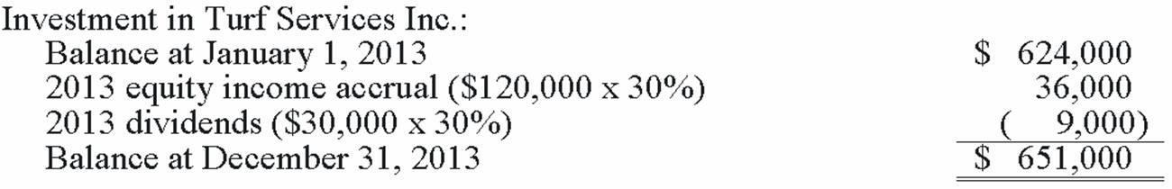

AACSB: Analytic
AICPA BB: Critical Thinking
AICPA FN: Measurement
Blooms: Apply
Difficulty: 2 Medium
Learning Objective: 01-02 Identify the sole criterion for applying the equity method of accounting and guidance in assessing whether the criterion is met.
Topic: Criteria for Utilizing the Equity Method

107. | Tinker Co. owns 25% of the common stock of Harbor Co. and uses the equity method to account for the investment. During 2013, Harbor reported income of $120,000 and paid dividends of $40,000. Harbor owns a building with a useful life of twenty years which is undervalued by $80,000.  Required:  Prepare a schedule to show the equity income Tinker should recognize for 2013 related to this investment.  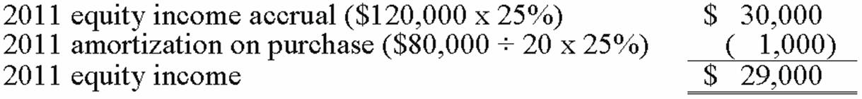

AACSB: Analytic
AICPA BB: Critical Thinking
AICPA FN: Measurement
Blooms: Apply
Difficulty: 2 Medium
Learning Objective: 01-04 Allocate the cost of an equity method investment and compute amortization expense to match revenues recognized from the investment to the excess of investor cost over investee book value.
Topic: Excess of Investment Cost Over Book Value Acquired

108. | Aqua Corp. purchased 30% of the common stock of Marcus Co. by paying $500,000. Of this amount, $50,000 is associated with goodwill.  Required:  Prepare the journal entry to record Aqua's investment.  The journal entry is:  The amount of goodwill does not affect the journal entry used to record the investment.

AACSB: Analytic
AICPA BB: Critical Thinking
AICPA FN: Measurement
Blooms: Apply
Difficulty: 2 Medium
Learning Objective: 01-03 Prepare basic equity method journal entries for an investor and describe the financial reporting for equity method investments.
Topic: Equity Method Accounting Procedures

109. | On January 2, 2013, Heinreich Co. paid $500,000 for 25% of the voting common stock of Jones Corp. At the time of the investment, Jones had net assets with a book value and fair value of $1,800,000. During 2013, Jones incurred a net loss of $60,000 and paid dividends of $100,000. Any excess cost over book value is attributable to goodwill with an indefinite life.  Required:  1) Prepare a schedule to show the amount of goodwill from Heinrich's investment in Jones.  2) Prepare a schedule to show the balance in Heinreich's investment account at December 31, 2013.  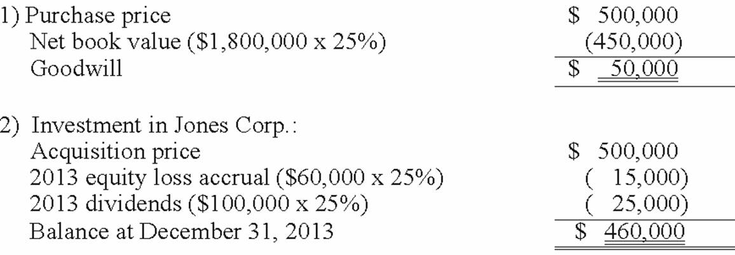

AACSB: Analytic
AICPA BB: Critical Thinking
AICPA FN: Measurement
Blooms: Apply
Difficulty: 3 Hard
Learning Objective: 01-02 Identify the sole criterion for applying the equity method of accounting and guidance in assessing whether the criterion is met.
Learning Objective: 01-04 Allocate the cost of an equity method investment and compute amortization expense to match revenues recognized from the investment to the excess of investor cost over investee book value.
Topic: Criteria for Utilizing the Equity Method
Topic: Excess of Investment Cost Over Book Value Acquired

110. | On January 3, 2013, Jenkins Corp. acquired 40% of the outstanding common stock of Bolivar Co. for $1,200,000. This acquisition gave Jenkins the ability to exercise significant influence over the investee. The book value of the acquired shares was $950,000. Any excess cost over the underlying book value was assigned to a patent that was undervalued on Bolivar's balance sheet. This patent has a remaining useful life of ten years. For the year ended December 31, 2013, Bolivar reported net income of $312,000 and paid cash dividends of $96,000.  Required:  Prepare a schedule to show the balance Jenkins should report as its Investment in Bolivar Co. at December 31, 2013.  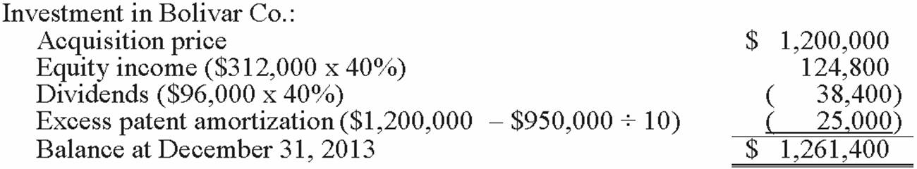

AACSB: Analytic
AICPA BB: Critical Thinking
AICPA FN: Measurement
Blooms: Apply
Difficulty: 3 Hard
Learning Objective: 01-04 Allocate the cost of an equity method investment and compute amortization expense to match revenues recognized from the investment to the excess of investor cost over investee book value.
Topic: Excess of Investment Cost Over Book Value Acquired

111. | On January 1, 2013, Spark Corp. acquired a 40% interest in Cranston Inc. for $250,000. On that date, Cranston's balance sheet disclosed net assets of $430,000. During 2013, Cranston reported net income of $100,000 and paid cash dividends of $30,000. Spark sold inventory costing $40,000 to Cranston during 2013 for $50,000. Cranston used all of this merchandise in its operations during 2013. Any excess cost over fair value is attributable to an unamortized trademark with a 20 year remaining life.  Required:  Prepare all of Spark's journal entries for 2013 to apply the equity method to this investment.  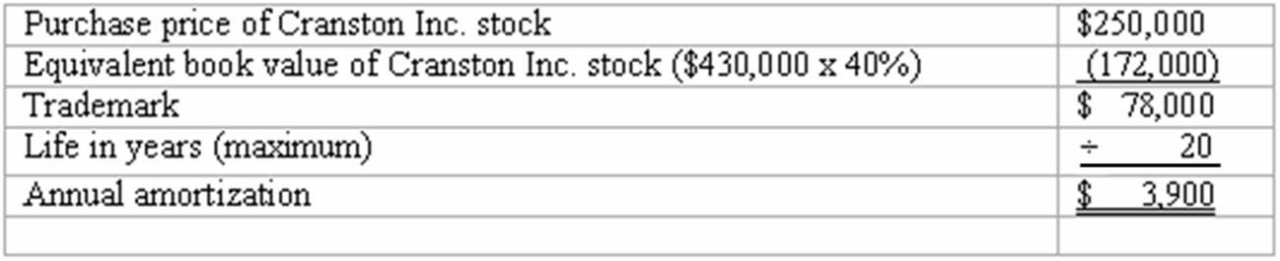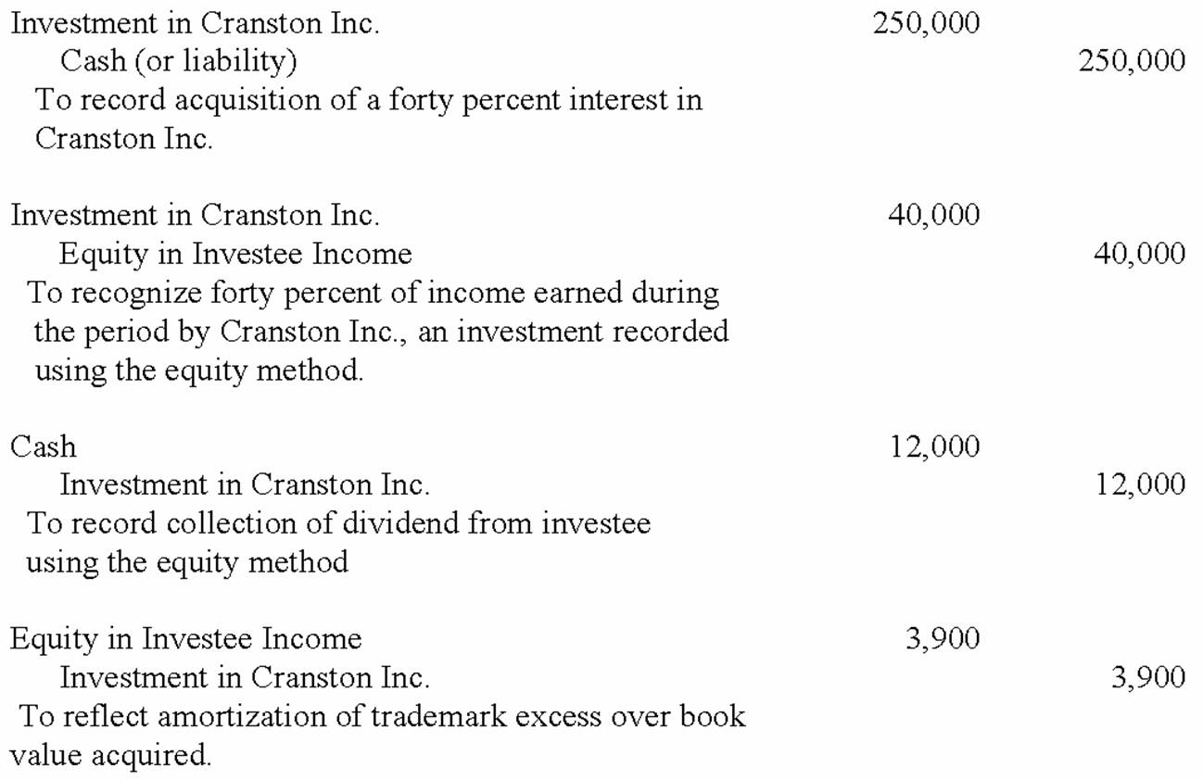

AACSB: Analytic
AICPA BB: Critical Thinking
AICPA FN: Measurement
Blooms: Apply
Difficulty: 3 Hard
Learning Objective: 01-02 Identify the sole criterion for applying the equity method of accounting and guidance in assessing whether the criterion is met.
Learning Objective: 01-04 Allocate the cost of an equity method investment and compute amortization expense to match revenues recognized from the investment to the excess of investor cost over investee book value.
Topic: Criteria for Utilizing the Equity Method
Topic: Excess of Investment Cost Over Book Value Acquired

112. | Wathan Inc. sold $180,000 in inventory to Miller Co. during 2012, for $270,000. Miller resold $108,000 of this merchandise in 2012 with the remainder to be disposed of during 2013.  Required:  Assuming Wathan owns 25% of Miller and applies the equity method, prepare the journal entry Wathan should have recorded at the end of 2012 to defer the unrealized intra-entity inventory profit.  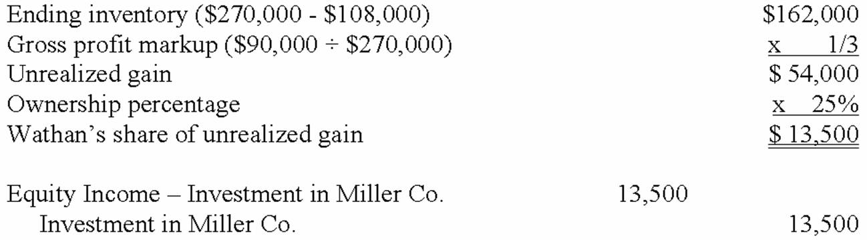

AACSB: Analytic
AICPA BB: Critical Thinking
AICPA FN: Measurement
Blooms: Apply
Difficulty: 3 Hard
Learning Objective: 01-06 Describe the rationale and computations to defer unrealized gains on intra-entity inventory transfers until the goods are either consumed or sold to outside parties.
Topic: Deferral of Unrealized Profits in Inventory

113. | Jager Inc. holds 30% of the outstanding voting shares of Kinson Co. and appropriately applies the equity method of accounting. Amortization associated with this investment equals $11,000 per year. For 2013, Kinson reported earnings of $100,000 and paid cash dividends of $40,000. During 2013, Kinson acquired inventory for $62,400, which was then sold to Jager for $96,000. At the end of 2013, Jager still held some of this inventory at its transfer price of $50,000.  Required:  Determine the amount of Equity in Investee Income that Jager should have reported for 2013.  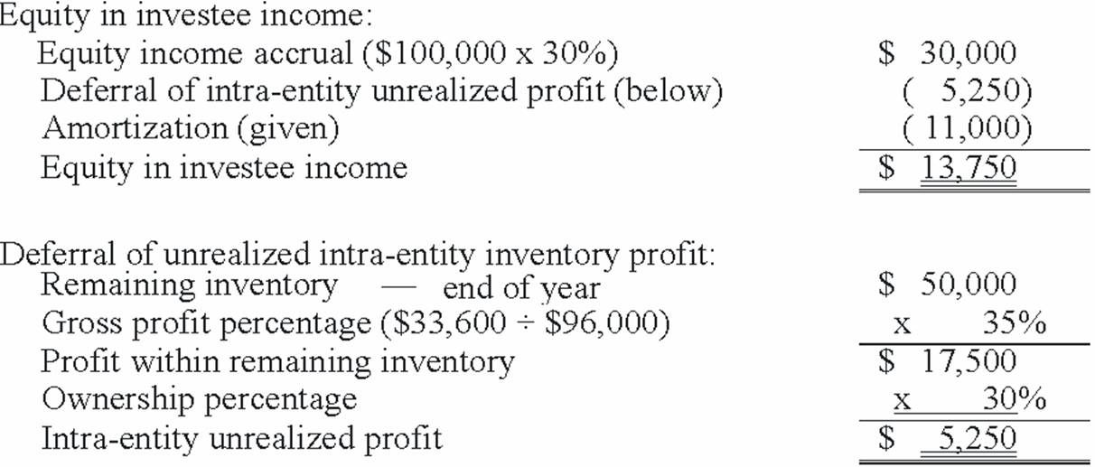

AACSB: Analytic
AICPA BB: Critical Thinking
AICPA FN: Measurement
Blooms: Apply
Difficulty: 3 Hard
Learning Objective: 01-06 Describe the rationale and computations to defer unrealized gains on intra-entity inventory transfers until the goods are either consumed or sold to outside parties.
Topic: Deferral of Unrealized Profits in Inventory

114. | On January 2, 2012, Hull Corp. paid $516,000 for 24% (48,000 shares) of the outstanding common stock of Oliver Co. Hull used the equity method to account for the investment. At the end of 2012, the balance in the investment account was $620,000. On January 2, 2013, Hull sold 12,000 shares of Oliver stock for $12 per share. For 2013, Oliver reported income of $118,000 and paid dividends of $30,000.  Required:  (A.) Prepare the journal entry to record the sale of the 12,000 shares.  (B.) After the sale has been recorded, what is the balance in the investment account?  (C.) What percentage of Oliver Co. stock does Hull own after selling the 12,000 shares?  (D.) Because of the sale of stock, Hull can no longer exercise significant influence over the operations of Oliver. What effect will this have on Hull's accounting for the investment?  (E.) Prepare Hull's journal entries related to the investment for the rest of 2013.  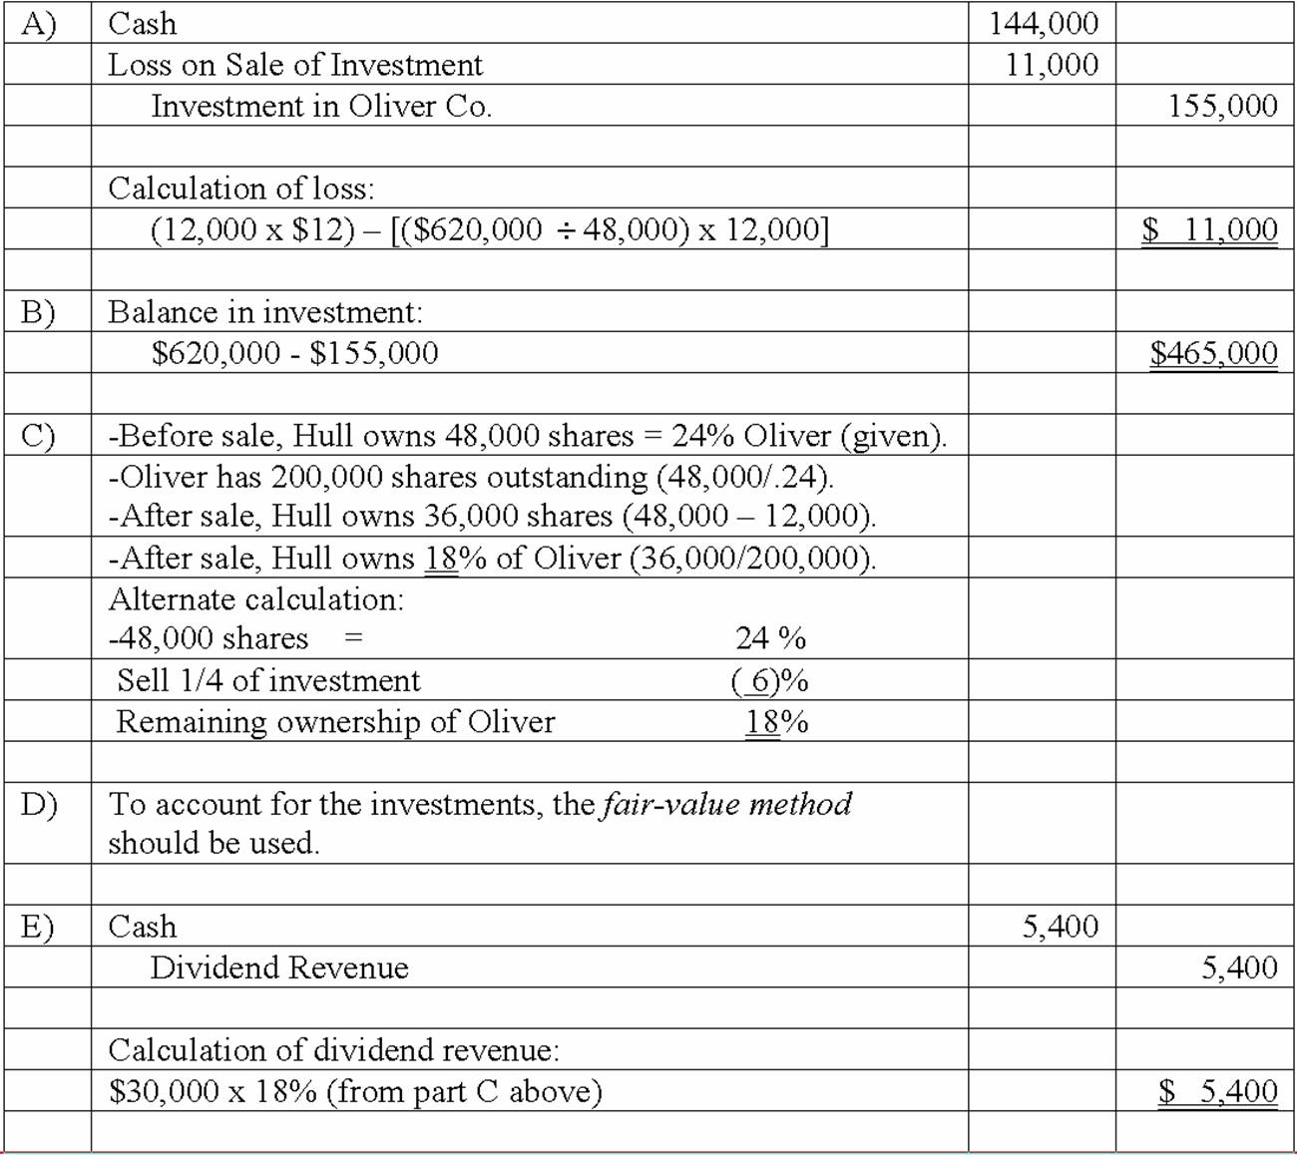

AACSB: Analytic
AICPA BB: Critical Thinking
AICPA FN: Measurement
Blooms: Apply
Difficulty: 3 Hard
Learning Objective: 01-01 Describe in general the various methods of accounting for an investment in equity shares of another company.
Learning Objective: 01-05d Understand the financial reporting consequences for sales of equity method investments.
Topic: Reporting the Sale of an Equity Investment
Topic: The Reporting of Investments in Corporate Equity Securities

115. | On January 1, 2013, Jolley Corp. paid $250,000 for 25% of the voting common stock of Tige Co. On that date, the book value of Tige was $850,000. A building with a carrying value of $160,000 was actually worth $220,000. The building had a remaining life of twenty years. Tige owned a trademark valued at $90,000 over cost that was to be amortized over 20 years.  During 2013, Tige sold to Jolley inventory costing $60,000, at a markup of 50% on cost. At the end of the year, Jolley still owned some of these goods with a transfer price of $33,000. Jolly uses a perpetual inventory system.  Tige reported net income of $200,000 during 2013. This amount included an extraordinary gain of $35,000. Tige paid dividends totaling $40,000.  Required:  Prepare all of Jolley's journal entries for 2013 in relation to Tige Co. Assume the equity method is appropriate for use.  Required journal entries:  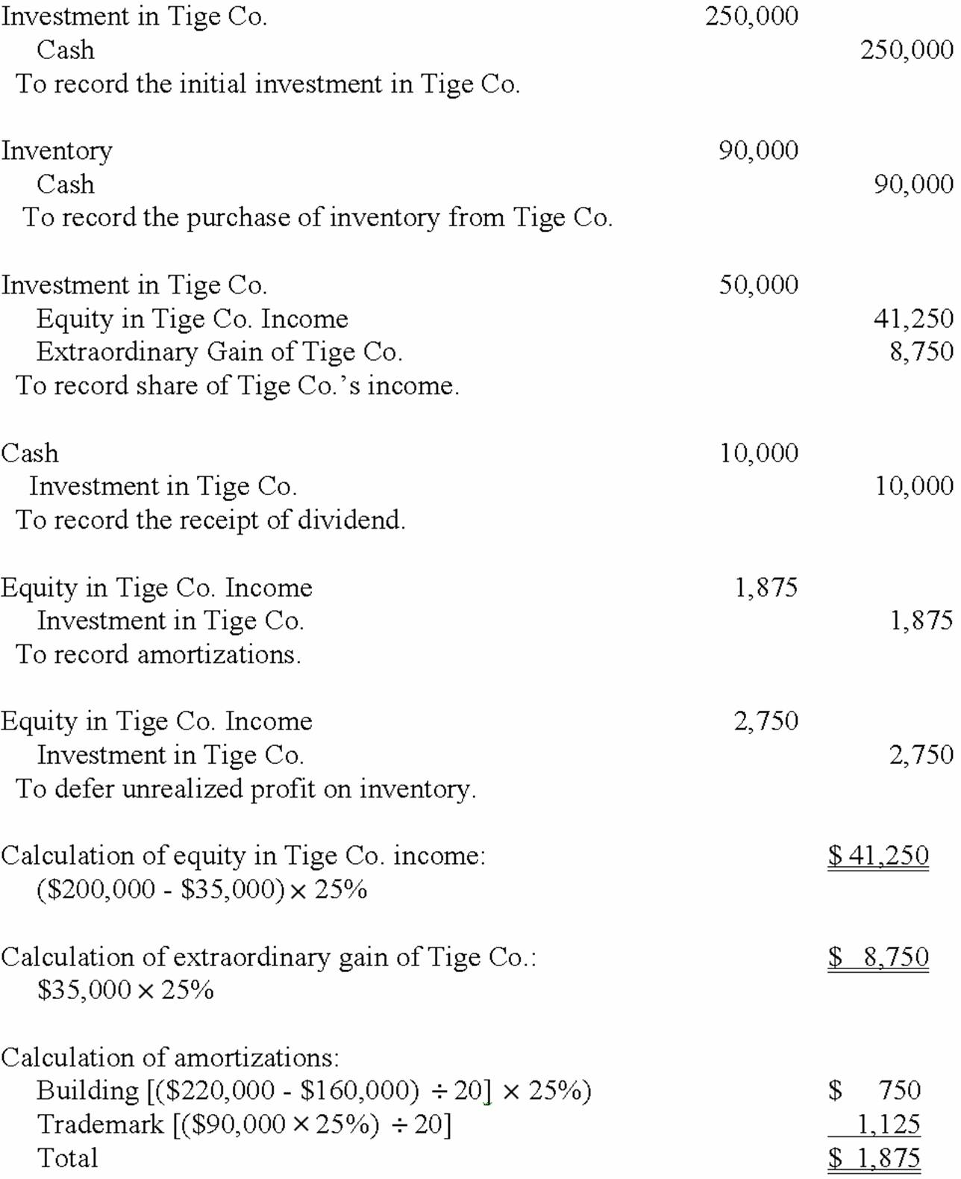  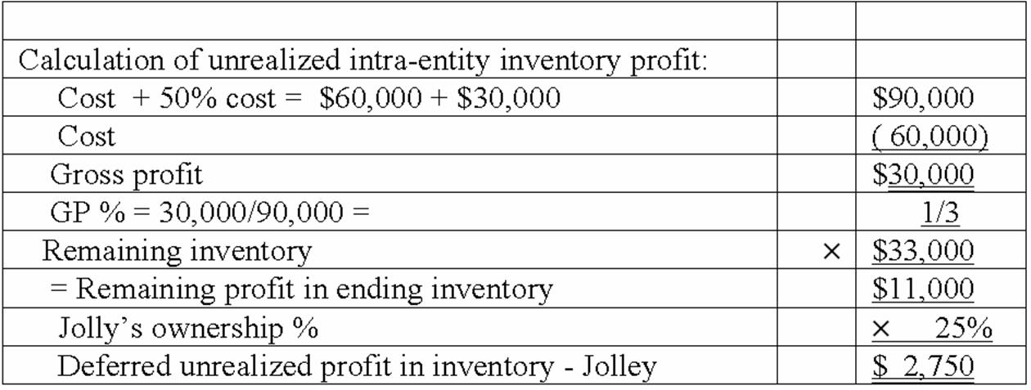

AACSB: Analytic
AICPA BB: Critical Thinking
AICPA FN: Measurement
Blooms: Apply
Difficulty: 3 Hard
Learning Objective: 01-02 Identify the sole criterion for applying the equity method of accounting and guidance in assessing whether the criterion is met.
Learning Objective: 01-03 Prepare basic equity method journal entries for an investor and describe the financial reporting for equity method investments.
Learning Objective: 01-04 Allocate the cost of an equity method investment and compute amortization expense to match revenues recognized from the investment to the excess of investor cost over investee book value.
Learning Objective: 01-06 Describe the rationale and computations to defer unrealized gains on intra-entity inventory transfers until the goods are either consumed or sold to outside parties.
Topic: Criteria for Utilizing the Equity Method
Topic: Deferral of Unrealized Profits in Inventory
Topic: Equity Method Accounting Procedures
Topic: Excess of Investment Cost Over Book Value Acquired

116. | On January 1, 2012, Pond Co. acquired 40% of the outstanding voting common shares of Ramp Co. for $700,000. On that date, Ramp reported assets and liabilities with book values of $2.2 million and $700,000, respectively. A building owned by Ramp had an appraised value of $300,000, although it had a book value of only $120,000. This building had a 12-year remaining life and no salvage value. It was being depreciated on the straight-line basis.  Ramp generated net income of $300,000 in 2012 and a loss of $120,000 in 2013. In each of these two years, Ramp paid a cash dividend of $70,000 to its stockholders.  During 2012, Ramp sold inventory to Pond that had an original cost of $60,000. The merchandise was sold to Pond for $96,000. Of this balance, $72,000 was resold to outsiders during 2012 and the remainder was sold during 2013. In 2013, Ramp sold inventory to Pond for $180,000. This inventory had cost only $108,000. Pond resold $120,000 of the inventory during 2013 and the rest during 2014.  Required:  For 2012 and then for 2013, calculate the equity income to be reported by Pond for external reporting purposes.  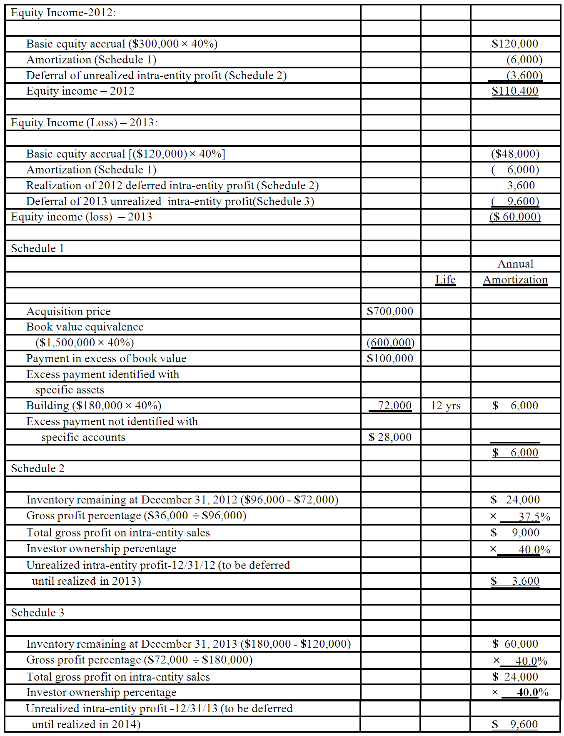

AACSB: Analytic
AICPA BB: Critical Thinking
AICPA FN: Measurement
Blooms: Apply
Difficulty: 3 Hard
Learning Objective: 01-05b Understand the financial reporting consequences for investee other comprehensive income.
Learning Objective: 01-05c Understand the financial reporting consequences for investee losses.
Learning Objective: 01-06 Describe the rationale and computations to defer unrealized gains on intra-entity inventory transfers until the goods are either consumed or sold to outside parties.
Topic: Deferral of Unrealized Profits in Inventory
Topic: Reporting Investee Losses
Topic: Reporting Investee Other Comprehensive Income and Irregular Items

117. | Pursley, Inc. acquires 10% of Ritz Corporation on January 3, 2012, for $80,000 when the book value of Ritz was $800,000. During 2012 Ritz reported net income of $125,000 and paid dividends of $30,000. On January 1, 2013, Pursley purchased an additional 20% of Ritz for $325,000, giving Pursley the ability to significantly influence the operating policies of Ritz. Any excess of cost over book value is attributable to goodwill with an indefinite life. What journal entry(ies) is(are) required on January 1, 2013?  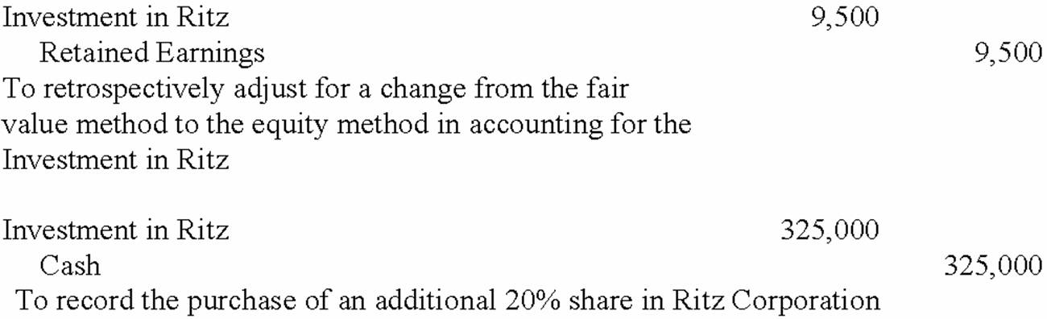

AACSB: Analytic
AICPA BB: Critical Thinking
AICPA FN: Measurement
Blooms: Apply
Difficulty: 2 Medium
Learning Objective: 01-03 Prepare basic equity method journal entries for an investor and describe the financial reporting for equity method investments.
Topic: Equity Method Accounting Procedures

118. | Steven Company owns 40% of the outstanding voting common stock of Nicole Corp. and has the ability to significantly influence the investee's operations. On January 3, 2013, the balance in the Investment in Nicole Corp. account was $503,000. Amortization associated with this acquisition is $12,000 per year. During 2013, Nicole earned net income of $120,000 and paid cash dividends of $40,000. Previously in 2012, Nicole had sold inventory costing $35,000 to Steven for $50,000. All but 25% of that inventory had been sold to outsiders by Steven during 2012. Additional sales were made to Steven in 2013 at a transfer price of $75,000 that had cost Nicole $54,000. Only 10% of the 2013 purchases had not been sold to outsiders by the end of 2013.  What amount of unrealized intra-entity inventory profit should be deferred by Steven at December 31, 2012?  [($50,000 - $35,000) × .25 × .40] = $1,500

AACSB: Analytic
AICPA BB: Critical Thinking
AICPA FN: Measurement
Blooms: Apply
Difficulty: 2 Medium
Learning Objective: 01-06 Describe the rationale and computations to defer unrealized gains on intra-entity inventory transfers until the goods are either consumed or sold to outside parties.
Topic: Deferral of Unrealized Profits in Inventory

119. | Steven Company owns 40% of the outstanding voting common stock of Nicole Corp. and has the ability to significantly influence the investee's operations. On January 3, 2013, the balance in the Investment in Nicole Corp. account was $503,000. Amortization associated with this acquisition is $12,000 per year. During 2013, Nicole earned net income of $120,000 and paid cash dividends of $40,000. Previously in 2012, Nicole had sold inventory costing $35,000 to Steven for $50,000. All but 25% of that inventory had been sold to outsiders by Steven during 2012. Additional sales were made to Steven in 2013 at a transfer price of $75,000 that had cost Nicole $54,000. Only 10% of the 2013 purchases had not been sold to outsiders by the end of 2013.  What amount of unrealized intra-entity profit should be deferred by Steven at December 31, 2013?  [($75,000 - $54,000) × .10 × .40] = $840

AACSB: Analytic
AICPA BB: Critical Thinking
AICPA FN: Measurement
Blooms: Apply
Difficulty: 2 Medium
Learning Objective: 01-06 Describe the rationale and computations to defer unrealized gains on intra-entity inventory transfers until the goods are either consumed or sold to outside parties.
Topic: Deferral of Unrealized Profits in Inventory

120. | Steven Company owns 40% of the outstanding voting common stock of Nicole Corp. and has the ability to significantly influence the investee's operations. On January 3, 2013, the balance in the Investment in Nicole Corp. account was $503,000. Amortization associated with this acquisition is $12,000 per year. During 2013, Nicole earned net income of $120,000 and paid cash dividends of $40,000. Previously in 2012, Nicole had sold inventory costing $35,000 to Steven for $50,000. All but 25% of that inventory had been sold to outsiders by Steven during 2012. Additional sales were made to Steven in 2013 at a transfer price of $75,000 that had cost Nicole $54,000. Only 10% of the 2013 purchases had not been sold to outsiders by the end of 2013.  What amount of equity income would Steven have recognized in 2013 from its ownership interest in Nicole?  [($120,000 × .4) - $12,000 - $840 + $1,500] = $36,660

AACSB: Analytic
AICPA BB: Critical Thinking
AICPA FN: Measurement
Blooms: Apply
Difficulty: 3 Hard
Learning Objective: 01-04 Allocate the cost of an equity method investment and compute amortization expense to match revenues recognized from the investment to the excess of investor cost over investee book value.
Learning Objective: 01-06 Describe the rationale and computations to defer unrealized gains on intra-entity inventory transfers until the goods are either consumed or sold to outside parties.
Topic: Deferral of Unrealized Profits in Inventory
Topic: Excess of Investment Cost Over Book Value Acquired

121. | Steven Company owns 40% of the outstanding voting common stock of Nicole Corp. and has the ability to significantly influence the investee's operations. On January 3, 2013, the balance in the Investment in Nicole Corp. account was $503,000. Amortization associated with this acquisition is $12,000 per year. During 2013, Nicole earned net income of $120,000 and paid cash dividends of $40,000. Previously in 2012, Nicole had sold inventory costing $35,000 to Steven for $50,000. All but 25% of that inventory had been sold to outsiders by Steven during 2012. Additional sales were made to Steven in 2013 at a transfer price of $75,000 that had cost Nicole $54,000. Only 10% of the 2013 purchases had not been sold to outsiders by the end of 2013.  What was the balance in the Investment in Nicole Corp. account at December 31, 2013?  [$503,000 + $36,660 - ($40,000 × .4)] = $523,660

AACSB: Analytic
AICPA BB: Critical Thinking
AICPA FN: Measurement
Blooms: Apply
Difficulty: 3 Hard
Learning Objective: 01-04 Allocate the cost of an equity method investment and compute amortization expense to match revenues recognized from the investment to the excess of investor cost over investee book value.
Learning Objective: 01-06 Describe the rationale and computations to defer unrealized gains on intra-entity inventory transfers until the goods are either consumed or sold to outside parties.
Topic: Deferral of Unrealized Profits in Inventory
Topic: Excess of Investment Cost Over Book Value Acquired

