Chapter 1
Corporate finance and the financial manager

Write 'True' if the statement is correct and 'False' if the statement is incorrect.
1) The Valuation Principle shows how to make the costs and benefits of a decision comparable so that we can evaluate them properly.
Answer: True
Difficulty: Basic
Learning Objective: 1.1 Identify the importance of financial information in both your personal and business life
Topic 1.1: Why study Finance?
AACSB: Application of Knowledge

2) Financial decisions require that you weigh alternatives in strictly monetary terms.
Answer: False
Difficulty: Basic
Learning Objective: 1.1 Identify the importance of financial information in both your personal and business life
Topic 1.1: Why study Finance?
AACSB: Analytical Thinking

Choose the one alternative that best completes the statement or answers the question.
3) Which of the following best describes why the Valuation Principle is a key concept in making financial decisions?
A) It shows how to assign monetary value to intangibles such as good health and wellbeing.
B) It gives a good indication of the net worth of a person, item, or company and can be used to estimate any changes in that net worth.
C) It shows how to make the costs and benefits of a decision comparable so that we can weigh them properly.
D) It allows fixed assets and liquid assets to be valued correctly.
Answer: C
Difficulty: Basic
Learning Objective: 1.1 Identify the importance of financial information in both your personal and business life
Topic 1.1: Why study Finance?
AACSB: Analytical Thinking
Write 'True' if the statement is correct and 'False' if the statement is incorrect.
4) Corporations are the most common type of business form in the world.
Answer: False
Difficulty: Basic
Learning Objective: 1.2 Understand the important features of the three main types of firms and see why the advantages of the corporate form have led it to dominate economic activity
Topic 1.2: The Three Types of Firms
AACSB: Application of Knowledge

5) Corporations have come to dominate the business world through their ability to raise large amounts of capital by sale of ownership shares to anonymous outside investors.
Answer: True
Difficulty: Basic
Learning Objective: 1.2 Understand the important features of the three main types of firms and see why the advantages of the corporate form have led it to dominate economic activity
Topic 1.2: The Three Types of Firms
AACSB: Application of Knowledge

Choose the one alternative that best completes the statement or answers the question.
6) Which of the following types of firms have limited liability?
A) Limited partnerships
B) Sole traders
C) Corporations
D) Limited partnerships and corporations
Answer: D
Difficulty: Basic
Learning Objective: 1.2 Understand the important features of the three main types of firms and see why the advantages of the corporate form have led it to dominate economic activity
Topic 1.2: The Three Types of Firms
AACSB: Application of Knowledge

7) In revenue terms, which type of firm is the dominant business form all over the world?
A) Partnership
B) Sole trader
C) Corporation
D) Limited partnership
Answer: C
Difficulty: Basic
Learning Objective: 1.2 Understand the important features of the three main types of firms and see why the advantages of the corporate form have led it to dominate economic activity
Topic 1.2: The Three Types of Firms
AACSB: Application of Knowledge

8) What is the most common type of firm in the world?
A) Limited partnership
B) Corporation
C) Partnership
D) Sole trader
Answer: D
Difficulty: Basic
Learning Objective: 1.2 Understand the important features of the three main types of firms and see why the advantages of the corporate form have led it to dominate economic activity
Topic 1.2: The Three Types of Firms
AACSB: Application of Knowledge

9) Which of the following is typically the major factor in limiting the growth of a sole trader?
A) It is extremely difficult to transfer control of such a firm to a new owner if the present owner dies or wishes to sell the firm.
B) Investors have a great deal of control over the day-to-day running of the firm, leading to confusion when conflicts in direction arise.
C) The organisation of such firms tends to become extremely complicated over time.
D) The amount of money that can be raised by the firm is limited by the fact that the single owner must make good on all debts.
Answer: D
Difficulty: Basic
Learning Objective: 1.2 Understand the important features of the three main types of firms and see why the advantages of the corporate form have led it to dominate economic activity
Topic 1.2: The Three Types of Firms
AACSB: Analytical Thinking

10) Joe is a general partner in a limited partnership firm, while Jane is a limited partner in that same firm. Which one of the following statements regarding their respective relationships to the firm is correct?
A) Jane is legally involved in the managerial decision making of the firm.
B) Joe has no management authority within the partnership.
C) Jane's liability for the firm's debts consists solely of her investment in the firm.
D) Withdrawal of Jane from the partnership will dissolve that partnership.
Answer: C
Difficulty: Basic
Learning Objective: 1.2 Understand the important features of the three main types of firms and see why the advantages of the corporate form have led it to dominate economic activity
Topic 1.2: The Three Types of Firms
AACSB: Application of Knowledge

11) What is the major way in which the roles and obligations of the owners of a corporation differ from the roles and obligations of limited partners in a limited partnership?
A) There is no separation between the company and its owners in a corporation
B) The owners of a corporation can withdraw from the company without the company being dissolved.
C) The owners of a corporation can take an active role in running the company.
D) The owners of a corporation have personal obligation for debts incurred by the company.
Answer: C
Difficulty: Basic
Learning Objective: 1.2 Understand the important features of the three main types of firms and see why the advantages of the corporate form have led it to dominate economic activity
Topic 1.2: The Three Types of Firms
AACSB: Application of Knowledge

12) Why is it possible for a corporation to enter into contracts, acquire assets, incur obligations, and enjoy protection against the seizure of its property?
A) The number of owners, and hence the spread of risk among these owners, is not limited.
B) The state in which the corporation is incorporated provides safeguards against any wrongdoing by the corporation.
C) Its owners are liable for any obligations it enters into.
D) It is a legally defined, artificial entity that is separate from its owners.
Answer: D
Difficulty: Basic
Learning Objective: 1.2 Understand the important features of the three main types of firms and see why the advantages of the corporate form have led it to dominate economic activity
Topic 1.2: The Three Types of Firms
AACSB: Application of Knowledge

13) In Australia, dividend imputation may reduce the tax payable by
A) a non-resident shareholder.
B) a resident shareholder.
C) a corporation.
D) both B and C
Answer: B
Difficulty: Basic
Learning Objective: 1.2 Understand the important features of the three main types of firms and see why the advantages of the corporate form have led it to dominate economic activity
Topic 1.2: The Three Types of Firms
AACSB: Application of Knowledge

14) What is the major advantage corporations have over other business entities?
A) A corporation's shares can be freely traded among its shareholders.
B) It is easier for a corporation to raise capital than other forms of businesses.
C) A corporation is treated as a separate legal entity for tax and legal purposes.
D) All of the above are advantages that a corporation has over other business forms.
Answer: D
Difficulty: Basic
Learning Objective: 1.2 Understand the important features of the three main types of firms and see why the advantages of the corporate form have led it to dominate economic activity
Topic 1.2: The Three Types of Firms
AACSB: Application of Knowledge

15) Helen owns 2.5% of the stock of the Median Corporation. If Median makes a dividend payment of $19 000 000 paid proportionally to its shareholders, how much of this amount would Helen receive, disregarding tax?
A) $479 000
B) $475 000
C) $500 000
D) $450 000
Answer: B
Difficulty: Moderate
Learning Objective: 1.2 Understand the important features of the three main types of firms and see why the advantages of the corporate form have led it to dominate economic activity
Topic 1.2: The Three Types of Firms
AACSB: Analytical Thinking

16) ValiantCorp is a corporation that earned $3 per share before it paid any taxes. ValiantCorp retained $1 of after tax earnings for reinvestment, and distributed what remained in dividend payments. If the corporate tax rate was 30% and dividend earnings were taxed at 12.5%, what was the value of the dividend earnings received after tax by a holder of 100 000 shares of ValiantCorp?
A) $112 500
B) $104 750
C) $96 250
D) $110 000
Answer: C
Difficulty: Moderate
Learning Objective: 1.2 Understand the important features of the three main types of firms and see why the advantages of the corporate form have led it to dominate economic activity
Topic 1.2: The Three Types of Firms
AACSB: Analytical Thinking

17) Big Business Limited distributes a fully franked dividend to its shareholders. Which of the following statements best describes the outcome for shareholders?
A) The company pays tax on the profits from which the dividend is paid.
B) The profits from which the dividend is paid are not taxed at the corporate level.
C) Shareholders must include their share of the profit from which the dividend is paid in their personal income tax return, but this amount is disregarded for their personal tax purposes.
D) both B and C
Answer: A
Difficulty: Complex
Learning Objective: 1.2 Understand the important features of the three main types of firms and see why the advantages of the corporate form have led it to dominate economic activity
Topic 1.2: The Three Types of Firms
AACSB: Application of Knowledge

18) You are a shareholder in a corporation which has announced a profit of $6 per share, of which it retains $2 for reinvestment and distributes the rest as dividend payments. A franking credit of $1.71 per share attaches to the dividend. Given that the personal tax rate is 35%, how much tax must you pay per share?
A) $0.28
B) $3.90
C) $2.00
D) $0
Answer: A
Difficulty: Complex
Learning Objective: 1.2 Understand the important features of the three main types of firms and see why the advantages of the corporate form have led it to dominate economic activity
Topic 1.2: The Three Types of Firms
AACSB: Analytical Thinking

19) What is the maximum number of non-employee shareholders a 'private' corporation may have?
A) 50
B) 25
C) 15
D) There is no limit
Answer: A
Difficulty: Basic
Learning Objective: 1.2 Understand the important features of the three main types of firms and see why the advantages of the corporate form have led it to dominate economic activity
Topic 1.2: The Three Types of Firms
AACSB: Application of Knowledge

20) What is the process of double taxation for the shareholders of a corporation in a 'classical' tax system?
A) Their shares are taxed when they are both bought and sold.
B) The owners of a corporation are taxed when they receive dividend payments and when they make a profit from the sale of shares.
C) The corporation must pay taxes on any profits it makes, and the capital raised by the sale of shares is also subject to taxation.
D) The corporation is taxed on the profits it makes, and the owners are taxed when this profit is distributed to them.
Answer: D
Difficulty: Basic
Learning Objective: 1.2 Understand the important features of the three main types of firms and see why the advantages of the corporate form have led it to dominate economic activity
Topic 1.2: The Three Types of Firms
AACSB: Application of Knowledge

21) A ‘sole trader’ is a type of firm owned by
A) two or more persons.
B) bankers.
C) one person.
D) shareholders.
Answer: C
Difficulty: Basic
Learning Objective: 1.2 Understand the important features of the three main types of firms and see why the advantages of the corporate form have led it to dominate economic activity
Topic 1.2: The Three Types of Firms
AACSB: Application of Knowledge

22) Which one of the following organisation forms has the most revenue?
A) Corporation
B) Sole trader
C) Partnership
D) Limited partnership
Answer: A
Difficulty: Basic
Learning Objective: 1.2 Understand the important features of the three main types of firms and see why the advantages of the corporate form have led it to dominate economic activity
Topic 1.2: The Three Types of Firms
AACSB: Application of Knowledge

23) Which of the following is NOT an advantage of a sole trader?
A) Limited liability
B) Single taxation
C) No separation of ownership and control
D) Ease of set-up
Answer: A
Difficulty: Moderate
Learning Objective: 1.2 Understand the important features of the three main types of firms and see why the advantages of the corporate form have led it to dominate economic activity
Topic 1.2: The Three Types of Firms
AACSB: Application of Knowledge

24) In a limited partnership, limited partners may
A) make managerial decisions for the firm.
B) have private property seized to pay off the firm's outstanding debts.
C) trigger a dissolution of the firm if they withdraw their participation.
D) none of the above
Answer: D
Difficulty: Basic
Learning Objective: 1.2 Understand the important features of the three main types of firms and see why the advantages of the corporate form have led it to dominate economic activity
Topic 1.2: The Three Types of Firms
AACSB: Application of Knowledge

25) A 'public' company
A) is never a 'reporting entity’.
B) is essentially the same as a 'private' company.
C) must appoint an auditor.
D) must have its shares traded on a stock exchange.
Answer: C
Difficulty: Basic
Learning Objective: 1.2 Understand the important features of the three main types of firms and see why the advantages of the corporate form have led it to dominate economic activity
Topic 1.2: The Three Types of Firms
AACSB: Application of Knowledge

Write the word or phrase that best completes each statement or answers the question.
26) What are the main differences between a ‘partnership’ and ‘sole trader’?
Answer: While a sole trader has the same identity as its single owner, a partnership of general partners has the same identity as its partners. Each general partner is responsible for the decisions taken by that partner as well as any other general partner.
Difficulty: Basic
Learning Objective: 1.2 Understand the important features of the three main types of firms and see why the advantages of the corporate form have led it to dominate economic activity
Topic 1.2: The Three Types of Firms
AACSB: Application of Knowledge

27) How is a corporation different from most of the other forms of business organisations?
Answer: A corporation has a separate legal identity from those of its owners. This separation gives the owners limited liability for the actions of the corporation. In Australia, the 'imputation system' of taxation may relieve double taxation, which is the main disadvantage of a corporation under a 'classical' tax system.
Difficulty: Moderate
Learning Objective: 1.2 Understand the important features of the three main types of firms and see why the advantages of the corporate form have led it to dominate economic activity
Topic 1.2: The Three Types of Firms
AACSB: Application of Knowledge

Write 'True' if the statement is correct and 'False' if the statement is incorrect.
28) The principal goal of the financial manager is to maximise the wealth of the chief financial officer (CFO).
Answer: False
Difficulty: Basic
Learning Objective: 1.3 Explain the goal of the financial manager and the reasoning behind that goal, as well as understand the three main types of decisions a financial manager makes
Topic 1.3: The Financial Manager
AACSB: Application of Knowledge

29) It is generally the duty of financial managers to ensure that a firm has the cash it needs for day-to-day transactions.
Answer: True
Difficulty: Basic
Learning Objective: 1.3 Explain the goal of the financial manager and the reasoning behind that goal, as well as understand the three main types of decisions a financial manager makes
Topic 1.3: The Financial Manager
AACSB: Application of Knowledge
Choose the one alternative that best completes the statement or answers the question.
30) Which of the following are major duties of a financial manager?
I. To make investment decisions
II. To make financing decisions
III. To manage cash flow from operating activities
A) I only
B) I and II only
C) I and III only
D) all of the above
Answer: D
Difficulty: Complex
Learning Objective: 1.3 Explain the goal of the financial manager and the reasoning behind that goal, as well as understand the three main types of decisions a financial manager makes
Topic 1.3: The Financial Manager
AACSB: Application of Knowledge

31) Why in general do financial managers make financial decisions in a corporation, rather than the owners making these decisions themselves?
A) There are often many owners, and they can often change as they buy and sell shares.
B) The owners may not be Australian citizens or residents.
C) The interests of the various owners may conflict with each other.
D) It is best for the control of the finances of a corporation to be in the hands of a disinterested third party.
Answer: A
Difficulty: Moderate
Learning Objective: 1.3 Explain the goal of the financial manager and the reasoning behind that goal, as well as understand the three main types of decisions a financial manager makes
Topic 1.3: The Financial Manager
AACSB: Analytical Thinking

32) What is the most important duty of a financial manager?
A) To decide how to pay for investments
B) To manage working capital
C) To make investment decisions
D) To ensure that the firm has enough cash on hand to meet its commitments at any given time
Answer: C
Difficulty: Moderate
Learning Objective: 1.3 Explain the goal of the financial manager and the reasoning behind that goal, as well as understand the three main types of decisions a financial manager makes
Topic 1.3: The Financial Manager
AACSB: Application of Knowledge
33) The financial manager of a well-regarded book publishing firm wishes to buy a small internet publishing company to provide an avenue for sale of its materials online. In order to raise the funds to make this purchase, the financial manager decides to sell more shares in the company. How is the financial manager raising funds in this case?
A) By increasing the value of shares held by the existing owners of the company
B) By increasing the debt burden carried by the company
C) By decreasing the ratio of equity to debt held by the company
D) By raising the company's equity by encouraging new owners to take a stake in the company
Answer: D
Difficulty: Basic
Learning Objective: 1.3 Explain the goal of the financial manager and the reasoning behind that goal, as well as understand the three main types of decisions a financial manager makes
Topic 1.3: The Financial Manager
AACSB: Application of Knowledge

34) Which of the following is NOT a reason why financial managers must take great care when making investment decisions?
A) These investment decisions determine whether the firm will add value for its owners.
B) These investment decisions typically involve substantial costs which must be carefully weighed against their potential benefits.
C) These investments determine the long-term directions in which the company may move.
D) These investment decisions determine the corporation's mix of debt and equity.
Answer: D
Difficulty: Moderate
Learning Objective: 1.3 Explain the goal of the financial manager and the reasoning behind that goal, as well as understand the three main types of decisions a financial manager makes
Topic 1.3: The Financial Manager
AACSB: Analytical Thinking

35) A company that produces racing motorbikes has several models that sell well within the motorcycle racing community and which are very profitable for the company. Despite having a profitable product, why must this company take care to ensure that it has sufficient cash on hand to meet its obligations?
A) New models will require a lot of money to develop and bring to market before they generate any revenue.
B) The company will have built up debts which must be repaid in order to bring the current models to market.
C) Profits from the sales of popular models will be lost when returned to the shareholders in the form of dividends.
D) Equity must be raised to finance the development of new models to replace the existing models.
Answer: A
Difficulty: Basic
Learning Objective: 1.3 Explain the goal of the financial manager and the reasoning behind that goal, as well as understand the three main types of decisions a financial manager makes
Topic 1.3: The Financial Manager
AACSB: Analytical Thinking

36) A typical 'public' company has many types of shareholders, from individuals holding a few shares, to large institutions that hold very large numbers of shares. How does a financial manager ensure that the priorities and concerns of such disparate shareholders are met?
A) The decisions taken by the financial manager should be solely influenced by the benefit to the company since, by maximising its fitness, he or she will also maximise the benefits of that company to the shareholders.
B) The financial manager should seek to make investments that do not harm the interests of the shareholders.
C) In general, all shareholders will agree that they are better off if the financial manager works to maximise the value of their investment.
D) The financial manager should consider the interests and concerns of large shareholders a priority, so the needs of those who hold a controlling interest in the company are met.
Answer: C
Difficulty: Basic
Learning Objective: 1.3 Explain the goal of the financial manager and the reasoning behind that goal, as well as understand the three main types of decisions a financial manager makes
Topic 1.3: The Financial Manager
AACSB: Reflective Thinking Skills

37) Whose interests should a financial manager consider paramount when making a decision?
A) the public who consume the company's goods and services
B) the senior management and associated colleagues at the executive level within the company
C) the employees and associated stakeholders who are employed by the company
D) the shareholders who have risked their money to become owners of the company
Answer: D
Difficulty: Basic
Learning Objective: 1.3 Explain the goal of the financial manager and the reasoning behind that goal, as well as understand the three main types of decisions a financial manager makes
Topic 1.3: The Financial Manager
AACSB: Ethical Understanding and Reasoning Abilities

Write the word or phrase that best completes each statement or answers the question.
38) What is the principal guiding factor for the financial manager?
Answer: Maximising shareholder wealth is the paramount guiding factor for the financial manager.
Difficulty: Basic
Learning Objective: 1.3 Explain the goal of the financial manager and the reasoning behind that goal, as well as understand the three main types of decisions a financial manager makes
Topic 1.3: The Financial Manager
AACSB: Application of Knowledge

Write 'True' if the statement is correct and 'False' if the statement is incorrect.
39) In most corporations, the owners exercise indirect control of the corporation.
Answer: True
Difficulty: Basic
Learning Objective: 1.4 Understand how a corporation is managed and controlled, the financial manager’s place in it, and some of the ethical issues financial managers face
Topic 1.4: The Financial Manager’s place in the corporation
AACSB: Application of Knowledge

40) The fact that corporations' shares are easily traded within the market has a net effect of acting as a disincentive for managers to favour the interests of shareholders over their own interests.
Answer: False
Difficulty: Basic
Learning Objective: 1.4 Understand how a corporation is managed and controlled, the financial manager’s place in it, and some of the ethical issues financial managers face
Topic 1.4: The Financial Manager’s place in the corporation
AACSB: Application of Knowledge

Choose the one alternative that best completes the statement or answers the question.
41) How do the shareholders of most corporations exercise their control of that corporation?
A) by electing members of a board of directors
B) by vetting the decisions of the board of directors
C) by providing oversight of the day-to-day running of the corporation
D) by voting on issues that concern them
Answer: A
Difficulty: Basic
Learning Objective: 1.4 Understand how a corporation is managed and controlled, the financial manager’s place in it, and some of the ethical issues financial managers face
Topic 1.4: The Financial Manager’s place in the corporation
AACSB: Application of Knowledge

42) Which of the following is NOT a function of the board of directors?
A) answering to shareholders of the company
B) determining how top executives should be compensated
C) day-to-day running of the company
D) monitoring the performance of the company
Answer: C
Difficulty: Basic
Learning Objective: 1.4 Understand how a corporation is managed and controlled, the financial manager’s place in it, and some of the ethical issues financial managers face
Topic 1.4: The Financial Manager’s place in the corporation
AACSB: Application of Knowledge

43) In most corporations, to whom does the chief financial officer report?
A) the board of directors
B) the controller
C) the chief executive officer
D) the shareholders
Answer: C
Difficulty: Basic
Learning Objective: 1.4 Understand how a corporation is managed and controlled, the financial manager’s place in it, and some of the ethical issues financial managers face
Topic 1.4: The Financial Manager’s place in the corporation
AACSB: Application of Knowledge

44) Which of the following would be more typically the responsibility of a controller rather than a treasurer?
A) capital budgeting
B) making investment decisions
C) overseeing accounting and tax functions
D) managing credit
Answer: C
Difficulty: Basic
Learning Objective: 1.4 Understand how a corporation is managed and controlled, the financial manager’s place in it, and some of the ethical issues financial managers face
Topic 1.4: The Financial Manager’s place in the corporation
AACSB: Application of Knowledge

45) Which of the following would be best considered to be an agency problem in the behaviour of the following financial managers?
A) Michael chooses to enhance his firm's reputation at some cost to its shareholders by sponsoring a team of athletes for the Special Olympics.
B) James ignores an opportunity for his company to invest in a new drug to fight Alzheimer's disease, judging the drug's chances of succeeding as low.
C) Sue instructs her staff to skip safety inspections in one of the company's factories, knowing that it will likely fail the inspection and incur significant costs to fix.
D) Bill chooses to pursue a risky investment for the company's funds, because his compensation will substantially rise if it succeeds.
Answer: D
Difficulty: Complex
Learning Objective: 1.4 Understand how a corporation is managed and controlled, the financial manager’s place in it, and some of the ethical issues financial managers face
Topic 1.4: The Financial Manager’s place in the corporation
AACSB: Reflective Thinking Skills

46) A factory owner wants his workers to produce as many widgets as they can, so he pays his workers based on how many widgets they produce. However, in order to make sure that the workers do not rush and produce a large number of poorly-made widgets, he checks the widgets at random at various stages of their manufacture. If a defect is found in a widget, the pay of the entire section of the factory responsible for that defect is docked. How is this factory owner seeking to solve the agency problem in this case?
A) by maximising the information that the principal obtains about the behaviour of the agents
B) by ensuring that all workers cooperate to maximise the gains of their section
C) by supplying incentives so the agents act in the way the principal desires
D) by making the agents into principals themselves
Answer: C
Difficulty: Basic
Learning Objective: 1.4 Understand how a corporation is managed and controlled, the financial manager’s place in it, and some of the ethical issues financial managers face
Topic 1.4: The Financial Manager’s place in the corporation
AACSB: Reflective Thinking Skills

47) In which of the following relationships is an agency problem LEAST likely to arise?
A) the relationship between a driver and the passengers in a car regarding the safe driving of that car
B) the relationship between high-level military officers and the soldiers who serve under them regarding the willingness of the soldiery to take risks
C) the relationship between a restaurateur and the suppliers of produce to that restaurant regarding the freshness of the produce supplied
D) the relationship between a hire-car company and the persons who hire that company's cars regarding the treatment of those cars
Answer: A
Difficulty: Basic
Learning Objective: 1.4 Understand how a corporation is managed and controlled, the financial manager’s place in it, and some of the ethical issues financial managers face
Topic 1.4: The Financial Manager’s place in the corporation
AACSB: Reflective Thinking Skills

48) What is the most common way that agency problems are addressed in most corporations?
A) by using disinterested outside bodies to adjudicate between managers and shareholders when such conflicts arise
B) by minimising the number of decisions that a manager makes where there is a conflict between the manager's interests and those of the shareholders
C) by terminating the employment of employees who are found to have put their own interests above that of the company's
D) by prosecuting managers who have been found to have illegally used company monies for their own benefit
Answer: B
Difficulty: Basic
Learning Objective: 1.4 Understand how a corporation is managed and controlled, the financial manager’s place in it, and some of the ethical issues financial managers face
Topic 1.4: The Financial Manager’s place in the corporation
AACSB: Reflective Thinking Skills

49) A company's board of directors chooses to provide a comprehensive health care plan for the families of all employees, despite the large cost. They argue that this will not only increase the number of employees who stay with the firm, and thus reduce some costs involved in employee turnover, but also increase the employees' diligence and industry. What general principle is being argued by the board of directors?
A) When a conflict of interest arises between shareholders and other stakeholders, in general, the correct solution is the one that creates the greatest good for the greatest number of stakeholders.
B) In a conflict between stakeholders in a company, the most important stakeholder is not always the shareholders.
C) Ethical decisions should be assessed on their moral value, not on their value in dollars and cents.
D) Some activities that decrease shareholders' wealth may have intangible benefits which increase the strength of the company overall.
Answer: D
Difficulty: Basic
Learning Objective: 1.4 Understand how a corporation is managed and controlled, the financial manager’s place in it, and some of the ethical issues financial managers face
Topic 1.4: The Financial Manager’s place in the corporation
AACSB: Reflective Thinking Skills

50) Why is the share price of a company an indication of the performance of that company's senior managers?
A) Larger companies tend to be better run and so have higher share prices.
B) Investors who can see that a company is well-run will hold onto their shares, even if the company faces temporary setbacks, since they know that the share price will likely rise again.
C) Well-run companies are invariably highly profitable, which leads to a higher share price.
D) In general, people want to invest in a well-managed corporation, which will drive up the price of its shares.
Answer: D
Difficulty: Basic
Learning Objective: 1.4 Understand how a corporation is managed and controlled, the financial manager’s place in it, and some of the ethical issues financial managers face
Topic 1.4: The Financial Manager’s place in the corporation
AACSB: Reflective Thinking Skills

51) A corporate raider gains a controlling fraction of the shares of a poorly-managed company and replaces the board of directors. How does the corporate raider hope to make a profit in this case?
A) by the sale of the assets held by the company that hold most of its value
B) by motivating the board of directors and other stakeholders in the company to make difficult short-term decisions that will increase the long-term viability of the company
C) by removing the employees' expectations of the continued poor performance of the company
D) by the rise in the value of the shares held by the raider when the new board of directors is judged to be superior to the ousted board of directors
Answer: D
Difficulty: Basic
Learning Objective: 1.4 Understand how a corporation is managed and controlled, the financial manager’s place in it, and some of the ethical issues financial managers face
Topic 1.4: The Financial Manager’s place in the corporation
AACSB: Reflective Thinking Skills

52) A ________ is when a rich individual or organisation purchases a large proportion of the shares of a poorly-performing firm and in doing so gets enough votes to replace the board of directors and the CEO.
A) shareholder proposal
B) shareholder action
C) hostile takeover
D) leveraged buyout
Answer: C
Difficulty: Moderate
Learning Objective: 1.4 Understand how a corporation is managed and controlled, the financial manager’s place in it, and some of the ethical issues financial managers face
Topic 1.4: The Financial Manager’s place in the corporation
AACSB: Application of Knowledge

Write the word or phrase that best completes each statement or answers the question.
53) Briefly discuss the issues in the ‘agency problem’.
Answer: The agency problem arises out of the principal-agent relationship existing between the shareholders and managers of a corporation. Although managers are required to put the shareholders' interests ahead of their own, in practice they tend to put their own interest ahead of the shareholders' interests.
Difficulty: Moderate
Learning Objective: 1.4 Understand how a corporation is managed and controlled, the financial manager’s place in it, and some of the ethical issues financial managers face
Topic 1.4: The Financial Manager’s place in the corporation
AACSB: Application of Knowledge

54) Explain some of the measures taken to reduce the ‘agency problem’.
Answer: The agency problem can be reduced by taking measures that align the managers' interests with those of the shareholders. For example, incentive-based compensation, such as employee share options, helps align the interests of these two constituents.
Difficulty: Moderate
Learning Objective: 1.4 Understand how a corporation is managed and controlled, the financial manager’s place in it, and some of the ethical issues financial managers face
Topic 1.4: The Financial Manager’s place in the corporation
AACSB: Analytical Thinking

Write 'True' if the statement is correct and 'False' if the statement is incorrect.
55) The shares of public corporations are traded on a stock market.
Answer: True
Difficulty: Basic
Learning Objective: 1.5 Understand the importance of financial markets, such as stock markets, to a corporation and the financial manager’s role as liaison to those markets
Topic 1.5: The Stock Market
AACSB: Application of Knowledge

56) Stock markets do not provide liquidity for a firm's shares.
Answer: False
Difficulty: Basic
Learning Objective: 1.5 Understand the importance of financial markets, such as stock markets, to a corporation and the financial manager’s role as liaison to those markets
Topic 1.5: The Stock Market
AACSB: Application of Knowledge
57) If a broker will buy a company share from you at $3.85 and sell it to you at $3.87, the bid price would be $3.85.
Answer: True
Difficulty: Basic
Learning Objective: 1.5 Understand the importance of financial markets, such as stock markets, to a corporation and the financial manager’s role as liaison to those markets
Topic 1.5: The Stock Market
AACSB: Application of Knowledge

Choose the one alternative that best completes the statement or answers the question.
58) Which of the following must be true for an asset to be considered ‘liquid’?
A) It pays regular dividends.
B) It is offered for sale on both primary and secondary markets.
C) It can be bought and sold at an organised stock market or bourse.
D) It can be easily bought and sold, and the selling price is very close to the buying price at a given point in time.
Answer: D
Difficulty: Basic
Learning Objective: 1.5 Understand the importance of financial markets, such as stock markets, to a corporation and the financial manager’s role as liaison to those markets
Topic 1.5: The Stock Market
AACSB: Analytical Thinking

59) Why is it in general difficult to determine the market price of a private corporation's shares at any point in time?
A) It has a limited number of owners.
B) It is difficult to obtain enough information to accurately value such a company.
C) There is no organised market for its shares.
D) The price of its shares is fixed by the owners.
Answer: C
Difficulty: Basic
Learning Objective: 1.5 Understand the importance of financial markets, such as stock markets, to a corporation and the financial manager’s role as liaison to those markets
Topic 1.5: The Stock Market
AACSB: Application of Knowledge

60) Which of the stock markets listed below is the smallest, as judged by trading volume?
A) NYSE Euronext (US)
B) London Stock Exchange
C) Australian Stock Exchange
D) Tokyo Stock Exchange
Answer: C
Difficulty: Basic
Learning Objective: 1.5 Understand the importance of financial markets, such as stock markets, to a corporation and the financial manager’s role as liaison to those markets
Topic 1.5: The Stock Market
AACSB: Application of Knowledge

61) Why is a stock exchange like NASDAQ considered a ‘secondary market’?
A) Shares sold on it are exchanged between investors without any involvement of the issuing corporation.
B) NASDAQ is called a secondary market because NYSE is considered a primary market.
C) The exchange has rules that attempt to ensure that bid and ask prices do not get too far apart.
D) It trades the second largest volume of shares in the world.
Answer: A
Difficulty: Basic
Learning Objective: 1.5 Understand the importance of financial markets, such as stock markets, to a corporation and the financial manager’s role as liaison to those markets
Topic 1.5: The Stock Market
AACSB: Application of Knowledge

62) On 19 August 2004, Google IPO offered 19 605 052 shares at a price of US$85 per share, which were sold in an online auction in a bid to make the shares more widely available. Which of the following statements best describes why these are considered a primary market transaction?
A) The shares were the first to be publicly issued by Google.
B) The transaction was between the corporation and investors.
C) Shares of Google from this time onward could be traded between investors on a stock exchange.
D) Google was at the time a recently-founded company seeking capital with which to expand.
Answer: B
Difficulty: Basic
Learning Objective: 1.5 Understand the importance of financial markets, such as stock markets, to a corporation and the financial manager’s role as liaison to those markets
Topic 1.5: The Stock Market
AACSB: Application of Knowledge

63) What is the ‘bid-ask spread’?
A) the difference in price available for an immediate sale of a share and the immediate purchase of that share
B) all of the costs and fees that a stock exchange charges in order to process a transaction
C) the difference in the selling price of a share between different exchanges
D) the rise or fall in the value of a share between the time it is acquired by an investor and sold by that investor
Answer: A
Difficulty: Basic
Learning Objective: 1.5 Understand the importance of financial markets, such as stock markets, to a corporation and the financial manager’s role as liaison to those markets
Topic 1.5: The Stock Market
AACSB: Application of Knowledge

64) Stella places a market order with her broker to buy 1 000 shares of Telstra Corp. The broker buys 1 000 shares at $15.40 each, and sells them to Stella at $15.55 each. He also charges a commission of $12.00. What is the bid-ask spread per share in this case?
A) $0.15
B) $15.40
C) $0.10
D) $1.50
Answer: A
Difficulty: Moderate
Learning Objective: 1.5 Understand the importance of financial markets, such as stock markets, to a corporation and the financial manager’s role as liaison to those markets
Topic 1.5: The Stock Market
AACSB: Analytical Thinking

65) Which of the following is a measure of the aggregate price level of collections of pre-selected shares?
A) NYSE
B) Euronext
C) NASDAQ
D) S&P/ASX 200
Answer: D
Difficulty: Basic
Learning Objective: 1.5 Understand the importance of financial markets, such as stock markets, to a corporation and the financial manager’s role as liaison to those markets
Topic 1.5: The Stock Market
AACSB: Application of Knowledge

Use the figure for the question(s) below.

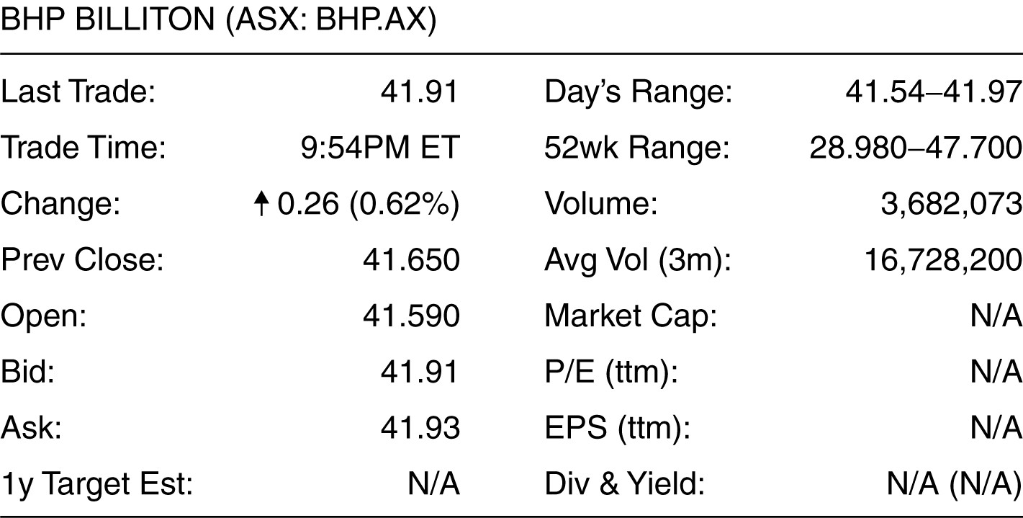

66) Using the above information, how much would you have to pay for a share of BHP Billiton stock if you wanted to ensure your trade would be immediately executed?
A) $41.59
B) $41.91
C) $41.65
D) $41.93
Answer: D
Difficulty: Basic
Learning Objective: 1.5 Understand the importance of financial markets, such as stock markets, to a corporation and the financial manager’s role as liaison to those markets
Topic 1.5: The Stock Market
AACSB: Analytical Thinking

Use the figure for the question(s) below.

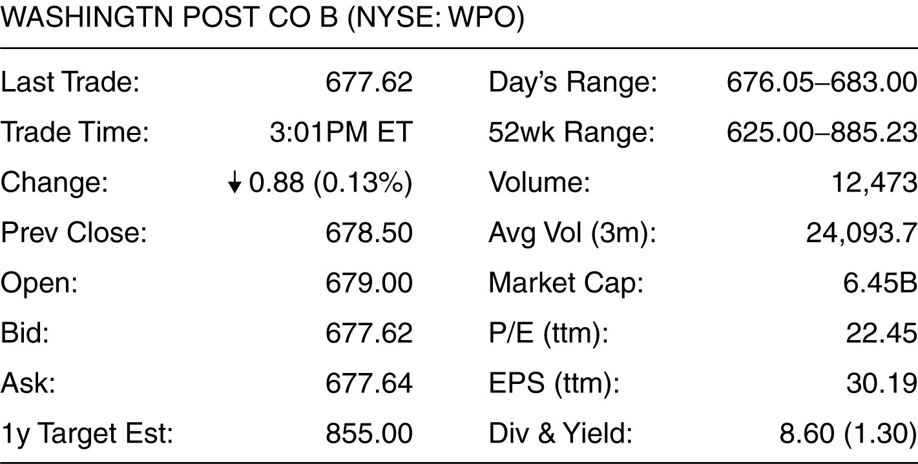

67) Using the above information, how much would you receive if you sold a share of Washington Post?
A) $683.00
B) $678.50
C) $677.62
D) $677.64
Answer: C
Difficulty: Basic
Learning Objective: 1.5 Understand the importance of financial markets, such as stock markets, to a corporation and the financial manager’s role as liaison to those markets
Topic 1.5: The Stock Market
AACSB: Analytical Thinking

Use the figure for the question(s) below.

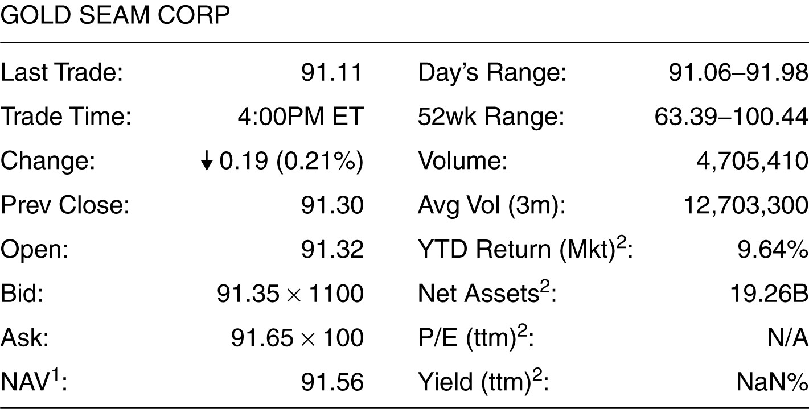

68) Based on the information shown above, what payment would you receive from selling 1 000 shares of Gold Seam Corp?
A) $91 810
B) $91 650
C) $91 700
D) $91 350
Answer: D
Difficulty: Basic
Learning Objective: 1.5 Understand the importance of financial markets, such as stock markets, to a corporation and the financial manager’s role as liaison to those markets
Topic 1.5: The Stock Market
AACSB: Analytical Thinking

Use the figure for the question(s) below.

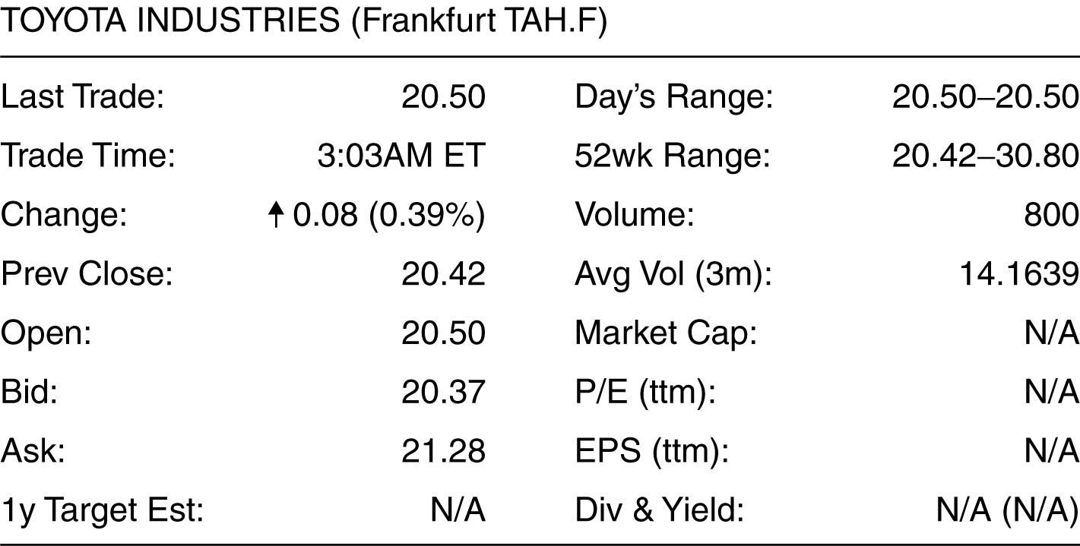

69) Based on the information shown above, how much would it cost you to buy 2 000 shares of Toyota Industries?
A) €40 740
B) €41 000
C) €40 840
D) €42 560
Answer: D
Difficulty: Basic
Learning Objective: 1.5 Understand the importance of financial markets, such as stock markets, to a corporation and the financial manager’s role as liaison to those markets
Topic 1.5: The Stock Market
AACSB: Analytical Thinking

Use the figure for the question(s) below.

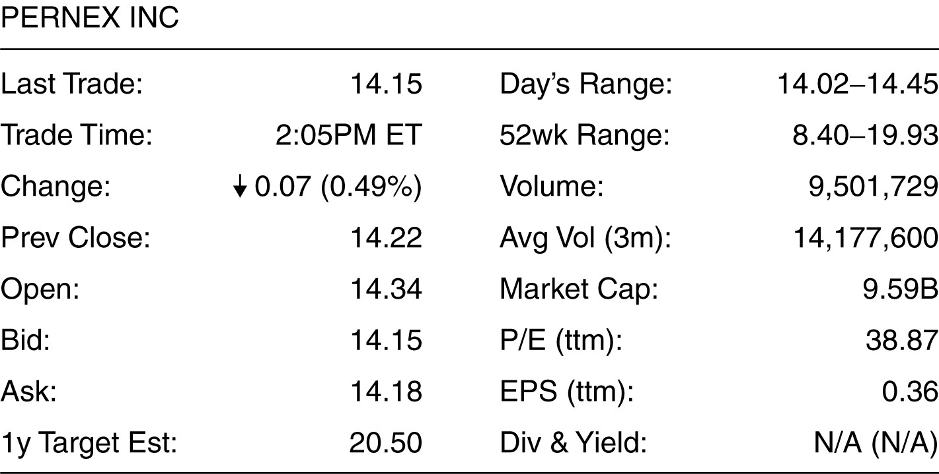

70) What is the bid-ask spread for Pernex Inc?
A) 1 cent
B) 12 cents
C) 3 cents
D) 6 cents
Answer: C
Difficulty: Basic
Learning Objective: 1.5 Understand the importance of financial markets, such as stock markets, to a corporation and the financial manager’s role as liaison to those markets
Topic 1.5: The Stock Market
AACSB: Analytical Thinking

Use the figure for the question(s) below.

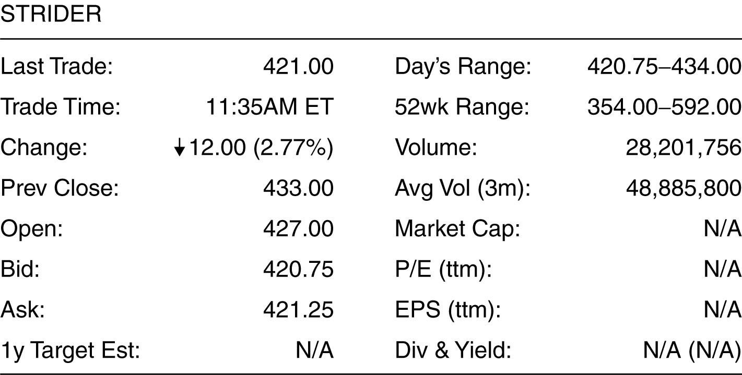

71) How much money would a stock exchange make from buying and selling 5 000 shares of Strider under the conditions shown above?
A) $5 875
B) $3 000
C) $2 500
D) $210 375
Answer: C
Difficulty: Moderate
Learning Objective: 1.5 Understand the importance of financial markets, such as stock markets, to a corporation and the financial manager’s role as liaison to those markets
Topic 1.5: The Stock Market
AACSB: Analytical Thinking

Write the word or phrase that best completes each statement or answers the question.
72) What are the terms for the two types of prices quoted for a share on an exchange?
Answer: The two quotes associated with a share quoted on the exchange are bid price and ask price.
Difficulty: Moderate
Learning Objective: 1.5 Understand the importance of financial markets, such as stock markets, to a corporation and the financial manager’s role as liaison to those markets
Topic 1.5: The Stock Market
AACSB: Application of Knowledge

73) What is the general relation of the two types of prices quoted for a share on an exchange?
Answer: The two prices are bid price and ask price. The ask price is higher than the bid price to deter a buyer from buying a stock and selling it back immediately, assuming everything else remains unchanged.
Difficulty: Moderate
Learning Objective: 1.5 Understand the importance of financial markets, such as stock markets, to a corporation and the financial manager’s role as liaison to those markets
Topic 1.5: The Stock Market
AACSB: Application of Knowledge

74) What is the term for the applicable price that I will pay, if I have to buy a share?
Answer: The buyer of a share pays the ask price when he buys the share.
Difficulty: Moderate
Learning Objective: 1.5 Understand the importance of financial markets, such as stock markets, to a corporation and the financial manager’s role as liaison to those markets
Topic 1.5: The Stock Market
AACSB: Application of Knowledge

75) What is the term for the applicable price that the seller gets when he/she sells a share on an exchange?
Answer: The seller gets the bid price when he sells a share on an exchange.
Difficulty: Moderate
Learning Objective: 1.5 Understand the importance of financial markets, such as stock markets, to a corporation and the financial manager’s role as liaison to those markets
Topic 1.5: The Stock Market
AACSB: Application of Knowledge

76) What are the main differences between the NYSE and ASX stock markets?
Answer: The NYSE has a physical location, a geographical address where traders gather to trade; but the ASX is an electronic market. Moreover, while the NYSE has one specialist in each stock, the ASX has multiple market makers serving the functions of both matching buyers and sellers and trading on their own account.
Difficulty: Moderate
Learning Objective: 1.5 Understand the importance of financial markets, such as stock markets, to a corporation and the financial manager’s role as liaison to those markets
Topic 1.5: The Stock Market
AACSB: Application of Knowledge

77) ‘Dark pools’ offer investors the ability to trade a better price with the trade-off that their order might not be filled if an excess of either buy or sell orders is received.
Answer: True
Difficulty: Basic
Learning Objective: 1.5 Understand the importance of financial markets, such as stock markets, to a corporation and the financial manager’s role as liaison to those markets
Topic 1.5: The Stock Market
AACSB: Application of Knowledge

Write 'True' if the statement is correct and 'False' if the statement is incorrect.
78) Raising new capital by issuing bonds is an example of a commercial banking activity.
Answer: False
Difficulty: Basic
Learning Objective: 1.6 Recognise the role that financial institutions play in the financial cycle of the economy
Topic 1.6: Financial Institutions
AACSB: Application of Knowledge

Choose the one alternative that best completes the statement or answers the question.
79) Put the following steps of the financial cycle in the correct order:
I. Money flows to companies who use it to fund growth through new products
II. People invest and save their money
III. Money flows back to savers and investors
A) II, I, III
B) II, III, I
C) III, II, I
D) I, II, III
Answer: A
Difficulty: Basic
Learning Objective: 1.6 Recognise the role that financial institutions play in the financial cycle of the economy
Topic 1.6: Financial Institutions
AACSB: Reflective Thinking Skills

80) Investments by wealthy individuals and endowments are a major source of money for each of the following EXCEPT:
A) hedge funds
B) managed funds
C) private equity funds
D) venture capital funds
Answer: B
Difficulty: Basic
Learning Objective: 1.6 Recognise the role that financial institutions play in the financial cycle of the economy
Topic 1.6: Financial Institutions
AACSB: Application of Knowledge

