Student name:__________
1) The economic concept that serves as the basis for the study of economics is:
A) inflation.
B) unemployment.
C) money.
D) scarcity.

2) As a consequence of the condition of scarcity:
A) there is always enough of everything.
B) production has to be centrally planned.
C) things which are plentiful have relatively high prices.
D) individuals and communities have to make choices among alternatives.

3) In every economic system, choices must be made because resources are:
A) infinite, but economic wants are finite.
B) finite, but economic wants are insatiable.
C) unlimited, but economic wants are limited.
D) limited, and so are economic wants.

4) Opportunity cost is best defined as:
A) marginal cost minus marginal benefit.
B) the time spent on an economic activity.
C) the value of the best foregone alternative.
D) the money cost of an economic decision.

5) Tammie makes $150 a day as a bank clerk. She takes off two days of work without pay to fly to another city to attend the concert of her favourite music group. The cost of transportation for the trip is $250. The cost of the concert ticket is $50. The opportunity cost of Tammie's trip to the concert is:
A) $300
B) $450
C) $500
D) $600

6) When a provincial government chooses to build more roads, the required resources are no longer available for spending on public education. This dilemma illustrates the concept of:
A) marginal analysis.
B) full employment.
C) full production.
D) opportunity cost.

7) Specialization and trade are beneficial to society because:
A) the output of economic goods may be increased with no increase in resources.
B) scarce resources are utilized more efficiently.
C) a division of labour lowers prices for products.
D) all of these are correct.

8) When economists describe "a market," they mean:
A) a place where stocks and bonds are traded.
B) information networks that allow individuals to keep in touch with each other.
C) a hypothetical place where the production of goods and services takes place.
D) a mechanism which coordinates actions of consumers and producers to establish equilibrium prices and quantities.

9) The institution that coordinates actions of consumers and producers to establish prices for goods and services is known as:
A) a market.
B) a monopoly.
C) a production possibilities curve.
D) consumer sovereignty.

10) A major argument for economic growth is that it:
A) creates an equal distribution of income.
B) protects common property resources.
C) leads to a higher standard of living.
D) reduces the amount of taxation.

11) One of the basic economic defences of economic growth rests on the conclusion that:
A) growth makes workers less obsolete and more secure in employment.
B) growth reduces the cost of "common property" resources to society.
C) growth makes the gap between unlimited wants and scarce resources less acute.
D) a growth-oriented society has a relatively equitable income distribution.

12) Concern about the general level of prices in an economy is primarily a concern about the economic goal of:
A) economic efficiency.
B) economic security.
C) price-level stability.
D) equity.

13) Assume that a tradeoff exists in the short run between inflation and unemployment. This relationship means that:
A) a low rate of unemployment causes a low rate of inflation.
B) the unemployment rate always equals the inflation rate.
C) less unemployment can be achieved with more inflation.
D) less unemployment can be achieved with less inflation.

14) The study of economics is primarily concerned with:
A) keeping private businesses from losing money.
B) demonstrating that capitalistic economies are superior to socialistic economies.
C) choices which are made in seeking to use scarce resources efficiently.
D) determining the most equitable distribution of society's output.

15) The assertion that "There is no free lunch" means:
A) there are always tradeoffs between economic goals.
B) all production involves the use of scarce resources and thus the sacrifice of alternative goods.
C) marginal analysis is not used in economic reasoning.
D) choices do not need be made if behaviour is rational.

16) The study of economics exists because:
A) government interferes with the efficient allocation of scarce resources.
B) resources are scarce in relation to human material wants.
C) the market system is an obstacle to the efficient use of plentiful resources to satisfy constrained wants.
D) resources are overly abundant as compared to wants; thus, an allocation problem exists.

17) Economics may best be defined as:
A) the interaction between macro and micro considerations.
B) the study of the behaviour of people and institutions in the production, distribution, and consumption of scarce goods.
C) the empirical testing of value judgments through the use of induction and deduction.
D) the use of policy to refute facts and hypotheses.

18) Purposeful behaviour suggests that:
A) everyone will make identical choices.
B) resource availability exceeds material wants.
C) individuals make decisions with some desired outcome in mind.
D) an individual's economic goals cannot involve tradeoffs.

19) Consumers spend their incomes to get the maximum benefit or satisfaction from the goods and services they purchase. This is a reflection of:
A) resource scarcity and the necessity of choice.
B) purposeful behaviour.
C) marginal costs which exceed marginal benefits.
D) the tradeoff problem which exists between competing goals.

20) The "economic perspective" refers to:
A) macroeconomic phenomena, but not microeconomic phenomena.
B) microeconomic phenomena, but not macroeconomic phenomena.
C) the making of rational decisions in a context of marginal costs and marginal benefits.
D) unlimited resources in a context of limited material wants.

21) The "economic perspective" entails:
A) rational behaviour by individuals and institutions.
B) a comparison of marginal benefits and marginal costs in decision making.
C) the altering of behaviour when marginal benefits and marginal costs change.
D) all of these are correct.

22) The economic perspective used in customer decision making at fast-food restaurants is reflected in:
A) customers selecting the shortest line.
B) customers leaving rather than waiting if all lines are long.
C) all customer lines tending to be of equal length.
D) all of these are correct.

23) How is the economic perspective reflected in lines for fast food?
A) Customers select the shortest line because they have perfect information.
B) Customers select the shortest line because they believe it will reduce their time cost of obtaining food.
C) Lines will typically be of unequal length because of the inefficiencies in counter service.
D) The set of food choices is often too complex for most customers and thus creates long lines.

24) From an economic perspective, when consumers leave a fast-food restaurant because the lines to be served are too long, they have concluded that the:
A) marginal cost of waiting is less than the marginal benefit of being served.
B) marginal cost of waiting is greater than the marginal benefit of being served.
C) management is exhibiting irrational behaviour by not maximizing profits.
D) management is making an assumption that other things are equal.

25) Consumers might leave a fast-food restaurant without being served because:
A) they are misinformed about the marginal cost and marginal benefits of the food being served.
B) they conclude that the marginal cost (monetary plus time costs) exceeds the marginal benefit.
C) the environment is not conducive to a rational choice.
D) the lines waiting for service are not of equal length.

26) At fast-food restaurants:
A) consumers enjoy complete and accurate information.
B) decisions are usually made by trial and error.
C) decisions entail comparisons of marginal costs and marginal benefits.
D) benefits always exceed costs.

27) Economics involves "marginal analysis" because:
A) most decisions involve changes in the status quo.
B) marginal benefits always exceed marginal costs.
C) marginal costs always exceed marginal benefits.
D) much economic behaviour is irrational.

28) You should decide to go to a movie:
A) if the marginal cost of the movie exceeds its marginal benefit.
B) if the marginal benefit of the movie exceeds its marginal cost.
C) if your income will allow you to buy a ticket
D) because movies are inherently good products.

29) Marginal costs exist because:
A) the decision to produce more of some product means the sacrifice of other products.
B) wants are scarce relative to resources.
C) households and businesses make rational decisions.
D) most decisions do not involve sacrifices or tradeoffs.

30) Even though local newspapers are very inexpensive, people rarely buy more than one of them each day. This fact:
A) is an example of irrational behaviour.
B) implies that reading should be taught through phonics rather than the whole language method.
C) contradicts the economic perspective.
D) implies that, for most people, the marginal benefit of reading a second newspaper is less than the marginal cost.

31) The process of developing hypotheses, testing them against facts, and using the results to construct theories is called:
A) opportunity cost calculation.
B) the scientific method.
C) marginal analysis.
D) microeconomics.

32) A "hypothesis" is:
A) a fundamental truth which all economists accept.
B) a tentative, untested principle.
C) the same as a normative statement.
D) always the result of induction.

33) From the perspective of economists, which term provides the highest degree of confidence for explaining economic behaviour?
A) an economic principle or a law
B) a fact
C) a hypothesis
D) an assumption

34) In constructing models, economists:
A) make simplifying assumptions.
B) include all available information.
C) must use mathematical equations.
D) attempt to duplicate the real world.

35) Economic models:
A) are of limited use because they cannot be tested empirically.
B) are limited to variables which are directly related to one another.
C) emphasize basic economic relationships by abstracting from the complexities of the real world.
D) are unrealistic and therefore of no practical consequence.

36) An economic model is:
A) a value judgment.
B) a fact.
C) built using theory.
D) built on correlations.

37) The term "ceteris paribus" means:
A) that if event A precedes event B, A has caused B.
B) that economics deals with facts, not values.
C) other things equal.
D) prosperity inevitably follows recession.

38) Suppose an economist says that "Other things equal, the lower the price of bananas, the greater the amount of bananas purchased." This statement indicates that:
A) the quantity of bananas purchased determines the price of bananas.
B) all factors other than the price of bananas (for example, consumer tastes and incomes) are assumed to be constant.
C) economists can conduct controlled laboratory experiments.
D) one cannot generalize about the relationship between the price of bananas and the quantity purchased.

39) The term "other things equal" means that:
A) the associated statement is normative.
B) many variables affect the variable under consideration.
C) the assumption that factors other than those being considered do not change.
D) when variable X increases so does related variable Y.

40) The basic purpose of the "other things equal" assumption is to:
A) allow one to reason about the relationship between variables X and Y without the intrusion of variable Z.
B) allow one to focus upon micro variables by ignoring macro variables.
C) allow one to focus upon macro variables by ignoring micro variables.
D) determine whether X causes Y or vice versa.

41) Microeconomics is concerned with:
A) the aggregate or total levels of income, employment, and output.
B) a detailed examination of specific economic units which comprise the economic system.
C) the concealing of detailed information about specific segments of the economy.
D) the establishing of an overall view of the operation of the economic system.

42) Microeconomics:
A) is concerned with the aggregate or total levels of income, employment, and output.
B) is not concerned with details, but only with the overall "big picture" of the economy.
C) is concerned with individual economic units and specific markets.
D) describes the aggregate flows of output and income.

43) Which of the following is a microeconomic statement?
A) The real domestic output increased by 2.5 percent last year.
B) Unemployment was 8.3 percent of the labour force last year.
C) The price of personal computers declined last year.
D) The general price level increased by 4 percent last year.

44) Macroeconomics approaches the study of economics from the viewpoint of:
A) the entire economy.
B) governmental units.
C) the operation of specific product and resource markets.
D) individual firms.

45) Which of the following is associated with macroeconomics?
A) an examination of the incomes of the University of Toronto Business School graduates
B) an empirical investigation of the general price level and unemployment rates in the 2000s
C) a study of the trend of pecan prices since World War II
D) a case study of pricing and production in the textbook industry

46) The problems of aggregate inflation and unemployment are:
A) major topics of macroeconomics.
B) not relevant to the Canadian economy.
C) major topics of microeconomics.
D) peculiar to socialistic economies.

47) Which of the following statements pertains to macroeconomics?
A) Because the minimum wage was raised, Mrs. Beepath decided to enter the labour force.
B) A decline in the price of soybeans caused farmer Wanek to plant more land in wheat.
C) The national productivity rate grew by 1.4 percent last year.
D) The Pumpkin Center Chartered Bank increased its interest rate on consumer loans by 1 percent.

48) Macroeconomics can best be described as the:
A) analysis of how a consumer tries to spend income.
B) study of the large aggregates of the economy or the economy as a whole.
C) analysis of how firms attempt to maximize their profits.
D) study of how supply and demand determine prices in individual markets.

49) Which of the following is a macroeconomic statement?
A) The gross profits of all Canadian businesses were $70 billion last year.
B) The price of beef declined by 3 percent last year.
C) General Motors' profits increased in 2012.
D) The productivity of steelworkers increased by 1 percent in 2012.

50) A positive statement is one which is:
A) derived by an abstract generalization.
B) suggestive of what should be done.
C) subjective and is based on a value judgment.
D) objective and is also based on facts.

51) Which of the following is a positive statement?
A) The humidity is too high today.
B) It is too hot to jog today.
C) The temperature is 30 degrees today.
D) I enjoy summer evenings when it cools off.

52) A positive statement is concerned with:
A) some goal which is desirable to society.
B) what should be.
C) what is.
D) the formulation of economic policy.

53) A normative statement is one which:
A) is based on the law of averages.
B) pertains only to microeconomics.
C) pertains only to macroeconomics.
D) is based upon value judgments.

54) Which of the following is a normative statement?
A) The temperature is high today.
B) The humidity is high today.
C) It is too hot to play tennis today.
D) It will cool off later this evening.

55) Normative statements are concerned with:
A) facts and theories.
B) what ought to be.
C) what is.
D) rational choice involving costs and benefits.

56) Most of the disagreement among economists involves:
A) facts.
B) theories.
C) positive statements.
D) normative statements.

57) Economics is concerned with using scarce productive resources efficiently in attempting to satisfy society's material wants. This statement is:
A) positive, but incorrect.
B) positive and correct.
C) normative, but incorrect.
D) normative and correct.

58) Ben says that "An increase in the tax on beer will raise its price." Holly argues that "Taxes should be increased on beer because college students drink too much." We can conclude that:
A) Ben's statement is normative, but Holly's is positive.
B) Holly's statement is normative, but Ben's is positive.
C) Both statements are normative.
D) Both statements are positive.

59) The global financial crisis that spread to Canada in late 2008 has been dubbed:
A) The housing bubble crash.
B) The great financial crisis.
C) The great recession.
D) The great depression.

60) The individuals and society both face an economic problem. This problem arises from the fact that:
A) wants are limited but the resources are not.
B) resources are scarce relative to individual's wants.
C) individuals and institutions behave only in their self-interest.
D) both wants and resources are unlimited.

61) The individual's limited income problem:
A) persists only because countries have failed to achieve continuous full employment.
B) exists because material wants are limited.
C) has been solved in all industrialized nations.
D) has been eliminated in affluent societies such as Canada and the United States.

62) When an economist says that material wants are insatiable, this means that:
A) economic resources are valuable only because they can be used to produce consumer goods.
B) economic resources—land, labour, capital, and entrepreneurial ability—are scarce.
C) these wants are virtually unlimited and therefore incapable of complete satisfaction.
D) the structure of consumer demand varies from time to time and from country to country.

63) As used in economics, the notion of scarce resources means that:
A) mineral deposits are only available in finite amounts.
B) resources are not so plentiful that all individuals' material wants can be fulfilled.
C) some resources are free while others have price tags on them.
D) the quantities available of some resources exceed the demand for them.

64) The budget line shows:
A) the amount of product A which a consumer is willing to give up to obtain one more unit of product B.
B) all possible combinations of two goods which can be purchased, given money income and the prices of the goods.
C) all equilibrium points on an indifference map.
D) all possible combinations of two goods which yield the same level of utility to the consumer.

65) The price ratio of the two products is the:
A) marginal rate of substitution.
B) slope of the budget line.
C) point of tangency for equilibrium.
D) elasticity of demand for the two products.

66) Refer to the budget line shown in the diagram below. If the consumer's money income is $20, the:
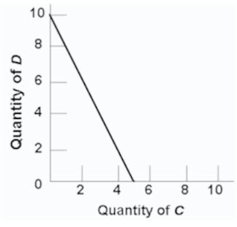
A) prices of C and D cannot be determined.
B) price of C is $2 and the price of D is $4.
C) consumer can obtain a combination of 5 units of both C and D.
D) price of C is $4 and the price of D is $2.

67) Refer to the diagram below, suppose you have a money income of $10 all of which you spend on Coke and boxes of popcorn. The prices of Coke and popcorn respectively are:
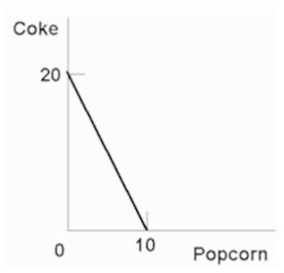
A) $.50 and $1.00.
B) $1.00 and $.50.
C) $1.00 and $2.00.
D) $.40 and $.50.

68) In moving along a given budget line:
A) the prices of both products and money income are assumed to be constant.
B) each point on the line will be equally satisfactory to consumers.
C) money income varies, but the prices of the two goods are constant.
D) the prices of both products are assumed to vary, but money income is constant.

69) In drawing a budget line it is assumed that:
A) consumer preferences are fixed.
B) the prices of the two products are variable.
C) money income is fixed.
D) consumer willingness to substitute between the two products is fixed.

70) Any combination of goods lying outside of the budget line:
A) implies that the consumer is not spending all of his income.
B) yields less utility than any point on the budget line.
C) yields less utility than any point inside the budget line.
D) is unattainable, given the consumer's income.

71) The budget line shift from cd to ab in the below figure is consistent with:
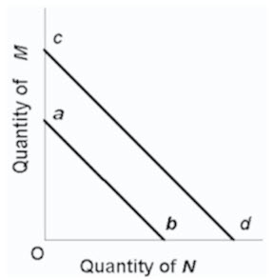
A) decreases in the prices of both M and N.
B) an increase in the price of M and a decrease in the price of N.
C) a decrease in money income.
D) an increase in money income.

72) A leftward shift of a consumer's budget line to a position parallel with the original one could indicate that the:
A) price of one product has decreased in relation to the other.
B) prices of both products have decreased in the same proportion.
C) marginal utilities derived from both products have decreased.
D) consumer's money income has increased but the prices of both products have increased proportionately more.

73) Which of the following statements is not correct?
A) A reduction in money income will shift the budget line to the right.
B) A reduction in money income accompanied by an increase in product prices will necessarily shift the budget line to the left.
C) An increase in product prices will shift the budget line to the left.
D) An increase in money income will shift the budget line to the right.

74) The society must also make choices under conditions of scarcity. This problem arises from the fact that:
A) society's wants are limited but the resources are not.
B) resources are scarce relative to society's wants.
C) societies behave only in their self-interest.
D) society's wants and resources are both unlimited.

75) The fundamental problem of economics is:
A) to establish a democratic political framework for the provision of social goods and services.
B) the establishment of prices which accurately reflect the relative scarcities of products and resources.
C) the scarcity of productive resources relative to material wants.
D) to achieve a more equitable distribution of money income in order to mitigate poverty.

76) Economic resources are also called:
A) free gifts of nature.
B) consumption goods.
C) units of money capital.
D) factors of production.

77) Money is not considered to be an economic resource because:
A) money, as such, is not productive.
B) idle money balances do not earn interest income.
C) the terms of trade can be determined in non-monetary terms.
D) money is a free gift of nature.

78) Which of the following is real capital?
A) a pair of stockings
B) a dump truck
C) a savings account
D) a share of TD Bank stock

79) The main function of the entrepreneur is to:
A) make routine pricing decisions.
B) innovate.
C) purchase capital.
D) create market demand.

80) The following production possibilities table represents an economy which is producing two products, tanks and autos. Refer to the table, in moving from possibility C to D, the cost of a tank in terms of autos is:
Product | A | B | C | D | E | F
Tanks | 0 | 1 | 2 | 3 | 4 | 5
Autos | 1000 | 950 | 850 | 650 | 350 | 0
A) 50
B) 100
C) 200
D) 300

81) (The following economy produces two products.)
Production Possibilities Table
Product | A | B | C | D | E | F
Steel | 0 | 1 | 2 | 3 | 4 | 5
Wheat | 100 | 90 | 75 | 55 | 30 | 0
Refer to the above table. A change from possibility C to B means that:
A) 1 unit of steel is given up to get 75 units of wheat.
B) 2 units of steel are given up to get 75 units of wheat.
C) 1 unit of steel is given up to get 15 more units of wheat.
D) 2 units of steel are given up to get 15 more units of wheat.

82) (The following economy produces two products.)
Production Possibilities Table
Product | A | B | C | D | E | F
Steel | 0 | 1 | 2 | 3 | 4 | 5
Wheat | 100 | 90 | 75 | 55 | 30 | 0
Refer to the above table. In moving from possibility C to D, the cost of a unit of steel in terms of a unit of wheat is:
A) 10
B) 20
C) 25
D) 30

83) (The following economy produces two products.)
Production Possibilities Table
Product | A | B | C | D | E | F
Steel | 0 | 1 | 2 | 3 | 4 | 5
Wheat | 100 | 90 | 75 | 55 | 30 | 0
Refer to the above table. A change from possibility B to C means that:
A) 10 units of wheat are given up to get one more unit of steel.
B) 15 units of wheat are given up to get one more unit of steel.
C) 15 units of wheat are equal to one unit of steel.
D) 75 units of wheat are equal to one unit of steel.

84) The production possibilities curve represents which of the following?
A) the amount of goods attainable with variable resources
B) the maximum amount of goods attainable with variable resources
C) maximum combinations of goods attainable with fixed resources
D) the amount of goods attainable if prices decline

85) The production possibilities curve represents:
A) the maximum amount of labour and capital available for production.
B) combinations of goods and services among which consumers are indifferent.
C) maximum combinations of products available with fixed resources and technology.
D) the maximum rate of growth of capital and labour in an economy.

86) The construction of a production possibilities curve assumes:
A) the quantities of all resources are fixed in the short run.
B) technology is not fixed.
C) there is no unemployment.
D) there is no government.

87) Assume an economy is operating at some point on its production possibilities curve which shows civilian and military goods. If the output of military goods is increased, the output of civilian goods:
A) will remain unchanged.
B) may be either increased or decreased.
C) must be decreased.
D) must also be increased.

88) The production possibilities curve shows:
A) the various combinations of two goods which can be produced when society uses its scarce resources efficiently.
B) the minimum outputs of two goods which will sustain a society.
C) the various combinations of two goods which can be produced when some resources are unemployed.
D) the ideal, but unattainable, combinations of two goods which would maximize consumer satisfactions.

89) The negative slope of the production possibilities curve is a graphical way of indicating that:
A) any economy "can have its cake and eat it too."
B) to produce more of one product we must accept less of another.
C) the principle of increasing opportunity costs does not apply to the economy as a whole.
D) consumers buy more when prices are low than they do when prices are high.

90) If an economy is operating on its production possibilities curve for consumer goods and capital goods, this means that:
A) it is impossible to produce more consumer goods.
B) resources cannot be reallocated between the two goods.
C) it is impossible to produce more capital goods.
D) more consumer goods can only be produced at the cost of fewer capital goods.

91) In drawing a production possibilities curve we hold constant:
A) the money supply.
B) the consumer price index.
C) both technology and resource supplies
D) resource supplies only.

92) The production possibilities curve tells us:
A) what specific combinations of two products is most desired by society.
B) that costs do not change as society varies its output.
C) costs are irrelevant in a society which has fixed resources.
D) what combinations of two goods can be produced with society's available resources.

93) When an economy is operating with maximum efficiency, the production of more of commodity A will mean the production of less of commodity B because:
A) of the law of decreasing opportunity costs.
B) material wants are insatiable.
C) resources are limited.
D) resources are not specialized and are imperfectly substitutable.

94) The production possibilities curve:
A) shows all of those levels of production which are consistent with a stable price level.
B) indicates that any combination of goods lying outside the curve is economically inefficient.
C) is a frontier between all combinations of two goods which can be produced and those combinations which cannot be produced.
D) shows all of those combinations of two goods which are most preferred by society.

95) The production possibilities curve illustrates the basic principle that:
A) the production of more of any one good will in time require smaller and smaller sacrifices of other goods.
B) an economy will automatically seek that level of output at which all of its resources are employed.
C) if all the resources of an economy are in use, more of one good can be produced only if less of another good is produced.
D) an economy's capacity to produce increases in proportion to its population size.

96) A production possibilities curve illustrates:
A) scarcity.
B) market prices.
C) consumer preferences.
D) the distribution of income.

97) A production possibilities curve shows:
A) that resources are unlimited.
B) that people prefer one of the goods more than the other.
C) the maximum amounts of two goods which can be produced assuming the full and efficient use of available resources.
D) combinations of capital and labour necessary to produce specific levels of output.

98) In drawing the production possibilities curve we assume that:
A) technology is fixed.
B) unemployment exists.
C) economic resources are unlimited.
D) wants are limited.

99) Which of the following is assumed in constructing a typical production possibilities curve?
A) the economy is using its resources inefficiently.
B) resources are perfectly shiftable among alternative uses.
C) production technology is fixed.
D) the economy is engaging in international trade.

100) Which of the following is not correct? A typical production possibilities curve:
A) indicates how much of two products a society can produce.
B) reveals how much each additional unit of one product will cost in terms of the other product.
C) specifies how much of each product society should produce.
D) indicates that to produce more of one product society must give up larger and larger amounts of the other product.

101) Which one of the following statements is correct?
A) Relative scarcity is no longer a central notion in economics because we are in an age of abundance.
B) Most production possibilities curves are convex as viewed from the origin.
C) The production possibilities curve shows society's preferences for consumer goods relative to capital goods.
D) The central concept underlying the production possibilities curve is that of limited resources.

102) The typical production possibilities curve is:
A) an upward sloping line which is concave to the origin.
B) a downward sloping line which is convex to the origin.
C) a downward sloping line which is concave to the origin.
D) a straight upward sloping line.

103) Refer to the diagram below. Points A, B, C, D, and E show:
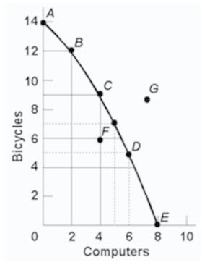
A) that the opportunity cost of bicycles increases, while that of computers is constant.
B) combinations of bicycles and computers which society can produce by using its resources efficiently.
C) that the opportunity cost of computers increases, while that of bicycles is constant.
D) that society's demand for computers is greater than its demand for bicycles.

104) Refer to the following production possibilities curves. Curve (a) is the current curve for the economy. Given production possibilities curve (a), the combination of capital and consumer goods indicated by point L:
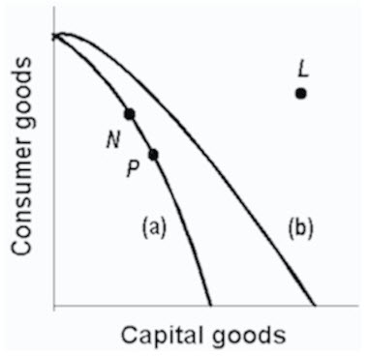
A) would entail substantial unemployment.
B) would entail an inefficient use of society's resources.
C) is beyond the productive capacity of this society.
D) suggests the productive capacity of the system is declining.

105) A point on the frontier of the production possibilities curve is:
A) attainable and the economy is efficient.
B) attainable, but the economy is inefficient.
C) unattainable, but the economy is inefficient.
D) unattainable and the economy is efficient.

106) A point inside the production possibilities curve is:
A) attainable and the economy is efficient.
B) attainable, but the economy is inefficient.
C) unattainable, but the economy is inefficient.
D) unattainable and the economy is efficient.

107) 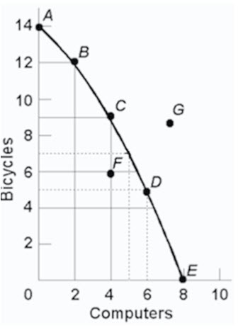
Refer to the above diagram. The combination of computers and bicycles shown by point G is:
A) attainable, but too costly.
B) unattainable, given currently available resources and technology.
C) attainable, but involves unemployment.
D) irrelevant because it is inconsistent with consumer preferences.

108) 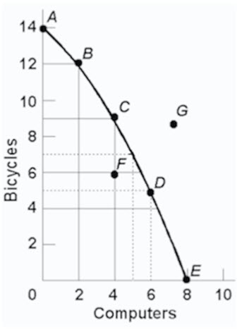
Refer to the above diagram. The combination of computers and bicycles shown by point F:
A) is unattainable, given currently available resources and technology.
B) is attainable, but entails economic inefficiency.
C) is irrelevant because it is inconsistent with consumer preferences.
D) suggests that opportunity costs are constant.

109) 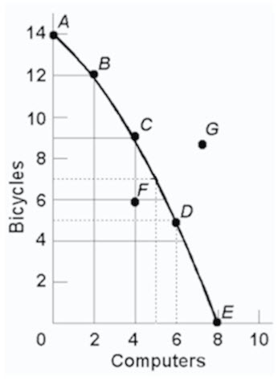
Refer to the above diagram. If society is currently producing the combination of bicycles and computers shown by point D, the production of 2 more units of bicycles:
A) cannot be realized because resources are fully employed.
B) will cost 1 unit of computers.
C) will cost 2 units of computers.
D) will cause some resources to become unemployed.

110) 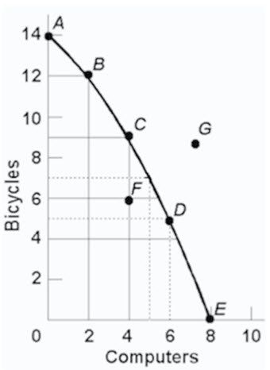
Refer to the above diagram. The movement down the production possibilities curve from point A to point E suggests that the production of:
A) computers, but not bicycles, are subject to increasing opportunity costs.
B) bicycles, but not computers, are subject to increasing opportunity costs.
C) both bicycles and computers are subject to constant opportunity costs.
D) both bicycles and computers are subject to increasing opportunity costs.

111) The slope of the typical production possibilities curve:
A) is positive.
B) increases as one moves southeast along the curve.
C) is constant as one moves down the curve.
D) decreases as one moves southeast along the curve.

112) The production possibilities curve has:
A) a positive slope which increases as we move along it from left to right.
B) a negative slope which increases as we move along it from left to right.
C) a negative slope which decreases as we move along it from left to right.
D) a negative slope which is constant as we move along it from left to right.

113) The law of increasing opportunity costs states that:
A) if society wants to produce more of a particular good, it must sacrifice larger and larger amounts of other goods to do so.
B) the sum of the costs of producing a particular good cannot rise above the current market price of that good.
C) if the sum of the costs of producing a particular good rises by a specified percent, the price of that good must rise by a greater relative amount.
D) if the prices of all the resources devoted to the production of goods increase, the cost of producing any particular good will increase at the same rate.

114) 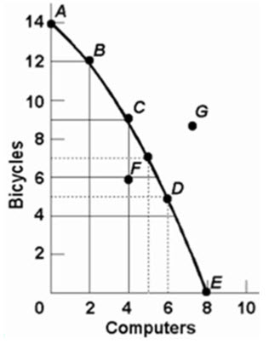
Refer to the above diagram. This production possibilities curve is:
A) convex to the origin because opportunity costs are constant.
B) linear because opportunity costs are constant.
C) concave to the origin because of increasing opportunity costs.
D) convex to the origin because of increasing opportunity costs.

115) 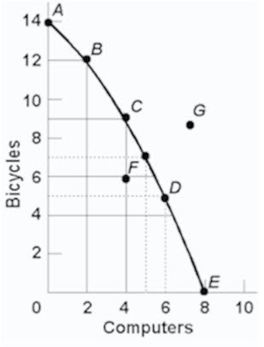
Refer to the above diagram. If society is currently producing 9 units of bicycles and 4 units of computers and it now decides to increase computer output to 6, the cost:
A) will be 4 units of bicycles.
B) will be 2 units of bicycles.
C) will be zero because unemployed resources are available.
D) of doing so cannot be determined from the information given.

116) The concept of opportunity cost:
A) is irrelevant in socialistic economies because of central planning.
B) suggests that the use of resources in any particular line of production means that alternative outputs must be forgone.
C) is irrelevant if the production possibilities curve is shifting to the right.
D) suggests that insatiable wants can be fulfilled.

117) Which of the following is not an illustration of the idea of opportunity cost?
A) A growing economy can produce more consumer goods and more capital goods at the same time.
B) If I buy a pizza, I will not be able to afford a movie.
C) Resources devoted to consumer goods production are not available for capital goods production.
D) The land a Manitoba farmer plants in wheat is not available for corn production.

118) Opportunity cost is best defined as:
A) the monetary price of any productive resource.
B) the amount of labour which must be used to produce one unit of any product.
C) the ratio of the prices of imported goods to the prices of exported goods.
D) the amount of one product which must be given up to produce one more unit of another product.

119) Production possibilities tables for two countries, North Cantina and South Cantina:
North Cantina
Production possibilities (alternatives)
 | A | B | C | D | E | F
Capital goods | 5 | 4 | 3 | 2 | 1 | 0
Consumer goods | 0 | 10 | 18 | 24 | 28 | 30
South Cantina
Production possibilities (alternatives)
 | A | B | C | D | E | F
Capital goods | 5 | 4 | 3 | 2 | 1 | 0
Consumer goods | 0 | 8 | 15 | 21 | 25 | 27
Refer to the above tables. If South Cantina is producing at production alternative D, the opportunity cost of the third unit of capital goods is:
A) 3 units of consumer goods.
B) 4 units of consumer goods.
C) 5 units of consumer goods.
D) 6 units of consumer goods.

120) Production possibilities tables for two countries, North Cantina and South Cantina:
North Cantina
Production possibilities (alternatives)
 | A | B | C | D | E | F
Capital goods | 5 | 4 | 3 | 2 | 1 | 0
Consumer goods | 0 | 10 | 18 | 24 | 28 | 30
South Cantina
Production possibilities (alternatives)
 | A | B | C | D | E | F
Capital goods | 5 | 4 | 3 | 2 | 1 | 0
Consumer goods | 0 | 8 | 15 | 21 | 25 | 27
Refer to the above tables. If North Cantina is producing at production alternative B, the opportunity cost of the eleventh unit of consumer goods will be:
A) 10 units of capital goods.
B) ¹/₄ of a unit of capital goods.
C) 8 units of capital goods.
D) ¹/₈ of a unit of capital goods.

121) Production possibilities tables for two countries, North Cantina and South Cantina:
North Cantina
Production possibilities (alternatives)
 | A | B | C | D | E | F
Capital goods | 5 | 4 | 3 | 2 | 1 | 0
Consumer goods | 0 | 10 | 18 | 24 | 28 | 30
South Cantina
Production possibilities (alternatives)
 | A | B | C | D | E | F
Capital goods | 5 | 4 | 3 | 2 | 1 | 0
Consumer goods | 0 | 8 | 15 | 21 | 25 | 27
Refer to the above tables. The opportunity cost of the fifth unit of capital goods:
A) is higher in North Cantina than in South Cantina.
B) is the same in North Cantina and South Cantina.
C) is lower in North Cantina than in South Cantina.
D) cannot be determined from the information provided.

122) 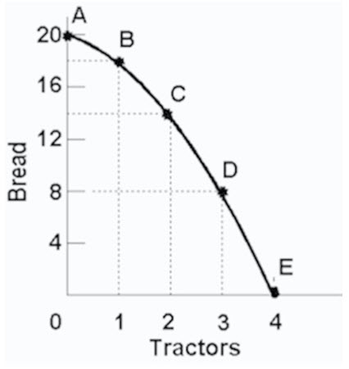
Refer to the above diagram. Starting at point A, the opportunity cost of producing each successive unit of tractors is:
A) a constant 2 units of bread.
B) 2, 4, 6, and 8 units of bread.
C) 8, 6, 4, and 2 units of bread.
D) the reciprocal of the output of tractors.

123) 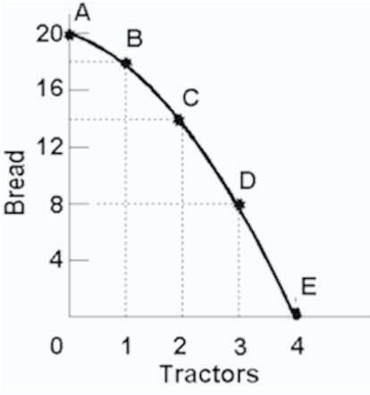
Refer to the above diagram. Starting at point E, the production of successive units of bread will cost:
A) a constant 8 units of tractors.
B) a constant 6 units of tractors.
C) ¹/₈,¹/₆,¹/₄, and¹/₂units of tractors.
D) ¹/₂,¹/₄,¹/₆, and¹/₈units of tractors.

124) Refer to the diagram below. The concept of opportunity cost is best represented by the:
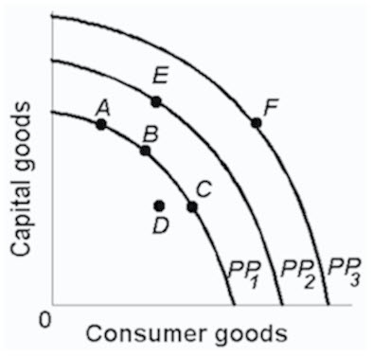
A) shift of the production possibilities curve from PP₁to PP₂.
B) move from B on PP₁to E on PP₂.
C) move from B on PP₁to C on PP₁.
D) move from D inside PP₁to B on PP₁.

125) The fact that the slope of the production possibilities curve becomes steeper as we move down along the curve indicates that:
A) the principle of increasing opportunity costs is relevant.
B) society's resources are limited.
C) the opportunity cost of producing each product is constant.
D) resources are perfectly shiftable between alternative uses.

126) Production possibilities (alternatives)
 | A | B | C | D | E | F
Capital goods | 5 | 4 | 3 | 2 | 1 | 0
Consumer goods | 0 | 5 | 9 | 12 | 14 | 15
Refer to the above table. If the economy is producing at production alternative C, the opportunity cost of the tenth unit of consumer goods will be:
A) 4 units of capital goods.
B) 2 units of capital goods.
C) 3 units of capital goods.
D) ¹/₃ of a unit of capital goods.

127) Production possibilities (alternatives)
 | A | B | C | D | E | F
Capital goods | 5 | 4 | 3 | 2 | 1 | 0
Consumer goods | 0 | 5 | 9 | 12 | 14 | 15
Refer to the above table. For these data the law of increasing opportunity costs is reflected in the fact that:
A) the amount of consumer goods which must be sacrificed to get more capital goods diminishes beyond a point.
B) larger and larger amounts of capital goods must be sacrificed to get additional units of consumer goods.
C) the production possibilities data would graph as a straight downsloping line.
D) the economy's resources are presumed not to be scarce.

128) Refer to the table below. In moving from possibility A to F, the cost of a unit of steel in terms of a unit of wheat:
(The following economy produces two products.)
Production Possibilities
Product | A | B | C | D | E | F
Steel | 0 | 1 | 2 | 3 | 4 | 5
Wheat | 100 | 90 | 75 | 55 | 30 | 0
A) increases.
B) decreases.
C) remains constant.
D) increases from A to B, and decreases from B to F.

129) A typical concave production possibilities curve implies:
A) that economic resources are scarce.
B) that society must choose among various attainable combinations of goods.
C) increasing opportunity costs.
D) all of these are correct.

130) Refer to the diagram below. This production possibilities curve is constructed such that:
Product | A | B | C | D | E | F
Bread | 0 | 1 | 2 | 3 | 4 | 5
Tractors | 100 | 90 | 75 | 55 | 30 | 0
A) resources are presumed to be perfectly shiftable between bread and tractors.
B) the opportunity cost of bread diminishes as more bread is produced.
C) the opportunity cost of tractors diminishes as more bread is produced.
D) the opportunity cost of both bread and tractors in terms of each other increases as more of each is produced.

131) The law of increasing opportunity costs exists because:
A) resources are not equally efficient in producing various goods.
B) the value of the dollar has diminished historically because of persistent inflation.
C) wage rates invariably rise as the economy approaches full employment.
D) consumers tend to value any good more highly when they have little of it.

132) The law of increasing opportunity costs is reflected in a production possibilities curve which is:
A) an upward sloping straight line.
B) a downward sloping straight line.
C) concave to the origin.
D) convex to the origin.

133) The production possibilities curve below shows the hypothetical relationship between the production of capital goods and consumer goods in an economy.
 | Production Alternatives
Products | A | B | C | D | E
Capital goods | 0 | 1 | 2 | 3 | 4
Consumer goods | 22 | 18 | 13 | 7 | 0
Refer to the above table. What is the opportunity cost of producing the third unit of capital goods?
A) 4 units of consumer goods
B) 5 units of consumer goods
C) 6 units of consumer goods
D) 7 units of consumer goods

134) The production possibilities curve below shows the hypothetical relationship between the production of capital goods and consumer goods in an economy.
 | Production Alternatives
Products | A | B | C | D | E
Capital goods | 0 | 1 | 2 | 3 | 4
Consumer goods | 22 | 18 | 13 | 7 | 0
Refer to the above table. What is the total opportunity cost of producing two units of capital goods?
A) 4 units of consumer goods
B) 5 units of consumer goods
C) 9 units of consumer goods
D) 13 units of consumer goods

135) The production possibilities curve below shows the hypothetical relationship between the production of capital goods and consumer goods in an economy.
 | Production Alternatives
Products | A | B | C | D | E
Capital goods | 0 | 1 | 2 | 3 | 4
Consumer goods | 22 | 18 | 13 | 7 | 0
Refer to the above table. What is the opportunity cost of producing the fourth unit of capital goods?
A) 6 units of consumer goods
B) 7 units of consumer goods
C) 15 units of consumer goods
D) 22 units of consumer goods

136) The production possibilities curve below shows the hypothetical relationship between the production of capital goods and consumer goods in an economy.
 | Production Alternatives
Products | A | B | C | D | E
Capital goods | 0 | 1 | 2 | 3 | 4
Consumer goods | 22 | 18 | 13 | 7 | 0
Refer to the above table. What is the total opportunity cost of producing three units of capital goods?
A) 6 units of consumer goods
B) 7 units of consumer goods
C) 15 units of consumer goods
D) 22 units of consumer goods

137) 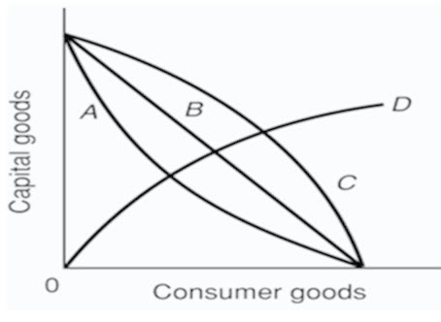
Refer to the above diagram. As it relates to production possibilities analysis, the law of increasing opportunity cost is reflected in curve:
A) A.
B) B.
C) C.
D) D.

138) 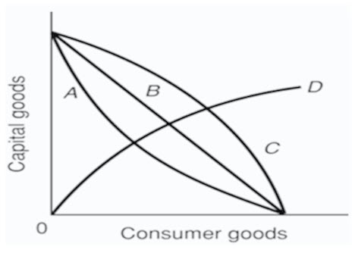
Refer to the above diagram. Curve B is a:
A) production possibilities curve indicating constant opportunity costs.
B) production possibilities curve indicating increasing opportunity costs.
C) demand curve indicating that the quantity of consumer goods demanded increases as the price of capital falls.
D) technology frontier curve.

139) If the production possibilities curve is a straight line:
A) the two products will sell at the same market prices.
B) economic resources are perfectly shiftable between the production of the two products.
C) the two products are equally important to consumers.
D) equal quantities of the two products will be produced at each possible point on the curve.

140) A nation's production possibilities curve is "bowed out" from the origin because:
A) resources are not equally efficient in producing every good.
B) the originator of the idea drew it this way and modern economists follow this convention.
C) resources are scarce.
D) wants are virtually unlimited.

141) If the production possibilities curve were a straight downsloping line, this would suggest that:
A) resources are perfectly substitutable between the production of these two goods.
B) it is possible to produce more of both products.
C) both products are equally capable of satisfying consumer wants.
D) the two products have identical prices.

142) Refer to the diagram below. The concave shape of each production possibilities curve indicates that:
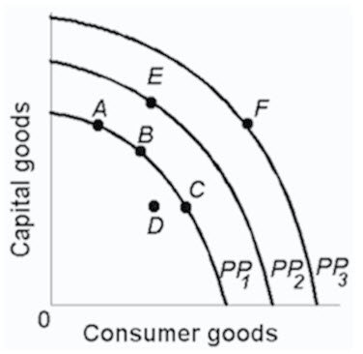
A) resources are perfectly substitutable.
B) wants are virtually unlimited.
C) prices are constant.
D) resources are not equally suited for alternative uses.

143) The marginal benefit curve is:
A) upward sloping because of increasing marginal opportunity costs.
B) upward sloping because successive units of a specific product yield less and less extra utility.
C) downward sloping because of increasing marginal opportunity costs.
D) downward sloping because successive units of a specific product yield less and less extra utility.

144) The marginal cost curve is:
A) upsloping because of increasing marginal opportunity costs.
B) upsloping because successive units of a specific product yield less and less extra utility.
C) downsloping because of increasing marginal opportunity costs.
D) downsloping because successive units of a specific product yield less and less extra utility.

145) The output of LED TVs should be:
A) reduced if marginal benefits exceed marginal costs.
B) reduced if marginal costs exceed marginal benefits.
C) increased if marginal costs exceed marginal benefits.
D) reduced to zero if their unit costs exceed the unit costs of alternative products.

146) If the output of product X is such that marginal benefit equals marginal cost:
A) the correct amount of resources is being allocated to X's production.
B) the value of producing X and the value of producing alternative products with available resources is the same.
C) there can be no net gain to society by allocating either more or less resources to producing X.
D) all of these are correct.

147) 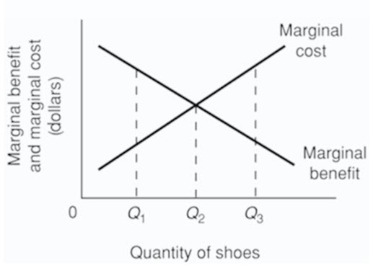
Refer to the above diagram for athletic shoes. The optimal output of shoes:
A) is Q₁.
B) is Q₂.
C) is Q₃.
D) is greater than Q₃.

148) 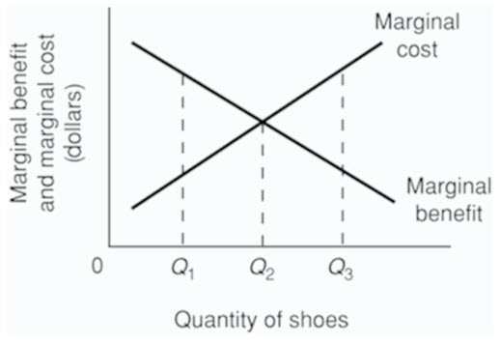
Refer to the above diagram for athletic shoes. If the current output of shoes is Q₁, then:
A) society would consider additional units of shoes to be more valuable than alternative products.
B) society would consider additional units of shoes to be less valuable than alternative products.
C) society would experience a net loss by producing more shoes.
D) resources are being allocated efficiently to the production of shoes.

149) 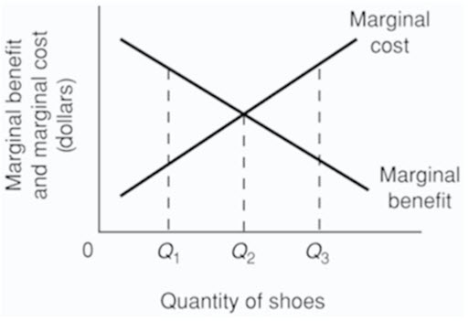
Refer to the above diagram for athletic shoes. If the current output of shoes is Q₃, then:
A) resources are being allocated efficiently to the production of shoes.
B) society would consider additional units of shoes to be more valuable than alternative products.
C) society would consider additional units of shoes to be less valuable than alternative products.
D) society would experience a net gain by producing more shoes.

150) Recessions are typically characterised by points:
A) inside the production possibilities curve.
B) outside the production possibilities curve.
C) on the production possibilities curve.
D) that are not attainable on the production possibilities curve.

151) Production possibilities (alternatives)
 | A | B | C | D | E | F
Capital goods | 5 | 4 | 3 | 2 | 1 | 0
Consumer goods | 0 | 5 | 9 | 12 | 14 | 15
Refer to the above table. As compared to production alternative D, the choice of alternative C would:
A) tend to generate a more rapid growth rate.
B) be unattainable.
C) entail unemployment.
D) tend to generate a slower growth rate.

152) Production possibilities (alternatives)
 | A | B | C | D | E | F
Capital goods | 5 | 4 | 3 | 2 | 1 | 0
Consumer goods | 0 | 5 | 9 | 12 | 14 | 15
Refer to the above table. A total output of 3 units of capital goods and 4 units of consumer goods:
A) is irrelevant because the economy is capable of producing a larger total output.
B) will result in the maximum rate of growth available to this economy.
C) would involve an inefficient use of the economy's scarce resources.
D) is unobtainable in this economy.

153) Production possibilities (alternatives)
 | A | B | C | D | E | F
Capital goods | 5 | 4 | 3 | 2 | 1 | 0
Consumer goods | 0 | 5 | 9 | 12 | 14 | 15
Refer to the above table. For this economy to produce a total output of 3 units of capital goods and 13 units of consumer goods it must:
A) achieve economic growth.
B) use its resources more efficiently than the data in the table now indicate.
C) allocate its available resources most efficiently among alternative uses.
D) achieve the full employment of available resources.

154) Production possibilities tables for two countries, North Cantina and South Cantina:
North Cantina Production possibilities (alternatives)
 | A | B | C | D | E | F
Capital goods | 5 | 4 | 3 | 2 | 1 | 0
Consumer goods | 0 | 10 | 18 | 24 | 28 | 30
South Cantina Production possibilities (alternatives)
 | A | B | C | D | E | F
Capital goods | 5 | 4 | 3 | 2 | 1 | 0
Consumer goods | 0 | 8 | 15 | 21 | 25 | 27
Refer to the above tables. Suppose that North Cantina is producing 2 units of capital goods and 17 units of consumer goods while South Cantina is producing 2 units of capital goods and 21 units of consumer goods. We can conclude that:
A) North Cantina is fully and efficiently using its resources, but South Cantina is not.
B) South Cantina is fully and efficiently using its resources, but North Cantina is not.
C) neither South Cantina nor North Cantina are fully and efficiently using their resources.
D) both South Cantina and North Cantina are fully and efficiently using their resources.

155) Production possibilities tables for two countries, North Cantina and South Cantina:
North Cantina Production possibilities (alternatives)
 | A | B | C | D | E | F
Capital goods | 5 | 4 | 3 | 2 | 1 | 0
Consumer goods | 0 | 10 | 18 | 24 | 28 | 30
South Cantina Production possibilities (alternatives)
 | A | B | C | D | E | F
Capital goods | 5 | 4 | 3 | 2 | 1 | 0
Consumer goods | 0 | 8 | 15 | 21 | 25 | 27
Refer to the above tables. Suppose that resources in North Cantina and South Cantina are identical in quantity and quality. We can conclude that:
A) South Cantina has better technology than North Cantina in producing both capital and consumer goods.
B) North Cantina has better technology than South Cantina in producing both capital and consumer goods.
C) North Cantina is growing more rapidly than South Cantina.
D) North Cantina has better technology than South Cantina in producing consumer goods.

156) Refer to the table below. According to the production possibilities schedule for the economy which produces two products, a combination of four tanks and 650 autos is: Production Possibilities
Production Possibilities
Product | A | B | C | D | E | F
Tanks | 0 | 1 | 2 | 3 | 4 | 5
Autos | 1000 | 950 | 850 | 650 | 350 | 0
A) attainable, but involves an efficient use of society's resources.
B) attainable, but would not be in the best interests of a strong national defence.
C) not attainable because it is not listed in the schedule.
D) not attainable because society does not have sufficient resources to produce this combination.

157) Assume that a change in government policy results in the increased production of both consumer goods and investment goods. It can be concluded that:
A) the economy was suffering from unemployment and/or the inefficient use of resources before the policy change.
B) the economy's production possibilities curve has been shifted to the left as a result of the policy decision.
C) this economy's production possibilities curve is convex (bowed inward) as viewed from the origin.
D) the law of increasing opportunity costs does not apply in this society.

158) Refer to the diagram. This economy will experience unemployment if it produces at point:
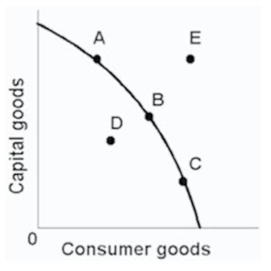
A) A.
B) B.
C) C.
D) D.

159) 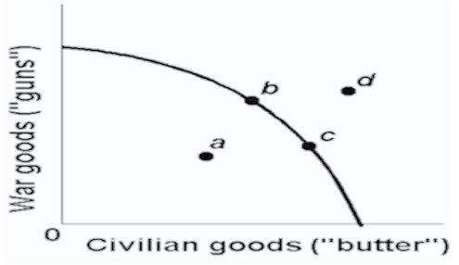
Refer to the above production possibilities curve. At the onset of World War II Canada had large amounts of idle human and property resources. Its economic adjustment from peacetime to wartime can best be described by the movement from point:
A) c to point b.
B) b to point c.
C) a to point b.
D) c to point d.

160) 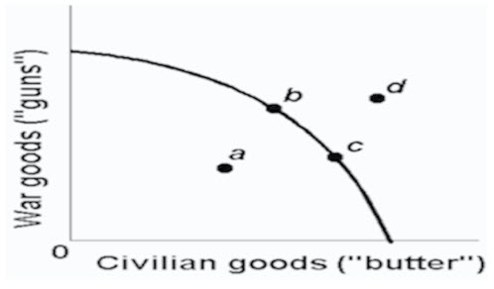
Refer to the above production possibilities curve. At the onset of World War II the Soviet Union's economy was already at full employment. Its economic adjustment from peacetime to wartime can best be described by the movement from point:
A) c to point b.
B) b to point c.
C) a to point b.
D) c to point d.

161) Any point inside the production possibilities curve indicates:
A) the realization of allocative efficiency.
B) that resources are imperfectly shiftable among alternative uses.
C) the presence of inflationary pressures.
D) that more output could be produced with available resources.

162) Unemployment and/or productive inefficiencies:
A) cause the production possibilities curve to shift outward.
B) can exist at any point on a production possibilities curve.
C) can both be illustrated by a point outside the production possibilities curve.
D) can both be illustrated by a point inside the production possibilities curve.

163) A point inside a production possibilities curve may indicate:
A) unemployment.
B) the inefficient use of resources.
C) failure to use the best available technology.
D) all of these are correct.

164) Assume an economy is incurring unemployment and failing to realize least-cost production. The immediate effect of resolving these problems will be to:
A) move the level of actual output closer to the economy's production possibilities curve.
B) create a less equal distribution of income.
C) shift its production possibilities curve to the left.
D) shift its production possibilities curve to the right.

165) If an economy is operating inside its production possibilities curve for consumer goods and capital goods, this means that it:
A) can only produce more consumer goods by producing fewer capital goods.
B) can only produce more capital goods by producing fewer consumer goods.
C) can produce more of both consumer goods and capital goods by using its resources more efficiently.
D) must improve its technology to produce more output.

166) Which of the following will not require an outward shift of the production possibilities curve?
A) an upgrading of the quality of a nation's human resources
B) the reduction of unemployment
C) an increase in the quantity of a society's labour force
D) the improvement of a society's technological knowledge

167) 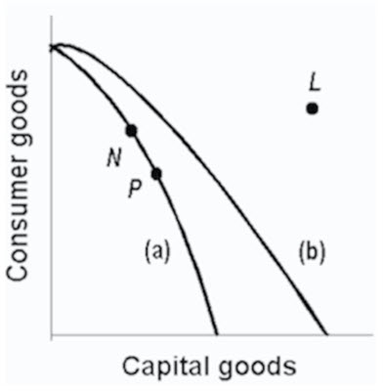
Refer to the above production possibilities curves. Curve (a) is the current curve for the economy. The movement from curve (a) to curve (b) suggests:
A) a movement from unemployment to full employment.
B) an improvement in capital goods technology but not in consumer goods technology.
C) an improvement in consumer goods technology but not in capital goods technology.
D) a decline in the total output of this society.

168) 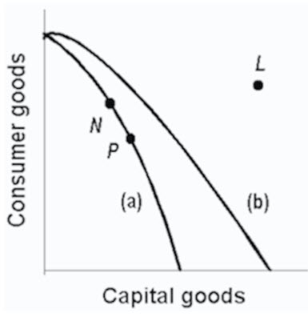
Refer to the above production possibilities curves. Curve (a) is the current curve for the economy. Other things being equal, society's current choice of point P on curve (a) will:
A) allow it to achieve more rapid economic growth than would the choice of point N.
B) entail a slower rate of economic growth than would the choice of point N.
C) entail the same rate of growth as would the choice of point N.
D) be unobtainable because it exceeds the productive capacity of the economy.

169) The basic difference between consumer goods and capital goods is that:
A) consumer goods are produced in the private sector and capital goods are produced in the public sector.
B) an economy that commits a relatively large proportion of its resources to capital goods must accept a lower growth rate.
C) the production of capital goods is not subject to the law of increasing opportunity costs.
D) consumer goods satisfy wants directly while capital goods satisfy wants indirectly.

170) Which of the following would be most likely to shift the production possibilities curve to the right?
A) a sudden and substantial expansion of consumer wants
B) an improvement in the literacy level and general level of education
C) a decline in the size of the population and labour force
D) shifting resources from butter to gun production

171) Which of the following will not shift a nation's production possibilities curve?
A) the acquisition of more education and training by its labour force
B) the widespread application of irrigation to its agricultural land
C) an increase in the rate of unemployment
D) the discovery of new super-conductivity materials which makes manufacturing more efficient

172) Which of the following will shift the production possibilities curve to the right?
A) an increase in the unemployment rate from 6 to 8 percent
B) a decline in the efficiency with which the present labour force is allocated
C) a decrease in the unemployment rate from 8 to 6 percent
D) a technological advance which allows farmers to produce more output from given inputs

173) Other things equal, which of the following would shift an economy's production possibilities curve to the left?
A) the discovery of a low-cost means of generating and storing solar energy
B) the entrance of more women into the labour force
C) a law requiring mandatory retirement from the labour force at age 55
D) an increase in the proportion of total output which consists of capital or investment goods

174) 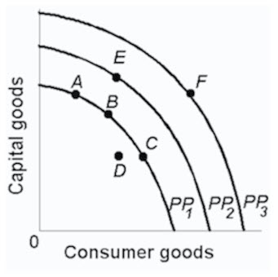
Refer to the above diagram. An improvement in technology will:
A) shift the production possibilities curve from PP₁to PP₂.
B) shift the production possibilities curve from PP₂to PP₁.
C) move the economy from A to C along PP₁.
D) move the economy from A, B, or C on PP₁to D.

175) 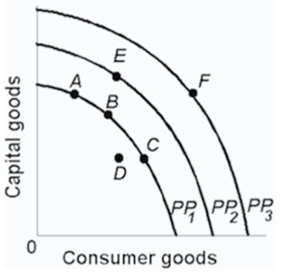
Refer to the above diagram. Which one of the following would shift the production possibilities curve from PP₁ to PP₂
A) immigration of skilled workers into the economy
B) worsening of the AIDS epidemic
C) an increase in consumer prices
D) a reduction in the age of retirement.

176) Which situation would most likely shift the production possibilities curve for a nation in an outward direction?
A) a decrease in the quality of products
B) an increase in the supply of resources
C) a decrease in the state of technology
D) an increase in the amount of discrimination

177) Which situation would most likely cause a nation's production possibilities curve to shift inward?
A) the construction of more capital goods
B) a decrease in discrimination based on race
C) an increase in the number of skilled immigrant workers
D) the destruction from bombing and warfare in a losing military conflict

178) All of the following could immediately or eventually lead to an inward shift of a nation's production possibilities curve, except:
A) an increase in the amount of discrimination.
B) a decline in the birth rate.
C) an increase in the average skill level of all occupational groups.
D) depletion and reduced availability of major energy resources.

179) Some agricultural sub-Saharan nations of Africa have over-farmed and overgrazed their land to the extent that significant portions of it have turned into desert. This suggests that:
A) the concavity of the production possibilities curves of such nations has increased.
B) the production possibilities curves of such nations have shifted inward.
C) the production possibilities curves of such nations have shifted outward.
D) these nations are operating at some point outside of their production possibilities curves.

180) Which of the following statements, if any, is correct for a nation which is producing only consumption and capital goods?
A) Other things equal, the more consumer goods a nation produces, the greater will be its future growth rate.
B) Other things equal, the more capital goods a nation produces, the greater will be its future growth rate.
C) There is no general relationship between the current division of output between consumer and capital goods and the future growth rate.
D) It will be producing at point within its Production Possibility Curve.

181) If country A has been investing a larger proportion of its domestic output than Canada has, then, we would expect:
A) a higher rate of growth of domestic output in country A than in Canada.
B) greater rightward shifts in country A's production possibilities curve as compared to Canada.
C) that in the long run living standards would rise more rapidly in country A than in Canada.
D) all of these are correct.

182) Deltonia produces both consumer and capital goods. If it reduces the percentage of its output devoted to capital goods, then:
A) its rate of growth will tend to decline.
B) its production possibilities curve will necessarily shift to the left.
C) it must also reduce the percentage of its output devoted to consumer goods.
D) its rate of growth will tend to increase.

183) Refer to the diagram below. Other things equal, this economy will achieve the most rapid rate of growth if:
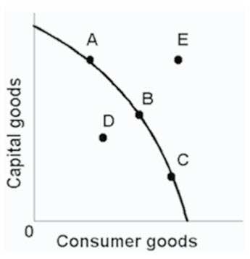
A) the ratio of capital to consumer goods is minimized.
B) it chooses point C.
C) it chooses point B.
D) it chooses point A.

184) The future location of the economy's production possibilities curve will be affected by:
A) the current division of domestic output between consumption and capital goods.
B) the rate of technological progress.
C) the growth of the economy's supplies of resources.
D) all of these are correct.

185) Refer to the diagram below. Which of the following positions relative to PP₁would be the most likely to result in a future production possibilities curve of PP₃, rather than PP₂?
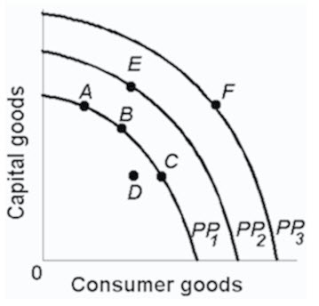
A) A.
B) B.
C) C.
D) D.

186) Through specialization and international trade a nation:
A) can achieve some combination of goods lying outside its production possibilities curve.
B) can move from a high consumption-low investment to a high investment-low consumption point on its production possibilities curve.
C) will achieve some combination of goods lying within its production possibilities curve.
D) will cause its production possibilities curve to shift leftward.

187) A country can achieve some combination of goods outside its production possibilities curve by:
A) idling some of its resources.
B) specializing and engaging in international trade.
C) buying the debt (bonds and stocks) of foreign nations.
D) producing more consumption goods and fewer capital goods.

188) International specialization and trade:
A) allow a nation to get more of a desired good at less sacrifice of some other good.
B) can allow an economy to circumvent the output limits imposed by its domestic production possibilities curve.
C) Has the same effect as having more and better resources.
D) all of these are correct.

189) Economists:
A) always put the independent variable on the horizontal axis and the dependent variable on the vertical axis.
B) always put the dependent variable on the horizontal axis and the independent variable on the vertical axis.
C) are somewhat arbitrary in assigning independent and dependent variables to the horizontal and vertical axes.
D) measure the slope of a line differently than do mathematicians.

190) If we say that two variables are directly related, this means that:
A) the relationship between the two is purely random.
B) an increase in one variable is associated with a decrease in the other variable.
C) an increase in one variable is associated with an increase in the other variable.
D) the graph has a down sloping line.

191) If we say that two variables are inversely related, this means that:
A) the two graph as an upsloping line.
B) an increase in one variable is associated with a decrease in the other.
C) an increase in one variable is associated with an increase in the other.
D) the resulting relationship can be portrayed by a straight line parallel to the horizontal axis.

192) Which of the following statements is correct?
A) The value of the independent variable is determined by the value of the dependent variable.
B) The value of the dependent variable is determined by the value of the independent variable.
C) The dependent variable designates the "cause" and the independent variable the "effect."
D) Dependent variables graph as upsloping lines; independent variables graph as downward sloping lines.

193) Refer to the below diagram. Which line(s) show(s) a positive relationship between x and y?
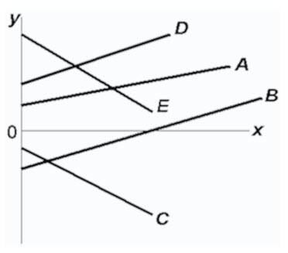
A) A only
B) both A and D
C) A, B, and D
D) both C and E

194) Refer to the below diagram. Which line(s) show(s) a negative relationship between x and y?
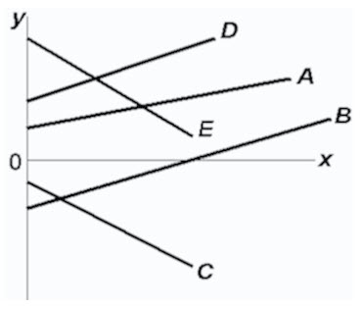
A) A only
B) both A and D
C) A, B, and D
D) both C and E

195) Refer to the below diagram. Which line(s) show(s) a positive vertical intercept?
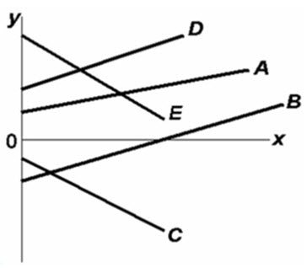
A) A and D only
B) B and C only
C) A, D, and E
D) A, D, and B

196) Refer to the below diagram. Which line(s) show(s) a negative vertical intercept?
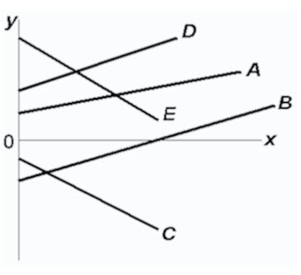
A) C only
B) both C and E
C) B, C, and E
D) both B and C

197) If two variables are inversely related, then as the value of one variable:
A) increases, the value of the other may either increase or decrease.
B) decreases, the value of the other decreases.
C) increases, the value of the other decreases.
D) increases, the value of the other increases.

198) If a positive relationship exists between x and y:
A) an increase in x will cause y to decrease.
B) a decrease in x will cause y to increase.
C) the relationship will graph as an upsloping line.
D) the vertical intercept must be positive.

199) Answer on the basis of the relationships shown in the below four figures. The amount of Y is directly related to the amount of X in:
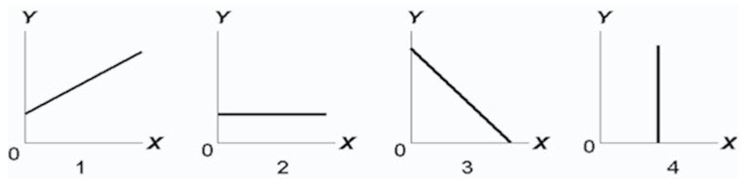
A) both 1 and 3.
B) both 1 and 2.
C) 2 only.
D) l only.

200) Answer on the basis of the relationships shown in the below four figures. The amount of Y is inversely related to the amount of X in:
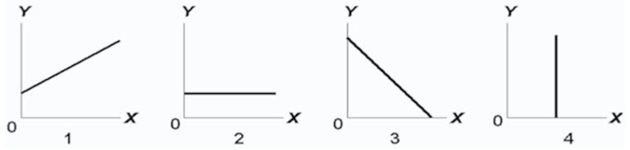
A) 2 only.
B) both 1 and 3.
C) 3 only.
D) 1 only.

201) Answer on the basis of the relationships shown in the below four figures. The amount of Y is unrelated to the amount of X in:
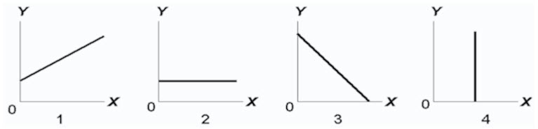
A) both 2 and 4.
B) 3 only.
C) 2 only.
D) 1

202) If price (P) and quantity (Q) are directly related, this means that:
A) a change in Q will alter P, but a change in P will not alter Q.
B) if P increases, Q will decrease.
C) if P increases, Q will also increase.
D) an increase in P will cause Q to change, but the direction in which Q changes cannot be predicted.

203) Assume that if the interest rate that businesses must pay to borrow funds were 20 percent, it would be unprofitable for businesses to invest in new machinery and equipment so that investment would be zero. But if the interest rate were 16 percent, businesses would find it profitable to invest $10 billion. If the interest rate were 12 percent, $20 billion would be invested. Assume that total investment continues to increase by $10 billion for each successive 4 percentage point decline in the interest rate.
Refer to the above information. Which of the following is an accurate verbal statement of the described relationship?
A) There is no regular or dependable relationship between business investment and the interest rate.
B) The amount of business investment is unaffected by changes in the interest rate.
C) Investment spending by businesses varies inversely with the interest rate.
D) Investment spending by businesses varies directly with the interest rate.

204) Assume that if the interest rate that businesses must pay to borrow funds were 20 percent, it would be unprofitable for businesses to invest in new machinery and equipment so that investment would be zero. But if the interest rate were 16 percent, businesses would find it profitable to invest $10 billion. If the interest rate were 12 percent, $20 billion would be invested. Assume that total investment continues to increase by $10 billion for each successive 4 Percentage-point decline in the interest rate.
Refer to the above information. Using i and I to indicate the interest rate and investment (in billions of dollars) respectively, which of the following is the correct tabular presentation of the described relationship?
(A) | (B) | (C) | (D)
i | I | I | I | i | I | i | I
20 | $50 | 24 | $10 | 20 | $0 | 20 | $10
16 | 40 | 20 | 20 | 16 | 10 | 16 | 20
12 | 30 | 16 | 30 | 12 | 20 | 12 | 30
8 | 20 | 12 | 40 | 8 | 30 | 8 | 40
4 | 10 | 8 | 50 | 4 | 40 | 4 | 50
0 | 0 | 4 | 60 | 0 | 50 | 0 | 60
A) column (A)
B) column (B)
C) column (C)
D) column (D)

205) Assume that if the interest rate that businesses must pay to borrow funds were 20 percent, it would be unprofitable for businesses to invest in new machinery and equipment so that investment would be zero. But if the interest rate were 16 percent, businesses would find it profitable to invest $10 billion. If the interest rate were 12 percent, $20 billion would be invested. Assume that total investment continues to increase by $10 billion for each successive 4 percentage point decline in the interest rate.
Refer to the above information. Which of the following correctly expresses the indicated relationship as an equation?
A) i = 20 - 4I.
B) i = 20 -.4I.
C) i = 24 -.4I.
D) i = 20 - 10I.

206) Assume that if the interest rate that businesses must pay to borrow funds were 20 percent, it would be unprofitable for businesses to invest in new machinery and equipment so that investment would be zero. But if the interest rate were 16 percent, businesses would find it profitable to invest $10 billion. If the interest rate were 12 percent, $20 billion would be invested. Assume that total investment continues to increase by $10 billion for each successive 4 percentage point decline in the interest rate.
Refer to the above information. Which of the following is the correct graphical presentation of the indicated relationship?
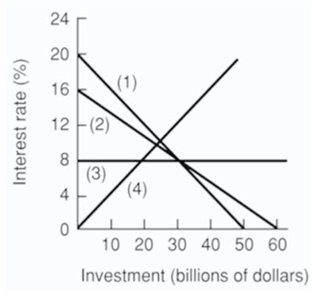
A) line 4
B) line 3
C) line 2
D) line 1

207)
After-tax income | Consumption
$1000 | $900
2000 | 1800
3000 | 2700
4000 | 3600
5000 | 4500
The above data suggest that:
A) consumption varies inversely with after-tax income.
B) consumption varies directly with after-tax income.
C) consumption and after-tax income are unrelated.
D) a tax increase will increase consumption.

208)
After-tax income | Consumption
$1000 | $900
2000 | 1800
3000 | 2700
4000 | 3600
5000 | 4500
The above data indicates that:
A) consumers spend 80 percent of their after-tax incomes.
B) consumers spend 90 percent of their after-tax incomes.
C) a tax reduction will reduce consumption.
D) the relationship between consumption and after-tax income is random.

209)
After-tax income | Consumption
$1000 | $900
2000 | 1800
3000 | 2700
4000 | 3600
5000 | 4500
The above data suggest that:
A) a policy of tax reduction will increase consumption.
B) a policy of tax increases will increase consumption.
C) tax changes will have no impact on consumption.
D) after-tax income should be lowered to increase consumption.

210) Refer to the below diagram. The variables X and Y are:
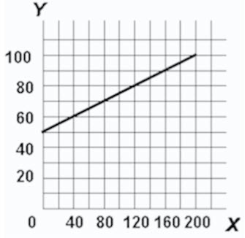
A) inversely related.
B) directly related.
C) unrelated.
D) negatively related.

211) Refer to the below diagram. The vertical intercept:
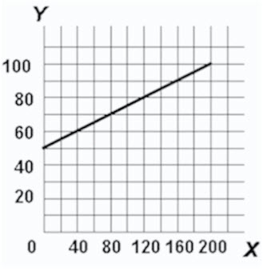
A) is 40.
B) is 50.
C) is 60.
D) cannot be determined from the information given.

212) Refer to the below diagram. The slope of the line:
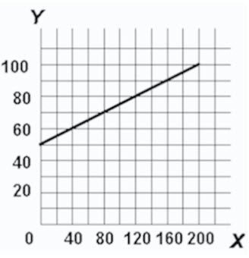
A) is -¹/₄.
B) is +¹/₄.
C) is.40.
D) cannot be determined from the information given.

213) Refer to the below diagram. The equation which shows the relationship between Y and X is:
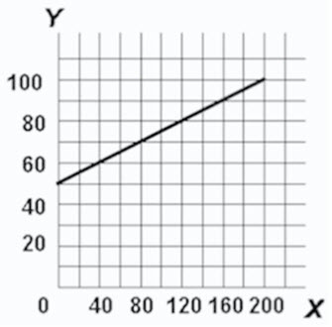
A) Y = 50 +¹/₄X.
B) X =¹/₄Y.
C) Y =.4X.
D) Y =¹/₄X - 50.

214) The slope of a straight line can be determined by:
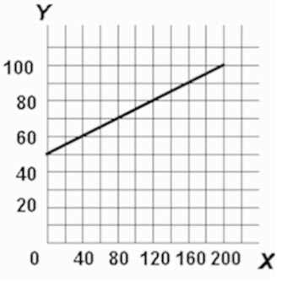
A) comparing the absolute horizontal change to the absolute vertical change between two points on the line.
B) comparing the absolute vertical change to the absolute horizontal change between two points on the line.
C) taking the reciprocal of the vertical intercept.
D) comparing the percentage vertical change to the percentage horizontal change between two points on the line.

215) 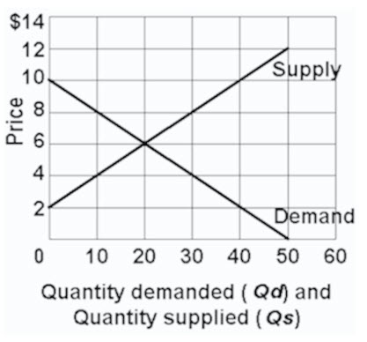
Refer to the above graph. Which of the following statements is correct?
A) Quantity demanded and quantity supplied are independent of price.
B) Price and quantity demanded are directly related.
C) Price and quantity supplied are directly related.
D) Price and quantity supplied are inversely related.

216) 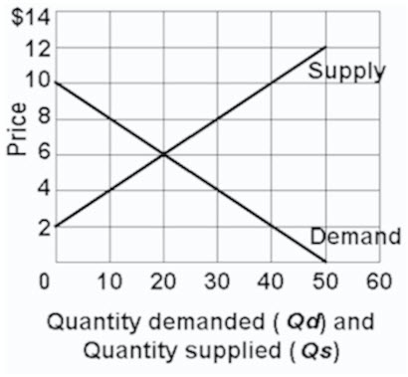
Refer to the above graph. Which of the following schedules correctly reflects "demand"?
(A) | (B) | (C) | (D)
P | Qd | P | Qd | P | Qd | P | Qd
$12 | 0 | $14 | 0 | $14 | 60 | $12 | 0
10 | 0 | 12 | 0 | 12 | 50 | 10 | 10
8 | 10 | 10 | 20 | 10 | 40 | 8 | 20
6 | 20 | 8 | 40 | 8 | 30 | 6 | 30
4 | 30 | 6 | 60 | 6 | 20 | 4 | 40
2 | 40 | 4 | 80 | 4 | 10 | 2 | 50
A) schedule (A)
B) schedule (B)
C) schedule (C)
D) schedule (D)

217) 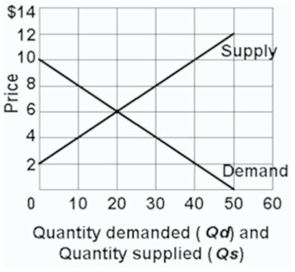
Refer to the above graph. Which of the following schedules correctly reflects "supply"?
(A) | (B) | (C) | (D)
P | Qd | P | Qd | P | Qd | P | Qd
$12 | 0 | $14 | 0 | $14 | 60 | $12 | 0
10 | 0 | 12 | 0 | 12 | 50 | 10 | 10
8 | 10 | 10 | 20 | 10 | 40 | 8 | 20
6 | 20 | 8 | 40 | 8 | 30 | 6 | 30
4 | 30 | 6 | 60 | 6 | 20 | 4 | 40
2 | 40 | 4 | 80 | 4 | 10 | 2 | 50
A) schedule (A)
B) schedule (B)
C) schedule (C)
D) schedule (D)

218) 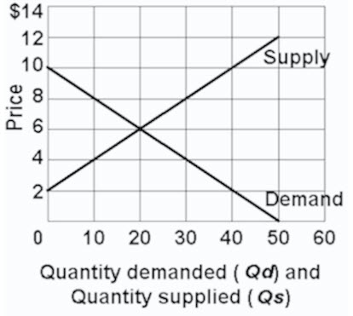
Refer to the above graph. Using Q_{d} for quantity demanded and P for price, which of the following equations correctly states the demand for this product?
A) P = Q_{d}/10.
B) P = 50 - P/2.
C) P = 10 -.2Q_{d}.
D) P = 10 - 2Q_{d}.

219) 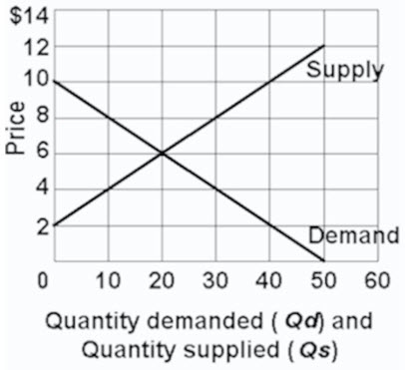
Refer to the above graph. Using Q_{s} for quantity supplied and P for price, which of the following equations correctly states the supply of this product?
A) P = 4 +.2Q_{s}.
B) P = 60/Q_{s}.
C) P = 10Q_{s} - 2P.
D) P = 2 +.2Q_{s}.

220) Assume a household would consume $100 worth of goods and services per week if its weekly income were zero and would spend an additional $80 per week for each $100 of additional income. Letting C represent consumption and Y represent income, the equation which summarizes this relationship is:
A) C = 80 + 100Y.
B) C = 100 +.8Y.
C) C = 100 + 80Y.
D) C = 80 +.1Y.

221) 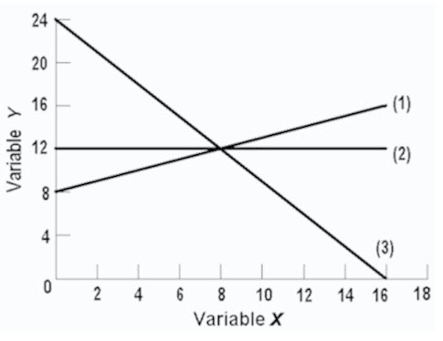
In line (1) on the above graph, the variables x and y are:
A) nonlinearly related.
B) positively related.
C) negatively related.
D) inversely related.

222) 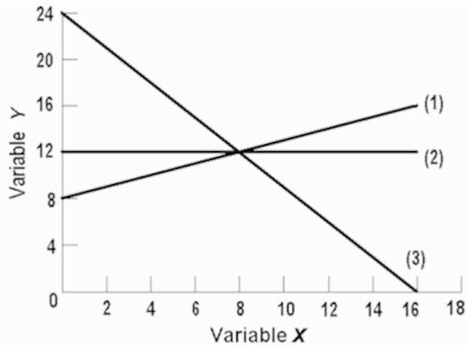
In line (3) on the above graph, variables x and y are:
A) directly related.
B) negatively related.
C) positively related.
D) nonlinearly related.

223) 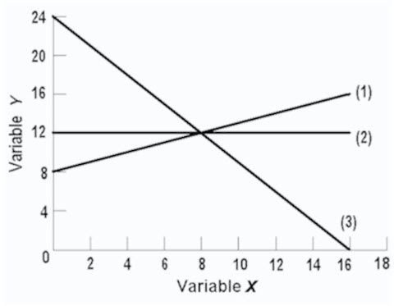
The linear equation for line (1) on the above graph is:
A) y = 8 + 2x.
B) y = 8 +.5x.
C) x = 8 +.5y.
D) y = 8 - 2x.

224) 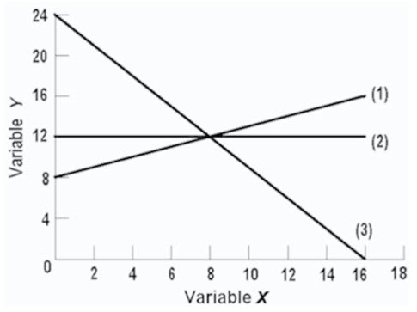
The slope of line (2) on the above graph is:
A) 0
B) B..66.
C) C..75.
D) 1.50.

225) 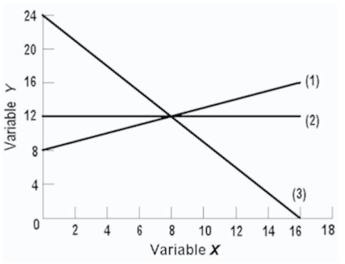
The linear equation for line (3) on the above graph is:
A) y = 24 - 1.5x.
B) y = 16 -.5x.
C) y = 24 -.66x.
D) y = 24 -.75x.

226) 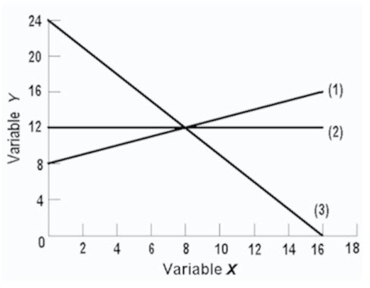
The vertical intercept of line (2) on the above graph is:
A) 8
B) 12
C) 16
D) 24

227) If the equation y = 5 + 6x was graphed, the:
A) slope would be -5.
B) slope would be +5.
C) slope would be +6.
D) vertical intercept would be +.6.

228) If the equation y = 15 - 4x was plotted, the:
A) vertical intercept would be -4.
B) vertical intercept would be +4.
C) vertical intercept would be +9.
D) slope would be -4.

229) If the equation y = -10 + 2.5x was plotted
A) the vertical intercept would be -10.
B) the slope would be + 2.5.
C) it would graph as an upsloping line.
D) all of these are correct.

230) Refer to the graph. The movement from line A to line A' represents a change in:
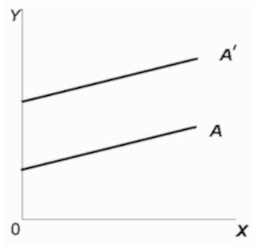
A) the slope only.
B) the intercept only.
C) both the slope and the intercept.
D) neither the slope nor the intercept.

231) In the below diagram variables x and y are:
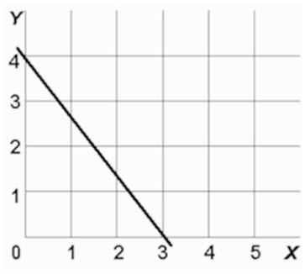
A) both dependent variables.
B) directly related.
C) inversely related.
D) unrelated.

232) In the below diagram the vertical intercept and slope are:
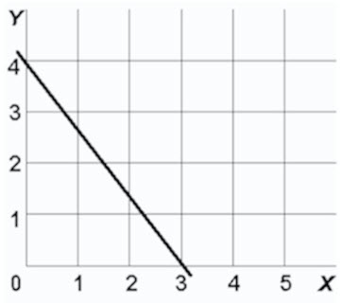
A) 4 and -1¹/₃respectively.
B) 3 and -1¹/₃respectively.
C) 3 and +³/₄respectively.
D) 4 and +³/₄respectively.

233) In the below diagram the equation for this line is:
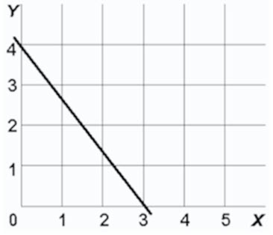
A) y = 4 - 1¹/₃x.
B) y = 3 +³/₄x.
C) y = 4 -³/₄x.
D) y = 4 + 1¹/₃x.

234) If we are considering the relationship between two variables and release the "other things equal" assumption, we would expect:
A) the relationship to change from direct to inverse.
B) the line representing that relationship on a graph to change locations.
C) the data points representing the relationship to become more randomly scattered.
D) the relationship to change from inverse to direct.

235) The amount of pizzas that consumers want to buy per week is reflected in the equation P = 15 -.02Q_{d}, where Q_{d} is the amount of pizzas purchased per week and P is the price of pizzas. On the basis of this information we can say that:
A) if pizzas were free, people would consume 800 per week.
B) more pizzas will be purchased at a high price than at a low price.
C) if the price of pizzas is $6, then 150 will be purchased.
D) 50 fewer pizzas will be purchased per week for every $1 increase in price.

236) Refer to the below diagram. The slope of curve ZZ at point B is:
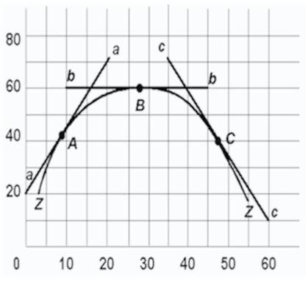
A) infinity.
B) zero.
C) one.
D) none of the these are true.

237) The slope of a line parallel to the vertical axis is:
A) zero.
B) one.
C) infinite.
D) one-half.

238) The slope of a line parallel to the horizontal axis is:
A) zero.
B) one.
C) infinite.
D) one-half.

239) The measured slope of a line:
A) is independent of how the two variables are denominated.
B) will be affected by how the two variables are denominated.
C) necessarily diminishes as one moves rightward on the line.
D) necessarily increases as one moves rightward on the line.

240) Slope of lines are especially important in economics because:
A) they measure marginal changes.
B) they always tell us something about profits.
C) positive slopes are always preferred to negative slopes.
D) they always relate to resource and output scarcity.

241) In a linear equation relating income and consumption, you know that the intercept is $1,000 and the slope of the line is.4. If income is $20,000, then consumption is:
A) $8,000
B) $9,000
C) $10,000
D) $11,000

242) Scarcity in relation to wants means you face trade-offs; therefore, having to make choices is which of the ten key concepts to retain for a lifetime?
A) Facing trade-offs
B) Opportunity cost
C) Choosing a little more or a little less
D) The influence of incentives

243) The cost of the choice you make is what you give up for it, is which of the ten key concepts to retain for a lifetime?
A) Facing trade-offs
B) Opportunity cost
C) Choosing a little more or a little less
D) The influence of incentives

244) Choices are usually made at the margin, is which of the ten key concepts to retain for a lifetime?
A) Facing trade-offs
B) Interest Expense
C) Marginal analysis
D) The influence of incentives

245) Markets usually do a good job of coordinating trade among individuals, groups, and nations. Is which of the ten key concepts to retain for a lifetime?
A) Facing trade-offs
B) Opportunity cost
C) The effectiveness of markets
D) The influence of incentives

246) The economic perspective focuses largely on:
A) marginal analysis.
B) rational task analysis.
C) total revenues.
D) total costs.

247) Like other branches of social science, economics relies on the:
A) trial and error method.
B) sub-optimization model.
C) heuristic method.
D) scientific method.

248) Which of the following countries had the highest average income in 2015?
A) Norway
B) Switzerland
C) United States
D) Canada

249) Which of the following positions did Canada occupy with regard to average income in 2015?
A) First
B) Fourth
C) Ninth
D) Twelfth

250) Refer to the figure below. The attainable area for the budget line includes:
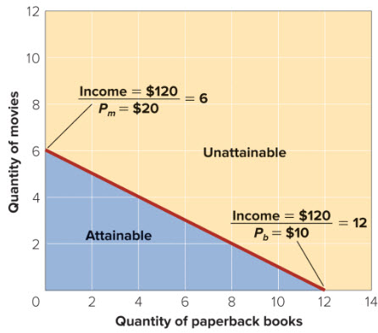
A) the area below the line but not the budget line itself.
B) the area below the budget line and the budget line.
C) the area above the budget line but no the budget line itself.
D) the area above the budget line and the budget line.

251) The production possibilities curve is bowed out from the origin because:
A) marginal benefits are equal.
B) marginal benefits decrease.
C) marginal benefits are unpredictable.
D) marginal benefits decrease and then increase in value.

252) (Consider This) Free products offered by firms
A) may or may not be free to society but are never free to individuals.
B) may or may not be free to individuals but are never free to society.
C) are produced and distributed at no cost to society.
D) are usually items nobody wants.

253) (Consider This) The assertion by economists that "there is no free lunch"
A) is contradicted by the presence of free goods offered by firms.
B) applies to goods that have prices, not to goods given away free by firms.
C) remains true even for goods given away free by firms.
D) applies to agricultural goods but not to manufactured goods.

254) A direct cost of going to college is
A) tuition, while an indirect cost (opportunity cost) is books and other supplies.
B) forgone income while in college, while an indirect cost (opportunity cost) is tuition.
C) tuition, while an indirect cost (opportunity cost) is forgone income while in college.
D) books and supplies, while an indirect cost (opportunity cost) is food and housing.

255) An exception to the advice "go to college, stay in college, and earn a degree" occurs when
A) tuition expenses are high and rising.
B) the opportunity cost of attending college is extraordinarily high.
C) the price of textbooks is high and rising.
D) the economy is growing rapidly and jobs are plentiful.

256) (Consider This) COVID-19 moved the Canadian economy:
A) Inside its PPF
B) Outside its PPF
C) Onto its PPF
D) None of these answers

257) (Consider This) Which of the following statements is correct for the Canadian economy, given the impact of COVID-19
A) There are fewer goods for the present, but also for the future.
B) There are more goods in the present, and also in the future.
C) There are fewer goods in the present, but more in the future.
D) There are more goods in the present, but fewer in the future.

258) At what point should you stop studying for an exam?
A) At the point where the marginal cost of studying = the marginal benefit of studying.
B) You should always study the maximum of hours for an exam!
C) You should study until the marginal cost of studying is equal to 0.
D) You should study until the marginal benefit of studying is equal to 0.

259) (The Last Word) How many Starbucks branches should the company open in Montreal?
A) MB should be equal MC for the very last store that it builds in a Montreal.
B) MB should be greater than MC for the very last store that it builds in a Montreal.
C) MB should be smaller than MC for the very last store that it builds in a Montreal.
D) MC should be equal to zero for the very last store that it builds in a Montreal.

260) What is a brief definition of economics? What are the conditions that give rise to this definition?

261) What are the key economic concepts that pertain to the individual?

262) What are the key economic concepts that pertain to interactions among individuals?

263) What are the key economic concepts that pertain to the economy as a whole?

264) What do economists mean when they say that "there is no free lunch"? Give another example to which this statement applies.

265) What are the three interrelated features of the economic perspective?

266) What is utility and what is its relevance to rational behaviour?

267) Use marginal analysis to explain why it is possible to "have too much of a good thing". Use education as an example.

268) What does it mean to say that theories, principles, and models are "purposeful simplifications"?

269) The distinguished economist Kenneth Boulding stated: "Theories without facts may be barren, but facts without theories are meaningless". Explain what he meant.

270) Explain the importance of the ceteris paribus or "other-things-equal" assumption.

271) "Bad theories are abstract and therefore unrealistic; good theories are fully realistic and fit all the facts". Evaluate.

272) "Economic models are somewhat like different types of maps". Evaluate.

273) Distinguish between microeconomics and macroeconomics.

274) Below are six statements. Indicate whether each one pertains to microeconomics (MIC) or macroeconomics (MAC).
(a) "The inflation rate in Canada hit its lowest level in the last twenty years".
(b) "The profits of BCE rose 20 percent during the past quarter".
(c) "A drought has occurred in the Prairies. The prices for barley are expected to rise sharply".
(d) "The nation's economy grew at an annual rate of 3.7 percent in the final quarter of the year".
(e) "The trade surplus in Canada was $4 billion last month".
(f) "General Motors plans to spend $800 million on a new automobile plant".

275) Why have the last few years been an exciting time to study macroeconomics?

276) Give one example of a positive economic statement and one example of a normative economic statement.

277) Below are six statements. Identify whether each is a positive or normative statement.
(a) The minimum wage should be increased so low-income workers can earn a living wage.
(b) The unemployment rate is too high and should be reduced through government actions.
(c) The rate of inflation was about 2 percent last year, an all time low for the past decade.
(d) The government should take action to break up the monopoly power of Air Canada.
(e) Interest rates should be lower in Canada so that people can afford to build a home.
(f) The Federal government achieved a budget surplus for the first time in thirty years.

278) Identify whether each of the following is a positive or normative statement.
(a) Should tuition fees increase, fewer students would obtain a post-secondary education.
(b) The Prime Minister announced that Canada is the best place in the world to live.

279) "Economists are scientists and therefore should not become involved in making value judgments which policy formulation necessarily entails". Do you agree?

280) "Economics cannot be scientific because it is based upon the value judgment that 'more (output) is better'". Do you agree?

281) What were the approximate average incomes of Canadians and Indians in 2019?

282) What is meant by the "the individual's economic problem"?

283) Over the years, certain countries have faced what is called a debt crisis. This is a situation in which a country is unable to pay back its government debt. Recently Greece suffered a debt crisis. Describe the Greek Debt Crisis, and explain its relation to the Economic Problem?

284) What variables are used to determine the individual's budget line?

285) How do income changes affect the position of the budget line?

286) What do economists mean when they say that economic resources or factors of production are scarce or limited in supply?

287) What is meant by "society's economic problem"?

288) List the four resource categories and give a brief description of each.

289) What four basic functions does the entrepreneur perform for the economy?

290) Explain and evaluate: "If resources were infinitely abundant in relation to the demand for them, the economic problem would dissolve in a sea of affluence".

291) "The relative scarcity of resources makes the operation of any economy a matter of choosing between alternatives". Explain.

292) "The two cornerstones of economics are the scarcity of resources and the multiplicity of wants. True economy consists of deriving maximum want satisfaction from available resources". Explain.

293) Explain the relationship between full employment of resources and full production.

294) The production possibilities table below shows the hypothetical relationship between the production of food and clothing in an economy.
Combination | Food | Clothing
A | 0 | 4
B | 7 | 3
C | 13 | 2
D | 18 | 1
E | 22 | 0
(a) What is the marginal opportunity cost of producing the second unit of clothing?
(b) What is the total opportunity cost of producing two units of clothing?
(c) What is the marginal opportunity cost of producing the third unit of clothing?
(d) What is the total opportunity cost of producing three units of clothing?

295) A production possibilities table for two products, grain and airplanes, is found below. Usual assumptions regarding production possibilities are implied. Grain is measured in tons and airplanes are measured in units of 1,000.
Combination | Grain (tons) | Airplanes (1,000s)
A | 0 | 7
B | 14 | 6
C | 26 | 5
D | 36 | 4
E | 44 | 3
F | 50 | 2
G | 54 | 1
H | 56 | 0
(a) Using the below graph construct a production possibilities curve from this information placing grain on the vertical axis and airplanes on the horizontal axis.
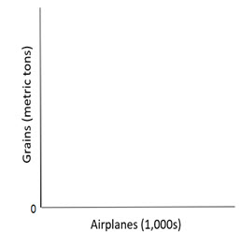
(b) What is the opportunity cost of producing the first unit of airplanes? The marginal opportunity cost of producing the fourth unit of airplanes?

296) A production possibilities table for two products, corn and paper, is found below. Usual assumptions regarding production possibilities are implied. Corn is measured in tons, and paper is measured per unit.
Combination | Corn | Paper
A | 0 | 6
B | 18 | 5
C | 33 | 4
D | 45 | 3
E | 54 | 2
F | 60 | 1
G | 63 | 0
(a) Using the following graph construct a production possibilities curve from this information placing corn on the vertical axis and paper on the horizontal axis.
(b) What is the marginal opportunity cost of producing the first unit of paper? The marginal opportunity cost of producing the fourth unit of paper?

297) What is the economic rationale for the law of increasing costs?

298) Explain how increasing opportunity costs are reflected graphically in the production possibilities curve. How would the curve appear if opportunity costs were constant?

299) An economy consists of five workers, who can produce either fish or fruit. The following table shows the daily output of each worker.
Worker | Fish | Fruit
A | 10 | 20
B | 6 | 10
C | 8 | 6
D | 8 | 4
E | 10 | 10
(a) Suppose one worker catches fish and four workers pick fruit. For the economy to achieve productive efficiency, which of the five workers must fish?
(b) Does the economy achieve full employment and productive efficiency by producing 26 fish and 20 fruit?

300) An economy consists of five workers, who can produce either fish or fruit. The following table shows the daily output of each worker.
Worker | Fish | Fruit
A | 4 | 4
B | 6 | 2
C | 2 | 1
D | 8 | 6
E | 4 | 1
(a) Suppose one worker catches fish and four workers pick fruit. For the economy to achieve productive efficiency, which of the five workers must fish?
(b) Does the economy achieve full employment and productive efficiency by producing 12 fish and 4 fruit?

301) What changes must occur for the potential total output of the economy to grow?

302) Look at the following production possibilities curve illustrating the possibilities in Sluggerville for producing bats and/or peanuts with the existing level of resources and technology.
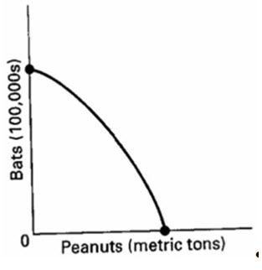
(a) Show a point U that would indicate unemployed resources in Sluggerville.
(b) Draw a new curve B that illustrates the results of improved technology in the production of bats, but no change in the production efficiency of peanuts.
(c) Show a point G that would indicate a point that is currently unattainable in the production of peanuts and bats in Sluggerville.

303) Explain how each event affects production possibilities.
(a) The population becomes more educated over time as the number of high school dropouts falls and the number of college graduates rises.
(b) The unemployment rate declines from 8 to 6 percent of the labour force.
(c) Businesses and government are unable to solve a major computer problem, thus reducing economic efficiency and national output.
(d) Advances in telecommunications and new technology significantly contribute to economic growth over time.
(e) The Federal government decides to allocate more resources to national defence.

304) Describe the adjustments in the production possibilities curves in each of the following situations for the Canadian economy.
(a) the economy moves from full employment into a deep recession
(b) the economy makes great strides in eliminating discrimination
(c) the end of the Cold War leads to cuts in military spending
(d) the government significantly increases spending for health and education

305) Evaluate. Since the production possibilities curve can shift outward over time, it is possible for an economy to get more of a product without incurring an opportunity cost.

306) One application of the production possibilities concept has been to explain the difference in growth patterns of a nation with a high level of investment (Alta) and an equivalent nation with a low level of investment (Zorn). Use the concept to explain why Alta's economic growth would be greater than that of Zorn over time.

307) The production possibilities curve suggests that a nation cannot live beyond its means or production potential. Explain why international trade would cause this statement to be modified.

308) Why do economists use graphs in their work?

309) In a two-dimensional graph showing the relationship between income and consumption in the economy, what is shown on the vertical axis and what is shown on the horizontal axis?

310) Define what is meant by a positive or direct relationship between two variables and describe the line graph depicting such a relationship.

311) Define what is meant by an inverse relationship between two variables and describe the line graph depicting such a relationship.

312) Differentiate between the independent and dependent variables in an economic relationship.

313) Describe the slope of a direct and an inverse relationship.

314) Show graphically the relationships that you would expect to find between (a) student IQs and grade point averages (GPAs); (b) the price of a product and the amount consumers will purchase; (c) the temperature and the number of people at the swimming pool. Which of these are direct relationships and which are inverse? What considerations might change the expected relationships?

315) Show graphically on the below graph the expected relationship between investment spending and interest rates. Put investment expenditures on the horizontal axis and the rate of interest on the vertical axis; connect the points and label the curve "Investment demand". Describe this relationship between the rate of interest and investment expenditures. Describe the slope of the investment curve.

316) There are two sets of x, y points on a straight line in a two-variable graph with y on the vertical axis and x on the horizontal axis. What would be the linear equation for the line if one set of points was (0, 12) and the other set was (12, 36)?

317) The value of the vertical intercept is $100 and the slope is 0.8 in a linear equation for consumption (measured on the vertical axis) and disposable income (measured on the horizontal axis). If disposable income is $1000, what is consumption? State the linear equation and show how you found the answer.

318) How do you determine the slope of a nonlinear curve? Will the slope be the same along the curve? Explain.

319) Using the below graph give the slopes of the lines tangent to the curve at points A, B, and C.
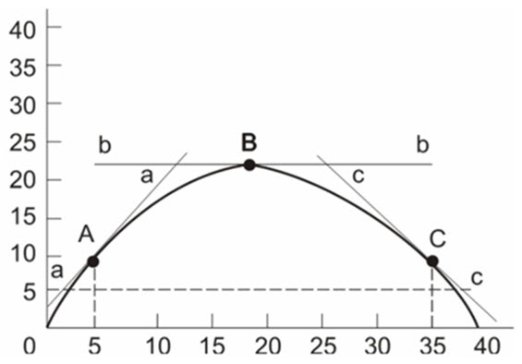

320) Rational individuals may make different choices because their information and circumstances differ.
⊚ true
⊚ false

321) Certain inherently desirable products such as education and health care should be produced so long as resources are available.
⊚ true
⊚ false

322) Marginal analysis means that decision-makers compare the extra benefits with the extra costs of a specific choice.
⊚ true
⊚ false

323) Choices entail marginal costs because resources are scarce.
⊚ true
⊚ false

324) If economic theories are solidly based on relevant facts, then there can be no question as to the character of appropriate economic policy.
⊚ true
⊚ false

325) The fact that economic generalizations are abstract renders them impractical and useless.
⊚ true
⊚ false

326) Macroeconomics explains the behaviour of individual households and business firms; microeconomics is concerned with the behaviour of aggregates or the economy as a whole.
⊚ true
⊚ false

327) Positive statements are expressions of value judgments.
⊚ true
⊚ false

328) Normative statements are expressions of facts.
⊚ true
⊚ false

329) Individuals face an economic problem but society does not.
⊚ true
⊚ false

330) The entrepreneur's sole function is to combine other resources (land, labour, and capital) in the production of some good or service.
⊚ true
⊚ false

331) Products and services are scarce because resources are scarce.
⊚ true
⊚ false

332) The process by which capital goods are accumulated is known as investment.
⊚ true
⊚ false

333) The production possibilities curve shows various combinations of two products which an economy can produce when achieving full employment and productive efficiency.
⊚ true
⊚ false

334) An economy will always operate at some point on its production possibilities curve.
⊚ true
⊚ false

335) 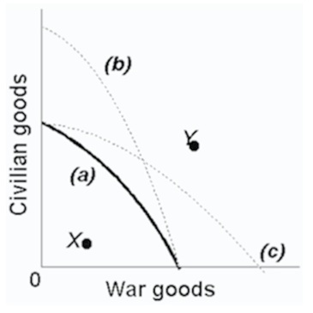
Refer to the above production possibilities curves. Given production possibilities curve (a), point Y indicates that society is failing to use available resources efficiently.
⊚ true
⊚ false

336) 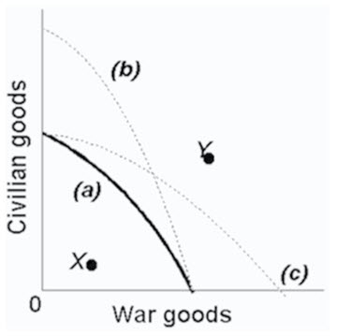
Refer to the above production possibilities curves. The movement from curve (a) to curve (b) implies an increase in the quantity and/or quality of society's productive resources.
⊚ true
⊚ false

337) {MISSING IMAGE}
Refer to the above production possibilities curves. Given production possibilities curve (a), the combination of civilian and war goods indicated by point X is unattainable to this economy.
⊚ true
⊚ false

338) An economy cannot produce at a point outside of its production possibilities curve because human material wants are insatiable.
⊚ true
⊚ false

339) Although sleeping in on a workday or school day has an opportunity cost, sleeping late on the weekend does not.
⊚ true
⊚ false

340) Recessions are characterised by points that are not attainable on the production possibilities curve.
⊚ true
⊚ false

341) Refer to the production possibilities curves. The movement from curve (a) to curve (c) indicates an improvement in civilian goods technology but not in war goods technology.
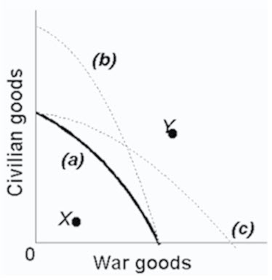
⊚ true
⊚ false

342) The present choice of position on the production possibilities curve will not influence the future location of the curve.
⊚ true
⊚ false

Answer Key
Test name: McConnell16ceCh1
1) D
2) D
3) B
4) C
5) D
6) D
7) D
8) D
9) A
10) C
11) C
12) C
13) C
14) C
15) B
16) B
17) B
18) C
19) B
20) C
21) D
22) D
23) B
24) B
25) B
26) C
27) A
28) B
29) A
30) D
31) B
32) B
33) A
34) A
35) C
36) C
37) C
38) B
39) C
40) A
41) B
42) C
43) C
44) A
45) B
46) A
47) C
48) B
49) A
50) D
51) C
52) C
53) D
54) C
55) B
56) D
57) B
58) B
59) C
60) B
61) B
62) C
63) B
64) B
65) B
66) D
67) A
68) A
69) C
70) D
71) C
72) D
73) A
74) B
75) C
76) D
77) A
78) B
79) B
80) C
81) C
82) B
83) B
84) C
85) C
86) A
87) C
88) A
89) B
90) D
91) C
92) D
93) C
94) C
95) C
96) A
97) C
98) A
99) C
100) C
101) D
102) C
103) B
104) C
105) A
106) B
107) B
108) B
109) B
110) D
111) B
112) B
113) A
114) C
115) A
116) B
117) A
118) D
119) D
120) D
121) A
122) B
123) C
124) C
125) A
126) D
127) B
128) A
129) D
130) D
131) A
132) C
133) C
134) C
135) B
136) C
137) C
138) A
139) B
140) A
141) A
142) D
143) D
144) A
145) B
146) D
147) B
148) A
149) C
150) A
151) A
152) C
153) A
154) B
155) D
156) D
157) A
158) D
159) C
160) A
161) D
162) D
163) D
164) A
165) C
166) B
167) B
168) A
169) D
170) B
171) C
172) D
173) C
174) A
175) A
176) B
177) D
178) C
179) B
180) B
181) D
182) A
183) D
184) D
185) A
186) A
187) B
188) D
189) C
190) C
191) B
192) B
193) C
194) D
195) C
196) D
197) C
198) C
199) D
200) C
201) A
202) C
203) C
204) C
205) B
206) D
207) B
208) B
209) A
210) B
211) B
212) B
213) A
214) B
215) C
216) A
217) C
218) C
219) D
220) B
221) B
222) B
223) B
224) A
225) A
226) B
227) C
228) D
229) D
230) B
231) C
232) A
233) A
234) B
235) D
236) B
237) C
238) A
239) B
240) A
241) B
242) A
243) B
244) C
245) C
246) A
247) D
248) A
249) B
250) B
251) B
252) B
253) C
254) C
255) B
256) A
257) A
258) A
259) A
320) TRUE
321) FALSE
322) TRUE
323) TRUE
324) FALSE
325) FALSE
326) FALSE
327) FALSE
328) FALSE
329) FALSE
330) FALSE
331) TRUE
332) TRUE
333) TRUE
334) FALSE
335) FALSE
336) TRUE
337) FALSE
338) FALSE
339) FALSE
340) FALSE
341) FALSE
342) FALSE

