Chapter 01
Limits, Alternatives, Choices

Multiple Choice Questions
1. | Economics is a social science that studies how individuals, institutions, and society may:  A. Expand the amount of resources available to them  B. Attain a minimum level of production  C. Best use resources to maximize satisfaction of economic wants  D. Reduce the amount of goods and services they need

2. | The basic truth that underlies the study of economics is the fact that we all face:  A. Death  B. Taxes  C. Risk  D. Scarcity

3. | A recurring theme in economics is that people:  A. Have unlimited resources, but limited economic wants  B. Can increase resources by limiting their economic wants  C. Have limited economic wants and limited resources  D. Have unlimited economic wants, but limited resources

4. | As a consequence of the problem of scarcity:  A. There is never enough of anything  B. Individuals have to make choices from among alternatives  C. Only some people can "have it all"  D. Things which are plentiful have relatively high prices

5. | What does "there is no such thing as a free lunch" mean in economics?  A. That scarce resources are used up to provide "freebies" and giveaways  B. That sometimes people may take friends out to lunch and pay for them  C. That all items in the lunch menu have specific prices  D. That products only have value because people are willing to pay for them

6. | The idea in economics that "there is no free lunch" means that:  A. Businesses would go bankrupt if they offered free lunches  B. The thought of a free lunch is often better than the reality of consuming it  C. There are opportunity costs involved even in free lunches  D. Free lunches used by businesses to attract customers is an inefficient marketing ploy

7. | The opportunity cost of doing or getting something is best and fully defined as:  A. The difference between the marginal cost and benefit of doing something  B. The materials used in doing or getting something  C. The value of the best alternative that is given up in order to do or get something  D. The money spent in doing or getting something

8. | Economic analysis assumes "purposeful behavior", which means that people will pursue decisions or actions:  A. That will increase their well-being  B. Always based on full or complete information  C. With minimal consideration for their emotions  D. Without any logical faults

9. | In analyzing human decision and action, economists assume that:  A. Scarcity is more important than choice  B. Costs are more important than benefits  C. People's behavior reflects rational self-interest  D. There are scarce resources in the economy

10. | The notion of "purposeful behavior" in the economic perspective suggests that:  A. People will tend to stick with a particular choice for a long period of time  B. Economic analysis will provide people with a single "right" way to behave  C. Economists do not believe that people can sometimes behave impulsively  D. One person's choice may differ from another's if their circumstances and information differ

11. | When studying human behavior, economists assume rational self-interest. This means that:  A. People make decisions based on some desired outcome  B. People are quite selfish, and are not concerned about others  C. People always make the right decisions  D. People have all the information they need to make a decision

12. | Lauren makes $150 a day as a bank clerk. She takes two days off work without pay, to fly to another city to attend the concert of her favorite band. The cost of transportation and lodging for the trip is $250. The cost of the concert ticket is $50. The opportunity cost of Lauren's decision to attend the concert is:  A. $600  B. $450  C. $300  D. $250

13. | When a state government chooses to build more roads, the resources used are no longer available for public education programs. This dilemma illustrates the concept of:  A. Production expenses  B. Unemployment issues  C. Unintended consequences  D. Opportunity cost

14. | The opportunity cost of constructing a new public highway is the:  A. Money cost of hiring contractors and construction workers for the new highway  B. Value of other goods and services that are sacrificed in order to construct the new highway  C. Expected cost of constructing the new highway in a future year  D. Value of shorter driving times and distances when the new highway is completed

15. | After graduating from high school, Adam is thinking about going to college. The college tuition is $15,000 a year. Instead of going to college, Adam could take a full-time job that pays $25,000. What is Adam's opportunity cost of attending college for one year?  A. $10,000  B. $15,000  C. $25,000  D. $40,000

16. | The opportunity cost to a consumer who smokes cigarettes consists of the:  A. Costs imposed on others who inhale second-hand smoke  B. Products that the consumer could have bought instead of cigarettes  C. Amount of cigarette-taxes paid by this consumer  D. Cost of complementary products such as lighters, ashtrays, and cigarette holders

17. | The economic perspective focuses largely on marginal analysis, which means analyzing:  A. Peripheral elements of a given issue or action  B. The minor aspects of a given issue or decision  C. The changes in the situation that would result from a given action  D. Emotional and psychological facets of a given action

18. | Which of the following is the best synonym for "marginal" in economics?  A. Scarce  B. Additional  C. Basic  D. Minor

19. | Which of the following is another way of saying "marginal benefits of an action"?  A. Benefits given up, once the action is taken  B. Unintended gains from taking the action  C. Benefits accruing to others, as a result of one's action  D. Extra benefits resulting from the action

20. | Mia wants to buy a book. The economic perspective suggests that Mia will buy the book if:  A. She has enough money to pay for the marginal cost of the book  B. The marginal benefit of the book is a positive value  C. The marginal cost of the book is greater than its marginal benefit  D. The marginal benefit of the book is greater than its marginal cost

21. | From an economic perspective, when a consumer decides to buy more life insurance, the consumer has most likely concluded that the:  A. Marginal cost of more insurance coverage is negative  B. Marginal benefit of more insurance coverage is greater than zero  C. Marginal benefit of more insurance coverage is greater than the marginal cost  D. Marginal cost of more insurance coverage is equal to the payment for the extra coverage

22. | From an economic perspective, when a student decides to go to the movies instead of studying for a test, it indicates that in the student's thinking the marginal:  A. Benefit of studying is greater than the marginal cost of studying  B. Cost of going to the movies is less than the marginal benefit of going to the movies  C. Benefit of studying are greater than the marginal benefit of going to the movies  D. Cost of going to the movies is greater than the marginal cost of studying

23. | From an economic perspective, when consumers leave a fast-food restaurant because the lines to be served are too long, they have concluded that the:  A. Marginal cost of waiting is less than the marginal benefit of being served  B. Marginal cost of waiting is greater than the marginal benefit of being served  C. Management is exhibiting irrational behavior by not maximizing profits  D. Management is making an assumption that other things are equal

24. | What is the best economic explanation for why a person would drop out of college to take a job or start a business?  A. he has a good idea for starting a business  B. he has to pay a higher tuition to attend college  C. the expected future benefits from starting a business now are greater than the costs  D. the opportunity cost of starting a business is high now, but will be low later in life

25. | What is a major opportunity cost of going to college on a full-time basis?  A. The cost of transportation to college instead of to a job  B. The cost of living expenses (room and board) to attend college  C. The foregone income that could be earned working full-time job  D. The greater income that will be earned from having a college degree

26. | The process of observing real-world behavior, developing hypotheses, testing them against facts, then using the results to construct theories is called:  A. Opportunity cost estimation  B. The scientific method  C. Marginal analysis  D. Normative analysis

27. | An economic model is a purposeful simplification of reality, whose function includes:  A. Understanding the full complexity of the real world  B. Predicting the behavior of each and every individual or organization  C. Analyzing the behavior of a typical or average consumer or firm  D. Forecasting economic random events with a high level of accuracy

28. | The economic principle that "unemployment rate will tend to increase as the economy moves into a recession" is an example of:  A. A normative statement  B. An assumption  C. A loaded terminology  D. A generalization

29. | Economic models do not reflect the full complexity of reality, but instead are based on:  A. Simplifications  B. Tradeoffs  C. Value judgments  D. Predictions

30. | The role of an assumption in an economic theory is to:  A. Add realism  B. Prove the theory  C. Cover special cases  D. Simplify the complex reality

31. | The ceteris paribus assumption is employed in economic analysis, in order to:  A. State economic goals  B. Simplify the complex world  C. Evaluate an economic system  D. Approximate real-world conditions

32. | Another way of saying "ceteris paribus" is:  A. Other things equal  B. In general  C. In reality  D. Because of this

33. | The purpose of the ceteris paribus assumption used in economic analysis is to:  A. Avoid making normative statements  B. Distinguish macroeconomics from microeconomics  C. Make sure that all relevant factors are considered  D. Focus on the effect of a single factor on a certain variable

34. | Economists have difficulty applying the scientific method because:  A. Economics has a short history  B. The scientific method does not really apply to economics  C. People are the focus of economics, and their behavior is highly predictable  D. Controlled laboratory experiments in economics are often not feasible

35. | Which of the following illustrates a macroeconomic question?  A. Should the salaries of financial executives be regulated by the government?  B. Are increasing wage demands by workers contributing to price inflation?  C. What is the least costly way to produce automobiles and trucks in the United States?  D. Will the introduction of a new computer chip change the demand for computers?

36. | Which of the following exemplifies a microeconomic question?  A. What is the current national rate of unemployment?  B. Is the economy experiencing a decline in the rate of inflation?  C. Will a new type of electronic reader or tablet increase the number of buyers?  D. Is the aggregate output in the economy greater this year than last year?

37. | Which question is an example of a macroeconomic question?  A. What is the level of industrial concentration in the U.S. automobile industry?  B. What economic incentives can be used to reduce the cost of health care in the nation?  C. What policies would be recommended for stimulating national economic growth?  D. What market conditions are expected for milk in the nation this year?

38. | Which question is an example of a microeconomic question?  A. What should the Federal government do to reduce the trade deficit with Japan?  B. Will the merger of two airlines likely lead to higher cost of air travel in the economy?  C. What factors are contributing to the steep rise in the federal government's total debt?  D. Will the inflation rate remain relatively stable this year?

39. | Which question is an illustration of a microeconomic question?  A. Is the volume of wine produced in one year dependent upon the price of wine?  B. Does government spending influence interest rates in the economy?  C. Is the purchasing power of the dollar higher or lower today than it was in 2008?  D. Which economic system is better for consumers and firms?

40. | Which question is an illustration of a macroeconomic question?  A. Is a corporation unresponsive to the demands of its customers?  B. Is a consumer boycott an effective means of reducing a product's price?  C. How will the government's budget deficit be affected by public infrastructure projects?  D. Are oil companies ripping off consumers by charging exorbitantly high prices for gasoline?

41. | Which of the following is a normative economic statement?  A. The Federal budget deficit rose by 120 billion dollars  B. The unemployment rate is expected to fall next month  C. A trade surplus of 200 billion dollars should be our policy goal  D. The federal funds rate was reduced by half a percentage point

42. | Matt observes that "there is a high correlation between educational attainment and the level of income." Jean concurs and adds that "high school graduates should all proceed to college."  A. Both Matt's and Jean's statements are positive  B. Both Matt's and Jean's statements are normative  C. Matt's statement is normative while Jean's statement is positive  D. Matt's statement is positive while Jean's statement is normative

43. | The statement in a newspaper that "consumer prices rose last month by 1 percent, and if this trend continues, the annual rate of inflation will be 12 percent for the year" is an example of:  A. A normative economic statement  B. A positive economic statement  C. Microeconomic analysis  D. Rational self-interest

44. | Which of the following is a positive economic statement?  A. Government must maintain the current level of defense spending to keep the nation safe  B. The minimum wage should be increased to give people a decent wage  C. Americans should buy American products in order to boost the national economy  D. Stock prices rose to a new record last month for the fourth month in a row

45. | Which of the following is a normative economic statement?  A. The poverty rate hit a new high last year and income distribution also worsened  B. Health care accounts for roughly a third of total spending in the economy  C. The government needs to revamp the Social Security program to make it sustainable  D. Retail sales are expected to continue on their downward trend in the next three quarters

46. | Which one of the following is a normative economic statement?  A. The unemployment rate fell for the fourth straight month, reflecting the effects from stronger economic growth in the second quarter  B. The worsening balance of trade must be corrected if this nation is to remain competitive in the world economy  C. Consumer prices are rising at a faster rate than in past months, indicating a renewal of inflationary pressures on the economy  D. To help balance the Federal budget, Congress increased the tax on gasoline to its highest level in the past ten years

47. | The economizing problem for individuals is a consequence of the fact that:  A. Economic means or incomes are greater than economic wants  B. Economic wants are greater than economic means or incomes  C. Positive economics is more important than normative economics  D. Normative economics is more important than positive economics

48. | Which of the following statements regarding people's wants is true?  A. Over time, people's wants tend to be stable and constant  B. As people consume more products, their wants will be reduced  C. Intangible serves, like tangible goods, may satisfy people's wants  D. People's wants do not include their basic needs

49. | A budget line is a graph that shows the various combinations of two products that a:  A. Consumer can buy with a given amount of money income  B. Business firm can produce with a given budget  C. Household can produce with a given amount of resources  D. Nation can trade with another nation

50. | Suppose that a consumer purchases just two goods, X and Y. The ratio of the price of good X to the price of good Y is the:  A. Intercept on the Y axis of the budget line  B. Intercept on the X axis of the budget line  C. Size of the shift in the budget line  D. Slope of the budget line

51. | Suppose that a consumer purchases just two goods, X and Y. The Y-intercept of the budget line in this case would indicate the:  A. Maximum dollar amount of budget that the consumers has for good Y  B. Price that the consumer has to pay for each unit of good Y  C. Maximum quantity of good Y that the consumer could buy with a given budget  D. Quantity of good Y that the consumer would want to buy

52. | Suppose that a consumer purchases just two goods, X and Y. The slope of the budget line would indicate the:  A. Opportunity cost of good Y in terms of good X given up for each unit of Y  B. Opportunity cost of good X in terms of good Y given up for each unit of Y  C. Maximum quantity of good Y that the consumer could buy with a given budget  D. Maximum quantity of good X that the consumer could buy with a given budget

53. | A point or product-combination to the left of and inside a budget line:  A. Is attainable, but a combination or point to the right of the line is unattainable  B. Is unattainable, but a combination or point to the right of the line is attainable  C. Costs more than a combination or point on the budget line  D. Costs more than a combination or point outside the budget line

54. | Assume that a consumer spends a given budget on only two goods, and that the prices of the two goods are constant. The budget line in this case would:  A. Definitely be a straight downward-sloping line  B. Possibly be a straight upward-sloping line  C. Be a curved graph bowed outwards  D. Be a curved bell-shaped graph

55. | Assume that a consumer has a given budget or income of $12, and that she can buy only two goods, apples or bananas. The price of an apple is $1.50 and the price of a banana is $0.75.  Refer to the information given above. If the consumer spent all of her budget on just apples or just bananas, how many apples or bananas maximum would she be able to buy?  A. 12 apples or 8 bananas  B. 8 apples or 12 bananas  C. 16 apples or 12 bananas  D. 8 apples or 16 bananas

56. | Assume that a consumer has a given budget or income of $12, and that she can buy only two goods, apples or bananas. The price of an apple is $1.50 and the price of a banana is $0.75.  Refer to the information given above. What is the slope of the budget line, if the quantity of apples were measured on the horizontal axis and bananas on the vertical axis?  A. -0.5  B. -0.8  C. -1.6  D. -2.0

57. | Assume that a consumer has a given budget or income of $12, and that she can buy only two goods, apples or bananas. The price of an apple is $1.50 and the price of a banana is $0.75.  Refer to the information given above. If the consumer decides to buy 4 apples, how many bananas can she also buy with the remainder of her budget?  A. 8 bananas  B. 4 bananas  C. 6 bananas  D. 10 bananas

58. | Assume that a consumer has a given budget or income of $12, and that she can buy only two goods, apples or bananas. The price of an apple is $1.50 and the price of a banana is $0.75.  Refer to the information given above. For this consumer, the opportunity cost of buying one more apple is:  A. 0.5 of a banana  B. 0.8 of a banana  C. 1 banana  D. 2 bananas

59. | Assume that a consumer has a given budget or income of $12, and that she can buy only two goods, apples or bananas. The price of an apple is $1.50 and the price of a banana is $0.75.  Refer to the information given above. For this consumer, the opportunity cost of buying two bananas is  A. 1 apple.  B. 1.5 apples.  C. 0.5 apple.  D. 0.75 apple.

60. | Assume that a consumer purchases only two products and there is a decrease in the consumer's income. The prices of the two products stay constant. The decrease in income will result in a:  A. Shift of the budget line inward to the left  B. Shift of the budget line outward to the right  C. A decrease in the slope of the budget line  D. An increase in the slope of the budget line

61. | Assume that a consumer purchases only two products. Suppose that the consumer's money income doubles, and the prices of the two products also double. These changes in income and prices will result in:  A. A shift of the budget line inward to the left  B. A shift of the budget line outward to the right  C. No change in the budget line  D. An increase in the slope of the budget line

62. | One major part of the opportunity costs of one's decision to go to college after high-school graduation is the:  A. Additional income that one can get if one had a college degree  B. Education that one gets while in college  C. High-school diploma needed in order to apply for college  D. Full-time job that one could have gotten instead of going to college

63. | The economizing problem faced by a society is:  A. To achieve a more equitable distribution of income in the society  B. A consequence of the fact that productive resources are scarce relative to economic wants  C. To establish prices which are fair for both producers and consumers  D. That product prices often rise more rapidly than incomes of consumers

64. | The economizing problem is essentially one of deciding how to make the best use of:  A. Limited resources to satisfy limited economic wants  B. Unlimited resources to satisfy unlimited economic wants  C. Unlimited resources to satisfy limited economic wants  D. Limited resources to satisfy unlimited economic wants

65. | Economists would classify all of the following as "land," except:  A. Two thousand acres of virgin forest  B. A hydroelectric dam  C. Crude oil reserves  D. Iron ore deposits

66. | The individual who brings together economic resources and assumes the risk of business ventures in a capitalist economy is called the:  A. Manager  B. Entrepreneur  C. Stockbroker  D. Banker

67. | Which of the following would not be considered a capital resource by economists?  A. A van used by a mother to transport the family around  B. An office computer used by an accountant  C. A crane used by a building contractor  D. A camera used by a professional photographer

68. | Which of the following is considered an economic resource?  A. The ice cream that kids buy at the ice cream parlor  B. The HD-TV sets in people's homes  C. The land that is designated as national parks by the government  D. shoppers buying stuff at the mall

69. | Which of the following is not a factor of production?  A. Money  B. Labor  C. Capital  D. Entrepreneur

70. | Which of the following is considered a firm's "factor of production"?  A. Money or cash balances of the firm  B. The firm's shares of common stock  C. U.S. Treasury bonds owned by the firm  D. The office building occupied by the firm

71. | Money is not considered to be an economic resource because:  A. As such it is not productive  B. Money is not a free gift of nature  C. Money is made by man  D. Idle money balances do not earn interest income

72. | One basic difference between "land" and "capital" resources is that land is:  A. Manufactured while capital is man-made  B. Unlimited while capital is limited  C. Natural while capital is man-made  D. Limited while capital is unlimited

73. | Which of the following is considered to be an entrepreneur?  A. A self-employed person  B. An MBA graduate hired by a firm to be its CEO  C. A production-line worker  D. A customer of a firm

74. | The role of the entrepreneur in society is to:  A. Provide capital to the firm which the management combines with labor  B. Bring the factors of production together and take the risks of producing  C. Control the land upon which all production takes place to get the most rent  D. Regulate what products are considered safe to market

75. | One basic difference between "labor" and "entrepreneur" is that:  A. Labor is hired by a firm whereas the entrepreneur owns the firm  B. An entrepreneurs has high-level skills whereas labor does not  C. Labor performs manual work whereas an entrepreneur performs mental work  D. Education is important for an entrepreneur but not for labor

76. | Which of the following is one of the simplifying assumptions made in constructing a production possibilities curve?  A. The state of technology is constantly changing  B. A wide variety of products are produced  C. Resources are fully employed and are used in least-cost methods of production  D. Quantities of available resources in the economy vary from one point to another

77. | The production possibilities curve is a graph of:  A. The maximum amounts of labor and capital resources available for production  B. Various combinations of goods and services among which consumers are indifferent  C. The maximum combinations of products that can be produced  D. The maximum amount of capital and labor that the economy can employ

78. | On a production possibilities curve, the single optimal or best combination of output for any society:  A. Is at a point near the top of the curve  B. Is at the precise midpoint of the curve  C. Is at a point near the bottom of the curve  D. Depends upon the preferences of society

79. | All of the following would affect the position and shape of a nation's production possibilities curve, except:  A. The amount of labor available  B. The level of unemployment  C. The amount of the capital resources  D. The rate of technological progress

80. | If a nation produces more consumer goods and less capital goods, then the nation will have:  A. More consumption now, but less consumption later  B. Less consumption now, but more consumption later  C. More consumption now, with no effect on consumption later  D. Less consumption later, with no effect on consumption now

81. | A nation can produce two products: steel and wheat. The table below is the nation's production possibilities schedule:  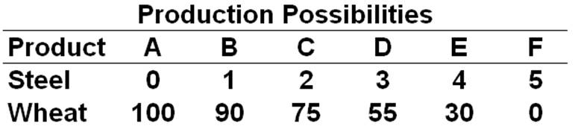  Refer to the above table. If the nation uses all of its resources to produce only wheat, then its production combination will be:  A. A  B. B  C. E  D. F

82. | A nation can produce two products: steel and wheat. The table below is the nation's production possibilities schedule:  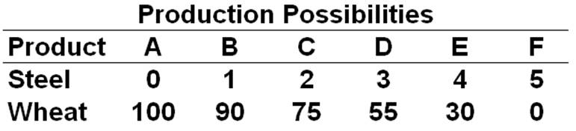  Refer to the above table. Which of the following output-combinations is unattainable:  A. 1 steel and 80 wheat  B. 4 steel and 55 wheat  C. 30 wheat and 3 steel  D. 95 wheat and 0 steel

83. | A nation can produce two products: steel and wheat. The table below is the nation's production possibilities schedule:  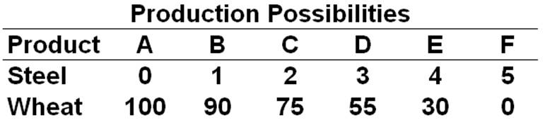  Refer to the above table. A change from combination C to B means that:  A. 1 unit of steel is given up to get 75 units of wheat  B. 2 units of steel are given up to get 75 units of wheat  C. 1 unit of steel is given up to get 15 more units of wheat  D. 2 units of steel are given up to get 15 more units of wheat

84. | A nation can produce two products: steel and wheat. The table below is the nation's production possibilities schedule:  Refer to the above table. The marginal opportunity cost of the third unit of steel is:  A. 18.3 units of wheat  B. 25 units of wheat  C. 20 units of wheat  D. 55 units of wheat

85. | A nation can produce two products: steel and wheat. The table below is the nation's production possibilities schedule:  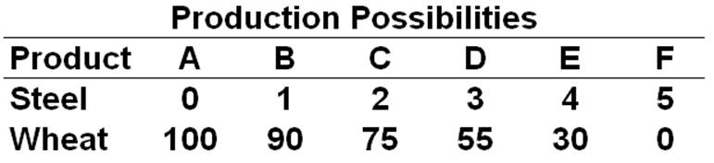  Refer to the above table. In moving from combination E to F, the opportunity cost of an additional unit of steel is:  A. 5 units of steel  B. 0 unit of wheat  C. 1 unit of steel  D. 30 units of wheat

86. | A nation can produce two products: steel and wheat. The table below is the nation's production possibilities schedule:  Refer to the above table. In moving stepwise from possibility A to B to C … to F, the opportunity cost of a unit of steel in terms of wheat:  A. Increases  B. Decreases  C. Remains constant  D. Increases at first then decreases

87. | A nation can produce two products: tanks and autos. The table below is the nation's production possibilities:  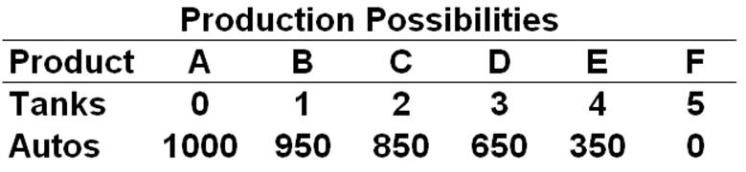  Refer to the above table. According to the production possibilities schedule, a combination of 4 tanks and 650 autos is:  A. Attainable, and involves an efficient use of society's resources  B. Attainable, but would not be in the best interests of a strong national defense  C. Less than (or below) the maximum attainable output combination  D. Not attainable because the nation does not have sufficient resources

88. | A nation can produce two products: tanks and autos. The table below is the nation's production possibilities:  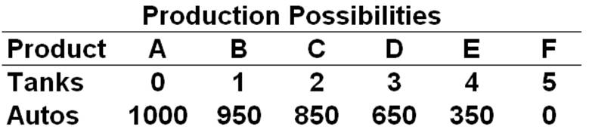  Given the production possibilities schedule above, a combination of 3 tanks and 350 autos:  A. Illustrates the tradeoff between tanks and autos  B. Is attainable but entails some unemployment or inefficient use of society's resources  C. Cannot be produced by society, given its current resources and production technology  D. Is not attainable because this combination is not listed in the schedule

89. | A nation can produce two products: tanks and autos. The table below is the nation's production possibilities:  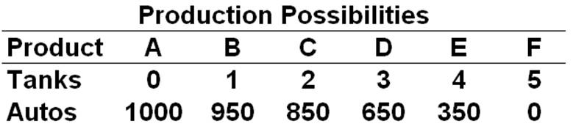  Refer to the above table. In moving from combination C to B, the opportunity cost of producing 100 more autos is:  A. 2 units of tanks  B. 1 unit of tanks  C. 850 units of autos  D. 1800 units of autos

90. | A nation can produce two products: tanks and autos. The table below is the nation's production possibilities:  Refer to the above table. The total opportunity cost of three units of tanks is:  A. 6 units of tanks  B. 350 units of autos  C. 650 units of autos  D. 1000 units of autos

91. | A nation can produce two products: tanks and autos. The table below is the nation's production possibilities:  Refer to the above table. The marginal opportunity cost of the fourth unit of tanks is:  A. 4 units of tanks  B. 300 units of autos  C. 350 units of autos  D. 1000 units of autos

92. | A nation can produce two products: tanks and autos. The table below is the nation's production possibilities:  Refer to the above table. If the nation produces more and more tanks, the opportunity cost of each additional tank in terms of autos:  A. Remains constant  B. Falls  C. Increases  D. Cannot be measured

93. | In a graph of the production possibilities curve, the two axes of the graph indicate the:  A. Prices of the two products that a nation can produce  B. Maximum quantities of the two resources that a nation possesses  C. Price of the products on the vertical axis, and quantities on the horizontal  D. Quantities of the two products that a nation can produce

94. | A point inside the production possibilities curve is ____ while a point outside the curve is ____.  A. Attainable; unattainable  B. Unattainable; attainable  C. Below the maximum possible; the maximum possible  D. The maximum possible; below the maximum possible

95. | A point or combination that is on the production possibilities curve is:  A. Attainable and resources are fully employed  B. Attainable, but some resources are unemployed  C. Unattainable, but some resources are unemployed  D. Attainable only if we get additional resources

96. | A point outside (to the right of) the production possibilities curve of a nation:  A. Is not attainable for this nation  B. Is easily attainable for this nation  C. Implies that there are unemployed resources in this nation  D. Implies that this nation is using its resources fully

97. | The following graph is the production possibilities curve of a nation:  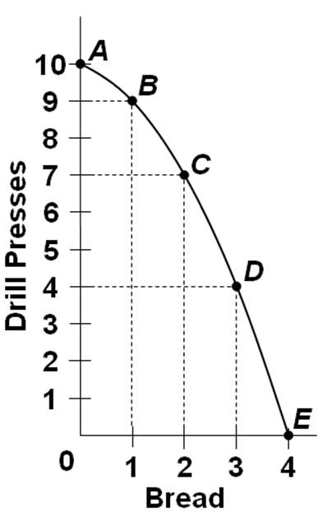  Refer to the above graph. The combination "5 drill presses and 2 bread" indicates:  A. An unattainable combination for the nation  B. Some resources in the nation are unemployed  C. An ideal combination for the nation  D. A combination produced when the nation is at full employment

98. | The following graph is the production possibilities curve of a nation:  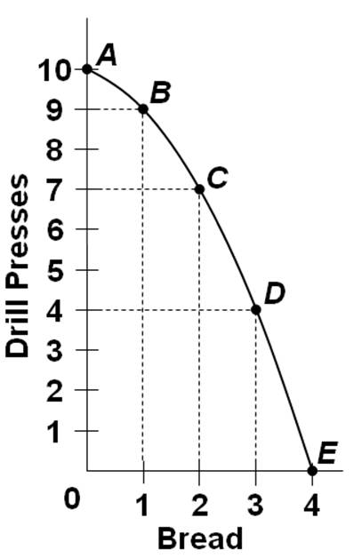  Refer to the above graph. Which of the following combinations would be unattainable?  A. 8 drill presses and 1 bread  B. 7 drill presses and 2 bread  C. 10 drill presses and 4 bread  D. 2 drill presses and 3 bread

99. | The following graph is the production possibilities curve of a nation:  Refer to the above graph. The total opportunity cost of nine drill presses is:  A. 1 unit of bread  B. 1 unit of drill presses  C. 3 units of bread  D. 10 units of drill presses

100. | The following graph is the production possibilities curve of a nation:  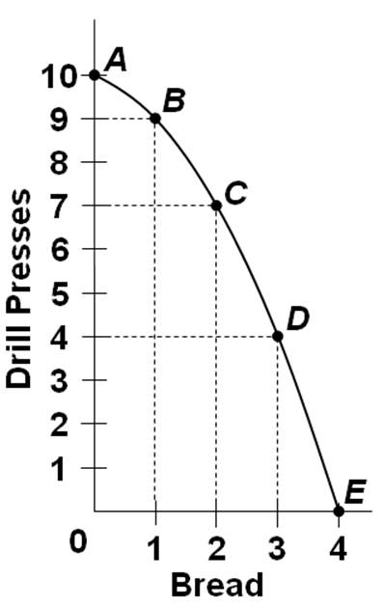  Refer to the above graph. The marginal opportunity cost of the fourth unit of bread is:  A. 0 unit of drill presses  B. 1 unit of drill presses  C. 3 units of drill presses  D. 4 units of drill presses

101. | A movement from one point to another along the production possibilities curve would imply that:  A. The labor force available to society has grown  B. Productivity has increased over time  C. Productivity has declined over time  D. Society is producing a different combination of outputs

102. | If a nation is initially on its production possibilities curve, then it can increase its production of one good only by:  A. Decreasing the production of the other good  B. Increasing the production of the other good  C. Holding constant the production of the other good  D. Decreasing the price of the other good

103. | Because of increasing opportunity costs, the production possibility curve:  A. Is bowed out from (or concave to) the origin  B. Can be either downward- or upward-sloping  C. At first rises, then falls eventually  D. Is a straight downward-sloping line

104. | The law of increasing opportunity costs states that:  A. Costs of production increase for one good, but costs decrease for the other good  B. Increases in wages and other resource costs is what the increasing opportunity costs refer to  C. Increases in the production of one good require larger and larger sacrifices of the other good  D. Increases in the production of one good make the production of that good and easier

105. | If the opportunity cost of producing extra units of one good (expressed in terms of the amount of another good given up) remains constant, then the shape of the production possibilities curve is:  A. A straight horizontal line  B. A straight downward-sloping line  C. An upward-sloping line  D. A vertical line

106. | Which of the following statements is an explanation for the law of increasing opportunity costs?  A. Many economic resources are better at producing one product rather than another  B. The economy is employing all of its available resources  C. In any economy, the state of technology is changing and resources are variable  D. The economy is achieving productive efficiency by producing goods at the least cost

107. | If the production possibilities curve is a straight line, then:  A. The opportunity cost of producing one good is zero  B. The law of increasing opportunity costs does not apply  C. The society can produce more of both goods simultaneously  D. The society is capable of producing only one of the goods and not the other

108. | If economic resources are perfectly interchangeable between the two products shown on a production possibilities graph:  A. The economy will always be at full employment  B. More of one product can be produced without producing less of the other product  C. The production possibilities curve would be a straight line  D. The two products are of equal value to the economy

109. | The best output or the optimal production of the nation is:  A. A combination of products at the midpoint of the production possibilities curve  B. A combination of products at the two endpoints of the production possibilities curve  C. Determined by equalizing the marginal benefits and marginal costs of each product  D. The production combination where the opportunity costs are minimized

110. | When a nation is under-allocating resources to the production of a good, then the:  A. Marginal benefit is greater than the marginal cost of the good  B. Marginal benefit is less than the marginal cost of the good  C. Marginal cost of producing the good is decreasing  D. Marginal benefit of producing the good is increasing

111. | If the marginal benefit of a good is less than its marginal cost, then the nation should:  A. Produce more of that good  B. Maintain the current level of production of that good  C. Reduce the marginal benefit of that good  D. Reduce the production of that good

112. | Suppose that a nation can only make two products: defense goods and civilian goods. In a graph of the marginal benefit (MB) and marginal cost (MC) of defense goods, a leftward shift of the MB curve will cause the optimal quantity of:  A. Civilian goods to decrease  B. Both civilian goods and defense goods to decrease  C. Defense goods to decrease  D. Defense goods to increase

113. | Imagine an ideal scenario where world peace prevails and all nations are led by peace-minded leaders. In such a world, the:  A. MB for defense goods would shift left  B. MB for defense goods would shift right  C. MC for defense goods would shift left  D. MC for defense goods would shift right

114. | 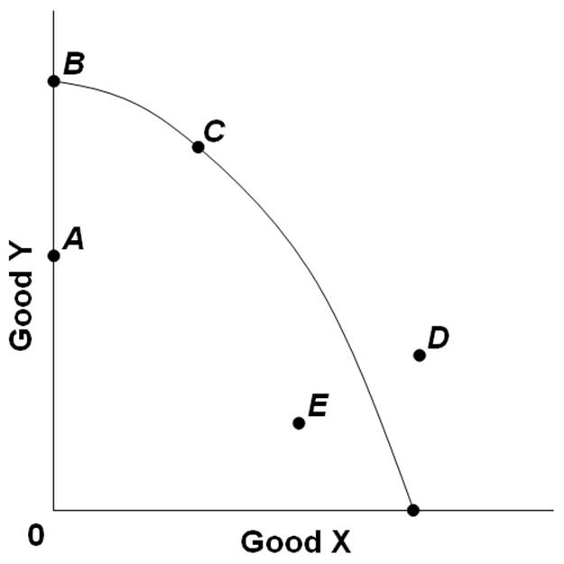  The graph above shows the production possibilities curve for an economy producing two goods, X and Y. Which of the points on the graph indicate unemployed resources?  A. D only  B. E and A only  C. B and A only  D. B and C only

115. | 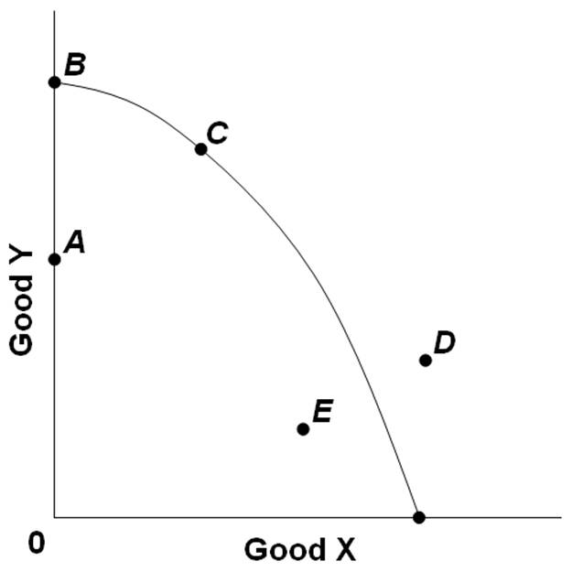  The graph above shows the production possibilities curve for an economy producing two goods, X and Y. All of the following may allow the economy to produce combination D in the future, except?  A. Lower unemployment  B. Increasing labor supply  C. Economic growth  D. Technological advances

116. | 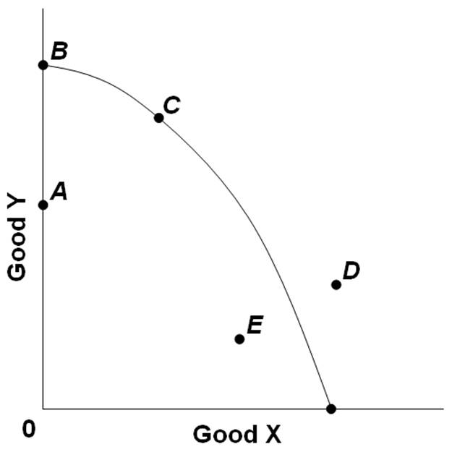  Refer to the above graph. Which of the following movements would indicate economic growth?  A. From point A to point C  B. From point B to point C  C. From point A to point E  D. From point C to point D

117. | If a nation is operating at a point inside the production possibilities curve, it indicates that the nation could:  A. Increase its production of both goods X and Y simultaneously  B. Increase its production of one good, but only at the expense of reducing the other good  C. Not produce any more of one of the goods X or Y  D. Not employ any more resources because all resources are now employed

118. | Consider an economy that is producing inside its production possibilities curve. This economy could move closer towards its production possibilities curve by:  A. Distributing incomes more equally  B. Employing more of its available resources  C. Increasing the levels of wages and prices  D. Acquiring additional resources

119. | A reduction in the level of unemployment would have which effect with respect to the nation's production possibilities curve?  A. It would shift the curve to the right  B. It would shift the curve to the left  C. It would not shift the curve; it would be represented by a movement from a point inside the curve toward a point on the curve  D. It would not shift the curve; it would be represented by a movement from a point on the curve to a point outside the curve

120. | 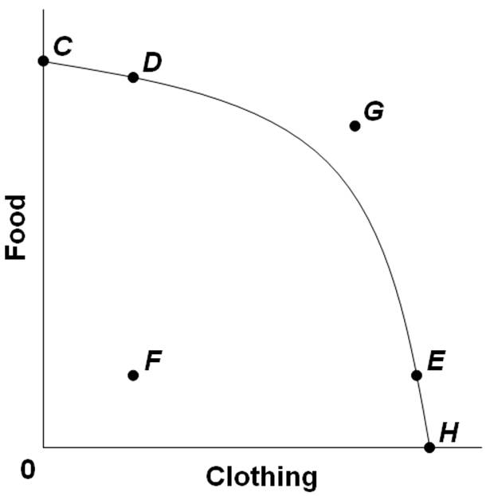  Refer to the above graph. Which of the following movements would indicate a reduction in unemployment?  A. From point C to point D  B. From point F to point H  C. From point E to point D  D. From point D to point G

121. | 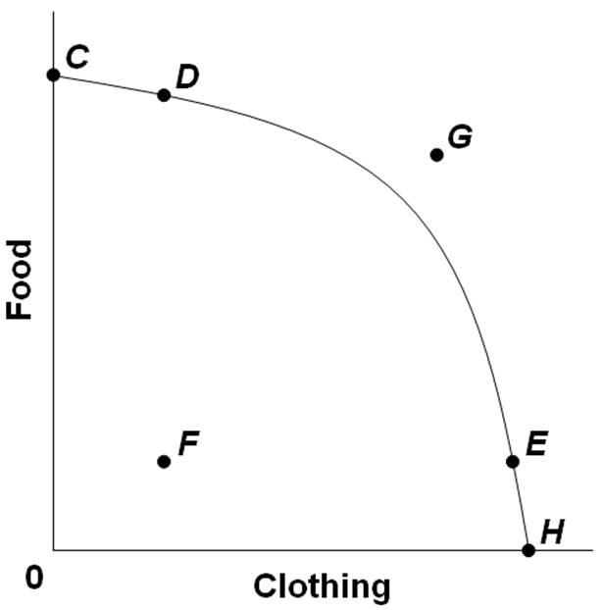  Refer to the above graph. Which of the following statements about combination G is true?  A. The nation cannot produce combination G even if the nation gets additional resources  B. The nation can currently produce combination G if the nation specializes and trades with another nation  C. The nation may not be able to produce combination G, but it can consume that combination if it specializes and trades  D. The nation would much prefer to be at combination F than at combination G

122. | 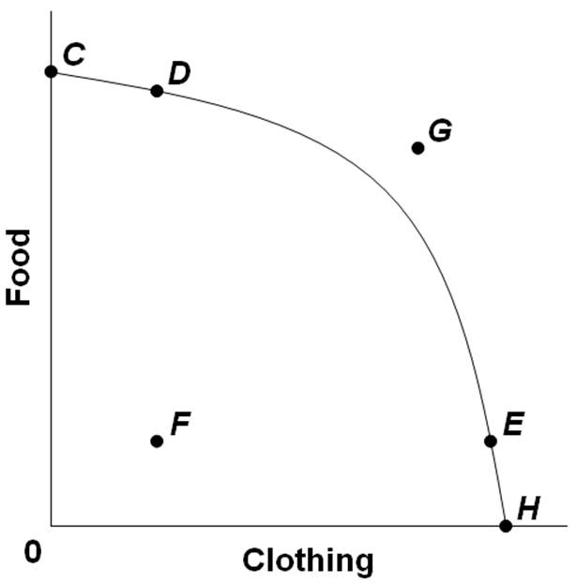  Which point or output-combination in the above graph could the nation produce only if it experienced economic growth?  A. Combination F  B. Combination G  C. Combination C  D. Combination E

123. | Economic growth may be represented by:  A. A movement from one end of the production possibilities curve to the other  B. An upward-sloping production possibilities curve  C. A movement from a point inside to a point on the production possibilities curve  D. A rightward shift of the production possibilities curve

124. | Economic growth is a result of:  A. A reduction in the unemployment rate  B. An increase in the opportunity costs of production  C. A decrease in the demand for resources  D. An increase in the supply of resources

125. | A nation that devotes more of its resources to the production of capital goods is likely to:  A. Cause its production possibilities curve to shift outward  B. Cause its production possibilities curve to shift inward  C. Increase the slope of its production possibilities curve  D. Decrease the slope of its production possibilities curve

126. | Which of the following statements is not correct?  A. An increase in a nation's labor supply will cause its potential output to increase  B. Economic growth can be illustrated by an expansion of a nation's production possibilities curve  C. An increase in the quantity of a nation's resources will cause economic growth, but an increase in the quality of resources will not  D. New technologies or new ways of producing output can cause a nation's production possibilities curve to shift outwards

127. | 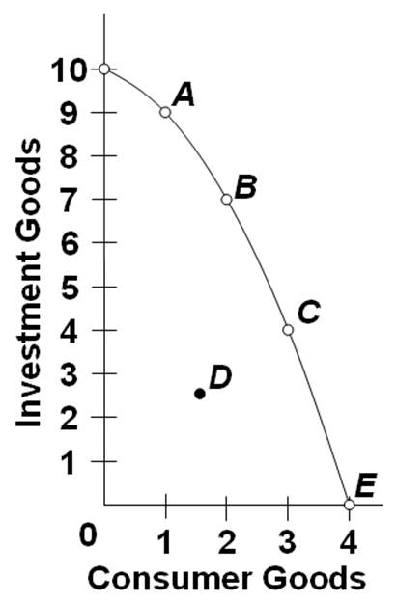  Refer to the above graph. Which point in the graph would allow a simultaneous increase in the production of both investment and consumer goods?  A. A  B. B  C. C  D. D

128. | 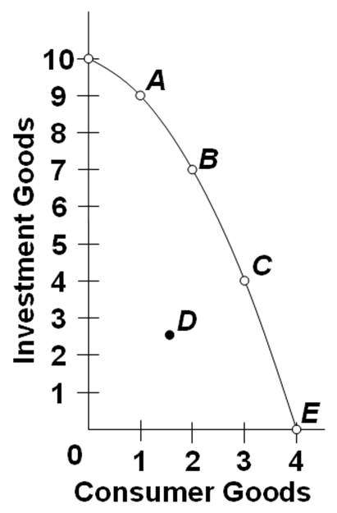  Refer to the above graph. The selection of which point on the production possibilities curve is most like to result in the largest increase in economic growth over time?  A. A  B. B  C. C  D. D

129. | Refer to the above graph. All of the following development would allow a movement from point C to a point outside the production possibilities curve, except:  A. An increase in the supply of resource  B. An improvement in the quality of resources  C. A reduction in unemployment of resources  D. A technological advance

130. | 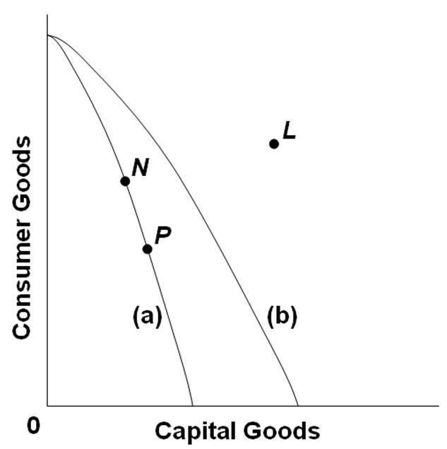  Refer to the above production possibilities curves. Curve (a) is the current curve for the economy. Focusing on curve (a), point N suggests that the economy currently produces:  A. More goods for the future than at point P  B. Less goods for the future than at point P  C. Less goods for the present than at point P  D. A combination of output that is less than its potential

131. | 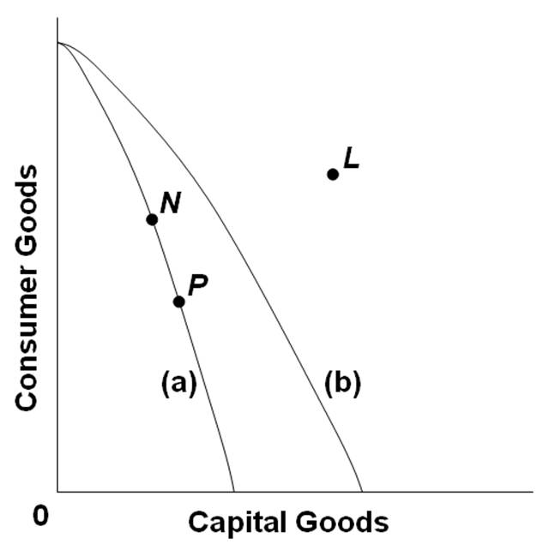  Refer to the above production possibilities curves. Curve (a) is the initial curve for the economy, and the nation is initially producing combination P. A shift from curve (a) to curve (b) suggests that the economy can then increase its production of capital goods:  A. Only if it reduces its production of consumer goods  B. So as to produce the combination L  C. And consumer goods simultaneously  D. But will have to hold constant its production of consumer goods

132. | Refer to the above production possibilities curves. Curve (a) is the initial curve for the economy. If the economy's production possibilities then shift to curve (b), then:  A. Point N would still indicate a case of full production and full employment of resources  B. Point P would still indicate a case of full production and full employment of resources  C. Point N would indicate some unemployment or underemployment of resources  D. Point L would indicate some unemployment or underemployment of resources

133. | Suppose there are two economies, Alpha and Beta, which have the same production possibilities curves. If Beta devotes more resources to produce capital goods than consumer goods as compared to Alpha, then in the future:  A. Alpha will experience greater economic growth than Beta  B. Beta will experience greater economic growth than Alpha  C. Alpha will not be able to achieve full employment or productive efficiency  D. Beta will not be able to achieve full employment or productive efficiency

134. | Cuba is a command economy that suffered a decline in economic growth because of a cut in the aid provided by the former Soviet Union when the latter collapsed. As a consequence, Cuba:  A. Experienced an outward shift of its production possibilities curve  B. Experienced an inward shift of its production possibilities curve  C. Moved from one point to another along its existing production possibilities curve  D. Went to a point inside its production possibilities curve

135. | Which situation would most likely cause a nation's production possibilities curve to shift inward?  A. An increase in unemployment  B. An increase in the amount of imports  C. An increase in the number of skilled immigrant workers  D. The destruction caused by bombing and warfare in a losing military conflict

136. | A nation can increase its production possibilities by:  A. Shifting resources to produce more consumer goods and less investment goods  B. Shifting resources from private goods to public goods  C. Improving labor productivity  D. Eliminating unemployment

137. | A society can consume a combination of goods outside its production possibilities if there is:  A. Lower unemployment  B. International specialization and trade  C. A change in consumers' tastes  D. A change in prices

138. | Specialization and international trade allows a nation to:  A. Produce a combination of goods that is beyond (or outside) its production possibilities  B. Consume a combination of goods that is beyond (or outside) its production possibilities  C. Have an upward-sloping production possibilities curve  D. Consume a lot of goods without having to produce any output

139. | Which pitfall to sound economic reasoning is reflected in a person's view that "pharmaceutical and oil companies are price-gouging the consumers"?  A. Faulty definition  B. Post hoc fallacy  C. Loaded terminology  D. Confusing correlation and causation

140. | Which pitfall to sound economic reasoning is illustrated when a person comments that "capitalists focus only on profits and don't care about their workers"?  A. Abstraction  B. Biases  C. The fallacy of composition  D. Confusing correlation and causation

141. | A person observes that consumer prices often fall when a nation experiences economic growth. The person then concludes that falling consumer prices leads to economic growth. This would be an example of:  A. The fallacy of composition  B. Biases  C. Confusing correlation and causation  D. The use of loaded terminology

142. | You observe that when stock prices rise, interest rates soon fall, and therefore conclude that higher stock prices lead to lower interest rates. This would be an example of:  A. The fallacy of composition  B. Tradeoff among economic goals  C. The post hoc fallacy  D. The use of loaded terminology

143. | Increasing the share of your income that you save is good for you. Therefore it would be good for the whole economy if everyone saved more. This exemplifies the:  A. Post hoc fallacy  B. Fallacy of composition  C. Use of loaded terminology  D. Confusion between correlation and causation

144. | Which of the following is the fallacy in the fallacy of composition?  A. Whatever goes up must come down  B. Facts are more important than theories  C. What is true for the part is necessarily also true for the whole  D. If event B occurs after event A, event A must have caused event B

145. | The post hoc, ergo propter hoc fallacy consists of:  A. Using an example to "prove" a different point  B. Inferring causality from chronological sequence  C. Jumping to conclusions from an inadequate number of cases  D. Arguing for or against a person's character rather than his view or opinion

True / False Questions
146. | Economics is the social science concerned with the best use of scarce resources to achieve maximum satisfaction of economic wants.  True False

147. | Marginal analysis is the valuation of insignificant or small benefits from doing things.  True False

148. | Rational behavior implies that different people faced with similar choices will make the same decisions.  True False

149. | Economic analysis is primarily concerned with marginal changes from the status quo, as a result of a certain action or decision.  True False

150. | The study of economics is not useful for consumers because economic analysis focuses only on businesses and the economy.  True False

151. | The scientific method does not apply to economics because economics studies human behavior which cannot be generalized.  True False

152. | Economic principles are value judgments about what the economy should be like or the way the economic world ought to be.  True False

153. | If falling gasoline prices are good for the consumers, then it must be good everyone in the economy.  True False

154. | Macroeconomics is concerned with the study of the nation-wide market for specific goods like oranges.  True False

155. | The comment that "taxes must be reduced for the good of the economy" is an example of a normative economic statement.  True False

156. | "The role of government in the economy should be kept to a minimum" is an example of a positive economic statement.  True False

157. | The economizing problem for individuals arises from the conflict between having relatively unlimited time and relatively limited jobs to do.  True False

158. | The budget line shows the various incomes that an individual can earn from different jobs.  True False

159. | The fundamental economic problem faced by a society is that productive resources are so varied and versatile, that it is hard to decide what to do with them.  True False

160. | The resource category called "land" includes forests, animals, and water resources.  True False

161. | When economists talk about the capital resources in the economy, they are referring to the amount of money circulating in the economy.  True False

162. | The quantity or supply of land resources available to a nation is pretty much fixed and cannot increase over time.  True False

163. | Entrepreneurship refers to a new college graduate who is looking for a job with a large company.  True False

164. | If economic resources were perfectly adaptable to alternative uses, then there would be constant opportunity costs along the production possibilities curve.  True False

165. | If the marginal benefits are greater than the marginal cost of an activity, then society should allocate fewer resources to this activity.  True False

166. | If society has over-allocated resources to a particular activity, then the marginal benefits of the activity would be less than the marginal costs.  True False

167. | A nation's production possibilities curve shows the maximum combinations of resources that a nation can use.  True False

168. | A reduction in the unemployment rate will cause the nation's production possibilities curve to shift outwards.  True False

169. | Economic growth is shown as an increase in production from inside the production possibilities curve out toward a point on the possibilities curve.  True False

170. | An increase in the labor supply due to immigration would shift the production possibilities curve to the left.  True False

171. | A nation's consumption is strictly limited by its production possibilities, even with international trade.  True False

Multiple Choice Questions
172. | If two variables are directly related, the relationship will have a graph that:  A. Is a straight line  B. May either be upward-sloping or downward-sloping  C. Is an upward-sloping line  D. Is horizontal

173. | If an inverse relationship exists between two variables, then:  A. As one variable increases, the other decreases  B. As one variable increases, so does the other  C. The two variables are close substitutes for each other  D. Both variables increase over time

174. | If two variables are completely unrelated to each other, then graphing these two variables will yield a line that is:  A. Always vertical  B. Always horizontal  C. Not a line, but only a single point  D. Either vertical or horizontal

175. | If A decreases, then B will also decrease. The graph relating the two variables A and B is:  A. Vertical  B. Downward-sloping  C. Upward-sloping  D. Horizontal

176. | In a relationship between two variables, the "independent variable" refers to the:  A. One measured on the vertical axis, in the convention of mathematics  B. One whose value is assumed constant  C. Effect or outcome  D. Cause or source variable

177. | The "other things equal" assumption is employed when:  A. The graph of a given relationship is shifting up or down  B. Economists draw a two-dimensional (or two-axes) graph  C. The relationship in direct, but not when it is inverse  D. The relationship in inverse, but not when it is direct

178. | The slope of a graph that shows a direct relationship is:  A. Always positive  B. Either positive or negative  C. Possibly zero  D. Either zero or infinite

179. | The slope of a graph with "income" on the horizontal axis and "saving" on the horizontal axis is +0.2. This means that if: (BOTH SAY HORIZONTAL)  A. Income is $100, then saving is $20  B. Income is 0.20, then saving is zero  C. Income increases by $100, then saving will rise by $20  D. Saving rises by $100, then income will rise by $20

180. | The question below are based on the following four sets of data-pairs: (1) A and B, (2) C and D, (3) E and F, and (4) G and H. In each set, the independent variable is in the left column and the dependent variable is in the right column.  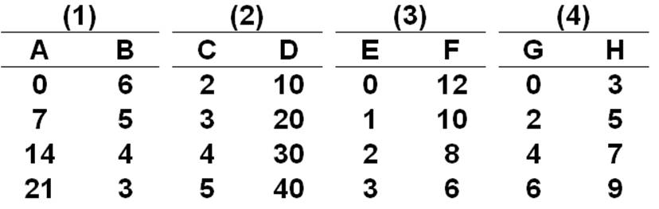  Which of the four sets of data pairs shows an inverse relationship between the independent and dependent variable?  A. 1 and 3  B. 2 and 3  C. 3 and 4  D. 2 and 4

181. | The question below are based on the following four sets of data-pairs: (1) A and B, (2) C and D, (3) E and F, and (4) G and H. In each set, the independent variable is in the left column and the dependent variable is in the right column.  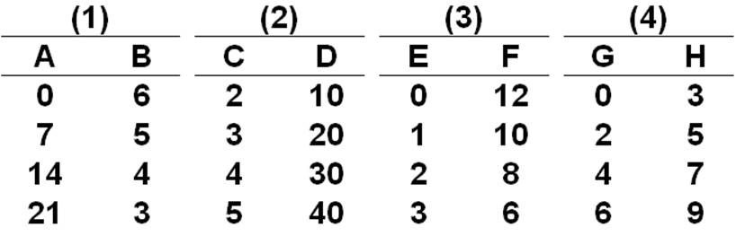  The slope of the linear graph that pictures data set 2 above is:  A. .10  B. 20  C. 5  D. 10

182. | The question below are based on the following four sets of data-pairs: (1) A and B, (2) C and D, (3) E and F, and (4) G and H. In each set, the independent variable is in the left column and the dependent variable is in the right column.  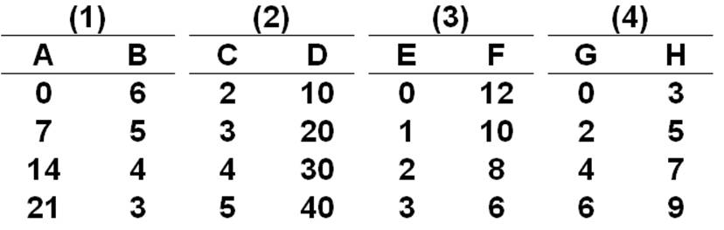  The vertical intercept is 12 in which of the above data sets?  A. 1  B. 2  C. 3  D. 4

183. | The question below are based on the following four sets of data-pairs: (1) A and B, (2) C and D, (3) E and F, and (4) G and H. In each set, the independent variable is in the left column and the dependent variable is in the right column.  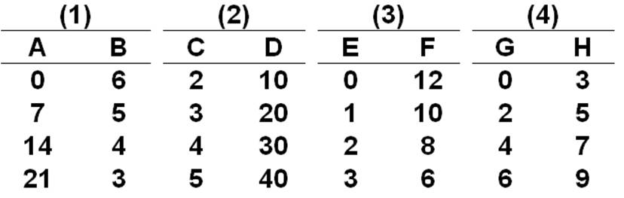  The linear equation for the relationship in data set 1 above is:  A. B = 6A  B. B = 6 + 7A  C. B = 6 - 7A  D. B = 6 - .14A

184. | In a constructing the demand graph to show how the price of a good price affects how much of it the buyers will buy, the convention that economists follow is to measure price on the:  A. Horizontal axis because it is the independent variable  B. Vertical axis because it is the dependent variable  C. Vertical axis even though it is the independent variable  D. Horizontal axis even though it is the dependent variable

185. | A relationship illustrated by an upward-sloping graph means that an:  A. Increase in the value of one variable causes the value of the other to decrease  B. Decrease in the value of one variable causes the value of the other to decrease  C. Decrease in the value of one variable causes the value of the other to increase  D. Increase in the value of one variable causes no change in the other variable

186. | In a graph of the relationship between income and saving, economists generally consider:  A. Income to be the independent variable and place it on the vertical axis  B. Income to be the dependent variable and place it on the horizontal axis  C. Saving to be the dependent variable and place it on the vertical axis  D. Saving to be the independent variable and place it on the vertical axis

187. | In a graph showing the relationship between variables X and Y, ceteris paribus means that:  A. X is inversely related to Y  B. X is positively related to Y  C. X and Y are independent  D. Other variables not shown are held constant

188. | In a graph with "crop yield" on the vertical axis and "rainfall" on the horizontal axis, the vertical intercept refers to the:  A. Steepness or flatness of the graph  B. Amount of rainfall when "crop yield" is zero  C. Amount of crop yield when "rainfall" is zero  D. Total crop yield during a given period of time

189. | Which of the following indicates an inverse relationship between x and y?  A. y = -3 + 5x  B. y = 6.2x  C. y = 7 - 0.9x  D. y = -50

190. | Which of the following suggests a direct relationship between x and y?  A. A change in y = -2 coupled with a change in x = -4  B. A change in y = 2 coupled with a change in x = 0  C. A change in y = -1 coupled with a change in x = 4  D. A change in y = 6 coupled with a change in x = -11

191. | 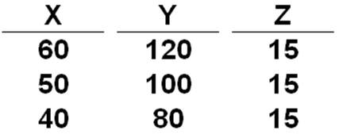  Variables X and Y in the above table are:  A. Positively related  B. Negatively related  C. Not directly related  D. Independently related

192. | Variables X and Z in the above table are:  A. Positively related  B. Negatively related  C. Independent  D. Nonlinearly related

193. | 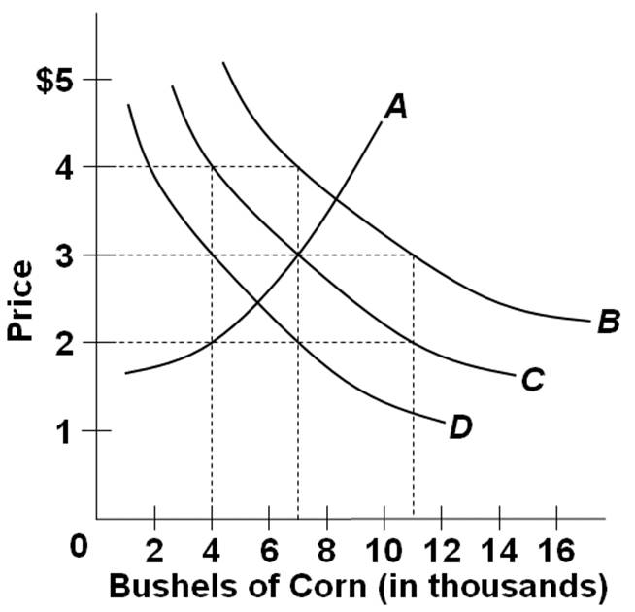  Refer to the following table which shows the quantities of corn demanded at various levels of corn price (hypothetical data).  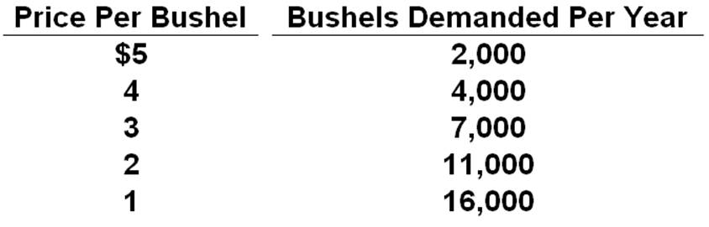  Which curve in the graph shown above best represents the data in the table?  A. A  B. B  C. C  D. D

194. | 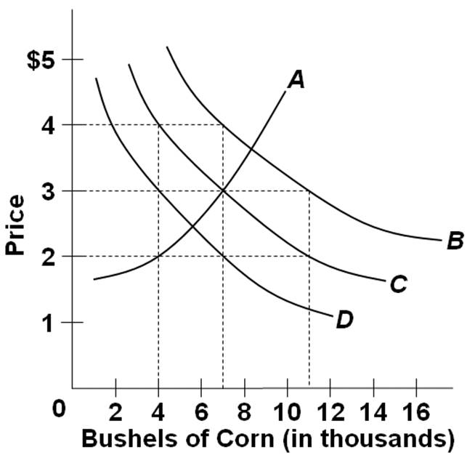  Refer to the above graph. Which curve shows a direct relationship between price and quantity?  A. A  B. B  C. C  D. D

195. | 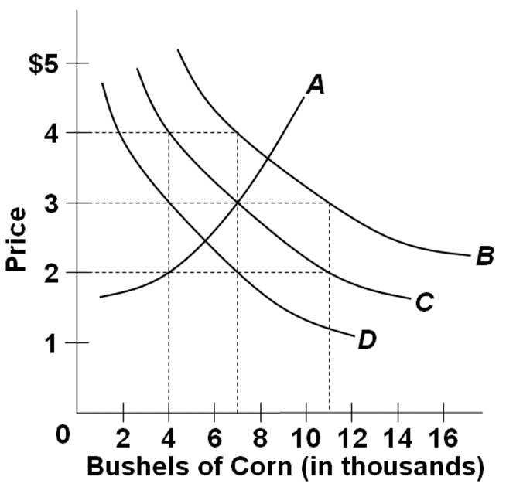  Refer to the above graph. From the economists' perspective, which is the independent variable and which is the dependent variable?  A. Price is the independent variable and quantity demanded is the dependent variable  B. Price is the dependent variable and quantity demanded is the independent variable  C. Both price and quantity demanded are independent variables  D. Both price and quantity demanded are dependent variables

196. | 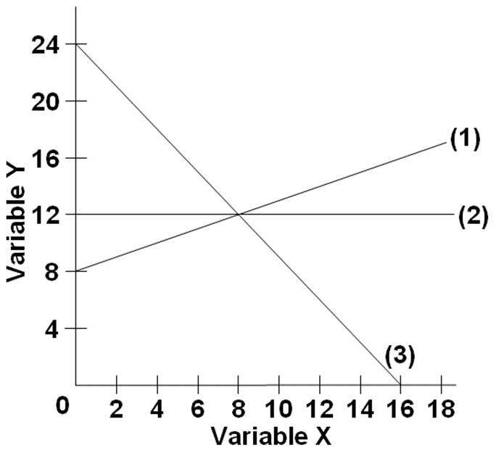  In line (2) on the above graph, the variables x and y are:  A. Nonlinearly related  B. Directly related  C. Not correlated  D. Inversely related

197. | 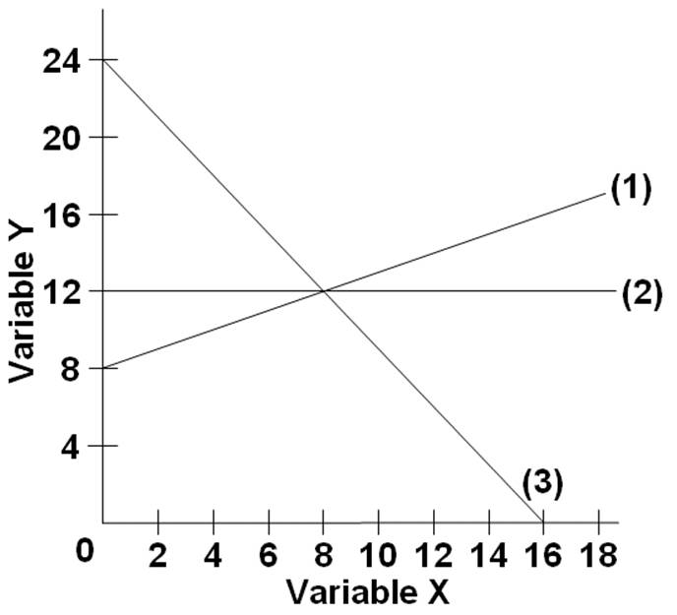  The slope of line (2) on the above graph is:  A. 0  B. 12  C. 18  D. Infinite

198. | The linear equation for line (1) on the above graph is:  A. y = 8 + 2x  B. y = 8 + .5x  C. x = 8 + .5y  D. y = 8 - 2x

199. | The vertical intercept of line (3) on the above graph is:  A. 16  B. 24/16 or 1.5  C. 24  D. -24/16 or -1.5

200. | If a linear relation is described by the equation was C = 35 - 5D, then the vertical intercept of the graph (where C is on the vertical axis) is:  A. 35  B. -5  C. 30  D. Not known

201. | If you knew that the vertical intercept for a straight line was 15, that the slope was -.5, and that the independent variable had a value of 8, the value of the dependent variable would be:  A. 8  B. 9  C. 10  D. 11

202. | If you knew that the vertical intercept for a straight line was 150 and that the slope of the line was 4, then the dependent variable would be 250 when the value of the independent variable is:  A. 15  B. 20  C. 25  D. 30

203. | 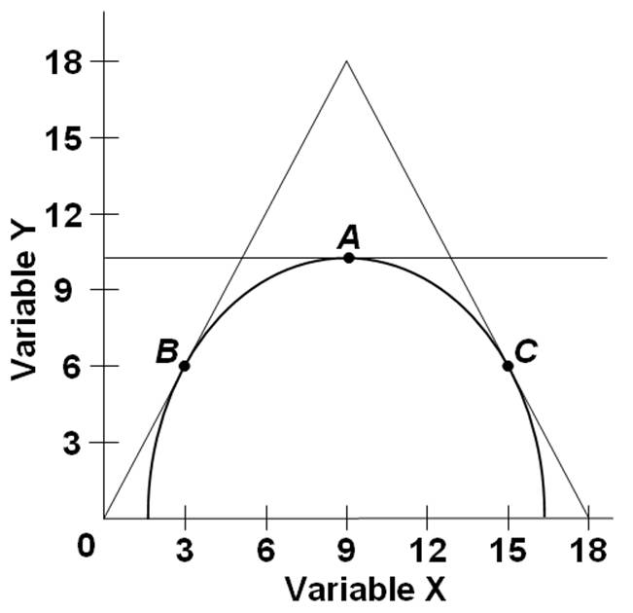  Refer to the above graph. The slope of the line tangent to the curve at point A is:  A. 0  B. .5  C. 2  D. 4

204. | 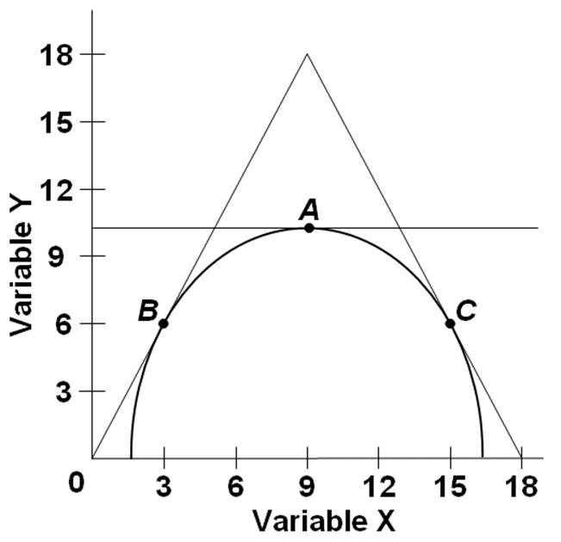  Refer to the above graph. The slope of the line tangent to the curve at point B is:  A. 0.5  B. 3  C. 6  D. 2.0

205. | 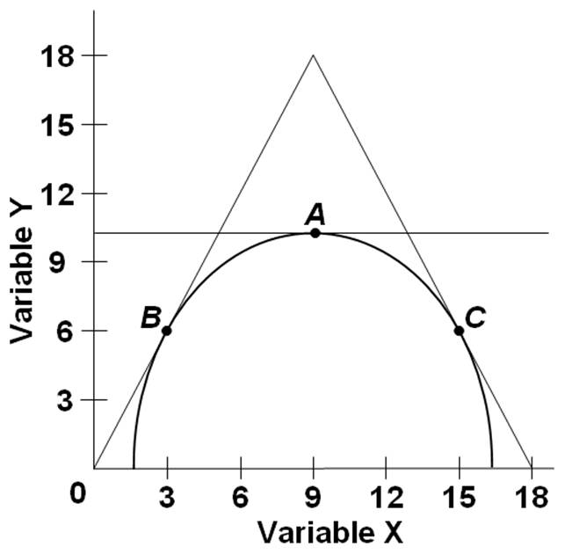  Refer to the above graph. The slope of the tangent line at various points on the curve as the value of X increases (i.e., as we move to the right along the curve) is: (confusing)  A. Increasing in algebraic value  B. Decreasing in algebraic value  C. Becoming more positive  D. Becoming less negative

206. | If you knew that the intercept for a straight line was 12, and that if the value of the independent variable was 3 the value of the dependent variable would be 18, then the slope of the line would be:  A. 1  B. 2  C. 3  D. 4

207. | In a linear equation relating income and consumption, you know that the intercept is $1,000 and the slope of the line is .4. If income is $20,000, then consumption is:  A. $8,000  B. $9,000  C. $10,000  D. $11,000

True / False Questions
208. | If two sets of data are inversely related, they will appear on a graph as an upward-sloping line.  True False

209. | If A is the dependent variable and B is the independent variable, then a change in A results in a change in B.  True False

210. | A linear relationship only refers to one whose graph is either vertical or horizontal.  True False

211. | In graphing a relationship between two variables, economists always follow the mathematical convention. Thus, if price is the independent variable then it is measured on the horizontal axis.  True False

212. | An assumption is usually made in a two-axes (or two-dimensional) graph that, aside from the two variables under study, the influence of all other variables or factors is assumed to be constant.  True False

213. | The slope of a graph measures the rate of change in one variable as the other variable changes.  True False

214. | The slope of a graph relating two variables is -5. This indicates that as one variable decreases, the other variable also decreases.  True False

215. | In the graph for the linear equation S = 15 - 5T, with T on the horizontal axis, the vertical intercept of the graph is -5.  True False

216. | In a curved graph that is dome-shaped, the tangent line at it maximum or highest point has an infinite slope.  True False

Chapter 01 Limits, Alternatives, Choices Answer Key
Multiple Choice Questions
1. | Economics is a social science that studies how individuals, institutions, and society may:  A. Expand the amount of resources available to them  B. Attain a minimum level of production  C. Best use resources to maximize satisfaction of economic wants  D. Reduce the amount of goods and services they need

AACSB: Analytic
Accessibility: Keyboard Navigation
Blooms: Remember
Difficulty: 1 Easy
Learning Objective: 01-01 Define economics and the features of the economic perspective.
Topic: The Economic Perspective

2. | The basic truth that underlies the study of economics is the fact that we all face:  A. Death  B. Taxes  C. Risk  D. Scarcity

AACSB: Analytic
Accessibility: Keyboard Navigation
Blooms: Remember
Difficulty: 1 Easy
Learning Objective: 01-01 Define economics and the features of the economic perspective.
Topic: The Economic Perspective

3. | A recurring theme in economics is that people:  A. Have unlimited resources, but limited economic wants  B. Can increase resources by limiting their economic wants  C. Have limited economic wants and limited resources  D. Have unlimited economic wants, but limited resources

AACSB: Analytic
Accessibility: Keyboard Navigation
Blooms: Remember
Difficulty: 1 Easy
Learning Objective: 01-01 Define economics and the features of the economic perspective.
Topic: The Economic Perspective

4. | As a consequence of the problem of scarcity:  A. There is never enough of anything  B. Individuals have to make choices from among alternatives  C. Only some people can "have it all"  D. Things which are plentiful have relatively high prices

AACSB: Reflective Thinking
Accessibility: Keyboard Navigation
Blooms: Understand
Difficulty: 2 Medium
Learning Objective: 01-01 Define economics and the features of the economic perspective.
Topic: The Economic Perspective

5. | What does "there is no such thing as a free lunch" mean in economics?  A. That scarce resources are used up to provide "freebies" and giveaways  B. That sometimes people may take friends out to lunch and pay for them  C. That all items in the lunch menu have specific prices  D. That products only have value because people are willing to pay for them

AACSB: Communication
Accessibility: Keyboard Navigation
Blooms: Understand
Difficulty: 2 Medium
Learning Objective: 01-01 Define economics and the features of the economic perspective.
Topic: The Economic Perspective

6. | The idea in economics that "there is no free lunch" means that:  A. Businesses would go bankrupt if they offered free lunches  B. The thought of a free lunch is often better than the reality of consuming it  C. There are opportunity costs involved even in free lunches  D. Free lunches used by businesses to attract customers is an inefficient marketing ploy

AACSB: Communication
Accessibility: Keyboard Navigation
Blooms: Understand
Difficulty: 2 Medium
Learning Objective: 01-01 Define economics and the features of the economic perspective.
Topic: The Economic Perspective

7. | The opportunity cost of doing or getting something is best and fully defined as:  A. The difference between the marginal cost and benefit of doing something  B. The materials used in doing or getting something  C. The value of the best alternative that is given up in order to do or get something  D. The money spent in doing or getting something

AACSB: Communication
Accessibility: Keyboard Navigation
Blooms: Remember
Difficulty: 1 Easy
Learning Objective: 01-01 Define economics and the features of the economic perspective.
Topic: The Economic Perspective

8. | Economic analysis assumes "purposeful behavior", which means that people will pursue decisions or actions:  A. That will increase their well-being  B. Always based on full or complete information  C. With minimal consideration for their emotions  D. Without any logical faults

AACSB: Communication
Accessibility: Keyboard Navigation
Blooms: Remember
Difficulty: 1 Easy
Learning Objective: 01-01 Define economics and the features of the economic perspective.
Topic: The Economic Perspective

9. | In analyzing human decision and action, economists assume that:  A. Scarcity is more important than choice  B. Costs are more important than benefits  C. People's behavior reflects rational self-interest  D. There are scarce resources in the economy

AACSB: Analytic
Accessibility: Keyboard Navigation
Blooms: Remember
Difficulty: 1 Easy
Learning Objective: 01-01 Define economics and the features of the economic perspective.
Topic: The Economic Perspective

10. | The notion of "purposeful behavior" in the economic perspective suggests that:  A. People will tend to stick with a particular choice for a long period of time  B. Economic analysis will provide people with a single "right" way to behave  C. Economists do not believe that people can sometimes behave impulsively  D. One person's choice may differ from another's if their circumstances and information differ

AACSB: Communication
Accessibility: Keyboard Navigation
Blooms: Remember
Difficulty: 1 Easy
Learning Objective: 01-01 Define economics and the features of the economic perspective.
Topic: The Economic Perspective

11. | When studying human behavior, economists assume rational self-interest. This means that:  A. People make decisions based on some desired outcome  B. People are quite selfish, and are not concerned about others  C. People always make the right decisions  D. People have all the information they need to make a decision

AACSB: Communication
Accessibility: Keyboard Navigation
Blooms: Remember
Difficulty: 1 Easy
Learning Objective: 01-01 Define economics and the features of the economic perspective.
Topic: The Economic Perspective

12. | Lauren makes $150 a day as a bank clerk. She takes two days off work without pay, to fly to another city to attend the concert of her favorite band. The cost of transportation and lodging for the trip is $250. The cost of the concert ticket is $50. The opportunity cost of Lauren's decision to attend the concert is:  A. $600  B. $450  C. $300  D. $250

AACSB: Reflective Thinking
Accessibility: Keyboard Navigation
Blooms: Apply
Difficulty: 3 Hard
Learning Objective: 01-01 Define economics and the features of the economic perspective.
Topic: The Economic Perspective

13. | When a state government chooses to build more roads, the resources used are no longer available for public education programs. This dilemma illustrates the concept of:  A. Production expenses  B. Unemployment issues  C. Unintended consequences  D. Opportunity cost

AACSB: Analytic
Accessibility: Keyboard Navigation
Blooms: Understand
Difficulty: 2 Medium
Learning Objective: 01-01 Define economics and the features of the economic perspective.
Topic: The Economic Perspective

14. | The opportunity cost of constructing a new public highway is the:  A. Money cost of hiring contractors and construction workers for the new highway  B. Value of other goods and services that are sacrificed in order to construct the new highway  C. Expected cost of constructing the new highway in a future year  D. Value of shorter driving times and distances when the new highway is completed

AACSB: Analytic
Accessibility: Keyboard Navigation
Blooms: Understand
Difficulty: 2 Medium
Learning Objective: 01-01 Define economics and the features of the economic perspective.
Topic: The Economic Perspective

15. | After graduating from high school, Adam is thinking about going to college. The college tuition is $15,000 a year. Instead of going to college, Adam could take a full-time job that pays $25,000. What is Adam's opportunity cost of attending college for one year?  A. $10,000  B. $15,000  C. $25,000  D. $40,000

AACSB: Analytic
Accessibility: Keyboard Navigation
Blooms: Apply
Difficulty: 3 Hard
Learning Objective: 01-01 Define economics and the features of the economic perspective.
Topic: The Economic Perspective

16. | The opportunity cost to a consumer who smokes cigarettes consists of the:  A. Costs imposed on others who inhale second-hand smoke  B. Products that the consumer could have bought instead of cigarettes  C. Amount of cigarette-taxes paid by this consumer  D. Cost of complementary products such as lighters, ashtrays, and cigarette holders

AACSB: Analytic
Accessibility: Keyboard Navigation
Blooms: Understand
Difficulty: 2 Medium
Learning Objective: 01-01 Define economics and the features of the economic perspective.
Topic: The Economic Perspective

17. | The economic perspective focuses largely on marginal analysis, which means analyzing:  A. Peripheral elements of a given issue or action  B. The minor aspects of a given issue or decision  C. The changes in the situation that would result from a given action  D. Emotional and psychological facets of a given action

AACSB: Communication
Accessibility: Keyboard Navigation
Blooms: Understand
Difficulty: 2 Medium
Learning Objective: 01-01 Define economics and the features of the economic perspective.
Topic: The Economic Perspective

18. | Which of the following is the best synonym for "marginal" in economics?  A. Scarce  B. Additional  C. Basic  D. Minor

AACSB: Communication
Accessibility: Keyboard Navigation
Blooms: Remember
Difficulty: 1 Easy
Learning Objective: 01-01 Define economics and the features of the economic perspective.
Topic: The Economic Perspective

19. | Which of the following is another way of saying "marginal benefits of an action"?  A. Benefits given up, once the action is taken  B. Unintended gains from taking the action  C. Benefits accruing to others, as a result of one's action  D. Extra benefits resulting from the action

AACSB: Communication
Accessibility: Keyboard Navigation
Blooms: Remember
Difficulty: 1 Easy
Learning Objective: 01-01 Define economics and the features of the economic perspective.
Topic: The Economic Perspective

20. | Mia wants to buy a book. The economic perspective suggests that Mia will buy the book if:  A. She has enough money to pay for the marginal cost of the book  B. The marginal benefit of the book is a positive value  C. The marginal cost of the book is greater than its marginal benefit  D. The marginal benefit of the book is greater than its marginal cost

AACSB: Analytic
Accessibility: Keyboard Navigation
Blooms: Understand
Difficulty: 2 Medium
Learning Objective: 01-01 Define economics and the features of the economic perspective.
Topic: The Economic Perspective

21. | From an economic perspective, when a consumer decides to buy more life insurance, the consumer has most likely concluded that the:  A. Marginal cost of more insurance coverage is negative  B. Marginal benefit of more insurance coverage is greater than zero  C. Marginal benefit of more insurance coverage is greater than the marginal cost  D. Marginal cost of more insurance coverage is equal to the payment for the extra coverage

AACSB: Analytic
Accessibility: Keyboard Navigation
Blooms: Apply
Difficulty: 2 Medium
Learning Objective: 01-01 Define economics and the features of the economic perspective.
Topic: The Economic Perspective

22. | From an economic perspective, when a student decides to go to the movies instead of studying for a test, it indicates that in the student's thinking the marginal:  A. Benefit of studying is greater than the marginal cost of studying  B. Cost of going to the movies is less than the marginal benefit of going to the movies  C. Benefit of studying are greater than the marginal benefit of going to the movies  D. Cost of going to the movies is greater than the marginal cost of studying

AACSB: Analytic
Accessibility: Keyboard Navigation
Blooms: Apply
Difficulty: 3 Hard
Learning Objective: 01-01 Define economics and the features of the economic perspective.
Topic: The Economic Perspective

23. | From an economic perspective, when consumers leave a fast-food restaurant because the lines to be served are too long, they have concluded that the:  A. Marginal cost of waiting is less than the marginal benefit of being served  B. Marginal cost of waiting is greater than the marginal benefit of being served  C. Management is exhibiting irrational behavior by not maximizing profits  D. Management is making an assumption that other things are equal

AACSB: Analytic
Accessibility: Keyboard Navigation
Blooms: Apply
Difficulty: 2 Medium
Learning Objective: 01-01 Define economics and the features of the economic perspective.
Topic: The Economic Perspective

24. | What is the best economic explanation for why a person would drop out of college to take a job or start a business?  A. he has a good idea for starting a business  B. he has to pay a higher tuition to attend college  C. the expected future benefits from starting a business now are greater than the costs  D. the opportunity cost of starting a business is high now, but will be low later in life

AACSB: Analytic
Accessibility: Keyboard Navigation
Blooms: Apply
Difficulty: 2 Medium
Learning Objective: 01-01 Define economics and the features of the economic perspective.
Topic: The Economic Perspective

25. | What is a major opportunity cost of going to college on a full-time basis?  A. The cost of transportation to college instead of to a job  B. The cost of living expenses (room and board) to attend college  C. The foregone income that could be earned working full-time job  D. The greater income that will be earned from having a college degree

AACSB: Analytic
Accessibility: Keyboard Navigation
Blooms: Apply
Difficulty: 2 Medium
Learning Objective: 01-01 Define economics and the features of the economic perspective.
Topic: The Economic Perspective

26. | The process of observing real-world behavior, developing hypotheses, testing them against facts, then using the results to construct theories is called:  A. Opportunity cost estimation  B. The scientific method  C. Marginal analysis  D. Normative analysis

AACSB: Communication
Accessibility: Keyboard Navigation
Blooms: Remember
Difficulty: 1 Easy
Learning Objective: 01-02 Describe the role of economic theory in economics.
Topic: Theories, Principles, and Models

27. | An economic model is a purposeful simplification of reality, whose function includes:  A. Understanding the full complexity of the real world  B. Predicting the behavior of each and every individual or organization  C. Analyzing the behavior of a typical or average consumer or firm  D. Forecasting economic random events with a high level of accuracy

AACSB: Communication
Accessibility: Keyboard Navigation
Blooms: Remember
Difficulty: 1 Easy
Learning Objective: 01-02 Describe the role of economic theory in economics.
Topic: Theories, Principles, and Models

28. | The economic principle that "unemployment rate will tend to increase as the economy moves into a recession" is an example of:  A. A normative statement  B. An assumption  C. A loaded terminology  D. A generalization

AACSB: Analytic
Accessibility: Keyboard Navigation
Blooms: Understand
Difficulty: 2 Medium
Learning Objective: 01-02 Describe the role of economic theory in economics.
Topic: Theories, Principles, and Models

29. | Economic models do not reflect the full complexity of reality, but instead are based on:  A. Simplifications  B. Tradeoffs  C. Value judgments  D. Predictions

AACSB: Analytic
Accessibility: Keyboard Navigation
Blooms: Remember
Difficulty: 1 Easy
Learning Objective: 01-02 Describe the role of economic theory in economics.
Topic: Theories, Principles, and Models

30. | The role of an assumption in an economic theory is to:  A. Add realism  B. Prove the theory  C. Cover special cases  D. Simplify the complex reality

AACSB: Analytic
Accessibility: Keyboard Navigation
Blooms: Remember
Difficulty: 1 Easy
Learning Objective: 01-02 Describe the role of economic theory in economics.
Topic: Theories, Principles, and Models

31. | The ceteris paribus assumption is employed in economic analysis, in order to:  A. State economic goals  B. Simplify the complex world  C. Evaluate an economic system  D. Approximate real-world conditions

AACSB: Communication
Accessibility: Keyboard Navigation
Blooms: Remember
Difficulty: 1 Easy
Learning Objective: 01-02 Describe the role of economic theory in economics.
Topic: Theories, Principles, and Models

32. | Another way of saying "ceteris paribus" is:  A. Other things equal  B. In general  C. In reality  D. Because of this

AACSB: Communication
Accessibility: Keyboard Navigation
Blooms: Remember
Difficulty: 1 Easy
Learning Objective: 01-02 Describe the role of economic theory in economics.
Topic: Theories, Principles, and Models

33. | The purpose of the ceteris paribus assumption used in economic analysis is to:  A. Avoid making normative statements  B. Distinguish macroeconomics from microeconomics  C. Make sure that all relevant factors are considered  D. Focus on the effect of a single factor on a certain variable

AACSB: Analytic
Accessibility: Keyboard Navigation
Blooms: Understand
Difficulty: 2 Medium
Learning Objective: 01-02 Describe the role of economic theory in economics.
Topic: Theories, Principles, and Models

34. | Economists have difficulty applying the scientific method because:  A. Economics has a short history  B. The scientific method does not really apply to economics  C. People are the focus of economics, and their behavior is highly predictable  D. Controlled laboratory experiments in economics are often not feasible

AACSB: Analytic
Accessibility: Keyboard Navigation
Blooms: Understand
Difficulty: 2 Medium
Learning Objective: 01-02 Describe the role of economic theory in economics.
Topic: Theories, Principles, and Models

35. | Which of the following illustrates a macroeconomic question?  A. Should the salaries of financial executives be regulated by the government?  B. Are increasing wage demands by workers contributing to price inflation?  C. What is the least costly way to produce automobiles and trucks in the United States?  D. Will the introduction of a new computer chip change the demand for computers?

AACSB: Analytic
Accessibility: Keyboard Navigation
Blooms: Understand
Difficulty: 2 Medium
Learning Objective: 01-03 Distinguish microeconomics from macroeconomics and positive economics from normative economics.
Topic: Microeconomics and Macroeconomics

36. | Which of the following exemplifies a microeconomic question?  A. What is the current national rate of unemployment?  B. Is the economy experiencing a decline in the rate of inflation?  C. Will a new type of electronic reader or tablet increase the number of buyers?  D. Is the aggregate output in the economy greater this year than last year?

AACSB: Analytic
Accessibility: Keyboard Navigation
Blooms: Understand
Difficulty: 2 Medium
Learning Objective: 01-03 Distinguish microeconomics from macroeconomics and positive economics from normative economics.
Topic: Microeconomics and Macroeconomics

37. | Which question is an example of a macroeconomic question?  A. What is the level of industrial concentration in the U.S. automobile industry?  B. What economic incentives can be used to reduce the cost of health care in the nation?  C. What policies would be recommended for stimulating national economic growth?  D. What market conditions are expected for milk in the nation this year?

AACSB: Analytic
Accessibility: Keyboard Navigation
Blooms: Understand
Difficulty: 2 Medium
Learning Objective: 01-03 Distinguish microeconomics from macroeconomics and positive economics from normative economics.
Topic: Microeconomics and Macroeconomics

38. | Which question is an example of a microeconomic question?  A. What should the Federal government do to reduce the trade deficit with Japan?  B. Will the merger of two airlines likely lead to higher cost of air travel in the economy?  C. What factors are contributing to the steep rise in the federal government's total debt?  D. Will the inflation rate remain relatively stable this year?

AACSB: Analytic
Accessibility: Keyboard Navigation
Blooms: Apply
Difficulty: 3 Hard
Learning Objective: 01-03 Distinguish microeconomics from macroeconomics and positive economics from normative economics.
Topic: Microeconomics and Macroeconomics

39. | Which question is an illustration of a microeconomic question?  A. Is the volume of wine produced in one year dependent upon the price of wine?  B. Does government spending influence interest rates in the economy?  C. Is the purchasing power of the dollar higher or lower today than it was in 2008?  D. Which economic system is better for consumers and firms?

AACSB: Analytic
Accessibility: Keyboard Navigation
Blooms: Apply
Difficulty: 3 Hard
Learning Objective: 01-03 Distinguish microeconomics from macroeconomics and positive economics from normative economics.
Topic: Microeconomics and Macroeconomics

40. | Which question is an illustration of a macroeconomic question?  A. Is a corporation unresponsive to the demands of its customers?  B. Is a consumer boycott an effective means of reducing a product's price?  C. How will the government's budget deficit be affected by public infrastructure projects?  D. Are oil companies ripping off consumers by charging exorbitantly high prices for gasoline?

AACSB: Analytic
Accessibility: Keyboard Navigation
Blooms: Understand
Difficulty: 2 Medium
Learning Objective: 01-03 Distinguish microeconomics from macroeconomics and positive economics from normative economics.
Topic: Microeconomics and Macroeconomics

41. | Which of the following is a normative economic statement?  A. The Federal budget deficit rose by 120 billion dollars  B. The unemployment rate is expected to fall next month  C. A trade surplus of 200 billion dollars should be our policy goal  D. The federal funds rate was reduced by half a percentage point

AACSB: Analytic
Accessibility: Keyboard Navigation
Blooms: Understand
Difficulty: 2 Medium
Learning Objective: 01-03 Distinguish microeconomics from macroeconomics and positive economics from normative economics.
Topic: Microeconomics and Macroeconomics

42. | Matt observes that "there is a high correlation between educational attainment and the level of income." Jean concurs and adds that "high school graduates should all proceed to college."  A. Both Matt's and Jean's statements are positive  B. Both Matt's and Jean's statements are normative  C. Matt's statement is normative while Jean's statement is positive  D. Matt's statement is positive while Jean's statement is normative

AACSB: Analytic
Accessibility: Keyboard Navigation
Blooms: Apply
Difficulty: 3 Hard
Learning Objective: 01-03 Distinguish microeconomics from macroeconomics and positive economics from normative economics.
Topic: Microeconomics and Macroeconomics

43. | The statement in a newspaper that "consumer prices rose last month by 1 percent, and if this trend continues, the annual rate of inflation will be 12 percent for the year" is an example of:  A. A normative economic statement  B. A positive economic statement  C. Microeconomic analysis  D. Rational self-interest

AACSB: Analytic
Accessibility: Keyboard Navigation
Blooms: Understand
Difficulty: 1 Easy
Learning Objective: 01-03 Distinguish microeconomics from macroeconomics and positive economics from normative economics.
Topic: Microeconomics and Macroeconomics

44. | Which of the following is a positive economic statement?  A. Government must maintain the current level of defense spending to keep the nation safe  B. The minimum wage should be increased to give people a decent wage  C. Americans should buy American products in order to boost the national economy  D. Stock prices rose to a new record last month for the fourth month in a row

AACSB: Analytic
Accessibility: Keyboard Navigation
Blooms: Understand
Difficulty: 2 Medium
Learning Objective: 01-03 Distinguish microeconomics from macroeconomics and positive economics from normative economics.
Topic: Microeconomics and Macroeconomics

45. | Which of the following is a normative economic statement?  A. The poverty rate hit a new high last year and income distribution also worsened  B. Health care accounts for roughly a third of total spending in the economy  C. The government needs to revamp the Social Security program to make it sustainable  D. Retail sales are expected to continue on their downward trend in the next three quarters

AACSB: Analytic
Accessibility: Keyboard Navigation
Blooms: Understand
Difficulty: 2 Medium
Learning Objective: 01-03 Distinguish microeconomics from macroeconomics and positive economics from normative economics.
Topic: Microeconomics and Macroeconomics

46. | Which one of the following is a normative economic statement?  A. The unemployment rate fell for the fourth straight month, reflecting the effects from stronger economic growth in the second quarter  B. The worsening balance of trade must be corrected if this nation is to remain competitive in the world economy  C. Consumer prices are rising at a faster rate than in past months, indicating a renewal of inflationary pressures on the economy  D. To help balance the Federal budget, Congress increased the tax on gasoline to its highest level in the past ten years

AACSB: Analytic
Accessibility: Keyboard Navigation
Blooms: Apply
Difficulty: 2 Medium
Learning Objective: 01-03 Distinguish microeconomics from macroeconomics and positive economics from normative economics.
Topic: Microeconomics and Macroeconomics

47. | The economizing problem for individuals is a consequence of the fact that:  A. Economic means or incomes are greater than economic wants  B. Economic wants are greater than economic means or incomes  C. Positive economics is more important than normative economics  D. Normative economics is more important than positive economics

AACSB: Analytic
Accessibility: Keyboard Navigation
Blooms: Remember
Difficulty: 1 Easy
Learning Objective: 01-05 List the categories of scarce resources and delineate the nature of society's economizing problem.
Topic: Individual's Economizing Problem

48. | Which of the following statements regarding people's wants is true?  A. Over time, people's wants tend to be stable and constant  B. As people consume more products, their wants will be reduced  C. Intangible serves, like tangible goods, may satisfy people's wants  D. People's wants do not include their basic needs

AACSB: Reflective Thinking
Accessibility: Keyboard Navigation
Blooms: Understand
Difficulty: 2 Medium
Learning Objective: 01-05 List the categories of scarce resources and delineate the nature of society's economizing problem.
Topic: Individual's Economizing Problem

49. | A budget line is a graph that shows the various combinations of two products that a:  A. Consumer can buy with a given amount of money income  B. Business firm can produce with a given budget  C. Household can produce with a given amount of resources  D. Nation can trade with another nation

AACSB: Analytic
Accessibility: Keyboard Navigation
Blooms: Remember
Difficulty: 1 Easy
Learning Objective: 01-05 List the categories of scarce resources and delineate the nature of society's economizing problem.
Topic: Individual's Economizing Problem

50. | Suppose that a consumer purchases just two goods, X and Y. The ratio of the price of good X to the price of good Y is the:  A. Intercept on the Y axis of the budget line  B. Intercept on the X axis of the budget line  C. Size of the shift in the budget line  D. Slope of the budget line

AACSB: Analytic
Accessibility: Keyboard Navigation
Blooms: Understand
Difficulty: 2 Medium
Learning Objective: 01-05 List the categories of scarce resources and delineate the nature of society's economizing problem.
Topic: Individual's Economizing Problem

51. | Suppose that a consumer purchases just two goods, X and Y. The Y-intercept of the budget line in this case would indicate the:  A. Maximum dollar amount of budget that the consumers has for good Y  B. Price that the consumer has to pay for each unit of good Y  C. Maximum quantity of good Y that the consumer could buy with a given budget  D. Quantity of good Y that the consumer would want to buy

AACSB: Analytic
Accessibility: Keyboard Navigation
Blooms: Understand
Difficulty: 2 Medium
Learning Objective: 01-05 List the categories of scarce resources and delineate the nature of society's economizing problem.
Topic: Individual's Economizing Problem

52. | Suppose that a consumer purchases just two goods, X and Y. The slope of the budget line would indicate the:  A. Opportunity cost of good Y in terms of good X given up for each unit of Y  B. Opportunity cost of good X in terms of good Y given up for each unit of Y  C. Maximum quantity of good Y that the consumer could buy with a given budget  D. Maximum quantity of good X that the consumer could buy with a given budget

AACSB: Analytic
Accessibility: Keyboard Navigation
Blooms: Understand
Difficulty: 2 Medium
Learning Objective: 01-05 List the categories of scarce resources and delineate the nature of society's economizing problem.
Topic: Individual's Economizing Problem

53. | A point or product-combination to the left of and inside a budget line:  A. Is attainable, but a combination or point to the right of the line is unattainable  B. Is unattainable, but a combination or point to the right of the line is attainable  C. Costs more than a combination or point on the budget line  D. Costs more than a combination or point outside the budget line

AACSB: Reflective Thinking
Accessibility: Keyboard Navigation
Blooms: Remember
Difficulty: 1 Easy
Learning Objective: 01-05 List the categories of scarce resources and delineate the nature of society's economizing problem.
Topic: Individual's Economizing Problem

54. | Assume that a consumer spends a given budget on only two goods, and that the prices of the two goods are constant. The budget line in this case would:  A. Definitely be a straight downward-sloping line  B. Possibly be a straight upward-sloping line  C. Be a curved graph bowed outwards  D. Be a curved bell-shaped graph

AACSB: Reflective Thinking
Accessibility: Keyboard Navigation
Blooms: Understand
Difficulty: 2 Medium
Learning Objective: 01-05 List the categories of scarce resources and delineate the nature of society's economizing problem.
Topic: Individual's Economizing Problem

55. | Assume that a consumer has a given budget or income of $12, and that she can buy only two goods, apples or bananas. The price of an apple is $1.50 and the price of a banana is $0.75.  Refer to the information given above. If the consumer spent all of her budget on just apples or just bananas, how many apples or bananas maximum would she be able to buy?  A. 12 apples or 8 bananas  B. 8 apples or 12 bananas  C. 16 apples or 12 bananas  D. 8 apples or 16 bananas

AACSB: Analytic
Accessibility: Keyboard Navigation
Blooms: Apply
Difficulty: 2 Medium
Learning Objective: 01-05 List the categories of scarce resources and delineate the nature of society's economizing problem.
Topic: Individual's Economizing Problem

56. | Assume that a consumer has a given budget or income of $12, and that she can buy only two goods, apples or bananas. The price of an apple is $1.50 and the price of a banana is $0.75.  Refer to the information given above. What is the slope of the budget line, if the quantity of apples were measured on the horizontal axis and bananas on the vertical axis?  A. -0.5  B. -0.8  C. -1.6  D. -2.0

AACSB: Analytic
Accessibility: Keyboard Navigation
Blooms: Apply
Difficulty: 3 Hard
Learning Objective: 01-05 List the categories of scarce resources and delineate the nature of society's economizing problem.
Topic: Individual's Economizing Problem

57. | Assume that a consumer has a given budget or income of $12, and that she can buy only two goods, apples or bananas. The price of an apple is $1.50 and the price of a banana is $0.75.  Refer to the information given above. If the consumer decides to buy 4 apples, how many bananas can she also buy with the remainder of her budget?  A. 8 bananas  B. 4 bananas  C. 6 bananas  D. 10 bananas

AACSB: Analytic
Accessibility: Keyboard Navigation
Blooms: Apply
Difficulty: 2 Medium
Learning Objective: 01-05 List the categories of scarce resources and delineate the nature of society's economizing problem.
Topic: Individual's Economizing Problem

58. | Assume that a consumer has a given budget or income of $12, and that she can buy only two goods, apples or bananas. The price of an apple is $1.50 and the price of a banana is $0.75.  Refer to the information given above. For this consumer, the opportunity cost of buying one more apple is:  A. 0.5 of a banana  B. 0.8 of a banana  C. 1 banana  D. 2 bananas

AACSB: Analytic
Accessibility: Keyboard Navigation
Blooms: Apply
Difficulty: 3 Hard
Learning Objective: 01-05 List the categories of scarce resources and delineate the nature of society's economizing problem.
Topic: Individual's Economizing Problem

59. | Assume that a consumer has a given budget or income of $12, and that she can buy only two goods, apples or bananas. The price of an apple is $1.50 and the price of a banana is $0.75.  Refer to the information given above. For this consumer, the opportunity cost of buying two bananas is  A. 1 apple.  B. 1.5 apples.  C. 0.5 apple.  D. 0.75 apple.

AACSB: Analytic
Accessibility: Keyboard Navigation
Blooms: Apply
Difficulty: 3 Hard
Learning Objective: 01-05 List the categories of scarce resources and delineate the nature of society's economizing problem.
Topic: Individual's Economizing Problem

60. | Assume that a consumer purchases only two products and there is a decrease in the consumer's income. The prices of the two products stay constant. The decrease in income will result in a:  A. Shift of the budget line inward to the left  B. Shift of the budget line outward to the right  C. A decrease in the slope of the budget line  D. An increase in the slope of the budget line

AACSB: Analytic
Accessibility: Keyboard Navigation
Blooms: Remember
Difficulty: 1 Easy
Learning Objective: 01-05 List the categories of scarce resources and delineate the nature of society's economizing problem.
Topic: Individual's Economizing Problem

61. | Assume that a consumer purchases only two products. Suppose that the consumer's money income doubles, and the prices of the two products also double. These changes in income and prices will result in:  A. A shift of the budget line inward to the left  B. A shift of the budget line outward to the right  C. No change in the budget line  D. An increase in the slope of the budget line

AACSB: Analytic
Accessibility: Keyboard Navigation
Blooms: Apply
Difficulty: 3 Hard
Learning Objective: 01-05 List the categories of scarce resources and delineate the nature of society's economizing problem.
Topic: Individual's Economizing Problem

62. | One major part of the opportunity costs of one's decision to go to college after high-school graduation is the:  A. Additional income that one can get if one had a college degree  B. Education that one gets while in college  C. High-school diploma needed in order to apply for college  D. Full-time job that one could have gotten instead of going to college

AACSB: Analytic
Accessibility: Keyboard Navigation
Blooms: Understand
Difficulty: 2 Medium
Learning Objective: 01-05 List the categories of scarce resources and delineate the nature of society's economizing problem.
Topic: Individual's Economizing Problem

63. | The economizing problem faced by a society is:  A. To achieve a more equitable distribution of income in the society  B. A consequence of the fact that productive resources are scarce relative to economic wants  C. To establish prices which are fair for both producers and consumers  D. That product prices often rise more rapidly than incomes of consumers

AACSB: Analytic
Accessibility: Keyboard Navigation
Blooms: Understand
Difficulty: 2 Medium
Learning Objective: 01-05 List the categories of scarce resources and delineate the nature of society's economizing problem.
Topic: Society's Economizing Problem

64. | The economizing problem is essentially one of deciding how to make the best use of:  A. Limited resources to satisfy limited economic wants  B. Unlimited resources to satisfy unlimited economic wants  C. Unlimited resources to satisfy limited economic wants  D. Limited resources to satisfy unlimited economic wants

AACSB: Analytic
Accessibility: Keyboard Navigation
Blooms: Remember
Difficulty: 1 Easy
Learning Objective: 01-05 List the categories of scarce resources and delineate the nature of society's economizing problem.
Topic: Society's Economizing Problem

65. | Economists would classify all of the following as "land," except:  A. Two thousand acres of virgin forest  B. A hydroelectric dam  C. Crude oil reserves  D. Iron ore deposits

AACSB: Analytic
Accessibility: Keyboard Navigation
Blooms: Understand
Difficulty: 2 Medium
Learning Objective: 01-05 List the categories of scarce resources and delineate the nature of society's economizing problem.
Topic: Society's Economizing Problem

66. | The individual who brings together economic resources and assumes the risk of business ventures in a capitalist economy is called the:  A. Manager  B. Entrepreneur  C. Stockbroker  D. Banker

AACSB: Analytic
Accessibility: Keyboard Navigation
Blooms: Remember
Difficulty: 1 Easy
Learning Objective: 01-05 List the categories of scarce resources and delineate the nature of society's economizing problem.
Topic: Society's Economizing Problem

67. | Which of the following would not be considered a capital resource by economists?  A. A van used by a mother to transport the family around  B. An office computer used by an accountant  C. A crane used by a building contractor  D. A camera used by a professional photographer

AACSB: Analytic
Accessibility: Keyboard Navigation
Blooms: Understand
Difficulty: 2 Medium
Learning Objective: 01-05 List the categories of scarce resources and delineate the nature of society's economizing problem.
Topic: Society's Economizing Problem

68. | Which of the following is considered an economic resource?  A. The ice cream that kids buy at the ice cream parlor  B. The HD-TV sets in people's homes  C. The land that is designated as national parks by the government  D. shoppers buying stuff at the mall

AACSB: Analytic
Accessibility: Keyboard Navigation
Blooms: Understand
Difficulty: 2 Medium
Learning Objective: 01-05 List the categories of scarce resources and delineate the nature of society's economizing problem.
Topic: Society's Economizing Problem

69. | Which of the following is not a factor of production?  A. Money  B. Labor  C. Capital  D. Entrepreneur

AACSB: Analytic
Accessibility: Keyboard Navigation
Blooms: Remember
Difficulty: 1 Easy
Learning Objective: 01-05 List the categories of scarce resources and delineate the nature of society's economizing problem.
Topic: Society's Economizing Problem

70. | Which of the following is considered a firm's "factor of production"?  A. Money or cash balances of the firm  B. The firm's shares of common stock  C. U.S. Treasury bonds owned by the firm  D. The office building occupied by the firm

AACSB: Analytic
Accessibility: Keyboard Navigation
Blooms: Understand
Difficulty: 2 Medium
Learning Objective: 01-05 List the categories of scarce resources and delineate the nature of society's economizing problem.
Topic: Society's Economizing Problem

71. | Money is not considered to be an economic resource because:  A. As such it is not productive  B. Money is not a free gift of nature  C. Money is made by man  D. Idle money balances do not earn interest income

AACSB: Analytic
Accessibility: Keyboard Navigation
Blooms: Remember
Difficulty: 1 Easy
Learning Objective: 01-05 List the categories of scarce resources and delineate the nature of society's economizing problem.
Topic: Society's Economizing Problem

72. | One basic difference between "land" and "capital" resources is that land is:  A. Manufactured while capital is man-made  B. Unlimited while capital is limited  C. Natural while capital is man-made  D. Limited while capital is unlimited

AACSB: Analytic
Accessibility: Keyboard Navigation
Blooms: Analyze
Difficulty: 2 Medium
Learning Objective: 01-05 List the categories of scarce resources and delineate the nature of society's economizing problem.
Topic: Society's Economizing Problem

73. | Which of the following is considered to be an entrepreneur?  A. A self-employed person  B. An MBA graduate hired by a firm to be its CEO  C. A production-line worker  D. A customer of a firm

AACSB: Analytic
Accessibility: Keyboard Navigation
Blooms: Understand
Difficulty: 2 Medium
Learning Objective: 01-05 List the categories of scarce resources and delineate the nature of society's economizing problem.
Topic: Society's Economizing Problem

74. | The role of the entrepreneur in society is to:  A. Provide capital to the firm which the management combines with labor  B. Bring the factors of production together and take the risks of producing  C. Control the land upon which all production takes place to get the most rent  D. Regulate what products are considered safe to market

AACSB: Analytic
Accessibility: Keyboard Navigation
Blooms: Understand
Difficulty: 2 Medium
Learning Objective: 01-05 List the categories of scarce resources and delineate the nature of society's economizing problem.
Topic: Society's Economizing Problem

75. | One basic difference between "labor" and "entrepreneur" is that:  A. Labor is hired by a firm whereas the entrepreneur owns the firm  B. An entrepreneurs has high-level skills whereas labor does not  C. Labor performs manual work whereas an entrepreneur performs mental work  D. Education is important for an entrepreneur but not for labor

AACSB: Analytic
Accessibility: Keyboard Navigation
Blooms: Analyze
Difficulty: 3 Hard
Learning Objective: 01-05 List the categories of scarce resources and delineate the nature of society's economizing problem.
Topic: Society's Economizing Problem

76. | Which of the following is one of the simplifying assumptions made in constructing a production possibilities curve?  A. The state of technology is constantly changing  B. A wide variety of products are produced  C. Resources are fully employed and are used in least-cost methods of production  D. Quantities of available resources in the economy vary from one point to another

AACSB: Analytic
Accessibility: Keyboard Navigation
Blooms: Remember
Difficulty: 1 Easy
Learning Objective: 01-06 Apply production possibilities analysis; increasing opportunity costs; and economic growth.
Topic: Production Possibilities Model

77. | The production possibilities curve is a graph of:  A. The maximum amounts of labor and capital resources available for production  B. Various combinations of goods and services among which consumers are indifferent  C. The maximum combinations of products that can be produced  D. The maximum amount of capital and labor that the economy can employ

AACSB: Analytic
Accessibility: Keyboard Navigation
Blooms: Remember
Difficulty: 1 Easy
Learning Objective: 01-06 Apply production possibilities analysis; increasing opportunity costs; and economic growth.
Topic: Production Possibilities Model

78. | On a production possibilities curve, the single optimal or best combination of output for any society:  A. Is at a point near the top of the curve  B. Is at the precise midpoint of the curve  C. Is at a point near the bottom of the curve  D. Depends upon the preferences of society

AACSB: Analytic
Accessibility: Keyboard Navigation
Blooms: Remember
Difficulty: 1 Easy
Learning Objective: 01-06 Apply production possibilities analysis; increasing opportunity costs; and economic growth.
Topic: Production Possibilities Model

79. | All of the following would affect the position and shape of a nation's production possibilities curve, except:  A. The amount of labor available  B. The level of unemployment  C. The amount of the capital resources  D. The rate of technological progress

AACSB: Analytic
Accessibility: Keyboard Navigation
Blooms: Understand
Difficulty: 2 Medium
Learning Objective: 01-06 Apply production possibilities analysis; increasing opportunity costs; and economic growth.
Topic: Production Possibilities Model

80. | If a nation produces more consumer goods and less capital goods, then the nation will have:  A. More consumption now, but less consumption later  B. Less consumption now, but more consumption later  C. More consumption now, with no effect on consumption later  D. Less consumption later, with no effect on consumption now

AACSB: Analytic
Accessibility: Keyboard Navigation
Blooms: Remember
Difficulty: 1 Easy
Learning Objective: 01-06 Apply production possibilities analysis; increasing opportunity costs; and economic growth.
Topic: Production Possibilities Model

81. | A nation can produce two products: steel and wheat. The table below is the nation's production possibilities schedule:  Refer to the above table. If the nation uses all of its resources to produce only wheat, then its production combination will be:  A. A  B. B  C. E  D. F

AACSB: Analytic
Blooms: Remember
Difficulty: 1 Easy
Learning Objective: 01-06 Apply production possibilities analysis; increasing opportunity costs; and economic growth.
Topic: Production Possibilities Model

82. | A nation can produce two products: steel and wheat. The table below is the nation's production possibilities schedule:  Refer to the above table. Which of the following output-combinations is unattainable:  A. 1 steel and 80 wheat  B. 4 steel and 55 wheat  C. 30 wheat and 3 steel  D. 95 wheat and 0 steel

AACSB: Analytic
Blooms: Understand
Difficulty: 2 Medium
Learning Objective: 01-06 Apply production possibilities analysis; increasing opportunity costs; and economic growth.
Topic: Production Possibilities Model

83. | A nation can produce two products: steel and wheat. The table below is the nation's production possibilities schedule:  Refer to the above table. A change from combination C to B means that:  A. 1 unit of steel is given up to get 75 units of wheat  B. 2 units of steel are given up to get 75 units of wheat  C. 1 unit of steel is given up to get 15 more units of wheat  D. 2 units of steel are given up to get 15 more units of wheat

AACSB: Analytic
Blooms: Understand
Difficulty: 2 Medium
Learning Objective: 01-06 Apply production possibilities analysis; increasing opportunity costs; and economic growth.
Topic: Production Possibilities Model

84. | A nation can produce two products: steel and wheat. The table below is the nation's production possibilities schedule:  Refer to the above table. The marginal opportunity cost of the third unit of steel is:  A. 18.3 units of wheat  B. 25 units of wheat  C. 20 units of wheat  D. 55 units of wheat

AACSB: Analytic
Blooms: Analyze
Difficulty: 3 Hard
Learning Objective: 01-06 Apply production possibilities analysis; increasing opportunity costs; and economic growth.
Topic: Production Possibilities Model

85. | A nation can produce two products: steel and wheat. The table below is the nation's production possibilities schedule:  Refer to the above table. In moving from combination E to F, the opportunity cost of an additional unit of steel is:  A. 5 units of steel  B. 0 unit of wheat  C. 1 unit of steel  D. 30 units of wheat

AACSB: Analytic
Blooms: Apply
Difficulty: 2 Medium
Learning Objective: 01-06 Apply production possibilities analysis; increasing opportunity costs; and economic growth.
Topic: Production Possibilities Model

86. | A nation can produce two products: steel and wheat. The table below is the nation's production possibilities schedule:  Refer to the above table. In moving stepwise from possibility A to B to C … to F, the opportunity cost of a unit of steel in terms of wheat:  A. Increases  B. Decreases  C. Remains constant  D. Increases at first then decreases

AACSB: Analytic
Blooms: Apply
Difficulty: 3 Hard
Learning Objective: 01-06 Apply production possibilities analysis; increasing opportunity costs; and economic growth.
Topic: Production Possibilities Model

87. | A nation can produce two products: tanks and autos. The table below is the nation's production possibilities:  Refer to the above table. According to the production possibilities schedule, a combination of 4 tanks and 650 autos is:  A. Attainable, and involves an efficient use of society's resources  B. Attainable, but would not be in the best interests of a strong national defense  C. Less than (or below) the maximum attainable output combination  D. Not attainable because the nation does not have sufficient resources

AACSB: Analytic
Blooms: Remember
Difficulty: 1 Easy
Learning Objective: 01-06 Apply production possibilities analysis; increasing opportunity costs; and economic growth.
Topic: Production Possibilities Model

88. | A nation can produce two products: tanks and autos. The table below is the nation's production possibilities:  Given the production possibilities schedule above, a combination of 3 tanks and 350 autos:  A. Illustrates the tradeoff between tanks and autos  B. Is attainable but entails some unemployment or inefficient use of society's resources  C. Cannot be produced by society, given its current resources and production technology  D. Is not attainable because this combination is not listed in the schedule

AACSB: Analytic
Blooms: Remember
Difficulty: 1 Easy
Learning Objective: 01-06 Apply production possibilities analysis; increasing opportunity costs; and economic growth.
Topic: Production Possibilities Model

89. | A nation can produce two products: tanks and autos. The table below is the nation's production possibilities:  Refer to the above table. In moving from combination C to B, the opportunity cost of producing 100 more autos is:  A. 2 units of tanks  B. 1 unit of tanks  C. 850 units of autos  D. 1800 units of autos

AACSB: Analytic
Blooms: Apply
Difficulty: 2 Medium
Learning Objective: 01-06 Apply production possibilities analysis; increasing opportunity costs; and economic growth.
Topic: Production Possibilities Model

90. | A nation can produce two products: tanks and autos. The table below is the nation's production possibilities:  Refer to the above table. The total opportunity cost of three units of tanks is:  A. 6 units of tanks  B. 350 units of autos  C. 650 units of autos  D. 1000 units of autos

AACSB: Analytic
Blooms: Apply
Difficulty: 3 Hard
Learning Objective: 01-06 Apply production possibilities analysis; increasing opportunity costs; and economic growth.
Topic: Production Possibilities Model

91. | A nation can produce two products: tanks and autos. The table below is the nation's production possibilities:  Refer to the above table. The marginal opportunity cost of the fourth unit of tanks is:  A. 4 units of tanks  B. 300 units of autos  C. 350 units of autos  D. 1000 units of autos

AACSB: Analytic
Blooms: Apply
Difficulty: 3 Hard
Learning Objective: 01-06 Apply production possibilities analysis; increasing opportunity costs; and economic growth.
Topic: Production Possibilities Model

92. | A nation can produce two products: tanks and autos. The table below is the nation's production possibilities:  Refer to the above table. If the nation produces more and more tanks, the opportunity cost of each additional tank in terms of autos:  A. Remains constant  B. Falls  C. Increases  D. Cannot be measured

AACSB: Analytic
Blooms: Apply
Difficulty: 2 Medium
Learning Objective: 01-06 Apply production possibilities analysis; increasing opportunity costs; and economic growth.
Topic: Production Possibilities Model

93. | In a graph of the production possibilities curve, the two axes of the graph indicate the:  A. Prices of the two products that a nation can produce  B. Maximum quantities of the two resources that a nation possesses  C. Price of the products on the vertical axis, and quantities on the horizontal  D. Quantities of the two products that a nation can produce

AACSB: Analytic
Accessibility: Keyboard Navigation
Blooms: Remember
Difficulty: 1 Easy
Learning Objective: 01-06 Apply production possibilities analysis; increasing opportunity costs; and economic growth.
Topic: Production Possibilities Model

94. | A point inside the production possibilities curve is ____ while a point outside the curve is ____.  A. Attainable; unattainable  B. Unattainable; attainable  C. Below the maximum possible; the maximum possible  D. The maximum possible; below the maximum possible

AACSB: Analytic
Accessibility: Keyboard Navigation
Blooms: Remember
Difficulty: 1 Easy
Learning Objective: 01-06 Apply production possibilities analysis; increasing opportunity costs; and economic growth.
Topic: Production Possibilities Model

95. | A point or combination that is on the production possibilities curve is:  A. Attainable and resources are fully employed  B. Attainable, but some resources are unemployed  C. Unattainable, but some resources are unemployed  D. Attainable only if we get additional resources

AACSB: Analytic
Accessibility: Keyboard Navigation
Blooms: Remember
Difficulty: 1 Easy
Learning Objective: 01-06 Apply production possibilities analysis; increasing opportunity costs; and economic growth.
Topic: Production Possibilities Model

96. | A point outside (to the right of) the production possibilities curve of a nation:  A. Is not attainable for this nation  B. Is easily attainable for this nation  C. Implies that there are unemployed resources in this nation  D. Implies that this nation is using its resources fully

AACSB: Analytic
Accessibility: Keyboard Navigation
Blooms: Remember
Difficulty: 1 Easy
Learning Objective: 01-06 Apply production possibilities analysis; increasing opportunity costs; and economic growth.
Topic: Production Possibilities Model

97. | The following graph is the production possibilities curve of a nation:  Refer to the above graph. The combination "5 drill presses and 2 bread" indicates:  A. An unattainable combination for the nation  B. Some resources in the nation are unemployed  C. An ideal combination for the nation  D. A combination produced when the nation is at full employment

AACSB: Analytic
Blooms: Understand
Difficulty: 1 Easy
Learning Objective: 01-06 Apply production possibilities analysis; increasing opportunity costs; and economic growth.
Topic: Production Possibilities Model

98. | The following graph is the production possibilities curve of a nation:  Refer to the above graph. Which of the following combinations would be unattainable?  A. 8 drill presses and 1 bread  B. 7 drill presses and 2 bread  C. 10 drill presses and 4 bread  D. 2 drill presses and 3 bread

AACSB: Analytic
Blooms: Understand
Difficulty: 1 Easy
Learning Objective: 01-06 Apply production possibilities analysis; increasing opportunity costs; and economic growth.
Topic: Production Possibilities Model

99. | The following graph is the production possibilities curve of a nation:  Refer to the above graph. The total opportunity cost of nine drill presses is:  A. 1 unit of bread  B. 1 unit of drill presses  C. 3 units of bread  D. 10 units of drill presses

AACSB: Analytic
Blooms: Apply
Difficulty: 3 Hard
Learning Objective: 01-06 Apply production possibilities analysis; increasing opportunity costs; and economic growth.
Topic: Production Possibilities Model

100. | The following graph is the production possibilities curve of a nation:  Refer to the above graph. The marginal opportunity cost of the fourth unit of bread is:  A. 0 unit of drill presses  B. 1 unit of drill presses  C. 3 units of drill presses  D. 4 units of drill presses

AACSB: Analytic
Blooms: Apply
Difficulty: 3 Hard
Learning Objective: 01-06 Apply production possibilities analysis; increasing opportunity costs; and economic growth.
Topic: Production Possibilities Model

101. | A movement from one point to another along the production possibilities curve would imply that:  A. The labor force available to society has grown  B. Productivity has increased over time  C. Productivity has declined over time  D. Society is producing a different combination of outputs

AACSB: Analytic
Accessibility: Keyboard Navigation
Blooms: Remember
Difficulty: 1 Easy
Learning Objective: 01-06 Apply production possibilities analysis; increasing opportunity costs; and economic growth.
Topic: Production Possibilities Model

102. | If a nation is initially on its production possibilities curve, then it can increase its production of one good only by:  A. Decreasing the production of the other good  B. Increasing the production of the other good  C. Holding constant the production of the other good  D. Decreasing the price of the other good

AACSB: Analytic
Accessibility: Keyboard Navigation
Blooms: Remember
Difficulty: 1 Easy
Learning Objective: 01-06 Apply production possibilities analysis; increasing opportunity costs; and economic growth.
Topic: Production Possibilities Model

103. | Because of increasing opportunity costs, the production possibility curve:  A. Is bowed out from (or concave to) the origin  B. Can be either downward- or upward-sloping  C. At first rises, then falls eventually  D. Is a straight downward-sloping line

AACSB: Analytic
Accessibility: Keyboard Navigation
Blooms: Remember
Difficulty: 1 Easy
Learning Objective: 01-06 Apply production possibilities analysis; increasing opportunity costs; and economic growth.
Topic: Production Possibilities Model

104. | The law of increasing opportunity costs states that:  A. Costs of production increase for one good, but costs decrease for the other good  B. Increases in wages and other resource costs is what the increasing opportunity costs refer to  C. Increases in the production of one good require larger and larger sacrifices of the other good  D. Increases in the production of one good make the production of that good and easier

AACSB: Analytic
Accessibility: Keyboard Navigation
Blooms: Remember
Difficulty: 1 Easy
Learning Objective: 01-06 Apply production possibilities analysis; increasing opportunity costs; and economic growth.
Topic: Production Possibilities Model

105. | If the opportunity cost of producing extra units of one good (expressed in terms of the amount of another good given up) remains constant, then the shape of the production possibilities curve is:  A. A straight horizontal line  B. A straight downward-sloping line  C. An upward-sloping line  D. A vertical line

AACSB: Analytic
Accessibility: Keyboard Navigation
Blooms: Understand
Difficulty: 2 Medium
Learning Objective: 01-06 Apply production possibilities analysis; increasing opportunity costs; and economic growth.
Topic: Production Possibilities Model

106. | Which of the following statements is an explanation for the law of increasing opportunity costs?  A. Many economic resources are better at producing one product rather than another  B. The economy is employing all of its available resources  C. In any economy, the state of technology is changing and resources are variable  D. The economy is achieving productive efficiency by producing goods at the least cost

AACSB: Analytic
Accessibility: Keyboard Navigation
Blooms: Remember
Difficulty: 2 Medium
Learning Objective: 01-06 Apply production possibilities analysis; increasing opportunity costs; and economic growth.
Topic: Production Possibilities Model

107. | If the production possibilities curve is a straight line, then:  A. The opportunity cost of producing one good is zero  B. The law of increasing opportunity costs does not apply  C. The society can produce more of both goods simultaneously  D. The society is capable of producing only one of the goods and not the other

AACSB: Analytic
Accessibility: Keyboard Navigation
Blooms: Understand
Difficulty: 2 Medium
Learning Objective: 01-06 Apply production possibilities analysis; increasing opportunity costs; and economic growth.
Topic: Production Possibilities Model

108. | If economic resources are perfectly interchangeable between the two products shown on a production possibilities graph:  A. The economy will always be at full employment  B. More of one product can be produced without producing less of the other product  C. The production possibilities curve would be a straight line  D. The two products are of equal value to the economy

AACSB: Analytic
Accessibility: Keyboard Navigation
Blooms: Understand
Difficulty: 2 Medium
Learning Objective: 01-06 Apply production possibilities analysis; increasing opportunity costs; and economic growth.
Topic: Production Possibilities Model

109. | The best output or the optimal production of the nation is:  A. A combination of products at the midpoint of the production possibilities curve  B. A combination of products at the two endpoints of the production possibilities curve  C. Determined by equalizing the marginal benefits and marginal costs of each product  D. The production combination where the opportunity costs are minimized

AACSB: Analytic
Accessibility: Keyboard Navigation
Blooms: Remember
Difficulty: 1 Easy
Learning Objective: 01-06 Apply production possibilities analysis; increasing opportunity costs; and economic growth.
Topic: Production Possibilities Model

110. | When a nation is under-allocating resources to the production of a good, then the:  A. Marginal benefit is greater than the marginal cost of the good  B. Marginal benefit is less than the marginal cost of the good  C. Marginal cost of producing the good is decreasing  D. Marginal benefit of producing the good is increasing

AACSB: Analytic
Accessibility: Keyboard Navigation
Blooms: Remember
Difficulty: 2 Medium
Learning Objective: 01-06 Apply production possibilities analysis; increasing opportunity costs; and economic growth.
Topic: Production Possibilities Model

111. | If the marginal benefit of a good is less than its marginal cost, then the nation should:  A. Produce more of that good  B. Maintain the current level of production of that good  C. Reduce the marginal benefit of that good  D. Reduce the production of that good

AACSB: Analytic
Accessibility: Keyboard Navigation
Blooms: Apply
Difficulty: 2 Medium
Learning Objective: 01-06 Apply production possibilities analysis; increasing opportunity costs; and economic growth.
Topic: Production Possibilities Model

112. | Suppose that a nation can only make two products: defense goods and civilian goods. In a graph of the marginal benefit (MB) and marginal cost (MC) of defense goods, a leftward shift of the MB curve will cause the optimal quantity of:  A. Civilian goods to decrease  B. Both civilian goods and defense goods to decrease  C. Defense goods to decrease  D. Defense goods to increase

AACSB: Analytic
Accessibility: Keyboard Navigation
Blooms: Apply
Difficulty: 2 Medium
Learning Objective: 01-06 Apply production possibilities analysis; increasing opportunity costs; and economic growth.
Topic: Production Possibilities Model

113. | Imagine an ideal scenario where world peace prevails and all nations are led by peace-minded leaders. In such a world, the:  A. MB for defense goods would shift left  B. MB for defense goods would shift right  C. MC for defense goods would shift left  D. MC for defense goods would shift right

AACSB: Analytic
Accessibility: Keyboard Navigation
Blooms: Analyze
Difficulty: 3 Hard
Learning Objective: 01-06 Apply production possibilities analysis; increasing opportunity costs; and economic growth.
Topic: Production Possibilities Model

114. | The graph above shows the production possibilities curve for an economy producing two goods, X and Y. Which of the points on the graph indicate unemployed resources?  A. D only  B. E and A only  C. B and A only  D. B and C only

AACSB: Analytic
Blooms: Remember
Difficulty: 1 Easy
Learning Objective: 01-07 Explain how economic growth and international trade increase consumption possibilities.
Topic: Unemployment, Growth, and the Future

115. | The graph above shows the production possibilities curve for an economy producing two goods, X and Y. All of the following may allow the economy to produce combination D in the future, except?  A. Lower unemployment  B. Increasing labor supply  C. Economic growth  D. Technological advances

AACSB: Analytic
Blooms: Understand
Difficulty: 2 Medium
Learning Objective: 01-07 Explain how economic growth and international trade increase consumption possibilities.
Topic: Unemployment, Growth, and the Future

116. | Refer to the above graph. Which of the following movements would indicate economic growth?  A. From point A to point C  B. From point B to point C  C. From point A to point E  D. From point C to point D

AACSB: Analytic
Blooms: Understand
Difficulty: 2 Medium
Learning Objective: 01-07 Explain how economic growth and international trade increase consumption possibilities.
Topic: Unemployment, Growth, and the Future

117. | If a nation is operating at a point inside the production possibilities curve, it indicates that the nation could:  A. Increase its production of both goods X and Y simultaneously  B. Increase its production of one good, but only at the expense of reducing the other good  C. Not produce any more of one of the goods X or Y  D. Not employ any more resources because all resources are now employed

AACSB: Analytic
Accessibility: Keyboard Navigation
Blooms: Understand
Difficulty: 2 Medium
Learning Objective: 01-07 Explain how economic growth and international trade increase consumption possibilities.
Topic: Unemployment, Growth, and the Future

118. | Consider an economy that is producing inside its production possibilities curve. This economy could move closer towards its production possibilities curve by:  A. Distributing incomes more equally  B. Employing more of its available resources  C. Increasing the levels of wages and prices  D. Acquiring additional resources

AACSB: Analytic
Accessibility: Keyboard Navigation
Blooms: Understand
Difficulty: 2 Medium
Learning Objective: 01-07 Explain how economic growth and international trade increase consumption possibilities.
Topic: Unemployment, Growth, and the Future

119. | A reduction in the level of unemployment would have which effect with respect to the nation's production possibilities curve?  A. It would shift the curve to the right  B. It would shift the curve to the left  C. It would not shift the curve; it would be represented by a movement from a point inside the curve toward a point on the curve  D. It would not shift the curve; it would be represented by a movement from a point on the curve to a point outside the curve

AACSB: Analytic
Accessibility: Keyboard Navigation
Blooms: Understand
Difficulty: 2 Medium
Learning Objective: 01-07 Explain how economic growth and international trade increase consumption possibilities.
Topic: Unemployment, Growth, and the Future

120. | Refer to the above graph. Which of the following movements would indicate a reduction in unemployment?  A. From point C to point D  B. From point F to point H  C. From point E to point D  D. From point D to point G

AACSB: Analytic
Blooms: Remember
Difficulty: 1 Easy
Learning Objective: 01-07 Explain how economic growth and international trade increase consumption possibilities.
Topic: Unemployment, Growth, and the Future

121. | Refer to the above graph. Which of the following statements about combination G is true?  A. The nation cannot produce combination G even if the nation gets additional resources  B. The nation can currently produce combination G if the nation specializes and trades with another nation  C. The nation may not be able to produce combination G, but it can consume that combination if it specializes and trades  D. The nation would much prefer to be at combination F than at combination G

AACSB: Analytic
Blooms: Understand
Difficulty: 3 Hard
Learning Objective: 01-07 Explain how economic growth and international trade increase consumption possibilities.
Topic: Unemployment, Growth, and the Future

122. | Which point or output-combination in the above graph could the nation produce only if it experienced economic growth?  A. Combination F  B. Combination G  C. Combination C  D. Combination E

AACSB: Analytic
Blooms: Understand
Difficulty: 2 Medium
Learning Objective: 01-07 Explain how economic growth and international trade increase consumption possibilities.
Topic: Unemployment, Growth, and the Future

123. | Economic growth may be represented by:  A. A movement from one end of the production possibilities curve to the other  B. An upward-sloping production possibilities curve  C. A movement from a point inside to a point on the production possibilities curve  D. A rightward shift of the production possibilities curve

AACSB: Analytic
Accessibility: Keyboard Navigation
Blooms: Remember
Difficulty: 1 Easy
Learning Objective: 01-07 Explain how economic growth and international trade increase consumption possibilities.
Topic: Unemployment, Growth, and the Future

124. | Economic growth is a result of:  A. A reduction in the unemployment rate  B. An increase in the opportunity costs of production  C. A decrease in the demand for resources  D. An increase in the supply of resources

AACSB: Analytic
Accessibility: Keyboard Navigation
Blooms: Remember
Difficulty: 1 Easy
Learning Objective: 01-07 Explain how economic growth and international trade increase consumption possibilities.
Topic: Unemployment, Growth, and the Future

125. | A nation that devotes more of its resources to the production of capital goods is likely to:  A. Cause its production possibilities curve to shift outward  B. Cause its production possibilities curve to shift inward  C. Increase the slope of its production possibilities curve  D. Decrease the slope of its production possibilities curve

AACSB: Analytic
Accessibility: Keyboard Navigation
Blooms: Remember
Difficulty: 1 Easy
Learning Objective: 01-07 Explain how economic growth and international trade increase consumption possibilities.
Topic: Unemployment, Growth, and the Future

126. | Which of the following statements is not correct?  A. An increase in a nation's labor supply will cause its potential output to increase  B. Economic growth can be illustrated by an expansion of a nation's production possibilities curve  C. An increase in the quantity of a nation's resources will cause economic growth, but an increase in the quality of resources will not  D. New technologies or new ways of producing output can cause a nation's production possibilities curve to shift outwards

AACSB: Analytic
Accessibility: Keyboard Navigation
Blooms: Understand
Difficulty: 2 Medium
Learning Objective: 01-07 Explain how economic growth and international trade increase consumption possibilities.
Topic: Unemployment, Growth, and the Future

127. | Refer to the above graph. Which point in the graph would allow a simultaneous increase in the production of both investment and consumer goods?  A. A  B. B  C. C  D. D

AACSB: Analytic
Blooms: Apply
Difficulty: 2 Medium
Learning Objective: 01-07 Explain how economic growth and international trade increase consumption possibilities.
Topic: Unemployment, Growth, and the Future

128. | Refer to the above graph. The selection of which point on the production possibilities curve is most like to result in the largest increase in economic growth over time?  A. A  B. B  C. C  D. D

AACSB: Analytic
Blooms: Apply
Difficulty: 3 Hard
Learning Objective: 01-07 Explain how economic growth and international trade increase consumption possibilities.
Topic: Unemployment, Growth, and the Future

129. | Refer to the above graph. All of the following development would allow a movement from point C to a point outside the production possibilities curve, except:  A. An increase in the supply of resource  B. An improvement in the quality of resources  C. A reduction in unemployment of resources  D. A technological advance

AACSB: Analytic
Blooms: Understand
Difficulty: 2 Medium
Learning Objective: 01-07 Explain how economic growth and international trade increase consumption possibilities.
Topic: Unemployment, Growth, and the Future

130. | Refer to the above production possibilities curves. Curve (a) is the current curve for the economy. Focusing on curve (a), point N suggests that the economy currently produces:  A. More goods for the future than at point P  B. Less goods for the future than at point P  C. Less goods for the present than at point P  D. A combination of output that is less than its potential

AACSB: Analytic
Blooms: Remember
Difficulty: 1 Easy
Learning Objective: 01-07 Explain how economic growth and international trade increase consumption possibilities.
Topic: Unemployment, Growth, and the Future

131. | Refer to the above production possibilities curves. Curve (a) is the initial curve for the economy, and the nation is initially producing combination P. A shift from curve (a) to curve (b) suggests that the economy can then increase its production of capital goods:  A. Only if it reduces its production of consumer goods  B. So as to produce the combination L  C. And consumer goods simultaneously  D. But will have to hold constant its production of consumer goods

AACSB: Analytic
Blooms: Understand
Difficulty: 2 Medium
Learning Objective: 01-07 Explain how economic growth and international trade increase consumption possibilities.
Topic: Unemployment, Growth, and the Future

132. | Refer to the above production possibilities curves. Curve (a) is the initial curve for the economy. If the economy's production possibilities then shift to curve (b), then:  A. Point N would still indicate a case of full production and full employment of resources  B. Point P would still indicate a case of full production and full employment of resources  C. Point N would indicate some unemployment or underemployment of resources  D. Point L would indicate some unemployment or underemployment of resources

AACSB: Analytic
Blooms: Apply
Difficulty: 3 Hard
Learning Objective: 01-07 Explain how economic growth and international trade increase consumption possibilities.
Topic: Unemployment, Growth, and the Future

133. | Suppose there are two economies, Alpha and Beta, which have the same production possibilities curves. If Beta devotes more resources to produce capital goods than consumer goods as compared to Alpha, then in the future:  A. Alpha will experience greater economic growth than Beta  B. Beta will experience greater economic growth than Alpha  C. Alpha will not be able to achieve full employment or productive efficiency  D. Beta will not be able to achieve full employment or productive efficiency

AACSB: Analytic
Accessibility: Keyboard Navigation
Blooms: Understand
Difficulty: 2 Medium
Learning Objective: 01-07 Explain how economic growth and international trade increase consumption possibilities.
Topic: Unemployment, Growth, and the Future

134. | Cuba is a command economy that suffered a decline in economic growth because of a cut in the aid provided by the former Soviet Union when the latter collapsed. As a consequence, Cuba:  A. Experienced an outward shift of its production possibilities curve  B. Experienced an inward shift of its production possibilities curve  C. Moved from one point to another along its existing production possibilities curve  D. Went to a point inside its production possibilities curve

AACSB: Analytic
Accessibility: Keyboard Navigation
Blooms: Apply
Difficulty: 2 Medium
Learning Objective: 01-07 Explain how economic growth and international trade increase consumption possibilities.
Topic: Unemployment, Growth, and the Future

135. | Which situation would most likely cause a nation's production possibilities curve to shift inward?  A. An increase in unemployment  B. An increase in the amount of imports  C. An increase in the number of skilled immigrant workers  D. The destruction caused by bombing and warfare in a losing military conflict

AACSB: Analytic
Accessibility: Keyboard Navigation
Blooms: Apply
Difficulty: 2 Medium
Learning Objective: 01-07 Explain how economic growth and international trade increase consumption possibilities.
Topic: Unemployment, Growth, and the Future

136. | A nation can increase its production possibilities by:  A. Shifting resources to produce more consumer goods and less investment goods  B. Shifting resources from private goods to public goods  C. Improving labor productivity  D. Eliminating unemployment

AACSB: Analytic
Accessibility: Keyboard Navigation
Blooms: Remember
Difficulty: 1 Easy
Learning Objective: 01-07 Explain how economic growth and international trade increase consumption possibilities.
Topic: Unemployment, Growth, and the Future

137. | A society can consume a combination of goods outside its production possibilities if there is:  A. Lower unemployment  B. International specialization and trade  C. A change in consumers' tastes  D. A change in prices

AACSB: Analytic
Accessibility: Keyboard Navigation
Blooms: Remember
Difficulty: 1 Easy
Learning Objective: 01-07 Explain how economic growth and international trade increase consumption possibilities.
Topic: Unemployment, Growth, and the Future

138. | Specialization and international trade allows a nation to:  A. Produce a combination of goods that is beyond (or outside) its production possibilities  B. Consume a combination of goods that is beyond (or outside) its production possibilities  C. Have an upward-sloping production possibilities curve  D. Consume a lot of goods without having to produce any output

AACSB: Analytic
Accessibility: Keyboard Navigation
Blooms: Understand
Difficulty: 3 Hard
Learning Objective: 01-07 Explain how economic growth and international trade increase consumption possibilities.
Topic: Unemployment, Growth, and the Future

139. | Which pitfall to sound economic reasoning is reflected in a person's view that "pharmaceutical and oil companies are price-gouging the consumers"?  A. Faulty definition  B. Post hoc fallacy  C. Loaded terminology  D. Confusing correlation and causation

AACSB: Analytic
Accessibility: Keyboard Navigation
Blooms: Understand
Difficulty: 2 Medium
Learning Objective: 01-02 Describe the role of economic theory in economics.
Topic: Theories, Principles, and Models

140. | Which pitfall to sound economic reasoning is illustrated when a person comments that "capitalists focus only on profits and don't care about their workers"?  A. Abstraction  B. Biases  C. The fallacy of composition  D. Confusing correlation and causation

AACSB: Analytic
Accessibility: Keyboard Navigation
Blooms: Understand
Difficulty: 2 Medium
Learning Objective: 01-02 Describe the role of economic theory in economics.
Topic: Theories, Principles, and Models

141. | A person observes that consumer prices often fall when a nation experiences economic growth. The person then concludes that falling consumer prices leads to economic growth. This would be an example of:  A. The fallacy of composition  B. Biases  C. Confusing correlation and causation  D. The use of loaded terminology

AACSB: Analytic
Accessibility: Keyboard Navigation
Blooms: Understand
Difficulty: 2 Medium
Learning Objective: 01-02 Describe the role of economic theory in economics.
Topic: Theories, Principles, and Models

142. | You observe that when stock prices rise, interest rates soon fall, and therefore conclude that higher stock prices lead to lower interest rates. This would be an example of:  A. The fallacy of composition  B. Tradeoff among economic goals  C. The post hoc fallacy  D. The use of loaded terminology

AACSB: Analytic
Accessibility: Keyboard Navigation
Blooms: Understand
Difficulty: 2 Medium
Learning Objective: 01-02 Describe the role of economic theory in economics.
Topic: Theories, Principles, and Models

143. | Increasing the share of your income that you save is good for you. Therefore it would be good for the whole economy if everyone saved more. This exemplifies the:  A. Post hoc fallacy  B. Fallacy of composition  C. Use of loaded terminology  D. Confusion between correlation and causation

AACSB: Analytic
Accessibility: Keyboard Navigation
Blooms: Understand
Difficulty: 2 Medium
Learning Objective: 01-02 Describe the role of economic theory in economics.
Topic: Theories, Principles, and Models

144. | Which of the following is the fallacy in the fallacy of composition?  A. Whatever goes up must come down  B. Facts are more important than theories  C. What is true for the part is necessarily also true for the whole  D. If event B occurs after event A, event A must have caused event B

AACSB: Analytic
Accessibility: Keyboard Navigation
Blooms: Remember
Difficulty: 1 Easy
Learning Objective: 01-02 Describe the role of economic theory in economics.
Topic: Theories, Principles, and Models

145. | The post hoc, ergo propter hoc fallacy consists of:  A. Using an example to "prove" a different point  B. Inferring causality from chronological sequence  C. Jumping to conclusions from an inadequate number of cases  D. Arguing for or against a person's character rather than his view or opinion

AACSB: Analytic
Accessibility: Keyboard Navigation
Blooms: Remember
Difficulty: 1 Easy
Learning Objective: 01-02 Describe the role of economic theory in economics.
Topic: Theories, Principles, and Models

True / False Questions
146. | Economics is the social science concerned with the best use of scarce resources to achieve maximum satisfaction of economic wants.  TRUE

AACSB: Analytic
Accessibility: Keyboard Navigation
Blooms: Remember
Difficulty: 1 Easy
Learning Objective: 01-01 Define economics and the features of the economic perspective.
Topic: The Economic Perspective

147. | Marginal analysis is the valuation of insignificant or small benefits from doing things.  FALSE

AACSB: Analytic
Accessibility: Keyboard Navigation
Blooms: Remember
Difficulty: 1 Easy
Learning Objective: 01-01 Define economics and the features of the economic perspective.
Topic: The Economic Perspective

148. | Rational behavior implies that different people faced with similar choices will make the same decisions.  FALSE

AACSB: Analytic
Accessibility: Keyboard Navigation
Blooms: Understand
Difficulty: 2 Medium
Learning Objective: 01-01 Define economics and the features of the economic perspective.
Topic: The Economic Perspective

149. | Economic analysis is primarily concerned with marginal changes from the status quo, as a result of a certain action or decision.  TRUE

AACSB: Analytic
Accessibility: Keyboard Navigation
Blooms: Remember
Difficulty: 1 Easy
Learning Objective: 01-01 Define economics and the features of the economic perspective.
Topic: The Economic Perspective

150. | The study of economics is not useful for consumers because economic analysis focuses only on businesses and the economy.  FALSE

AACSB: Analytic
Accessibility: Keyboard Navigation
Blooms: Remember
Difficulty: 1 Easy
Learning Objective: 01-01 Define economics and the features of the economic perspective.
Topic: The Economic Perspective

151. | The scientific method does not apply to economics because economics studies human behavior which cannot be generalized.  FALSE

AACSB: Analytic
Accessibility: Keyboard Navigation
Blooms: Understand
Difficulty: 2 Medium
Learning Objective: 01-02 Describe the role of economic theory in economics.
Topic: Theories, Principles, and Models

152. | Economic principles are value judgments about what the economy should be like or the way the economic world ought to be.  FALSE

AACSB: Analytic
Accessibility: Keyboard Navigation
Blooms: Remember
Difficulty: 1 Easy
Learning Objective: 01-02 Describe the role of economic theory in economics.
Topic: Theories, Principles, and Models

153. | If falling gasoline prices are good for the consumers, then it must be good everyone in the economy.  FALSE

AACSB: Analytic
Accessibility: Keyboard Navigation
Blooms: Understand
Difficulty: 2 Medium
Learning Objective: 01-02 Describe the role of economic theory in economics.
Topic: Theories, Principles, and Models

154. | Macroeconomics is concerned with the study of the nation-wide market for specific goods like oranges.  FALSE

AACSB: Analytic
Accessibility: Keyboard Navigation
Blooms: Understand
Difficulty: 2 Medium
Learning Objective: 01-03 Distinguish microeconomics from macroeconomics and positive economics from normative economics.
Topic: Microeconomics and Macroeconomics

155. | The comment that "taxes must be reduced for the good of the economy" is an example of a normative economic statement.  TRUE

AACSB: Analytic
Accessibility: Keyboard Navigation
Blooms: Understand
Difficulty: 2 Medium
Learning Objective: 01-03 Distinguish microeconomics from macroeconomics and positive economics from normative economics.
Topic: Microeconomics and Macroeconomics

156. | "The role of government in the economy should be kept to a minimum" is an example of a positive economic statement.  FALSE

AACSB: Analytic
Accessibility: Keyboard Navigation
Blooms: Understand
Difficulty: 2 Medium
Learning Objective: 01-03 Distinguish microeconomics from macroeconomics and positive economics from normative economics.
Topic: Microeconomics and Macroeconomics

157. | The economizing problem for individuals arises from the conflict between having relatively unlimited time and relatively limited jobs to do.  FALSE

AACSB: Analytic
Accessibility: Keyboard Navigation
Blooms: Understand
Difficulty: 2 Medium
Learning Objective: 01-05 List the categories of scarce resources and delineate the nature of society's economizing problem.
Topic: Individual's Economizing Problem

158. | The budget line shows the various incomes that an individual can earn from different jobs.  FALSE

AACSB: Analytic
Accessibility: Keyboard Navigation
Blooms: Understand
Difficulty: 2 Medium
Learning Objective: 01-05 List the categories of scarce resources and delineate the nature of society's economizing problem.
Topic: Individual's Economizing Problem

159. | The fundamental economic problem faced by a society is that productive resources are so varied and versatile, that it is hard to decide what to do with them.  FALSE

AACSB: Analytic
Accessibility: Keyboard Navigation
Blooms: Remember
Difficulty: 1 Easy
Learning Objective: 01-05 List the categories of scarce resources and delineate the nature of society's economizing problem.
Topic: Society's Economizing Problem

160. | The resource category called "land" includes forests, animals, and water resources.  TRUE

AACSB: Analytic
Accessibility: Keyboard Navigation
Blooms: Remember
Difficulty: 1 Easy
Learning Objective: 01-05 List the categories of scarce resources and delineate the nature of society's economizing problem.
Topic: Society's Economizing Problem

161. | When economists talk about the capital resources in the economy, they are referring to the amount of money circulating in the economy.  FALSE

AACSB: Analytic
Accessibility: Keyboard Navigation
Blooms: Remember
Difficulty: 1 Easy
Learning Objective: 01-05 List the categories of scarce resources and delineate the nature of society's economizing problem.
Topic: Society's Economizing Problem

162. | The quantity or supply of land resources available to a nation is pretty much fixed and cannot increase over time.  FALSE

AACSB: Analytic
Accessibility: Keyboard Navigation
Blooms: Remember
Difficulty: 1 Easy
Learning Objective: 01-05 List the categories of scarce resources and delineate the nature of society's economizing problem.
Topic: Society's Economizing Problem

163. | Entrepreneurship refers to a new college graduate who is looking for a job with a large company.  FALSE

AACSB: Analytic
Accessibility: Keyboard Navigation
Blooms: Understand
Difficulty: 2 Medium
Learning Objective: 01-05 List the categories of scarce resources and delineate the nature of society's economizing problem.
Topic: Society's Economizing Problem

164. | If economic resources were perfectly adaptable to alternative uses, then there would be constant opportunity costs along the production possibilities curve.  TRUE

AACSB: Analytic
Accessibility: Keyboard Navigation
Blooms: Understand
Difficulty: 2 Medium
Learning Objective: 01-06 Apply production possibilities analysis; increasing opportunity costs; and economic growth.
Topic: Production Possibilities Model

165. | If the marginal benefits are greater than the marginal cost of an activity, then society should allocate fewer resources to this activity.  FALSE

AACSB: Analytic
Accessibility: Keyboard Navigation
Blooms: Remember
Difficulty: 1 Easy
Learning Objective: 01-06 Apply production possibilities analysis; increasing opportunity costs; and economic growth.
Topic: Production Possibilities Model

166. | If society has over-allocated resources to a particular activity, then the marginal benefits of the activity would be less than the marginal costs.  FALSE

AACSB: Analytic
Accessibility: Keyboard Navigation
Blooms: Understand
Difficulty: 2 Medium
Learning Objective: 01-06 Apply production possibilities analysis; increasing opportunity costs; and economic growth.
Topic: Production Possibilities Model

167. | A nation's production possibilities curve shows the maximum combinations of resources that a nation can use.  FALSE

AACSB: Analytic
Accessibility: Keyboard Navigation
Blooms: Remember
Difficulty: 1 Easy
Learning Objective: 01-06 Apply production possibilities analysis; increasing opportunity costs; and economic growth.
Topic: Production Possibilities Model

168. | A reduction in the unemployment rate will cause the nation's production possibilities curve to shift outwards.  FALSE

AACSB: Analytic
Accessibility: Keyboard Navigation
Blooms: Remember
Difficulty: 1 Easy
Learning Objective: 01-07 Explain how economic growth and international trade increase consumption possibilities.
Topic: Unemployment, Growth, and the Future

169. | Economic growth is shown as an increase in production from inside the production possibilities curve out toward a point on the possibilities curve.  FALSE

AACSB: Analytic
Accessibility: Keyboard Navigation
Blooms: Understand
Difficulty: 2 Medium
Learning Objective: 01-07 Explain how economic growth and international trade increase consumption possibilities.
Topic: Unemployment, Growth, and the Future

170. | An increase in the labor supply due to immigration would shift the production possibilities curve to the left.  FALSE

AACSB: Analytic
Accessibility: Keyboard Navigation
Blooms: Remember
Difficulty: 1 Easy
Learning Objective: 01-07 Explain how economic growth and international trade increase consumption possibilities.
Topic: Unemployment, Growth, and the Future

171. | A nation's consumption is strictly limited by its production possibilities, even with international trade.  FALSE

AACSB: Analytic
Accessibility: Keyboard Navigation
Blooms: Understand
Difficulty: 2 Medium
Learning Objective: 01-07 Explain how economic growth and international trade increase consumption possibilities.
Topic: Unemployment, Growth, and the Future

Multiple Choice Questions
172. | If two variables are directly related, the relationship will have a graph that:  A. Is a straight line  B. May either be upward-sloping or downward-sloping  C. Is an upward-sloping line  D. Is horizontal

AACSB: Analytic
Accessibility: Keyboard Navigation
Blooms: Remember
Difficulty: 1 Easy
Learning Objective: 01-08 (Appendix) Understand graphs; curves; and slopes as they relate to economics.
Topic: Graphs and Their Meaning

173. | If an inverse relationship exists between two variables, then:  A. As one variable increases, the other decreases  B. As one variable increases, so does the other  C. The two variables are close substitutes for each other  D. Both variables increase over time

AACSB: Analytic
Accessibility: Keyboard Navigation
Blooms: Remember
Difficulty: 1 Easy
Learning Objective: 01-08 (Appendix) Understand graphs; curves; and slopes as they relate to economics.
Topic: Graphs and Their Meaning

174. | If two variables are completely unrelated to each other, then graphing these two variables will yield a line that is:  A. Always vertical  B. Always horizontal  C. Not a line, but only a single point  D. Either vertical or horizontal

AACSB: Analytic
Accessibility: Keyboard Navigation
Blooms: Remember
Difficulty: 1 Easy
Learning Objective: 01-08 (Appendix) Understand graphs; curves; and slopes as they relate to economics.
Topic: Graphs and Their Meaning

175. | If A decreases, then B will also decrease. The graph relating the two variables A and B is:  A. Vertical  B. Downward-sloping  C. Upward-sloping  D. Horizontal

AACSB: Analytic
Accessibility: Keyboard Navigation
Blooms: Understand
Difficulty: 2 Medium
Learning Objective: 01-08 (Appendix) Understand graphs; curves; and slopes as they relate to economics.
Topic: Graphs and Their Meaning

176. | In a relationship between two variables, the "independent variable" refers to the:  A. One measured on the vertical axis, in the convention of mathematics  B. One whose value is assumed constant  C. Effect or outcome  D. Cause or source variable

AACSB: Analytic
Accessibility: Keyboard Navigation
Blooms: Remember
Difficulty: 1 Easy
Learning Objective: 01-08 (Appendix) Understand graphs; curves; and slopes as they relate to economics.
Topic: Graphs and Their Meaning

177. | The "other things equal" assumption is employed when:  A. The graph of a given relationship is shifting up or down  B. Economists draw a two-dimensional (or two-axes) graph  C. The relationship in direct, but not when it is inverse  D. The relationship in inverse, but not when it is direct

AACSB: Analytic
Accessibility: Keyboard Navigation
Blooms: Remember
Difficulty: 1 Easy
Learning Objective: 01-08 (Appendix) Understand graphs; curves; and slopes as they relate to economics.
Topic: Graphs and Their Meaning

178. | The slope of a graph that shows a direct relationship is:  A. Always positive  B. Either positive or negative  C. Possibly zero  D. Either zero or infinite

AACSB: Analytic
Accessibility: Keyboard Navigation
Blooms: Understand
Difficulty: 2 Medium
Learning Objective: 01-08 (Appendix) Understand graphs; curves; and slopes as they relate to economics.
Topic: Graphs and Their Meaning

179. | The slope of a graph with "income" on the horizontal axis and "saving" on the horizontal axis is +0.2. This means that if: (BOTH SAY HORIZONTAL)  A. Income is $100, then saving is $20  B. Income is 0.20, then saving is zero  C. Income increases by $100, then saving will rise by $20  D. Saving rises by $100, then income will rise by $20

AACSB: Analytic
Accessibility: Keyboard Navigation
Blooms: Understand
Difficulty: 2 Medium
Learning Objective: 01-08 (Appendix) Understand graphs; curves; and slopes as they relate to economics.
Topic: Graphs and Their Meaning

180. | The question below are based on the following four sets of data-pairs: (1) A and B, (2) C and D, (3) E and F, and (4) G and H. In each set, the independent variable is in the left column and the dependent variable is in the right column.  Which of the four sets of data pairs shows an inverse relationship between the independent and dependent variable?  A. 1 and 3  B. 2 and 3  C. 3 and 4  D. 2 and 4

AACSB: Analytic
Blooms: Understand
Difficulty: 1 Easy
Learning Objective: 01-08 (Appendix) Understand graphs; curves; and slopes as they relate to economics.
Topic: Graphs and Their Meaning

181. | The question below are based on the following four sets of data-pairs: (1) A and B, (2) C and D, (3) E and F, and (4) G and H. In each set, the independent variable is in the left column and the dependent variable is in the right column.  The slope of the linear graph that pictures data set 2 above is:  A. .10  B. 20  C. 5  D. 10

AACSB: Analytic
Blooms: Apply
Difficulty: 2 Medium
Learning Objective: 01-08 (Appendix) Understand graphs; curves; and slopes as they relate to economics.
Topic: Graphs and Their Meaning

182. | The question below are based on the following four sets of data-pairs: (1) A and B, (2) C and D, (3) E and F, and (4) G and H. In each set, the independent variable is in the left column and the dependent variable is in the right column.  The vertical intercept is 12 in which of the above data sets?  A. 1  B. 2  C. 3  D. 4

AACSB: Analytic
Blooms: Analyze
Difficulty: 2 Medium
Learning Objective: 01-08 (Appendix) Understand graphs; curves; and slopes as they relate to economics.
Topic: Graphs and Their Meaning

183. | The question below are based on the following four sets of data-pairs: (1) A and B, (2) C and D, (3) E and F, and (4) G and H. In each set, the independent variable is in the left column and the dependent variable is in the right column.  The linear equation for the relationship in data set 1 above is:  A. B = 6A  B. B = 6 + 7A  C. B = 6 - 7A  D. B = 6 - .14A

AACSB: Analytic
Blooms: Analyze
Difficulty: 3 Hard
Learning Objective: 01-08 (Appendix) Understand graphs; curves; and slopes as they relate to economics.
Topic: Graphs and Their Meaning

184. | In a constructing the demand graph to show how the price of a good price affects how much of it the buyers will buy, the convention that economists follow is to measure price on the:  A. Horizontal axis because it is the independent variable  B. Vertical axis because it is the dependent variable  C. Vertical axis even though it is the independent variable  D. Horizontal axis even though it is the dependent variable

AACSB: Analytic
Accessibility: Keyboard Navigation
Blooms: Apply
Difficulty: 2 Medium
Learning Objective: 01-08 (Appendix) Understand graphs; curves; and slopes as they relate to economics.
Topic: Graphs and Their Meaning

185. | A relationship illustrated by an upward-sloping graph means that an:  A. Increase in the value of one variable causes the value of the other to decrease  B. Decrease in the value of one variable causes the value of the other to decrease  C. Decrease in the value of one variable causes the value of the other to increase  D. Increase in the value of one variable causes no change in the other variable

AACSB: Analytic
Accessibility: Keyboard Navigation
Blooms: Understand
Difficulty: 2 Medium
Learning Objective: 01-08 (Appendix) Understand graphs; curves; and slopes as they relate to economics.
Topic: Graphs and Their Meaning

186. | In a graph of the relationship between income and saving, economists generally consider:  A. Income to be the independent variable and place it on the vertical axis  B. Income to be the dependent variable and place it on the horizontal axis  C. Saving to be the dependent variable and place it on the vertical axis  D. Saving to be the independent variable and place it on the vertical axis

AACSB: Analytic
Accessibility: Keyboard Navigation
Blooms: Understand
Difficulty: 2 Medium
Learning Objective: 01-08 (Appendix) Understand graphs; curves; and slopes as they relate to economics.
Topic: Graphs and Their Meaning

187. | In a graph showing the relationship between variables X and Y, ceteris paribus means that:  A. X is inversely related to Y  B. X is positively related to Y  C. X and Y are independent  D. Other variables not shown are held constant

AACSB: Analytic
Accessibility: Keyboard Navigation
Blooms: Remember
Difficulty: 1 Easy
Learning Objective: 01-08 (Appendix) Understand graphs; curves; and slopes as they relate to economics.
Topic: Graphs and Their Meaning

188. | In a graph with "crop yield" on the vertical axis and "rainfall" on the horizontal axis, the vertical intercept refers to the:  A. Steepness or flatness of the graph  B. Amount of rainfall when "crop yield" is zero  C. Amount of crop yield when "rainfall" is zero  D. Total crop yield during a given period of time

AACSB: Analytic
Accessibility: Keyboard Navigation
Blooms: Understand
Difficulty: 2 Medium
Learning Objective: 01-08 (Appendix) Understand graphs; curves; and slopes as they relate to economics.
Topic: Graphs and Their Meaning

189. | Which of the following indicates an inverse relationship between x and y?  A. y = -3 + 5x  B. y = 6.2x  C. y = 7 - 0.9x  D. y = -50

AACSB: Analytic
Accessibility: Keyboard Navigation
Blooms: Apply
Difficulty: 3 Hard
Learning Objective: 01-08 (Appendix) Understand graphs; curves; and slopes as they relate to economics.
Topic: Graphs and Their Meaning

190. | Which of the following suggests a direct relationship between x and y?  A. A change in y = -2 coupled with a change in x = -4  B. A change in y = 2 coupled with a change in x = 0  C. A change in y = -1 coupled with a change in x = 4  D. A change in y = 6 coupled with a change in x = -11

AACSB: Analytic
Accessibility: Keyboard Navigation
Blooms: Apply
Difficulty: 3 Hard
Learning Objective: 01-08 (Appendix) Understand graphs; curves; and slopes as they relate to economics.
Topic: Graphs and Their Meaning

191. | Variables X and Y in the above table are:  A. Positively related  B. Negatively related  C. Not directly related  D. Independently related

AACSB: Analytic
Blooms: Understand
Difficulty: 2 Medium
Learning Objective: 01-08 (Appendix) Understand graphs; curves; and slopes as they relate to economics.
Topic: Graphs and Their Meaning

192. | Variables X and Z in the above table are:  A. Positively related  B. Negatively related  C. Independent  D. Nonlinearly related

AACSB: Analytic
Blooms: Understand
Difficulty: 2 Medium
Learning Objective: 01-08 (Appendix) Understand graphs; curves; and slopes as they relate to economics.
Topic: Graphs and Their Meaning

193. | Refer to the following table which shows the quantities of corn demanded at various levels of corn price (hypothetical data).  Which curve in the graph shown above best represents the data in the table?  A. A  B. B  C. C  D. D

AACSB: Analytic
Blooms: Understand
Difficulty: 2 Medium
Learning Objective: 01-08 (Appendix) Understand graphs; curves; and slopes as they relate to economics.
Topic: Graphs and Their Meaning

194. | Refer to the above graph. Which curve shows a direct relationship between price and quantity?  A. A  B. B  C. C  D. D

AACSB: Analytic
Blooms: Understand
Difficulty: 2 Medium
Learning Objective: 01-08 (Appendix) Understand graphs; curves; and slopes as they relate to economics.
Topic: Graphs and Their Meaning

195. | Refer to the above graph. From the economists' perspective, which is the independent variable and which is the dependent variable?  A. Price is the independent variable and quantity demanded is the dependent variable  B. Price is the dependent variable and quantity demanded is the independent variable  C. Both price and quantity demanded are independent variables  D. Both price and quantity demanded are dependent variables

AACSB: Analytic
Blooms: Understand
Difficulty: 2 Medium
Learning Objective: 01-08 (Appendix) Understand graphs; curves; and slopes as they relate to economics.
Topic: Graphs and Their Meaning

196. | In line (2) on the above graph, the variables x and y are:  A. Nonlinearly related  B. Directly related  C. Not correlated  D. Inversely related

AACSB: Analytic
Blooms: Understand
Difficulty: 2 Medium
Learning Objective: 01-08 (Appendix) Understand graphs; curves; and slopes as they relate to economics.
Topic: Graphs and Their Meaning

197. | The slope of line (2) on the above graph is:  A. 0  B. 12  C. 18  D. Infinite

AACSB: Analytic
Blooms: Understand
Difficulty: 2 Medium
Learning Objective: 01-08 (Appendix) Understand graphs; curves; and slopes as they relate to economics.
Topic: Graphs and Their Meaning

198. | The linear equation for line (1) on the above graph is:  A. y = 8 + 2x  B. y = 8 + .5x  C. x = 8 + .5y  D. y = 8 - 2x

AACSB: Analytic
Blooms: Analyze
Difficulty: 3 Hard
Learning Objective: 01-08 (Appendix) Understand graphs; curves; and slopes as they relate to economics.
Topic: Graphs and Their Meaning

199. | The vertical intercept of line (3) on the above graph is:  A. 16  B. 24/16 or 1.5  C. 24  D. -24/16 or -1.5

AACSB: Analytic
Blooms: Remember
Difficulty: 1 Easy
Learning Objective: 01-08 (Appendix) Understand graphs; curves; and slopes as they relate to economics.
Topic: Graphs and Their Meaning

200. | If a linear relation is described by the equation was C = 35 - 5D, then the vertical intercept of the graph (where C is on the vertical axis) is:  A. 35  B. -5  C. 30  D. Not known

AACSB: Analytic
Accessibility: Keyboard Navigation
Blooms: Understand
Difficulty: 2 Medium
Learning Objective: 01-08 (Appendix) Understand graphs; curves; and slopes as they relate to economics.
Topic: Graphs and Their Meaning

201. | If you knew that the vertical intercept for a straight line was 15, that the slope was -.5, and that the independent variable had a value of 8, the value of the dependent variable would be:  A. 8  B. 9  C. 10  D. 11

AACSB: Analytic
Accessibility: Keyboard Navigation
Blooms: Apply
Difficulty: 3 Hard
Learning Objective: 01-08 (Appendix) Understand graphs; curves; and slopes as they relate to economics.
Topic: Graphs and Their Meaning

202. | If you knew that the vertical intercept for a straight line was 150 and that the slope of the line was 4, then the dependent variable would be 250 when the value of the independent variable is:  A. 15  B. 20  C. 25  D. 30

AACSB: Analytic
Accessibility: Keyboard Navigation
Blooms: Apply
Difficulty: 3 Hard
Learning Objective: 01-08 (Appendix) Understand graphs; curves; and slopes as they relate to economics.
Topic: Graphs and Their Meaning

203. | Refer to the above graph. The slope of the line tangent to the curve at point A is:  A. 0  B. .5  C. 2  D. 4

AACSB: Analytic
Blooms: Remember
Difficulty: 1 Easy
Learning Objective: 01-08 (Appendix) Understand graphs; curves; and slopes as they relate to economics.
Topic: Graphs and Their Meaning

204. | Refer to the above graph. The slope of the line tangent to the curve at point B is:  A. 0.5  B. 3  C. 6  D. 2.0

AACSB: Analytic
Blooms: Apply
Difficulty: 3 Hard
Learning Objective: 01-08 (Appendix) Understand graphs; curves; and slopes as they relate to economics.
Topic: Graphs and Their Meaning

205. | Refer to the above graph. The slope of the tangent line at various points on the curve as the value of X increases (i.e., as we move to the right along the curve) is: (confusing)  A. Increasing in algebraic value  B. Decreasing in algebraic value  C. Becoming more positive  D. Becoming less negative

AACSB: Analytic
Blooms: Analyze
Difficulty: 3 Hard
Learning Objective: 01-08 (Appendix) Understand graphs; curves; and slopes as they relate to economics.
Topic: Graphs and Their Meaning

206. | If you knew that the intercept for a straight line was 12, and that if the value of the independent variable was 3 the value of the dependent variable would be 18, then the slope of the line would be:  A. 1  B. 2  C. 3  D. 4

AACSB: Analytic
Accessibility: Keyboard Navigation
Blooms: Analyze
Difficulty: 3 Hard
Learning Objective: 01-08 (Appendix) Understand graphs; curves; and slopes as they relate to economics.
Topic: Graphs and Their Meaning

207. | In a linear equation relating income and consumption, you know that the intercept is $1,000 and the slope of the line is .4. If income is $20,000, then consumption is:  A. $8,000  B. $9,000  C. $10,000  D. $11,000

AACSB: Analytic
Accessibility: Keyboard Navigation
Blooms: Analyze
Difficulty: 3 Hard
Learning Objective: 01-08 (Appendix) Understand graphs; curves; and slopes as they relate to economics.
Topic: Graphs and Their Meaning

True / False Questions
208. | If two sets of data are inversely related, they will appear on a graph as an upward-sloping line.  FALSE

AACSB: Analytic
Accessibility: Keyboard Navigation
Blooms: Remember
Difficulty: 1 Easy
Learning Objective: 01-08 (Appendix) Understand graphs; curves; and slopes as they relate to economics.
Topic: Graphs and Their Meaning

209. | If A is the dependent variable and B is the independent variable, then a change in A results in a change in B.  FALSE

AACSB: Analytic
Accessibility: Keyboard Navigation
Blooms: Understand
Difficulty: 2 Medium
Learning Objective: 01-08 (Appendix) Understand graphs; curves; and slopes as they relate to economics.
Topic: Graphs and Their Meaning

210. | A linear relationship only refers to one whose graph is either vertical or horizontal.  FALSE

AACSB: Analytic
Accessibility: Keyboard Navigation
Blooms: Remember
Difficulty: 1 Easy
Learning Objective: 01-08 (Appendix) Understand graphs; curves; and slopes as they relate to economics.
Topic: Graphs and Their Meaning

211. | In graphing a relationship between two variables, economists always follow the mathematical convention. Thus, if price is the independent variable then it is measured on the horizontal axis.  FALSE

AACSB: Analytic
Accessibility: Keyboard Navigation
Blooms: Remember
Difficulty: 1 Easy
Learning Objective: 01-08 (Appendix) Understand graphs; curves; and slopes as they relate to economics.
Topic: Graphs and Their Meaning

212. | An assumption is usually made in a two-axes (or two-dimensional) graph that, aside from the two variables under study, the influence of all other variables or factors is assumed to be constant.  TRUE

AACSB: Analytic
Accessibility: Keyboard Navigation
Blooms: Remember
Difficulty: 1 Easy
Learning Objective: 01-08 (Appendix) Understand graphs; curves; and slopes as they relate to economics.
Topic: Graphs and Their Meaning

213. | The slope of a graph measures the rate of change in one variable as the other variable changes.  TRUE

AACSB: Analytic
Accessibility: Keyboard Navigation
Blooms: Understand
Difficulty: 2 Medium
Learning Objective: 01-08 (Appendix) Understand graphs; curves; and slopes as they relate to economics.
Topic: Graphs and Their Meaning

214. | The slope of a graph relating two variables is -5. This indicates that as one variable decreases, the other variable also decreases.  FALSE

AACSB: Analytic
Accessibility: Keyboard Navigation
Blooms: Understand
Difficulty: 2 Medium
Learning Objective: 01-08 (Appendix) Understand graphs; curves; and slopes as they relate to economics.
Topic: Graphs and Their Meaning

215. | In the graph for the linear equation S = 15 - 5T, with T on the horizontal axis, the vertical intercept of the graph is -5.  FALSE

AACSB: Analytic
Accessibility: Keyboard Navigation
Blooms: Remember
Difficulty: 1 Easy
Learning Objective: 01-08 (Appendix) Understand graphs; curves; and slopes as they relate to economics.
Topic: Graphs and Their Meaning

216. | In a curved graph that is dome-shaped, the tangent line at it maximum or highest point has an infinite slope.  FALSE

AACSB: Analytic
Accessibility: Keyboard Navigation
Blooms: Understand
Difficulty: 2 Medium
Learning Objective: 01-08 (Appendix) Understand graphs; curves; and slopes as they relate to economics.
Topic: Graphs and Their Meaning

