1. Find parametric equations to represent the line segment from .
​
a.
b.
c.
d.
e.

ANSWER: | d

2. If a projectile is fired with an initial velocity of v₀ meters per second at an angle α above the horizontal and air resistance is assumed to be negligible, then its position after t seconds is given by the parametric equations
​
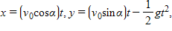
​
where g is the acceleration of gravity 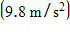. If a gun is fired with α = 55° and v₀ = 440 m/s when will the bullet hit the ground?
​
 | a. | t = 244 s
 | b. | t = 74 s
 | c. | t = 344 s
 | d. | t = 124 s
 | e. | t = 224 s

ANSWER: | b

3. Describe the motion of a particle with position (x, y) as t varies in the given interval 0 ≤ t ≤ 2π.
​
​
 | a. | Moves once counterclockwise along the circle x² + y² = 1 starting and ending at (0, –6).  ​
 | b. | Moves once counterclockwise along the ellipse starting and ending at (0, 6).  ​
 | c. | Moves once counterclockwise along the ellipse starting and ending at (–6, 0).  ​
 | d. | Moves once clockwise along the ellipse starting and ending at (0, 6).  ​
 | e. | Moves once clockwise along the circle starting and ending at (0, 6).  ​

ANSWER: | d

4. If a and b are fixed numbers, find parametric equations for the set of all points P determined as shown in the figure, using the angle ang as the parameter. Write the equations for a = 15 and b = 6.
​
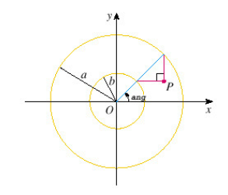
​
​
​
​
​
​
ANSWER: | ​  ​  ​  ​

5. Find parametric equations for the path of a particle that moves once clockwise along the circle , starting at (4, 9).

ANSWER:

6. Eliminate the parameter to find a Cartesian equation of the curve.

ANSWER:

7. Sketch the parametric curve and eliminate the parameter to find the Cartesian equation of the curve.
​
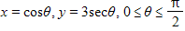
​
​
ANSWER: | ​  ​  ​  ​  ​  ​  ​  ​

8. Eliminate the parameter to find a Cartesian equation of the curve.
​

ANSWER: | x = 6 – y

9. Find the point(s) of intersection of the following two parametric curves, by first eliminating the parameter, then solving the system of equations.
​
and
​
 | a.
 | b.
 | c.
 | d. | (0, 0) and (1, 1)
 | e. | (0, 0), (1, -1), and (1, 1)

ANSWER: | d

10. Find the point(s) of intersection of the following two parametric curves, by first eliminating the parameter, then solving the system of equations.
​
and 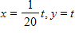
​
 | a.
 | b.
 | c.
 | d. | (45, 900) and (5, 100)
 | e. | (45, 900) and (900, 100)

ANSWER: | d

11. Eliminate the parameter to find a Cartesian equation of the curve.
​

a.
b.
c.
d.
e.

ANSWER: | a

12. Find the parametric equations for the path of a particle that moves two and a half times clockwise around the circle , starting at .
​
a.
b.
c.
d.
e.

ANSWER: | a

13. Find parametric equations for the ellipse 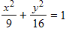.
​
a.
b.
c.
d.
e.

ANSWER: | a

14. Let P be a point at a distance 6 units from the center of a circle of radius 2. The curve traced out by P as the circle rolls along a straight line is called a trochoid. (Think of the motion of a point on a spoke of a bicycle wheel.) Assuming the line is the x-axis and when P is at one of its lowest points, find the parametric equations of the trochoid. (Hint: use the same parameter as for the cycloid.)
​
a.
b.
c.
d.
e.

ANSWER: | a

15. Determine which of the following parametric equations matches the graph.
​
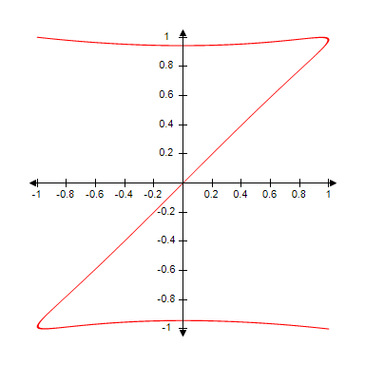
​
a.
b.
c.
d.
e.

ANSWER: | a

